Supplementary Information for

Construction of An Efficient Electrode with Ionomer Binding Sites for Stable Water Electrolysis
Kejie Lao^{1,2,#}, Linrui Wen^{1,2,3,#}, Huihong Lin^{1,2,#}, Linyuan Chen^{1,#}, Meiquan Huang^{1,2}, Xinru Liu^{1,2}, Yaping Pan^{1,2}, Zhiyao Liang¹, Shuirong Li⁴, Xiaoliang Fang⁴,
Xian-Kui Wei^{1,2,*}, Hua Bing Tao^{1,2,5,*} and Nanfeng Zheng^{1,2}
¹ New Cornerstone Science Laboratory, State Key Laboratory for Physical Chemistry of Solid Surfaces, Collaborative Innovation Center of Chemistry for Energy Materials, and College of Chemistry and Chemical Engineering, Xiamen University, Xiamen 361005, China
² Innovation Laboratory for Sciences and Technologies of Energy Materials of Fujian Province (IKKEM), Xiamen 361005, China
³ Amoy Island Hydrogen (Xiamen) Technology Co., Ltd., Xiamen 361103, China
⁴ College of Energy, Xiamen University, Xiamen 361005, China
⁵ Gulei Innovation Institute, Xiamen University, Zhangzhou 363200, China
*Corresponding author: hbtao@xmu.edu.cn (H. B. T.), xkwei@xmu.edu.cn (X. W.)
#Equal contributions
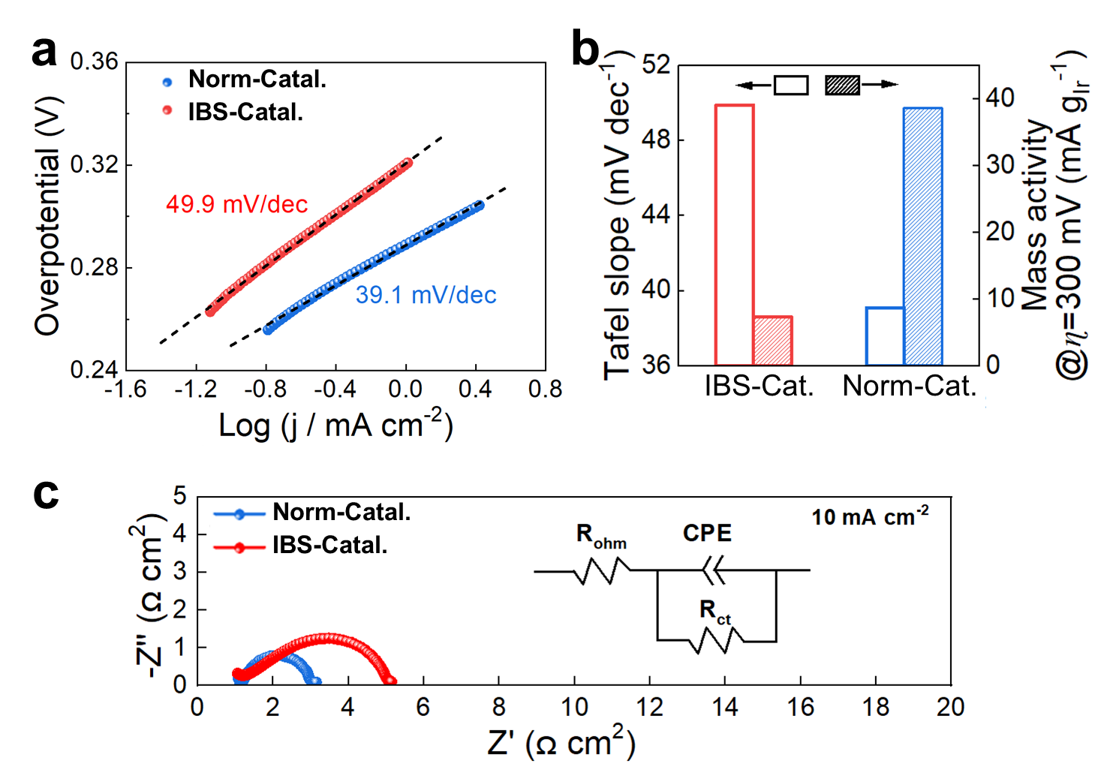
Supplementary Figure 1. Ideal liquid electrolyte evaluation of two prototypical model catalysts. (a) Tafel plots. (b) Mass activity at an overpotential of 300 mV. (c) Nyquist plots of GEIS conducted at 10 mA/cm².
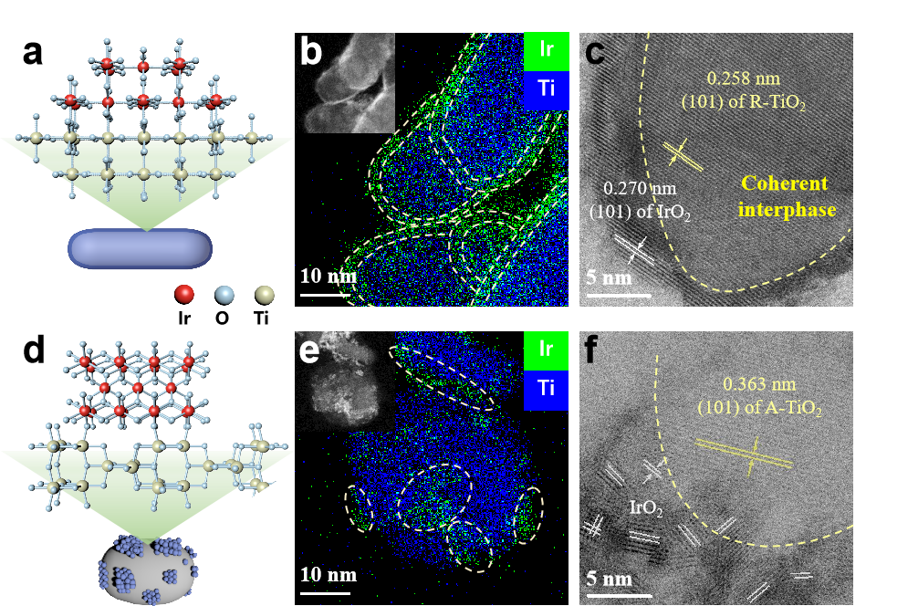
Supplementary Figure 2. Structure of the two catalysts. (a) Structure diagram of Norm-Catal. (b) HAADF-STEM image (inset) and EDX elemental mappings of Norm-Catal. (c) High-resolution STEM image of Norm-Catal. (d) Structure diagram of IBS-Catal. (e) HADDF-STEM image (inset) and EDX elemental mappings of IBS-Catal. (f) High-resolution STEM image of IBS-Catal.

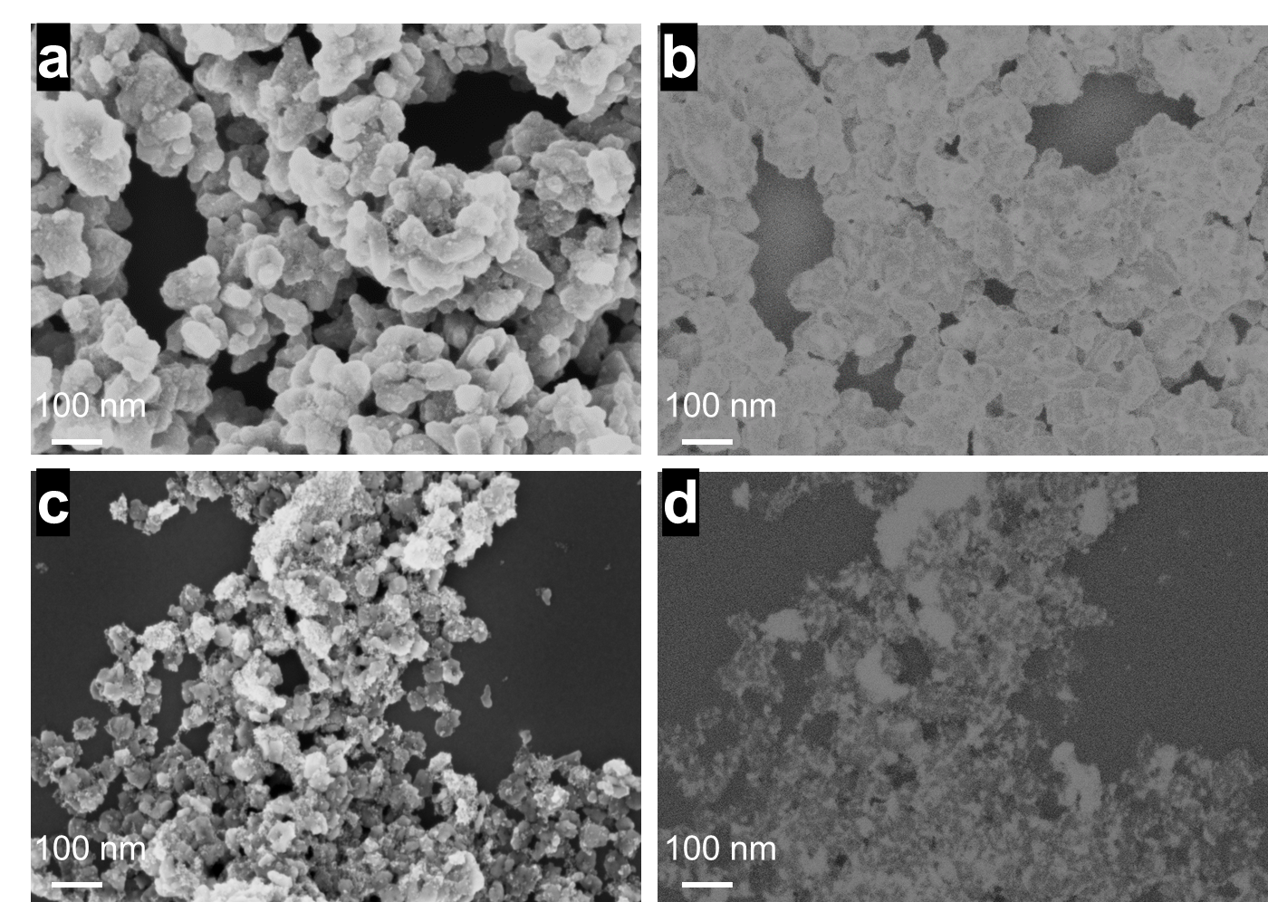
Supplementary Figure 3. SEM of the two model catalysts. (a) Secondary electron imaging and (b) backscattered electron imaging of Norm-Catal. (c) Secondary electron imaging and (d) backscattered electron imaging of IBS-Catal.

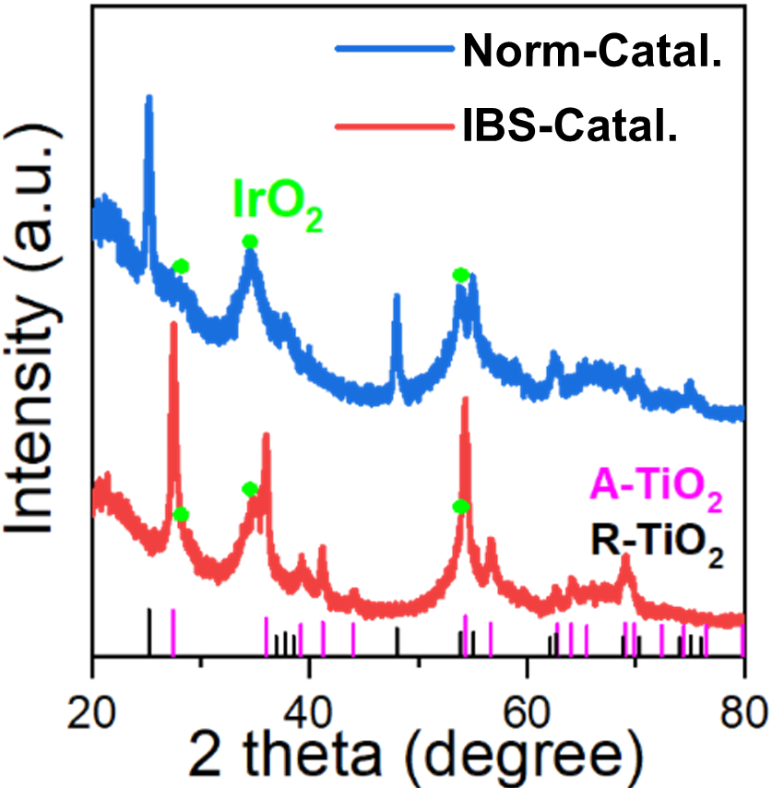
Supplementary Figure 4. XRD of the two catalysts.

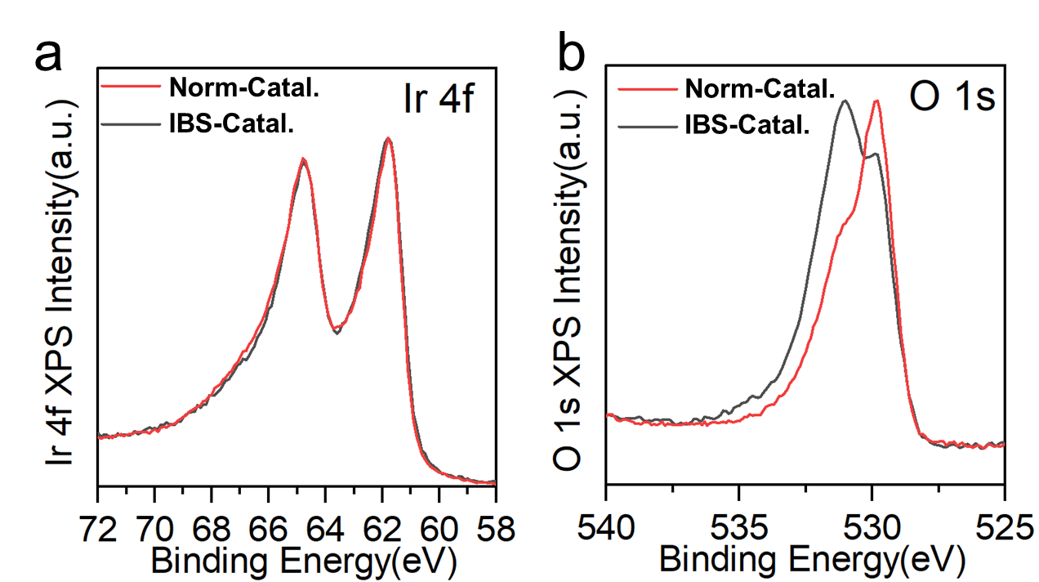
Supplementary Figure 5. High-resolution XPS Ir 4f spectra and O 1s spectra of two prototypical model catalysts.

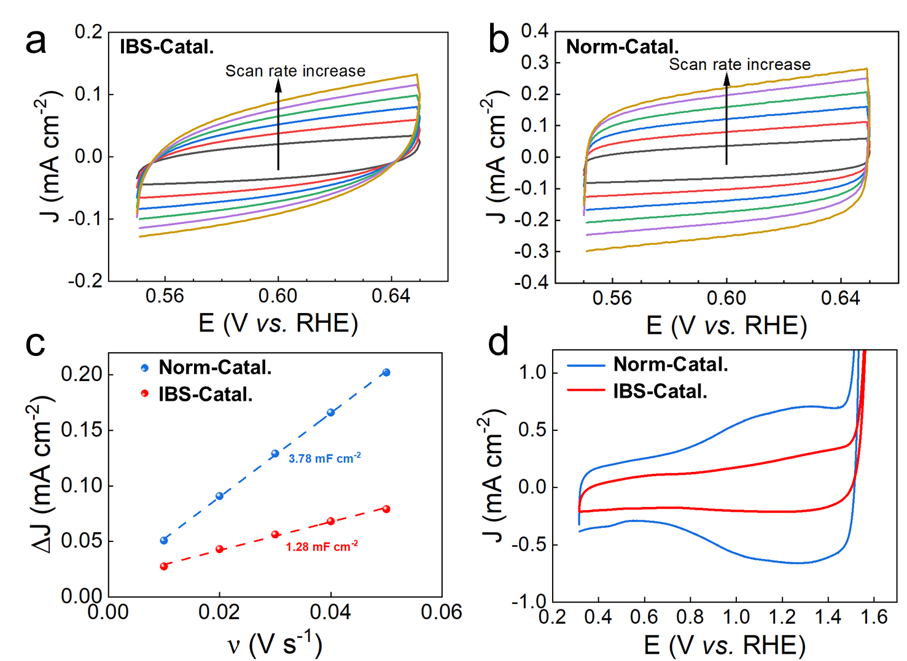
Supplementary Figure 6. Ideal liquid electrolyte evaluation of two prototypical model catalysts. CVs recorded at the different scan rate of (a) IBS-Catal. and (b) Norm-Catal. (c) C_{dl} plots derived from CV curves. (d) CVs recorded at the scan rate of 50 mV s⁻¹.

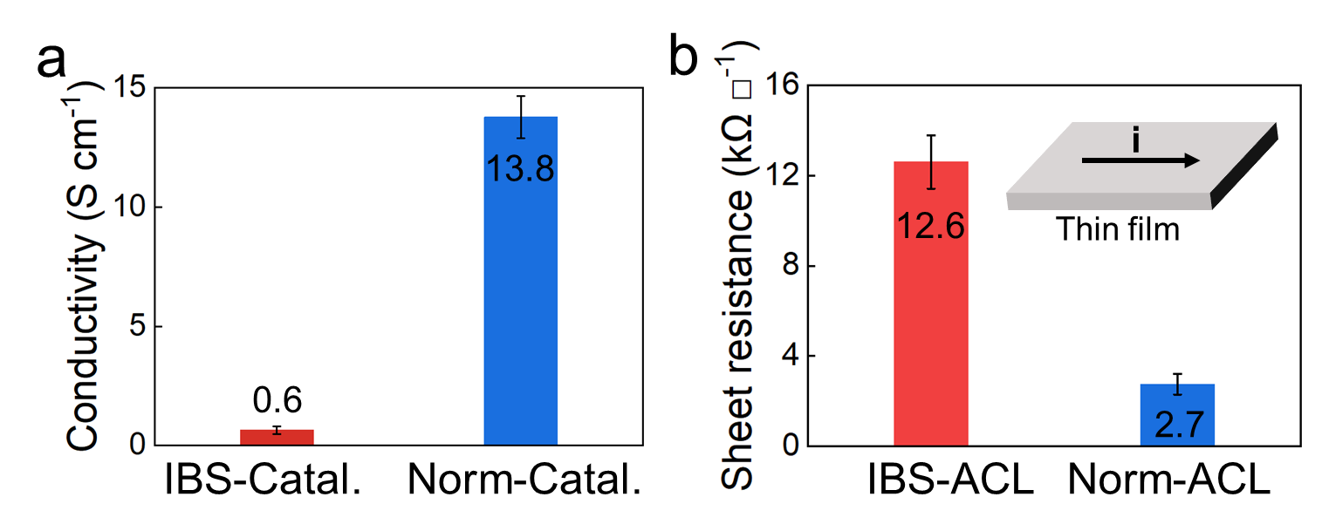
Supplementary Figure 7. Differences in electronic conduction between the two. (a) Conductivity of the two catalyst powders. (b) Sheet resistance of the two catalyst layers.

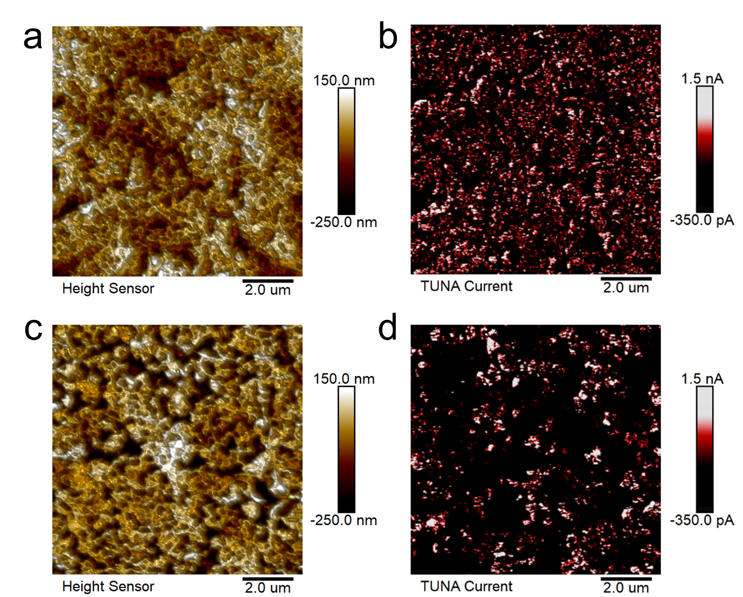
Supplementary Figure 8. AFM images of the two catalyst layer. (a) Topographic image and (b) current distribution of Norm-ACL. (c) Topographic image and (d) current distribution of IBS-ACL.

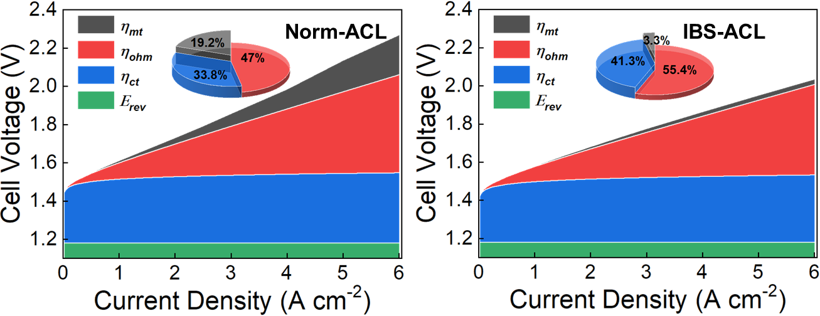
Supplementary Figure 9. Breakdown of cell voltage into various voltage losses of (a) Norm-Catal., (b) IBS-Catal. and their respective components proportion of overpotential at 6.0 A cm⁻².

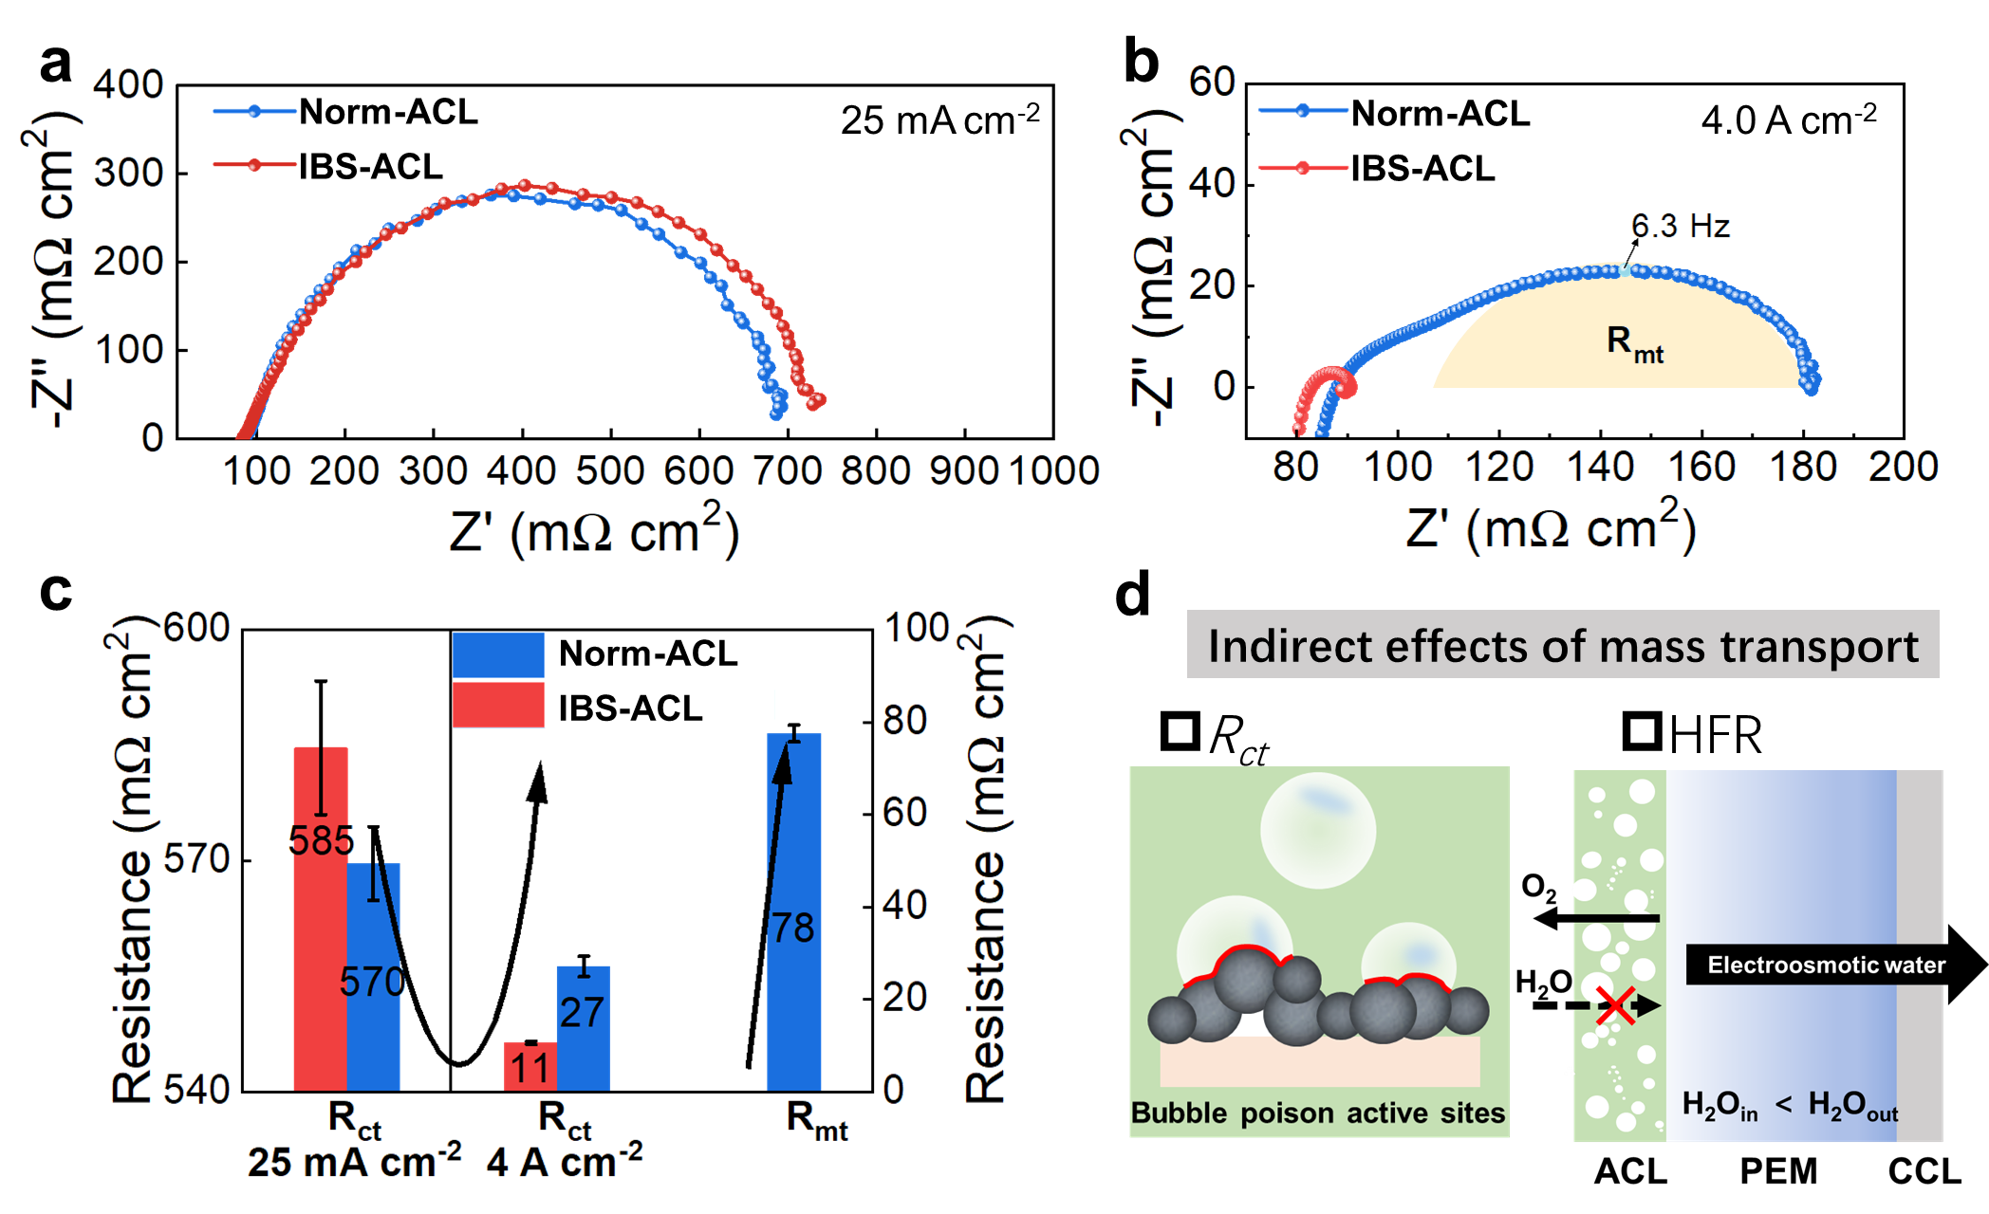
Supplementary Figure 10. (a) Nyquist plots of GEIS curves of the two ACLs conducted at 25 mA/cm². (b) Nyquist plots of GEIS curves of the two ACLs conducted at 4.0 A/cm². (c) Fitted R_{ct}, R_{mt} results of both ACLs. (d) Illustration of indirect effects of mass transport.

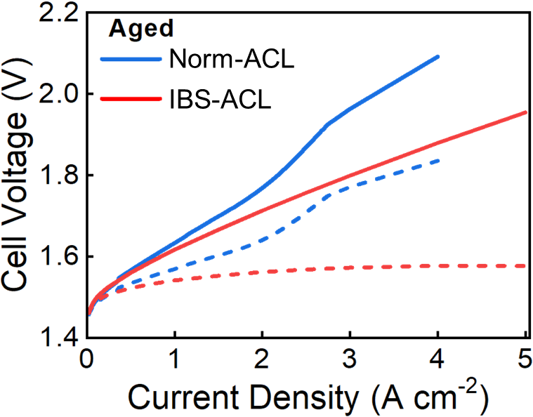
Supplementary Figure 11. Polarization curve of the two ACLs after PEMWE stable operation condition at 80 ℃ and 2.0 A/cm².

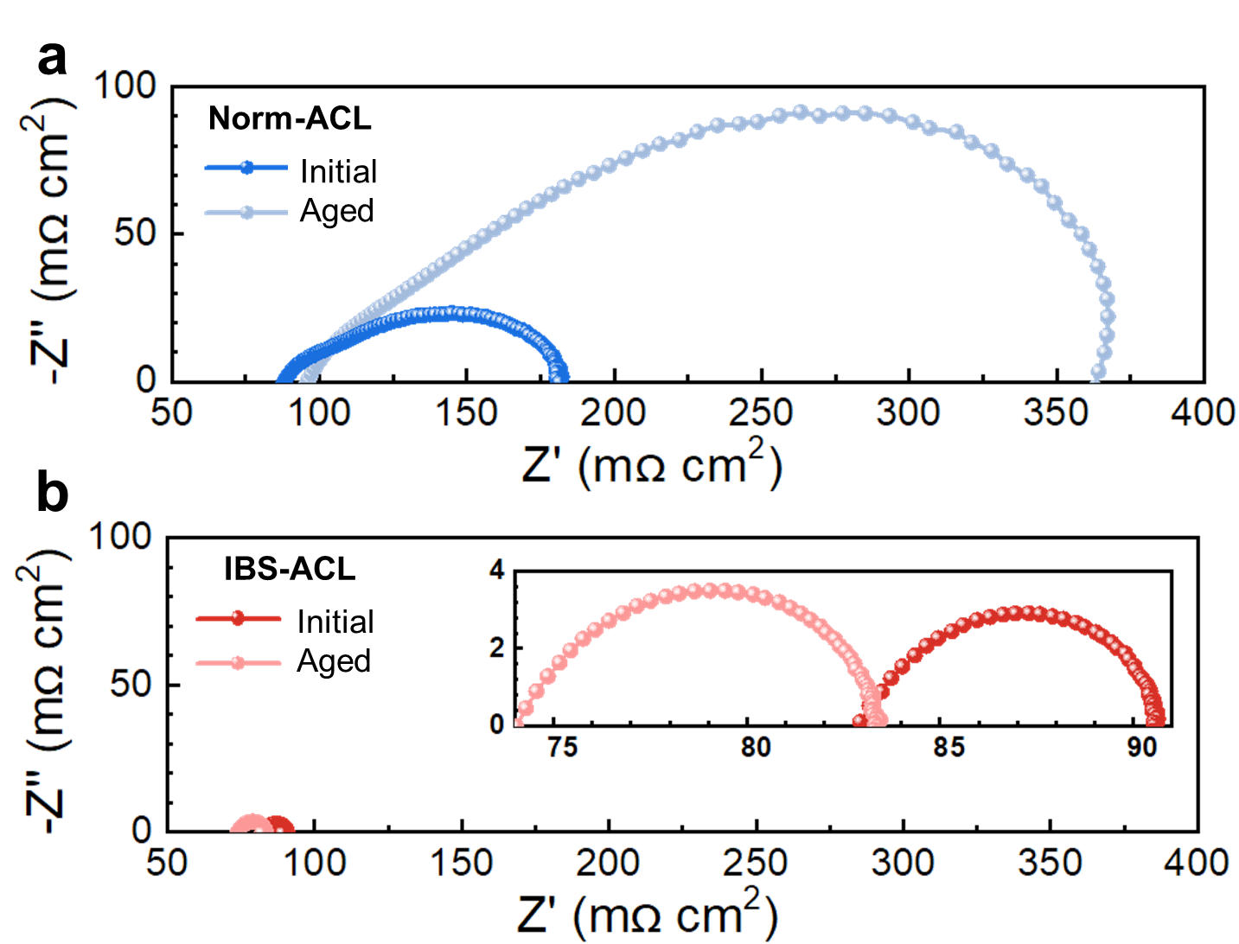
Supplementary Figure 12. (a) GEIS curves of the Norm-ACL conducted at 4.0 A/cm² for the initial and aged ACL. (b) GEIS curves of the IBS-ACL conducted at 4.0 A/cm² for the initial and aged ACL.

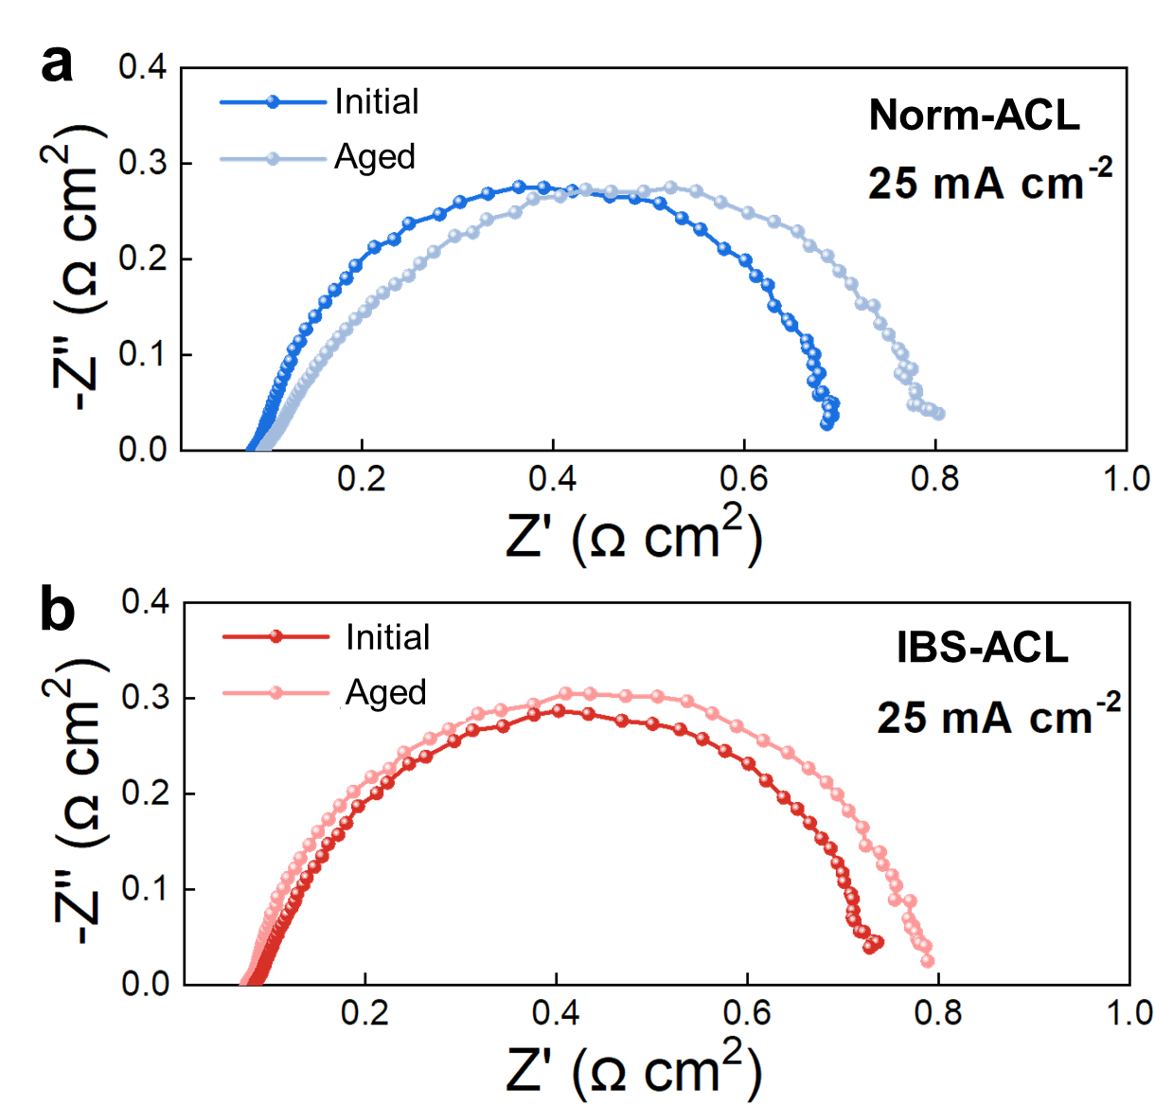
Supplementary Figure 13. (a) GEIS curves of the Norm-ACL conducted at 25 mA/cm² for the initial and aged ACL. (b) GEIS curves of the IBS-ACL conducted at 25 mA/cm² for the initial and aged ACL.

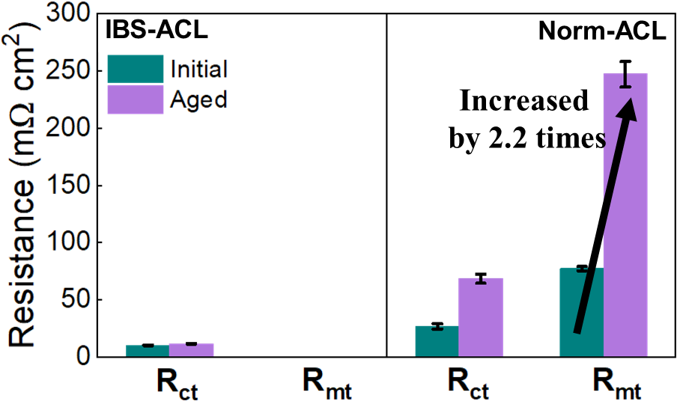
Supplementary Figure 14. Fitted R_{ct} and R_{mt} results of before and after aging.

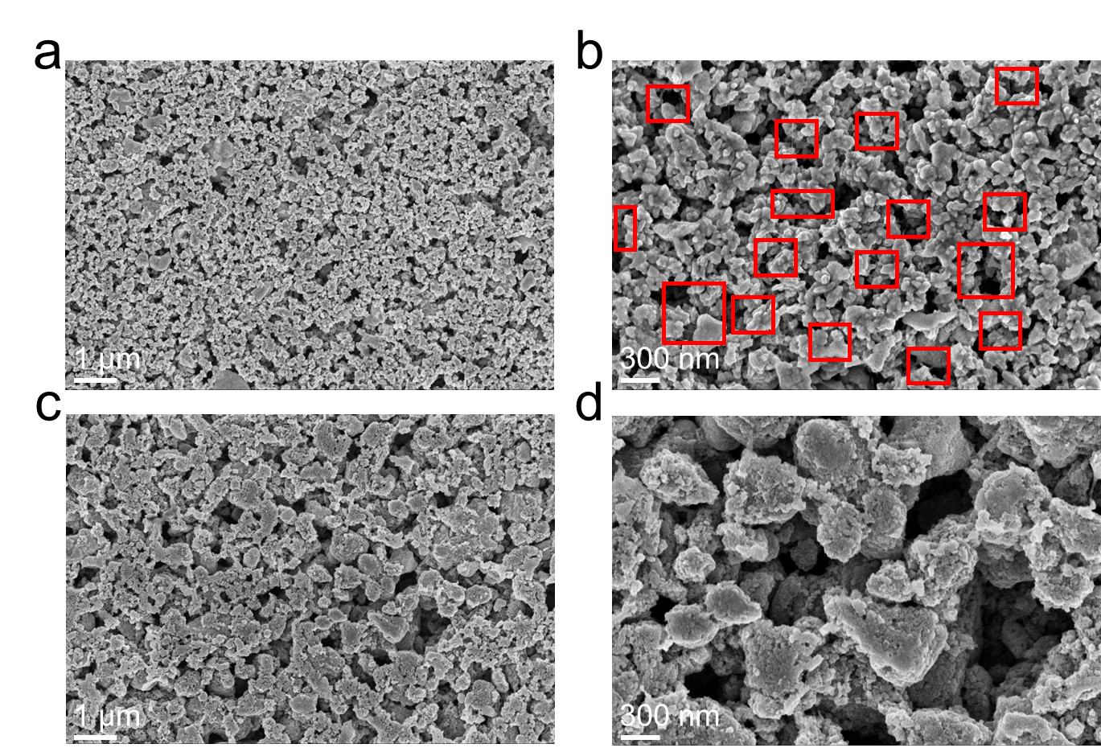
Supplementary Figure 15. Surface morphology of (a-b) Norm-ACL and (c-d) IBS-ACL by SEM.

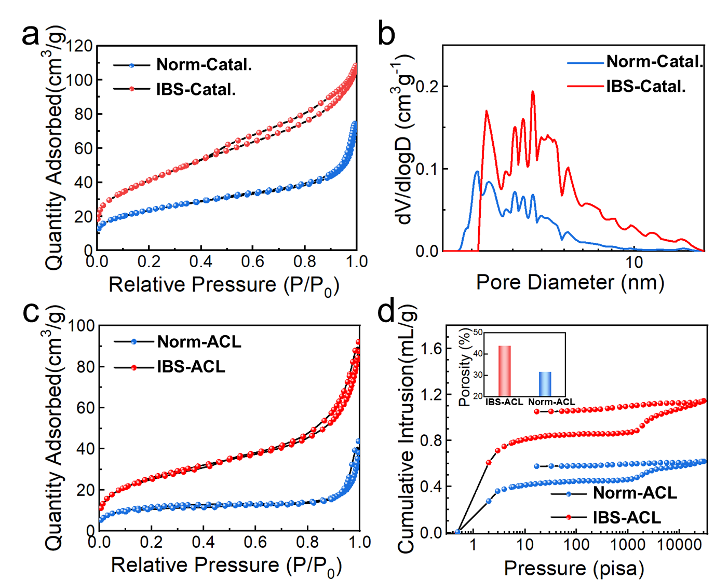
Supplementary Figure 16. Structure Characterization of the two catalysts and corresponding ACLs. (a) N₂ adsorption/desorption isotherms for the two catalysts and (b) the corresponding BJH pore-size distribution analyzed from the desorption branch. (c) N₂ adsorption/desorption isotherms and (d) mercury intrusion porosimetry for the two ACLs. The inset is the corresponding porosity.

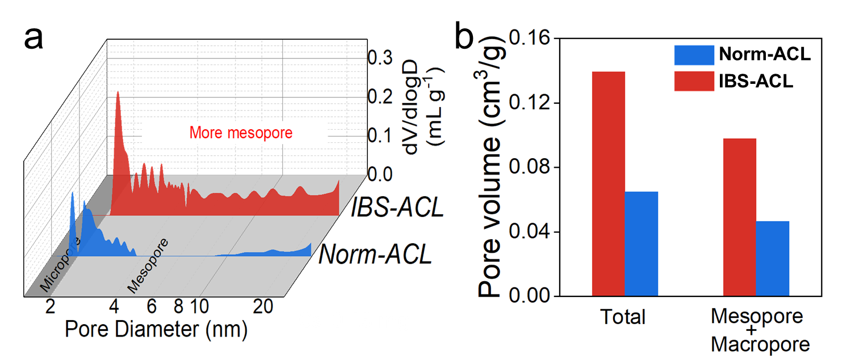
Supplementary Figure 17. Structure Characterization of the two ACLs. (a) Pore-size distribution curves by BET. (b) Pore volume by BET: the total pore volume is determined through single point adsorption, while the micropore volume is calculated using the Horvath-Kawazoe method.

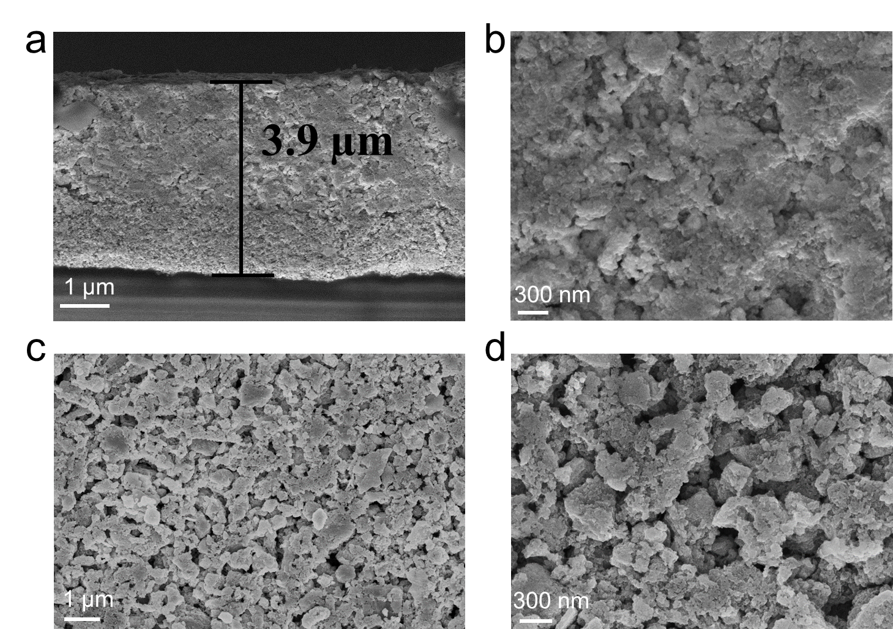
Supplementary Figure 18. Structure characterization of ACL. (a-b) The cross-section and (c-d) surface topography of IBS-ACL after hot press.

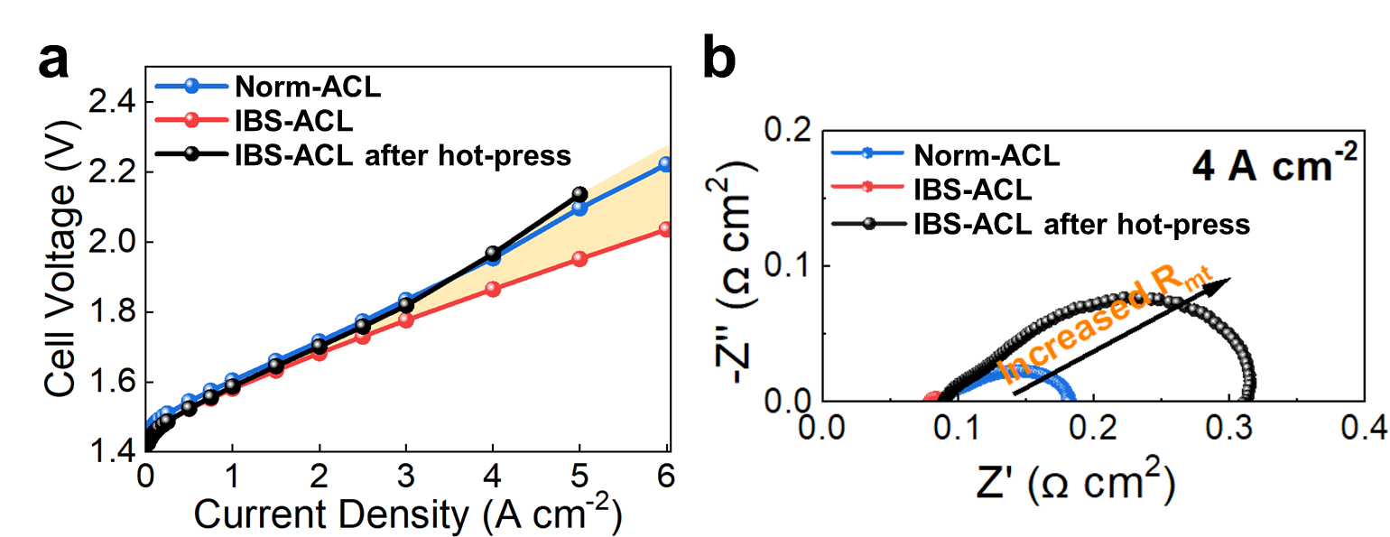
Supplementary Figure 19. (a) Polarization curve in PEMWE cell after hot press. (b) GEIS curves of the IBS-ACL after hot press conducted at 4.0 A/cm².

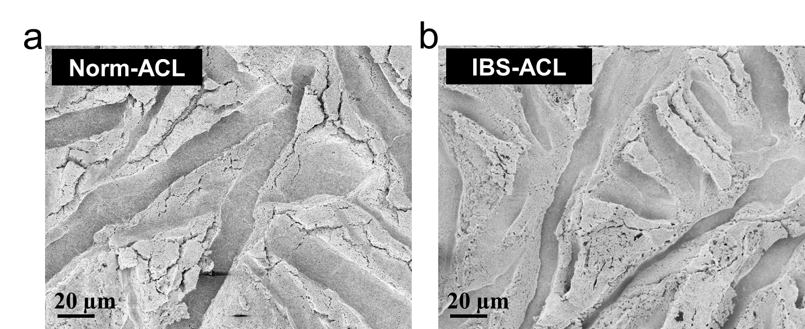
Supplementary Figure 20. (a) Characterization of the aged Norm-ACL after testing. (b) Characterization of the aged IBS-ACL after testing.

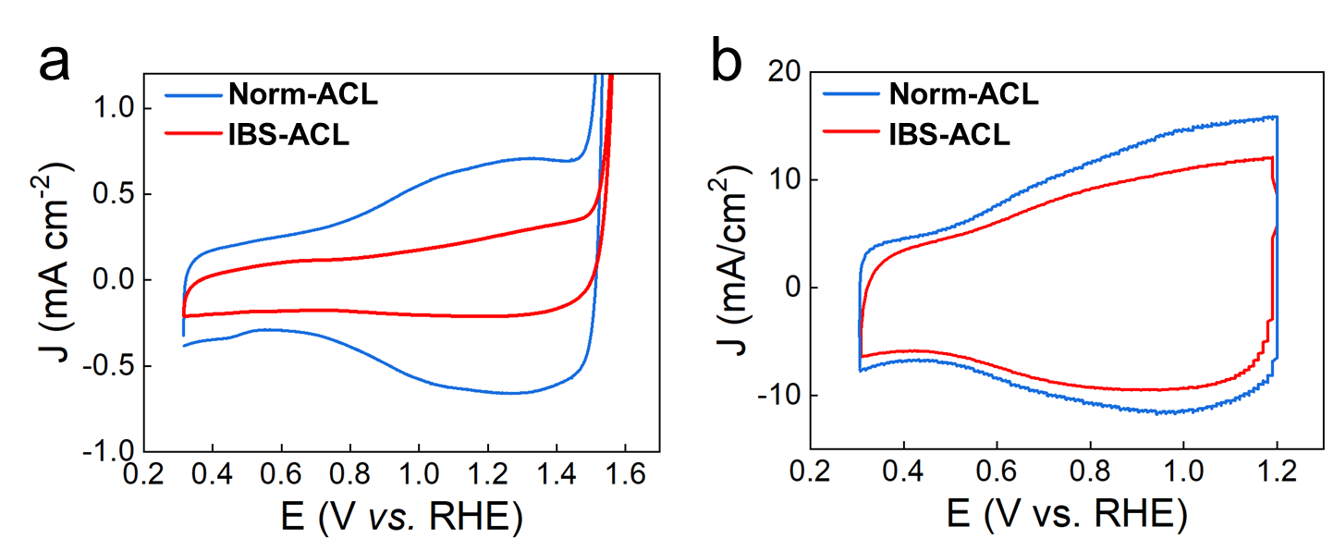
Supplementary Figure 21. Cyclic voltammograms recorded at the different electrolyte systems. (a) CVs recorded in ideal liquid electrolyte at scan rate of 50 mV s⁻¹. (b) CVs recorded in PEMWE device at scan rate of 50 mV s⁻¹.

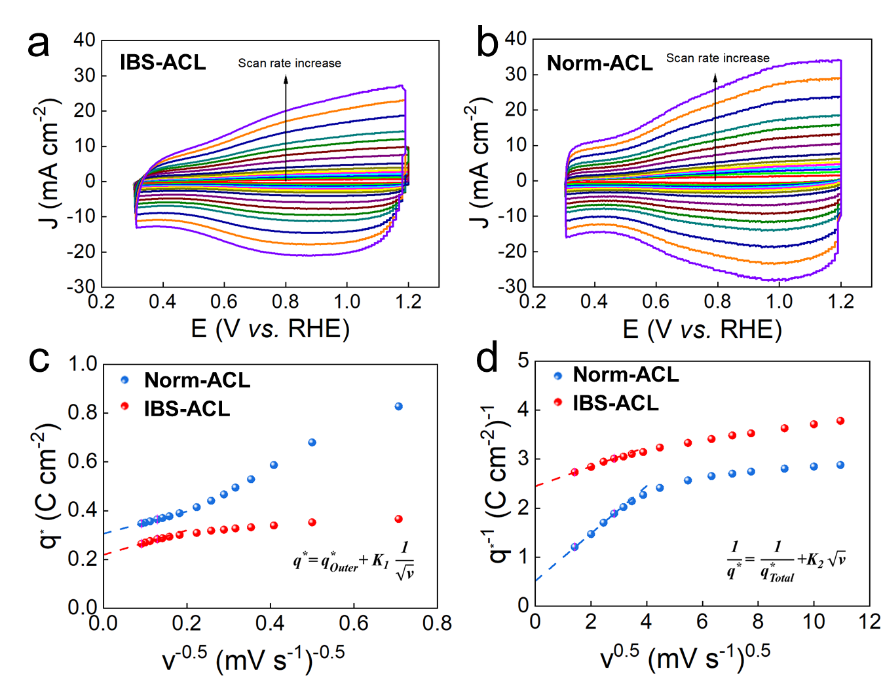
Supplementary Figure 22. Cyclic voltammograms recorded at the different scan rate of (a) IBS-ACL and (b) Norm-ACL. (c) The voltammetric charge (q* ) vs. v^{-0.5} curves and (d) q*⁻¹ vs. v^{0.5} curves.

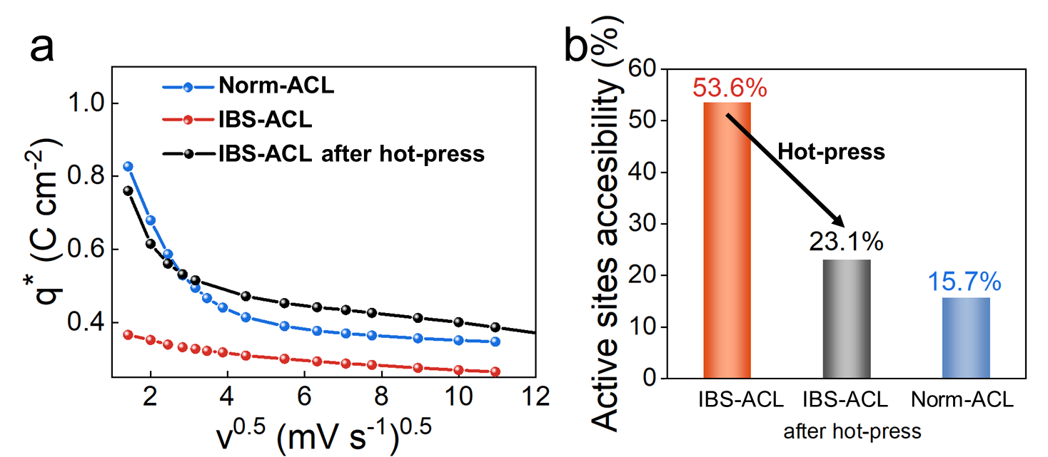
Supplementary Figure 23. (a) Voltammetric charge of CVs recorded as functions of scan rate. (b) The utilization rate of ECSA on ACL.

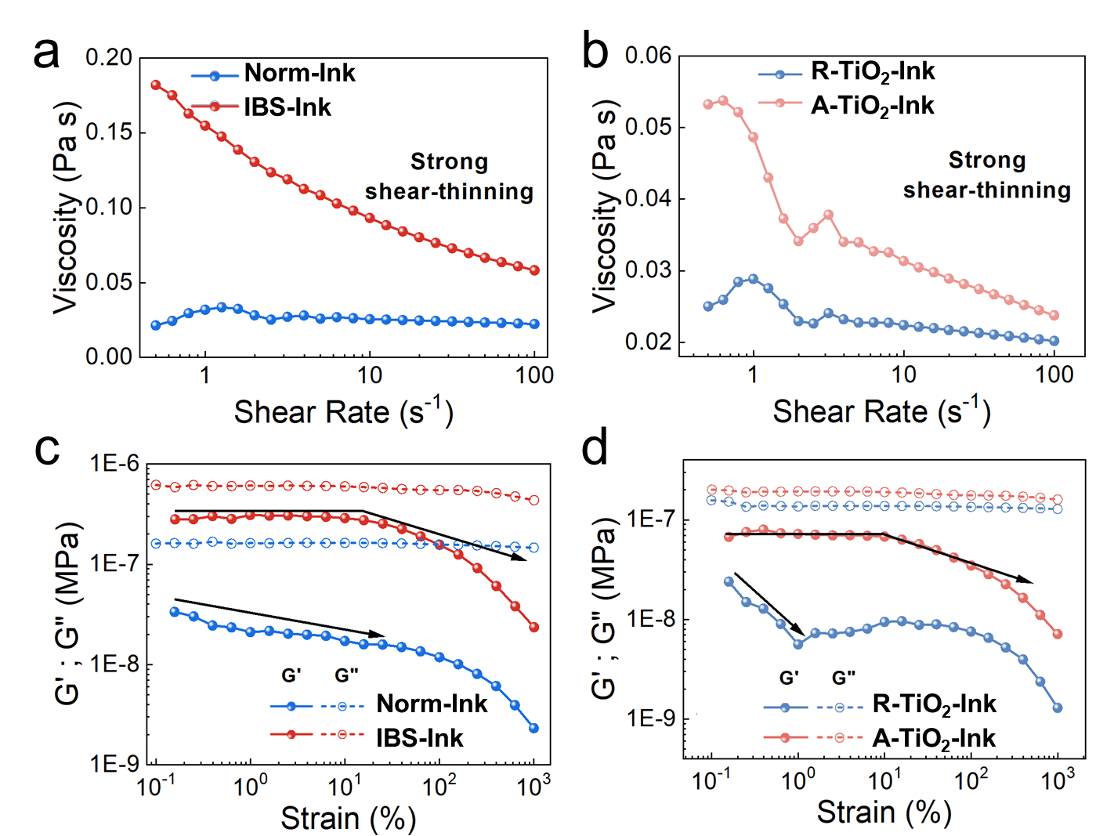
Supplementary Figure 24. Rheological behavior of ink system. Steady-shear relative viscosity data of ink for (a) the two catalysts and (b) supports. Amplitude-sweep measurements, elastic (G’) and loss (G’’) moduli as a function of strain amplitude, of inks for (c) the two catalysts and (d) supports.

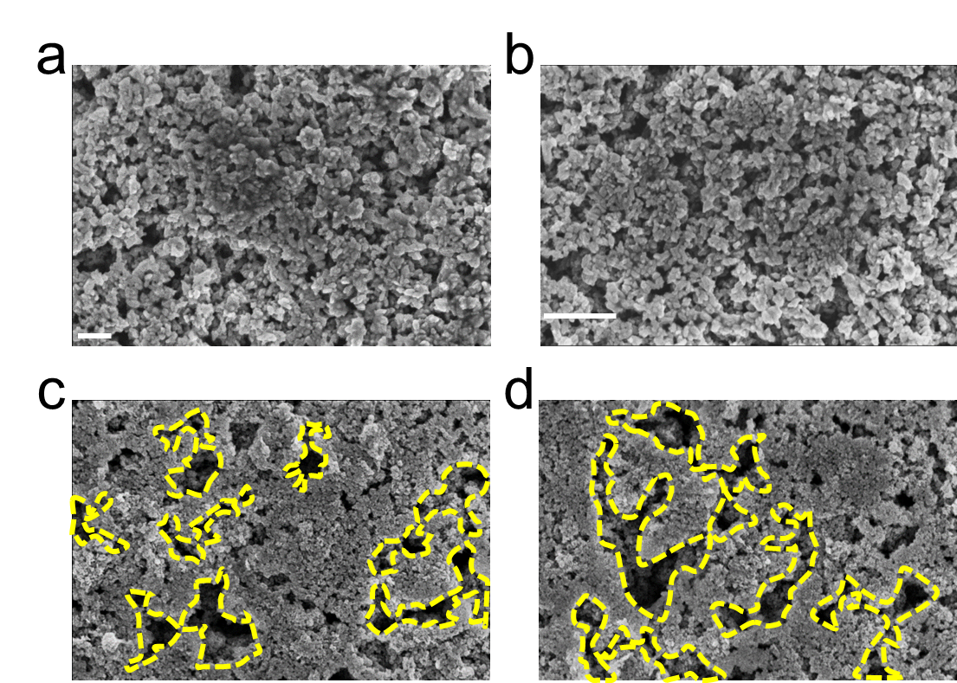
Supplementary Figure 25. Surface morphology of ACLs based on R-TiO₂ (a-b) and A-TiO₂ (c-d), characterized by SEM.

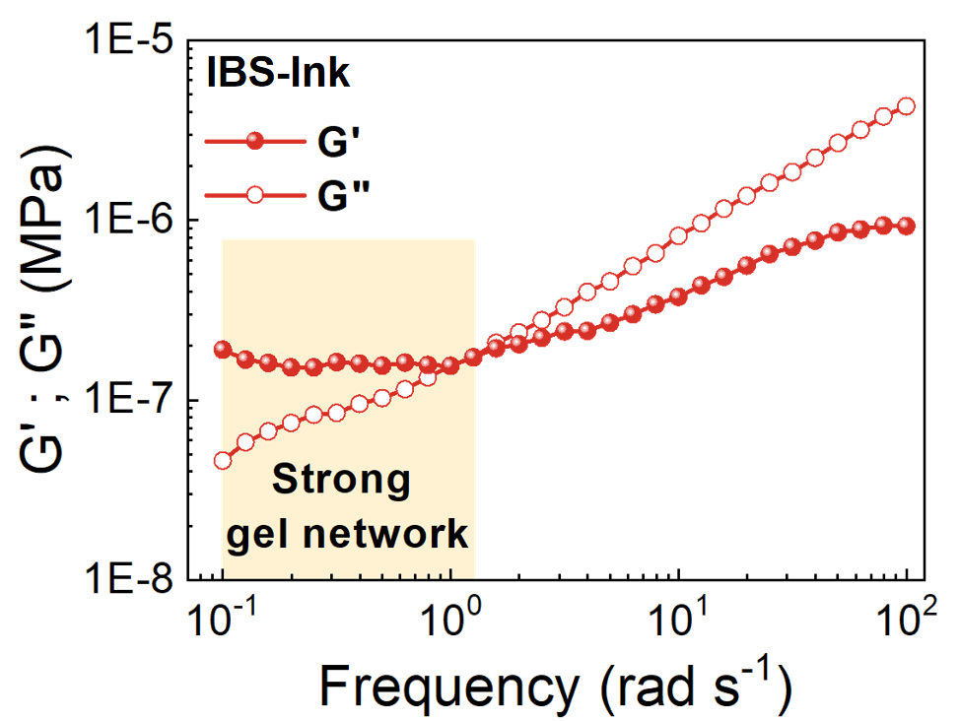
Supplementary Figure 26. Frequency-sweep measurements, elastic (G’) and loss (G’’) muduli as function of frequency.

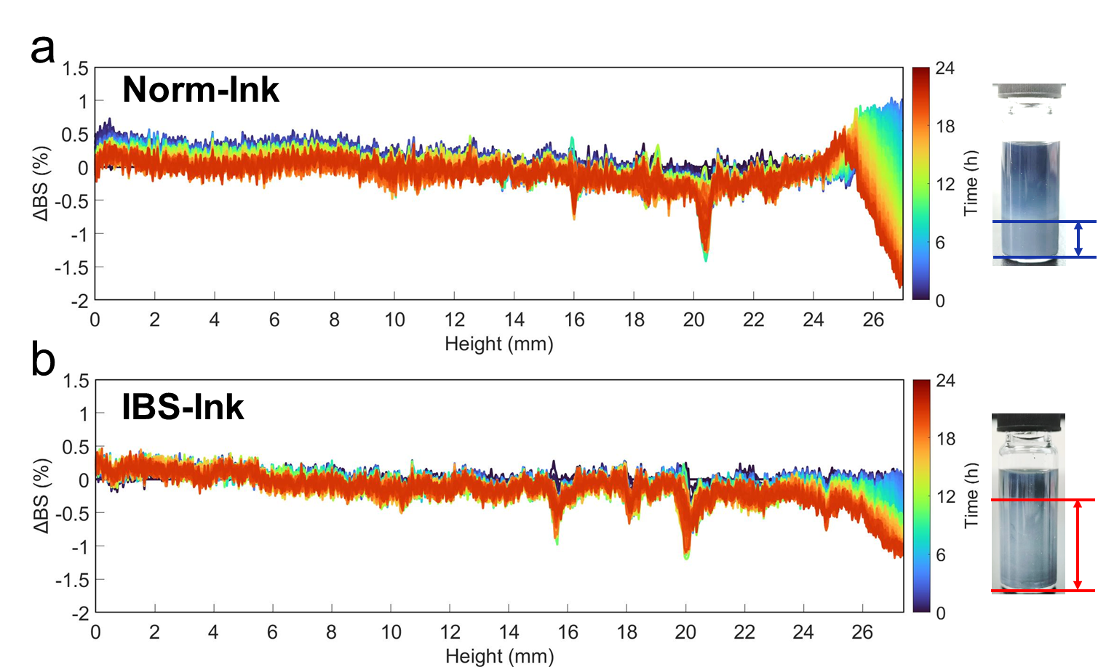
Supplementary Figure 27. Characterization of microdynamics and distribution of ink by multiple dynamic light scattering (MDLS) technology at 60 ℃. Variation of backscattering intensity (Delta BSI) over 24 hours of (a) Norm-Ink and (b) IBS-Ink. The inset (right) is the ink after aging for a month.

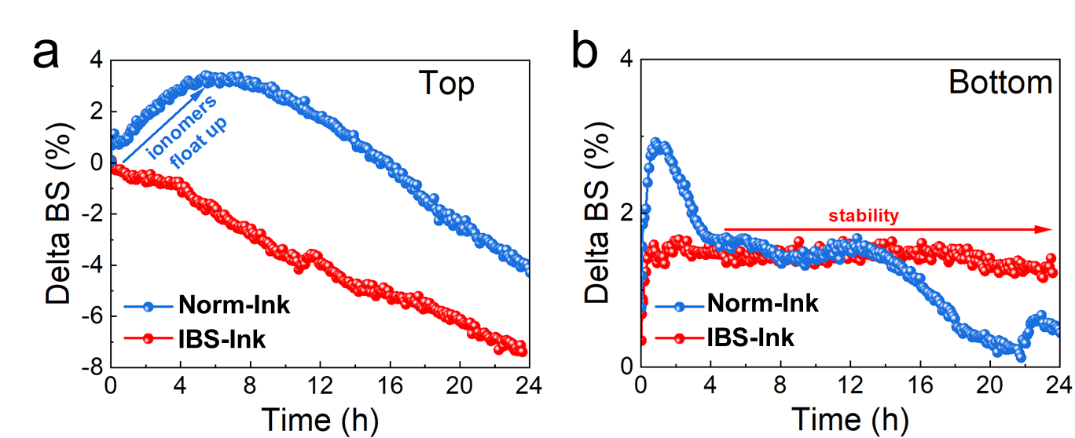
Supplementary Figure 28. Delta BSI of the local region in actual ink systems over 24 hours. (a) Top layer and (b) bottom layer of ink.

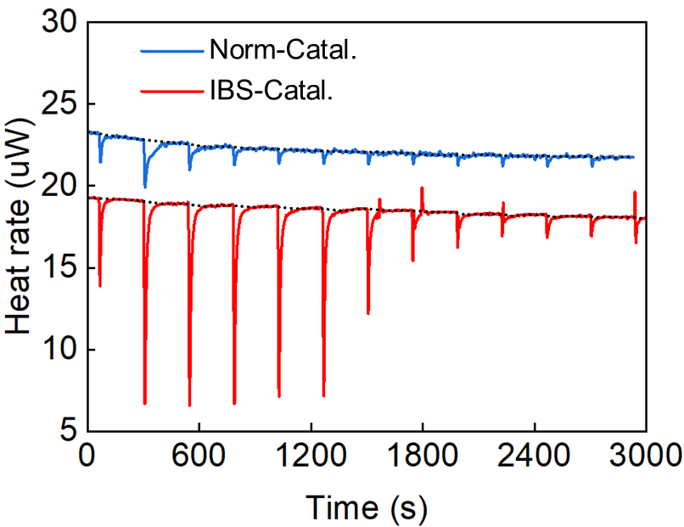
Supplementary Figure 29. Raw ITC data after background subtraction. The initial injection is excluded from the fitting to prevent any influence from air bubbles during equilibration on the measurement. Occasional bubble disturbances may introduce noise, especially at higher ionomer concentrations.

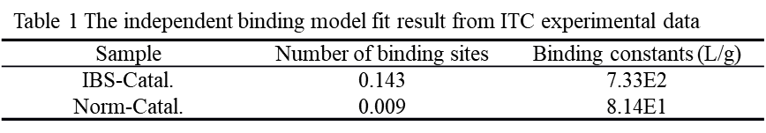
Supplementary Table 1. Thermodynamic parameters, including binding constant (K_{b}) and number of binding sites (N), were extracted from an independent binding isotherm using the Langmuir model.

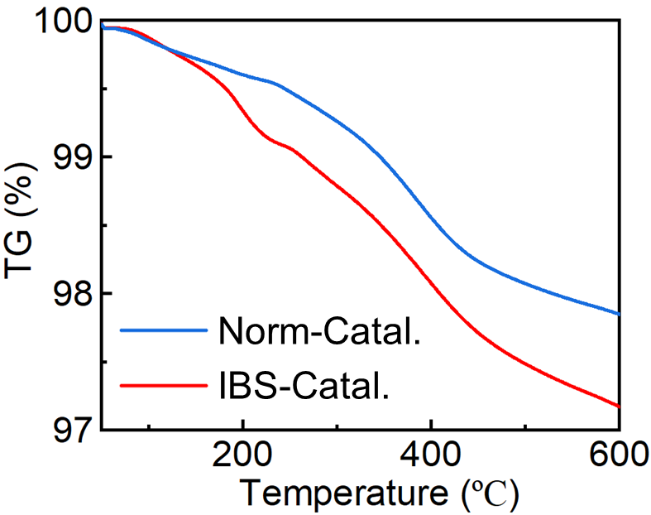
Supplementary Figure 30. Thermogravimetric analysis of the two catalysts at a heating rate of 5 ℃/min in an Ar atmosphere.

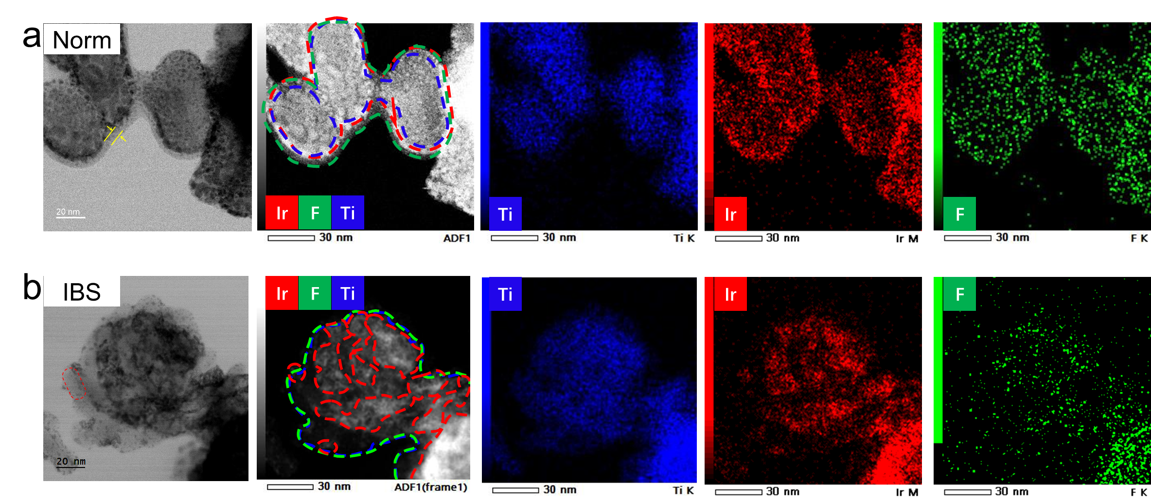
Supplementary Figure 31. (a) From left to right: high-resolution BF-STEM image, corresponding HAADF-STEM image, and EDS maps of F, Ir, Ti for Norm-ACL. (b) From left to right: high-resolution BF-STEM image, corresponding HAADF-STEM image, and EDS maps of F, Ir, Ti for IBS-ACL.

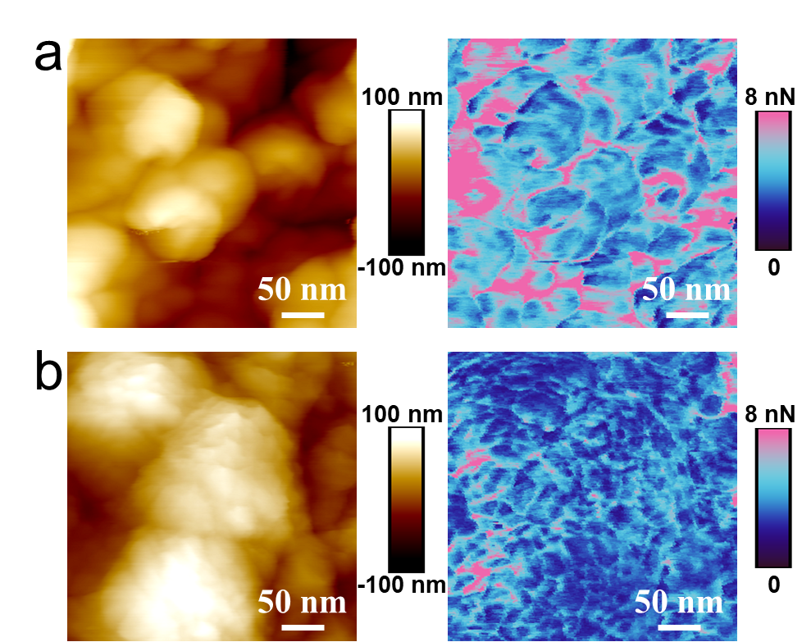
Supplementary Figure 32. Surface ionomer distribution characterization of the two ACLs. (a) Topographic image (left) and adhesion distribution (right) of Norm-ACL by AFM. (b) Topographic image (left) and adhesion distribution (right) of IBS-ACL by AFM.

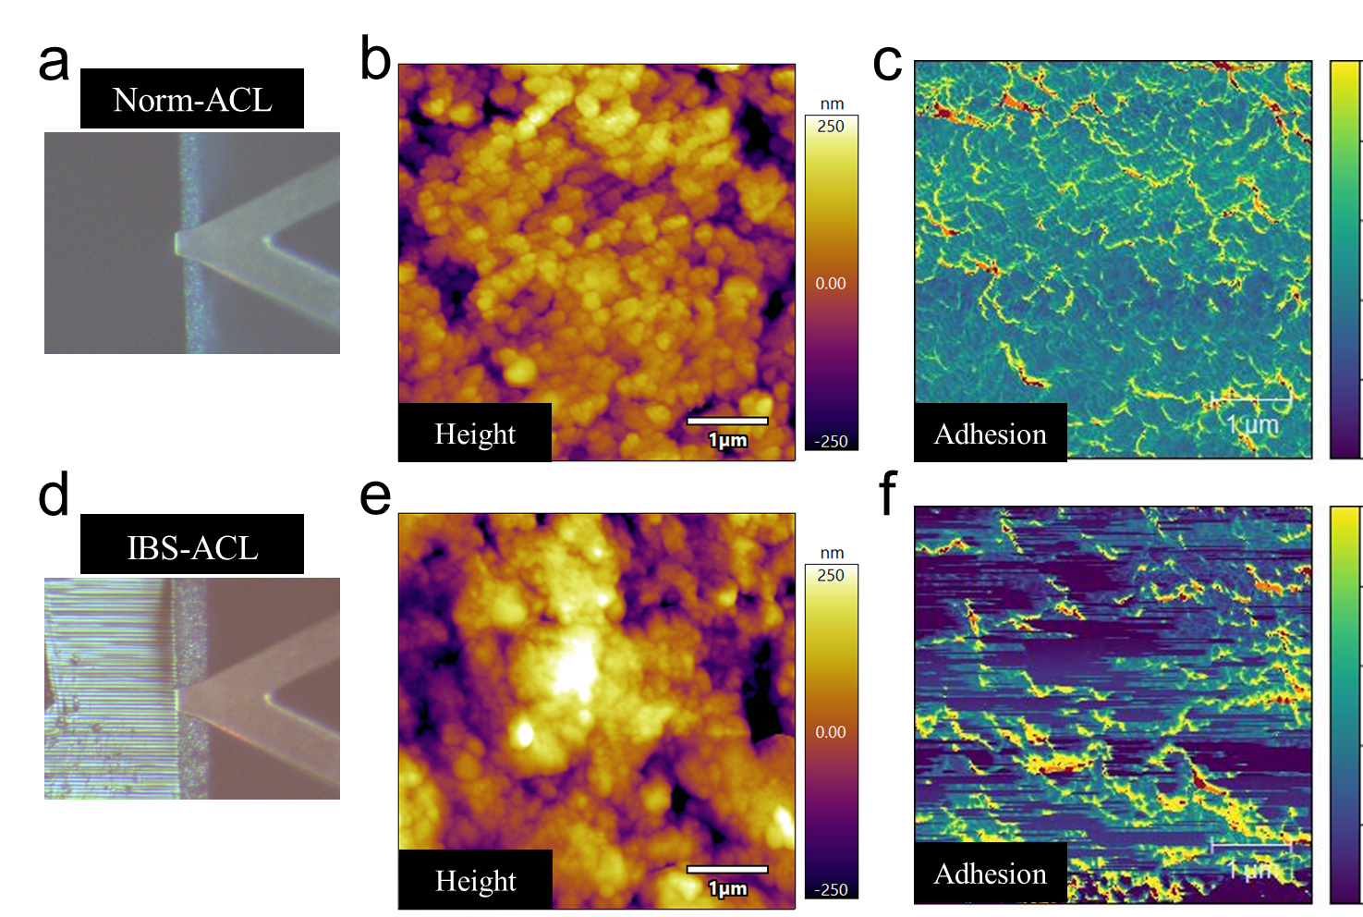
Supplementary Figure 33. Cross-sectional ionomer distribution characterization of the two ACLs. (a) Cross-section under a microscope, (b) topographic image and (c) adhesion distribution of Norm-ACL by AFM. (d) Cross-section under a microscope, (e) topographic image and (f) adhesion distribution of IBS-ACL by AFM.

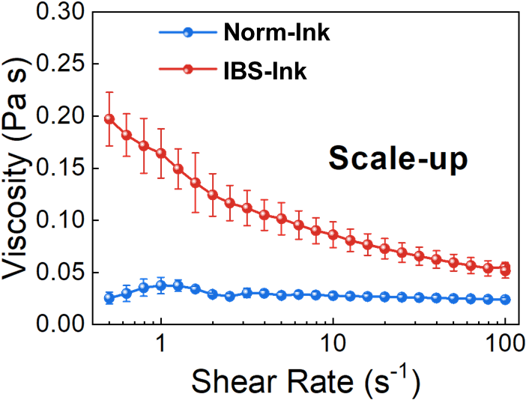
Supplementary Figure 34. Steady-shear relative viscosity data of inks after scale-up.

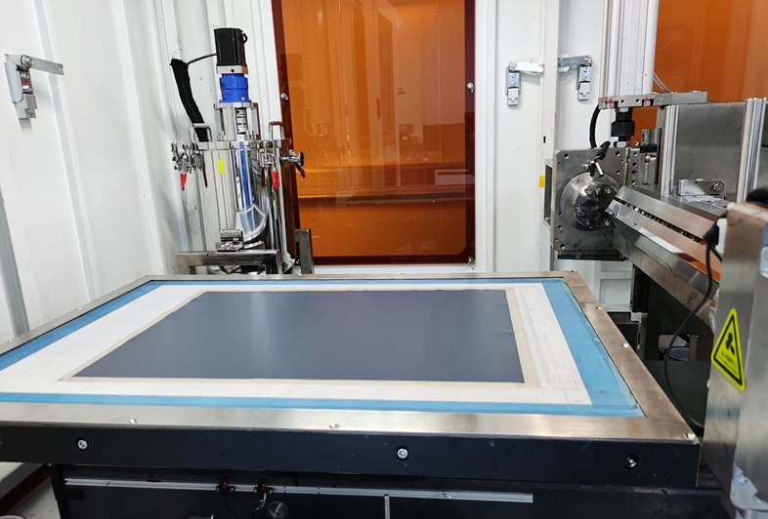
Supplementary Figure 35. The sheet-type slot-die extrusion coating process as implemented in real-world manufacturing.

