Supporting Information for
“Recyclable Silicone Elastomers from Non-Carbon Heteroatomic Polymer Backbones”

Yuanbo Zhang¹, Feiyang Li¹, Jia Tian², Shenghan Zhang¹, Muqing Cao¹, Ruihao Zhou¹, Lu Wang³, Peng-Fei Cao², Huaping Xu¹*

*Corresponding author: xuhuaping@mail.tsinghua.edu.cn

¹Department of Chemistry, Tsinghua University, Beijing 100084, China
²College of Materials Science and Engineering, Beijing University of Chemical Technology, Beijing, 100029, China
³SINOPEC (Beijing) Research Institute of Chemical Industry Co., Ltd.

Table of Contents
S1. Materials and Methods 3
S1.1 Reagents and Materials 3
S1.2 Characterizations 4
S2. Synthesis of Polymers 7
S2.1 Synthesis of Dialkyl Tellurides 7
S2.2 Synthesis of PTeSiO-Cx Copolymers 8
S3. Structural Characterizations 9
S3.1 ¹H NMR of Dialkyl Tellurides 9
S3.2 ¹H NMR of Monomers and Co-polymers 10
S3.3 Molecular Weights Evolution (GPC) 11
S3.4 PTeSiO–C4 (¹H, ¹²⁵Te, ²³Si, signal assignments) 12
S3.5 PTeSiO–C8 (¹H, ¹²⁵Te, signal assignments) 15
S3.6 PTeSiO–C12 (¹H, ¹²⁵Te, signal assignments) 17
S3.7 DOSY NMR Analyses (1D and 2D) 19
S3.8 ¹H NMR of Distillate 25
S3.9 TOF-SIMS Profiles 26
S3.10 TBAF-Mediated Cleavage Reaction 29
S3.11 XPS Spectra of PTeSiO-Cx 31
S3.12 FTIR Spectroscopy 32
S3.13 Raman Spectroscopy 33
S4. General Material Properties 34
S4.1 Polymer Physics of Te–O–Si–O Chains Compared with PDMS 34
S4.2 Absolute Molecular Weight by MALS 37
S4.3 Molecular Conformation Analysis 39
S4.4 Material Processing and Solvent Resistance 43
S4.5 Thermal Analyses (DSC, DMA, TGA) 45
S4.6 Structural analysis by XRD and SAXS 48
S4.7 Fabrication of Crosslinked PDMTeS-20 51
S4.8 Dielectric Properties 52
S5. Modulating Hetero-Chain Ratio 53
S5.1 Synthesis of PTeSiO-Rx Copolymers 53
S5.2 Determination of Hetero-chain Ratios 54
S5.3 Rheological Evolution and Te–O Dependent Transitions 55
S5.4 DSC Profiles of PTeSiO–Rx 57
S5.5 Spin-Coated PTeSiO Films 58
S6. Reductive Depolymerization 59
S6.1 Depolymerization and Separation Process 59
S6.2 Kinetic Analyses of Depolymerization 60
S6.3 GPC Analyses of Depolymerized Products 64
S6.4 ¹H NMR for Depolymerized Mixtures 66
S6.5 ¹H NMR for Separated Products 68
S6.6 Recovery Efficiency 70
S7. References 71

S1. Materials and Methods

S1.1 Reagents and Materials
All chemicals used in this study were sourced from reputable suppliers, and used as received unless otherwise noted. Dimethyldiethoxysilane (DDS), hexamethylcyclotrisiloxane (D3), 1-bromobutane, 1-bromooctane, 1-bromododecane, and tetramethylammonium hydroxide (TMAH, 10% in MeOH) were purchased from Macklin Biochemical Co., Ltd. Tellurium powder (99.9%, 100 mesh), sodium borohydride (NaBH₄, >98%), and hydrogen peroxide solution (30 wt.%) were obtained from Aladdin Biochemical Technology Co., Ltd. Tetrabutylammonium fluoride (TBAF, 1.0 M in THF), polydimethylsiloxane oils (PDMS, 100 cSt and 500 cSt viscosity grades), α,ω-dihydroxy polydimethylsiloxane (101 silicone, 5000 cSt viscosity grades), methyltris(methylethylketoxime)silane (MOS, 97%), and dibutyltin dilaurate (DBTDL, 97%) were supplied by ACMEC Biochemical Technology Co., Ltd. L-ascorbic acid (vitamin C, 99%) and anhydrous sodium sulfate (99%) were purchased from Sinopharm Chemical Reagent Co., Ltd. Ultrapure water was used for all aqueous solutions. Analytical-grade organic solvents were obtained from Titan Scientific Co., Ltd. Deuterated solvents, including chloroform-d (CDCl₃, with and without TMS) and methanol-d₄ (CD₃OD, with and without TMS), were purchased from Shanghai ACMEC Biochemical Co., Ltd. TMS-free solvents were specifically employed to avoid interference from Si–CH₃ resonances at 0 ppm in polymer NMR spectra. Casting molds were fabricated in-house.

S1.2 Characterizations
a) Structural characterizations
Nuclear magnetic resonance (NMR) and diffusion-ordered spectroscopy (DOSY): ¹H diffusion-ordered spectroscopy (DOSY) measurements were performed on a JEOL JNM-ECZL600G spectrometer equipped with a z-gradient probe, using a standard pulsed-field gradient spin-echo (PGSE) sequence with gradient strengths incremented over 16–32 steps. Two-dimensional DOSY spectra were acquired and processed using Bruker TopSpin 4.0. Conventional ¹H NMR spectra were recorded on a Bruker AVANCE NEO 400 MHz spectrometer (sample concentration: 10–20 mg mL⁻¹). ²⁹Si and ¹²⁵Te NMR spectra were collected on a Bruker AVANCE NEO 600 MHz spectrometer (sample concentration: 200 mg mL⁻¹). Samples were dissolved in CDCl₃ or CD₃OD depending on solubility. For silicon-containing samples, deuterated solvents without TMS were used to avoid interference near the Si resonance region. All spectra were acquired at 298 K unless otherwise specified.
Gel permeation chromatography (GPC): GPC was performed on an Agilent 1260 Infinity II system using tetrahydrofuran (THF) as the mobile phase, with molecular weights calibrated against polystyrene standards. Gel permeation chromatography equipped with a multi-angle light scattering (GPC-MALS, Waters) was used to determine the absolute molecular weight and molecular conformation, equipping a DAWN HELEOS II laser scattering detector and a differential refractive index (dRI) detector. 2 mg/mL ~ 10 mg/mL dilute solution in THF was used, with an inline dRI and 18-angle MALS detector.
Time-of-flight secondary ion mass spectrometry (TOF-SIMS): TOF-SIMS was performed on an IONTOF TOF.SIMS 5–100 instrument (IONTOF GmbH, Germany) using a Bi³⁺ primary ion source, with depth profiling conducted via a GCIB sputtering beam (10 keV, 45°) at a calibrated rate of 0.14 nm/s for SiO₂.
X-ray photoelectron spectroscopy (XPS): XPS measurements was performed on a Thermo Scientific ESCALAB 250Xi instrument using Al Kα radiation (1486.6 eV), with all binding energies calibrated to the C 1s peak at 284.8 eV.
Fourier transform infrared (FTIR) and Raman spectroscopy: FTIR spectra were recorded on a Nicolet iS50 spectrometer equipped with an attenuated total reflectance (ATR) accessory. Raman spectra were collected on a WITec Alpha300R confocal Raman system equipped with a 532 nm TEM00 laser.
b) Material performance tests:
Mechanical testing: Tensile tests were performed on a Shimadzu AGS-X universal testing machine (100 N load cell) at a crosshead speed of 20 mm min⁻¹, using standard dumbbell-shaped samples (30 × 5 × 1.5 mm) with a 15 mm gauge length. Each sample employs at least four specimens for tested per conditions.
Rheological measurements: Rheological master curve was constructed using a TA Instruments DHR-2 rheometer with a 25 mm parallel-plate geometry and 1 mm gap. Dynamic frequency-sweep tests (0.1–100 rad/s, 1% strain) were performed under dry nitrogen over a broad temperature in 10 °C increments. Time–temperature superposition (TTS) was applied using 0 °C as the reference, capturing the full viscoelastic response over wide temperature range (–130 to 130 °C), well below the onset of thermal decomposition from TGA.
General rheological tests across the PTeSiO–Rx series were conducted on a Netzsch Kinexus Pro+ rheometer with a parallel-plate geometry, using ~0.2 mm films prepared in-situ by drop-casting concentrated solutions onto the lower plate. Frequency-sweep curves were performed at 25 °C (0.1–100 Hz, 1.0% strain), and oscillatory temperature-sweep tests were conducted from 0 to 130 °C at 1% strain and 1 Hz with a heating rate of 5 °C min⁻¹. Commercial PDMS oil (500 cSt, M_{n} ∼15.0 kDa) was measured under identical conditions as a reference.
Dynamic mechanical analysis (DMA), thermogravimetric analysis (TGA), and differential scanning calorimetry (DSC): DMA in tensile mode was carried out on a NETZSCH DMA 242E under a constant strain of 1% and frequency of 1 Hz at heating rate of 5 K min⁻¹, with the sample size of 30 × 5 × 1.5 mm. TGA was conducted on a TA Instruments Q500 analyzer under nitrogen flow, using a heating rate of 20 K min⁻¹. DSC were recorded on a Mettler-Toledo DSC3 instrument under nitrogen atmosphere with a heating–cooling program at heating rate of 15 K min⁻¹, unless otherwise specified.
Broadband dielectric spectroscopy (BDS): Dielectric measurements were performed on a Novocontrol CONCEPT-80 dielectric analyzer with a Quatro Cryosystem. Freestanding PTeSiO films (ϕ = 20 mm, thickness = 2.0 mm) were placed between gold-coated electrodes. Temperature-dependent ε′ and tan δ were measured at 1 kHz from –130 to 100 °C (3 K min⁻¹), and frequency-dependent data were collected at 25 °C over 1–10⁶ Hz.
Morphology Characterizations: Scanning electron microscopy (SEM) was performed on a ZEISS Sigma 500 microscope. Thin films of PTeSiO–Rx were prepared by spin-coating polymer solutions of varying concentrations (10, 20, and 50 mg mL⁻¹) onto silicon wafers, followed by solvent evaporation. Cross-sectional morphologies were examined from fractured silicon wafers, and the samples were sputter-coated with a thin layer of gold. Transmission electron microscopy (TEM) was performed on a JEOL JEM-2100 microscope operated at 200 KV, revealing polymer morphology in the poor solvent (methanol). Samples were prepared by precipitating 1 mL of dilute polymer solution (10 mg mL⁻¹ in chloroform) into excess methanol (100 mL), yielding a dispersion (~0.1 mg mL⁻¹). Aliquots were drop-cast onto carbon-coated copper grids (200 mesh), blotted, and dried under an infrared heat lamp before imaging.
General Computational Settings: All DFT calculations were performed using Gaussian 16 (revision B.01). Geometry optimizations and frequency calculations were conducted at the B3LYP-D3(BJ)/def2-SVP level to confirm local minima and obtain thermal corrections to Gibbs free energy. Single-point energies were computed on the optimized geometries using the M06-2X-D3 functional with the ma-def2-TZVPP basis set. Reported Gibbs free energies combine the M06-2X single-point energies with thermal corrections from B3LYP calculations.

S2. Synthesis of Polymers

S2.1 Synthesis of Dialkyl Tellurides
Dialkyl telluride monomers (TeCx, x = 4, 8, and 12) were synthesized following reported procedures,¹ with scale-up modifications to accommodate over 5 g of tellurium powder. A 500 mL single-neck flask equipped with a constant-pressure dropping funnel was employed. Briefly, sodium borohydride (10.0 g) was dissolved in 80 mL of water and preloaded into the funnel. Tellurium powder (5.0 g, 39.2 mmol) was dispersed in 20 mL water and placed in a 50 °C water bath, after which the sodium borohydride solution was added dropwise. Following complete reduction of Te to NaTeH, a solution of bromoalkane (1-bromobutane, 1-bromooctane, or 1-bromododecane; 78.4 mmol in 100 mL THF) was introduced to afford TeC4, TeC8, or TeC12, respectively. The mixture was stirred for 24 h to ensure full conversion. Caution: The reduction step liberates hydrogen gas; appropriate ventilation and precautions must be taken to avoid pressure buildup or ignition hazards.
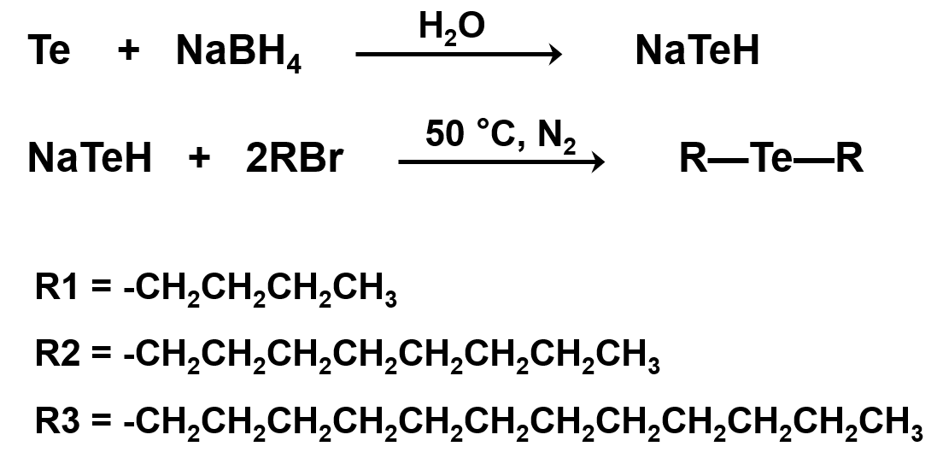
Figure S1. Synthesis of dialkyl tellurides with varying alkyl lengths (TeC4, TeC8, and TeC12)
Purification. Crude products were purified by extracting the aqueous phase with dichloromethane (3–4 times) until the organic layer became colorless. The combined organic extracts were dried over anhydrous sodium sulfate, filtered, and concentrated under reduced pressure using a rotary evaporator, yielding yellow liquid TeCx products (¹H NMR in Fig. S2). From 5 g of tellurium powders, the synthesis yielded 9.37 g of TeC8, 13.19 g of TeC16, and 17.66 g of TeC24, corresponding to yields of 95.8%, 95.2%, and 96.8%, respectively.

S2.2 Synthesis of PTeSiO-Cx Copolymers
PTeSiO–Cx copolymers (x = C4, C8, C12, denoting alkyl side-chain length) were synthesized via hydrolytic–oxidative copolymerization (HOCP). Pre-synthesized TeCx served as oxidation precursors, and alkoxysilanes (D3/DDS) was employed as siloxane feedstocks for base-catalyzed equilibration.² Both siloxane hydrolysis³ and telluride oxidation⁴ are well-established and controllable pathways. In this biphasic system, monomers were dissolved in organic phase, while the aqueous phase dissolved the oxidant (H₂O₂) and base/phase-transfer catalyst (TMAH). Upon phase contact, organotellurides were oxidized to telluroxides, which acted as electrophilic centers for nucleophilic attack by silanol intermediates. Concurrently, hydrolysis generated Si–OH groups that condensed with Te–OH to form Te–O–Si linkages at the liquid-liquid interface. TMAH simultaneously catalyzed siloxane hydrolysis and promoted interfacial transfer of the reactive species.
Representative procedure. An equilibrated siloxane premix (500 mg; DDS/D3 = 2:1, w/w) was dissolved in CHCl₃ (5 mL), then combined with TeC4 (500 mg) and stirred at room temperature for 30 min. The solution was then layered with an equal aqueous volume (5 mL) of 4 M H₂O₂ and stirred until the yellow solution become a clear, colorless biphasic mixture. TMAH (50 µL, 10% in MeOH) was then introduced to initiate interfacial copolymerization. The equal-mass operation (TeC12 : siloxane = 1:1, w/w) compensates for minor siloxane hydrolysis/partition into the aqueous phase under HOCP, ensuring near-equivalent Te:Si centers in the backbone. Using TeC4, TeC8, or TeC12 under equal-mass Te/siloxane feeds afforded PTeSiO–C4, PTeSiO–C8, and PTeSiO–C12, respectively.
Purification. The organic phase was separated and slowly added dropwise into vigorously stirred cold methanol (>10-fold excess), inducing immediate precipitation of the polymer. The resulting white solids were collected by vacuum filtration and thoroughly washed three times with fresh methanol to remove residual monomers and low-molecular-weight byproducts. Finally, the product was dried under reduced pressure at 40 °C to afford PTeSiO as a fine white powder (Fig. S28a).

S3. Structural Characterizations

S3.1 ¹H NMR of Dialkyl Tellurides
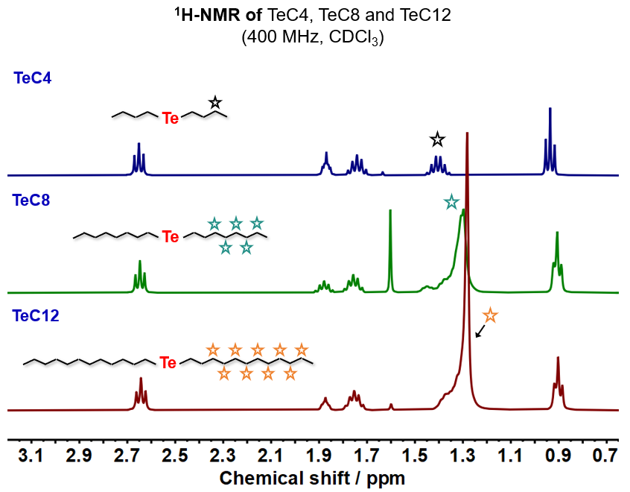
Figure S2. ¹H NMR spectra of TeC4, TeC8, and TeC12.

S3.2 ¹H NMR of Monomers and Co-polymers
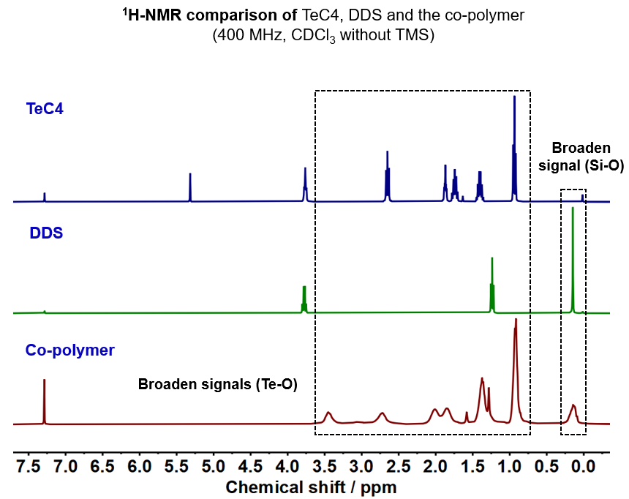
Figure S3. ¹H NMR comparison of TeC4, DDS and the copolymer PTeSiO–C4. ¹H NMR of PTeSiO–C4 shows a broadened resonance at ~0.14 ppm, characteristic of polymerized Si-O chains, and multiple broadened signals spanning 0.6 to 3.6 ppm, assigned to polymerized Te–O segments along the backbone.

S3.3 Molecular Weights Evolution (GPC)
Figure S4. GPC traces of PTeSiO–C4, PTeSiO–C8, and PTeSiO–C12 recorded over 1–3 days of polymerization, showing progressive shifts toward higher molecular weight distributions.

Table S1 | Number-average molecular weight (M_{n}) and dispersity (Ð) of PTeSiO–C4, PTeSiO–C8, and PTeSiO–C12 determined by GPC at different polymerization times.
Sample | PTeSiO-C4 |  |  | PTeSiO-C8 |  |  | PTeSiO-C12
Sample | 1 day | 2 days | 3 days | 1 day | 2 days | 3 days | 1 day | 2 days | 3 days
M_{n} (g mol⁻¹) | 3,700 | 9,800 | 14,500 | 3,800 | 10,100 | 17,300 | 4,200 | 10,700 | 19,800
Ð | 2.15 | 2.18 | 2.27 | 1.81 | 1.92 | 2.13 | 1.86 | 2.14 | 2.16

S3.4 PTeSiO–C4 (¹H, ¹²⁵Te, ²³Si, signal assignments)
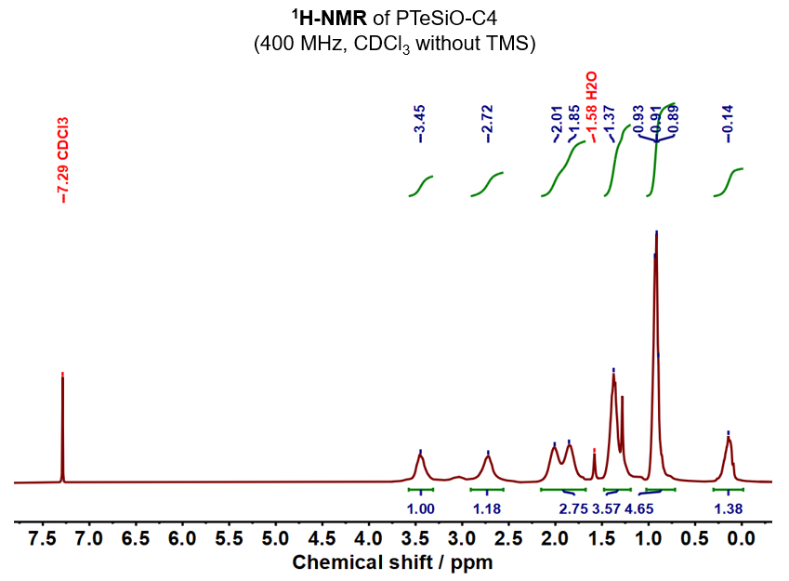
Figure S5. ¹H NMR of PTeSiO-C4. A broad resonance at δ = 0.14 ppm is assigned to the Si–CH₃ protons in the polymerized siloxane segments. Additional broadened signals at δ = 0.91 ppm, 1.37 ppm, 2.01 and 1.85 ppm, 3.40 and 2.75 ppm are corresponding to the terminal –CH₃, β–CH₂, γ–CH₂, and α–CH₂ protons adjacent to the Te atom, respectively.
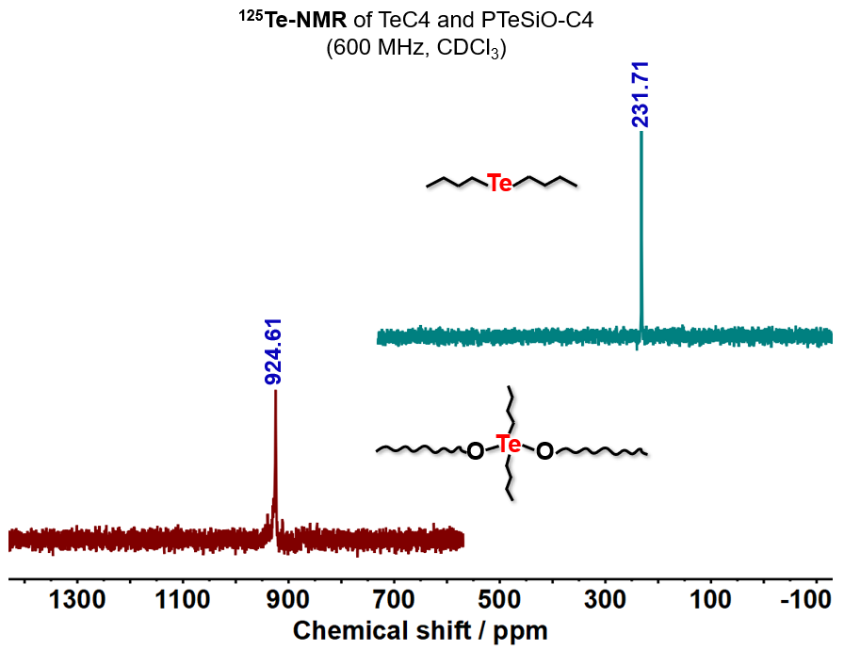
Figure S6. ¹²⁵Te NMR spectra of TeC4 and PTeSiO–C4. ¹²⁵Te resonance of PTeSiO–C4 appears upfield relative to TeC4, consistent with Te–O bond formation along the polymer backbone. Such upfield shifts proved that Te atoms are bound to electronegative oxygen atoms, reflecting electronic shielding at the tellurium center.⁵
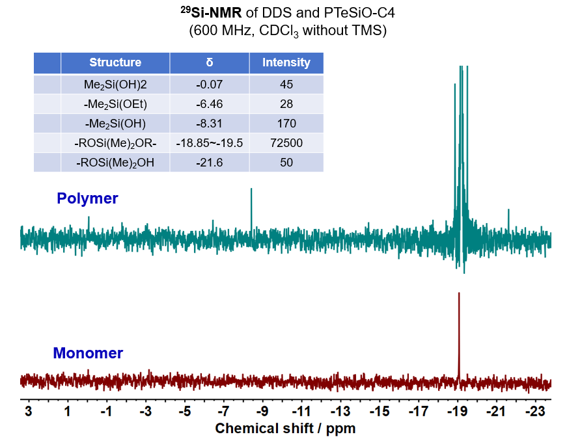
Figure S7. ²⁹Si NMR of PTeSiO-C4 and Si-monomer DDS. The observed multiple resonances in PTeSiO–C4 confirm the hydrolytic and polycondensation of Si–O units.⁶

S3.5 PTeSiO–C8 (¹H, ¹²⁵Te, signal assignments)
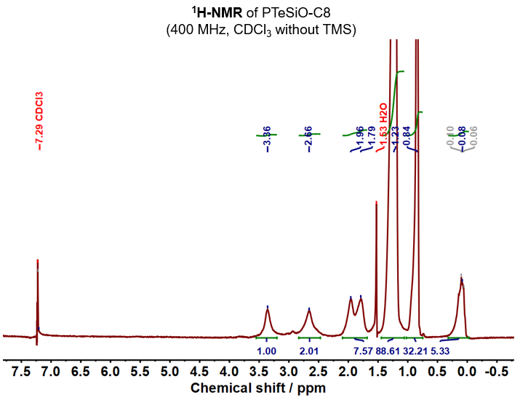
Figure S8. ¹H NMR of PTeSiO-C8.
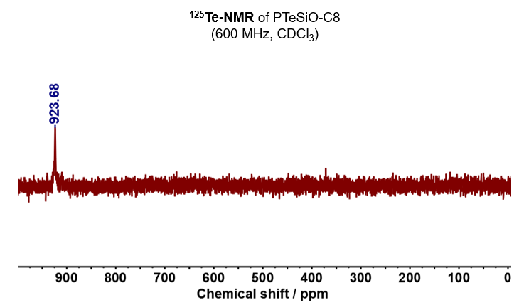
Figure S9. ¹²⁵Te NMR of PTeSiO-C8.

S3.6 PTeSiO–C12 (¹H, ¹²⁵Te, signal assignments)
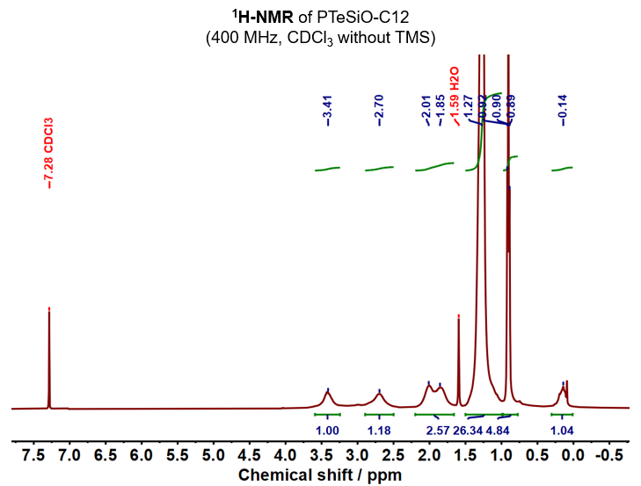
Figure S10. ¹H NMR of PTeSiO-12.
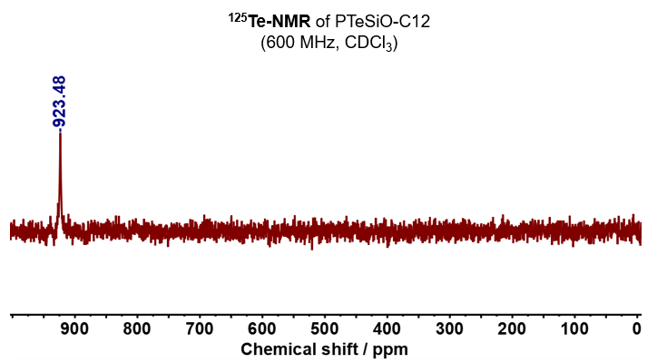
Figure S11. ¹²⁵Te NMR of PTeSiO-C12.

S3.7 DOSY NMR Analyses (1D and 2D)
Figure S12. ¹H DOSY of PTeSiO-C4. The stack spectra show attenuation signals with increasing NMR gradient field. The gradient strengths were incremented from 2% to 95% of the maximum gradient amplitude in 28 steps
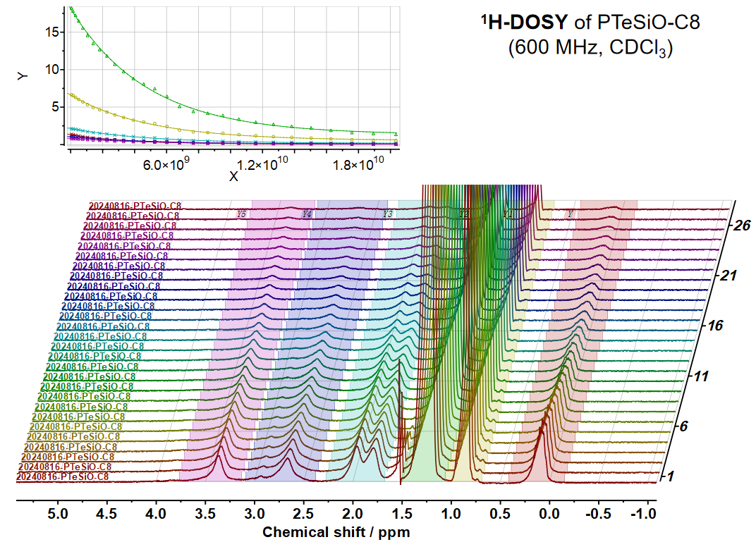
Figure S13. ¹H DOSY of PTeSiO-C8 (Gradient strengths were incremented from 2% to 95% of the maximum gradient amplitude in 28 steps). The data shows good correlation for fitting the diffusion coefficient.
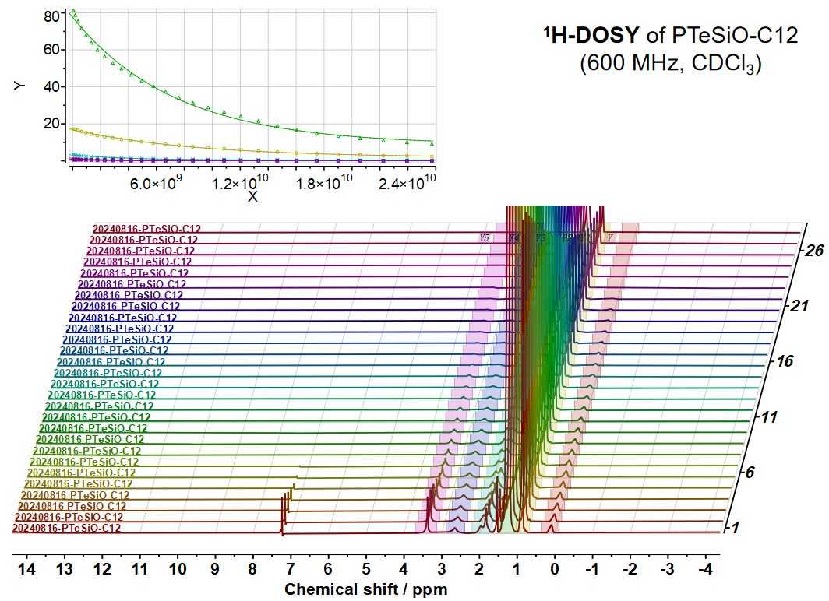
Figure S14. ¹H DOSY of PTeSiO-C12 (Gradient strengths were incremented from 2% to 95% of the maximum gradient amplitude in 28 steps). The data shows good correlation for fitting the diffusion coefficient.
Figure S15. 2D DOSY transform spectra of PTeSiO-C4, -C8, and -C12 (Vertical axis represents log D; units: log m² s⁻¹).
DOSY analysis:
a) Confirming the co-polymerization backbone:
Diffusion coefficient (D) was extracted by fitting the attenuation from 1D DOSY (Fig. S12-S14) intensities as a function of pulsed field gradient strength, based on a mono-exponential decay model (Bayesian mode).^{7,8} The transformed 2D spectra (Fig. S15) show consistent D values for Si–CH₃ resonances (δ = 0.14 ppm) and Te-alkyl protons (δ = 0.87, 1.25, 1.89 ppm, coupled signals at 2.66 and 3.35 ppm) across the PTeSiO-Cx series. This concordance indicates that the Si–O and Te–O segments diffuse as a single species, consistent with covalent linkage within individual polymer chains rather than discrete molecular components.
Table S2 | Diffusion coefficients of PTeSiO-C4, -C8, and -C12
Polymers | Side chains | log(D) [log(m² s⁻¹)] | D [m² s⁻¹]
PTeSiO-C4 | C₄H₉ | -9.66 | 2.19 × 10⁻¹⁰
PTeSiO-C8 | C₈H₁₇ | -9.72 | 1.91 × 10⁻¹⁰
PTeSiO-C12 | C₁₂H₂₅ | -10.01 | 9.77 × 10⁻¹¹

b) Diffusion behaviors for varying side-chain length
To assess the side-chain effects on chain mobility, diffusion coefficients were obtained from the 2D DOSY spectra (vertical axis, log D (m²/s)), and are summarized in Table S2; their magnitudes fall within the expected range for polymer diffusions in chloroform. Across the series, D decreases monotonically with increasing alkyl side-chain length, consistent with the Stokes–Einstein relation:
where k_{B} is the Boltzmann constant, T is temperature, η is solvent viscosity (CDCl₃: ~0.54 mPa·s at 25 °C), and R_{H} is the hydrodynamic radius of the solute.
Under constant temperature and viscosity conditions, the inverse proportionality between D and R_{H} suggests that long side chains effectively enlarge the polymer’s hydrodynamic volume, thereby reducing diffusivity. For such bottlebrush-like architecture of PTeSiO, the contribution of side chains to the overall size is significant, according to scaling laws for bottlebrush polymers in good solvents.⁹
where N_{SC} is the number of side chains and n is the number of methylene units per side chain.
Thus, DOSY NMR corroborates the bottlebrush model: longer alkyl side chains enlarge the hydrodynamic volume and steric drag, thereby lowering the polymer translational diffusion. These findings indicates that side-chain modulation can be leveraged to tune polymer diffusion in solution. This structure–mobility relationship offers a practical design handle for tailoring soft matter behavior in applications involving molecular transport, solvation, and exchange dynamics.

S3.8 ¹H NMR of Distillate
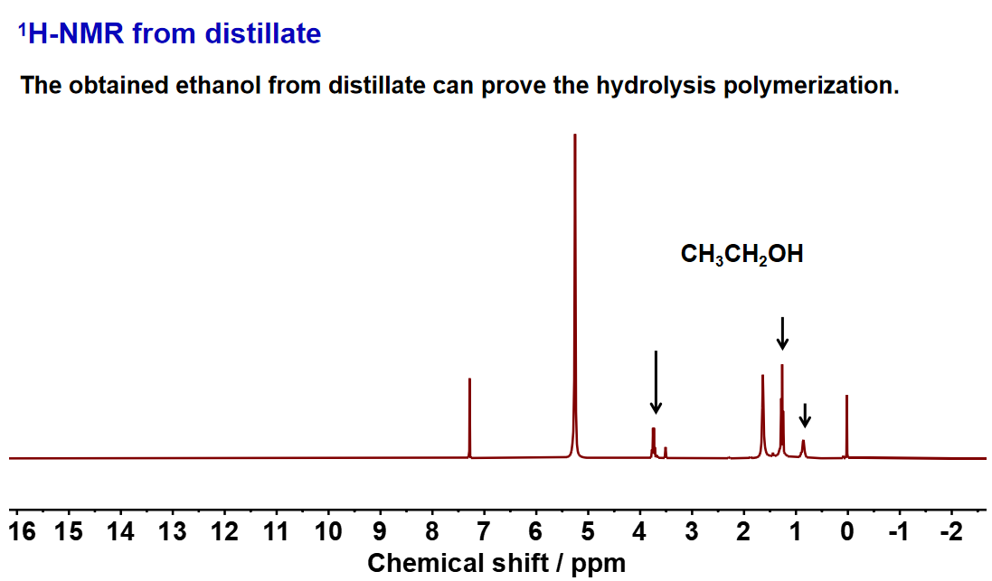
Figure S16. ¹H NMR spectrum shows characteristic resonances of ethanol from the aqueous phase, confirming the hydrolysis of the siloxane monomer.

S3.9 TOF-SIMS Profiles
Figure S17. TOF-SIMS analysis of PTeSiO–C4 (positive ion mode). Representative secondary ion images and corresponding m/z spectra reveal key fragments [C2H6Si]⁺, [C2H6SiO+H]⁺, [C4H9Te]⁺, and [C4H9TeO+H]⁺, confirming the incorporation of both siloxane and butyl telluride segments.
Figure S18. TOF-SIMS analysis of PTeSiO–C8 (positive ion mode). Ion signals at m/z = 58.0, 75.0, 356.4, and 373.4 correspond to [C2H6Si]⁺, [C2H6SiO+H]⁺, [C8H17Te]⁺, and [C8H17TeO+H]⁺, respectively.
Figure S19. TOF-SIMS analysis of PTeSiO–C12 (positive ion mode). Fragmentation peaks at m/z = 58.0, 75.0, 468.4, and 484.6 match [C2H6Si]⁺, [C2H6SiO+H]⁺, [C24H50Te]⁺, and [C24H50TeO+H]⁺, respectively.

Analysis: Positive-mode TOF-SIMS was perfectly performed for PTeSiO–C4, –C8, and –C12 to validate their chemical structure. All spectra show clear fragment ions corresponding to Si-based units (e.g., [C2H6Si]⁺ and [C2H6SiO+H]⁺) and Te-containing side groups (e.g., [C4H9Te]⁺, [C8H17Te]⁺, [C12H25Te]⁺), as well as their oxygenated counterparts ([Te–O+H]⁺), indicating successful integration of Te-O and Si-O segments.

S3.10 TBAF-Mediated Cleavage Reaction
To confirm the copolymer backbones of Si–O–Te–O backbone, we employed a TBAF-mediated cleavage reaction to selectively cleave Si–O bonds. TBAF, a common deprotection reagent for silyl ethers, was employed to selectively cleave Si–O bonds through nucleophilic attack of fluoride at the silicon center.^{10,11} In a typical procedure, 500 mg of PTeSiO–C12 was dissolved in 5 mL of CHCl₃, followed by adding 500 μL of TBAF solution (1.0 M in THF). The mixture was stirred at the room temperature, and the molecular weight evolution of the mixture was monitored by GPC. A parallel control group without TBAF treatment was performed under identical conditions.
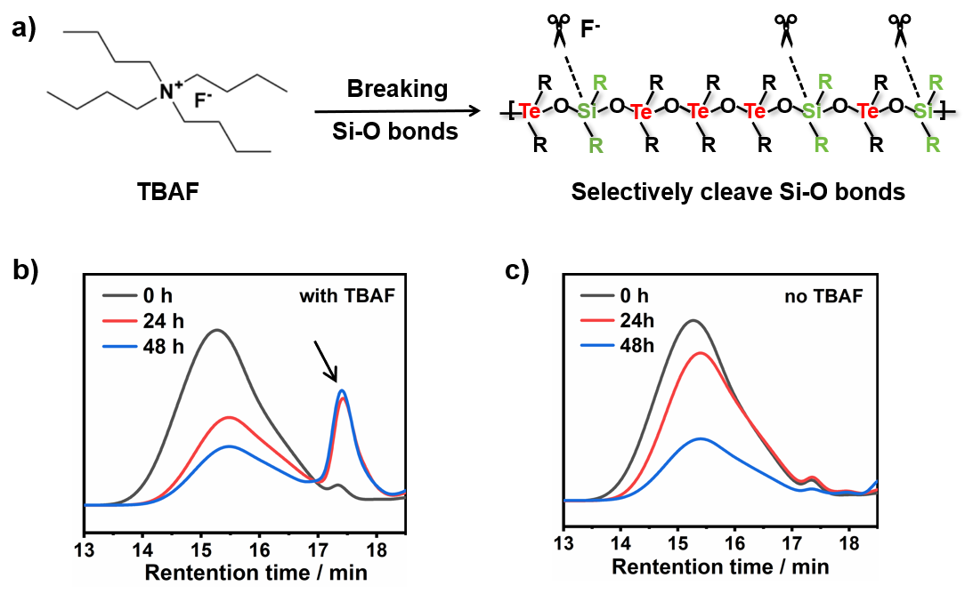
Figure S20. (a) Schematic illustration of the TBAF-mediated reaction. (b) GPC traces of PTeSiO–C12 after TBAF treating for 0, 24 and 48 h. (c) Control experiment without TBAF.

Table S3 | Molecular weight information during TBAF reaction
Reaction Time | Peak | M_{n} (g mol⁻¹) | Đ (M_{w}/M_{n})
0 h | Single | 23,900 | 2.04
24 h | 1 | 10,700 | 1.57
 | 2 | 1,800 | 1.16
48 h | 1 | 11,500 | 1.48
 | 2 | 1,700 | 1.15
Analysis: The evolution of M_{n} and Ð over time shows progressive cleavage of Si–O bonds, as evidenced by the decrease in molecular weight and the concurrent emergence of a new peak at ~17.5 min (M_{n} = 1,700 g mol⁻¹) with a relatively narrow distribution. The high-molecular-weight fraction can be attributed to partially cleaved polymer chains, while the low-molecular-weight fraction arises from short fragments generated by backbone scission. The results indicate that fluoride ions preferentially cleave Si–O linkages while Te–O bonds remain stable. These findings offer indirect but compelling evidence for the formation of Te–O–Si–O long-chain within the copolymer backbone.

S3.11 XPS Spectra of PTeSiO-Cx
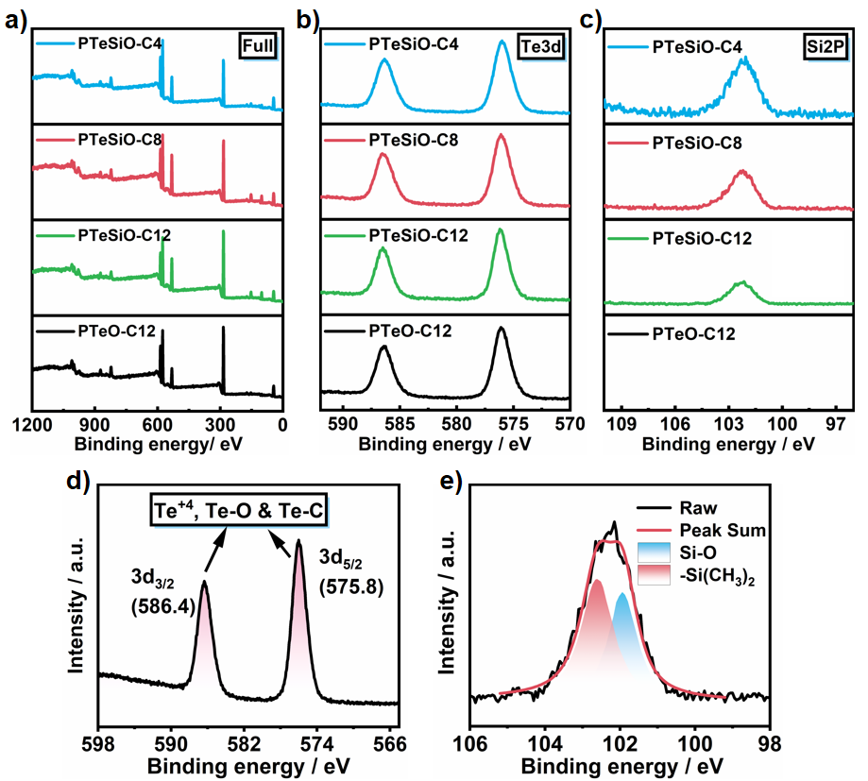
Figure S21. XPS characterization of PTeSiO–Cx copolymers and comparison with PTeO–C12 (Te–O–only backbone).
a, Full XPS spectra reveal the elemental compositions of PTeSiO–Cx (including Si, Te, O, C) and PTeO (only Te, O, C).
b, High-resolution Te 3d spectra of PTeSiO–C4, –C8, and –C12, showing consistent binding energies of Te–O linkages comparable to those in PTeO.
c, High-resolution Si 2p spectra of PTeSiO–C4, –C8 and –C12, compared with PTeO (Si-free control), showing characteristic Si–O binding energies that confirm the incorporation of siloxane segments in PTeSiO.
d–e, Peak deconvolution for high-resolution Te 3d and Si 2p XPS spectra of PTeSiO-C4, showing Te⁴⁺/Te–O/Te–C and Si–O/–Si(CH₃)₂ species, supporting the copolymer backbone.

S3.12 FTIR Spectroscopy
Figure S22. FTIR characteristics of PTeSiO–C4.
A broad absorption band between 3200–3600 cm⁻¹ corresponds to O–H stretching, indicating terminal -OH groups on PTeSiO. The peak at 1087 cm⁻¹ is assigned to asymmetric stretching of Si–O–Si linkages¹², while a strong absorption at 602 cm⁻¹ corresponds to Te–O stretching of organotelluroxide units.¹³ Additional bands at 2800–3000 cm⁻¹ arise from aliphatic C–H stretching in the side chains.

S3.13 Raman Spectroscopy
Figure S23. Raman characteristics of PTeSiO-C4.
The spectrum shows vibrational features consistent with the FTIR data. A prominent band at 591 cm⁻¹ is attributed to Te–O stretching vibration, whose strong Raman intensity reflects the high polarizability of the Te–O bond. The Si–O–Si asymmetric stretch near 1085 cm⁻¹ is weak in Raman but prominent in IR, in line with the selection rules: IR activity follows changes in dipole moment, whereas Raman activity requires changes in molecular polarizability. Bands in the 2800–3000 cm⁻¹ region arise from aliphatic C–H stretching.

S4. General Material Properties

S4.1 Polymer Physics of Te–O–Si–O Chains Compared with PDMS
At the molecular level, polymer chain conformations are fundamentally dictated by their backbone architectures—particularly bond lengths, angles, and rotational barriers—which govern large-scale chain flexibility and entanglement. To elucidate how the hetero-chain on modulating these behaviors, we constructed a physical model of Te–O–Si–O hetero-chains, and compare them quantitatively with the well-established Si–O–Si frameworks. All data sources are provided in S4.1–S4.3, and overall results s are summarized in Table S4.
Table S4 | Structural parameters of PDMS and Te–O–Si–O copolymers
Property | PDMS (Si–O–Si) | Te–O–Si–O Polymer
Bond length (Å) | ~1.62 (Si–O) | ~1.67 (Si–O), ~2.12 (Te–O)
Local bond Angles | 143°(∠SiOSi) | ~123.8° (∠TeOSi), ~132.8° (∠TeOTe)
Characteristic ratio C∞ | ~4.6 | ＜4.0 (estimated)
Bond dissociation energy | Si–O: ~450 kJ/mol | Te–O: ~335 kJ/mol
Entanglement molecular weight M_{e} | ~12,000 g/mol | Significantly lower
Coil compactness | Moderate | Globally expanded
Radius of gyration R_{g} | ~3.5 nm (eq. M_{n}) | 34.2 nm (eq. M_{n})
Single-chain elasticity K₀ | Si-O (16.5 nN) | Te-O (16.2 nN)
Entanglement density | Low | High
Viscoelasticity in melt | Low | High
Potential interactions | Low | Te···O and Te···π
Chain character | Gaussian coil | Expanded semi-flexible
In dilute solution or in the melt, polymer chains are approximated to a random coil. The coil dimensions are determined by mean-square end-to-end distance R² = C∞ nb², where b is the average bond length and C∞ is the characteristic ratio—a metric of local chain stiffness. PDMS is known to be highly flexible (C∞ ≈ 4.6) with a typical Si–O–Si bond angle of ~143°. In the case of Te–O–Si–O motifs, density functional theory (DFT) optimization (Extended Data S4.3) revealed a longer Te–O bond (~2.12 Å) and a smaller Te–O–Si angle (~123.8°), implying locally greater rotational freedom at the hetero-junctions.
(1) Single-chain dimensions (GPC–MALS).
The single chain conformation of PTeSiO was measured by GPC equipped with a multi-angle light scattering detection (GPC–MALS, Extended Data S4.2), which revealed a more expanded coiling conformation. At a comparable degree of polymerization, the Z-averaged radius of gyration (R_{g}) of PTeSiO-C12 was determined as ~34.2 nm—more than one order of magnitude that of PDMS (~3.5 nm, at same M_{n}). This expansion is attributed to the cumulative effects of bulky tellurium atoms and polarizable Te-O segments, as well as intrinsic segmental rigidity and dense side chains, which disfavor intrachain folding and promote chain swelling.

(2) Melt entanglement and viscoelasticity.
In the melting state, entanglement behavior is dictated by entanglement molecular weight (M_{e}) and zero-shear viscosity (η₀), which can be described by tube model:. For PDMS¹⁴, M_{e} ≈ 12,000 g/mol (very high, due to extreme chain flexibility and weak interchain interactions). However, Te–O–Si–O offers these attributes:
(i) heavier atoms increase segmental volume and reduce free volume;
(ii) enhanced polarizability, especially from Te, may foster dipolar or chalcogen-bonding interactions (e.g., Te···O, Te···π);
(iii) lower symmetry which disfavors chain slippage.
These features reduced M_{e}, thus promoting the entanglement and enhanced viscoelasticity. Frequency-sweep rheology (Extended Data S5.3) revealed a monotonic increase in G′ and η* with rising Te–O content, consistent with tighter melt networks and slower chain relaxation. Single-molecule force spectroscopy reveals the comparable single-chain elasticity (K₀) of the Te–O backbone (16.2 nN) to that of PDMS (16.5 nN),1 supporting that the higher macroscopic modulus arises primarily from Te–O–driven entanglement rather than intrinsic bond-level stiffness.
(3) Physical picture of Te-O-Si-O chains.
Te–O–Si–O chains are locally more rotatable but globally form expanded, sterically crowded coiling chains owing to bulky, polarizable Te-containing segments and dense side chains—an effect reminiscent of bottlebrush-like architecture. This combination enhances entanglement density and yields higher melt viscoelasticity than PDMS at comparable M_{𝑛}. Consequently, Te–O–Si–O copolymers behave as entangled, thermoplastically processable elastomeric systems without covalent crosslinking, contrasting with the prototypical flexible-Gaussian-coil behaviour of PDMS. These features rationalize the side-chain and hetero-chain-ratio tunability observed in the main text.

S4.2 Absolute Molecular Weight by MALS
The absolute molecular weight and mean square radius of gyration (R_{g}) of PTeSiO–C12 was determined by GPC–MALS. The overlay of dRI (blue) and LS (red) signals shows a dominant peak centered at ~14.1 min with clear baseline resolution in Fig. S28. Integration of the primary light scattering peak (10.8–18.3 min retention) excluded low-molecular-weight tails and solvent artifacts.
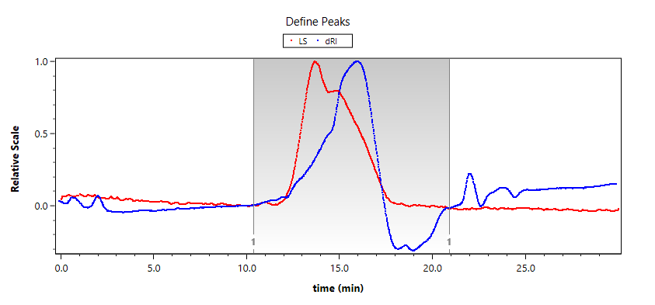
Figure S24. GPC–MALS chromatogram of PTeSiO–C12.
Key results are summarized in Table S5. For PTeSiO–C12, the absolute molecular weight was determined as M_{n} = 17.64 kDa with Z-averaged R_{g} = 34.2 nm, indicating a highly expanded coil conformation. For comparison, the coil dimension of PDMS at the same M_{n} can be estimated using the chain-size constant equation reported by Fetters et al.^{14,15}
Thus, the R_{g} of PDMS is given by:
This calculation demonstrates that, at equivalent M_{n}, PTeSiO–C12 coils are much more expanded (R_{g} = 34.2 nm) than PDMS coils (R_{g} ≈ 3.5 nm). Such a high R_{g} is fully consistent with our proposed bottlebrush-like PTeSiO architecture, and the pronounced expansion was attributed to the large atomic radius of tellurium and the strong polarity of Te–O bonds, which increase backbone rigidity, interchain repulsion, and solvation.
These structural features drive the chains into a more extended, semi-flexible conformation compared to the compact coils of Si–O–Si–based chains. The enlarged dimension is expected to lower the entanglement molecular weight and contribute to the distinctive rheological responses of PTeSiO copolymers.
Table S5 | The absolute molecular weight information of PTeSiO–C12
M_{n} (kDa) | M_{w} (kDa) | M_{p} (kDa) | M_{z} (kDa) | Ð | R_{g} | dn/dc
17.64 | 27.40 | 12.92 | 48.22 | 1.553 | 34.2 nm | 0.0643 mL/g

S4.3 Molecular Conformation Analysis
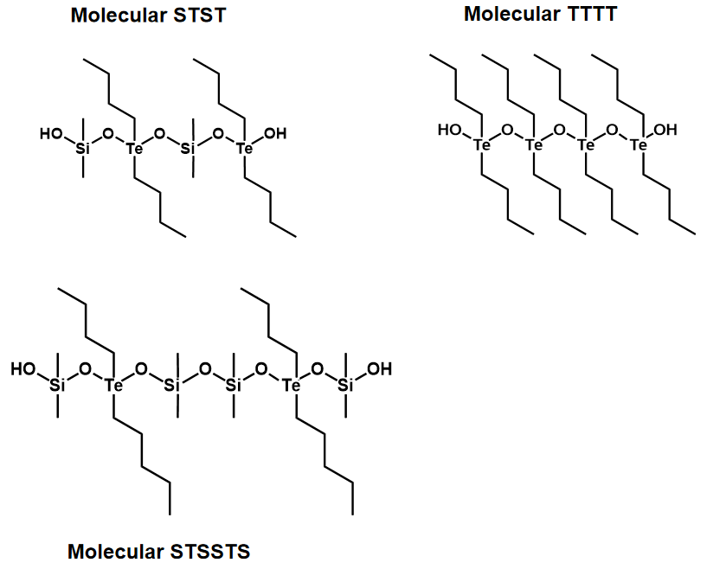
Figure S25. Three model molecules for DFT optimization.
To elucidate the conformational influence of Te–O incorporation into PDMS backbones, three model molecules—STST, TTTT, and STSSTS—were constructed for DFT analyses. STST typically reflects the molecular conformation of PTeSiO with side-chain environments, TTTT used to evaluate Te–O–Te, and STSSTS represents Te–O–Si–O backbone for assessing chain curvature.
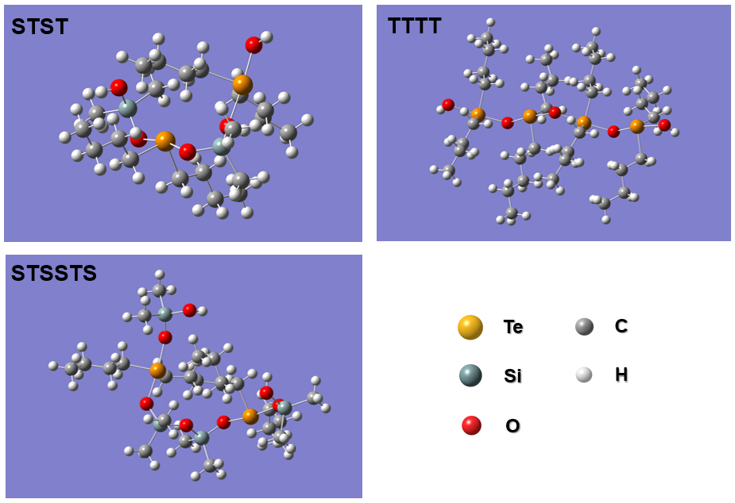
Figure S26. DFT-optimized geometries for the molecular conformations of STST, TTTT, and STSSTS, obtained at the B3LYP-D3(BJ)/def2-SVP level.¹⁶
Table S6 | DFT-optimized bond angle and length information
The table summarizes the key bond angles (in degrees, °) extracted from DFT-optimized geometries of STST, TTTT, and STSSTS:
Bond Angle Type | STST (°) | TTTT (°) | STSSTS (°)
SiOSi | – | – | 143.13
TeOSi | 123.78 | – | 127.67
TeOTe | – | 132.75 | –
OTeO | 167.47 | 171.09 | 167.68
OSiO | 107.96 | – | 109.82
CTeC | – | 102.19 | –
Key average bond lengths and associated dissociation energies (in Å and kJ mol⁻¹) for the STSSTS model:
Table S7 | Average bond lengths and dissociation Energy
Bond Type | Bond Length (Å) | Dissociation Energy (kJ/mol)
Te–O | 2.115 | 335.21
Si–O | 1.665 | 531.40

Incorporation of Te–O units increases backbone flexibility and curvature compared to PDMS. The STSSTS model shows a wider Si–O–Si angle (~143°) and a longer Te–O bond (~2.12 Å) than Si–O (~1.67 Å), consistent with the larger size and polarizability of Te. In contrast, the TTTT model adopts a more linear geometry dominated by Te–O–Te linkages. These structural features highlight how Te–O disrupts backbone regularity, promotes chain coiling, and facilitates entanglement and viscoelasticity in Te–O–Si–O copolymers.
The bond dissociation energies (BDEs) were calculated by cleaving each bond within STSSTS model. The optimizing radical species indicate that Te–O bond (335.2 kJ/mol) is considerably weaker than Si–O bond (531.4 kJ/mol), consistent with the high reactivity and low bond order associated with tellurium-based linkages. The bond energy of Si-O is generally approximated as ~ 450 kJ/mol, thus these values may be overestimated due to the intramolecular interactions and steric effects induced by Te-O unit and its bond polarity.
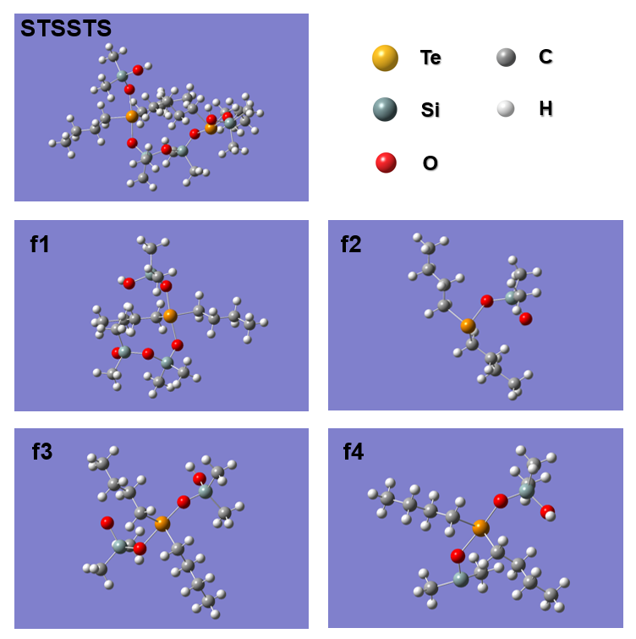
Figure S27. DFT-optimized geometries for cleaving Si-O bonds (f1 and f2) and Te-O bonds (f3 and f4) within STSSTS model.

S4.4 Material Processing and Solvent Resistance
PTeSiO–Cx allows the thermoplastic processability from crude polymer powders into bulk material. We demonstrate two processes for the fabrication of materials.
a. Hot-pressing fabrication: Crude polymer powders (e.g. PTeSiO–C12) were directly loaded into a pre-defined metal mold and compressed at 15 MPa using a hot press machine. The platens were preheated to 80 °C and maintained for 30 min. Upon cooling down, the process yielded colorless, transparent materials.
b. Solvent-casting fabrication: For solvent-casting to film fabrication, 3.0 g of PTeSiO–Cx powder was dissolved in 20 mL chloroform with stirring to form a homogeneous solution. The solution was poured into a glass mold placed on a leveled heating stage, heated to 30 °C and maintained for 30 min, then cooled to room temperature. The resulting transparent film was carefully peeled from the mold.
Figure S28. Processability of PTeSiO–Cx powders demonstrated by solvent casting into freestanding films and hot pressing into defined shapes.
Table S8 | Solvent resistance in common solvents
Solubility | Solvent name | Chemical class
Soluble | Cyclohexane | Non-polar alicyclic hydrocarbon
Soluble | n-Hexane | Non-polar aliphatic hydrocarbon
Soluble | Chloroform | Halogenated alkane
Soluble | Dichloromethane | Halogenated alkane
Soluble | Carbon tetrachloride | Halogenated alkane
Soluble | Petroleum ether | Mixed alkanes (non-polar)
Soluble | Toluene | Aromatic hydrocarbon
Soluble | Tetrahydrofuran | Cyclic ether
Insoluble | Ethanol | Polar protic alcohol
Insoluble | Acetone | Polar aprotic ketone
Insoluble | Ethyl acetate | Polar aprotic ester
Insoluble | N,N-Dimethylformamide | Polar aprotic amide
Insoluble | N,N-Dimethylacetamide | Polar aprotic amide
Insoluble | Dimethyl sulfoxide | Highly polar aprotic sulfoxide
Insoluble | N-Methyl-2-pyrrolidone | Polar aprotic lactam
Insoluble | Tetraethyl orthosilicate | Alkoxysilane precursor
Insoluble | Acetonitrile | Polar aprotic nitrile
Insoluble | 1,4-Dioxane | Cyclic ether
Insoluble | Formaldehyde (aqueous) | Aldehyde (aqueous solution)

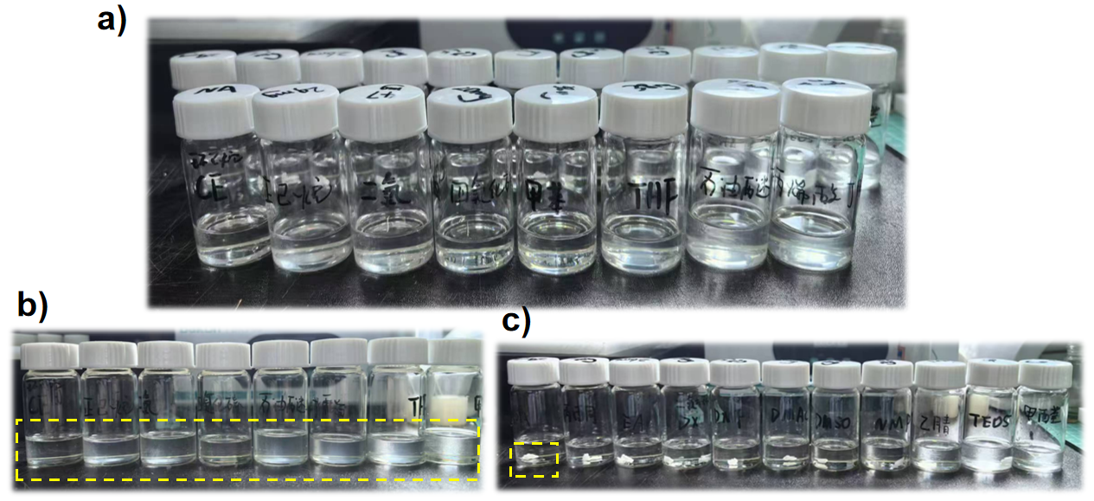
Figure S29. Solvent resistance of PTeSiO. a) front row shows solvents in which polymer can be dissolved; back row indicates that the polymer remains insoluble. b–c), polymers are dissolved and undissolved in solvents, orderly with the summarized Table S8.

S4.5 Thermal Analyses (DSC, DMA, TGA)
a. DSC curves of PTeSiO-Cx
Figure S30. DSC profiles of PTeSiO–C4, PTeSiO–C8, and PTeSiO–C12.
DSC thermograms were recorded under heating–cooling cycles across the full temperature range to probe thermal behaviors of PTeSiO. Among the samples, only PTeSiO–C12 displayed discernible crystallization (T_{c}) and melting (T_{m}) events near –30 °C, attributable to ordering of the long alkyl side chains, consistent with the relaxation features observed in rheological master curves. In contrast, no clear glass transition was detected in any sample by DSC, likely due to the intrinsically small heat capacity change (ΔCp) associated with the segmental dynamics of PTeSiO.¹⁷ To more reliably probe the glass transition behavior, DMA measurements were therefore conducted.
b. DMA curves of PTeSiO-Cx
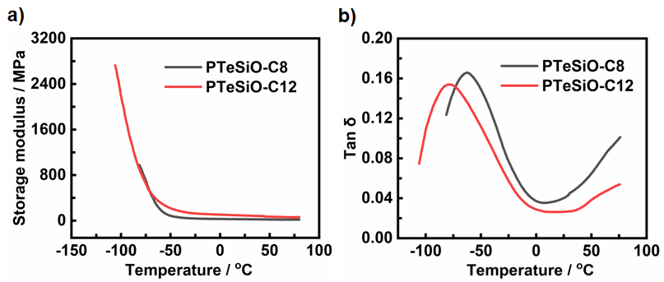
Figure S31. DMA profiles of PTeSiO copolymers. Distinct glass transitions were observed at –60 °C and –80 °C for PTeSiO–C8 and PTeSiO–C12, respectively. For PTeSiO–C4, a complete thermal trace could not be obtained because its low-temperature brittleness led to unreliable modulus values. Both PTeSiO–C8 and –C12 exhibit thermoplastic elastomeric behavior at room temperature, maintaining rubbery plateaus. Typically, the characteristic viscoelastic response of PTeSiO–C12 is demonstrated by its rheological master curves in main text.
c. TGA curves of PTeSiO-Cx
Figure S32. TGA profiles of PTeSiO–C4, PTeSiO–C8, and PTeSiO–C12 under nitrogen.
All samples display a distinct two-step degradation. The first mass loss, initiating near 150 °C, is assigned to cleavage of Te–O linkages and decomposition of alkyl side chains. A second stage from ~280 °C corresponds to breakdown of the siloxane backbone. Increasing alkyl side-chain length results in progressively higher char yields at 500 °C (9.2% for C4, 25.1% for C8, and 32.8% for C12), consistent with enhanced carbonization arising from the greater carbon content and more effective packing of longer side chains, which suppress complete volatilization.

S4.6 Structural analysis by XRD and SAXS
The structural organization of the PTeSiO-Cx (x = 4, 8, 12) series was investigated by wide-angle X-ray diffraction (XRD) and small-angle X-ray scattering (SAXS), with the key results summarized in Table S9.
Table S9 | XRD and SAXS information
Sample | XRD features | SAXS features (d-spacing) | Interpretation
PTeSiO-C4 | 2θ ≈ 7° (d ≈ 12.6 Å) | Not measured | Short-range lamellar order
PTeSiO-C8 | 2θ ≈ 5° (d ≈ 17.7 Å) | d₁ = 1.72 nm | Microphase separation; side-chain packing
PTeSiO-C12 | No low-angle in XRD | d₂ = 2.15 nm, Broadened features | Long side chains disrupt ordering, induce diffuse nanostructure

a. XRD patterns
XRD of all samples exhibit a broad peak at 2θ ≈ 20°, indicating amorphous packing of the Te–O–Si–O main-chain backbone (d ≈ 4.4 Å). The corresponding d-spacing (~4.4 Å) is calculated using Bragg’s law:
In PTeSiO-C4, another sharp peak at 2θ ≈ 7° (d ≈ 12.6 Å) indicates short-range lamellar-like order, corresponding to their side chain characteristics. In PTeSiO-C8, this feature becomes a weak shoulder at ~5° (d ≈ 17.7 Å), suggesting increased interchain spacing due to longer side chains. In PTeSiO-C12, no discernible low-angle XRD features are observed, which require SAXS analysis to detect its longer-range correlations.
Figure S33. XRD patterns of PTeSiO–Cx copolymers.
b. SAXS patterns
SAXS were performed to resolve the precise longer-range correlations of PTeSiO–C8 and PTeSiO–C12. The characteristic distances (d) were calculated using the relation:
PTeSiO-C8 and PTeSiO-C12 exhibits scattering peaks at q = 0.58 Å⁻¹ and 0.46 Å⁻¹, corresponding to d₁ = 1.721 nm and d₂ = 2.152 nm, corresponding to the long alkyl side-chain induced microphase separation, which indicates their bottle-brush like architectures from –C4, –C8 and –C12 side-chains.¹⁸
Figure S34. SAXS patterns of PTeSiO–C8 and –C12 copolymers.

S4.7 Fabrication of Crosslinked PDMTeS-20
We show a room-temperature-vulcanizing (RTV) silicone fabrication by blending a hydroxyl-terminated PTeSiO-C12 with a commercial α,ω-dihydroxy polydimethylsiloxane (101 silicone), designated as PDMTeS. Both precursors bear terminal –OH groups that crosslink with MOS in the presence of DBTDL as the catalyst.
In a typical procedure, 2.0 g of PTeSiO–C12 powder was dissolved in 10 mL chloroform and mixed with 8.0 g of 101 silicone. The mixture was stirred at 80 °C for 30 min to afford a homogeneous pre-polymer blend. Subsequently, 1.4 g of MOS, 0.010 g of DBTDL, and 1.5 g of silicone oil (100 cSt) were added and mixed thoroughly. The viscous mixture was cast into pre-cleaned molds and cured under ambient moisture at room temperature for 48 h. The cured samples were then demolded to obtain the crosslinked PDMTeS-20 elastomer.

S4.8 Dielectric Properties
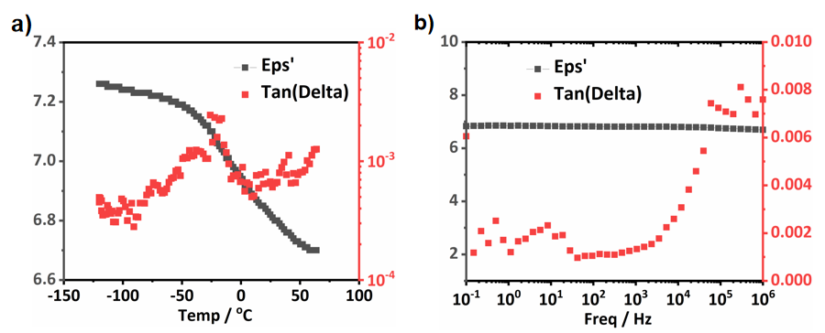
Figure S35. Dielectric performance of bulk PTeSiO–C12 film.
a, Temperature-dependent dielectric constant (ε′, black) and loss tangent (tan δ, red) of a freestanding PTeSiO film (ϕ = 20 mm, thickness = 2.0 mm), measured from −130 °C to 100 °C at 1 kHz.
b, Frequency-dependent ε′ and tan δ at 25 °C (1–10⁶ Hz). Owing to the high polarizability of Te–O bonds, the polymer exhibits a moderately high dielectric constant (ε′ ≈ 7.0) with minimal temperature and frequency dependence. The loss tangent remains below 0.008 across the entire range, indicating negligible dielectric relaxation and low energy dissipation.
Table S10 | Dielectric performance of common dielectric polymeric materials.¹⁹
Material | ε′ (1 kHz) | Tan δ (1 kHz) | Remarks
PTeSiO | ~7.0 | < 0.001 | Moderate ε′, ultralow loss
PDMS²⁰ | ~2.8 | < 0.001 | Low ε′ and loss, flexible
PVDF²¹ | 10–12 | ~0.05 | High ε′ but large dielectric loss
PI (Kapton) | ~3.4 | ~0.005 | Good thermal stability, moderate ε′
PEI²² | ~3.0 | ~0.01 | Slightly higher loss, frequency-dependent ε′
The results highlight the potentials of Te–O–Si–O polymers as dielectric materials owing to their intrinsic polarizability of Te–O bonds upon main-chain. PTeSiO–C12 film displays stable dielectric properties over a broad temperature and frequency range, with ultralow loss (tan δ < 10⁻³). Compared to conventional polar polymers, it offers a rare combination of fluorine- and cyano-free structure, good film integrity, and low-dissipation dielectric response, highlighting potentials for flexible electronics and insulating applications.

S5. Modulating Hetero-Chain Ratio

S5.1 Synthesis of PTeSiO-Rx Copolymers
Under the HOCP conditions, a library of PTeSiO–Rx copolymers was obtained by varying the mass fraction (x) of the Te-containing monomer in the feed while keeping the total monomer mass constant. The subscript x in PTeSiO–Rx denotes the mass fraction of Te-containing monomer. Given the superior stretchability of PTeSiO–C12, TeC12 was selected as the telluride monomer for tuning the hetero-chain ratio. The synthesis followed the general HOCP protocol described in Section S2.3, and the reaction formulations are summarized in Table S11. The effective Te:Si ratio was verified by NMR (see Table S12).
Table S11 | Composition for the synthesis of PTeSiO-Rx copolymers
Copolymer | Te:Si | TeC12 (mg) | DDS + D3 (mg) | Base Catalyst | Oxidant (5 mL) | Solvent (5 mL)
PDMS | Si only | – | 500 | – | 4M H₂O₂ | CHCl₃
PTeSiO-R2 | 2:8 | 100 | 400 | TMAH | 4M H₂O₂ | CHCl₃
PTeSiO-R4 | 4:6 | 200 | 300 | TMAH | 4M H₂O₂ | CHCl₃
PTeSiO-R5 | 5:5 | 250 | 250 | TMAH | 4M H₂O₂ | CHCl₃
PTeSiO-R6 | 6:4 | 300 | 200 | TMAH | 4M H₂O₂ | CHCl₃
PTeSiO-R8 | 8:2 | 400 | 100 | TMAH | 4M H₂O₂ | CHCl₃
PTeO | Te only | 500 | – | TMAH | 4M H₂O₂ | CHCl₃
Note: All copolymerizations were conducted at ambient temperature under vigorous stirring. TeC12: dialkyltelluride monomer; DDS + D3: mixture of linear and cyclic siloxanes..

S5.2 Determination of Hetero-chain Ratios
The Te–O:Si–O unit ratio can be quantified from ¹H NMR spectra (CDCl₃ without TMS, Fig. 4b), and is summarized in Table S12. We selected two diagnostic, end-group-free resonances on determining the hetero-chain ratios: (i) the α-methylene to Te (Te–CH₂–, 2H) at δ = 2.5–3.0 ppm; (ii) the Si-bound methyl (Si–CH₃, 3H) at δ = 0.14 ppm.
Integrated areas of I_{Te–CH2} and I_{Si–CH3} were corrected by their proton numbers, respectively, and the molar ratio of Te–O and Si–O units was calculated as:
Table S12 | NMR-derived hetero-chain composition of PTeSiO–Rx
Sample | I_{Si–CH3}​ (norm) | I_{Te–CH2}​ (norm) | n(Te–O:Si–O) | Te-O units (mol%) | Si-O units (mol%)
PTeO | — | — | Te-only | ~100 | ~0
PTeSiO-R8 | 1.00 | 2.00 | 3.00 : 1 | 75.0 | 25.0
PTeSiO-R6 | 1.00 | 1.60 | 2.40 : 1 | 70.6 | 29.4
PTeSiO-R5 | 1.00 | 1.30 | 1.95 : 1 | 66.1 | 33.9
PTeSiO-R4 | 1.00 | 0.90 | 1.35 : 1 | 57.4 | 42.6
PTeSiO-R2 | 1.00 | 0.70 | 1.05 : 1 | 51.2 | 48.8
Notes: Integration windows were drawn to avoid overlap; baseline was corrected prior to integration. Reported mol% are rounded to one decimal place. Uncertainty from baseline and phase is typically ±2–3 mol%.

S5.3 Rheological Evolution and Te–O Dependent Transitions
Temperature-dependent shear rheology reveals a progressive evolution in viscoelastic behavior from PTeSiO-R2 to PTeO. The complex viscosity η decreases exponentially with increasing temperature, indicating the onset of large-scale chain slippage and transition into a viscous flow regime. The temperature at which η drops below 4000 Pa·s is defined as the flow temperature T_{f}, serving for thermal processability.
Figure S36. Temperature-dependent viscoelastic properties of PTeSiO-Rx with increasing Te–O content upon the polymer backbone
Analysis: At low Te–O levels (PTeSiO–R2, R4), the materials behave as viscous thermoplastic melts, with rapid η decay upon heating, and broad mechanical crossover regions (G' = G''). These features reflect segmental slippage and fast relaxation of flexible, sparsely entangled chains. The low T_{f} values indicate facile flow under mild heating.²³
At intermediate Te–O content (R5–R6), the rheological response shifts toward entangled viscoelastic networks. G′ and G″ exhibit temperature-dependent crossover, η becomes more thermally stable, and the materials resist flow to higher temperatures. This behavior suggests enhanced interchain interactions and reduced chain mobility, likely arising from the increased polarity and rigidity of Te–O segments.
At high Te–O content (R8 and PTeO), the polymers display gel-like or soft-solid characteristics, with G′ consistently exceeding G″ and η approaching a near-constant value. These materials exhibit minimal thermal relaxation and no crossover behavior, consistent with a frozen, network-dominated architecture. The G' can be interpreted using the classical rubber elasticity equation:
where ν_{e} is the number density of elastically network strands (entanglements per unit volume), k_{B} is the Boltzmann constant, and T is the absolute temperature. The increase in G′ reflects a higher entanglement density induced by Te–O incorporation.
Table S13. Dominant viscoelastic regimes as a function of Te–O content.
Te–O Content Range | Viscoelastisity | Interpretation
Low (R2–R4) | Slippage + fast relaxation | Flexible chains, sparse entanglements
Medium (R5–R6) | Entangled network formation | Polar Te–O units promote denser transient associations
High (R8–PTeO) | Gel-like network elasticity | Rigid Te–O backbone freezes chain motion
These results demonstrate that modulating Si–O/Te–O ratio offers a versatile platform in tuning material rheological behavior from a melt-processable polymers to a viscoelastic gel by controlling entanglement, polarity, and conformational freedom of the main chain.
Figure S37. Temperature-dependent viscoelastic curves of from R2 to PTeO showed the evolution of η from 0 to 120 °C with varying backbone of Te-O/Si-O composition.

S5.4 DSC Profiles of PTeSiO–Rx
Figure S38. DSC profiles of PTeSiO–Rx copolymers from R2 to PTeO. All Te–O–containing samples exhibit no discernible glass transition in DSC, which can be ascribed to the intrinsic characteristics of PTeSiO, where only a minute heat-capacity increment (ΔC_{p}) during T_{g} falls below the sensitivity of DSC detection.¹⁷ The determination of T_{g} and related relaxation processes requires cross-validation by DMA or rheology.

S5.5 Spin-Coated PTeSiO Films
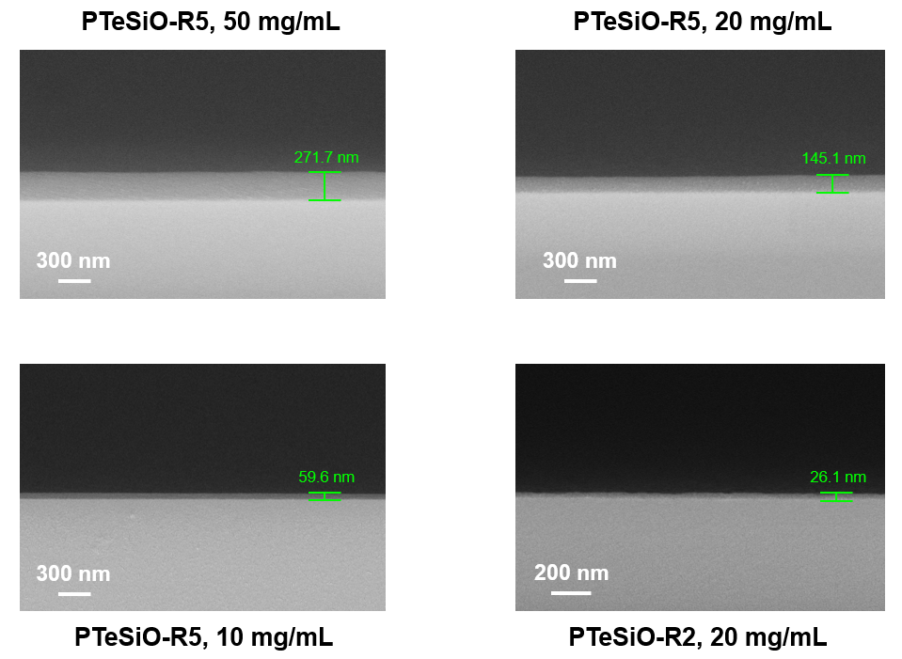
Figure S39. SEM image of spin-coated PTeSiO films.
Thin films of PTeSiO–Rx were fabricated by spin-coating solutions of varying concentrations (10 mg/mL, 20 mg/mL, and 50 mg/mL) onto silicon wafers, followed by solvent evaporation. The copolymers exhibited excellent film-forming ability, yielding continuous and defect-free morphologies as confirmed by cross-sectional SEM of fractured samples. The film thickness was readily tunable from ~20 to ~270 nm by adjusting the precursor concentration and hetero-chain ratio, highlighting the controllable processability of PTeSiO in coating applications.

S6. Reductive Depolymerization

S6.1 Depolymerization and Separation Process
Depolymerization process: Reductive depolymerization was achieved using varying concentration of vitamin C solutions. In a representative procedure, ~0.5 g of waste PTeSiO was suspended in a biphasic mixture of 10 mL ethyl acetate and 10 mL aqueous vitamin C solution (0.2 M, 0.5 M, and 1.0 M). The mixture was stirred at room temperature for 24 h until PTeSiO was completely dissolved in organic phase, generating a homogeneous orange-yellow transparent solution, and the depolymerization was completed. Notably, intact PTeSiO is insoluble in ethyl acetate, while the depolymerized products readily dissolve.
Phase-selective separation and purification: The phase-selective purification was employed to realize the separation and cycling of telluride monomer and low-M_{n} siloxane species. Following rotary evaporation to remove ethyl acetate, ~0.5 g of depolymerized crude product—comprising the mixture of low-molecular-weight siloxane and dialkyl telluride species—was suspended in 5 mL petroleum ether. Subsequent liquid–liquid extraction was performed using a 9:1 methanol/water solution (washing for 3–4 cycles). Dialkyl tellurides selectively partitioned into the petroleum ether phase, while siloxane oligomers can be recovered in the methanol/water layer. Following a solvent removal by rotary evaporation, then can afford the isolated products.²⁴

S6.2 Kinetic Analyses of Depolymerization
To investigate the reductive depolymerization kinetics, we create a simple model to verify the reduction reaction using varying concentrations of vitamin C (0.2 M, 0.5 M, and 1.0 M). PTeSiO-R2 was selected as a representative sample. For each concentration, the residue mass and the recovered monomer mass were weighted as recorded in Table S14 and Table S15to fit the kinetic models (Figure S40d).
Owing to large excess of reductant, a pseudo-first-order model (first-order in polymer) was expected to describe the kinetics, the general equation is as follows:
Where A₀ is the initial mass of PTeSiO, t is the reaction time.
The depolymerization kinetics follow pseudo-first-order behavior due to excess reductant. The pseudo-first-order rate constants (k) were estimated as 0.13 h⁻¹ (0.2 M), 0.25 h⁻¹ (0.5 M), and 0.37 h⁻¹ (1.0 M), corresponding to effective half-depolymerization of approximately 5.5 h, 2.7 h, and 1.9 h, respectively. As a result, at 0.5 M and 1.0 M vitamin C, the polymer is fully degraded in hours. Lowering the reductant concentration lead to incomplete conversion, but even achieves ~80% depolymerization efficiency in 12–24 h using 0.2 M vitamin C.
Figure S40. Depolymerization of PTeSiO under varying vitamin C concentrations. a) digital photograph showing depolymerization of PTeSiO-R2 for each vitamin C concentration. b) percentage of residual mass loss. c) percentage of recovered monomer. d) linear fit of the logarithmic plot of residual mass supports a pseudo-first-order kinetic model.
Table S14 | The recorded residual mass (mg) during depolymerization
Depolymerization was monitored under varying concentrations of vitamin C solution ( 0.2 M, 0.5 M, and 1.0 M). At each time point, the residual mass of three parallel samples was recorded. Complete degradation occurred within 12 h at 1.0 M and within 24 h at 0.5 M vitamin C, highlighting the concentration-dependent depolymerization efficiency.
Time (h) | Sample 1 | Sample 2 | Sample 3 | Sample 1 | Sample 2 | Sample 3 | Sample 1 | Sample 2 | Sample 3
 | 0.2 M Reductant | 0.2 M Reductant | 0.2 M Reductant | 0.5 M Reductant | 0.5 M Reductant | 0.5 M Reductant | 1.0 M Reductant | 1.0 M Reductant | 1.0 M Reductant
0 | 503.2 | 499.8 | 501.2 | 498.9 | 502.0 | 499.5 | 503.5 | 498.0 | 502.3
3 | 432.8 | 403.7 | 421.0 | 292.5 | 276.8 | 266.5 | 166.6 | 148.8 | 152.6
6 | 291.6 | 278.1 | 279.2 | 137.9 | 113.6 | 121.6 | 63.7 | 52.8 | 49.0
12 | 126.5 | 103.8 | 115.2 | 32.6 | 18.9 | 22.7 | 0.0 | 0.0 | 0.0
24 | 83.8 | 79.6 | 92.1 | 0.0 | 0.0 | 0.0 | 0.0 | 0.0 | 0.0
Table S15 | The recorded mass of recovered mixtures (mg)
The recovered mass (mg) of crude mixtures was quantified using three parallel samples at each time point. Significant recovery was observed within 6–12 h, with near-complete recovery at 24 h under 0.5 M and 1.0 M conditions.
Time (h) | Sample 1 | Sample 2 | Sample 3 | Sample 1 | Sample 2 | Sample 3 | Sample 1 | Sample 2 | Sample 3
 | 0.2 M Reductant | 0.2 M Reductant | 0.2 M Reductant | 0.5 M Reductant | 0.5 M Reductant | 0.5 M Reductant | 1.0 M Reductant | 1.0 M Reductant | 1.0 M Reductant
0 | 0 | 0 | 0 | 0 | 0 | 0 | 0 | 0 | 0
3 | 42.6 | 33.8 | 49.3 | 110.5 | 128.2 | 117.1 | 212.5 | 221.7 | 219.3
6 | 106.8 | 121.4 | 128.7 | 233.2 | 258 | 248.7 | 331.7 | 300.8 | 310.2
12 | 222.1 | 248.2 | 257.0 | 368.2 | 355.8 | 340.2 | 399.8 | 412.3 | 411.7
24 | 310.5 | 322.1 | 305.6 | 428.6 | 405.2 | 401.1 | 402.8 | 411.5 | 409.8

S6.3 GPC Analyses of Depolymerized Products
GPC analyses of depolymerized products were performed using PTeSiO-R2 as a representative sample. Depolymerization was carried out in a biphasic ethyl acetate/water system with 0.5 M vitamin C solution. The organic phase was collected, dried under nitrogen, redissolved in THF, and filtered prior to GPC injection (Fig. S41).
Table S16 | GPC results of PTeSiO-R2 during depolymerization
Sample | Peak | M_{n} (g mol⁻¹) | Đ (M_{w}/M_{n}) | Assigned species
PTeSiO-R2 | single | 10700 | 2.02 | -
Depolymerization for 24 h | 1 | 1950 | 1.54 | low-molecular-weight PDMS
 | 2 | 480 | 1.04 | TeC12
 | 3 | 220 | 1.02 | Cyclic siloxanes (predominantly D3/D4)
Pristine PTeSiO-R2 displayed a single broad peak (M_{n} = 10,700 g mol⁻¹, Đ = 2.02). After treating with 0.5 M vitamin C, three well-resolved peaks emerged. Peak 1 (M_{n} = 1,950 g mol⁻¹; Đ = 1.54) is attributed to low-molecular-weight PDMS fragments (approximately 20~25 repeating –[SiO(Me)₂]– units). Peak 2 approximately corresponds to the depolymerized monomer of TeC12 (M_{n} = 480 g mol⁻¹; Đ = 1.04), indicating the main-chain Te–O scission. Peak 3 (M_{n} = 220 g mol⁻¹; Đ = 1.02) is assigned to cyclic siloxane (predominantly D3/D4), in line with the well-known depolymerization pathways.
Figure S41. GPC profiles after depolymerization (0.5 M vitamin C treating for 24 h), demonstrating vitamin C triggered main-chain depolymerization of PTeSiO.

S6.4 ¹H NMR for Depolymerized Mixtures
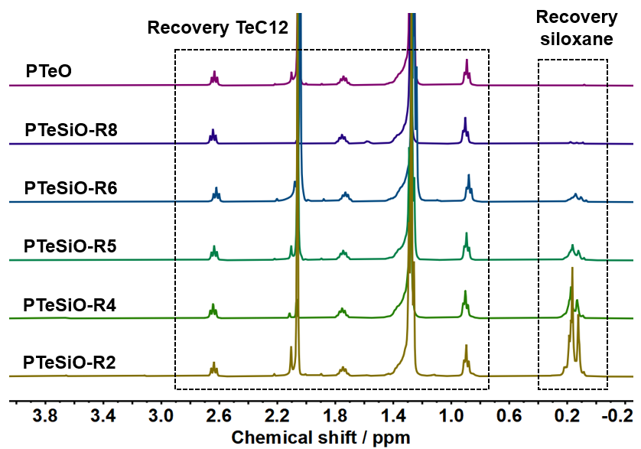
Figure S42. ¹H NMR of spectra of the depolymerized mixtures across PTeSiO–Rx series. The fraction of recovered siloxanes increases markedly with higher Si–O hetero-chain ratios. Relative peak integrations enable normalized quantitative estimation of the recovered monomer composition (Table S17).
Recovered Monomer Ratios Estimation
Table S17. Relative molar fractions from ¹H NMR Estimation
Sample | Integrals (δ at 0.18 ppm, 3H) | Integrals (δ at 2.65 ppm, 2H) | Siloxanes (mol %) | TeC12 (mol %)
PTeSiO-R2 | 1.00 | 0.11 | 85.8% | 14.2%
PTeSiO-R4 | 1.00 | 0.31 | 68.3% | 31.7%
PTeSiO-R5 | 1.00 | 0.50 | 57.1% | 42.9%
PTeSiO-R6 | 1.00 | 0.81 | 45.5% | 54.9%
PTeSiO-R8 | 1.00 | 3.34 | 16.6% | 83.4%
PTeO | – | 1.00 | 0% | 100.0%
The relative contents of dialkyltellurides and siloxanes in depolymerized mixtures were quantified by ¹H NMR analysis (Figure 42). The signal at δ = 0.18 ppm (Si–CH₃, 3H) was normalized to 1.00 as an internal reference, while the resonance at δ = 2.65 ppm corresponds to methylene protons adjacent to tellurium (Te–CH₂–, 2H). On the basis of the relative integrals of these peaks, the molar composition of the recovered mixtures was calculated (Table S17).

S6.5 ¹H NMR for Separated Products
¹H NMR after separation and purification (in petroleum ether phase)
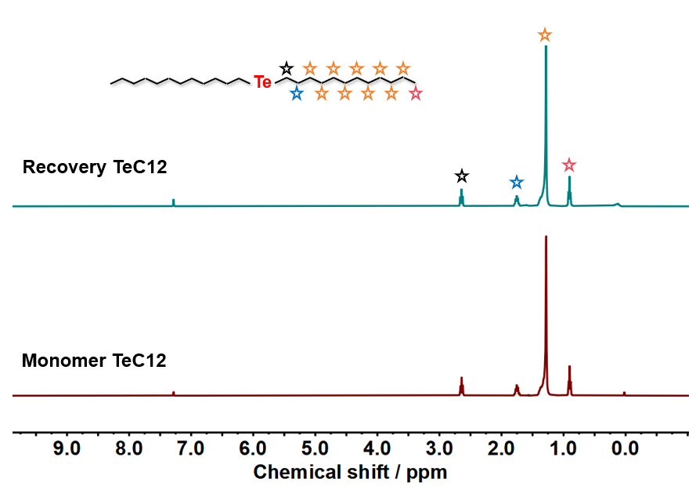
Figure S43. ¹H NMR spectrum of the recovered TeC12 after separation from the petroleum ether phase, showing full agreement with the original TeC12, confirming high-purity of the recovered Te-monomer.
¹H NMR after separation and purification (in 9:1 menthol/water phase)
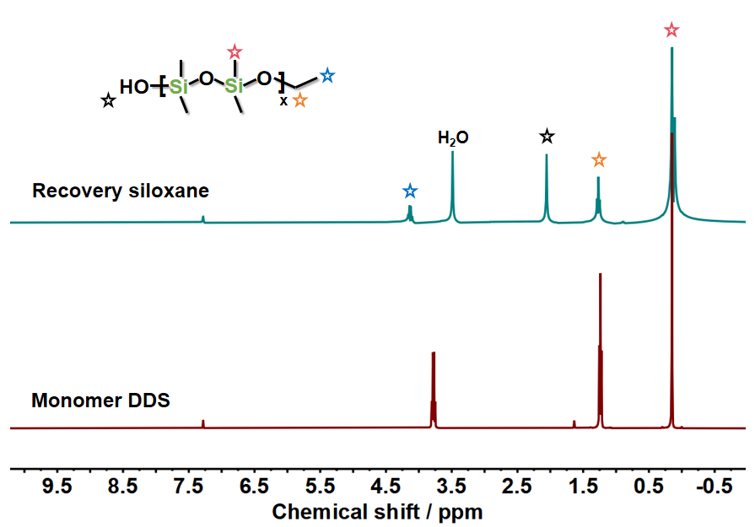
Figure S44. ¹H NMR shows the recovered siloxanes from menthol/water phase as compared with siloxane monomer DDS, revealing signals characteristics consistent with the purified low-molecular-weight siloxane.²⁵

S6.6 Recovery Efficiency
Table S18 | Depolymerizing and monomer recovery efficiency. The theoretical mass of each monomer can be calculated using the initial polymer mass (m₀) and the determined Te–O/Si–O hetero-chain composition.
Co-polymer | m₀ (mg) | m₁ (mg) | m_Si (mg) | Theoretical m_Si (mg) | η_Si (%) | m_Te (mg) | Theoretical m_Te (mg) | η_Te (%)
PTeSiO-R2 | 532.3 | 457.3 | 271.8 | 324.7 | 83.7 | 168.5 | 207.6 | 81.2
PTeSiO-R4 | 523.3 | 461.0 | 178.3 | 225.0 | 79.2 | 243.5 | 298.3 | 81.6
PTeSiO-R5 | 496.8 | 438.8 | 122.7 | 154.0 | 79.6 | 291.4 | 342.8 | 85.0
PTeSiO-R6 | 576.9 | 497.0 | 130.5 | 155.8 | 83.7 | 348.0 | 421.1 | 82.6
PTeSiO-R8 | 515.8 | 451.5 | 72.1 | 87.7 | 82.2 | 360.9 | 428.1 | 84.3
PTeO | 551.3 | 493.0 | 0.0 | 0.0 | - | 493.0 | 551.3 | 89.4
m₀: initial co-polymer mass;
m₁: mass of crude depolymerization mixture;
m_Si and m_Te: mass of recovered siloxane and TeC12, respectively.
Thus, η (monomer recovery efficiency) can be calculated as:
η = (m_recovered / m_theoretical) × 100%,
m_theoretical is the expected mass calculated by hetero-chain constitution.

S7. References
- Dai, Y. et al. Polytelluoxane: a chalcogen polymer that bridges the gap between inorganic oxides and macromolecules. Chem 9, 2006 (2023).
- Kantor, S. W. et al. The mechanism of the acid- and base-catalyzed equilibration of siloxanes. J. Am. Chem. Soc. 76, 5190 (1954).
- Scott, D. W. Equilibria between linear and cyclic polymers in methylpolysiloxanes. J. Am. Chem. Soc. 68, 2294 (1946).
- Dai, Y. et al. Tellurium-containing polymers: recent developments and trends. Prog. Polym. Sci. 141, 101678 (2023).
- Pietrasiak, E. et al. Understanding ¹²⁵Te NMR chemical shifts in disymmetric organo-telluride compounds from natural chemical shift analysis. Phys. Chem. Chem. Phys. 22, 2319 (2020).
- Sugahara, Y. et al. ²⁹Si NMR study of hydrolysis and initial polycondensation processes of organoalkoxysilanes. I. Dimethyldiethoxysilane. J. Non-Cryst. Solids 139, 25 (1992).
- Monnery, B. D. et al. Polymer conformation determination by NMR spectroscopy: comparative diffusion ordered ¹H NMR spectroscopy of poly(2-ethyl-2-oxazoline)s and poly(ethylene glycol) in D₂O. Polym. Chem. 15, 3077 (2024).
- Peat, G. et al. SHARPER-DOSY: sensitivity-enhanced diffusion-ordered NMR spectroscopy. Nat. Commun. 14, 4410 (2023).
- Raj, W. et al. The structure and dynamics of bottlebrushes: simulation and experimental studies combined. Polymer 261, 125409 (2022).
- Rupasinghe, B. et al, Full circle recycling of polysiloxanes via room-temperature fluoride-catalyzed depolymerization to repolymerizable cyclics. ACS Appl. Polym. Mater. 3 1828 (2021).
- Weiss, R. et al. Evidence for and evaluation of fluorine–tellurium chalcogen bonding. Chem. Sci. 14 7221 (2023).
- Bele, A. et al. Dielectric silicone elastomers filled with in situ generated polar silsesquioxanes: preparation, characterization and evaluation of electromechanical performance. Mater. Des. 106, 454 (2016).
- Arnaudov, M. et al. Infrared-spectral investigation of tellurites. Mater. Res. Bull. 17, 1121 (1982).
- Fetters, L. J. et al. Chain dimensions and entanglement spacings. In Physical Properties of Polymers Handbook (ed. Mark, J. E.) 447– (Springer, New York, 2007).
- Striegel, A.M. et al. Size-exclusion chromatography with multi-angle static light scattering. Nat. Rev. Methods. Primers. 5, 40 (2025).
- Zheng, J. et al. Minimally augmented Karlsruhe basis sets. Theor. Chem. Acc. 128, 295 (2011).
- Gracia-Fernández, F. et al. Comparative study of the dynamic glass transition temperature by DMA and TMDSC. Polym. Test. 29, 1002 (2010).
- Bichler, K. J. et al. Dynamical comparison of different polymer architectures—bottlebrush vs linear polymer. Macromolecules 54, 1829 (2021).
- Chen, J. et al. Engineering the dielectric constants of polymers: from molecular to mesoscopic scales. Adv. Mater. 36, 2308670 (2024).
- Li, S. et al. Functional PDMS elastomers: bulk composites, surface engineering, and precision fabrication. Adv. Sci. 10, 2304506 (2023).
- Padurariu, L. et al. Role of microstructures in the dielectric properties of PVDF-based nanocomposites containing high-permittivity fillers for energy storage. ACS Appl. Mater. Interfaces 15, 13535 (2023).
- Cao, S. et al. Novel polyetherimide dielectrics: molecular design, energy storage property, and self-healing performance. Macromol. Rapid Commun. 44, 2300372 (2023).
- Peirotti, M. B. et al. Relaxation modes of molten polydimethylsiloxane. Rheol. Acta 37, 449 (1998).
- Sato, Y. et al. Preparation of polyethoxysiloxanes as a solid (“solid sol”) by acid-catalyzed sol–gel reaction of tetraethoxysilane. Macromolecules 58, 5757 (2025).
- Issa, A. A. et al. Polymerization of organoalkoxysilanes: kinetics of the polycondensation progress and the effect of solvent properties and salt addition. Chem. Phys. 530, 110642 (2020).

