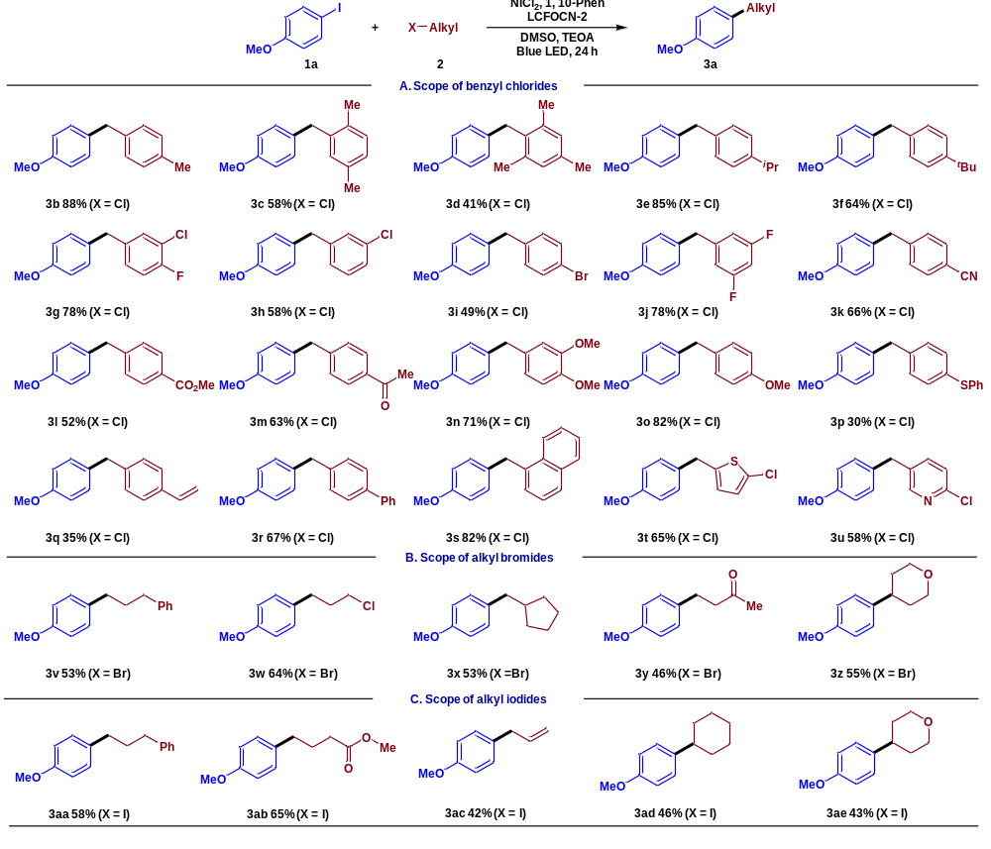
Scheme 1 Nickel/photoredox dual-catalyzed cross-electrophile coupling of 1a and 2. Reaction condition:1a (0.3 mmol), 2 (0.3 mmol), NiCl₂ (5 mol%), 1,10-Phenanthroline (5 mol%), DMSO (3.8 mL), triethanolamine (TEOA 5 eq.), blue LED light irradiation, 24 h, rt, isolated yield.
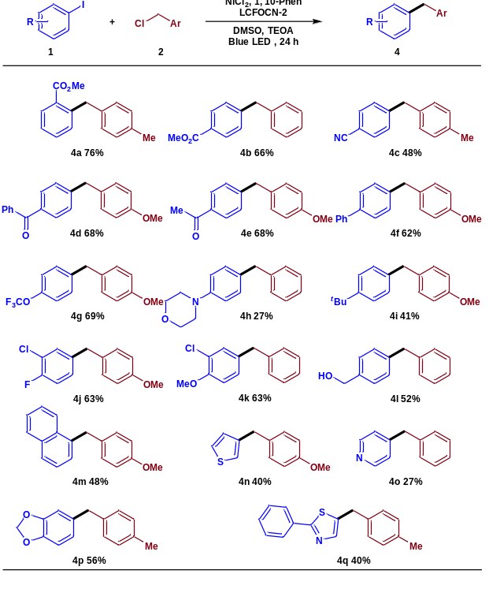
Scheme 2. Nickel/photoredox dual-catalyzed cross-electrophile coupling of 1 and 2. Reaction condition: 1 (0.3 mmol), 2 (0.3 mmol), NiCl₂ (5 mol%), 1,10-Phenanthroline (5 mol%), DMSO (3.8 mL), triethanolamine (TEOA 5 eq.), blue LED light irradiation, 24 h, rt, isolated yield.
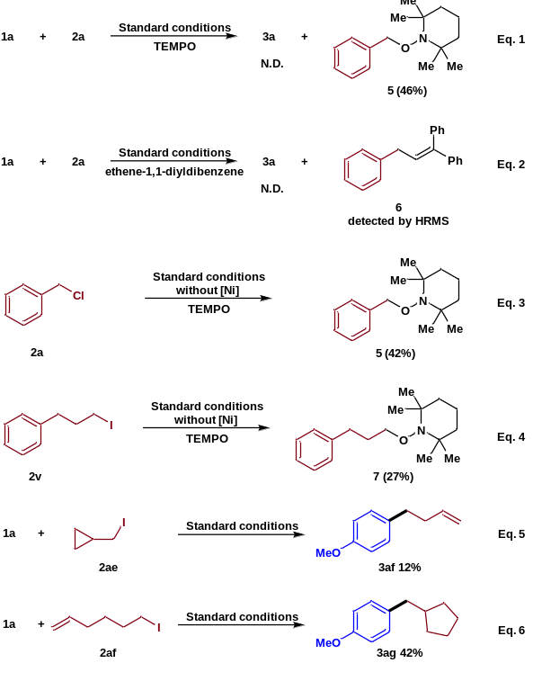
Scheme 3. Control experiments.
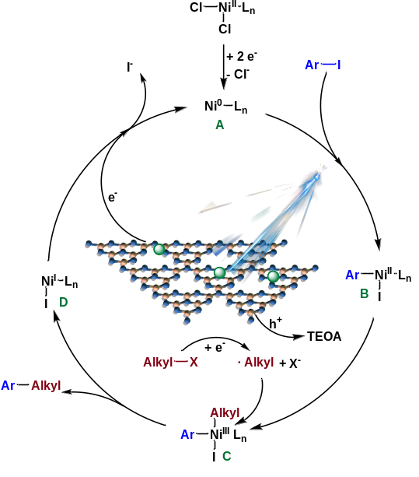
Scheme 4. Proposed mechanism.

