Supplementary Information for “Anthropogenic influence on temperature and precipitation trends in the Western Mediterranean: A multi-method approach”

Diego A. Campos^{1,2}, Matías E. Olmo¹, Pep Cos¹, Margarida Samsó¹, and Francisco Doblas-Reyes^{1,3}

¹ Earth Sciences Department, Barcelona Supercomputing Center, Barcelona, Spain.
² Facultat de Física, Universitat de Barcelona, Barcelona, Spain.
³ Catalan Institution for Research and Advanced Studies, ICREA.

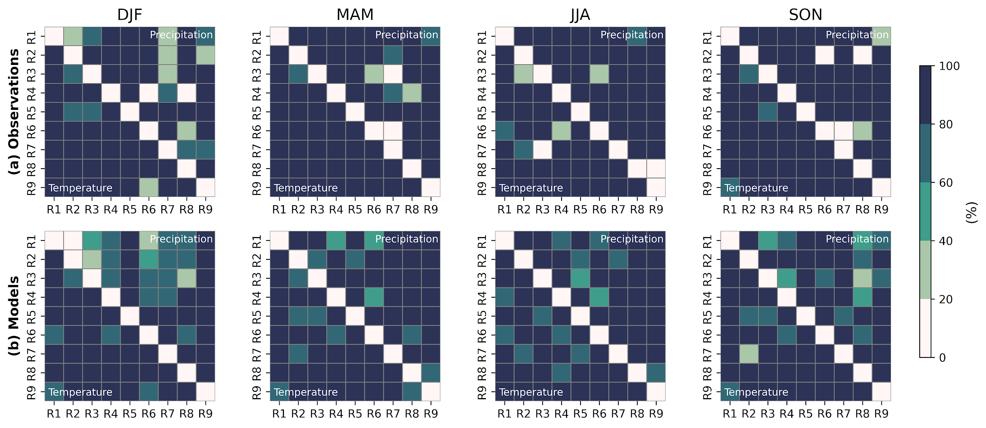
Supplementary Figure 1: Seasonal rank-sum test for temperature (lower half of each box) and precipitation (upper half of each box). Colours indicate the percentage of observations ((a), upper panels) and model ensemble members ((b), lower panels) that have p-values lower than reference alpha = 0.05.

To assess whether the defined clusters effectively capture distinct regional climatologies, we compared the seasonal Probability Distribution Functions (PDFs) of temperature and precipitation across clusters using the non-parametric Rank-Sum test (Mann & Whitney, 1947). For each variable, the PDFs were constructed using the median values within each cluster. Two clusters were considered significantly different if either temperature or precipitation showed a statistically significant difference at the 5% level.
Supplementary Figure 1 shows, in the upper panel, the percentage of observational datasets (out of three) with p-values below the reference α level, and in the lower panel, the percentage of model ensemble members meeting the same criterion. A higher percentage indicates a stronger ability of the model members (or observational datasets) to distinguish that pair of regions significantly, whether in terms of temperature or precipitation.

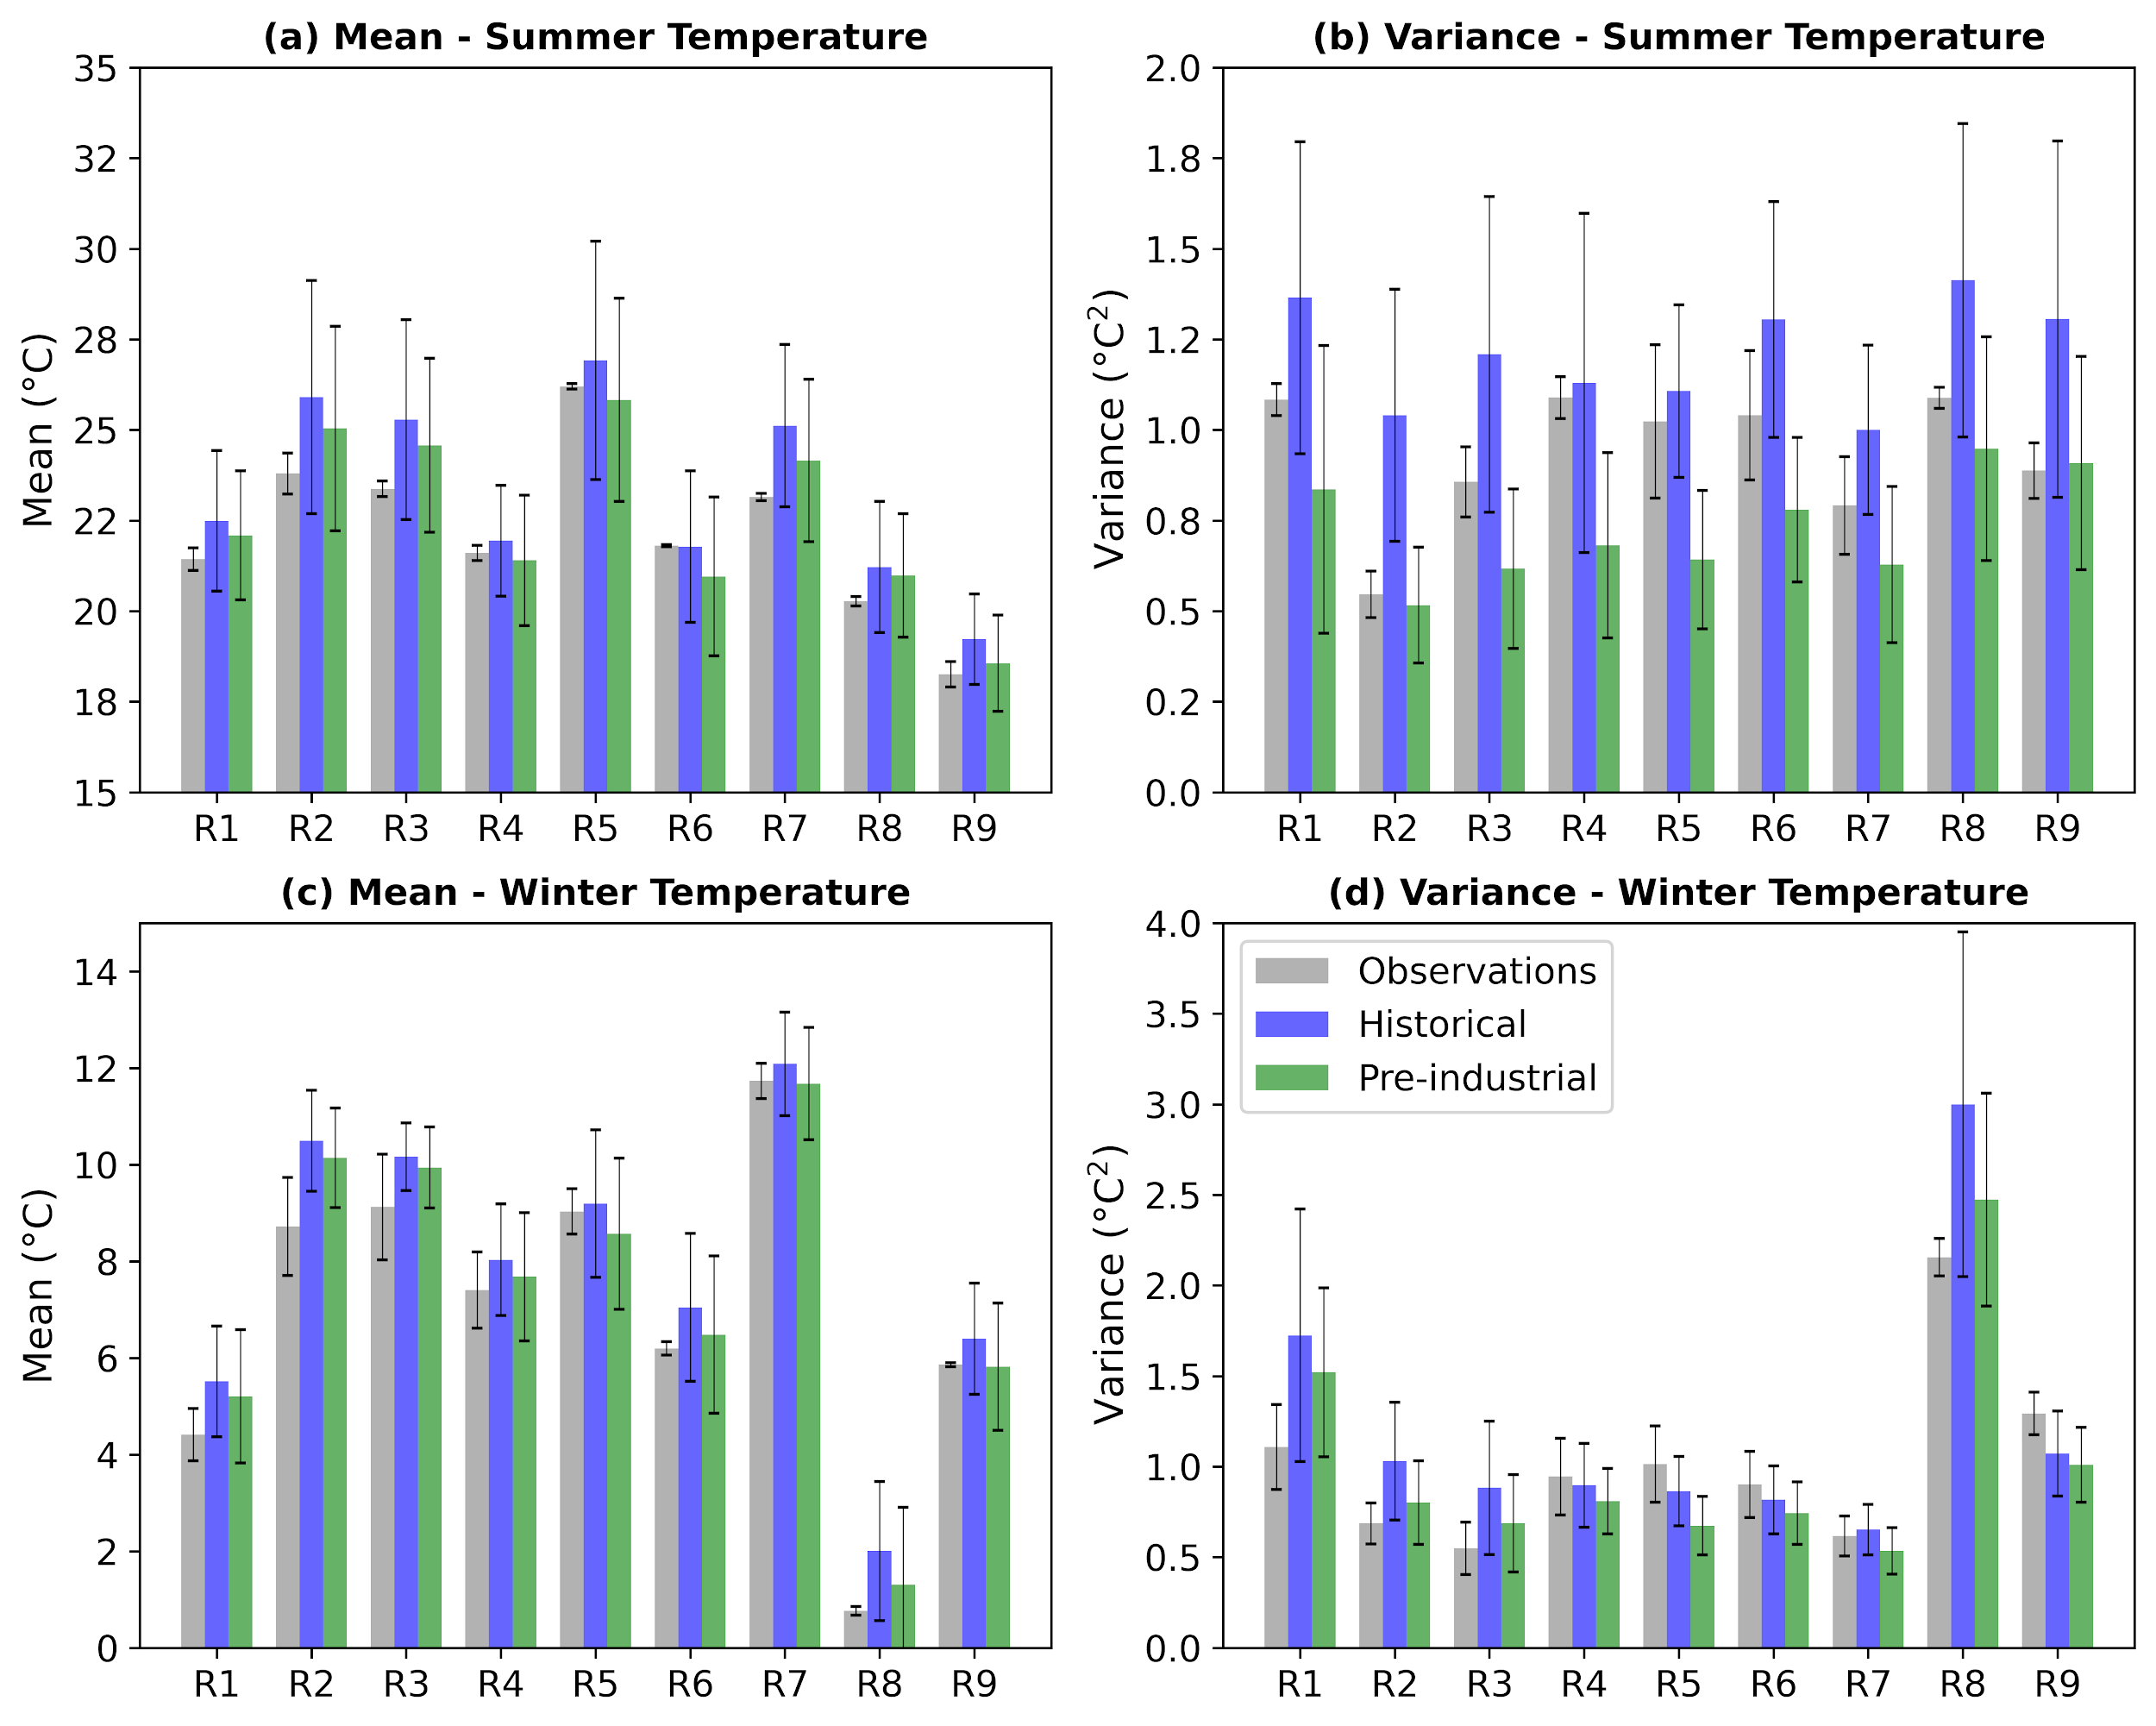
Supplementary Figure 2: Sub-regional time mean (left panels) and time variance (right panels) of regional median temperature values for summer (top) and winter (bottom). Grey bars represent observations, blue bars correspond to historical simulations (actual climate) for the 1961–1990 period, and green bars show results from 100-year segments of pre-industrial control runs. Vertical lines indicate the standard deviation of mean and variance values from observations and model ensemble members.

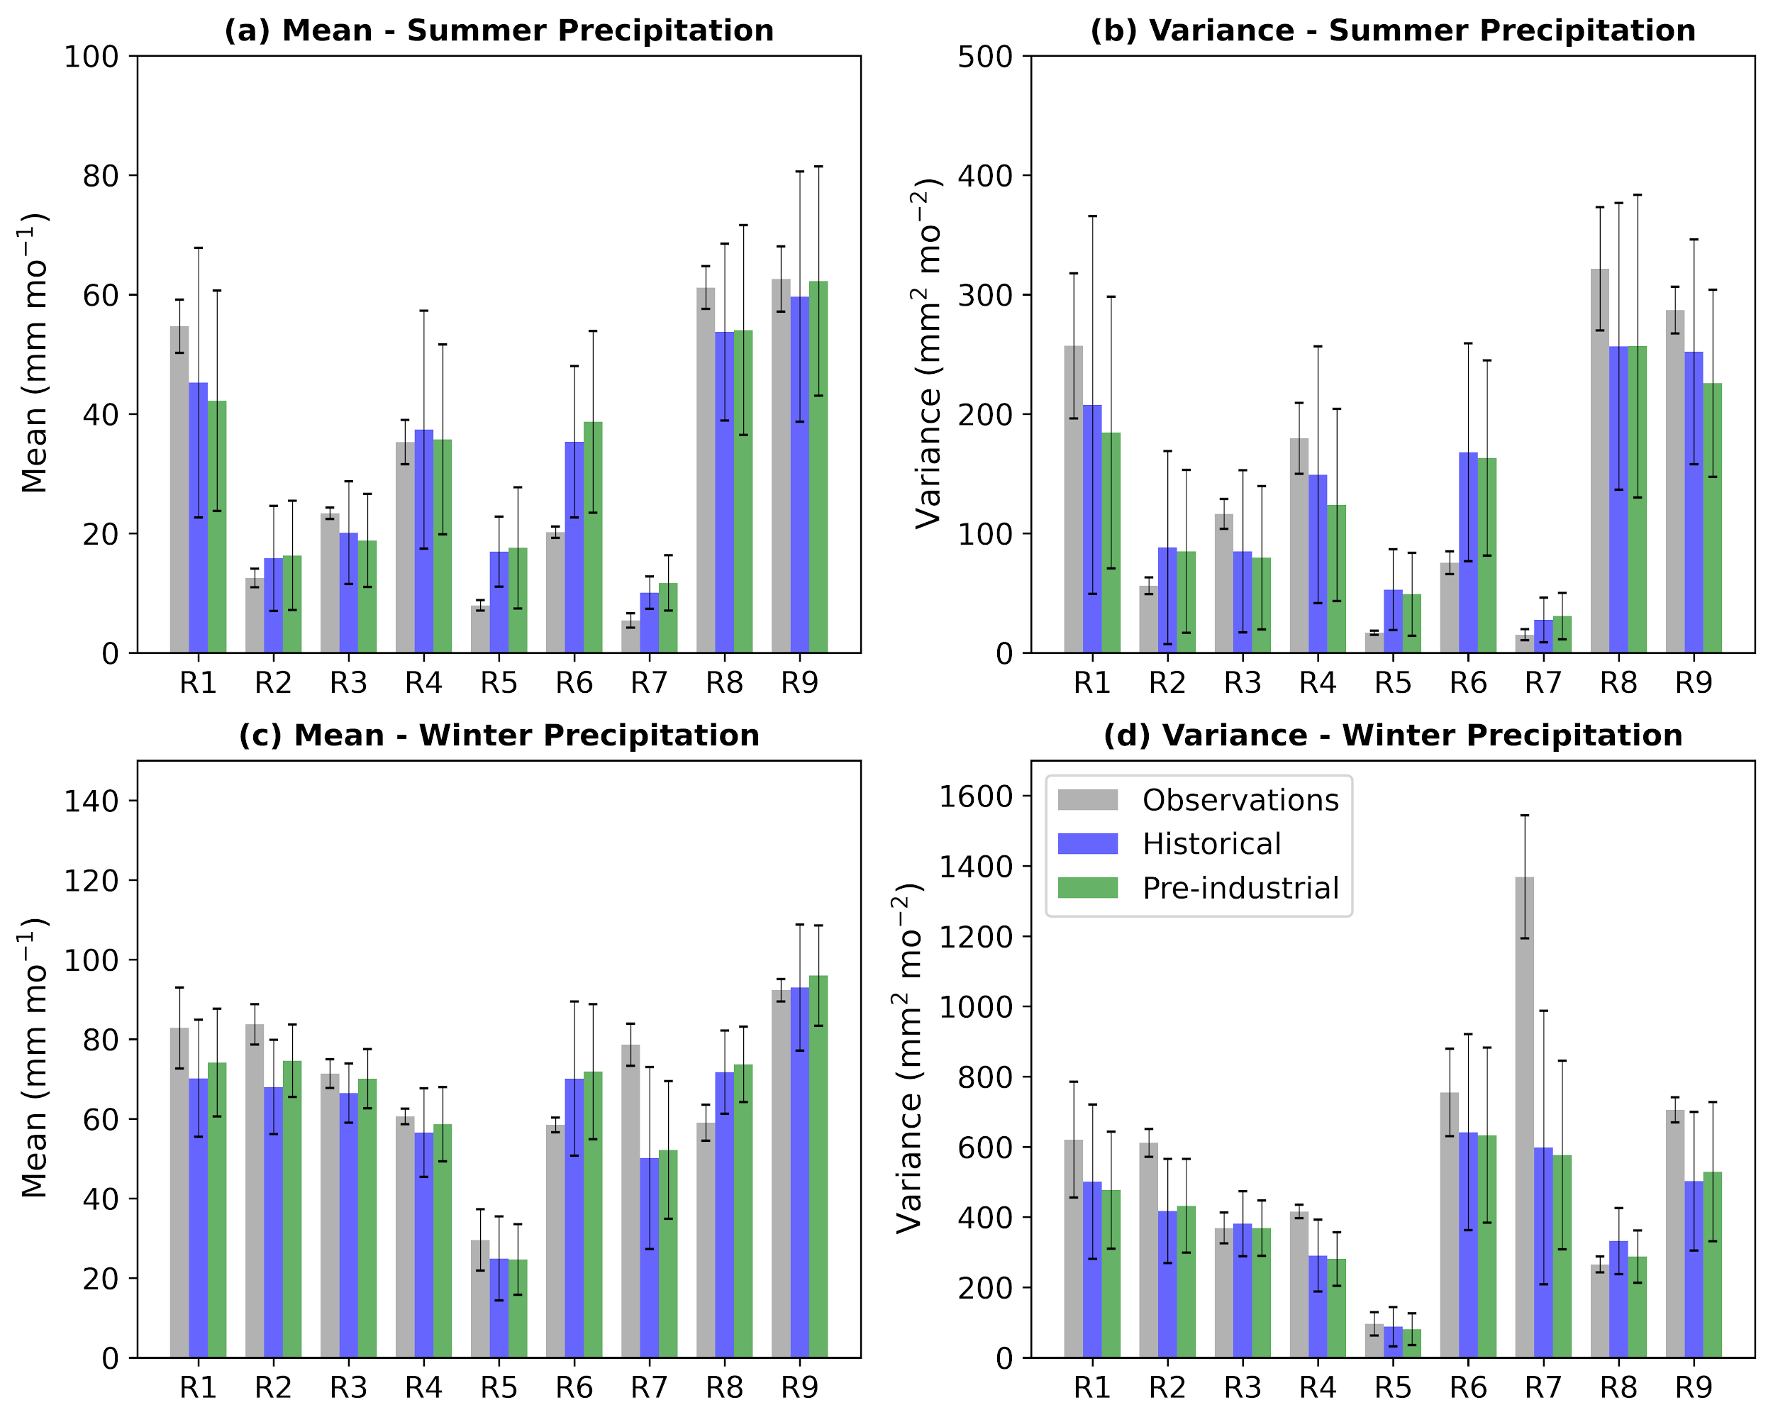
Supplementary Figure 3: Sub-regional time mean (left panels) and time variance (right panels) of regional median precipitation values for summer (top) and winter (bottom). Grey bars represent observations, blue bars correspond to historical simulations (actual climate) for the 1961–1990 period, and green bars show results from 100-year segments of pre-industrial control runs. Vertical lines indicate the standard deviation of mean and variance values from observations and model ensemble members.

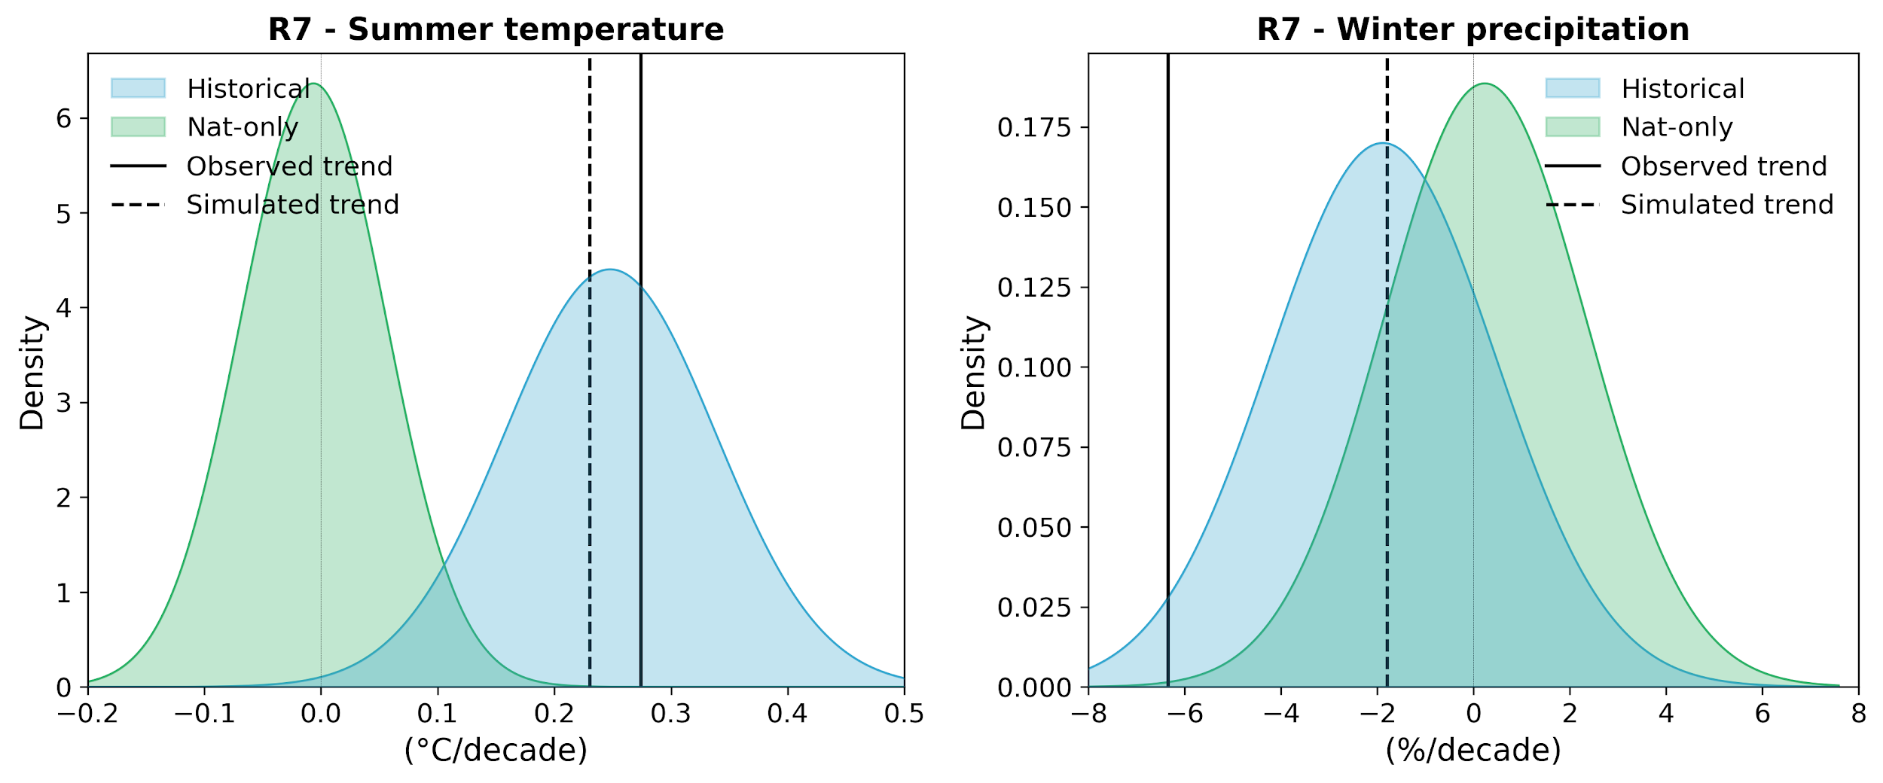
Supplementary Figure 4: Distribution of simulated 1951-2020 trends for Historical (light blue) en Natural-only (green) experiments of summer temperature (left) and winter precipitation (right) in Region 7. Vertical lines show the mean observed and simulated trends for this region in each case. Distributions are Gaussian and obtained using all the ensemble members of the corresponding model subset. The observed trend is obtained as the mean trend using the observation datasets. The simulated trend is obtained as the mean of the multi-model ensemble.

Supplementary Table 1: P-values from the $χ^{2}$hypothesis test for temperature statistical models. The model with All Forcings (AFs), Internal variability only (IV), greenhouse gases only (GHG), anthropogenic aerosols only (AAer) and natural only (Nat) as described in the Methods section. In bold p-values < 0.05.
 | Winter |  |  |  |  | Summer
 | AFs | IV | GHG | AAer | Nat | AFs | IV | GHG | AAer | Nat
R1 | 0.999 | 0.437 | 0.984 | 0.274 | 0.462 | 1.000 | 0.001 | 0.802 | 0.093 | 0.097
R2 | 0.998 | 0.264 | 0.941 | 0.137 | 0.428 | 1.000 | 0.000 | 0.552 | 0.003 | 0.002
R3 | 0.999 | 0.299 | 0.971 | 0.116 | 0.39 | 1.000 | 0.000 | 0.637 | 0.024 | 0.015
R4 | 0.996 | 0.314 | 0.991 | 0.097 | 0.289 | 1.000 | 0.000 | 0.858 | 0.014 | 0.013
R5 | 0.996 | 0.087 | 0.985 | 0.023 | 0.196 | 1.000 | 0.000 | 0.558 | 0.001 | 0.000
R6 | 0.988 | 0.163 | 0.996 | 0.051 | 0.15 | 1.000 | 0.000 | 0.791 | 0.000 | 0.002
R7 | 0.991 | 0.064 | 0.997 | 0.038 | 0.099 | 0.993 | 0.000 | 0.844 | 0.000 | 0.012
R8 | 0.999 | 0.457 | 0.988 | 0.266 | 0.558 | 1.000 | 0.000 | 0.6 | 0.008 | 0.045
R9 | 0.991 | 0.458 | 0.997 | 0.165 | 0.358 | 1.000 | 0.002 | 0.922 | 0.068 | 0.039

Supplementary Table 2: P-values from the $χ^{2}$hypothesis test for precipitation statistical models. The model with All Forcings (AFs), Internal variability only (IV), greenhouse gases only (GHG), anthropogenic aerosols only (AAer) and natural only (Nat) as described in the Methods section. In bold p-values < 0.05.
 | Winter |  |  |  |  | Summer
 | AFs | IV | GHG | AAer | Nat | AFs | IV | GHG | AAer | Nat
R1 | 1.000 | 1.000 | 1.000 | 1.000 | 1.000 | 0.997 | 0.997 | 0.818 | 0.999 | 0.997
R2 | 0.998 | 0.998 | 0.997 | 1.000 | 0.996 | 0.997 | 0.979 | 0.955 | 0.990 | 0.995
R3 | 0.999 | 0.999 | 0.998 | 0.998 | 0.996 | 1.000 | 0.999 | 0.923 | 1.000 | 0.999
R4 | 1.000 | 0.999 | 1,000 | 0.999 | 0.999 | 0.998 | 1.000 | 0.950 | 0.989 | 1.000
R5 | 0.998 | 0.968 | 0.998 | 0.957 | 0.954 | 1.000 | 0.999 | 0.984 | 0.961 | 0.999
R6 | 0.997 | 1.000 | 0.999 | 1.000 | 1.000 | 0.999 | 0.999 | 0.983 | 0.944 | 1.000
R7 | 0.999 | 0.991 | 0.995 | 0.998 | 0.995 | 1.000 | 0.986 | 0.999 | 0.955 | 0.995
R8 | 0.999 | 0.999 | 0.999 | 1.000 | 0.994 | 0.993 | 0.996 | 0.868 | 0.999 | 0.992
R9 | 1.000 | 0.999 | 1.000 | 1.000 | 0.997 | 0.988 | 1.000 | 0.898 | 0.988 | 1.000

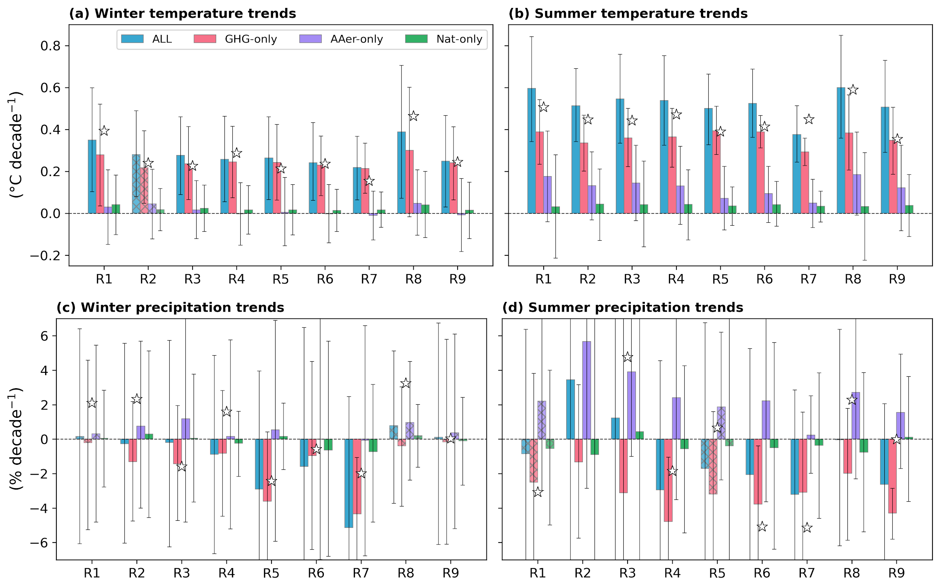
Supplementary Figure 5: 1981-2020 trends in forced model simulations and observations on the sub-regions of the Western Mediterranean using the corresponding model subset. (a) Winter temperature trends, (b) Summer temperature, (c) Winter precipitation, and (d) Summer precipitation. Simulations with all forcings (ALL, in turquoise), greenhouse gas forcing only (GHG, in pink), anthropogenic aerosols only (AAer, in purple), and natural only (Nat, in green). Bars show the trend from the signal model best estimates (${\hat{Y}}^{*}$for ALL and ${\hat{X_{i}}}^{*}$for the single-forced experiments), and error bars show the 95% confidence interval (see Methods). Observed trends are presented with star markers. Masked regions correspond to those where observed and simulated trends show significant discrepancies.

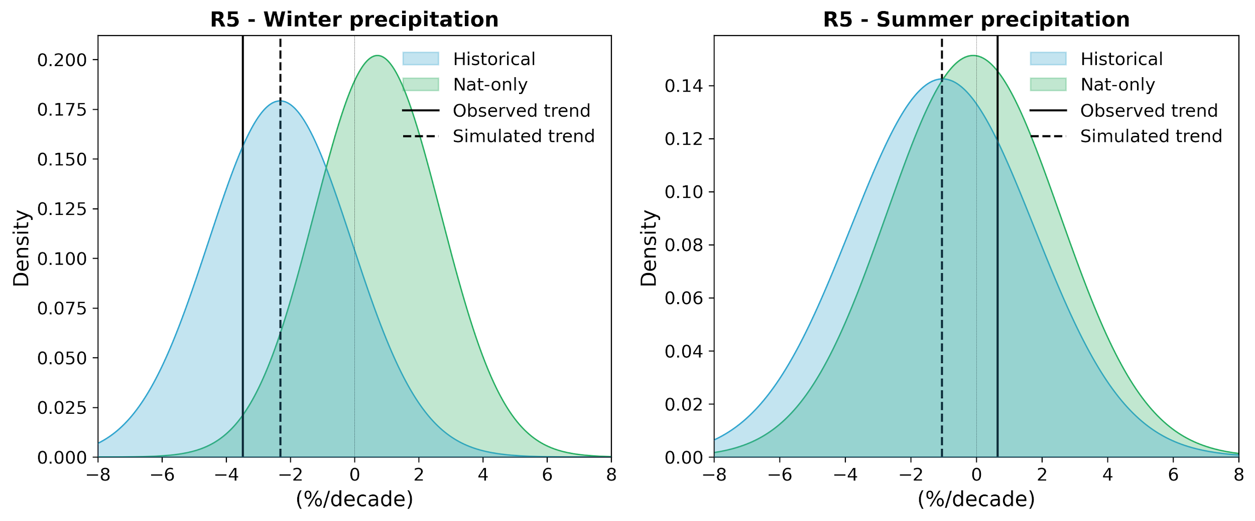
Supplementary Figure 6: Distribution of simulated 1951-2020 trends for Historical (light blue) en Natural-only (green) experiments of winter (left) and summer (rigth) precipitation in Region 5. Vertical lines show the mean observed and simulated trends for this region in each case. Distributions are Gaussian and obtained using all the ensemble members of the corresponding model subset. The observed trend is obtained as the mean trend using the observation datasets. The simulated trend is obtained as the mean of the multi-model ensemble.

