Supplementary Information Documents

Analysis of RSF and RP between left and right kidney
Anatomical differences between left and right kidney were evaluated on dual-echo GRE images displaying full-kidney coverage (n=187). As compared to the right kidney, the compartments of the left kidney were larger across all the groups, with values up to 7% and 36% in average higher in the RP and RSF compartments, respectively, (Supplemental Information Fig. 2a-c and Table 2).

Supplementary Information Figures
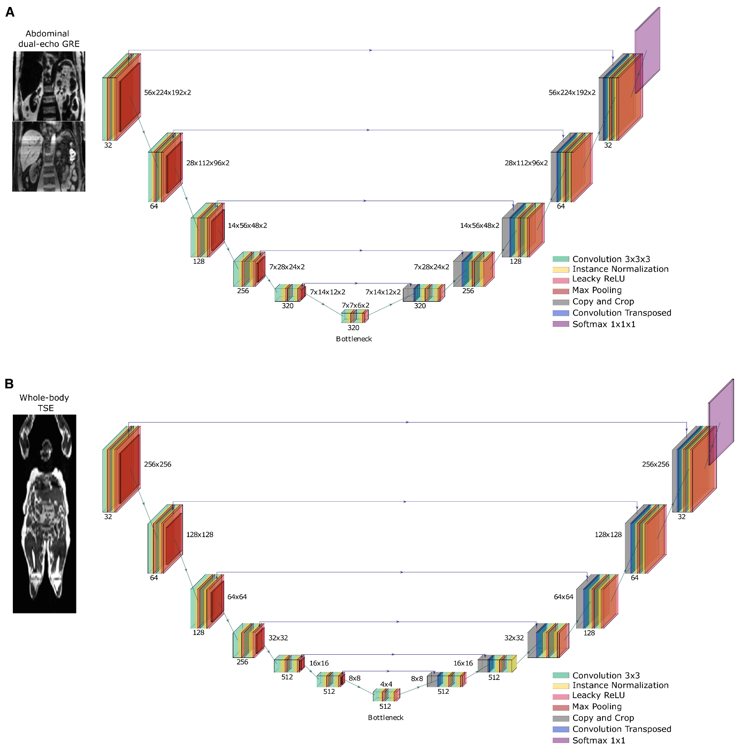
Fig. 1: U-Net architectures for abdominal GRE and whole-body TSE images
Display of the coronal view of the (A) abdominal dual-echo gradient echo (GRE) and (B) whole-body turbo spin-echo (TSE) MRI protocols and their respective 3D- and 2D U-shaped convolutional neural networks, which were optimized using a nnU-Net framework. ​The networks consist of a decoder-encoder structure with skip connections to preserve spatial information. For each level, two sequential blocks of convolution-instance normalization-activation layers were applied following max-pooling. A softmax multi-class function is used to reduce the number of feature maps to the number of output classes.

Fig. 2: Comparison of renal parenchyma and renal sinus fat between high-resolution abdominal GRE and whole-body TSE images with interslice-gaps
The scatter plots display the estimates of (A) renal parenchyma (RP) (cm³) and (B) renal sinus fat (RSF) (cm³) calculated from the dual-echo gradient-echo (GRE) images against the respective values from the same person obtained from the analysis of turbo-spin echo (TSE) images acquired with interslice-gaps. Linear regression (red line) and identity lines (back line) as well as the coefficients of determination (R²) are displayed.
Fig. 3: Comparison between whole-kidney and single-slice approach for RSF-RP ratio analysis
The half-violin plots and the corresponding scatter and boxplots display the percentage difference between the renal sinus fat-to-renal parenchyma (RSF-RP) ratio calculated using a whole-kidney and single-slice approach. Median percentage differences are displayed (black lines).

Fig. 4 Comparison of left and right kidney structures across gender and glycaemic status
The half-violin plots and the corresponding scatter and boxplots display the percentage difference between the volume of the left and the right kidney for (A) the renal parenchyma (RP) and (B) renal sinus fat (RSF).

Supplementary Information Tables

Table 1: Summary of the Parameters used for Abdominal Dual-echo GRE and Whole-body MR Image Acquisition
 | General MRI parameters
 | abdominal  dual-echo GRE | whole-body  TSE
TR/TE(s) (ms) | 3.76/1.32, 2.40 | 400/38
FA (°) | 10 | 90
Slice thickness (mm) | 2 | 10
Interslice-gap (mm) | - | 10
FoV (mm) | 375×306×250
Matrix size | 252×170×125 | 256×256
BW (Hz) | 1240 | 787
ETL | - | 7
SENSE factor | 2 | -
BW: Bandwidth
ETL: Echo Train Length
GRE: Gradient-Echo
FA: Flip Angle
FoV: Field of View
TE: Time of Echo
TR: Time of Repetition
TSE: Turbo-Spin Echo
SENSE: Sensitivity Encoding

Table 2: Left and Right Kidney Quantification from Whole-kidney Analysis of Dual-echo GRE Images
 | Male
 | Control  (n=31) |  | T1D  (n=45) |  | T2D  (n=38)
 | RP | RSF | RP | RSF | RP | RSF
Left kidney (cm³) | 160.1  ±36.3 | 15.7  ±8.4 | 168.5  ±35.8 | 12.7  ±6.3 | 174.9  ±36.2 | 13.7  ±8.0
Right kidney (cm³) | 149.6  ±31.2 | 13.4  ±8.2 | 166.5  ±37.4 | 9.9  ±6.5 | 170.3  ±36.8 | 11.0  ±8.0
Δ (%) | 5.8  ±9.8 | 19.1  ±30.1 | 1.1  ±7.6 | 29.1  ±24.3 | 2.4  ±11.3 | 23.2  ±30.6
 | Female
 | Control  (n=14) |  | T1D  (n=27) |  | T2D  (n=23)
 | RP | RSF | RP | RSF | RP | RSF
Left kidney (cm³) | 152.6  ±36.1 | 11.7  ±7.1 | 151.3  ±41.4 | 9.9  ±6.6 | 143.8  ±25.1 | 12.7  ±8.5
Right kidney (cm³) | 149.3  ±36.2 | 8.0  ±7.0 | 142.3  ±36.2 | 6.3  ±5.2 | 134.7  ±25.8 | 10.6  ±8.1
Δ (%) | 2.1  ±8.5 | 40.8  ±31.6 | 5.2  ±8.5 | 36.9  ±44.0 | 6.3  ±8.7 | 20.9  ±21.9
Note: values are reported as mean±standard deviation (SD)

RP: Renal Parenchyma
RSF: Renal Sinus Fat
T1D: Type 1 Diabetes
T2D: Type 2 Diabetes

