Supplementary Material 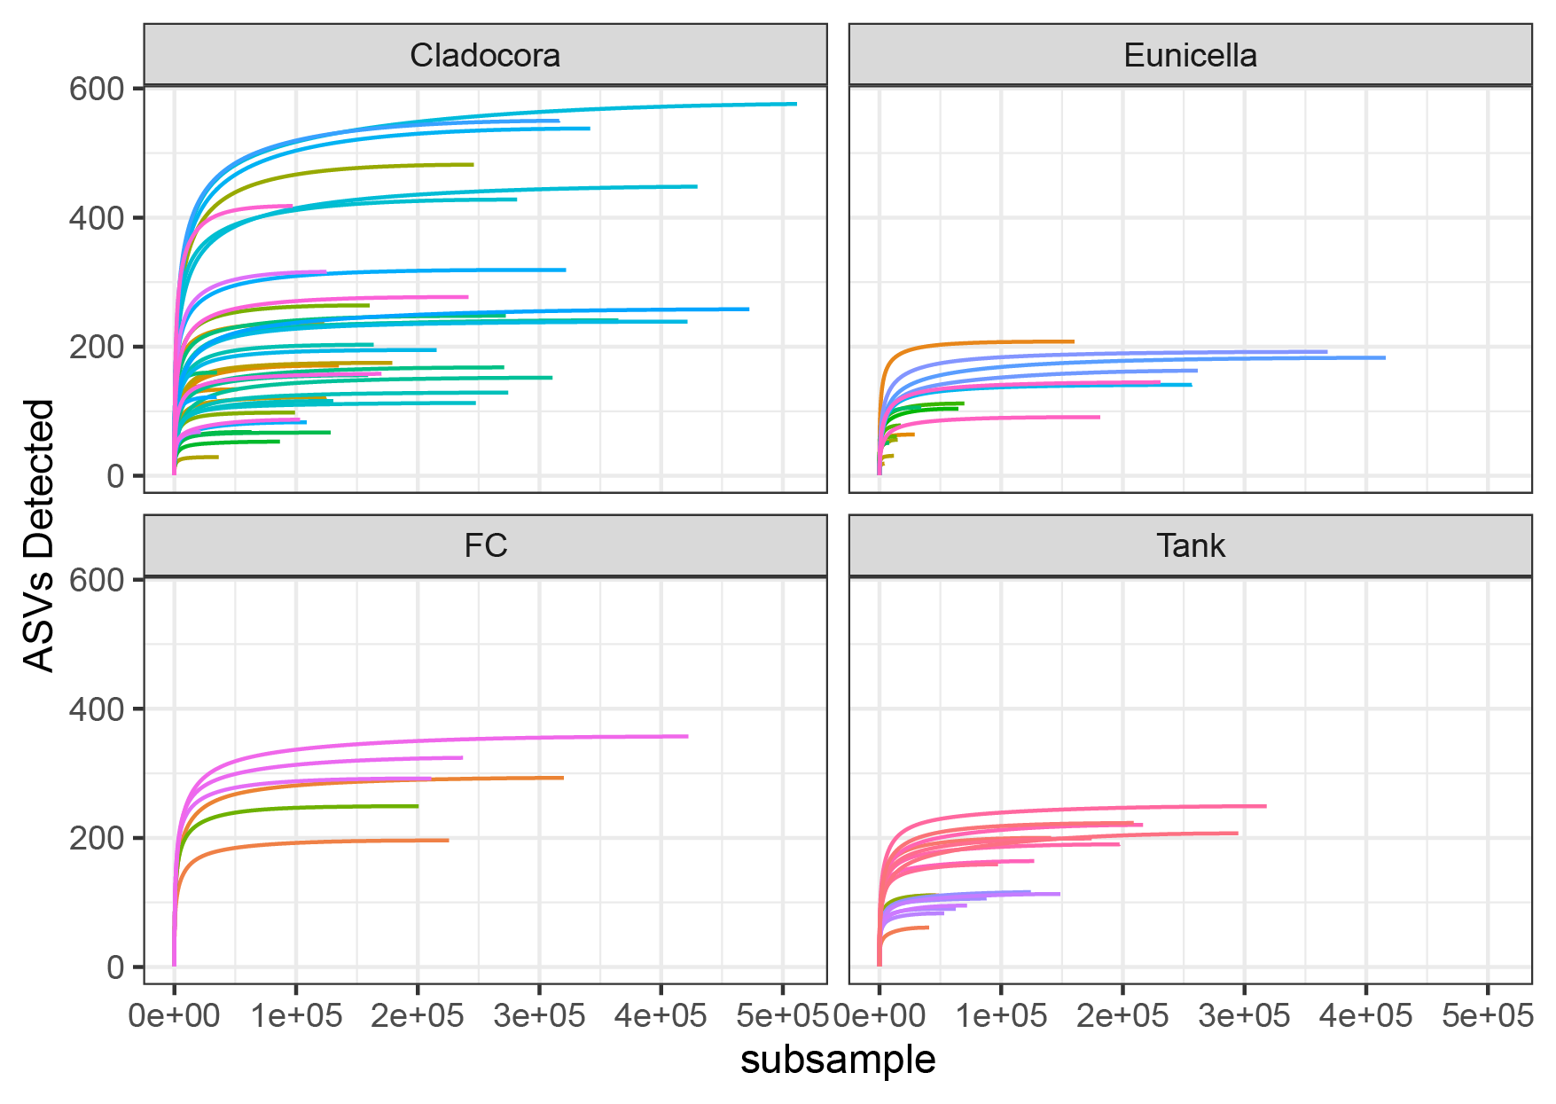
Supplementary Figure S1. Rarefaction curves showing the number of ASVs for each set of data from Cladocora caespitosa, Eunicella singularis, flow chamber (“FC”), and tank.
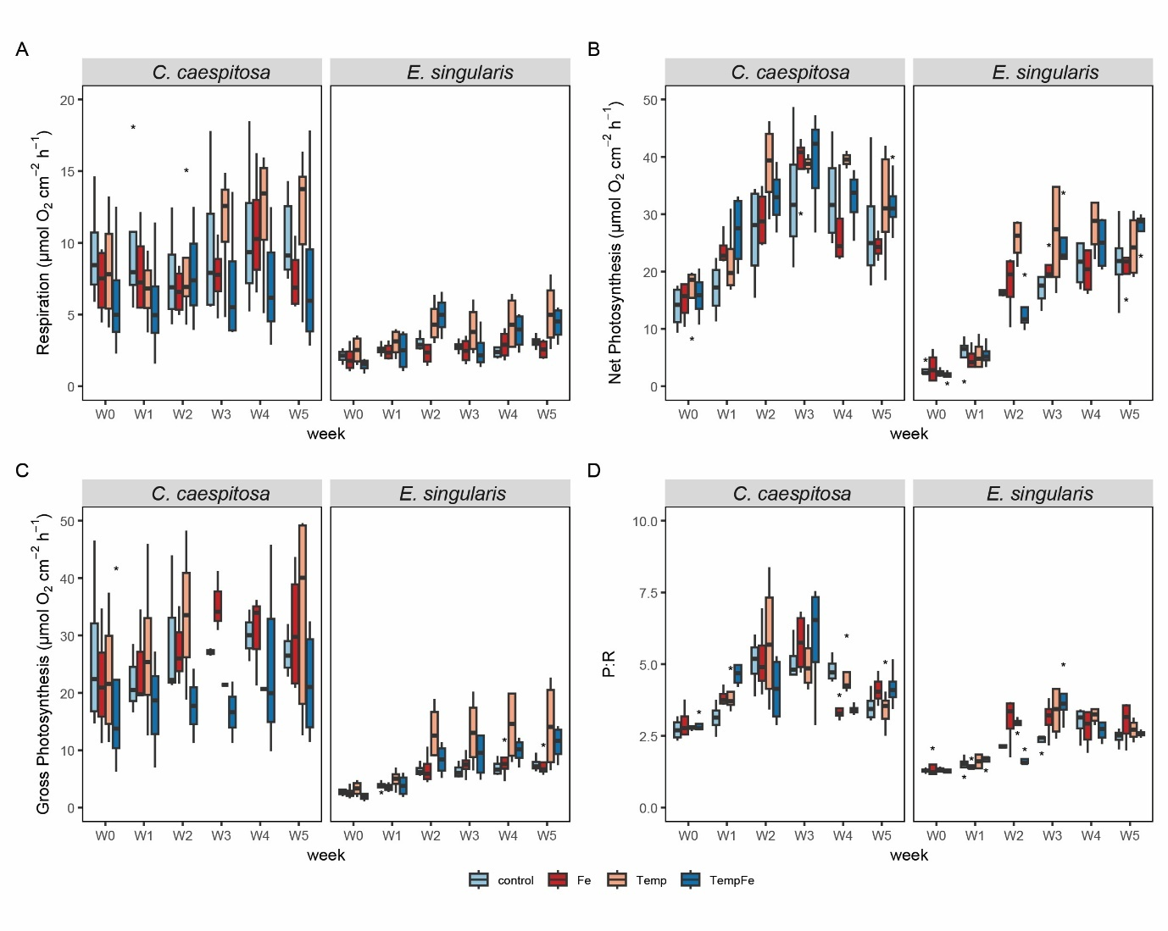
Supplementary Figure S2. Physiological parameters of corals under experimental conditions. (A) Respiration rate, (B) net photosynthesis rate, (C) gross photosynthesis rate, (D) ratio of gross photosynthesis to respiration (P_{G}:R) measured using respirometry in C. caespitosa and E. singularis. Condition indicates the Control, pulses of Fe(III) to expose corals to 20 nM Fe day⁻¹ (“Fe”), increased temperature (“Temp”) and combined exposure to high temperature and iron enrichment (“TempFe”).

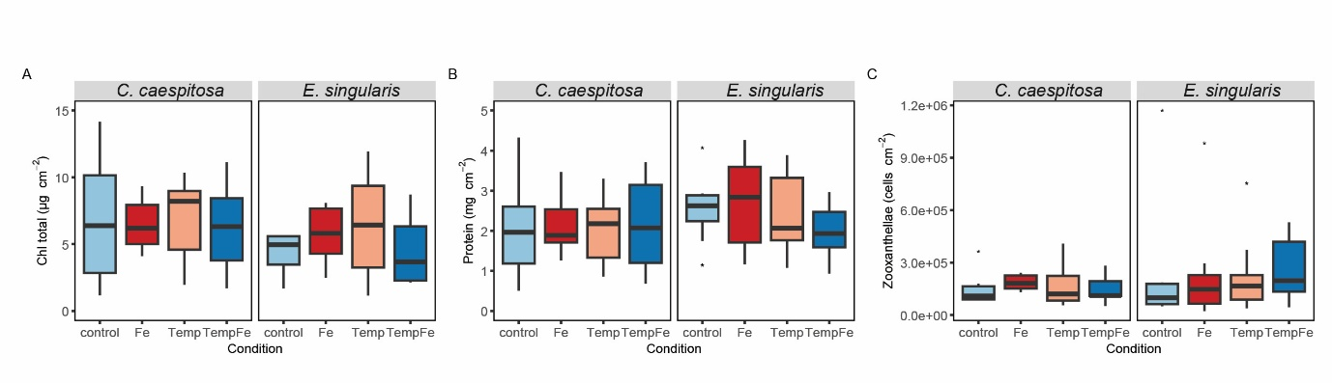
Supplementary Figure S3. Symbiont density, chlorophyll concentrations, and host protein content in Cladocora caespitosa and Eunicella singularis under different experimental treatments. Bar plots show (A) total chlorophyll (µg cm⁻²), (B) host protein content mg cm ⁻², and (C) symbiont density (cells cm⁻²) for each species exposed to Control conditions (Control), iron enrichment (Fe, 20 nM Fe/day), elevated temperature (Temp, 24 °C), and combined stress (TempFe, 24 °C + 20 nM Fe day-1).

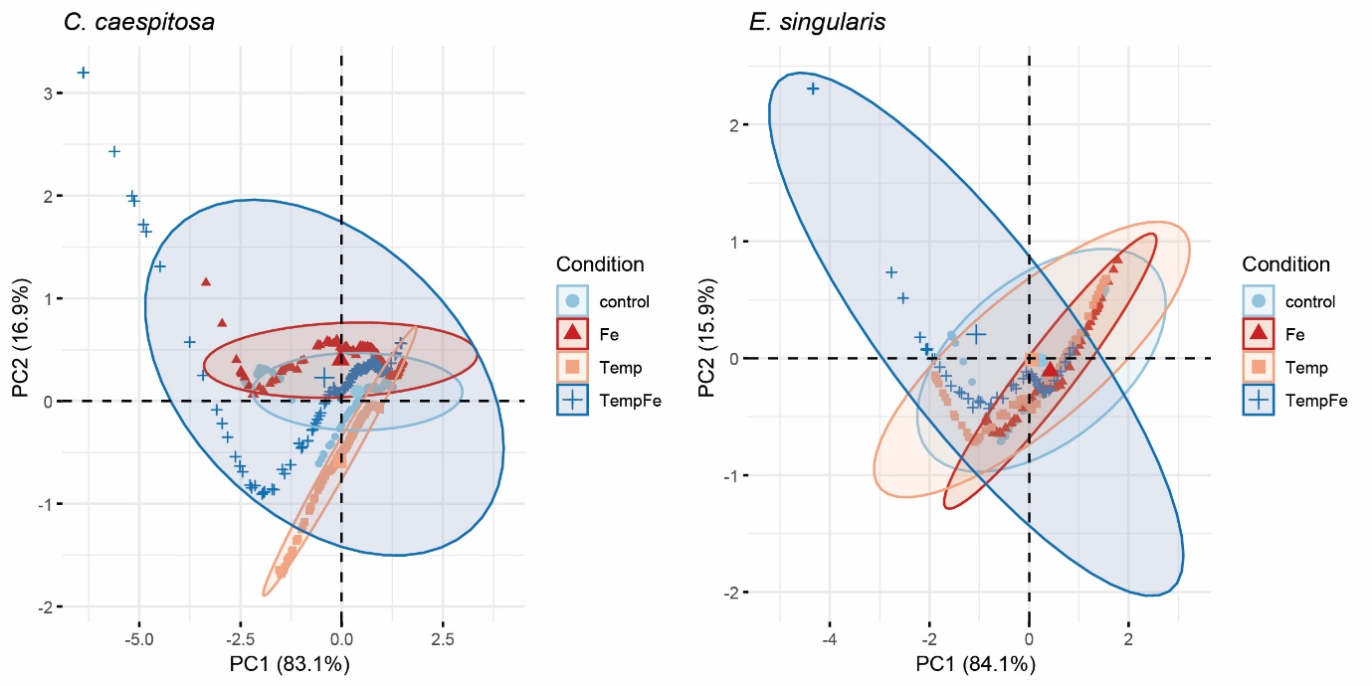
Supplementary Figure S4. Principal component analysis (PCA) of O₂ concentration profiles within the gastrovascular cavity of Cladocora caespitosa and Eunicella singularis under experimental conditions. PCA plots display variation in O₂ profiles across treatment groups: Control (light blue circles), iron enrichment (Fe, red triangles), elevated temperature (Temp, orange squares), and combined iron and temperature (TempFe, dark blue crosses). Ellipses represent 95% confidence intervals for each condition.
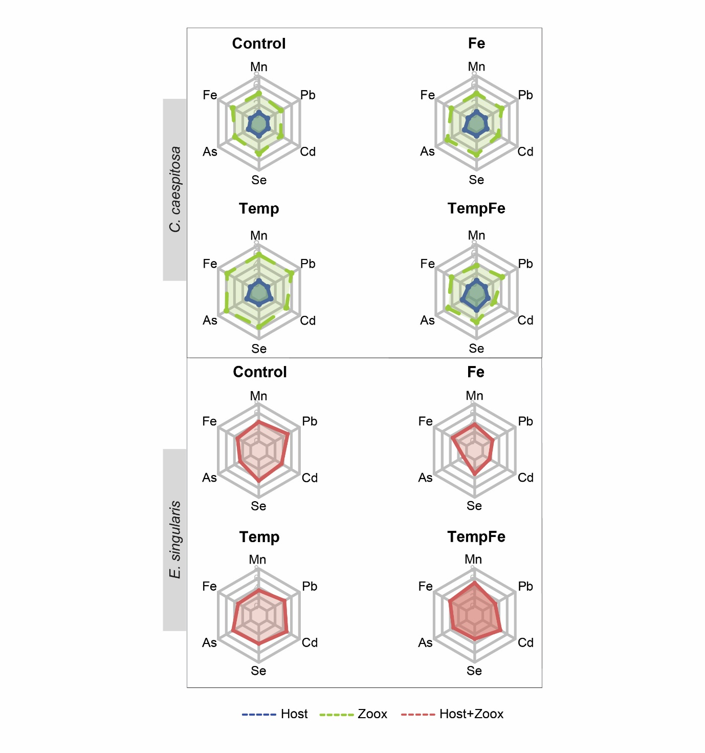
Supplementary Figure S5. Radar plots of log₁₀-transformed mean concentrations (μg g⁻¹) of six trace metals (Mn, Fe, As, Se, Cd, Pb) in coral host and symbiont compartments across treatments. Separate plots show metal content in the host tissue (blue) and algal symbionts (green). Eunicella singularis under the same four experimental treatments, where only the combined host-symbiont fraction was analyzed (red). The data represent treatment means. Maxima and minima were standardized per plot for visualization.

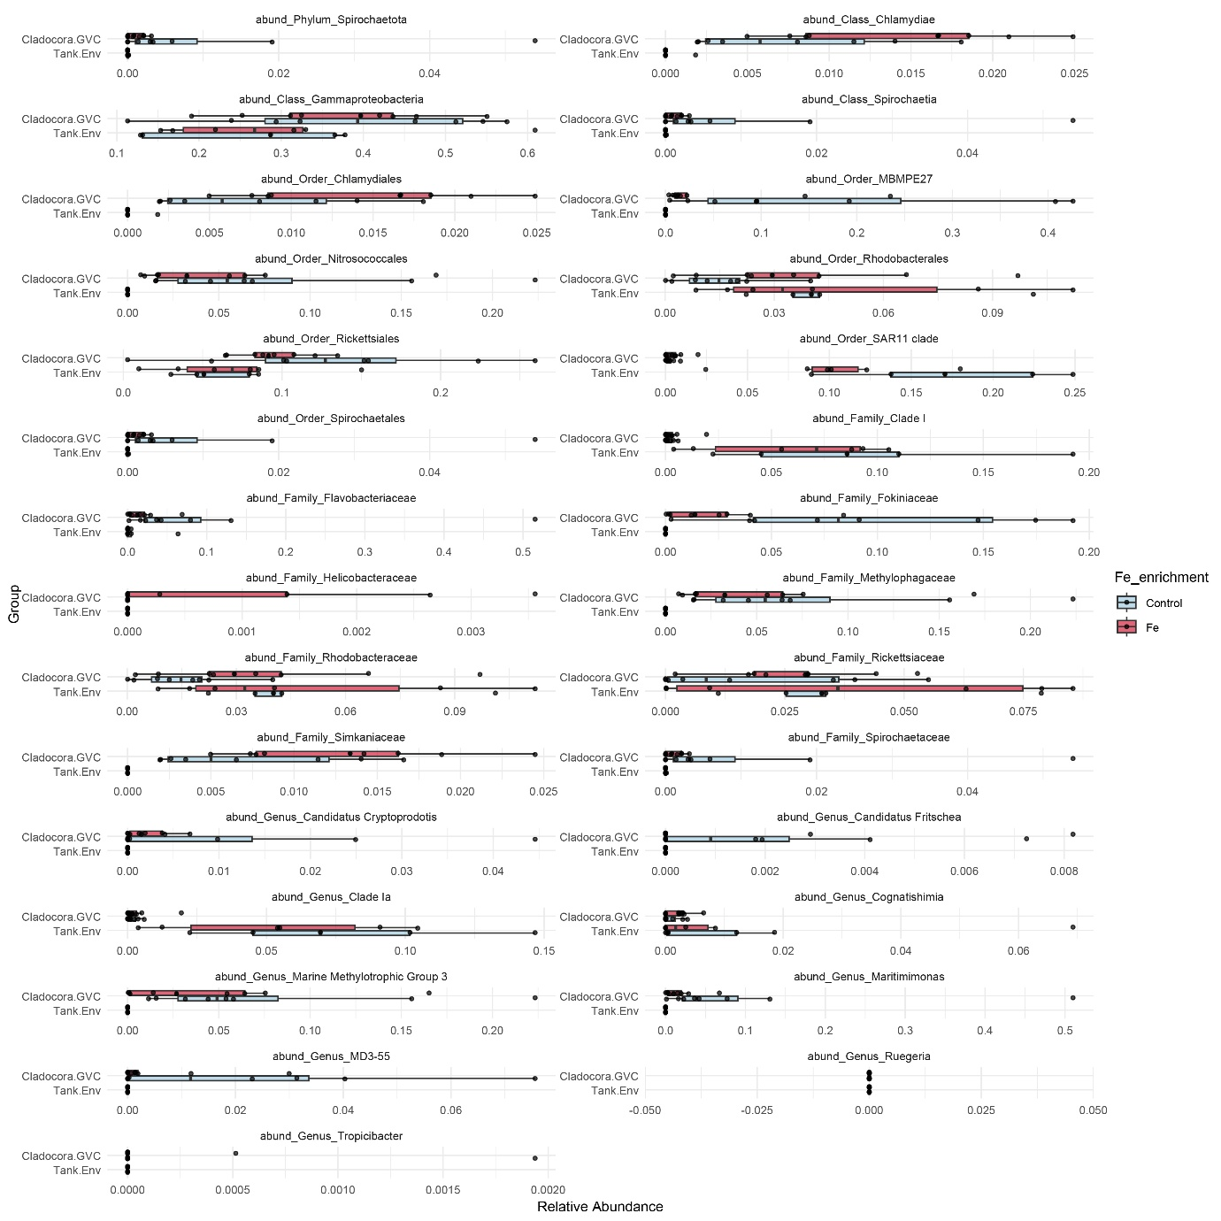
Supplementary Figure S6. Relative abundance of significantly enriched microbial taxa in Cladocora caespitosa gastric cavity and tank water samples under iron enrichment conditions (20 nM Fe/day). Taxa shown were identified as significantly different (ALDEx2, Benjamini–Hochberg adjusted p < 0.05, overlap < 0.2) across taxonomic levels (phylum to genus) and plotted as compositional relative abundance across sample groups (Cladocora.GVC, Tank.Water). Boxplots display the median and interquartile range with jittered individual sample points overlaid. Horizontal layout and facet wrapping by taxon facilitate comparison across groups. Iron enrichment did not universally increase microbial abundance but selectively modulated certain bacterial lineages. Colors represent treatment conditions: Control (blue) and Fe-enriched (red)

Supplementary Table S1. Multivariate analysis of variance (MANOVA) results for variable chlorophyll fluorescence parameters. The analysis tested the effects of experimental conditions (Control, Fe, Temp, TempFe), coral species (Cladocora caespitosa, Eunicella singularis), and their interaction. Df = degrees of freedom, Pillai = Pillai’s trace, Approx. F = approximate F-statistic, and Pr(>F) = associated p-value.
Multivariate analysis of variance (MANOVA)
 | Df | Pillai | Approx. F | Pr(>F)
Condition | 3 | 0.117 | 0.49 | 0.88
Species | 1 | 0.147 | 1.96 | 0.14
Condition:Species | 3 | 0.280 | 1.24 | 0.28
Residuals | 36

Supplementary Table S2. Multivariate analysis of variance (MANOVA) results for O₂ concentration profiles within the gastrovascular cavity of Cladocora caespitosa and Eunicella singularis. The MANOVA tested the effects of experimental conditions (Control, Fe, Temp, TempFe), species, and their interaction on O₂ concentration profiles measured within the gastric cavity under light and dark conditions. Df = degrees of freedom, Pillai = Pillai’s trace, Approx. F = approximate F-statistic, and Pr(>F) = associated p-value.
Multivariate analysis of variance (MANOVA)
 | Df | Pillai | Approx. F | Pr(>F)
Condition | 3 | 0.235 | 38.994 | < 0.001
Species | 1 | 0.006 | 2.76 | 0.067
Condition:Species | 3 | 0.137 | 21.945 | < 0.001
Residuals | 877

Supplementary Table S3. Concentrations of trace metals (Mn, Fe, As, Se, Cd, Pb) in seawater, coral host tissue, and algal symbionts (zooxanthellae) under different experimental conditions. Data are reported as mean (± standard deviation) in µg L⁻¹ for seawater samples and in µg g⁻¹ dry weight for coral tissue and symbionts. Seawater samples include experimental tanks across all treatments (Control, Fe, Temp, TempFe) and a field reference. For Cladocora caespitosa, host and symbiont fractions were analyzed separately, while for Eunicella singularis, due to the difficulty of symbiont isolation, host and symbionts were analyzed as a combined fraction.
Species | Compartment | Condition | Mn  μg L⁻¹ | Fe  μg L⁻¹ | As  μg L⁻¹ | Se  μg L⁻¹ | Cd  μg L⁻¹ | Pb  μg L⁻¹
Seawater | Tank | Control | 0.76  (1.07) | 31.31  (12.42) | 0.15  (0.22) | 16.50  (3.27) | 0.00  (0.00) | 0.00  (0.00)
Seawater | Tank | Fe | 0.33  (0.02) | 22.15  (2.85) | 0.00  (0.00) | 22.06  (2.97) | 0.00  (0.00) | 0.00  (0.00)
Seawater | Tank | Temp | 0.00 | 10.51 | 0.00 | 24.39 | 0.00 | 0.00
Seawater | Tank | TempFe | 0.00 | 12.62 | 0.00 | 16.28 | 0.00 | 0.00
Seawater | Field | Field | 0.00 | 40.86 | 0.00 | 2.31 | 0.02 | 0.31
C. caespitosa | Host | Control | 27.28  (5.94) | 62.11  (21.95) | 3.81  (1.10) | 18.22  (3.69) | 0.20  (0.04) | 0.28  (0.14)
C. caespitosa | Host | Fe | 26.23  (8.26) | 44.68  (18.77) | 3.51  (1.22) | 14.95  (3.95) | 0.18  (0.07) | 0.14  (0.08)
C. caespitosa | Host | Temp | 21.33  (6.57) | 57.70  (16.12) | 2.87  (0.78) | 16.96  (2.37) | 0.12  (0.05) | 0.29  (0.11)
C. caespitosa | Host | TempFe | 24.82  (10.57) | 56.56  (22.16) | 3.44  (0.88) | 18.99  (5.10) | 0.16  (0.12) | 0.23  (0.10)
C. caespitosa | Zooxanthellae | Control | 207.54  (81.43) | 4534.55  (1933.74) | 12.46  (4.82) | 48.12  (15.80) | 0.97  (0.56) | 12.61  (7.54)
C. caespitosa | Zooxanthellae | Fe | 134.59  (63.63) | 2099.66  (1062.02) | 10.39  (2.82) | 44.93  (16.20) | 0.64  (0.42) | 4.81  (2.49)
C. caespitosa | Zooxanthellae | Temp | 162.20  (24.98) | 3664.42  (852.29) | 9.24  (1.48) | 35.05  (7.00) | 0.28  (0.08) | 9.62  (1.98)
C. caespitosa | Zooxanthellae | TempFe | 127.32  (60.47) | 3270.67  (1833.30) | 8.07  (2.78) | 27.52  (7.73) | 0.33  (0.25) | 7.11  (3.21)
E. singularis | Host+Zoox | Control | 3.09  (1.61) | 15.03  (6.92) | 1.04  (0.97) | 0.86  (0.36) | 0.45  (0.27) | 2.21  (0.90)
E. singularis | Host+Zoox | Fe | 3.70  (0.50) | 15.31  (8.05) | 2.11  (1.06) | 0.71  (0.42) | 0.55  (0.23) | 2.17  (0.66)
E. singularis | Host+Zoox | Temp | 5.72  (2.98) | 25.10  (16.41) | 7.85  (3.93) | 1.61  (0.68) | 1.42  (0.69) | 3.99  (1.96)
E. singularis | Host+Zoox | TempFe | 2.27  (0.64) | 9.31  (3.77) | 0.98  (0.58) | 0.34  (0.08) | 0.17  (0.08) | 1.18  (0.53)

Supplementary Table S4. Multivariate analysis of variance (MANOVA) results testing the effects of condition, coral species, and tissue origin on trace metal content. The MANOVA was performed on log-transformed concentrations of six trace metals (Mn, Fe, As, Se, Cd, Pb) in host tissue and algal symbionts of Cladocora caespitosa and Eunicella singularis across experimental conditions (Control, Fe, Temp, TempFe). Df = degrees of freedom, Pillai = Pillai’s trace, Approx. F = approximate F-statistic, Num Df = multivariate numerator degrees of freedom, Den Df = multivariate denominator degrees of freedom, and Pr(>F) = associated p-value.
Multivariate analysis of variance (MANOVA)
 | Df |  | Pillai | Approx. F | Num Df | Den Df | Pr(>F)
Condition | 3 |  | 1,327 | 6.08 | 18 | 138 | < 0.001
Species | 1 |  | 0.988 | 646.58 | 6 | 44 | < 0.001
Origin | 1 |  | 0.968 | 220.89 | 6 | 44 | < 0.001
Condition:Species | 3 |  | 0.986 | 3.75 | 18 | 138 | < 0.001
Condition:Origin | 3 |  | 0.329 | 0.95 | 18 | 138 | 0.525
Residuals | 49

Table S5. Effects of iron enrichment (Fe), increased temperature (Temp), and their combination (TempFe) on metal content in the symbionts and host of Cladocora caespitosa and Eunicella singularis. Coloured cells indicate trends in metal concentrations across treatments and compartments (Fig. 4). Notes: n.s. (=): Not significant, no change observed; ↑: indicates an increase in metal content; ↓: indicates a decrease in metal content.
Cladocora caespitosa
Symbionts
Metal | Fe 18 °C |  | Temp 24 °C |  | TempFe 24 °C
As | n.s. | = | n.s. | = | n.s. | =
Cd | n.s. | = | p < 0.05 | ↓ | p < 0.01 | ↓
Fe | n.s. | = | p < 0.01 | ↑ | p < 0.01 | ↑
Mn | n.s. | = | n.s. | = | n.s. | =
Pb | n.s. | = | p < 0.01 | ↑ | p < 0.01 | ↑
Se | p < 0.01 | ↑ | n.s. | = | n.s. | =
Host
Metal | Fe 18 °C |  | Temp 24 °C |  | TempFe 24 °C
As | n.s. | = | n.s. | = | n.s. | =
Cd | n.s. | = | n.s. | = | n.s. | =
Fe | n.s. | = | n.s. | = | n.s. | =
Mn | n.s. | = | n.s. | = | n.s. | =
Pb | p < 0.05 | ↓ | n.s. | = | n.s. | =
Se | n.s. | = | n.s. | = | n.s. | =
Eunicella singularis
Symbionts + Host
Metal | Fe 18 °C |  | Temp 24 °C |  | TempFe 24 °C
As | n.s. | = | p < 0.01 | ↑ | n.s. | =
Cd | n.s. | = | p < 0.01 | ↑ | n.s. | =
Fe | n.s. | = | p < 0.05 | ↑ | n.s. | =
Mn | n.s. | = | p < 0.05 | ↑ | n.s. | =
Pb | n.s. | = | p < 0.01 | ↑ | n.s. | =
Se | n.s. | = | p < 0.01 | ↑ | n.s. | =

Supplementary Table S6. Permutational multivariate analysis of variance (PERMANOVA) results testing the effect of iron enrichment on microbial community composition. The analysis was performed on CLR-transformed ASV data using Euclidean distance matrices. A stratified PERMANOVA (adonis2, 999 permutations) was conducted with sample type (Cladocora GVC vs. surface) as the strata. A follow-up PERMANOVA analysis was performed within each compartment.
Permutational Multivariate Analysis of Variance (PERMANOVA)
adonis2(formula = dist_matrix ~ Fe_enrichment, data = samdata, strata = samdata$SampleType)
 | Df | Sum of Sqs | R² | F | Pr(>F)
Model | 1 | 4175 | 0.041 | 0.9931 | 0.049
Residuals | 23 | 96687 | 0.959
Total | 24 | 100861 | 1.00
adonis2(formula = sub_dist ~ Fe_enrichment, data = sub_meta.GVC)
 | Df | Sum of Sqs | R² | F | Adjusted-p
Model | 1 | 6202 | 0.104 | 1.6203 | 0.024
Residuals | 14 | 53591 | 0.896
Total | 15 | 59793 | 1.00
adonis2(formula = sub_dist ~ Fe_enrichment, data = sub_meta.surface)
 | Df | Sum of Sqs | R² | F | Adjusted-p
Model | 1 | 2317 | 0.142 | 1.163 | 0.024
Residuals | 7 | 13943 | 0.857
Total | 8 | 16261 | 1.00

Supplementary Table S7. Type II ANOVA results for the effects of coral species, sample type, and iron enrichment on microbial alpha diversity (ExpShannon). The linear model was fitted on log-transformed exponential Shannon diversity values, with factors including the interaction between species and sample type (interaction), Fe enrichment (Fe_enrichment), and their interaction.
TYPE II ANOVA
aov(log(ExpShannon) ~ interaction * Fe_enrichment, data = div)
 | Df | Sum of Sqs | F | Pr(>F)
Interaction | 3 | 20.153 | 28.705 | < 0.001
Fe_enrichment | 1 | 1.892 | 8.083 | < 0.01
Interaction:Fe_enrichment | 3 | 3.320 | 4.729 | < 0.001
Residuals | 44 | 10.297

