Supplementary Figures

Supplementary Figure 1. Missingness Analysis and Random Forest Imputation Diagnostics

1A.
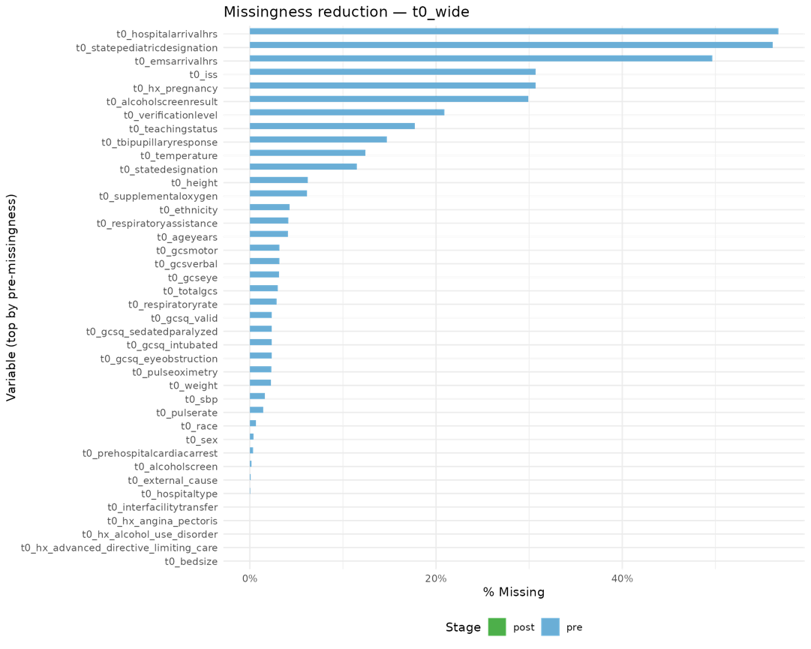

1B. Correlational Matrix for Baseline Dataset
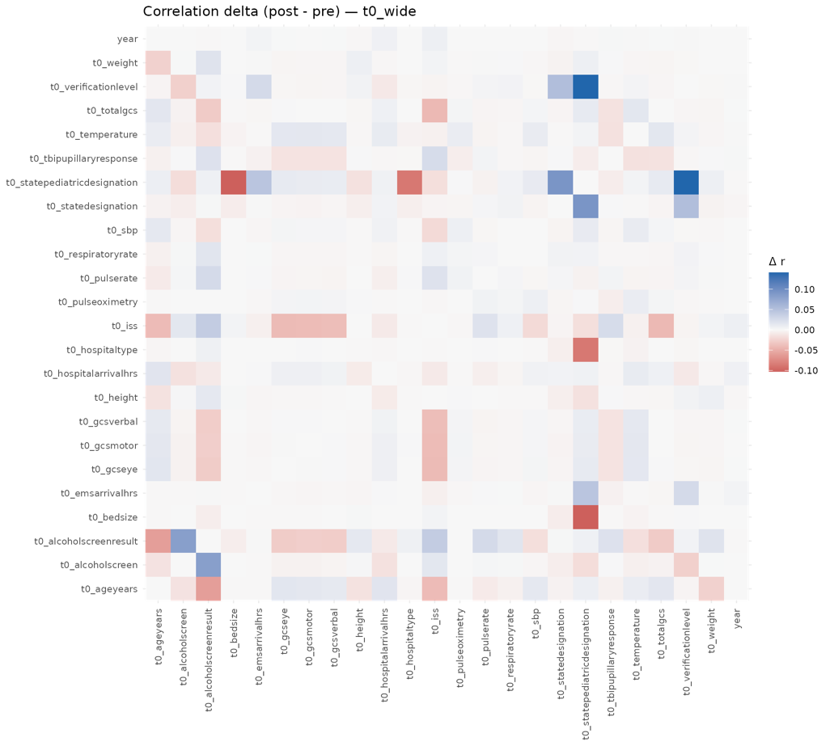

1C. Distributions of Most Missing Imputed Variables
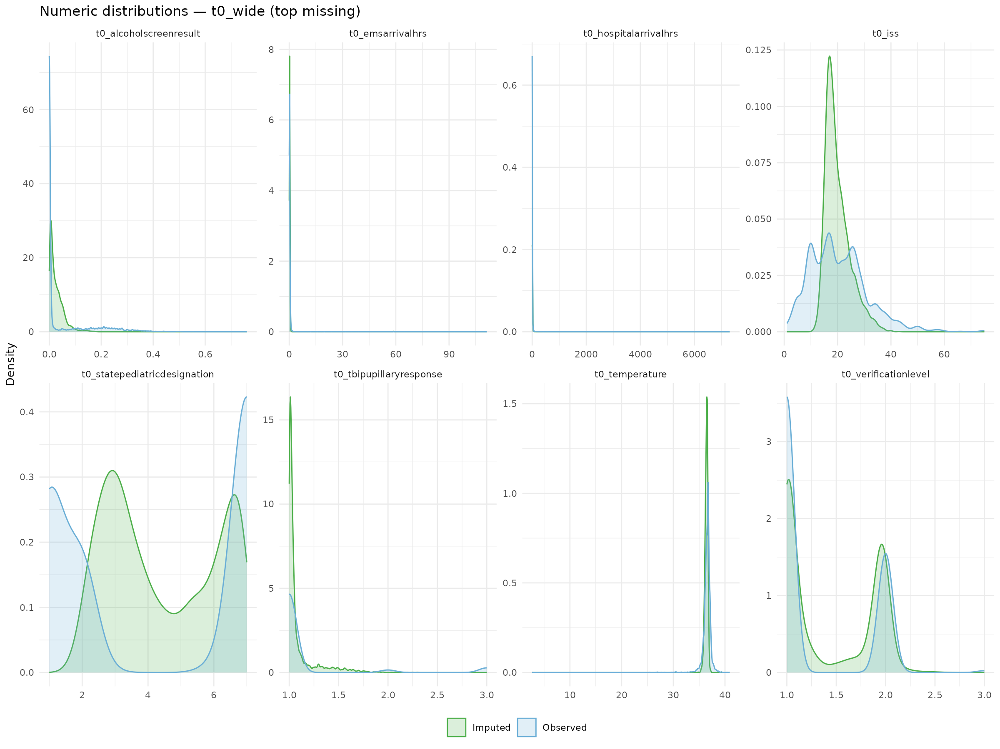

1D. Top Missing Columns in the Time Varying Dataset
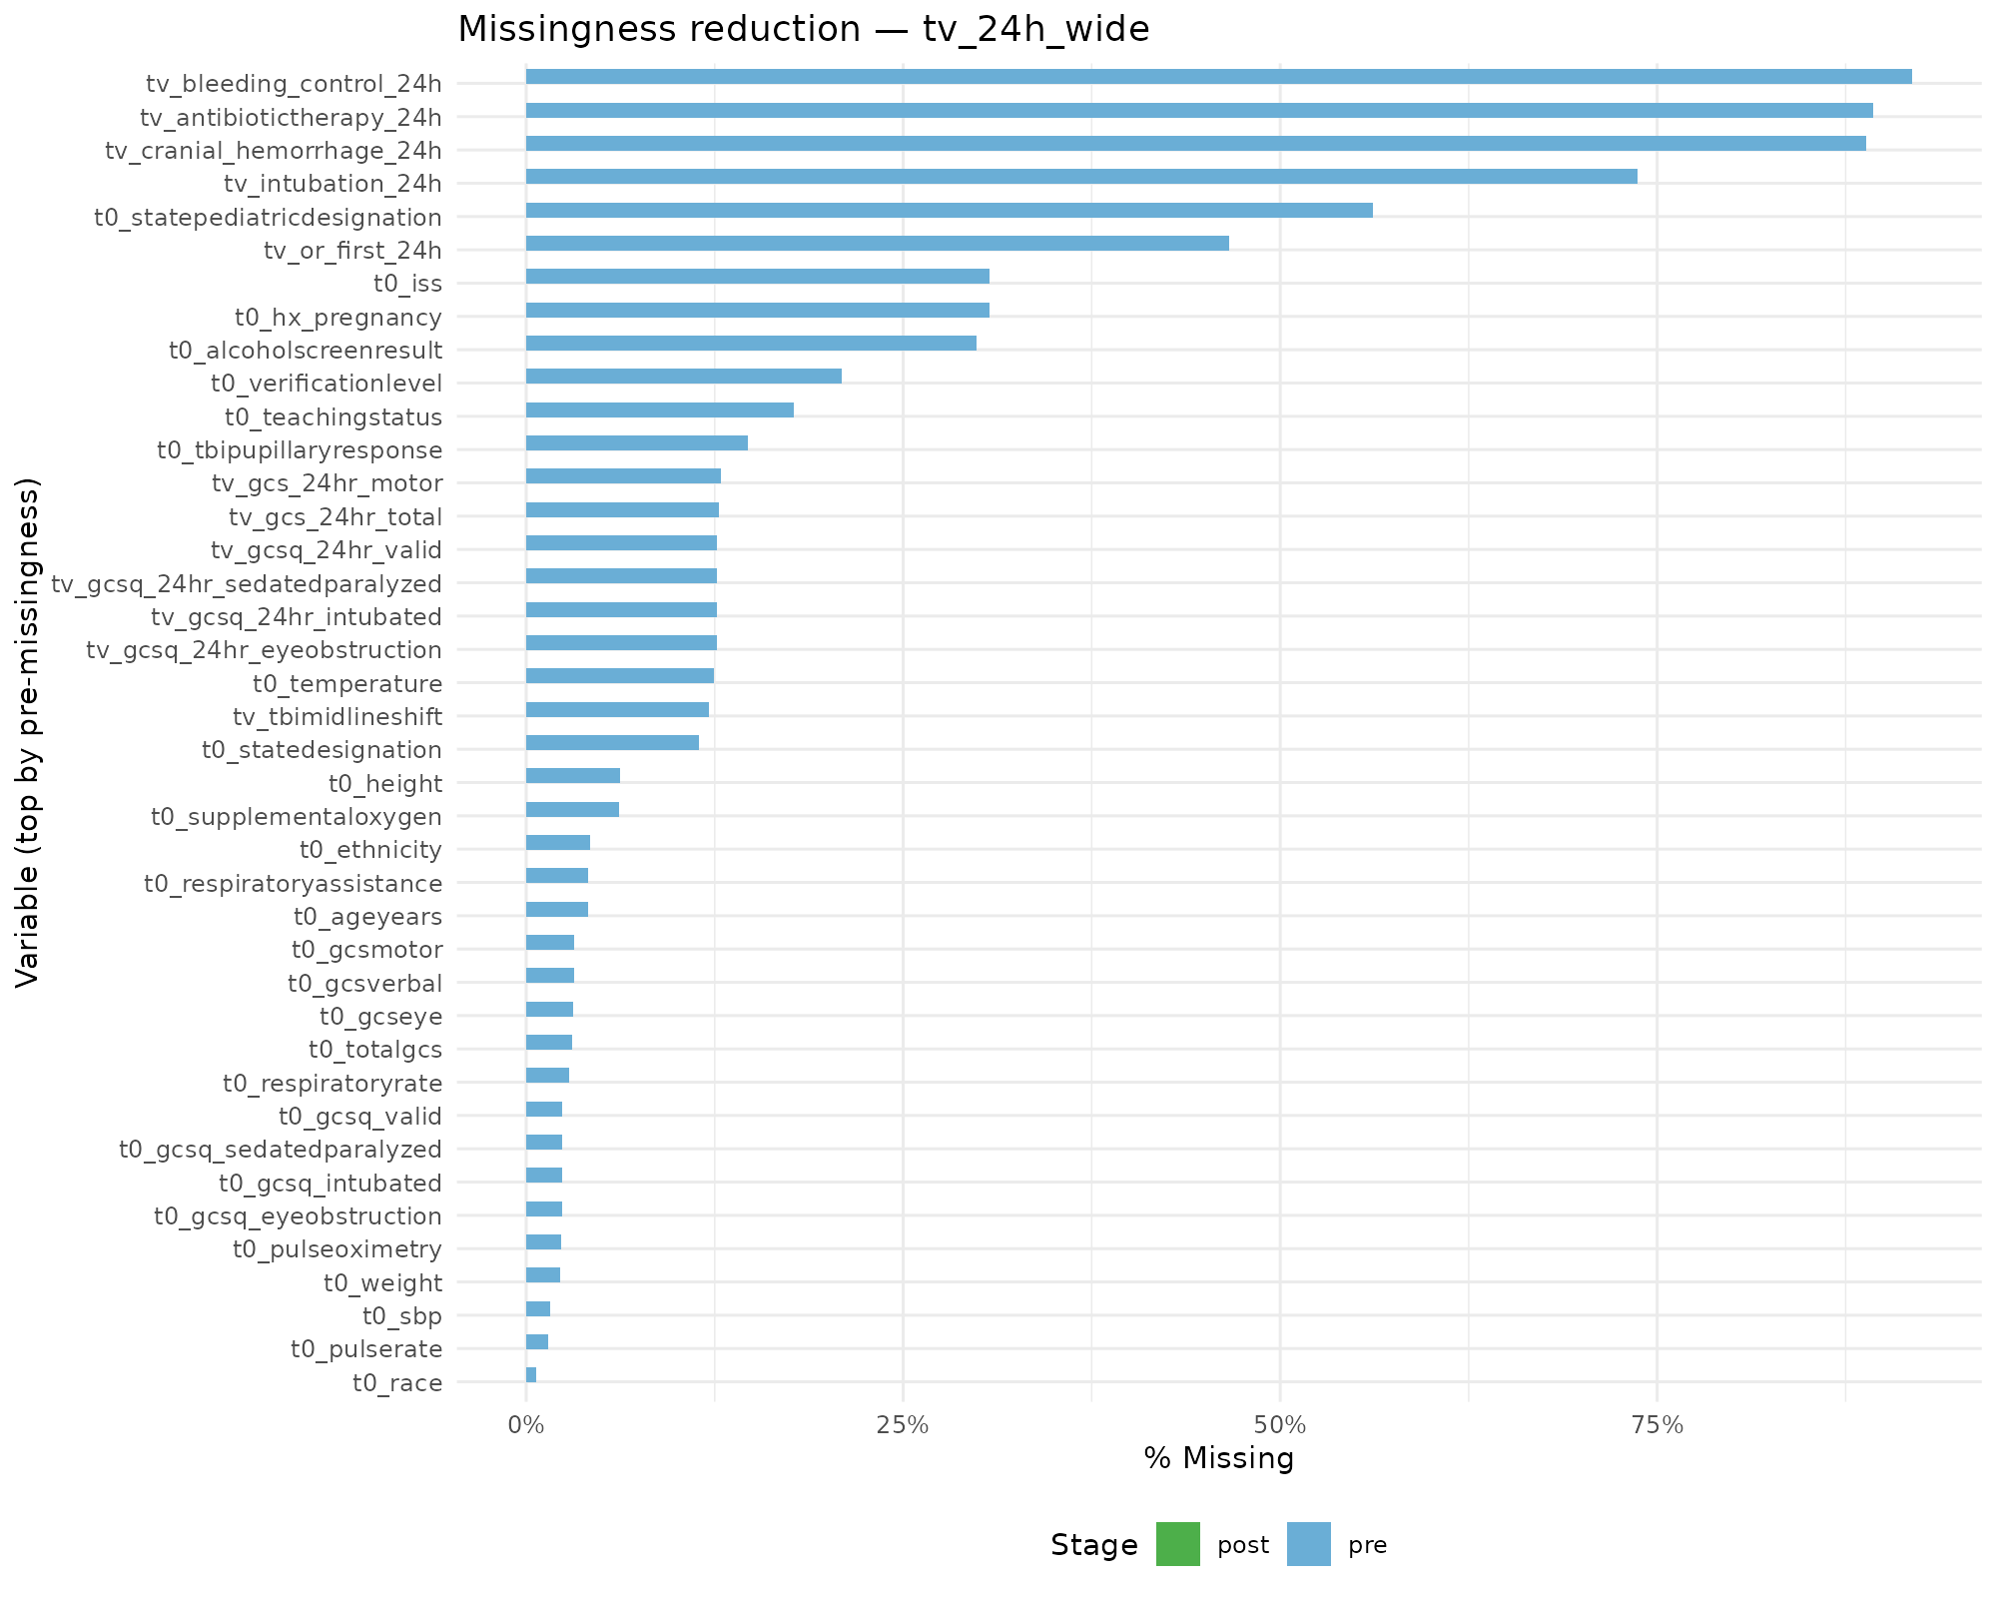

1E. Correlational Matrix for Baseline Dataset
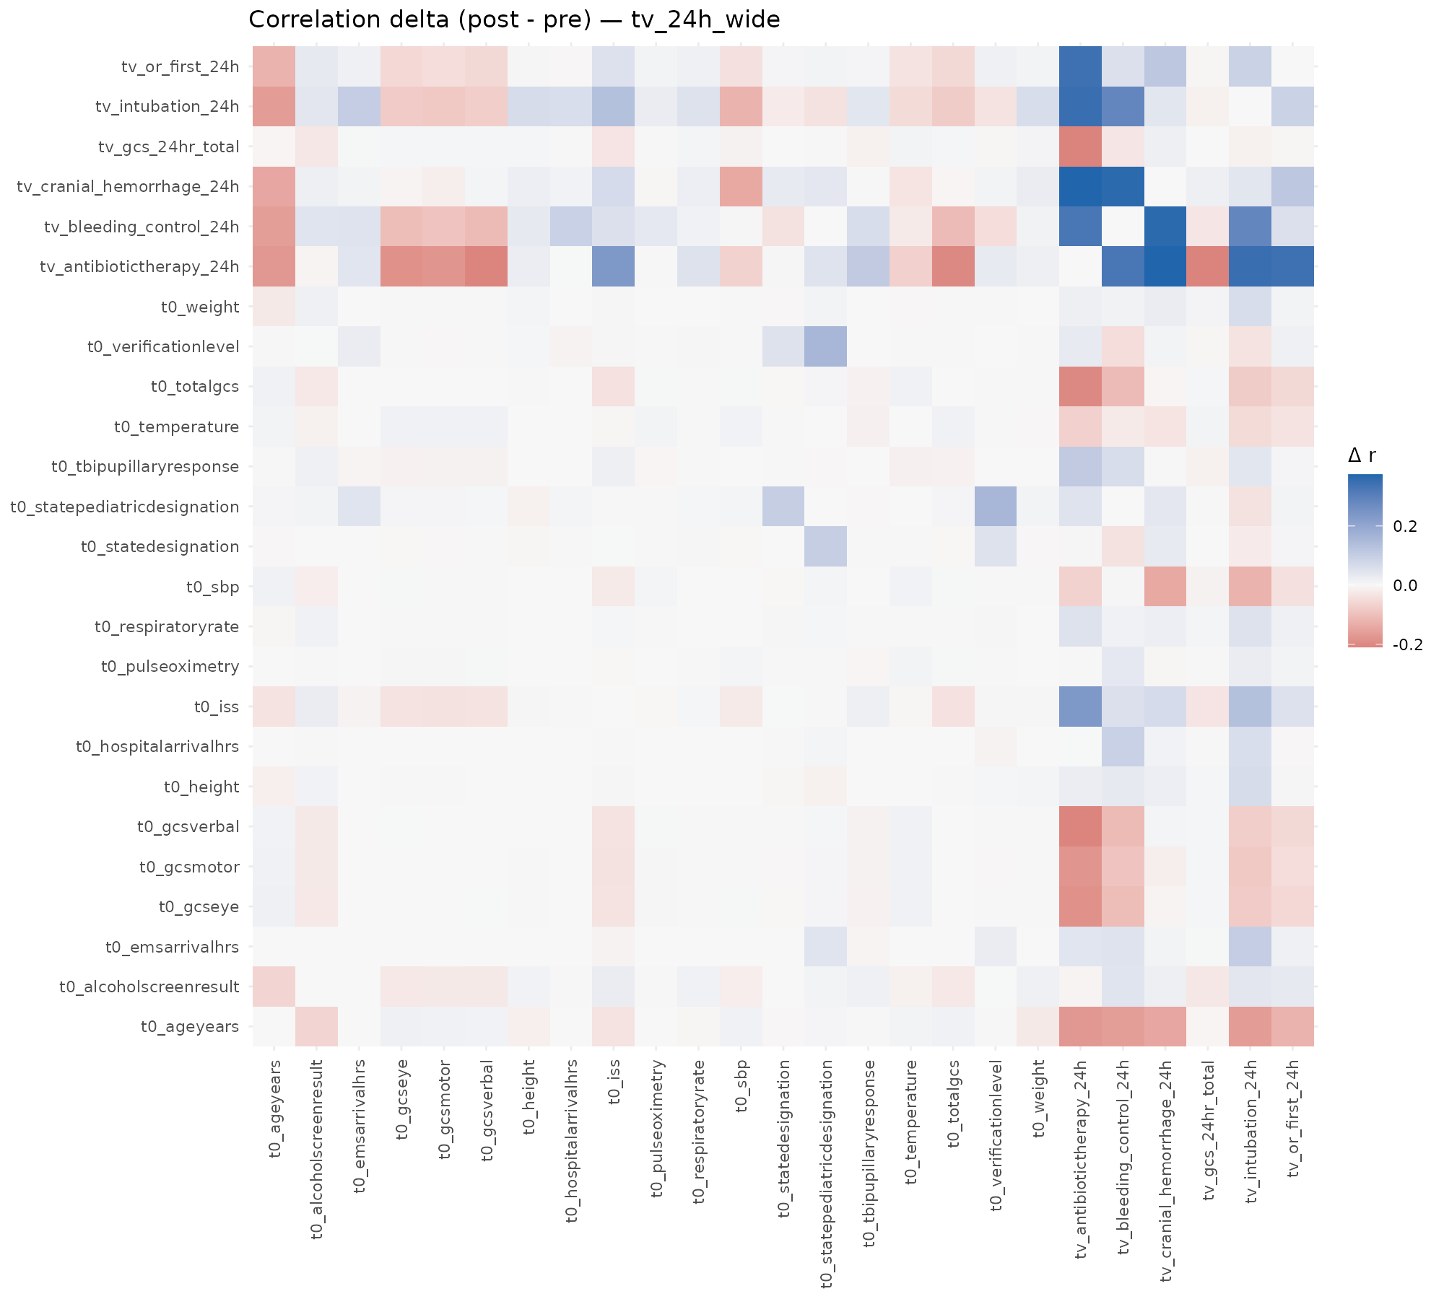

1F. Example Distributions of Imputed Variables
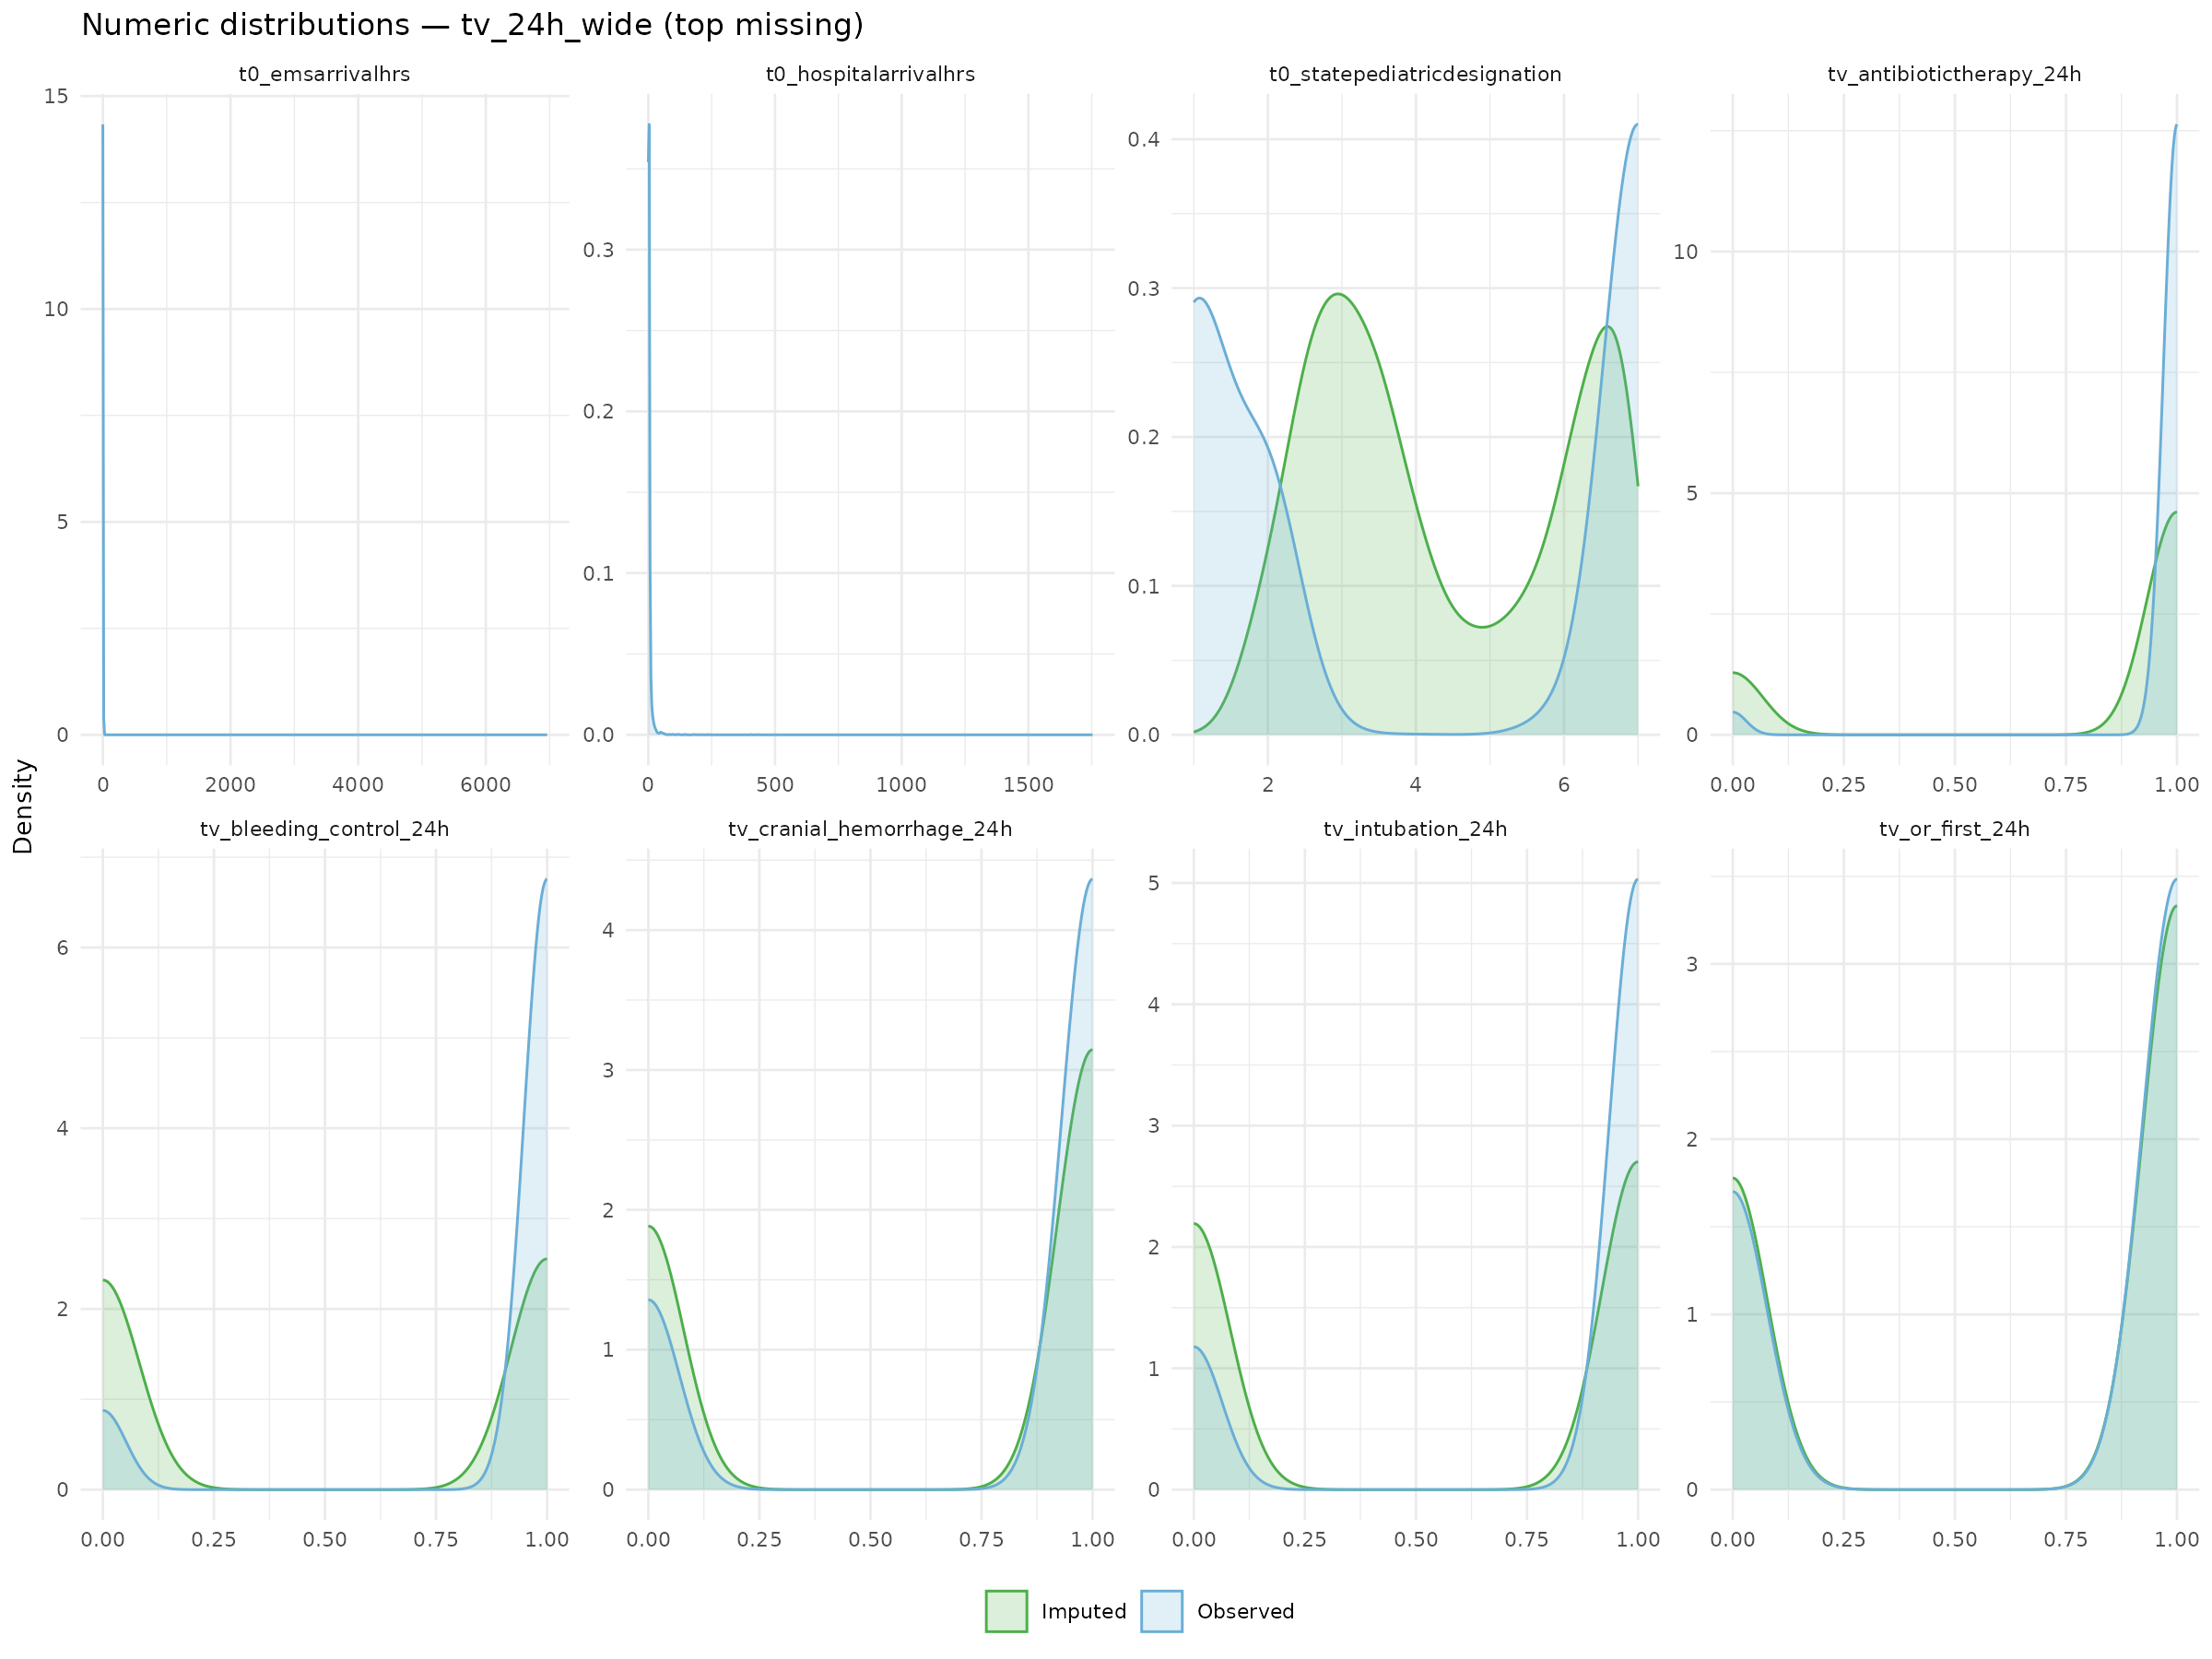

Note: The above figures show the missingness of the dataset pre-imputation. They also show the single random forest imputation process, and that the quality of data is preserved as evidenced by example distributions.

Supplementary Figure 2. LASSO Regression Diagnostics and Results

2A.
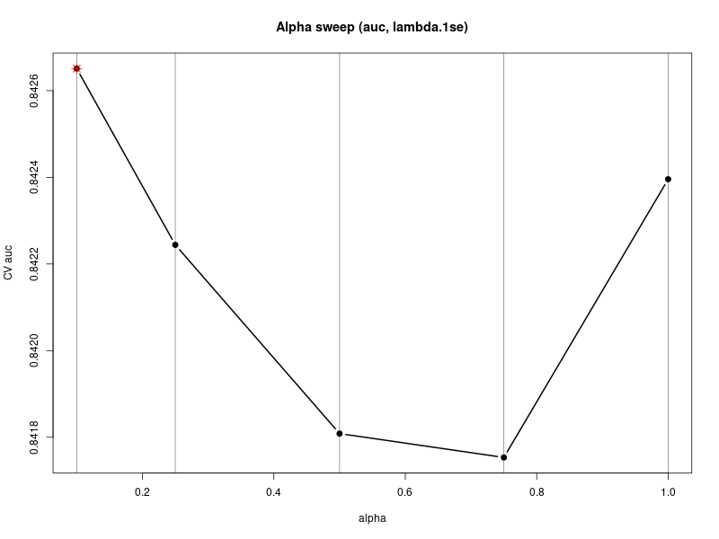
Note: Shows cross-validated AUC for different α values in an elastic net model. α = 1 favors LASSO (sparse), α = 0 favors Ridge (smooth). The optimal α (red star) provided the best predictive performance

2B.
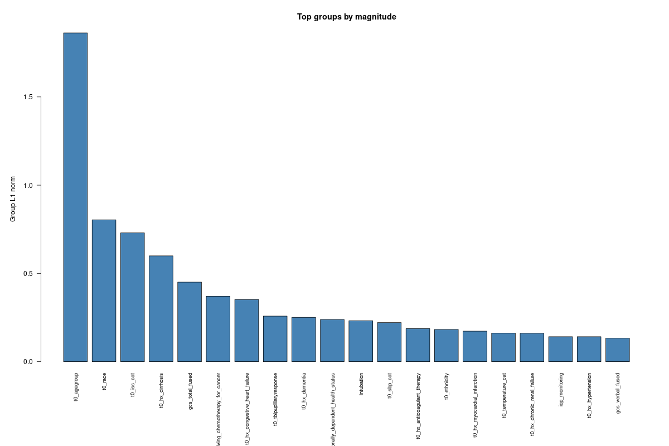

Note: Top variables as determined by the LASSO selection, trained on mortality.

2C. AUC Curve for LASSO Selection on Mortality

Supplementary Figure 3. Clone-Censor-Weight Diagnostics

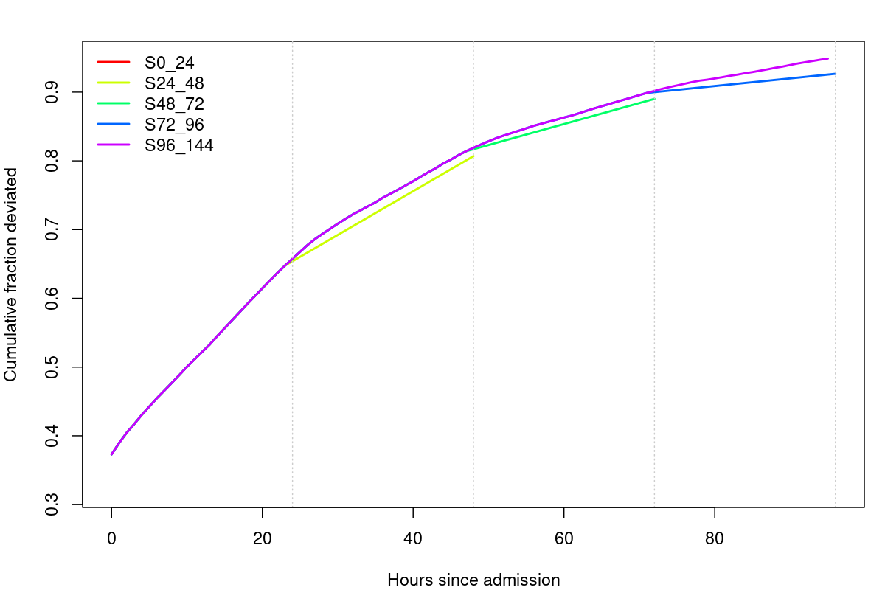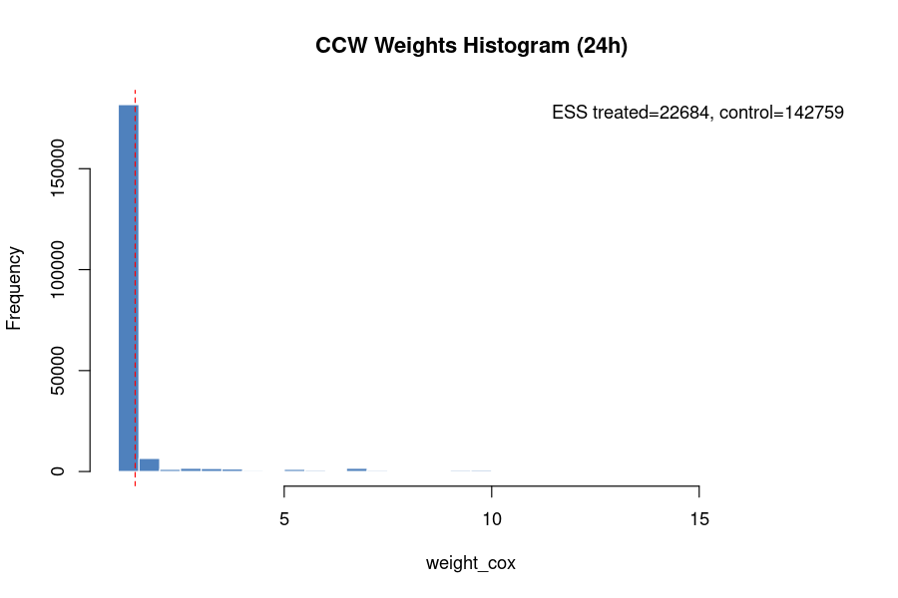
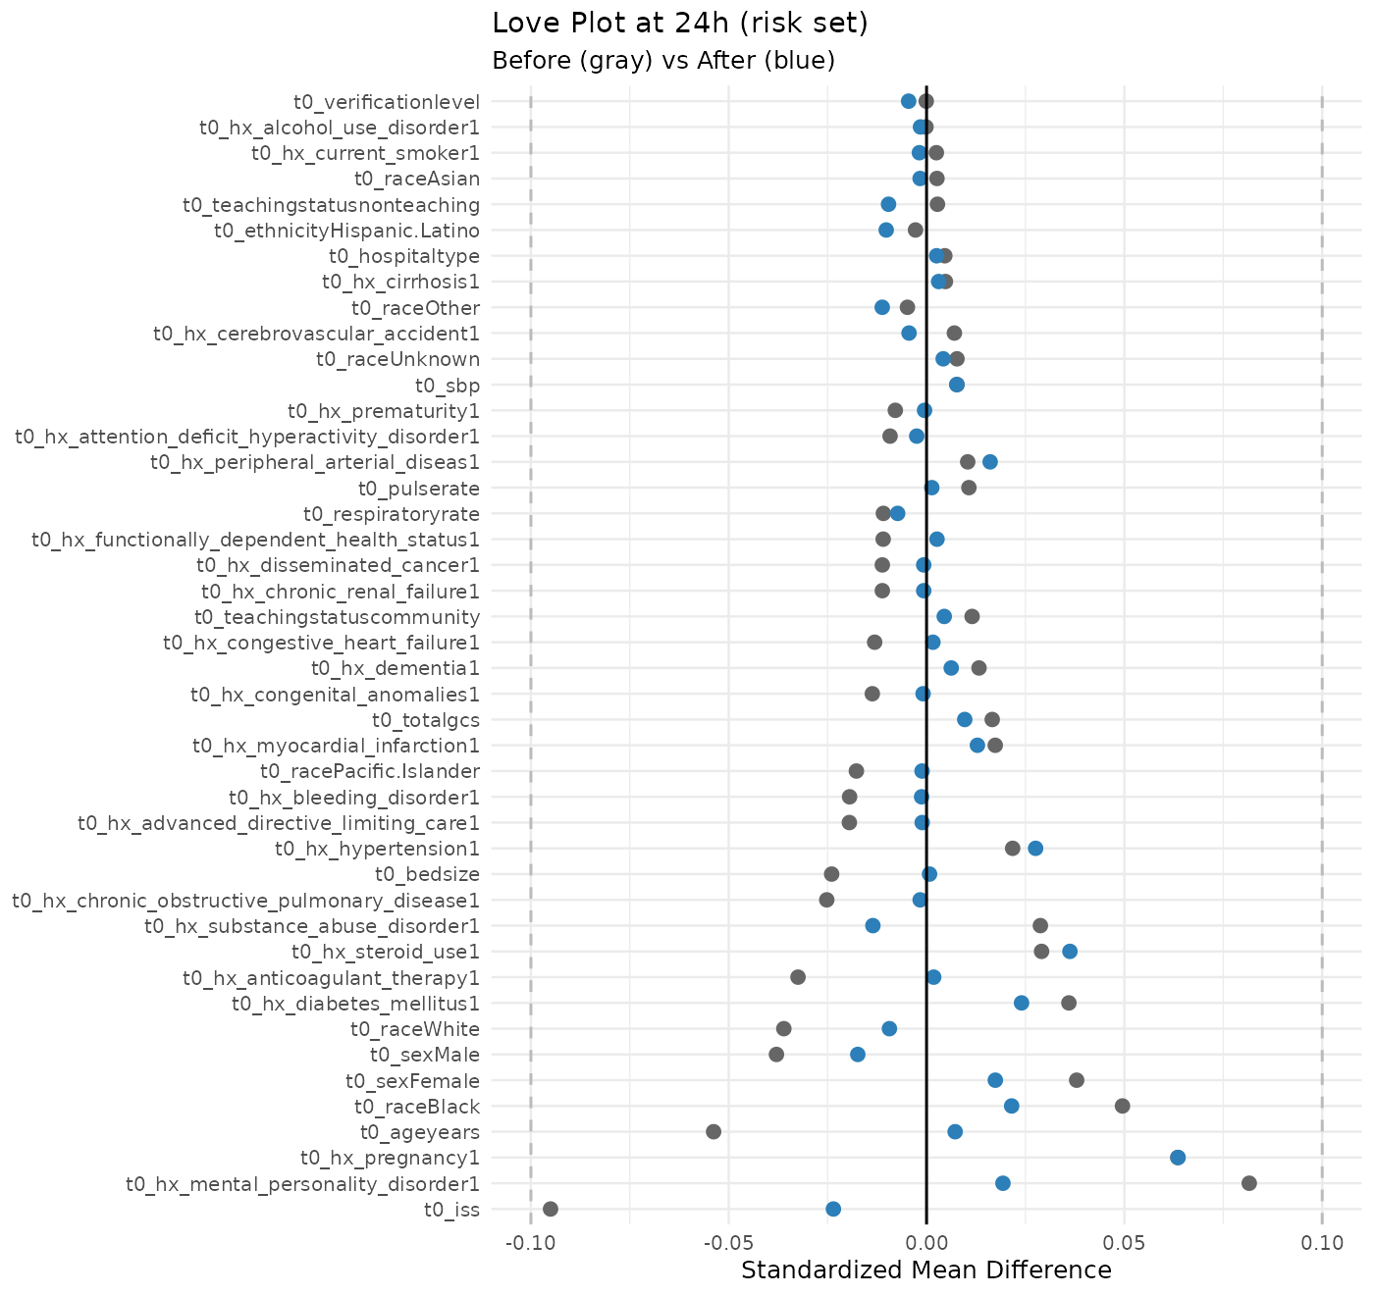

Supplementary Figure 4. K-means Cluster Diagnostics

