Supplementary Materials for
“Intertwined charge density wave order in vanadium based kagome superconductors”

Kuanglv Sun^{1‡}, Linpeng Nie^{1‡}, Hongyu Li¹, Jiyin Zhao¹, Huachen Rao¹, Fanghang Yu¹, Mengzhu Shi¹, Ziji Xiang¹, Jianjun Ying^{2,3}, Zhenyu Wang^{2,3}, Tao Wu^{1,2,3,4,5*} and Xianhui Chen^{1,2,3,4,5*}
1. Hefei National Research Center for Physical Sciences at the Microscale, University of Science and Technology of China, Hefei, Anhui 230026, China
2. CAS Key Laboratory of Strongly coupled Quantum Matter Physics, Department of Physics, University of Science and Technology of China, Hefei, Anhui 230026, China
3. CAS Center for Excellence in Superconducting Electronics (CENSE), Shanghai 200050, China
4. Collaborative Innovation Center of Advanced Microstructures, Nanjing University, Nanjing 210093, China
5. Hefei National Laboratory, University of Science and Technology of China, Hefei 230088, China
‡These authors contributed equally to this work
*Correspondence to: wutao@ustc.edu.cn, chenxh@ustc.edu.cn

This PDF file includes:
S1. Comparison the magnitude relation between A_{1g} and E_{2g} in different groups’ result
S2. Geometry-dependent elastoresistance coefficient ${d(∆R/R)}_{yy}/dε_{xx}$
S3. The elastoresistance results of uniaxial strain device
S4. The elastoresistance results of Modified Montgomery method
S5. The discussion of peak structure at T_{CDW}
S6. Determination of T* by ${{d\left(ΔR/R\right)}_{xx}}/{dε_{xx}}$ and ${{d(dR}_{xx}}/{dε_{xx})/dT}$
S7. The evolution of residual resistance ratios (RRRs)
S8. The sign of charge stripe in Sn-doped case
S9. Understanding of elastoresistance behavior in Triple-Q CDW by scalar order parameters
S10. Strain transmission of PZT stacks

S1. Comparison the magnitude relation between A_{1g} and E_{2g} in different groups’ result

Groups | Method | A_{1g}/E_{2g} (80K)
T. Asaba et al. | Two-bar | ~ 2
T. Asaba et al. | Montgomery | ~ 2
Zhaoyu Liu et al. | Two-bar | ~ 2.4
Zhaoyu Liu et al. | Montgomery | ~ 5.3
Mehdi Frachet et al. | Two-bar | ~ 10
Our group | Two-bar | ~ 1-6
Our group | Montgomery | ~ 5

Supplementary Table 1. Comparison of different groups elastoresistance results [1–3]. The magnitude relation between A_{1g} and E_{2g} is compared at 80 K, to avoid additional responses at T* or T_{CDW}. There is a significant difference in results of magnitude relation among different groups, in which some groups results are 2 times, and some groups results are 10 times. Hence, it is necessary to repeat elastoresistance measurements, especially two-bar method.

S2. Geometry-dependent elastoresistance coefficient ${d(∆R/R)}_{yy}/dε_{xx}$

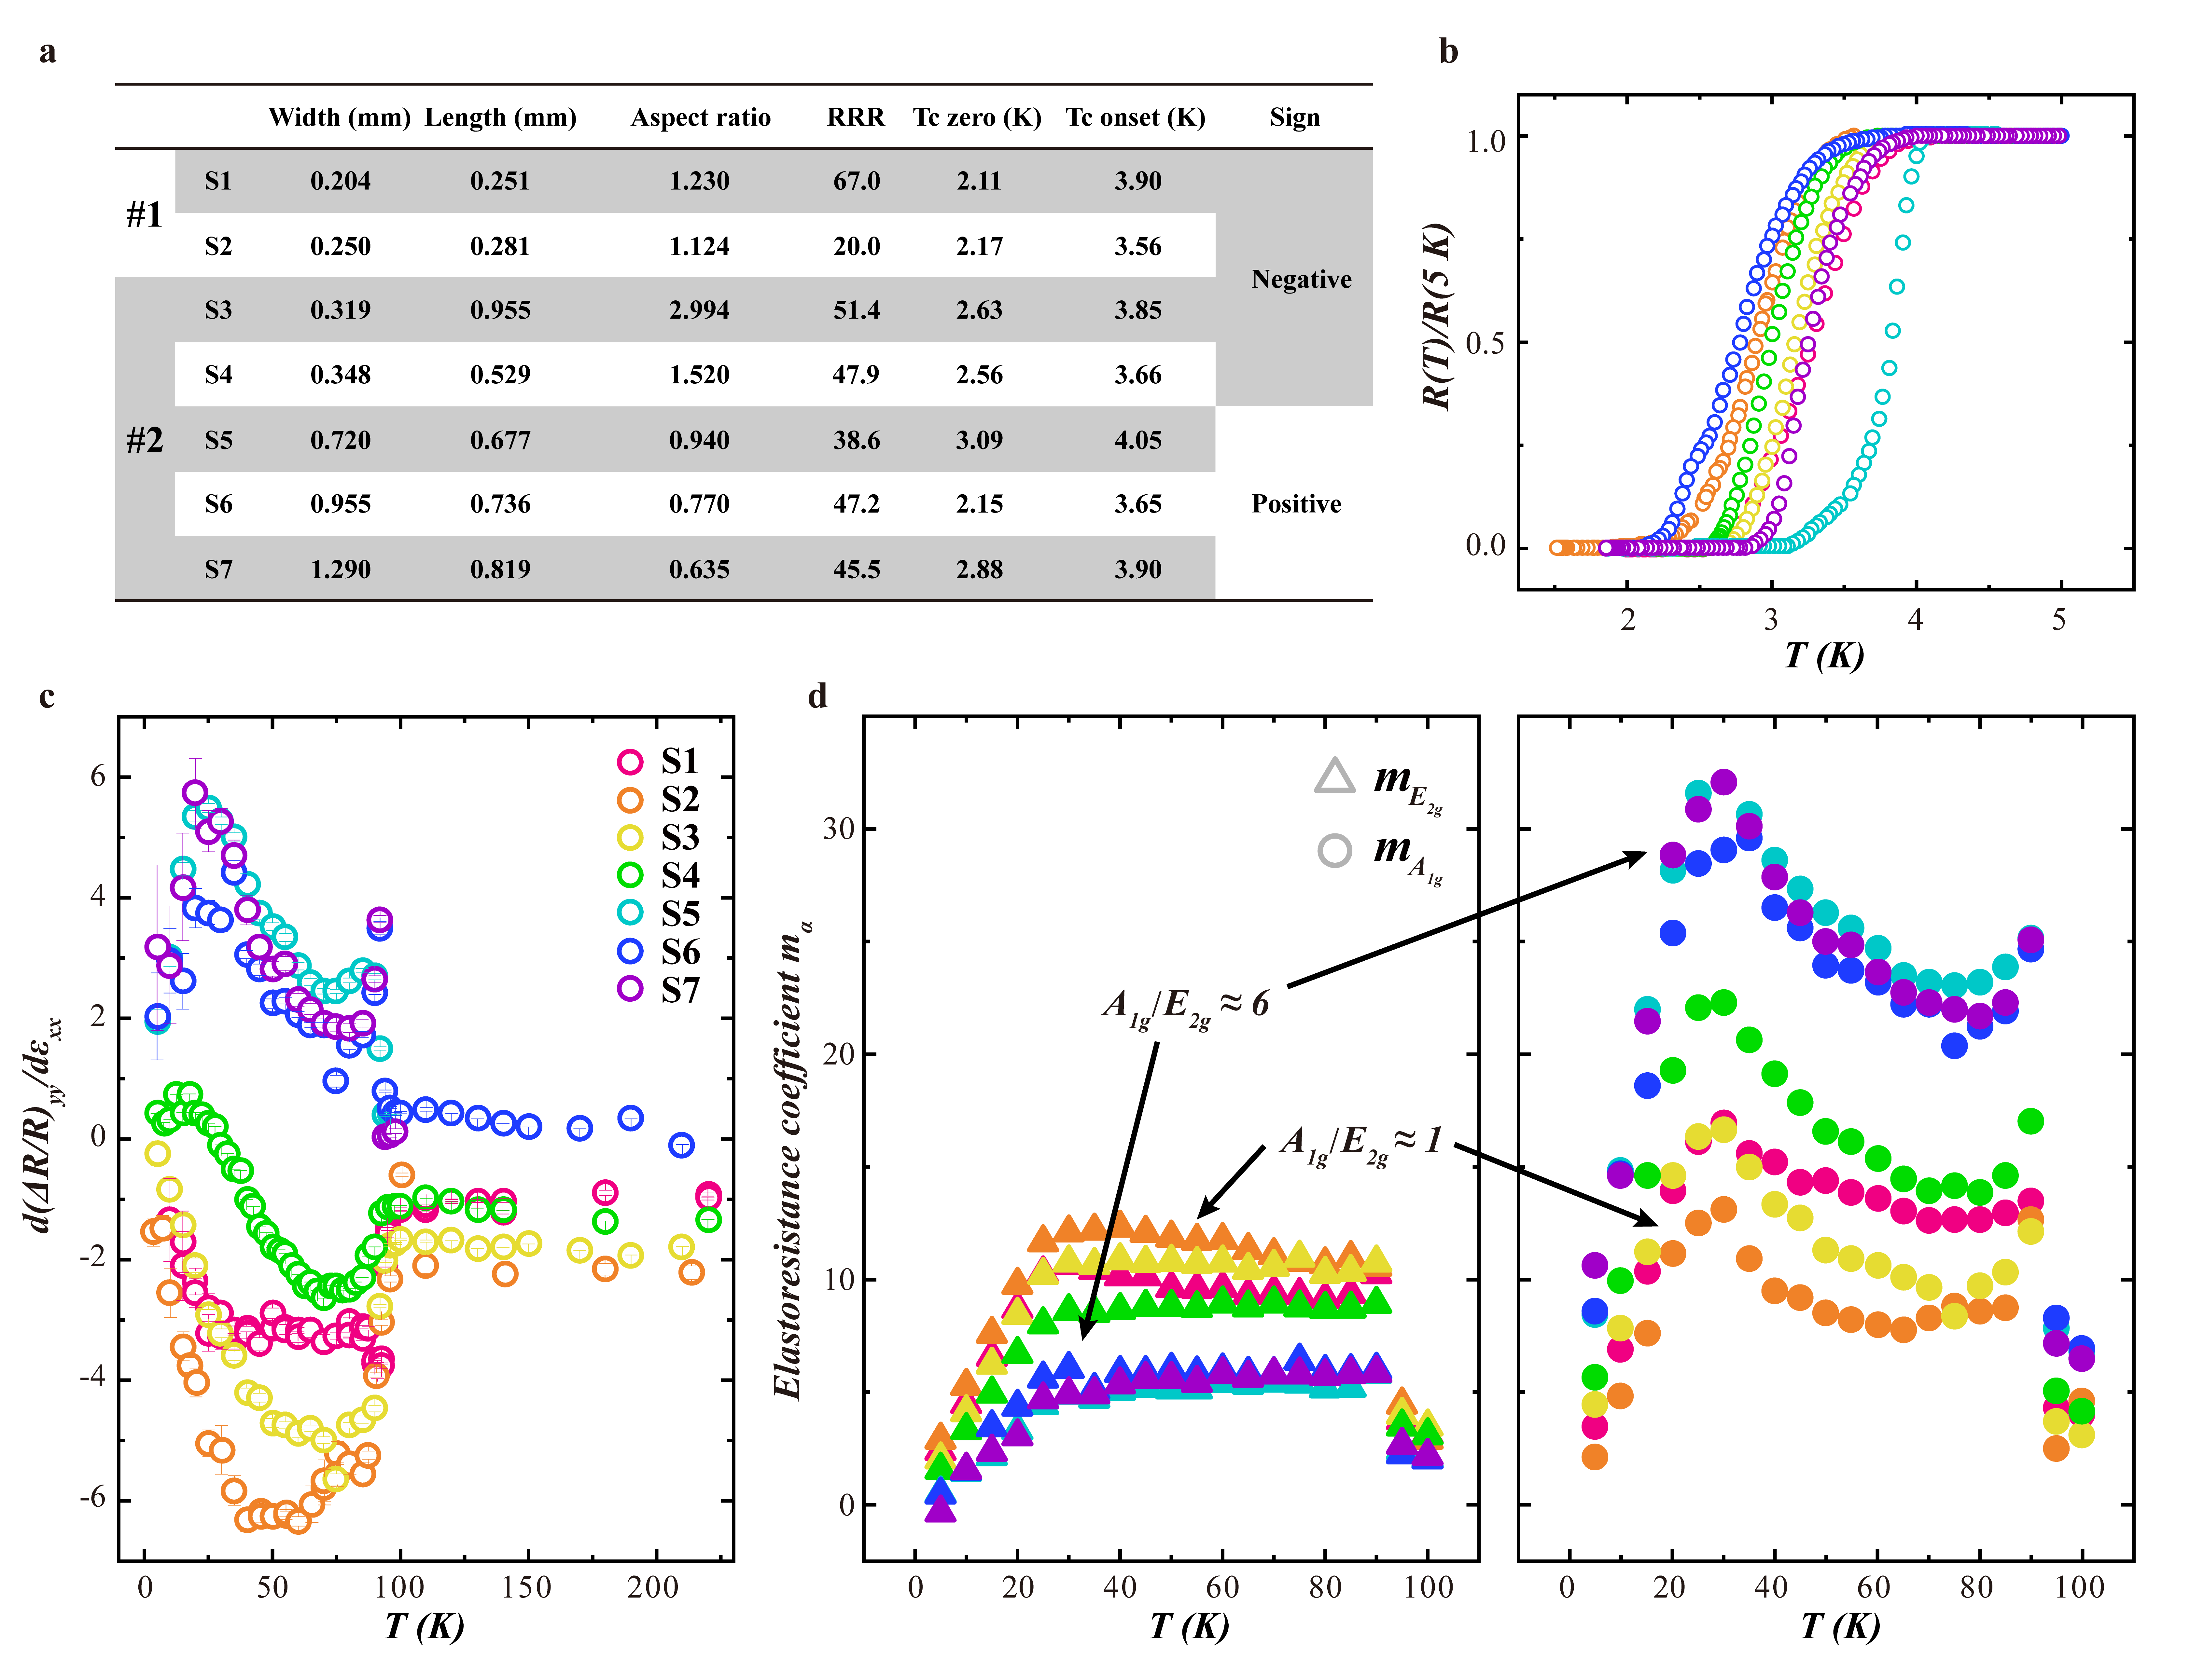
Supplementary Figure 1. Two-bar method for pristine CsV₃Sb₅ with different aspect ratio. a, Detail information for all the samples is listed as a table, with sample width, length between two voltage measurement electrodes, residual resistivity ratio (RRR), Tc-zero, Tc-onset and the sign of the elastoresistance coefficient in the y direction, where #1 and #2 represent different sample batches. b, Renormalized resistance R(T)/R(5K) for different samples glued on PZT stack. c, Elastoresistance coefficient ${d(∆R/R)}_{yy}/dε_{xx}$ for different samples. The error bars attached on each point are the standard deviation from the linear fitting. d, E_{2g} and A_{1g} elastoresistance response for different samples, which is calculated with the same ${d(∆R/R)}_{xx}/dε_{xx}$ presented in the main text. When the aspect ratio is large (sample shape like a bar or stick), ${{d\left(ΔR/R\right)}_{yy}}/{dε_{xx}}$ is a negative value, leading A_{1g} is comparable with E_{2g} and both A_{1g} and E_{2g} slightly increase below T_{CDW} (yellow and orange circle). In contrast, when the aspect ratio is smaller (sample shape like a square), ${{d\left(ΔR/R\right)}_{yy}}/{dε_{xx}}$ is a positive value, leading A_{1g} dominantly increases and E_{2g} is nearly temperature-independent (blue and purple circle). Quantitatively, the different sign of ${{d\left(ΔR/R\right)}_{yy}}/{dε_{xx}}$ lead to 1-6 times difference in the magnitude relation between A_{1g} and E_{2g}. The different sign of ${d(∆R/R)}_{yy}/dε_{xx}$ could be attributed to the nonideal glue condition (see Method for formula explanation). To avoid possible strain inhomogeneity, we further perform elastoresistance measurement via a uniaxial strain device, which could provide more accurate and stable strain.

S3. The elastoresistance results of uniaxial strain device

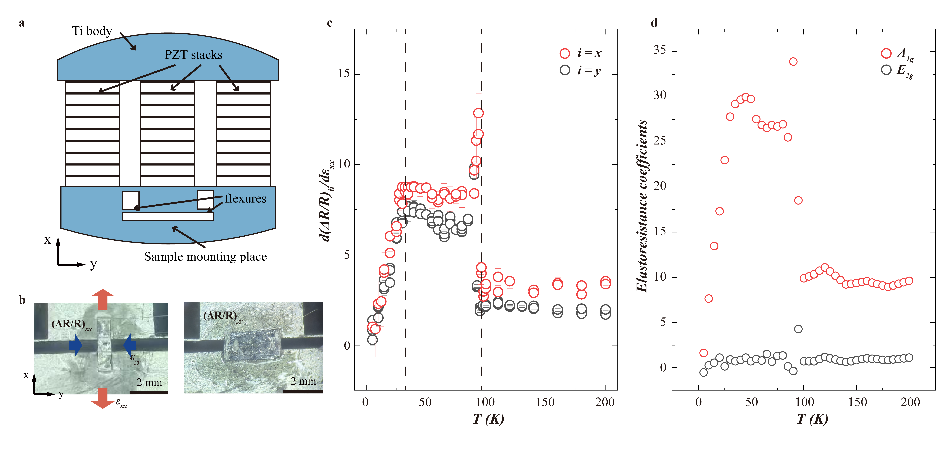
Supplementary Figure 2. Elastoresistance measured by uniaxial strain device. a, Diagram of uniaxial strain device. b, Photograph of the experimental setup for transverse and longitudinal elastoresistance measurements. c, Temperature dependence of Elastoresistance coefficients ${{d\left(ΔR/R\right)}_{xx}}/{dε_{xx}}$ and ${{d\left(ΔR/R\right)}_{yy}}/{dε_{xx}}$ measured by uniaxial-strain device. ${{d\left(ΔR/R\right)}_{yy}}/{dε_{xx}}$ presents positive values which is similar to the sample with smaller aspect ratio in two-bar method, indicating the result of sample with smaller aspect ratio in two-bar method is more intrinsic. d, Temperature dependence of A_{1g} and E_{2g} responses measured by uniaxial-strain device. The magnitude relation between A_{1g} and E_{2g} is too large (~20) comparing with other groups, probably owing to we measure ${{d\left(ΔR/R\right)}_{xx}}/{dε_{xx}}$ and ${{d\left(ΔR/R\right)}_{yy}}/{dε_{xx}}$ in two separate sample. To obtain the precise magnitude relation between A_{1g} and E_{2g}, we further check the elastoresistance in one sample via Montgomery method.

S4. The elastoresistance results of Modified Montgomery method

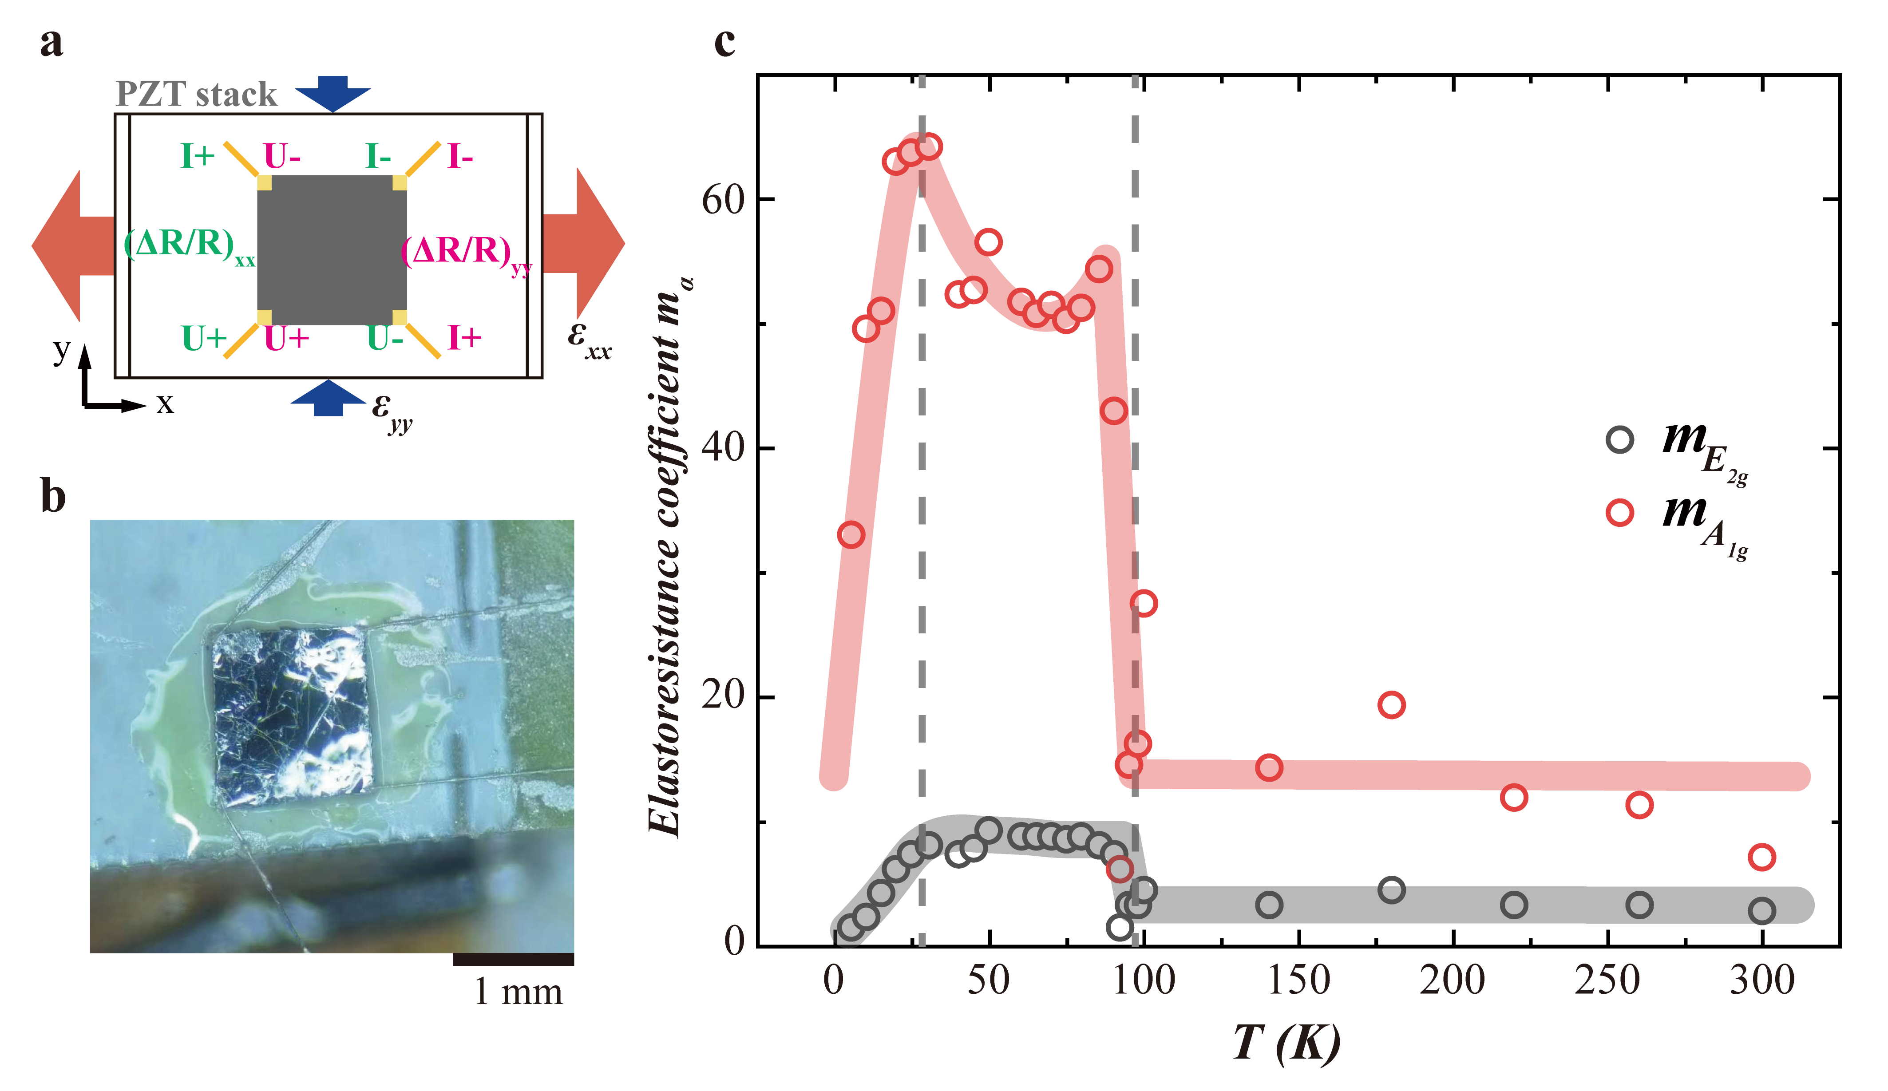
Supplementary Figure 3. Modified Montgomery method. a, Schematic diagram of the modified Montgomery method. b, Photograph of the piezoelectric stack with a square CsV₃Sb₅ single crystal glued on its surface. Sample length L_{x} = 1.25 mm, width L_{y} = 1.33 mm, and thickness L_{z} = 0.015 mm. c, A_{1g} and E_{2g} symmetry elastoresistivity responses calculated by the Montgomery method. Both A_{1g} and E_{2g} symmetry present a jump at T_{CDW} and a decrease at T*. Below T_{CDW}, E_{2g} maintains a constant, while A_{1g} dominantly increase. Quantitatively, A_{1g} is around 5 times larger than E_{2g}, which is consistent with the results of smaller aspect ratio sample in Two-bar method.

S5. The discussion of peak structure at T_{CDW}

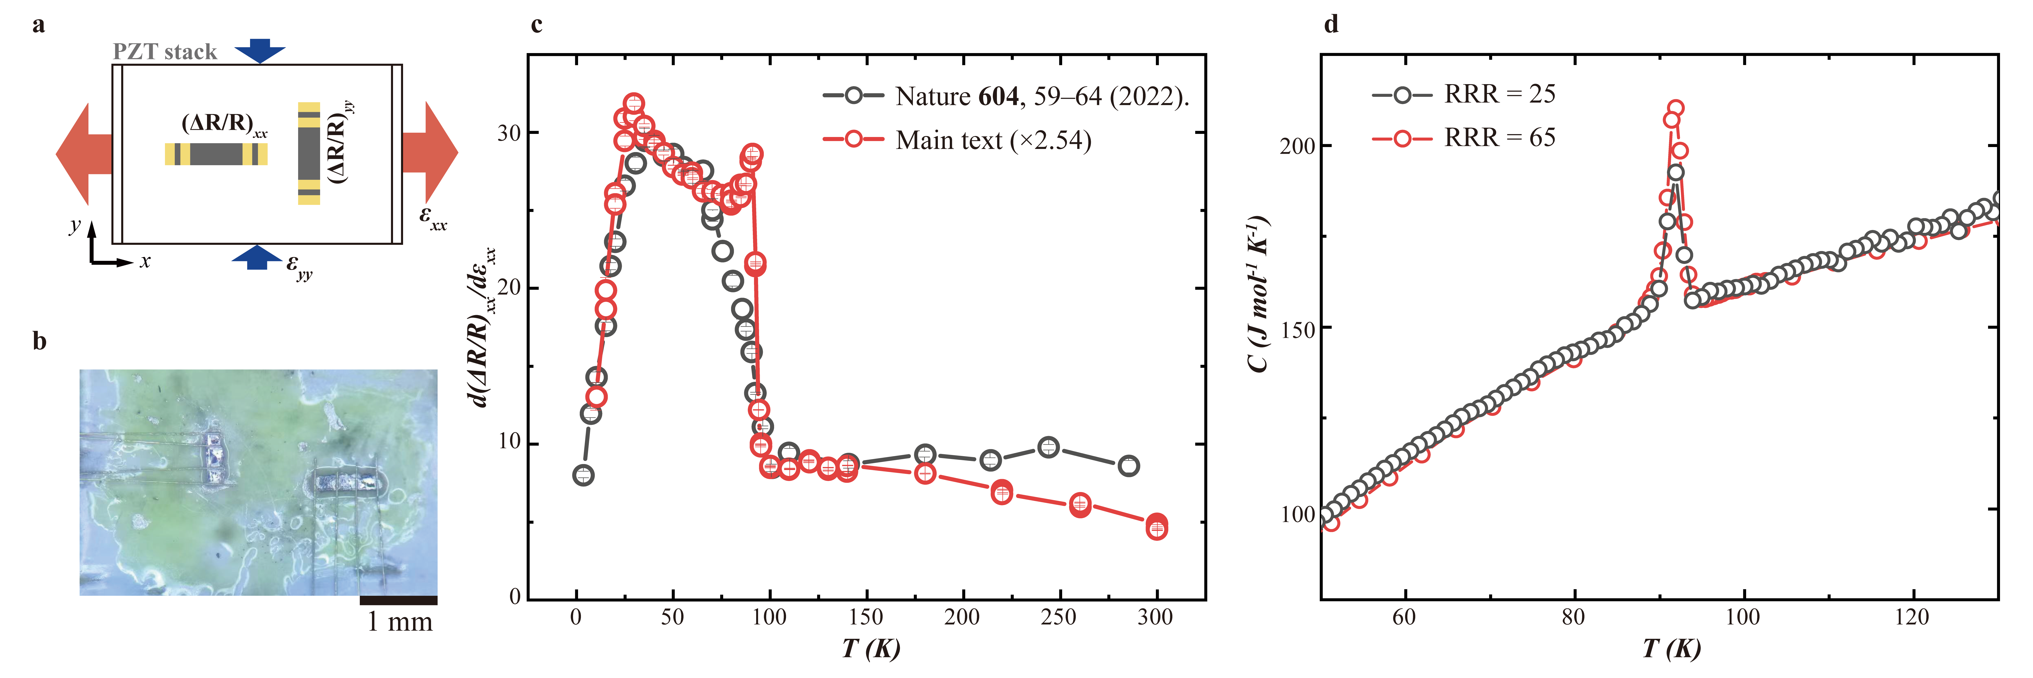
Supplementary Figure 4. The possible effect of strain inhomogeneity in different measurements with the two-bar method. a, Schematic diagram of the two-bar method. b, Picture of the piezoelectric stack with a two-bar CsV₃Sb₅ single crystal glued on its surface. c, Comparison of elastoresistance responses for E_{2g} symmetry. The black hollow circle is quoted from Ref [4], and the red hollow circle is illustrated in the main text. For better comparison, we multiplied the data from the main text by 2.4, which is related to the difference in strain conditions. The error bars attached on each point are the standard deviation from the linear fitting. These two results both present a decrease at approximately 35 K, and the obvious difference is the discontinuous jump at T_{CDW}. d, Heat capacity for the CsV₃Sb₅ single crystal with different residual resistivity ratios (RRRs). The heat capacity jump at T_{CDW} for RRR = 25 (black hollow circle) is similar and comparable to that in the sample with RRR = 65 (red hollow circle), suggesting the same quality in these samples with different RRR. Since elastoresistance measures thermodynamic quantity, the singularity part in heat capacity could explain the discontinuous jump in elastoresistance coefficients. Hence, the absence of a discontinuous jump at T_{CDW} in Ref [4] should not be simply related to sample quality. On the other hand, sample thickness and gluing conditions could lead to different strain inhomogeneities, which would strongly affect the discontinuous jump in elastoresistance (see the discussion in the main text). This might also be the reason for the different values of RRR.

S6. Determination of T* by ${{d\left(ΔR/R\right)}_{xx}}/{dε_{xx}}$ and ${{d(dR}_{xx}}/{dε_{xx})/dT}$
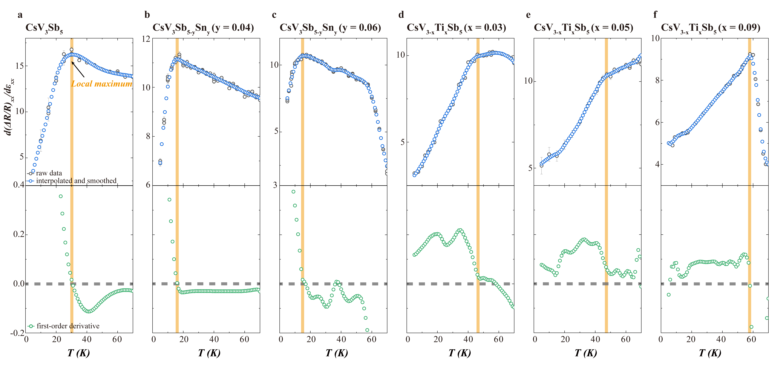
Supplementary Figure 5. Determination of T* by ${{d\left(ΔR/R\right)}_{xx}}/{dε_{xx}}$. a – f is the determination of T* for pristine CsV₃Sb₅, CsV₃Sb_{5-y}Sn_{y} (y = 0.04 and 0.06) and CsV_{3-x}Ti_{x}Sb₅ (x = 0.03, 0.05 and 0.09), respectively. In each upper panel, raw data (black circle) are interpolated and smoothed (blue circle), and their first-order derivate (green circle) is illustrated in the corresponding lower panel. We define the local maximum as T*, where the first-order derivative equals zero (marked by a yellow solid line). This definition is explicit for pristine CsV₃Sb₅ and its Sn-doped cases. However, in Ti-doped cases, a rounded stage appears around the local maximum, owing to the mixture contribution from electronic instability and first-order transition. In this condition, a local maximum, where the slope is opposite on both sides, could be changed into an inflection point, where the slope is discontinuous on both sides. Hence, we define T* as the temperature where the slope is suddenly changed for Ti-doped cases. The error bar is defined by the minimum temperature spacing around the local maximum.

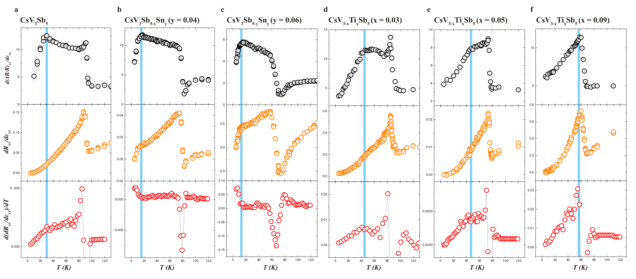
Supplementary Figure 6. Determination of T* by ${{d(dR}_{xx}}/{dε_{xx})/dT}$. a – f is the determination of T* via ${{d(dR}_{xx}}/{dε_{xx})/dT}$ for pristine CsV₃Sb₅, CsV₃Sb_{5-y}Sn_{y} (y = 0.04 and 0.06) and CsV_{3-x}Ti_{x}Sb₅ (x = 0.03, 0.05 and 0.09), respectively. Upper panel (black circle) in each column represents ${{d\left(ΔR/R\right)}_{xx}}/{dε_{xx}}$, and we can define an inflection point at T* as shown in Supplementary Figure 5. Middle panel (yellow circle) represents ${{dR}_{xx}}/{dε_{xx}}$, which is the raw data of elastoresistance, without normalization of R or (R-R₀). For clarity, we scale ${{dR}_{xx}}/{dε_{xx}}$ to 0 at 0 K and to 1 at 300 K. And lower panel (red circle) represents corresponding ${{d(dR}_{xx}}/{dε_{xx})/dT}$, in which we can clearly resolve an inflection point (indicated by blue solid line) at T*. These findings prove that the determination of T* is independent with normalization.

S7. The evolution of residual resistance ratios (RRRs)

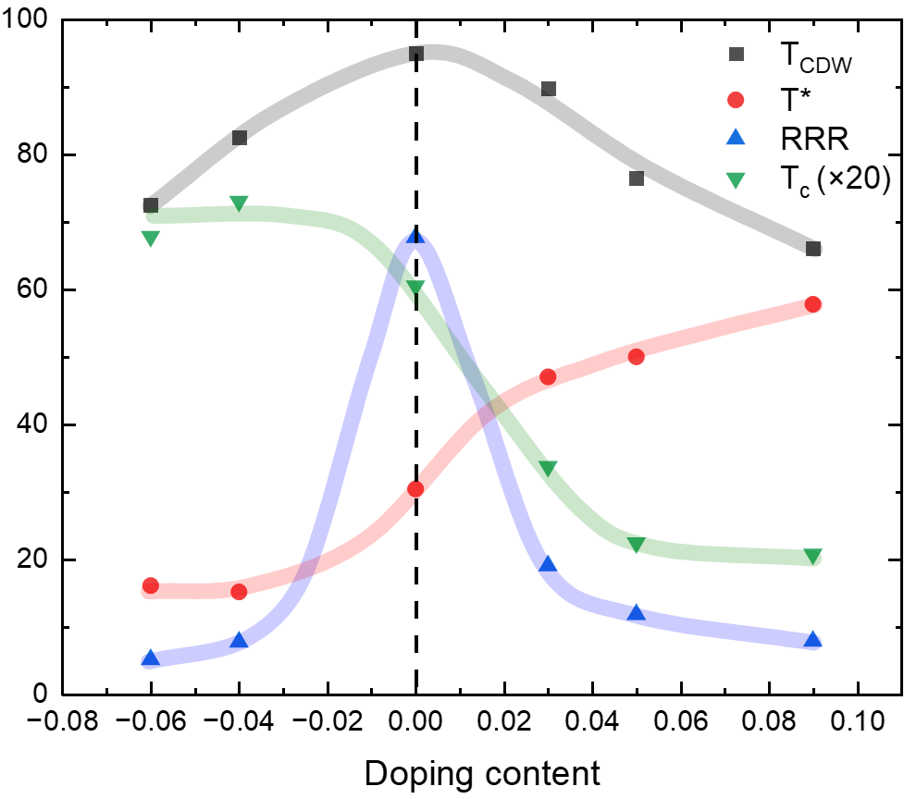

Supplementary Figure 7. The evolution of residual resistance ratios (RRRs) for CsV₃Sb₅ and Ti/Sn-doped CsV₃Sb₅ samples. Characterized temperature T_{CDW}, T*, Tc and Residual Resistance Ratios (RRRs) in hole-doped CsV3Sb5. Negative doping value indicates Sn doped and positive value indicates Ti doped. The evolution of T_{CDW} and T* is not related to RRR.

S8. The sign of incommensurate charge stripes in Sn-doped case

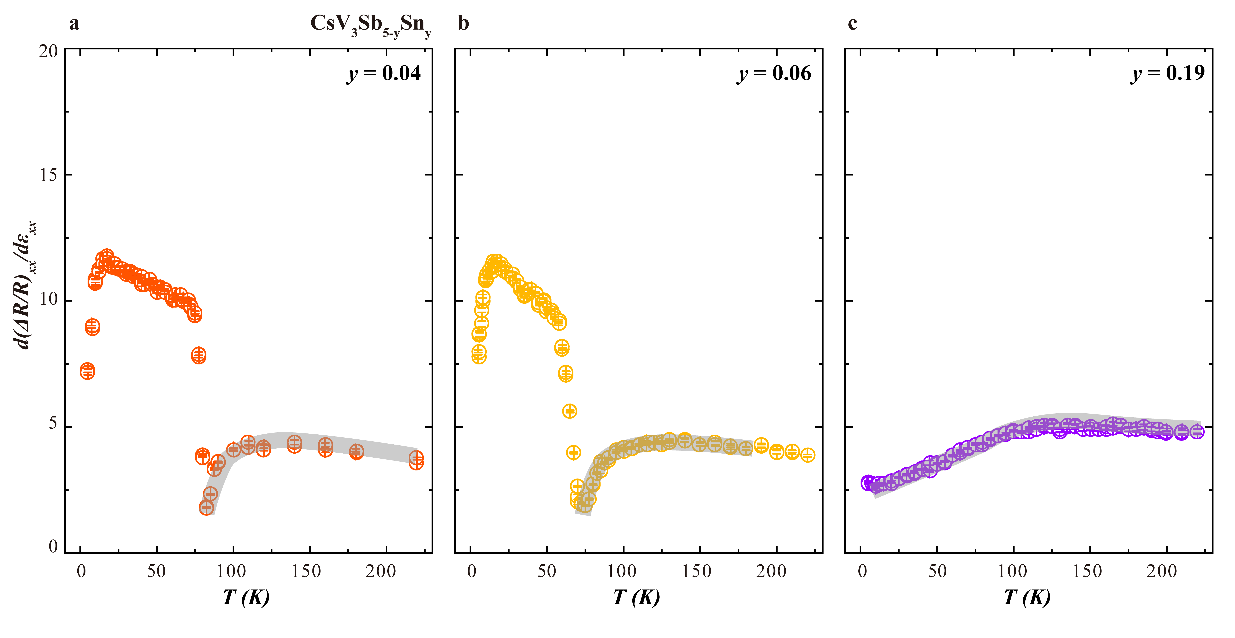
Supplementary Figure 8. Elastoresistance coefficient ${{d\left(ΔR/R\right)}_{xx}}/{dε_{xx}}$ for CsV₃Sb_{5-y}Sn_{y} (y = 0.04, 0.06 and 0.19). All three panels use the same scale. Data for y = 0.04 and y = 0.06 are reproduced from Fig. 2 of the main text. The solid gray lines serve as guides to the eye. The Sn-doped samples exhibit a notable temperature-dependent behavior near the charge density wave transition temperature T_{CDW}, as indicated by the gray lines. Above T_{CDW}, the elastoresistance response shows a negative deviation from the high-temperature baseline, which is dominated by geometric effects. This contrasts with the positive response observed below T_{CDW}. To further investigate this negative response, we measured a higher doping concentration (y = 0.19), which exhibits a negative elastoresistance across the entire temperature range. X-ray measurements on the y = 0.15 Sn-doped sample suggest that this negative response may be associated with incommensurate charge stripes. Within this framework, the negative responses for y = 0.04 and 0.06 can be interpreted as an emerging incommensurate charge stripe order that is truncated by the formation of a triple-Q CDW phase (positive response).

S9. Understanding of elastoresistance behavior in Triple-Q CDW by scalar order parameters

In Methods section, we constructed a free energy based on the M and L unstable phonon modes, focusing on a specific CDW pattern such as the staggered trihexagonal CDW phase. While considering all six order parameters is useful for investigating a particular CDW pattern, the coupling of multiple order parameters complicates the mathematical analysis and obscures the physical picture when studying complex temperature-dependent behaviors.

To focus on the universal behavior of elastoresistance, we introduce a single scalar order parameter, $η_{l}$. For simplicity, this scalar order parameter is not predefined as symmetric or asymmetric. From a parity perspective, strain describes displacement (even parity), and the order parameter $η_{l}$, which describes triple-Q CDW (charge quantity), is also even parity. Similarly, resistivity measurements involving voltage and current are even-parity quantities. Therefore, $η_{l}$ is directly proportional to the resistivity.

The elastoresistance response, defined as $m_{ij}={∂{(∆R/R)}_{i}}/∂ε_{j}$, is proportional to the susceptibility $χ=∂η_{l}/∂ε$, i.e., the derivative of the order parameter with respect to the strain field. To simulate a first-order triple-Q CDW transition, a third-order term is included in the free energy:
$F=αη_{l}^{2}+βη_{l}^{4}+γη_{l}^{3}$.

The form of strain coupling plays a key role in determining the elastoresistance behavior. Since both strain and $η_{l}$ are even-parity quantities, two main coupling forms are allowed: bilinear coupling $\left(εη_{l}\right)$ and linear-quadratic coupling $\left(εη_{l}^{2}\right)$. As shown in Supplementary Figure 9, the elastoresistance response, expressed as the susceptibility $χ=∂η_{l}/∂ε$, is compared for these two coupling forms under both first- and second-order transitions.

Supplementary Figure 9. Temperature-dependent behavior of strain susceptibility $χ=∂η_{l}/∂ε$ for bilinear coupling $\left(εη_{l}\right)$ and linear-quadratic coupling $\left(εη_{l}^{2}\right)$, under first-order (black squares) and second-order (red circles) transitions. Left: bilinear coupling; Right: linear-quadratic coupling.

- For bilinear coupling, the strain acts as a conjugate field, directly inducing the order parameter. This leads to a Curie-Weiss behavior above the transition temperature, regardless of whether the transition is first or second order.
- For linear-quadratic coupling, the strain affects the second-order term, effectively shifting the critical temperature. In this case, no significant response is generally observed above T_{CDW}.
- Additionally, bi-quadratic coupling $\left(ε^{2}η_{l}^{2}\right)$ is always allowed irrespective of the order parameter’s parity. It behaves similarly to linear-quadratic coupling, since $ε^{2}$ or $ε$ acts as an effective field.

To best match our experimental results at T_{CDW} in CsV₃Sb₅, the linear-quadratic coupling $εη_{l}^{2}$ is a suitable choice. This model reproduces a temperature-independent behavior above T_{CDW}, a sharp peak just below T_{CDW}, and a recovery to temperature-independent behavior at lower temperatures. This coupling from also corresponds to Equation 17 in Method section.

Introduction of incipient electronic order

To account for the additional energy scale T*, which likely originates from electronic degrees of freedom, we introduce a second order parameter $η_{e}$. Experimental constraints allow us to construct a suitable free energy for $η_{e}$:

- Heat capacity and thermal expansion show no thermodynamic transition below T_{CDW}, suggesting that $η_{e}$ is not ordered at finite temperature. In this sense, we can treat $η_{e}$ as an incipient order with bare transition temperature at 0 K. This ensures that the heat capacity $C=-T{∂^{2}F}/{∂T^{2}}$ shows no anomaly below T_{CDW}, consistent with experiments (see Supplementary Figure 10).
- The kink-like feature at T* in elastoresistance measurements suggests that $η_{e}$ is even-parity and couples to strain via a bilinear term $εη_{e}$, because only bilinear coupling gives an increasing response above the critical temperature (0 K).
- Since both $η_{e}$ and $η_{l}$ are even-parity, the simplest time-reversal-invariant coupling is bilinear: $η_{l}η_{e}$.
- The nature of the electronic transition (first- or second-order) remains uncertain since $η_{e}$ does not fully order at finite temperature. Including a third-order term $η_{e}^{3}$ does not qualitatively change the T-dependent behavior of susceptibility.

Supplementary Figure 10. Temperature-dependent elastoresistance $χ=∂η_{e}/∂ε$ and corresponding heat capacity. Left: elastoresistance; Right: heat capacity.

We thus construct the following free energy including both the triple-Q CDW order ($η_{l}$) and the incipient electronic order ($η_{e}$):
$$F=α_{l}\left(T-T_{l}\right)η_{l}^{2}+{β_{l}η}_{l}^{4}+γ_{l}η_{l}^{3}+α_{e}\left(T-T_{e}\right)η_{e}^{2}+{β_{e}η}_{e}^{4}+γ_{e}η_{e}^{3}+gη_{l}η_{e}+λ_{l}εη_{l}^{2}+λ_{e}εη_{e}.$$
To match experimental data, we set $α_{l}={β_{l}=α}_{e}=β_{e}=1,$ $γ_{l}=γ_{e}=-2$, $λ_{l}=λ_{e}=-0.1$, $T_{l}=94$, and $T_{e}=0$. By now, the total elastoresistance response is a weighted sum:
$χ_{all}=m∂η_{l}/∂ε+n∂η_{e}/∂ε$,
where $m,n$ reflect the contribution of each order parameter to resistivity. We focus on the susceptibility of the electronic order $η_{e}$, by setting $m=0$ and $g=-10$. As shown in Supplementary Figure 10, a kink-like maximum at T* is constructed in $∂η_{e}/∂ε$. And the same parameters produce no heat capacity anomaly at T*.

In Figure 4 of the main text, by varying the coupling constant $g$, we can identify a characteristic temperature T* that manifests as either a local maximum or a kink-like feature in the response curve.
For the local maximum, T* is defined as the temperature at which the first derivative with respect to temperature is zero and the second derivative is negative. For the kink-like structure, which reflects an abrupt change in slope, T* is defined as the point where the third derivative with respect to temperature is zero and the fourth derivative is negative.

Understanding of Sn-doped results

Supplementary Figure 11. The simulated temperature-dependent elastoresistance, defined as $χ=∂η_{e}/∂ε$, for the Sn-doped case. The parameters used are: $α_{l}={β_{l}=α}_{e}=β_{e}=1,$ $γ_{l}=γ_{e}=-2$, $λ_{e}=-0.1$, $λ_{l}=0.1$, $T_{l}=94$, and $T_{e}=0$.

Using the scalar Ginzburg–Landau framework introduced above, we can also interpret the Sn-doped results. As shown in Fig. 2 of the main text, the elastoresistance of Sn-doped samples exhibits two main differences from the parent compound: the original positive peak at T_{CDW} is replaced by a negative dip, and above T_{CDW}, the response shows a gradually enhanced negative signal spanning over ∼20 K in the x = 0.06 case, rather than an abrupt jump in parent compound.
Within the Ginzburg–Landau picture, the sign reversal in the response can be captured by changing the sign of the strain coupling coefficient $λ_{l}$ associated with the triple-Q CDW order. Meanwhile, the gradual Curie–Weiss-like enhancement above T_{CDW} can be reproduced by including a bilinear strain coupling term of the form $λ_{l}εη_{l}$. Simulations based on this modified coupling form show good qualitative agreement with the experimental data, as shown in Supplementary Figure 11.

Understanding of T*

As demonstrated earlier, T* manifests in the simulated $∂η_{e}/∂ε$ as either a local maximum or a kink-like feature. This behavior arises from two contributions to $η_{e}$: one stems from the intrinsic electronic instability associated with its incipient order near 0 K, and the other is induced through bilinear coupling with the gradually developing CDW order parameter $η_{l}$.
From the perspective of the E_{2g} symmetry channel, the triple-Q CDW order $η_{l}$ inherently breaks rotational symmetry, leading to a C₂-symmetric state. The incipient electronic order $η_{e}$ further enhances this C₂ anisotropy, revealed by STM and QPI measurements. Our Ginzburg-Landau model successfully captures this physical picture.
Regarding the relative magnitudes of the A_{1g} and E_{2g} responses, the A_{1g} signal is approximately five times larger than that of E_{2g}. The relatively weak E_{2g} response underscores the robust and stable anisotropic nature of the system: the C₂-symmetric electronic state is so well established that it becomes less susceptible to additional symmetry-breaking strain perturbations, resulting in a lower strain susceptibility within the E_{2g} channel.

Numerical methods

In above calculation, due to the first-order nature of the phase transition and the non-linear coupling, the equilibrium order parameter and susceptibility are difficult to solve analytically. Instead, we use numerical methods to find the free energy minimum.
A simple numerical procedure is implemented as follows:
- With strain set to zero, use the FindMinimum function to obtain the equilibrium order parameter $φ(0)$.
- Repeat the process with a small strain value $ε_{0}$ to obtain$φ\left(ε_{0}\right)$.
- Calculate the susceptibility numerically as:
$$χ=\frac{∂φ}{∂ε}=\frac{ φ\left(ε_{0}\right)-φ(0)}{ε_{0}}.$$

Summary

In short, although this phenomenological free energy does not capture all microscopic details of the triple-Q CDW, it successfully describes the first-order transition at T_{CDW} and the kink at T* within a mean-field framework, confirming its utility for modeling the observed elastoresistance behavior.

S10. Strain transmission of PZT stacks

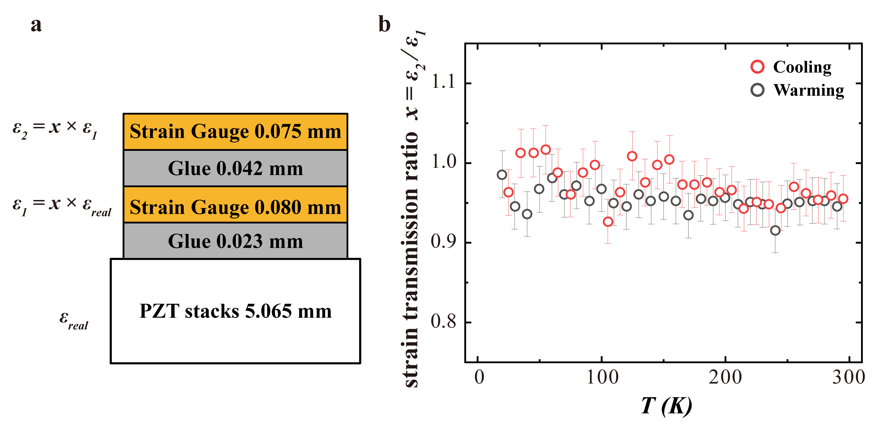
Supplementary Figure 12. Temperature dependence of the strain transmission of PZT stacks. a, Schematic diagram of the side view of the strain transmission test configuration. The first strain gauge is glued on the top of the PZT stacks, and the second strain gauge is glued on the first gauge. The thickness of the PZT stacks, strain gauges and glue can be measured. Assuming the strain transmission ratio of the glue is a constant x (0 < x < 1) and the ideal strain applied by PZT stacks is ε_{real}, the strain detected by the first strain gauge is ε₁ = x ε_{real}, and the strain detected by the second strain gauge is ε₂ = x ε₁. Hence, the strain transmission ratio is given as x = ε₂/ε₁, which is 1 for perfect transmission and 0 for no transmission. b, The temperature dependence of the strain transmission ratio measured during a cooling and warming cycle. In the whole temperature region, there is good (≥ 90%) strain transmission that shows a small temperature dependence. Below 80 K, the strain transmission ratio x is larger than 1, which is attributed to the small temperature dependence of the gauge factor. The gauge factor provided by the manufacturer is given as 1.96 with 2% error. In the main text, we take the gauge factor as 2 for simplicity. The error bar attached to each point indicates the gauge factor error.

Supplementary References

1. Frachet, M. et al. Colossal c -Axis Response and Lack of Rotational Symmetry Breaking within the Kagome Planes of the CsV₃Sb₃ Superconductor. Phys. Rev. Lett. 132, 186001 (2024).
2. Liu, Z. et al. Absence of E_{2g} Nematic Instability and Dominant A_{1g} Response in the Kagome Metal Cs₃Sb₅. Phys. Rev. X 14, 031015 (2024).
3. Asaba, T., Onishi, A. & Kageyama, Y. Evidence for an odd-parity nematic phase above the charge-density-wave transition in a kagome metal. Nat. Phys. 20, 40–46 (2024).
4. Nie, L. et al. Charge-density-wave-driven electronic nematicity in a kagome superconductor. Nature 604, 59–64 (2022).
5. Chu, J.-H., Kuo, H.-H., Analytis, J. G. & Fisher, I. R. Divergent nematic susceptibility in an iron arsenide superconductor. Science 337, 710–712 (2012).

