Supporting materials
Fig. S1-S7

Supplementary Fig. S1. Back scattering electron images of Fe-0.2C (left) and Fe-1.7C (right).

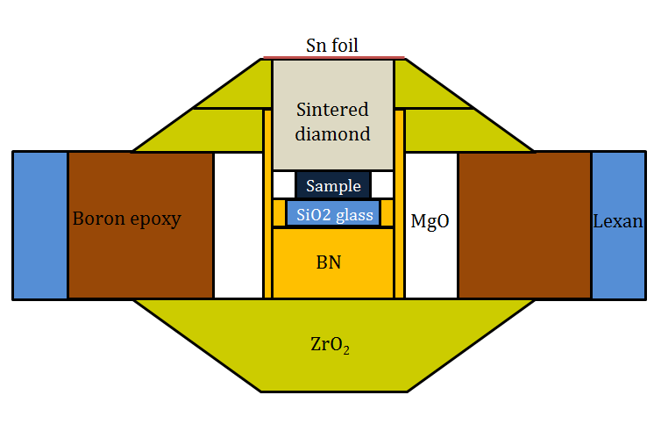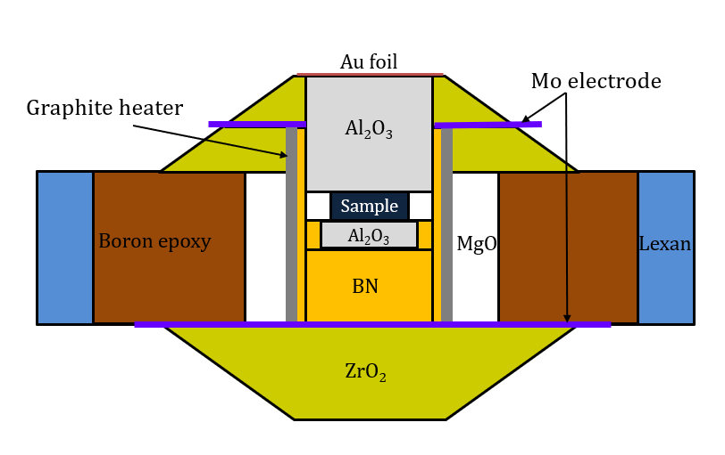
Supplementary Fig. S2. High-pressure PE cell assembly for acoustic velocity measurements of Fe and Fe-C alloys. Up: room temperature cell; Down: high-temperature cell.

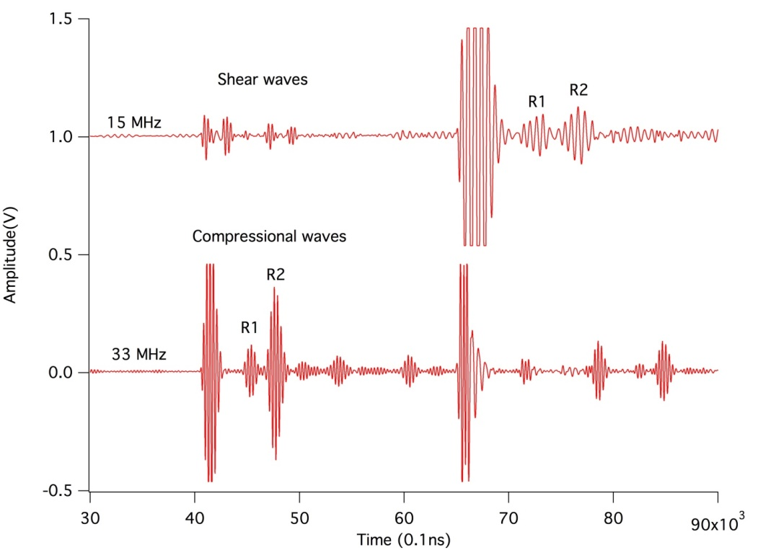
Supplementary Fig. S3. Representative V_{P} and V_{S} signals at 3.5 GPa and 1200 K. R₁ and R₂ signals represent reflected acoustic waves at the interfaces of the sample and alumina rods.

Synchrotron Mӧssbauer spectroscopy (SMS)
The SMS spectra of ⁵⁷Fe-enriched Fe-0.2C sample were collected at beamline 16ID-D, APS, ANL. The incident X-ray beam with a monochromatic energy of 14.41 keV and a bandwidth of 2 meV was focused to 5 × 7 µm in the Full width at half maximum (FWHM) on the sample position to excite ⁵⁷Fe nuclei. An avalanche photodiode detector (APD) was employed to collect the time-delayed SMS signals in the forward direction with a collection time of about 3–4 hours for each pressure datapoint. Pressure was calibrated before and after each measurement using the fluorescence of ruby with an uncertainty of 0.1–0.4. A platelet of the Fe-0.2C sample with a thick of ~70 μm was loaded into the sample chamber of Re gasket in a symmetric DAC. The diamond anvil culet size was 500 μm. Silicon oil served as a pressure-transmitting medium. Mössbauer hyperfine parameters, including quadrupole splitting and magnetic hyperfine field of the Fe-0.2C sample were derived using the CONUSS program ¹.
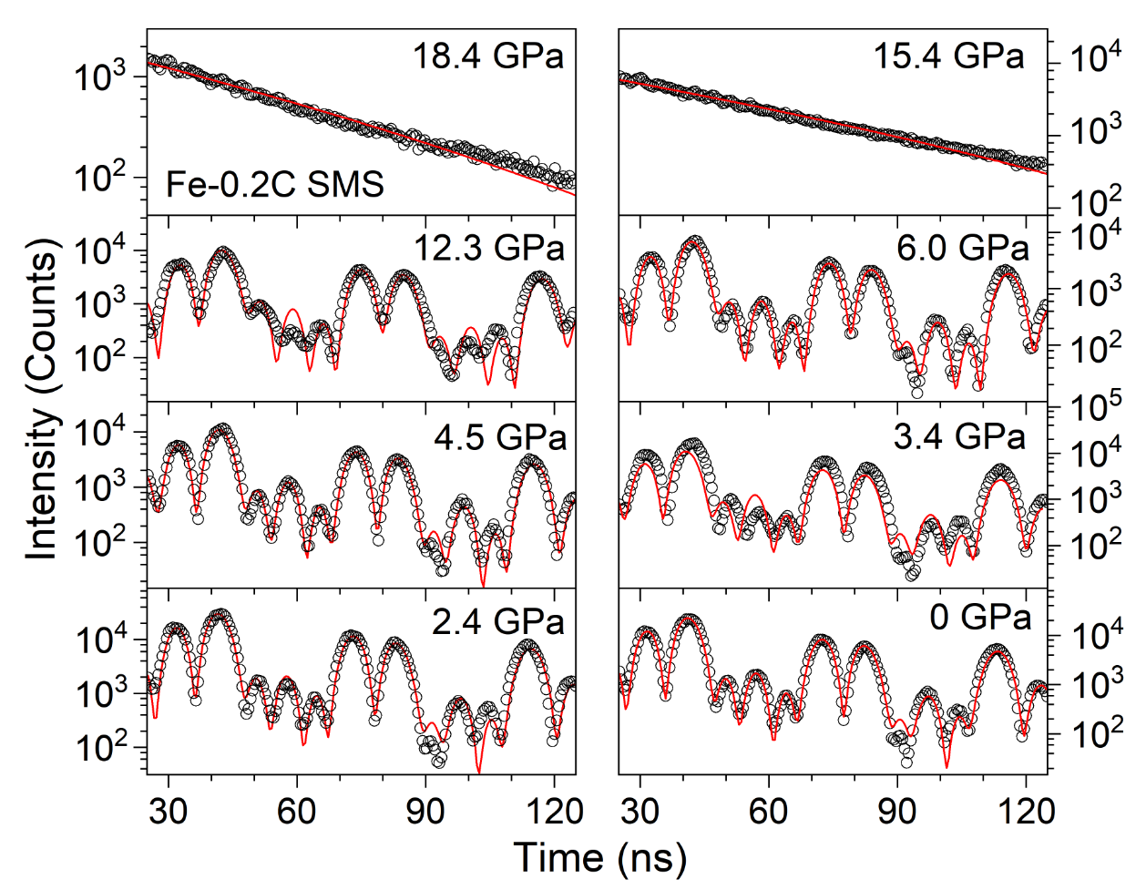
Supplementary Fig. S4. SMS spectra of ⁵⁷Fe-enriched Fe-0.2C up to 18.4 GPa at room temperature.

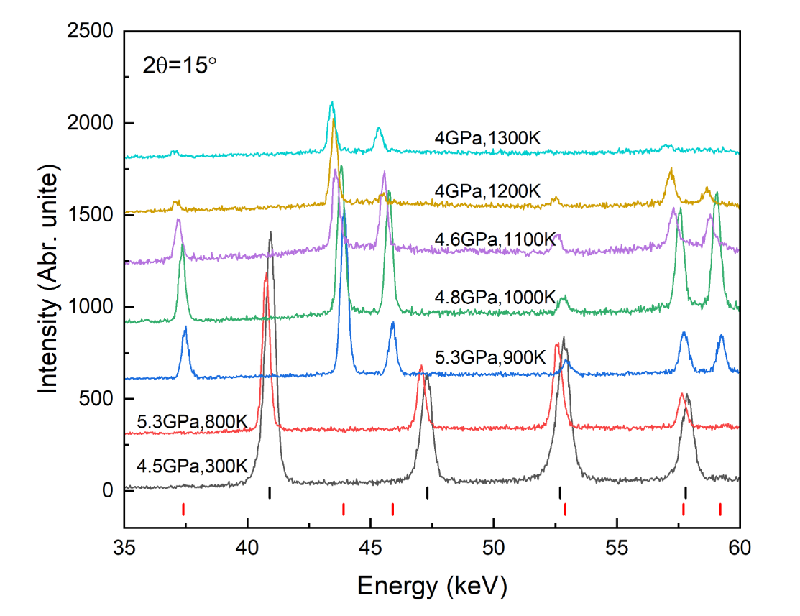
Supplementary Fig. S5. EDXRDs of Fe-0.2C at high pressure and high temperature. The short vertical lines denote the peaks of bcc (black) and fcc (red) phases.

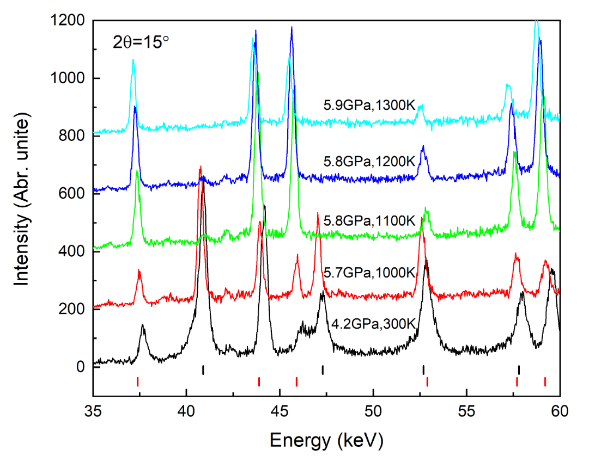
Supplementary Fig. S6. EDXRDs of Fe-1.7C at high pressure and high temperature. The short vertical lines denote the peaks of bcc (black) and fcc (red) phases.

Temperature effect on acoustic velocities
The temperature effect on acoustic velocities is presented in Supplementary Fig. S7. The V_{P} of bcc-I Fe-0.2C keeps constant as a function of temperature below 600 K, indicating a negligible temperature effect in this temperature range. However, as temperature increases further, the V_{P}s at all three heating cycles decrease versus temperature. The temperature dependence is about 0.0018 $km/(s∙K)$. An interesting observation is that there is a discontinuity at ~800 K in the 1.3-2.5 GPa dataset of bcc-I Fe-0.2C. The XRD shows it is in bcc phase, but V_{P} drops from 6.3 km/s to 5.6 km/s and it keeps ~5.6 km/s before the bcc-fcc phase transition. This might be attributed to approaching the bcc-fcc phase boundary. Temperature effect is invisible on V_{P} of bcc-II and fcc-I Fe-0.2C. It is long being known that V_{S} is temperature-sensitive ²⁻⁴. The temperature dependence of V_{S} for bcc-Fe-0.2C (bcc-I and bcc-II) is comparable to that of its fcc counterpart (fcc-I and fcc-II), which is ~0.0013 $km/(s∙K)$. The temperature effect on V_{P} of Fe-1.7C is difficult to describe because it is in mixed bcc and fcc phase below 1000 K. It seems temperature effect on V_{P} could be neglected in bcc&fcc-I phase. While temperature may pose an effect on bcc&fcc-II phase, because the V_{P} decrease as a function of temperature. Similar V_{P} drops (0.6-1.0 km/s) are observed in bcc&fcc phase around 900 K in the three heating cycles. The V_{P} drops at ~800 K in Fe-0.2C and at ~900 K in Fe-1.7C indicate that the phase boundaries determined by acoustic velocity and XRD are slightly different. A 200-300 K difference would exist. It is unlikely to analyze the temperature effect on V_{P} of both fcc-I and fcc-II Fe-1.7C because of the limited data. The temperature effects of V_{S} for both bcc&fcc- and fcc-Fe-1.7C are same, which is ~0.0007 $km/(s∙K)$.

The current V_{P} of fcc-Fe is in the range of 5.5-5.7 km, which is in good accord with the extrapolated results to lower pressure in ref. ⁵. 0.2wt.% carbon has negligible effect on V_{P} of fcc-Fe below 4.5 GPa, while 1.7wt.% carbon could lower down the V_{P} by ~0.4 km/s. The effect of carbon on V_{P} of fcc-Fe at fcc-I stabilized P-T conditions is contrary to that of light elements on bcc-Fe, hcp-Fe, and liquid Fe ⁶⁻⁸. Contrary effect can also be observed in V_{S} of fcc-I Fe-C alloys. The V_{S} of fcc-Fe is ~3.0 km/s, however those of fcc-I Fe-0.2C and fcc-I Fe-1.7C are in the range of 2.4-2.7 km/s. A reduction of 0.3-0.6 km/s is caused by 0.2-1.7wt.% carbon. Compared with the light element effect on V_{P} and V_{S}, the ISPT induce much more velocity reduction. Above 4 GPa, the V_{P} and V_{S} of fcc-II Fe-C alloys are reduced by ~1.0 km/s and ~0.5 km/s, respectively.
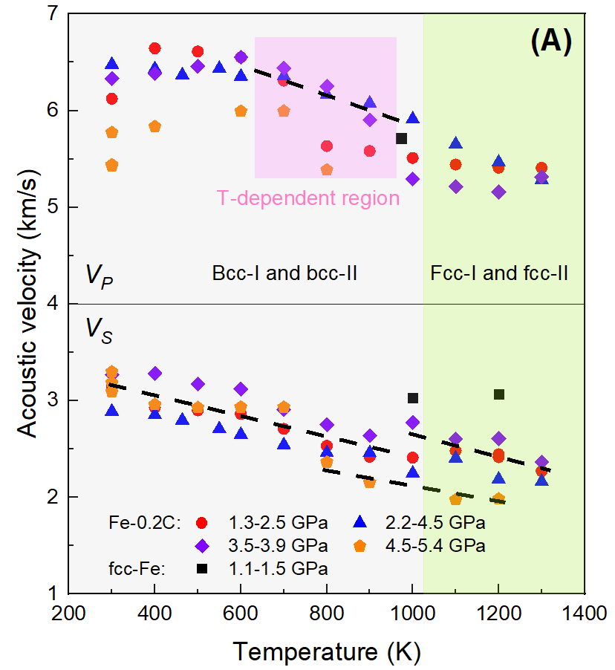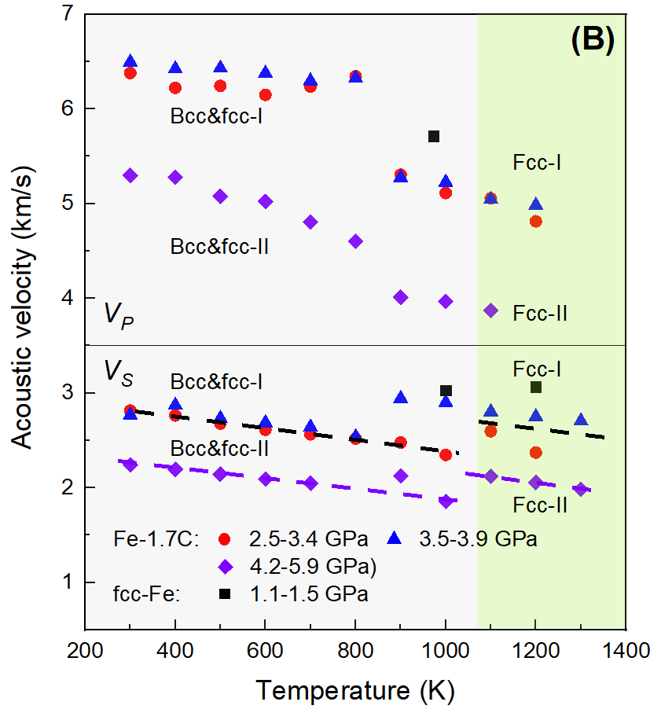
Supplementary Fig. S7. Temperature effect on acoustic velocities of Fe-0.2C (A) and Fe-1.7C (B). The dash curves are hand-drawn variation trends of V_{P} and V_{s} as a function of temperature. Each colored symbol represents a heating cycle. During a heating cycle, the pressure increases because of the thermal contribution.

Phase diagram of Fe-1.7C
The phase diagram of Fe-1.7C is shown in Fig. S8. The incorporation of 1.7wt.% carbon could slightly lower down the bcc/fcc phase boundary (blue dash curve) of the Fe. The phase boundary of bcc-I/II and fcc-I/II Fe-1.7C is also depressed by about 1 GPa compared with that of Fe-0.2C.

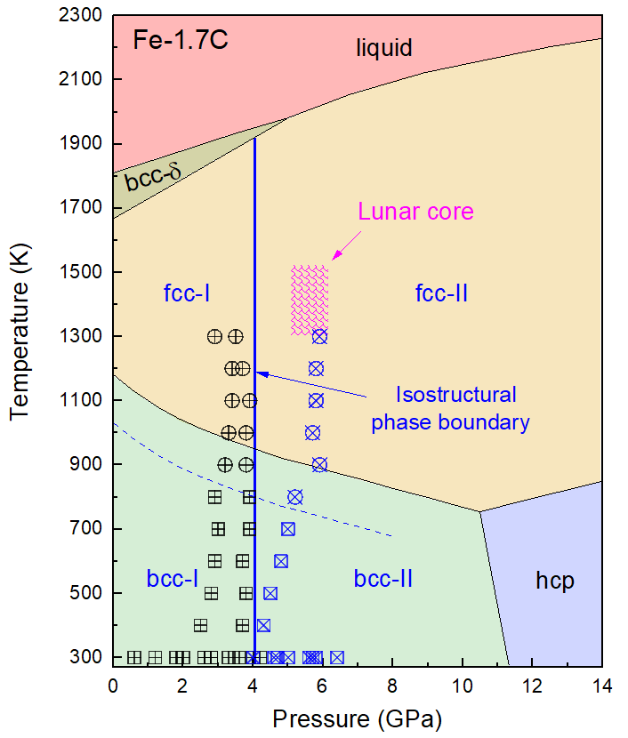
Supplementary Fig. S8. Phase diagram of Fe-1.7C.

Reference
1 Sturhahn, W. Nuclear resonant spectroscopy. J. Phys. Condens. Matt. 16, S497 (2004).
2 Shibazaki, Y. et al. Compressional and shear wave velocities for polycrystalline bcc-Fe up to 6.3 GPa and 800 K. Am. Mineral. 101, 1150-1160 (2016).
3 Whitaker, M. L., Liu, W., Liu, Q., Wang, L. & Li, B. Thermoelasticity of ε-FeSi to 8 GPa and 1273 K. Am. Mineral. 94, 1039-1044 (2009).
4 Lin, J.-F. et al. Sound velocities of hot dense iron: Birch's law revisited. Science 308, 1892-1894, doi:10.1126/science.1111724 (2005).
5 Antonangeli, D. et al. Toward a mineral physics reference model for the Moon’s core. Proc. Nat. Acad. Sci. 112, 3916-3919 (2015).
6 Liu, J., Lin, J.-F., Alatas, A. & Bi, W. Sound velocities of bcc-Fe and Fe0. 85Si0. 15 alloy at high pressure and temperature. Phys. Earth Planet. Inter. 233, 24-32 (2014).
7 Shimoyama, Y. et al. Thermoelastic properties of liquid Fe‐C revealed by sound velocity and density measurements at high pressure. J. Geophys. Res. 121, 7984-7995 (2016).
8 Lin, J. F. et al. Sound velocities of iron‐nickel and iron‐silicon alloys at high pressures. Geophys. Res. Lett. 30 (2003).

