Efficacy and safety of cryoablation procedures using mouse models of bladder cancer

Shogo Inui, Saya Ito*, Takashi Ueda, Takumi Shiraishi, Atsuko Fujihara, Yuta Inoue, Hideto Taga, Osamu Ukimura
Department of Urology, Graduate School of Medical Science, Kyoto Prefectural University of Medicine, Kyoto-City, Kyoto 602-8566, Japan

Shogo Inui and Saya Ito contributed equally to this work

*Corresponding author.
Saya Ito
Department of Urology, Graduate School of Medical Science, Kyoto Prefectural University of Medicine, Kyoto-City, Kyoto 602-8566, Japan
FAX: +81 75 251 5598
TEL: +81 75 251 5595
E-mail: itosaya@koto.kpu-m.ac.jp

Supplementary Information
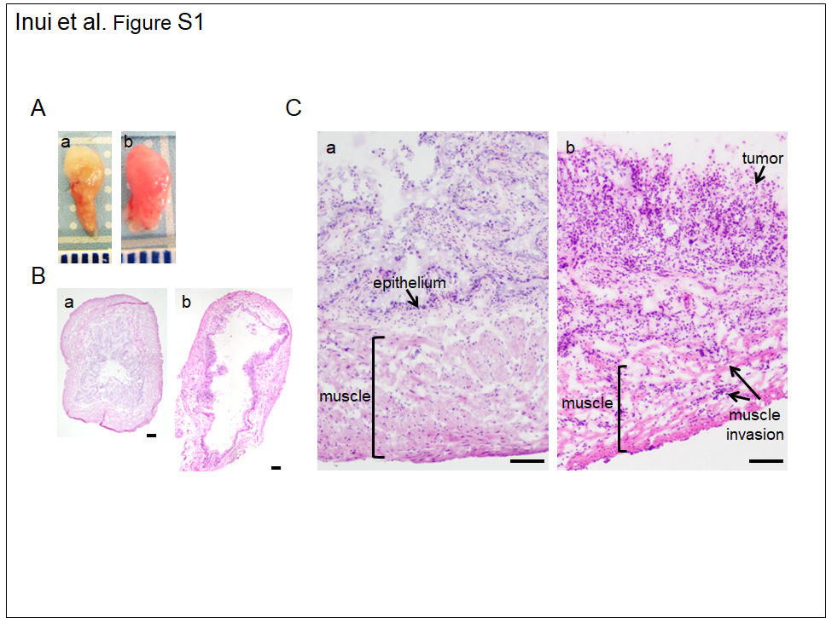 Fig. S1.
Generation of model bladder cancer mice: (A) Macroscopic appearance of non-BBN-treated mice (a) and BBN-treated mice (b). (B) Histopathological evaluation of non-BBN-treated mice (a) and BBN-treated mice (b). Histopathological evaluation, H&E-stained image, magnification 40×, Scale bars indicate 300 μm. (C) H&E-stained image as in Fig. S1B, magnification 100×, Scale bars indicate 100 μm.

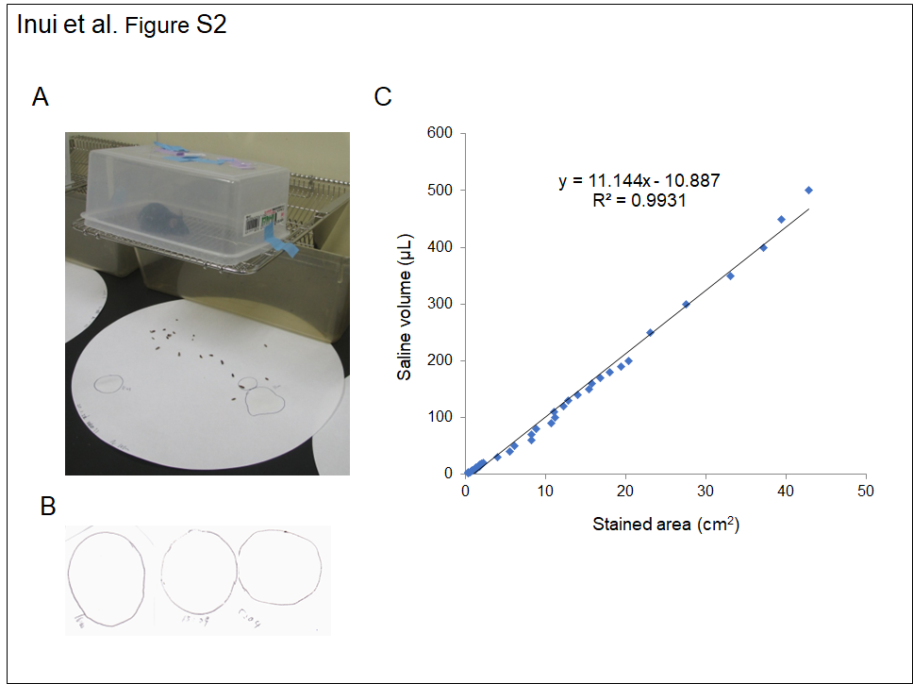 Fig. S2.
VSOP method: (A) Mice were placed on a wire-netted cage cover 20 cm above the filter paper. (B) As shown in the example in the photograph, urination time and urine spots were recorded on filter paper over a 2-h. (C) There was a linear correlation between liquid volume and stained areas on the filter paper within the range of 2 to 500 μL (y = 11.144x – 10.887, R² = 0.9931).

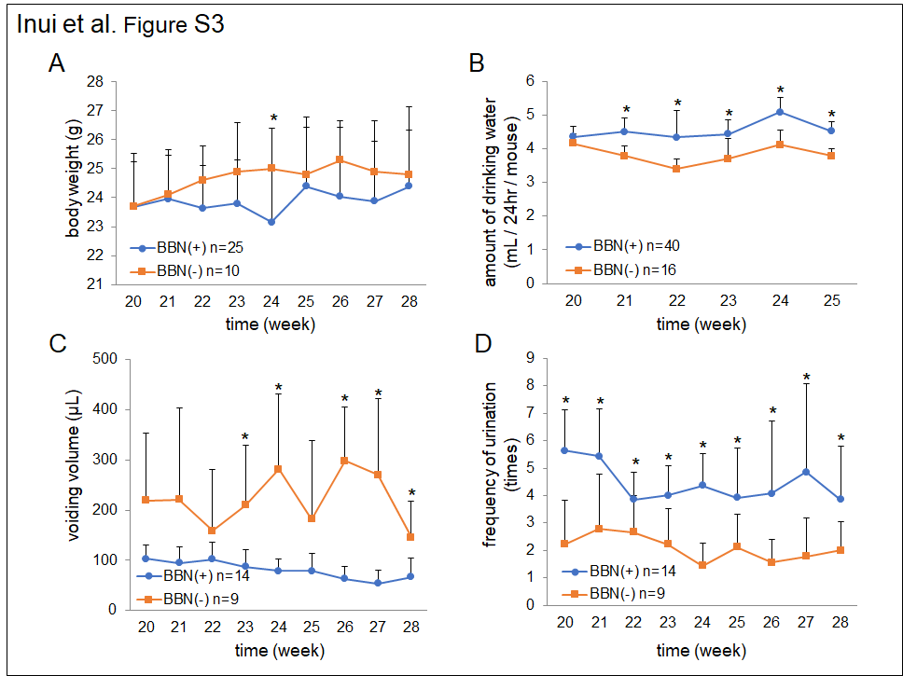 Fig. S3.
Influence of BBN administration on physiological effects in mice: (A) Body weight changes after BBN treatment. (B) Changes in amount of water consumed. (C) Voiding volume. (D) Frequency of urination. Asterisk indicates p < 0.05.

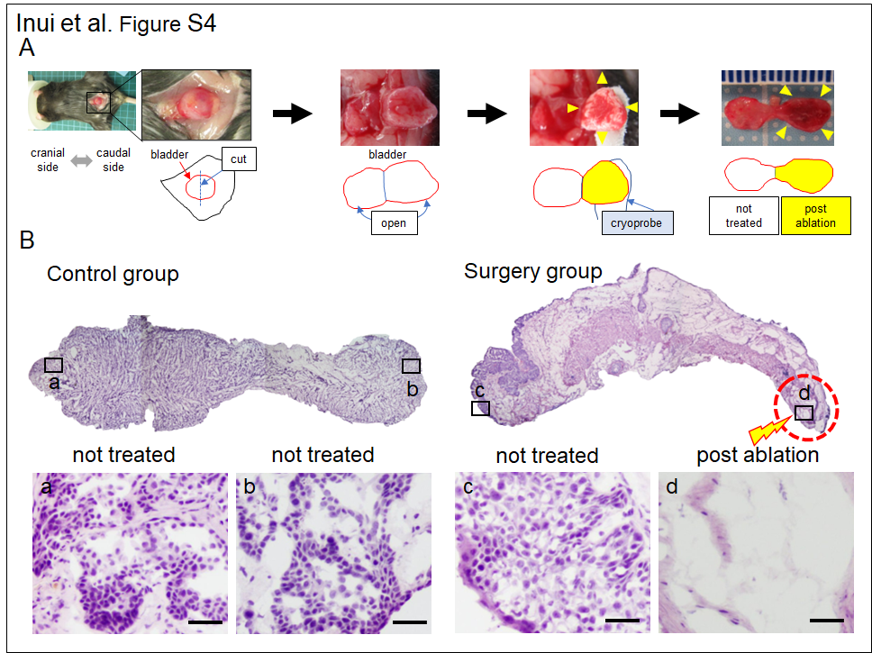 Fig. S4.
Therapeutic efficacy of cryoablation on bladder tissues: (A) In the efficacy validation experiment, the bladder was divided into two sections and cryoablation was performed on one side only. (B) H&E-stained images, magnification × 40 (top images) and × 200 (bottom images). The areas labeled a, b, c, and d in the bottom image correspond to the boxed regions in the top image. Scale bars indicate 25 μm. The d-area is the cryoablated region.

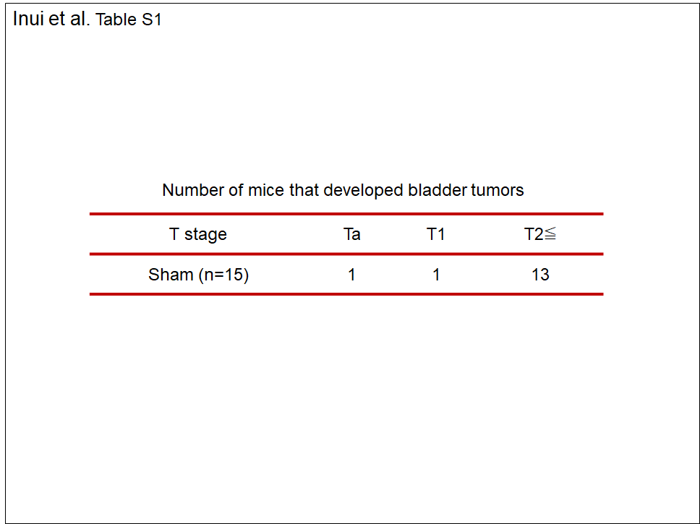
Table S1. Number of mice that developed bladder tumors

sample No. | group | Tumor size with cryoablation |  |  | BW (g)
sample No. | group | length (μm) | width (μm) | height (μm) | BW (g)
1 | POD0 | 5.3 | 4.9 | 3 | 23
2 | POD0 | 4.5 | 4 | 2.8 | 26
3 | POD0 | 4.5 | 3.7 | 3.5 | 27
4 | POD0 | 4.1 | 4.1 | 2.5 | 23
5 | POD0 | 4.2 | 3.9 | 2.4 | 22
6 | POD0 | 4.6 | 3.8 | 2.2 | 22
7 | POD0 | 4.5 | 4.2 | 3.6 | 23
8 | POD0 | 5.3 | 4 | 2.9 | 24
9 | POD0 | 4.3 | 3.7 | 2.5 | 23
10 | POD0 | 4.3 | 3.8 | 2.3 | 22
11 | POD0 | 4 | 4 | 2.5 | 26
12 | POD1 | 3.6 | 3.6 | 2.7 | 21
13 | POD1 | 4.2 | 3.5 | 3 | 24
14 | POD1 | 4 | 3.9 | 3 | 24
15 | POD1 | 4 | 3.8 | 2.8 | 21
16 | POD1 | 4.4 | 3.7 | 2.6 | 20
17 | POD1 | 4.6 | 4.1 | 2.6 | 20
18 | POD1 | 4.6 | 4.2 | 2.6 | 21
19 | POD1 | 4.4 | 4.3 | 3 | 22
20 | POD1 | 5.3 | 3.7 | 1.8 | 21
21 | POD1 | 5.5 | 4.6 | 3.1 | 20
22 | POD1 | 4.9 | 4 | 2.6 | 23
23 | POD1 | 5.3 | 3.6 | 3.6 | 20
24 | POD3 | 3 | 3 | 2 | 21
25 | POD3 | 3.8 | 3.8 | 2.2 | 23
26 | POD3 | 3.5 | 3 | 2.4 | 23
27 | POD3 | 5.2 | 4.7 | 4 | 22
28 | POD3 | 3.9 | 3.2 | 2.4 | 22
29 | POD3 | 3.9 | 2.8 | 2.8 | 20
30 | POD3 | 3.8 | 3.6 | 2.5 | 21
31 | POD3 | 3.9 | 3.9 | 3.2 | 22
32 | POD3 | 4.1 | 3.9 | 3.1 | 22
33 | POD3 | 3.6 | 3.5 | 2.8 | 21
34 | POD3 | 3.8 | 3.4 | 3 | 24
35 | POD3 | 4.6 | 3.6 | 2.1 | 20
36 | POD3 | 3.3 | 3 | 2 | 23
37 | POD3 | 3.5 | 3.3 | 3.3 | 29
38 | POD7 | 2.2 | 2.1 | 1.4 | 22
39 | POD7 | 2 | 1.7 | 1 | 25
40 | POD7 | 2 | 1.7 | 1.5 | 24
41 | POD7 | 2.6 | 1.9 | 1.4 | 22
42 | POD7 | 2.5 | 2.4 | 1.4 | 22
43 | POD7 | 2.7 | 2.6 | 1.5 | 22
44 | POD7 | 1.8 | 1.7 | 1.4 | 22
45 | POD7 | 2.4 | 2.2 | 1.7 | 23
46 | POD7 | 2.2 | 2.1 | 1.4 | 22
47 | POD7 | 2.6 | 2.5 | 1.9 | 21
48 | POD7 | 3.3 | 2.3 | 1.9 | 25
49 | POD7 | 3.2 | 2.8 | 1.6 | 20
50 | POD7 | 3.9 | 3.1 | 2 | 23
51 | POD7 | 2.2 | 1.8 | 1.1 | 28
52 | POD14 | 1.5 | 0.9 | 1.2 | 22
53 | POD14 | 1.3 | 1.3 | 1.1 | 25
54 | POD14 | 0 | 0 | 0 | 25
55 | POD14 | 0 | 0 | 0 | 23
56 | POD14 | 2.8 | 2.8 | 1.7 | 23
57 | POD14 | 2 | 1 | 1 | 21
58 | POD14 | 2.9 | 1.2 | 1 | 23
59 | POD14 | 0 | 0 | 0 | 24
60 | POD14 | 1.7 | 1.7 | 0 | 23
61 | POD14 | 1.9 | 1.5 | 0.8 | 22
62 | POD14 | 2.5 | 1.9 | 1.4 | 27
63 | POD14 | 3 | 2.4 | 1.8 | 20
64 | POD14 | 3.4 | 3.3 | 2.4 | 25
65 | POD28 | 2.7 | 2.3 | 1.2 | 24
66 | POD28 | 2.8 | 2.1 | 1 | 31
67 | POD28 | 0 | 0 | 0 | 26
68 | POD28 | 0 | 0 | 0 | 27
69 | POD28 | 3.1 | 2.3 | 1 | 25
70 | POD28 | 3.5 | 1.9 | 1.2 | 25
71 | POD28 | 0 | 0 | 0 | 26
Table S2. Measurements at each time point following cryoablation in each individual animal.

