Supplementary Information: Analysis

Replication set

Here we report the results of analysing the replication set. Recall that n = 2084 and only baseline and timepoint 1 data were collected. Findings replicate those of the main data.

Fig SI.A.1 (A). Means of myth agreement ratings with by-participant standard errors and violin distributions (question-answer, qa, fact-only, fo, fact-myth, fm). (B). Means of myth agreement by baseline (high >3 score, low <4 score) and correction format. Where baseline myth agreement was high, question-answer and fact-myth were most effective at lowering ratings.

Research Question 1: Which correction formats are effective immediately and after a delay?
All formats were significantly lower at timepoint 1 than at baselines (Fig SI.A.1 (A)), all β’s < 0.43, SE’s < 0.076, df’s > 11, t’s < -6.95, p’s < .001.

Research Question 2: What is the most effective correction format?
As reported in the main text, there was a question-answer vs fact-only interaction with baseline β = 0.053, SE = 0.018, df = 19, p = .0075, no question-answer vs fact-myth interaction with baseline : β = -0.0028, SE = 0.013, df = 24, p = .84, but an interaction of fact-only and fact-myth with baseline, β = -0.061, SE = 0.016, df = 19, t = -3.91, p < .001 (Fig SI.A.1 (B)).

Effects of age

Rationale for analysis. Myth belief has been reported to differ between older and younger participants, and backfire effects may be more likely for older participants, but a consistent pattern to guide health campaigns remains elusive. In a recent study Vijaykumar et al. (1) found younger participants (18-54) had higher belief for COVID-19 misinformation, which appears to reverse the previous narrative that older participants are more vulnerable to misinformation (2). For example, older participants were previously found to express more confidence in false memories (3), and share more fake news or links to political misinformation (4,5). It is possible this reflects a divergence between health myths and other kinds of misinformation, if older participants have accumulated more health or science knowledge to rely upon. However, there has also been a backfire effect reported for COVID-19 myth-busting in older adults, at least in the UK, where misinformation belief actually increased after viewing the corrective materials (1). Likewise, one of the earliest papers on the familiarity backfire effect (6) found that one week after reading material correcting influenza myth correction, older participants had greater belief in the myths than prior to intervention but younger participants did not, although Swire et al., (7), failed to find backfire effects in older participants.

Analysis and Results. To compare older and younger participants, we created a new factor, age_group, which divided participants into younger (<56 years old, n = 813) or older (>55, n = 481) participants (following the distinction made by Vijaykumar et al. (1)). We then combined this factor with Model 2:

Model 3: Myth_agreement ~ correction*baseline*timepoint*age_group + (1+timepoint|participant) + (1+correction*baseline*timepoint*age_group||myth)

where age_group is a fixed effect with appropriate random effects. Correlations were suppressed for myth random effects. Analysis was on the main set only, not the replication set.

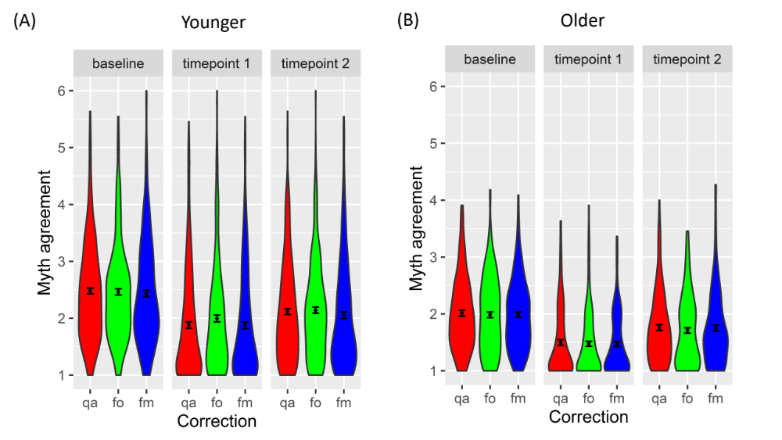
Fig SI.A.2. Myth agreement ratings for (A) younger participants and (B) older participants. For both groups, the interventions successfully lowered agreement at both timepoints. Younger participants had more varied and higher average ratings than older participants but a shallower increase from timepoint 1 to timepoint 2. Legend as for Fig.SI.A.1.

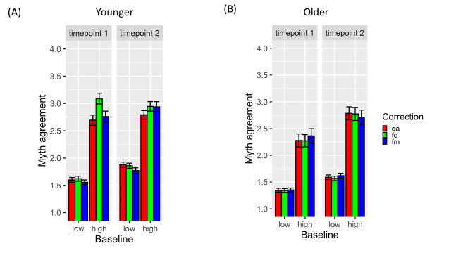
Fig SI.A.3. Means of myth agreement by baseline, correction format and time for (A) younger participants (B) older participants. Where baseline myth agreement was high, the question-answer format and fact-myth were most effective at lowering ratings at timepoint 1, while at timepoint 2, question-answer and fact-only were most effective. Legend as for Fig.SI.A.1.

There were stark differences in agreements ratings across age (Fig SI.A.2 & Fig SI.A.3). Younger participants showed higher agreement overall than older participants, β = -0.12, SE = 0.018, df = 131, t = -6.78, p < .001, and there was an interaction of age by time, β = -0.029, SE= 0.0065, df = 12.17, t = -4.42, p < .001, with the increase from timepoint 1 to timepoint 2 being greater in older participants (Fig SI.A.2 & Fig SI.A.3). Because there were significant three and four-way interactions involving age, correction format, baseline and time (age by question-answer vs fact-only by baseline, β = -0.11, SE = 0.028, df = 41, t = -3.96, p < .001; age by question-answer vs fact-myth by baseline β = 0.085, SE = 0.031, df = 22, t = 2.70, p = 0.013; age by fact-only vs fact-myth by baseline by time, β = -0.044, SE = 0.022, df = 19490, t = -2.01, p = 0.045), we consider the effects of correction format on younger and older participants separately (convergence issues prevented us from estimating the simple effects of age from Model 2).

Younger participants
There was a significant question-answer vs fact-only by baseline by time interaction, β = -0.063, se = 0.026, df = 9128, p = 0.014. Simple effects showed that at timepoint 1, there was a significant question-answer vs fact-only by baseline interaction (Fig SI.A.3.), β = 0.097, SE = 0.024, df = 29, t = 4.01, p < .001, such that question-answer was more effective than fact-only at high baselines, but at timepoint 2 there was not, β = 0.032, SE = 0.023, df = 25, t = 1.39, p = 0.18.
There was a marginal question-answer vs fact-myth by baseline by time interaction, β = 0.044, SE = 0.026, df = 10010, p = 0.09, with effects larger at timepoint 2. At timepoint 1, there was no significant question-answer vs fact-myth by baseline interaction, β = 0.024, SE = 0.022, df = 45, t = 1.13, p = 0.26, but there was at timepoint 2, β = -0.074, SE = 0.021, df = 56, t = -3.49, p < .001, such that question-answer was more effective at reducing myth agreement than fact-myth at high baselines.
Finally, there was a significant fact-only vs fact-myth by baseline by time interaction, β = 0.11, SE = 0.027, df = 10320, t = 4.01, p < .001. At timepoint 1, there was a fact-only vs fact-myth by baseline interaction β = -.074, SE = 0.021, df = 56, t = -3.49, p < .001, with fact-only less effective than fact-myth at higher baseline, but at timepoint 2, the ordering of fact-only and fact-myth had reversed, so that fact only was now more effective than fact-myth, although not significantly so, β = -0.036, SE = 0.023, df = 29, t = -1.59, p = 0.12.

Older participants
For older participants, importantly, there were no backfire effects. There were also no interactions with format. There was a significant main effect of time, β = 0.24, SE = 0.042, df = 12, t = 5.87, p < .001, such that agreement increased from timepoint 1 to timepoint 2.

Discussion
There were stark differences in myth belief between age groups. Older people had substantially lower belief in myths than younger people, consistent with Vijaykumar (1) and (8), both at baseline and after correction. The convergence across studies suggests that these findings are not due to idiosyncratic choices of myths but represents a general pattern in the belief of misinformation. One explanation is that older people are able to engage their more extensive general knowledge to discount new information (9), as argued by Vijaykumar (1), but it is also possible that they are exposed to a smaller range of myths, with less frequent repetition, than younger people, due to lower engagement with social media.
Although we replicated the age differences in myth belief observed by Vijakumar, we observed clear positive correction effects in older people (SI.A) rather than backfire effects. Differences could have arisen because of the materials used. Vijaykumar et al. used only one myth (the curative properties of garlic), whereas we used eleven (of which none concerned garlic), and it is possible that only certain myths yield backfire effects. Vijaykumar et al. also reinforced the myth prior to correction, which we did not. There may therefore be an interaction between age, reinforcement and correction that was present in Vijaykumar but not in our study.
Myth agreement in older participants was corrected at similar proportions to younger participants immediately post-intervention. However, beliefs returned towards baseline at a faster rate than for younger participants, perhaps because correcting beliefs requires strategic memory processes, and these are less efficient in older people (7,10).
Correction format effects were present in younger participants - more clearly than in the main analysis - but not in older participants. Furthermore, there were interactions with age that indicate that this was not only due to lower baseline beliefs in the older group but to the participants themselves. One explanation is that there were floor effects in the older group but not the younger group: older participants were at minimum agreement levels at timepoint 1, whereas younger participants were not. However, it is clear that by timepoint 2, older participants were not at floor level, and at timepoint 2 no effects of correction format were visible in older participants but they were in younger participants. It is therefore possible that the differing cognitive abilities of older participants are responsible for the insensitivity to correction format.

Vaccine concern

Rationale for analysis. Nyhan and Reifler (11)found that participants with high vaccine concerns showed lower intentions to obtain the influenza vaccine after a myth-busting intervention i.e. a backfire effect. We therefore analysed our data to test whether similar effects would be observed with COVID-19 vaccine myths and vaccine concern participants.

Analysis, results and discussion. Participants were asked on a 5-point scale whether they were generally concerned about vaccines (see SI.M), just as in Nyhan and Reifler. Those participants who completed both timepoints and answered either “concerned” or “extremely concerned” were included in the analysis (N=99).

We restricted the analysis to the two items that asked explicitly about vaccines, “It is mandatory for me to have my COVID-19 vaccination,” and “I can return to normal life immediately if I have had my COVID-19 vaccine.”

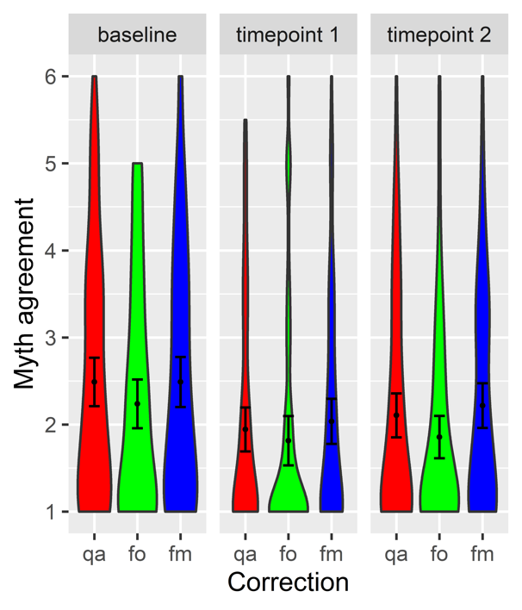
Fig SI.A.4. Means of myth agreement ratings for vaccine concern participants on vaccine related items. All correction formats show lower myth agreement post-intervention, in contrast to the backfire effects observed by Nyhan & Reifler (11). Legend as for Fig.SI.A.1.

Model 1 was applied to each correction format and to each timepoint. We found no evidence of backfire effects (Fig SI.A.4.). Indeed, each correction condition was significantly or marginally lower at timepoint 1 and 2 than at baseline, all β’s < -0.27, SE’s < 0.17, df’s > 1.76, t’s > 2.54, p’s < .094.

Discussion.
Vaccine concern participants behaved similarly to the sample as a whole i.e. there was no backfire, in contrast to Nhyan and Reifler.
There were a number of important differences between the study which could explain the difference. First, the vaccine myths we used were not contentious or political. For example, we did not try to address concerns about the harm that a COVID-19 vaccine might do, nor try to persuade participants of the benefits of the vaccine. Second, Nyhan & Riefler conducted their intervention by telephone, which may be a more persuasive but also a more emotive correction method than the image presentation method we used. Finally, the location of the studies was different. Nyhan & Riefler conducted their study in the USA, where vaccinations may be more more contentious than in the UK.
The disassociation between the presence of the backfire effect and the factors distinguishing the two studies suggest that the effect observed by Nyhan & Reifler was a world-view backfire effect, in which participants strengthened their beliefs while seeking to defend them (world view (12)), rather than a familiarity backfire effect, in which memory processes increase the familiarity of myths (7,13). Our materials should have caused a familiarity backfire effect, if such effects were common, but they may not have been sufficiently contentious to cause world-view backfire.

References

1. Vijaykumar S, Jin Y, Rogerson D, Lu X, Sharma S, Maughan A, et al. How shades of truth and age affect responses to COVID-19 (Mis)information: randomized survey experiment among WhatsApp users in UK and Brazil. Humanit Soc Sci Commun. 2021;8(1):1–12.
2. Wylie LE, Patihis L, McCuller LL. Misinformation Effect in Older Versus Younger Adults A Meta-Analysis and Review. Psychology Press; 2014. 38–66 p.
3. Jacoby LL, Rhodes MG. False Remembering in the Aged. 2006;15(2):49–53.
4. Grinberg N, Joseph K, Friedland L, Swire-thompson B, Lazer D. Fake news on Twitter during the 2016. 2019;378(January):374–8.
5. Guess A, Nagler J, Tucker J. Less than you think : Prevalence and predictors of fake news dissemination on Facebook. 2019;(January):1–9.
6. Skurnik I, Yoon C, Park DC, Schwarz N. How Warnings about False Claims Become Recommendations. J Consum Res. 2005;31(4):713–24.
7. Swire B, Ecker UKH, Lewandowsky S. The role of familiarity in correcting inaccurate information. J Exp Psychol Learn Mem Cogn. 2017;43(12):1948–61.
8. Matthew A. Baum, Ognyanova K, Chwe H, Quintana A, Perlis RH, Lazer D, et al. THE STATE OF THE NATION : A 50-STATE COVID-19 SURVEY REPORT # 14 : MISINFORMATION AND VACCINE ACCEPTANCE [Internet]. 2020 [cited 2021 Jun 2]. Available from: http://www.kateto.net/covid19/COVID19 CONSORTIUM REPORT 14 MISINFO SEP 2020.pdf. Accessed
9. Umanath S, Marsh EJ. Understanding How Prior Knowledge Influences Memory in Older Adults. 2014; Available from: https://doi.org/10.1177/1745691614535933
10. Prull MW, Dawes LLC, Iii AMM, Rosenberg HF, Light LL. Recollection and familiarity in recognition memory : Adult age differences and neuropsychological test correlates Recollection and Familiarity in Recognition Memory : Adult Age Differences and Neuropsychological Test Correlates. 2014;(May).
11. Nyhan B, Reifler J. Does correcting myths about the flu vaccine work? An experimental evaluation of the effects of corrective information. Vaccine. 2015;33(3):459–64.
12. Nyhan B, Reifler J. When Corrections Fail : The Persistence of Political Misperceptions. 2010;303–30.
13. Lewandowsky S, Ecker UKH, Seifert CM, Schwarz N, Cook J. Misinformation and its correction: Continued influence and successful debiasing. Psychol Sci Public Interes. 2012;13(3):106–31.

