Supplementary Figure 1. Correlation Plots of Each Variable Domain
The plots represent three domains: (a) Lifestyle and Socioeconomic Variables, (b) Anthropometric and Physical Measurements, and (c) Metabolic and Biochemical Markers. (a) Lifestyle and Socioeconomic Variables exhibited generally low inter-variable correlations, suggesting minimal redundancy among features. (b) Anthropometric and Physical Measurements demonstrated relatively high correlations across several variables, indicating potential multicollinearity within this domain. (c) Metabolic and Biochemical Markers showed strong correlations among certain variables, particularly those representing related physiological processes. These findings informed the application of principal component analysis (PCA) during model training to address multicollinearity, and also provided important context for interpreting feature contributions during model validation.
(a) (b) (c)
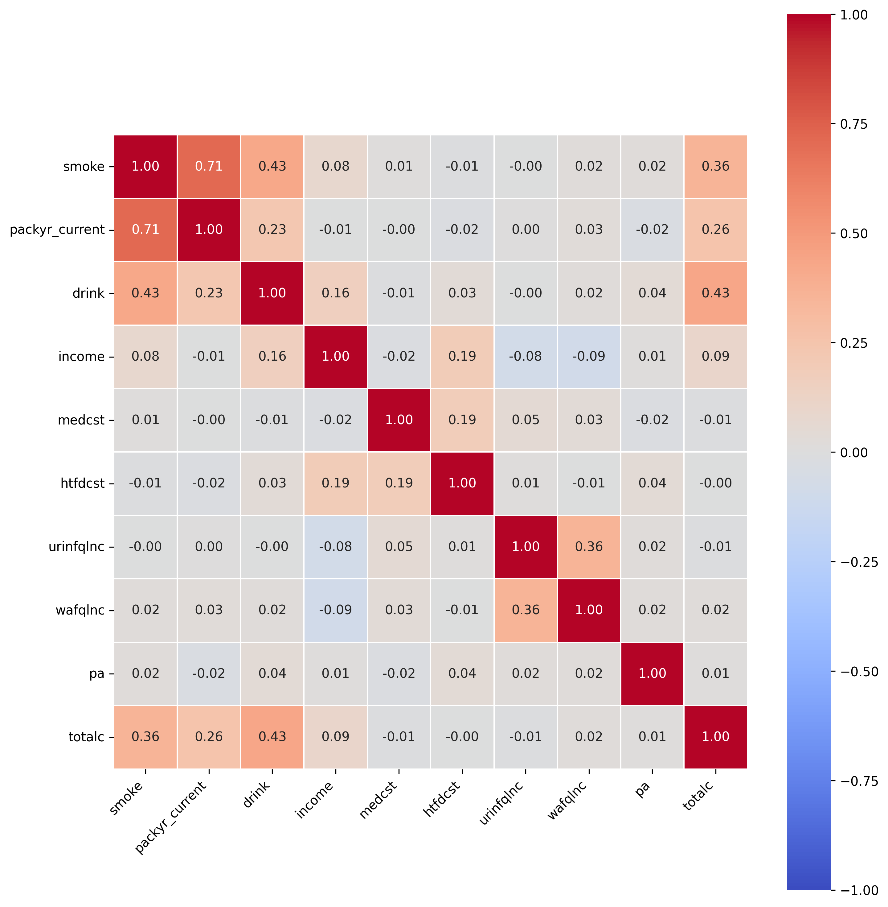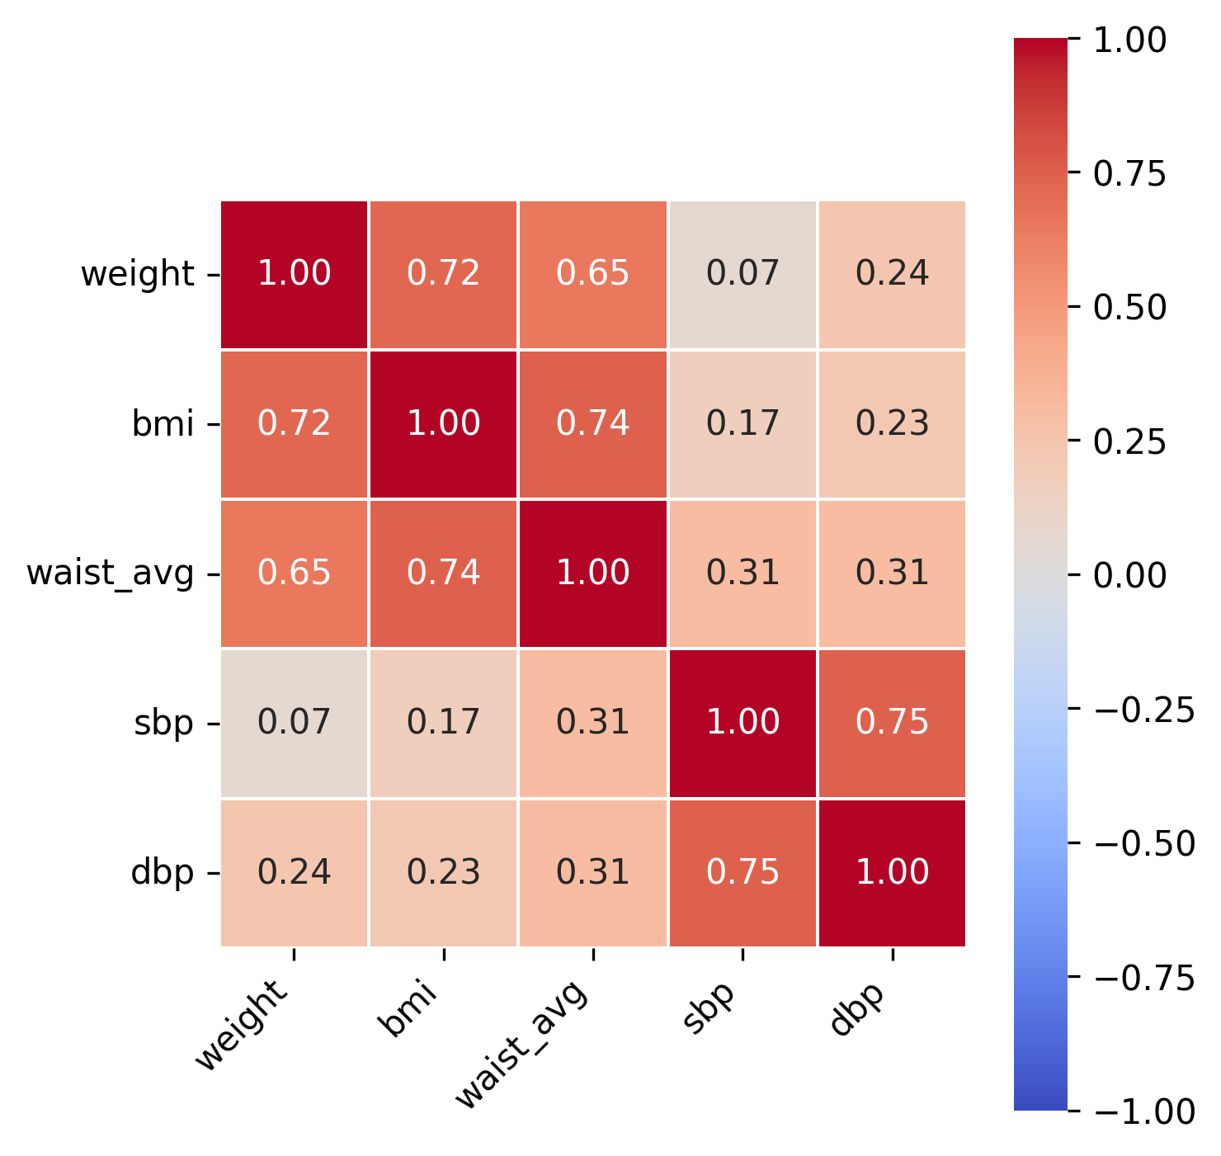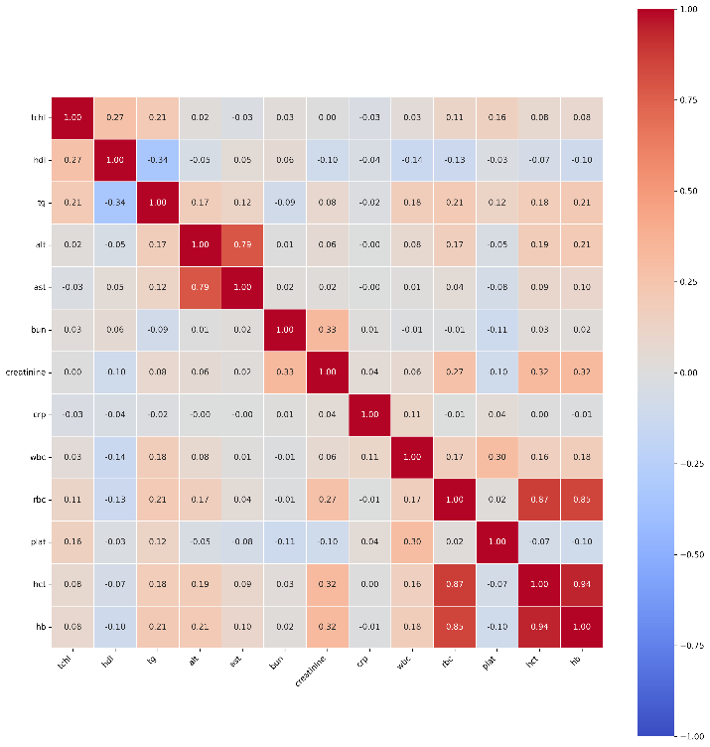
Supplementary Table 1. Model performance metrics comparing models using all features including diagnostic glycemic markers (oral glucose tolerance test, fasting blood glucose, HbA1c)

Metrics | PCA Strategy | LR | RF | XGBoost | LGBM
AUROC | Original Features | 0.983 | 0.996 | 0.9997 | 0.9998
AUROC | Hybrid (Original+PC) | 0.983 | 0.995 | 0.9997 | 0.9998
AUROC | PC-Based | 0.984 | 0.998 | 0.9998 | 0.9999
Precision | Original Features | 0.924 | 0.960 | 0.986 | 0.995
Precision | Hybrid (Original+PC) | 0.933 | 0.950 | 0.987 | 0.993
Precision | PC-Based | 0.936 | 0.967 | 0.989 | 0.993
Recall | Original Features | 0.964 | 0.982 | 0.994 | 0.989
Recall | Hybrid (Original+PC) | 0.964 | 0.985 | 0.994 | 0.989
Recall | PC-Based | 0.969 | 0.984 | 0.994 | 0.989
F1 Score | Original Features | 0.944 | 0.970 | 0.990 | 0.992
F1 Score | Hybrid (Original+PC) | 0.948 | 0.967 | 0.991 | 0.991
F1 Score | PC-Based | 0.952 | 0.976 | 0.991 | 0.991
Accuracy | Original Features | 0.943 | 0.971 | 0.990 | 0.992
Accuracy | Hybrid (Original+PC) | 0.948 | 0.967 | 0.991 | 0.991
Accuracy | PC-Based | 0.952 | 0.976 | 0.991 | 0.991

Supplementary Figure 2. SHAP (SHapley Additive exPlanations) feature importance plot from the best-performing model (XGBoost) showing the overwhelming contribution of glucose-related variables (change in 2-hour OGTT glucose, 2-hour OGTT glucose level, HbA1c change, fasting glucose change) when diagnostic markers are included in T2D prediction

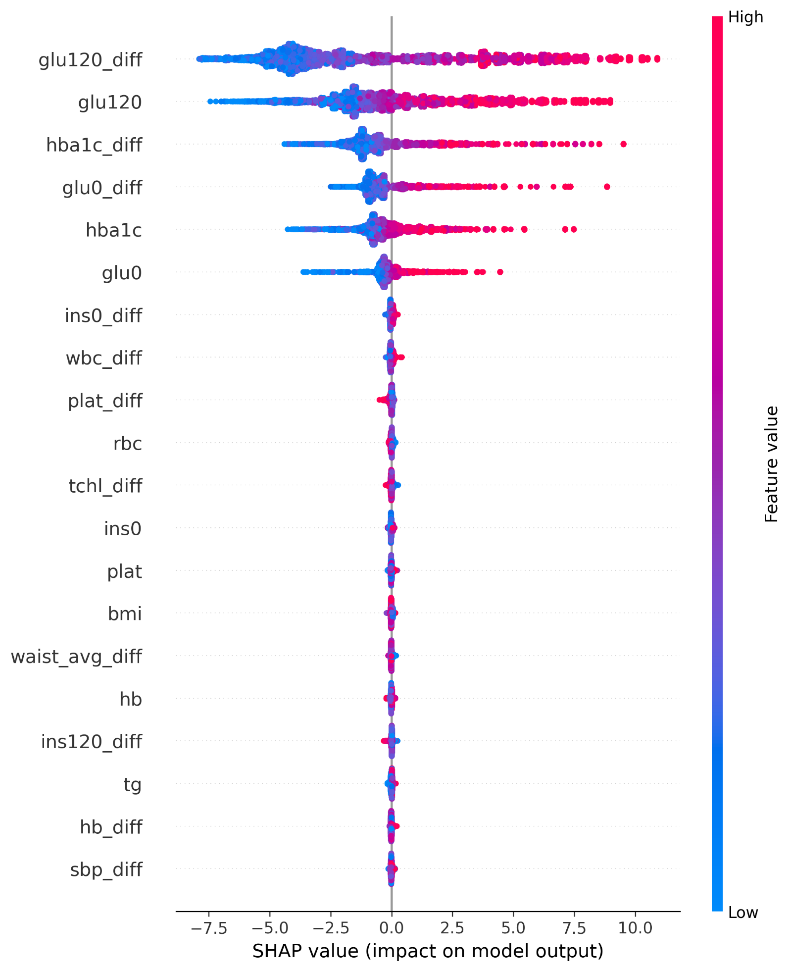

Variable abbreviations represent the following measurements: Static variables include glu120 (2-hour post-load glucose, mg/dL), glu0 (fasting blood glucose, mg/dL), hba1c (hemoglobin A1C, %), ins0 (fasting insulin, μU/mL), ins120 (2-hour post-load insulin, μU/mL), rbc (red blood cell count, 10³/µL), tchl (total cholesterol, mg/dL), plat (platelet count, 10³/µL), bmi (body mass index, kg/m²), waist_avg (average waist circumference, cm), hb (hemoglobin, g/dL), tg (triglycerides, mg/dL), and sbp (systolic blood pressure, mmHg). Change variables with ‘_diff’ suffix represent temporal changes between follow-up and baseline measurements, including glu120_diff, hba1c_diff, glu0_diff, ins0_diff, wbc_diff (white blood cell count change), plat_diff, tchl_diff, waist_avg_diff, ins120_diff, hb_diff, and sbp_diff. Higher SHAP values (red points) indicate increased T2D risk, while lower values (blue points) indicate decreased risk. Variables are ordered by feature importance from highest to lowest impact on model predictions.

Supplementary Figure 3. Cross-validation performance of ensemble model across five folds
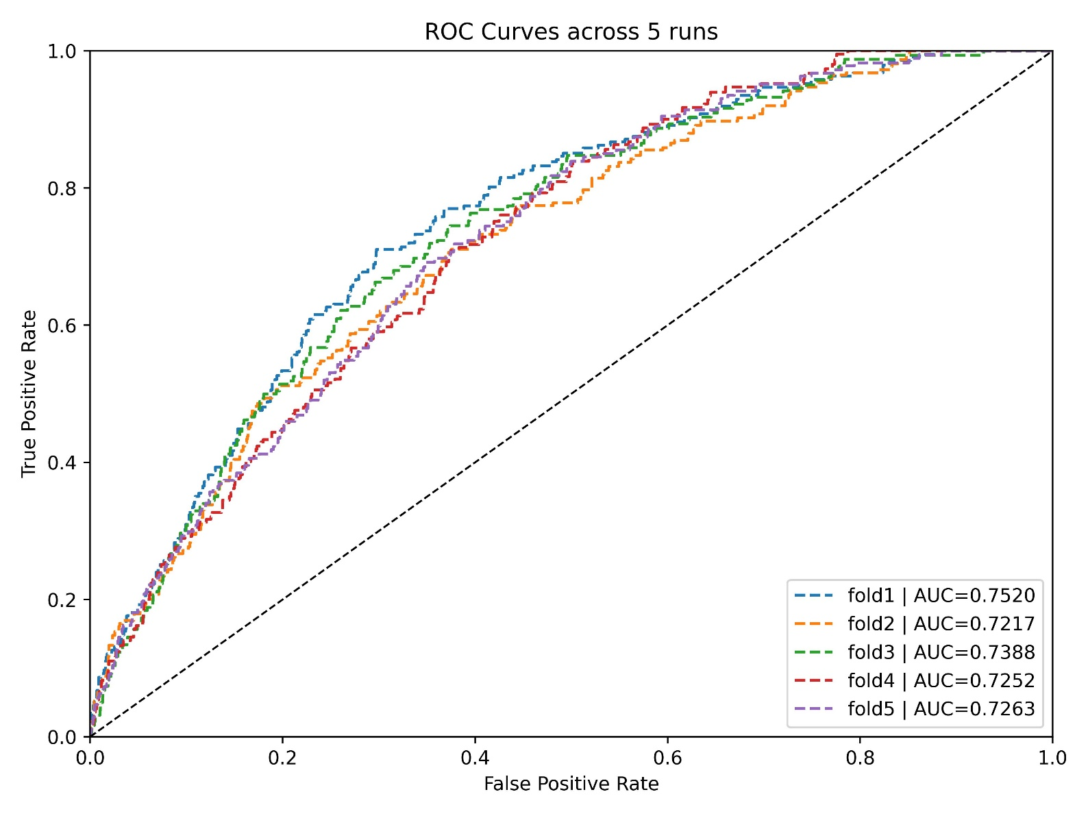

Receiver Operating Characteristic (ROC) curves from 5-fold cross-validation analysis of the XGBoost model using all features with hybrid approach (original variables + principal components) in the training set (80% of ASAS cohort). Each colored line represents the ROC curve from one fold, demonstrating consistent performance across folds with AUROC values ranging from 0.7217 to 0.7520. The diagonal dashed line represents the reference line for random classification (AUC = 0.5). The consistent performance across all folds confirms the robustness and stability of the model.

Supplementary Methods: Detailed Model Development and Implementation
S1. Baseline Model: Logistic Regression
S1.1 Model description
Logistic regression was implemented as the baseline model to establish a performance benchmark for T2D onset prediction. The model follows the standard logistic regression formulation:
$$Logit\left(p\right)= β_{0}+ \sum_{i=1}^{n}{β_{i }x_{i}}$$
where p represents the probability of T2D onset, β₀ is the intercept term, βᵢ are the regression coefficients, and xᵢ are the predictor variables.

S1.2 Model Training and Statistical Analysis
The logistic regression model provided β coefficients and corresponding p-values for each variable, allowing for quantitative interpretation of effect sizes and directions, as well as assessment of statistical significance. Selected Significant Predictor (Example): Red blood cell count change (rbc_diff): β = 0.6289, p < 0.001

S2. Tree-Based Models
S2.1 Random Forest (RF)
- Constructs decision paths based on various combinations of input features
- Each node split determined by threshold value of selected variable
- Training guided by information gain or variance reduction criteria
- Effective for capturing nonlinear relationships and variable interactions
- Handles categorical/missing values without feature scaling requirement
S2.2 XGBoost (eXtreme Gradient Boosting)
- Gradient boosting framework with advanced regularization
- Sequential tree building with error correction
- Optimized for performance and computational efficiency
S2.3 LightGBM (Light Gradient Boosting Machine)
- Gradient boosting framework optimized for efficiency
- Leaf-wise tree growth strategy
- Advanced categorical feature handling
S2.4 Tree structure analysis and clinical interpretability
Supplementary Figure 4. XGBoost Decision Tree Structure Analysis
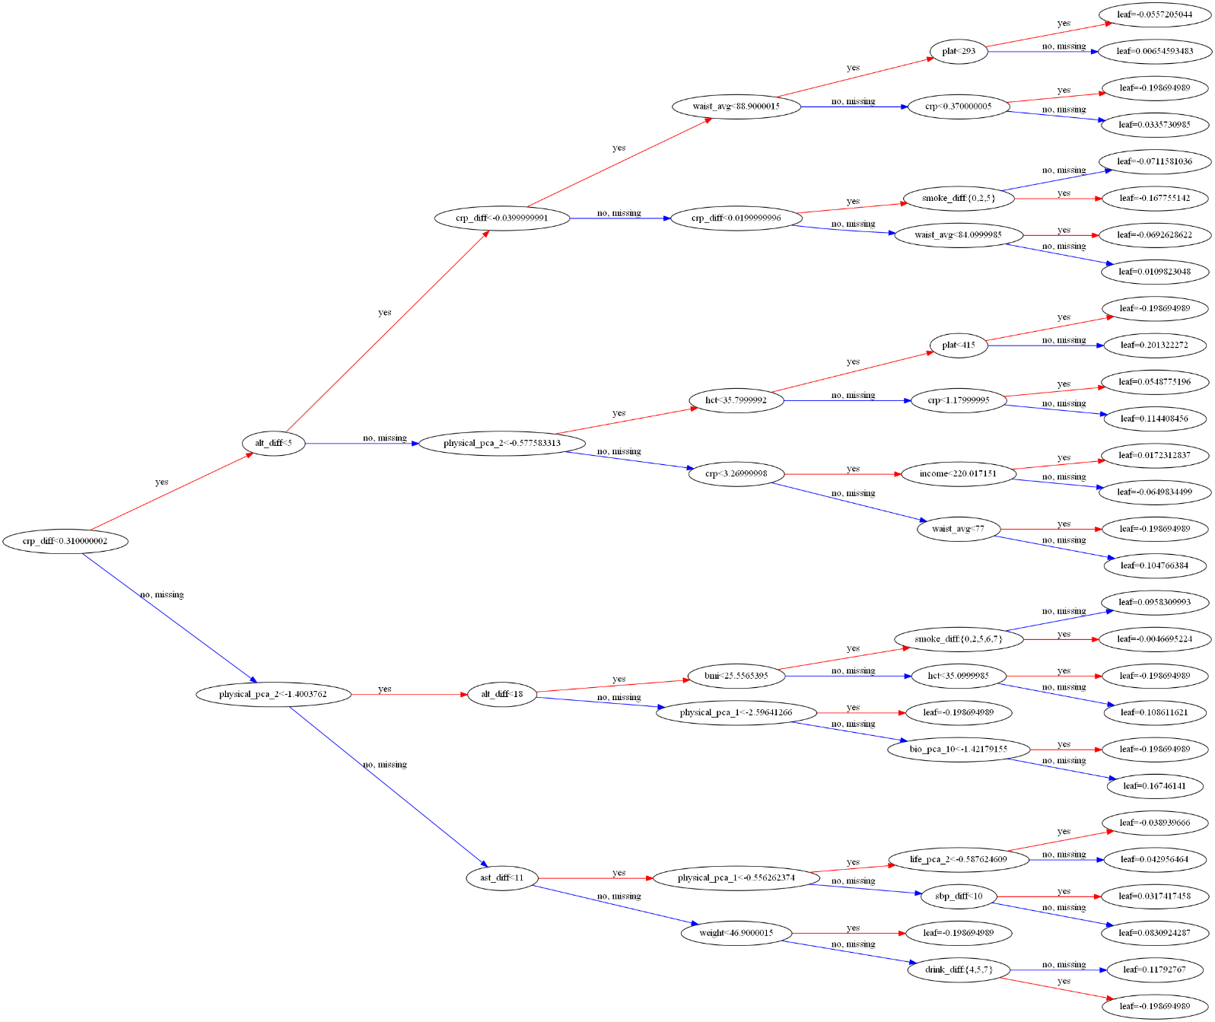
For the XGBoost model using all variables with PCA, we examined the variables used at each decision node, the corresponding split thresholds (e.g., BMI < 25.56, waist_avg < 88.9), and the resulting leaf values of the terminal nodes. This analysis allowed us to assess whether each feature contributed to prediction based on clinically meaningful thresholds. Through this process, we confirmed that the model was not merely partitioning data in a mechanical manner but was instead learning decision criteria that are interpretable within a real-world healthcare context. The complete tree structure visualization is provided in Supplementary Figure 3. Furthermore, to enhance reproducibility and transparency, the complete set of tree structures, including all node splits and weight information of the trained XGBoost model, has been made publicly available via GitHub (https://github.com/..)

S3. Neural Network Models
S3.1 Artificial Neural Network (ANN)
- Capable of learning complex non-linear functions across high-dimensional features
- Hidden layer computations enable internalization of implicit interaction effects
- Captures intricate patterns difficult to express using linear or tree-based models

S3.2 Recurrent Neural Network (RNN)
RNN was specifically designed to handle the hierarchical structure of principal components. The principal components generated by PCA exhibit a sequential information structure: the first principal component captures the largest portion of data variance, while subsequent components represent residual variance in descending order. This cumulative and ordered nature of principal components aligns with RNN architecture for sequential processing.

(1) Network Architecture:
We designed an RNN architecture that processes principal components sequentially based on their variance contribution ranking (pca0 → pca1 → pca2 → pca3). This hierarchical processing approach treats the ordered variance structure as a meaningful sequence, allowing the network to build cumulative representations of the underlying data patterns. The RNN hidden state at processing step t was computed as:
hᵗ = tanh(Wₓ·pcaᵗ + Wₕ·hᵗ⁻¹ + b)
where pcaᵗ represents the principal component at step t, and the final prediction was obtained through linear transformation of the last hidden state.

- Wₓ ∈ ℝⁿʰⁱᵈᵈᵉⁿ×¹ : weight matrix for input-to-hidden transitions
- Wₕ ∈ ℝⁿʰⁱᵈᵈᵉⁿ×ⁿʰⁱᵈᵈᵉⁿ : weight matrix for hidden-to-hidden transitions
- b ∈ ℝⁿʰⁱᵈᵈᵉⁿ : bias vector
- pca^{t} : hyperbolic tangent activation function

(2) Sequential Processing Steps:
- h¹ = tanh(Wₓ·pca0 + b)
- h² = tanh(Wₓ·pca1 + Wₕ·h¹ + b)
- h³ = tanh(Wₓ·pca2 + Wₕ·h² + b)
- h⁴ = tanh(Wₓ·pca3 + Wₕ·h³ + b)
Final prediction output: y = Wᵧ·h⁴ + c

