The removal performance and mechanisms of tetracycline over Mn-rich limonite
Luyao Wang^{a,b}, Hanlin Wang^{a,b}, Haibo Liu^{a,b}, Xuehua Zou^{a,b}, Dong Chen^{a,b}, Ziyang Chu^{a,b}, Jinchao Hu^{a,b}, Tianhu Chen^{a,b,}
ª Key Laboratory of Nano-minerals and Pollution Control of Anhui Higher Education Institutes, Hefei University of Technology, Hefei, 230009, China
^{b} Environmental Mineral and Material, School of Resources and Environmental Engineering, Hefei University of Technology, Hefei, 230009, China

Supporting Information

Table. S1 XRF results of the Mn-rich limonite.
Table. S2 Kinetic parameters on TC removal under various conditions.
Table. S3 The adsorption kinetic parameters on TC removal acquired from pseudo-first-order and pseudo-second order models.
Table. S4 The isotherms parameters for TC adsorption on limonite acquired from Langmuir and Freundlich models.
Fig. S1 Kinetic fittings of the TC removal process under various conditions.
Fig. S2 Arrhenius plot fitting.
Fig. S3 Adsorption kinetic and isotherm fittings for TC adsorption on limonite.
Fig. S4 LSV curves obtained by limonite.
Fig. S5 LC-MS spectra of TC at various reaction time.
Fig. S6 XRD patterns of the Mn-rich limonite, Mn-free limonite, goethite and MnO₂, and comparison of the removal performances of TC by the above three materials.

Table. S1 XRF results of the Mn-rich limonite.
Composition | Fe₂O₃ | MnO | SiO₂ | Al₂O₃ | ZnO
Content/% | 65.5 | 20.1 | 6.8 | 4.3 | 1.5

Table. S2 Kinetic parameters on TC removal under various conditions.
Different conditions |  |  |  | Parameters
Dosage (g/L) | Initial pH | Coexisting anions  (1.0 mM) | Temperature  (K) | k_{obs}  (mg⁻¹ L min⁻¹) | R²
0.2 | 5.0 | - | 298 ± 2 | 0.8×10⁻⁴ | 0.977
0.4 | 5.0 | - | 298 ± 2 | 2.7×10⁻⁴ | 0.997
0.6 | 5.0 | - | 298 ± 2 | 6.9×10⁻⁴ | 0.995
0.8 | 5.0 | - | 298 ± 2 | 13.0×10⁻⁴ | 0.997
1.0 | 5.0 | - | 298 ± 2 | 21.0×10⁻⁴ | 0.997
2.0 | 5.0 | - | 298 ± 2 | 43.0×10⁻⁴ | 0.938
0.8 | 3.0 | - | 298 ± 2 | 11.0×10⁻⁴ | 0.975
0.8 | 5.0 | - | 298 ± 2 | 13.0×10⁻⁴ | 0.998
0.8 | 7.0 | - | 298 ± 2 | 11.0×10⁻⁴ | 0.996
0.8 | 9.0 | - | 298 ± 2 | 12.0×10⁻⁴ | 0.996
0.8 | 11.0 | - | 298 ± 2 | 0.6×10⁻⁴ | 0.947
0.8 | 5.0 | - | 283 | 2.4×10⁻⁴ | 0.951
0.8 | 5.0 | - | 293 | 7.6×10⁻⁴ | 0.946
0.8 | 5.0 | - | 303 | 18.0×10⁻⁴ | 0.996
0.8 | 5.0 | Control | 298 ± 2 | 6.7×10⁻⁴ | 0.997
0.8 | 5.0 | Cl⁻ | 298 ± 2 | 7.1×10⁻⁴ | 0.995
0.8 | 5.0 | NO₃⁻ | 298 ± 2 | 7.4×10⁻⁴ | 0.997
0.8 | 5.0 | SO₄²⁻ | 298 ± 2 | 7.1×10⁻⁴ | 0.997
0.8 | 5.0 | PO₄³⁻ | 298 ± 2 | 3.9×10⁻⁴ | 0.997

Table. S3 The adsorption kinetic parameters on TC removal acquired from pseudo-first-order and pseudo-second order models.
Pseudo-first-order |  |  | Pseudo-second order
$$\text{log}\left({\text{q}}_{\text{e}}\text{-}{\text{q}}_{\text{t}}\right)\text{=log}{\text{q}}_{\text{e}}\text{- }\frac{{\text{k}}_{\text{1}}\text{t}}{\text{2.303}}$$ |  |  | $$\frac{\text{t}}{{\text{q}}_{\text{t}}}\text{ = }\frac{\text{1}}{{\text{k}}_{\text{2}}{\text{q}}_{\text{e}}^{\text{2}}}\text{ + }\frac{\text{t}}{{\text{q}}_{\text{e}}}$$
q_{e}  mg g⁻¹ | k₁  min⁻¹ | R² | q_{e}  mg g⁻¹ | k₂  mg g⁻¹ min⁻¹ | R²
24.3 | 8.8×10⁻³ | 0.964 | 37.9 | 9.0×10⁻⁴ | 0.999

Table. S4 The isotherms parameters for TC adsorption on Mn-rich limonite acquired from Langmuir and Freundlich models.
Langmuir |  |  | Freundlich
$$\frac{{\text{C}}_{\text{e}}}{{\text{q}}_{\text{e}}}\text{= }\frac{\text{1}}{{\text{q}}_{\text{m}}{\text{K}}_{\text{L}}}\text{+ }\frac{{\text{C}}_{\text{e}}}{{\text{q}}_{\text{m}}}$$ |  |  | $$\text{ln}{\text{q}}_{\text{e}}\text{= ln}{\text{K}}_{\text{F}}\text{ + }\frac{\text{ln}{\text{C}}_{\text{e}}}{\text{n}}$$
R² | K_{L}  L mg⁻¹ | q_{m}  mg g⁻¹ | R² | K_{F}  L g⁻¹ | n
0.983 | 0.3 | 102.5 | 0.995 | 33.3 | 3.1

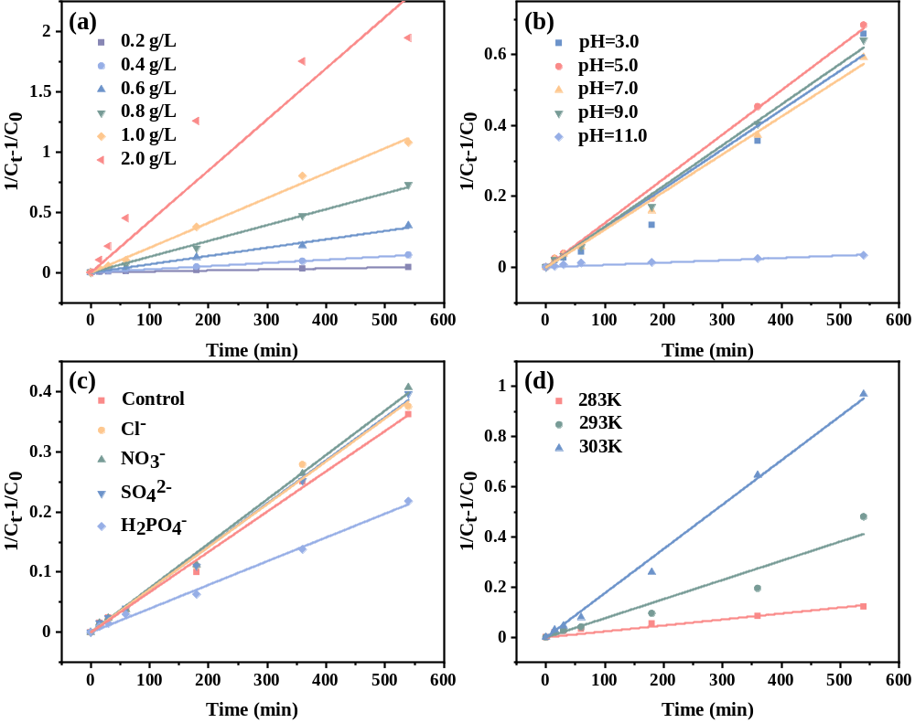
Fig. S1 Kinetic fittings of the TC removal process under various conditions (conditions: TC = 30.0 mg/L, dosage = 0.8 g/L, pH = 5.0).

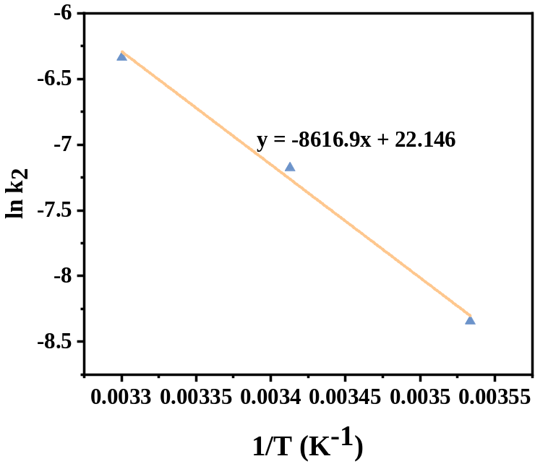
Fig. S2 Arrhenius plot fitting

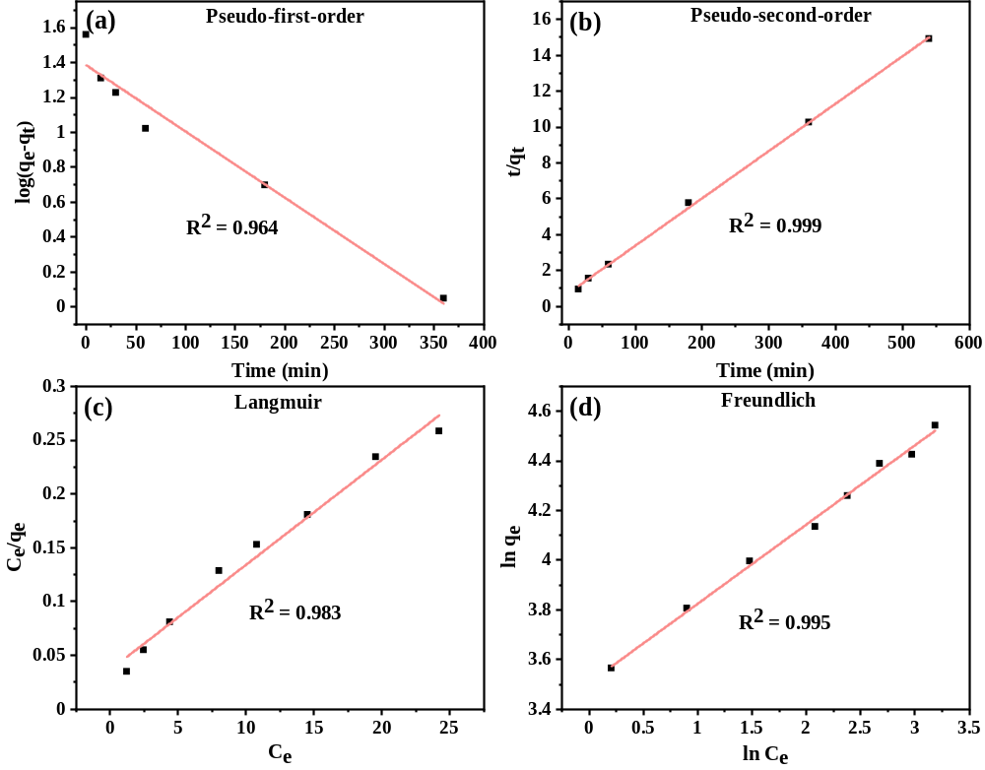
Fig. S3 Adsorption kinetic and isotherm fittings for TC sorption on limonite, pseudo-first-order (a), pseudo-second-order (b), Langmuir (c) and Freundlich (d) models (conditions: TC = 30.0 mg/L, dosage = 0.8 g/L, pH = 5.0).

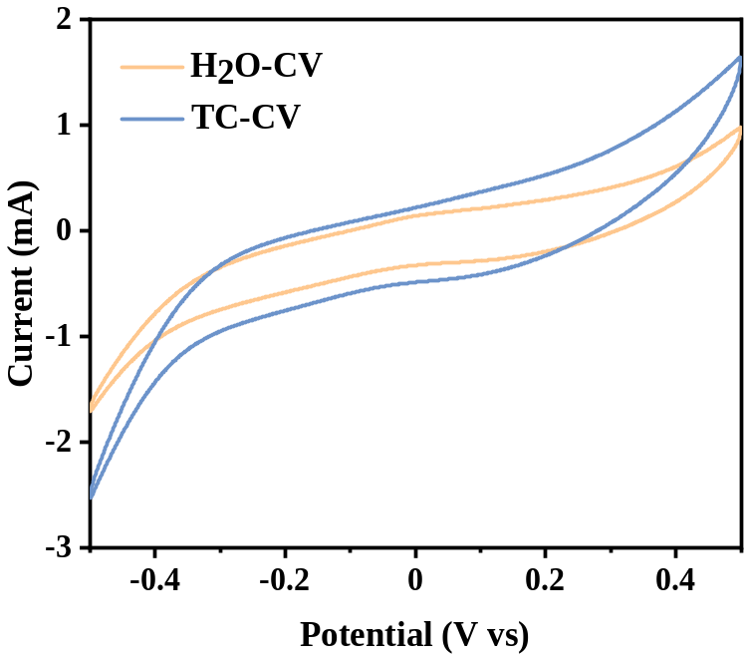
Fig. S4 CV curves obtained by limonite in Na₂SO₄ solution (conditions: TC = 30.0 mg/L, dosage = 0.8 g/L, pH = 5.0, Na₂SO₄ = 0.1 M).
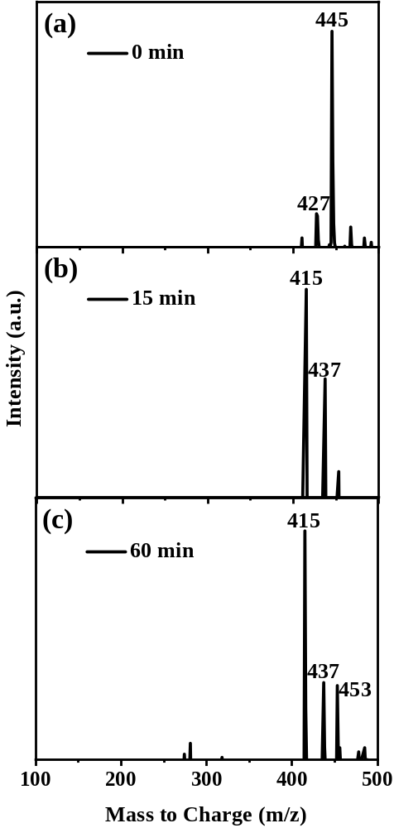
Fig. S5 LC-MS spectra of TC at 0 min (a), 15 min (b) and 60 min (c) (conditions: TC = 30.0 mg/L, dosage = 0.8 g/L, pH = 5.0).

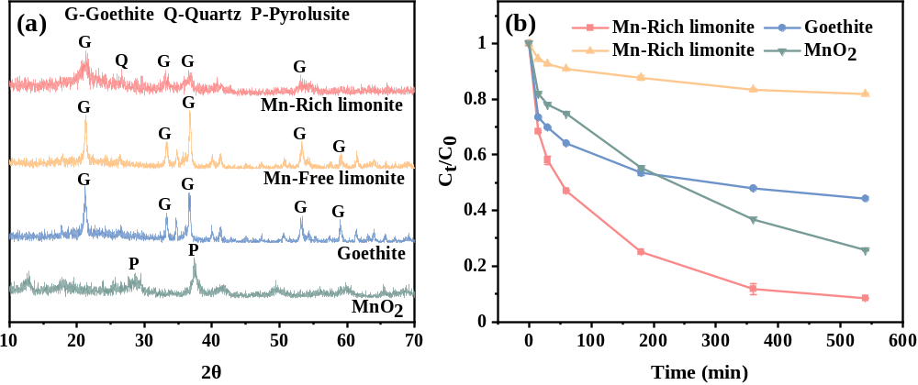
Fig. S6 XRD patterns (a) of the Mn-rich limonite, Mn-free limonite, goethite and MnO₂, and comparison of the removal performances (b) of TC by the above three materials (conditions: TC = 30.0 mg/L, dosage = 0.8 g/L, pH = 5.0).

Corresponding author at: School of Resources and Environmental Engineering, Hefei University of Technology, Hefei, 230009, China. E-mail address: chentianhu@hfut.edu.cn

