Table 1. Patient and tumor information for each treatment cohort
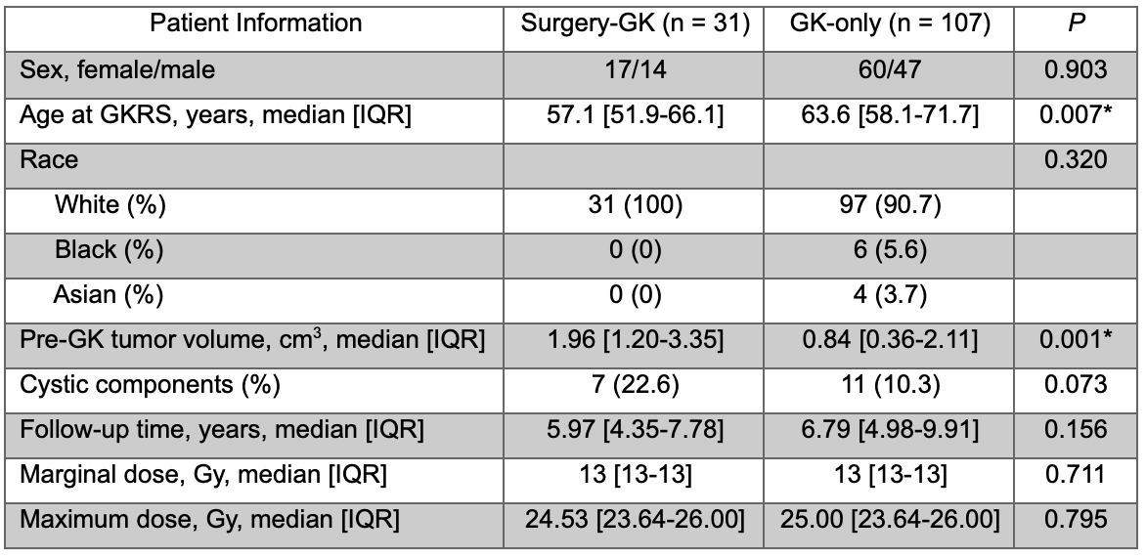
* Represents statistical significance

Table 2A. House-Brackmann grades for patients receiving surgery and subsequent GKRS
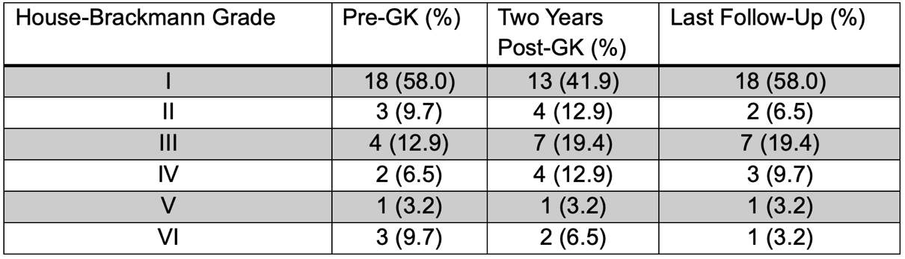

Table 2B. House-Brackmann grades for patients receiving primary GKRS
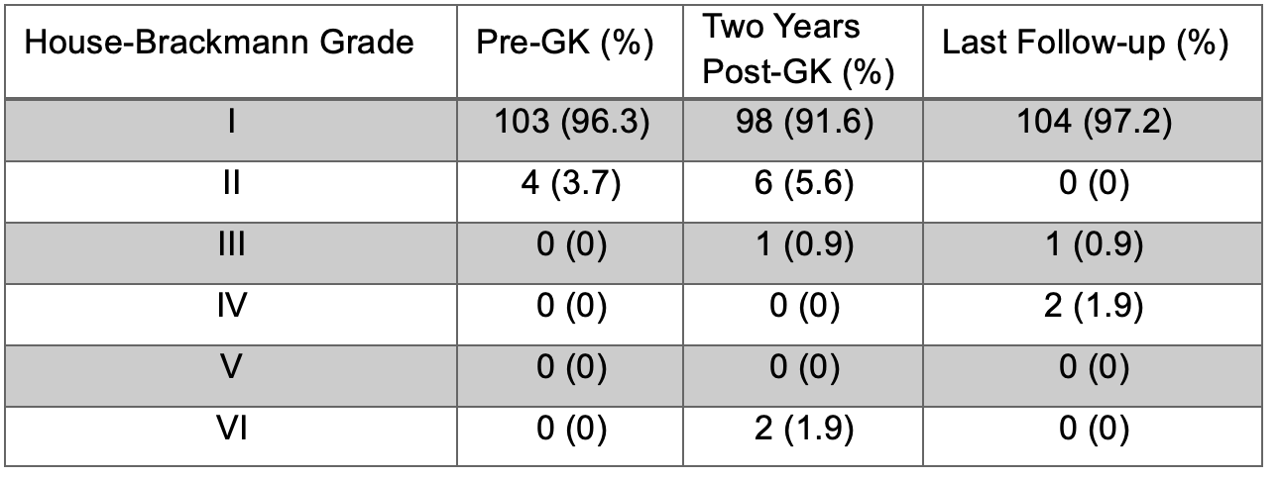

Table 3A. Regression analysis results for new or worsened facial palsy within 2 years of GKRS
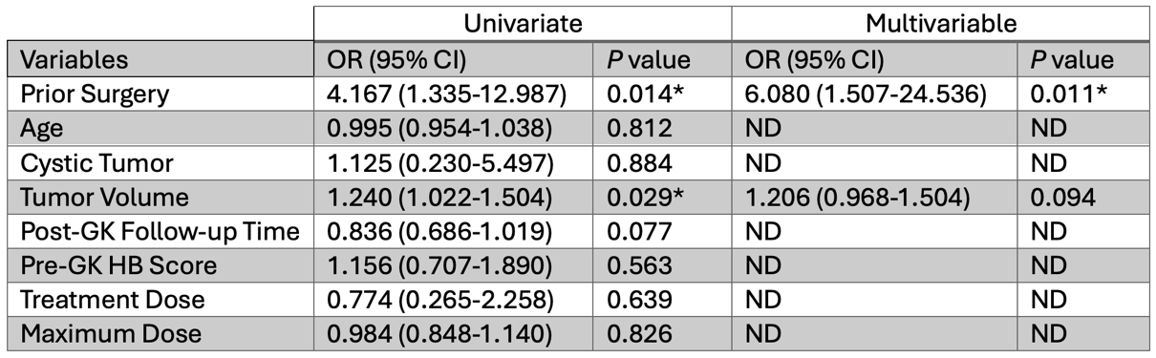
* Represents statistical significance

Table 3B. Regression analysis results for new or worsened facial palsy at last follow-up
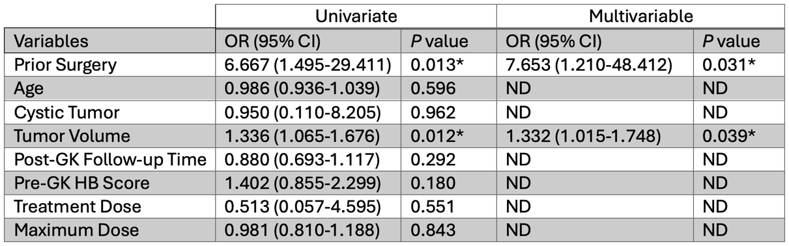
* Represents statistical significance

Table 4. Studies reporting facial nerve outcomes after GKRS in patients with history of prior surgical resection
