Supporting information
Mechanism study on enhancing solar-blind photoelectric performance of β-Ga₂O₃ via Zn-p co-doping combined with strain regulation
Jie Zhang, Huan Liu, Huimin Yu, Qingyu Hou, Yuqin Guan
School of Science, Inner Mongolia University of Technology, Hohhot 010010, China
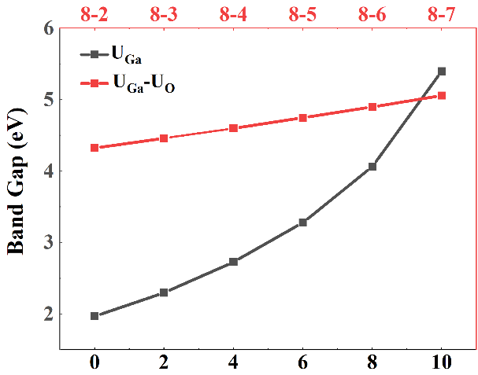
Fig. S1 Test results for the Hubbard U value.
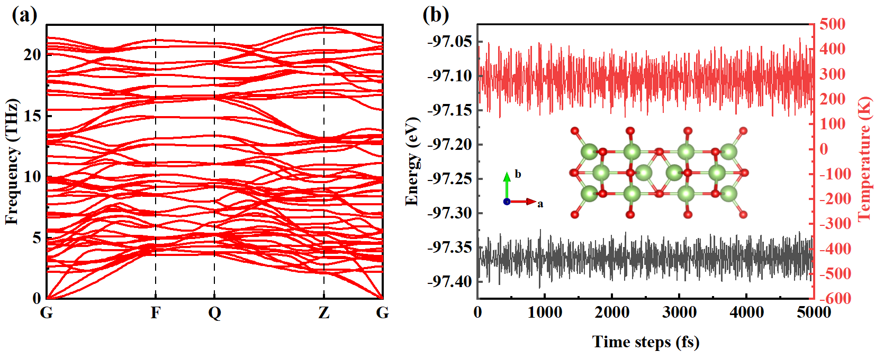
Fig. S2 (a) Phonon dispersion curves of β-Ga₂O₃; (b) Ab initio molecular dynamics simulation results of β-Ga₂O₃.
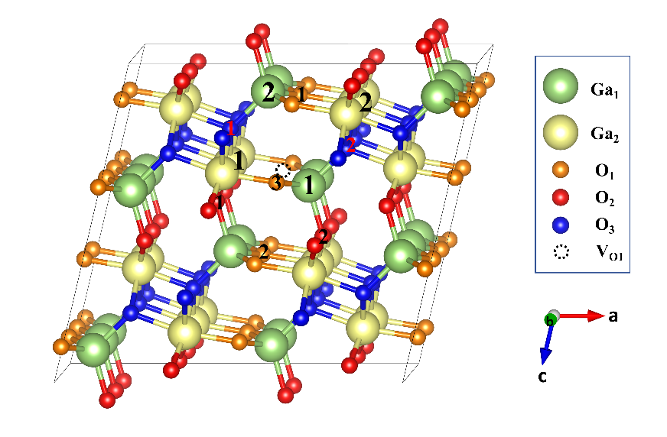
Fig. S3 Crystal structures of β-Ga₂O₃ doped systems.
Table S1 Lattice constants, cell volume, and defect formation energy of each doping system in β-Ga₂O₃.
Models | P-V_{O1}/  Zn-V_{O1}  (Å) | a  (Å) | b  (Å) | c  (Å) | β  (°) | V  (Å³) | E_{f} (eV)
 |  |  |  |  |  |  | O-rich | Ga-rich
β-Ga₂O₃ | —— | 12.45 | 3.09 | 5.88 | 103.67 | 219.46 | —— | ——
V_{O1} | —— | 12.51 | 3.09 | 5.87 | 103.55 | 219.19 | 3.88 | 0.77
V_{O2} | —— | 12.47 | 3.09 | 5.86 | 103.70 | 218.92 | 4.20 | 1.09
V_{O3} | —— | 12.41 | 3.09 | 5.88 | 103.60 | 219.11 | 4.41 | 1.31
V_{O1}-P_{O1-1} | 2.85 | 12.73 | 3.08 | 5.86 | 103.30 | 223.76 | 5.13 | −1.08
V_{O1}-P_{O1-2} | 3.03 | 12.77 | 3.10 | 5.84 | 103.59 | 224.74 | 6.54 | 0.33
V_{O1}-P_{O1-3} | 3.09 | 12.67 | 3.09 | 5.87 | 103.38 | 223.45 | 5.55 | −0.66
V_{O1}-P_{O2-1} | 2.89 | 12.53 | 3.09 | 5.93 | 103.23 | 223.13 | 6.00 | −0.21
V_{O1}-P_{O2-2} | 2.99 | 12.54 | 3.10 | 5.94 | 103.79 | 223.43 | 6.01 | −0.20
V_{O1}-P_{O3-1} | 2.94 | 12.64 | 3.10 | 5,93 | 104.28 | 224.69 | 6.15 | −0.06
V_{O1}-P_{O3-2} | 3.00 | 12.63 | 3.09 | 5.92 | 103.56 | 224.48 | 6.47 | 0.26
V_{O1}-Zn_{Ga1-1} | 1.86 | 12.55 | 3.08 | 5.88 | 103.58 | 220.82 | −0.57 | 0.98
V_{O1}-Zn_{Ga1-2} | 3.47 | 12.56 | 3.08 | 5.87 | 103.54 | 220.63 | 0.07 | 1.62
V_{O1}-Zn_{Ga2-1} | 1.97 | 12.52 | 3.08 | 5.88 | 103.52 | 220.43 | −0.30 | 1.25
V_{O1}-Zn_{Ga2-2} | 3.52 | 12.57 | 3.08 | 5.87 | 103.51 | 221.10 | 0.16 | 1.71
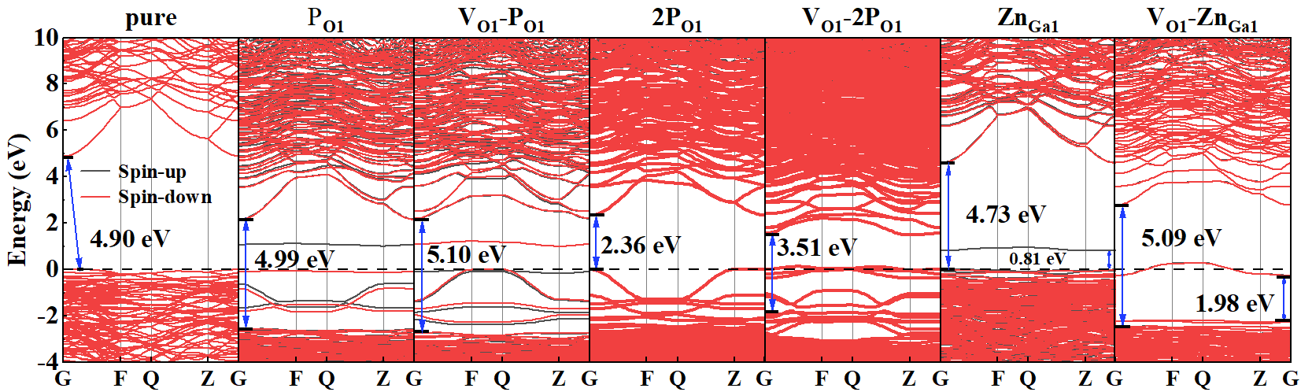
Fig. S4 Band structures of β-Ga₂O₃ for each doping system.
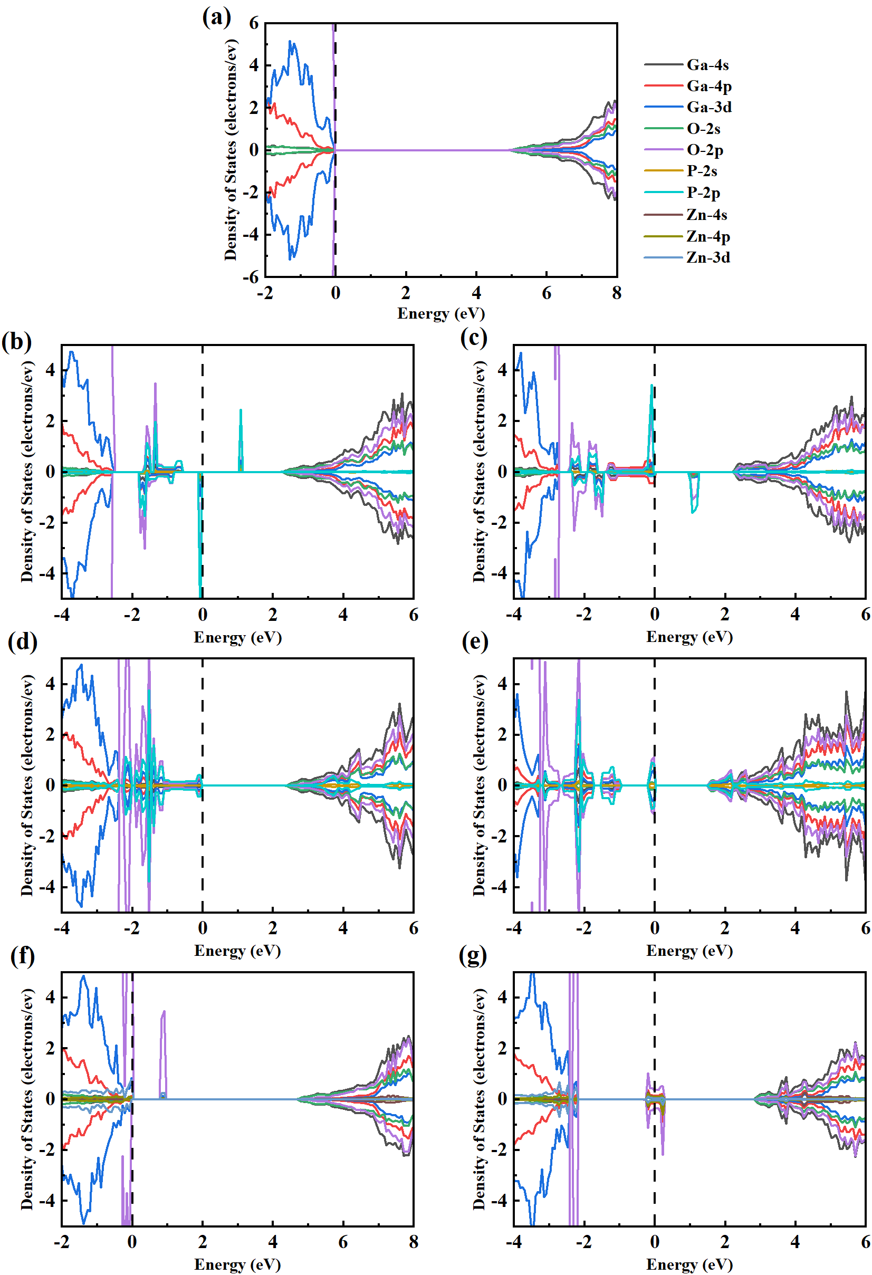
Fig. S5 Partial density of states (pdos) of β-Ga₂O₃ for each doping system: (a) Pure β-Ga₂O₃; (b) P_{O1}-doped β-Ga₂O₃; (c) V_{O1}-P_{O1}-codoped β-Ga₂O₃; (d) 2P_{O1}-doped β-Ga₂O₃; (e) V_{O1}-2P_{O1}-codoped β-Ga₂O₃; (f) Zn_{Ga1}-doped β-Ga₂O₃; (g) V_{O1}-Zn_{Ga1}-codoped β-Ga₂O₃.
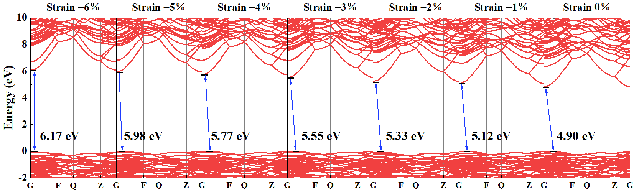
Fig. S6 Band structures of β-Ga₂O₃ under compressive strain from −6% to 0%.
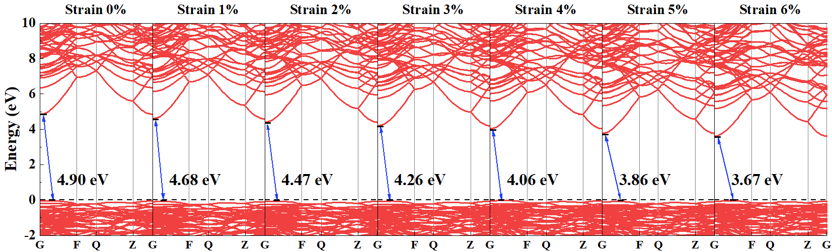
Fig. S7 Band structures of β-Ga₂O₃ under compressive strain from 0% to +6%.
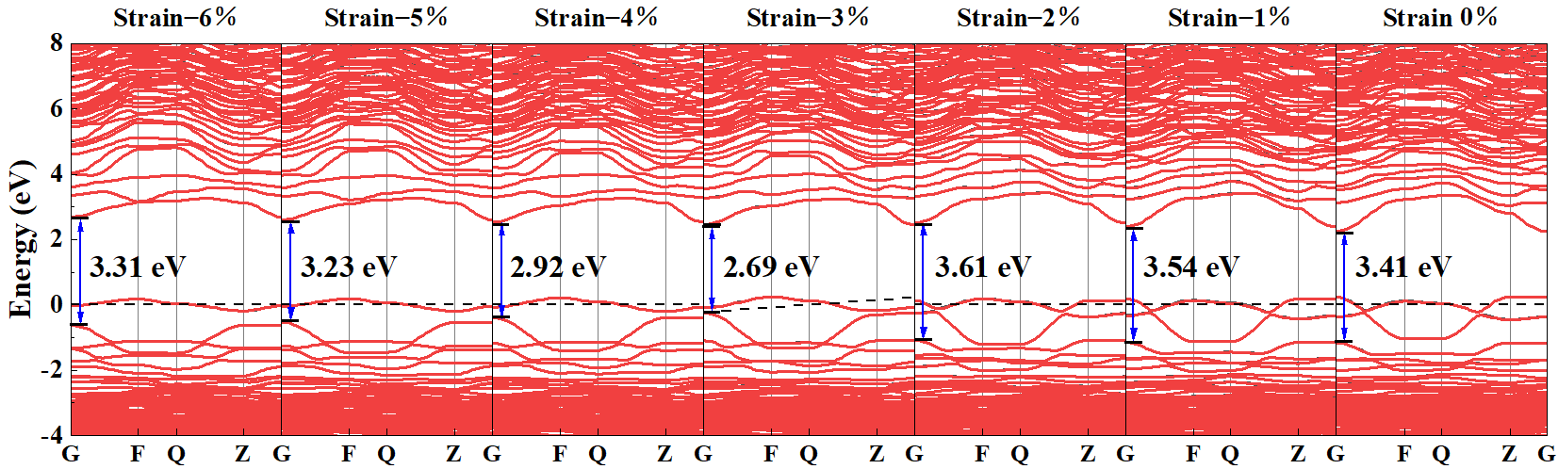
Fig.S8 Band structures of V_{O}-Zn_{Ga}-2P_{O} system in β-Ga₂O₃ under compressive strain from −6% to 0%.
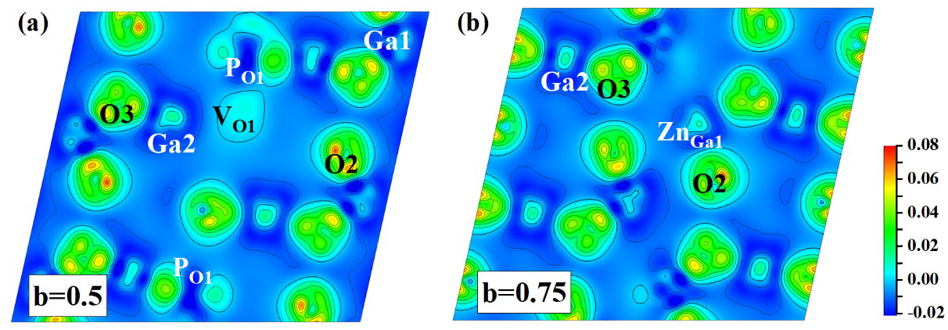
Fig. S9 Electron density distribution of V_{O}-Zn_{Ga}-2P_{O} system in β-Ga₂O₃ on the (010) plane under −0.05 compressive strain.

Corresponding author：Yuqin Guan E-mail address：gyqzlf@163.com

