LYL1 is critical for adult hematopoietic stem cell-derived B and T lymphopoiesis
Chiu SK, et al.

SUPPLEMENTARY FIGURES…………………………………………………...…………..……………2
Supplementary Figure 1. Loss of Lyl1 on hematopoiesis in adult mice……………………….…….…2
Supplementary Figure 2. Hematopoietic phenotype of Lyl1 deletion in adult HSPCs…………..……..3

Supplementary Figures
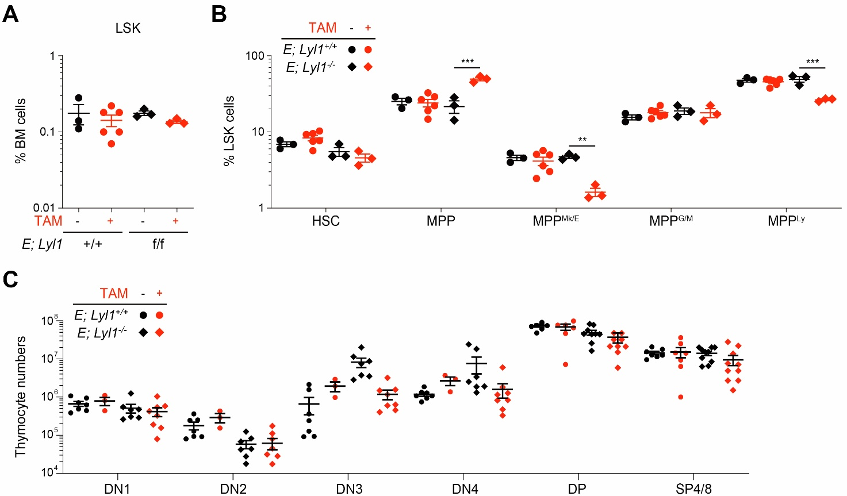
Supplementary Figure 1. Loss of Lyl1 on hematopoiesis in adult mice. Proportion of the Lineage-negative Sca-1- and Kit-positive (LSK) cells (A), and tthe different subsets of hematopoietic stem and progenitors (HSPC) in the LSK population (B), in the bone marrow (BM) of E; Lyl1^{+/+} (control) and E; Lyl1^{f/f} (Lyl1cKO) mice four weeks after treatment with tamoxifen (TAM). Hematopoietic stem cell (HSC) and multipotent progenitor (MPP) populations; megakaryocyte and erythroid biased (MPP^{Mk/E}), lymphoid-primed (MPP^{Ly}), and myeloid/granulocyte and monocyte biased (MPP^{G/M}) MPP populations. Mean ± S.E.M., 2-way ANOVA with Tukey’s correction test; **P<0.01 and ***P<0.001 compared to vehicle-treated controls. C, Absolute numbers of T-cell populations in the thymus of mice four weeks post-TAM treatment. CD4⁻CD8⁻ double-negative (DN); CD4⁺CD8⁺ double-positive (DP), CD4⁺/CD8⁺ single-positive (SP4/8) populations. Mean ± S.E.M., 2-way ANOVA with Tukey’s correction test; compared to vehicle-treated controls.

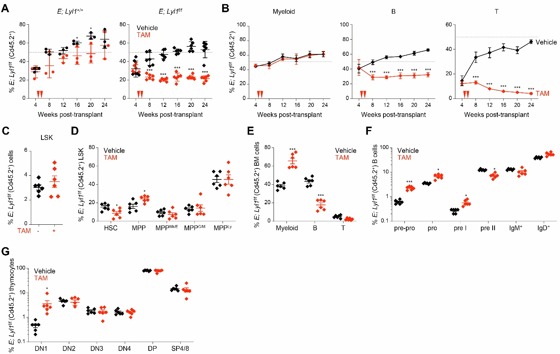
Supplementary Figure 2. Hematopoietic phenotype of Lyl1 deletion in adult HSPCs. A, Longitudinal assessment of the relative representation (%) of donor-derived (Cd45.2⁺) cells in the peripheral blood of recipients transplanted with bone marrow (BM) of E; Lyl1^{+/+} (control) and E; Lyl1^{f/f} (Lyl1cKO) mice. Dashed line represents 50% engraftment. B-C, Proportion (%) of E; Lyl1^{f/f} Lineage-negative Sca-1- and Kit-positive (LSK) cells (B), and tthe different subsets of hematopoietic stem and progenitor cells in the LSK population (C), from the BM of recipients at twenty-four weeks after transplantation. D-E, Percentage of E; Lyl1^{f/f} mature myeloid, B- and T-cells in the peripheral blood over time (D) and in the BM at twenty-four weeks after transplantation (E). Dashed line represents 50% engraftment. F-G, Relative representation (%) of donor-derived E; Lyl1^{f/f} B-cell populations in the BM (F), and T-cell populations in the thymus (G) of recipients at twenty-four weeks after transplantation. Tamoxifen (TAM); hematopoietic stem cell (HSC) and multipotent progenitor (MPP) populations; megakaryocyte and erythroid biased (MPP^{Mk/E}), lymphoid-primed (MPP^{Ly}), and myeloid/granulocyte and monocyte biased (MPP^{G/M}) MPP populations; CD4⁻CD8⁻ double-negative (DN); CD4⁺CD8⁺ double-positive (DP), CD4⁺/CD8⁺ single-positive (SP4/8) populations. Mean ± S.E.M., 2-way ANOVA with Tukey’s correction test; *P<0.05, **P<0.01 and ***P<0.001 compared to vehicle-treated controls.

