Supplementary Materials

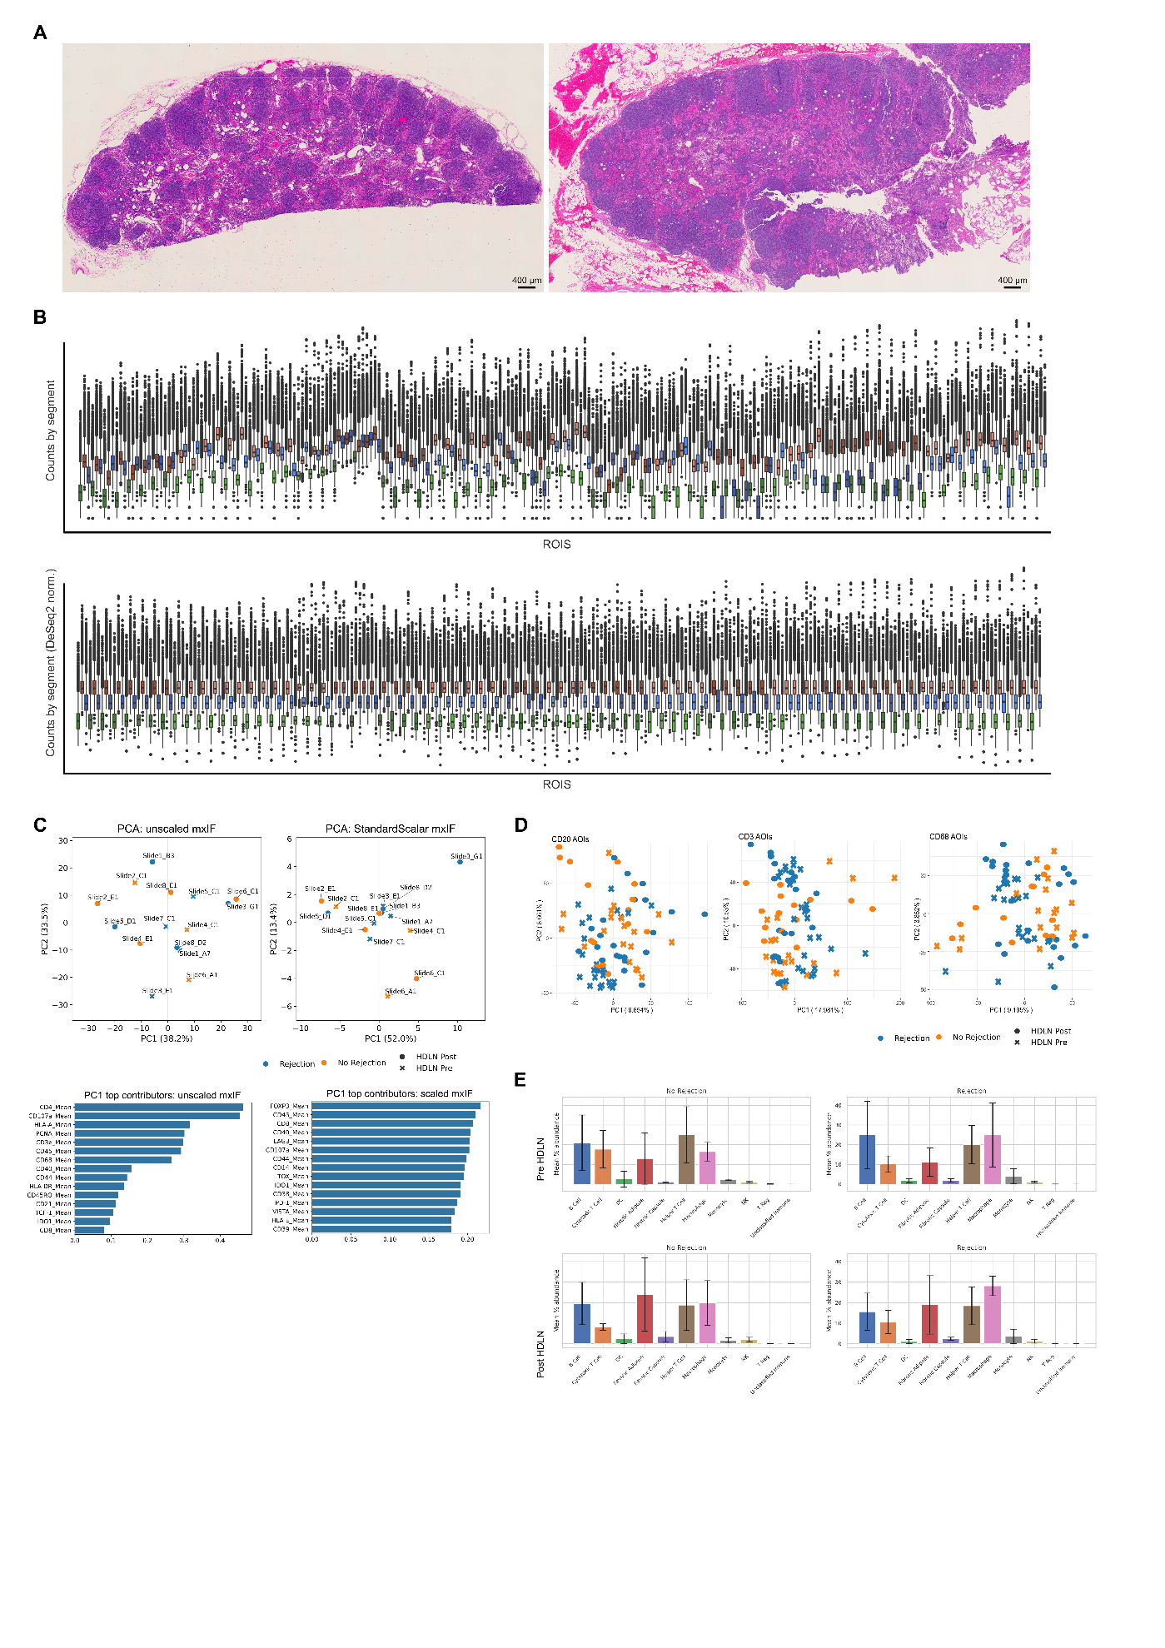

Supplementary Materials Figure 1. WTA and MxIF validation
A. Whole-slide H&E from one case: pre-HDLN (left) vs. post-HDLN (right). B. GeoMx WTA counts per ROI: raw (top) and DESeq2-normalized (bottom). C. PCA of the 35-marker MxIF features before (left) and after (right) z-score scaling. D. PCA of scaled GeoMx WTA expression, shown by sequenced (antibody-defined) compartment. E. MxIF-derived cell-type composition comparing pre- vs. post-HDLN, stratified by outcome (rejection vs. non-rejection). Error bars show per-case standard deviation.
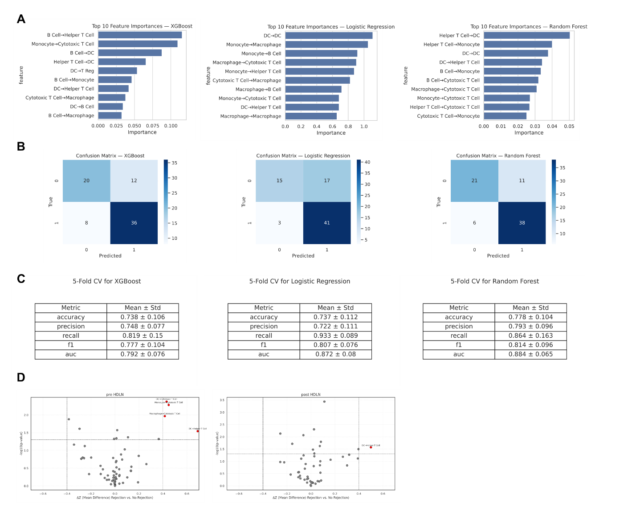
Supplementary Materials Figure 2. Machine learning and differential analysis of spatial-interaction z-scores
A. Feature importances from XGBoost, logistic regression, and random forest models trained on spatial-interaction z-score features with 5-fold cross-validation. B. Confusion matrices for the best-performing model across folds. C. Performance metrics across 5-fold CV (per-fold standard deviations are reported). D. Differential interaction analysis using z-scores: rejection vs. non-rejection within pre-HDLN (left) and post-HDLN (right).
Supplementary Table 1. Cases by diagnosis, slide, and outcome
Supplementary Table 2. MxIF panel information
Supplementary Table 3. Hypothesis-driven ORA gene sets

