Suppl. Figure 1: Relationship of a) sensitivity (true positive rate, i.e. hit rate) and b) precision (predicted positive value, i.e. the model’s ability not to overestimate hits) as a function of narrowing the focus from the whole study (all) to site to traps, , separately for the taxonomic levels of species (solid lines) and genera (dotted lines) for Syrphidae (blue), Auchenorrhyncha (orange), and Orthoptera (green).

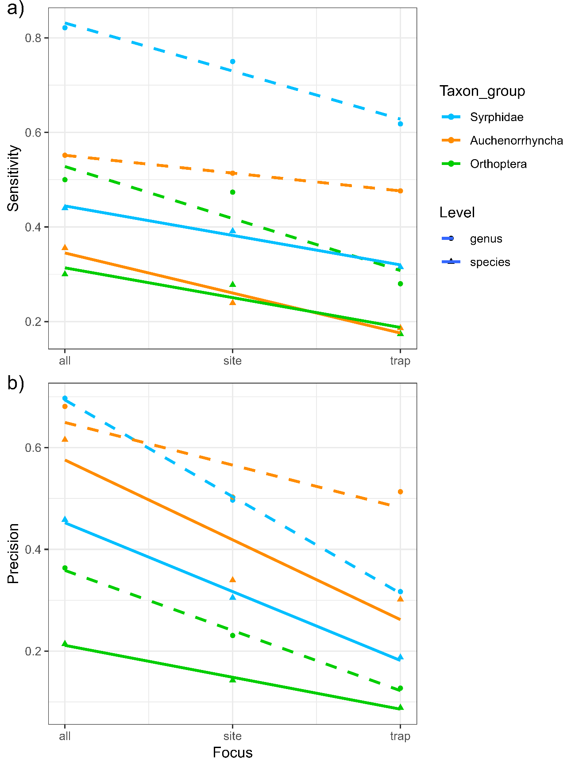

Suppl. Table 1: Metabarcording species list https://1drv.ms/x/c/578dc22e678997ce/EY1QQtzIZSBKi6bN_AfmLowB_bgZI1G3CrK5Jr62lhEowg?e=FznCZo

Suppl. Table 2: Statistical test of the relationship of species numbers determined by metabarcoding versus morphology

2a: Testing a 1:1 relationship of species numbers determined by metabarcoding against morphology across all taxon groups and separately for Syrphidae, Auchenorrhyncha and Orthoptera.
without Intercept (1:1 relationship)
 | estimate | SE | Statistics | P value | lower CI | upper CI
All | 0.83 | 0.05 | 16.5 | < 0.001 | 0.73 | 0.94
Syrphidae | 1.29 | 0.11 | 12.3 | < 0.001 | 1.08 | 1.5
Auchenorrhyncha | 0.53 | 0.035 | 15.3 | < 0.001 | 0.46 | 0.6
Orthoptera | 0.96 | 0.44 | 2.16 | 0.053 | -0.017 | 1.93

2b: Mixed effects models (lmer) accounting for differences between sites.
 |  | estimate | SE | df | t value Pr(>|t|) | P value
All | intercept | 10.14 | 1.95 | 14.31 | 5.21 | < 0.001
 | slope | 0.16 | 0.096 | 56.98 | 1.62 | 0.11
Syrphidae | intercept | 5.25 | 0.81 | 18.09 | 6.49 | < 0.001
 | slope | 0.26 | 0.13 | 55.68 | 2.07 | 0.044
Auchenorrhyncha | intercept | 4.59 | 1.09 | 12.20 | 4.20 | < 0.001
 | slope | 0.060 | 0.072 | 57.26 | 0.84 | 0.41
Orthoptera | intercept | 0.69 | 0.15 | 13.24 | 4.71 | < 0.001
 | slope | 0.14 | 0.16 | 53.77 | 0.92 | 0.36

Suppl. Table 3: Study sites across Germany with the numbers representing the Nature protected area (NSG), is abbreviation used in the manuscript along the selected sampling period of the second halve of May 2020.
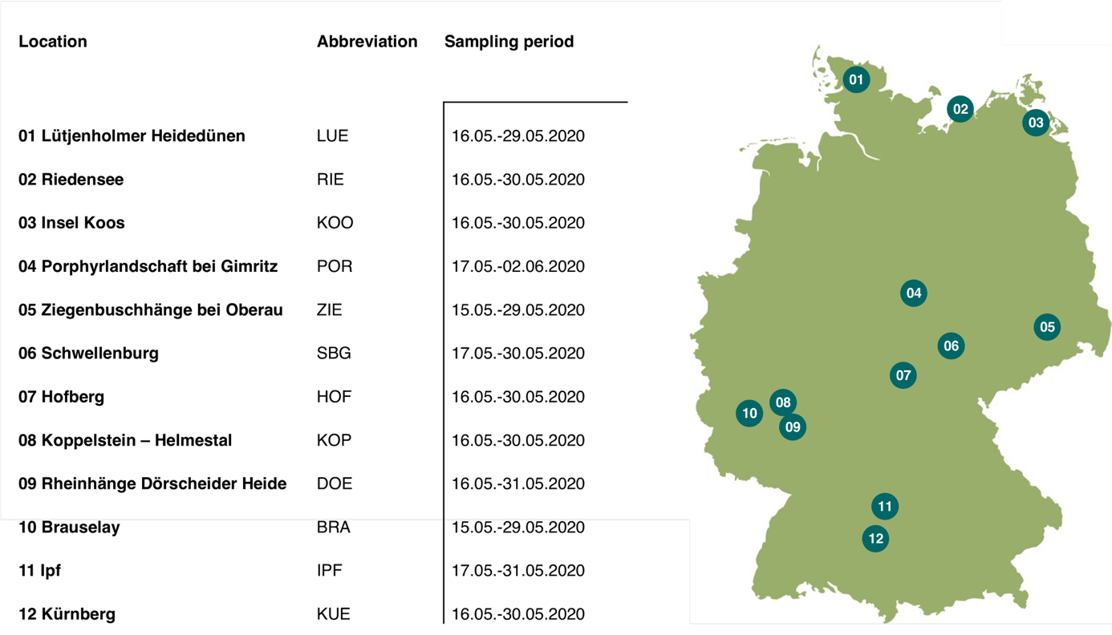

Suppl. Table 4: Number of species per site (transect with five traps) identified by metabarcoding, by morphology, their congruence for single traps and sites (TP = true positives, TN = true negatives, FP = false positives, FN = false negatives), as well as the confusion matrix values (Sensitivity, specific, precision, accuracy, error rate and F1 score) for sites.

Suppl. Table 4a: Syrphidae
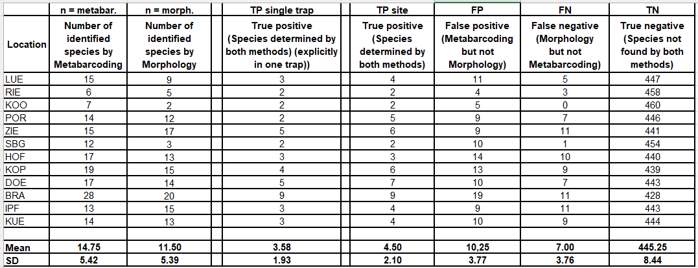
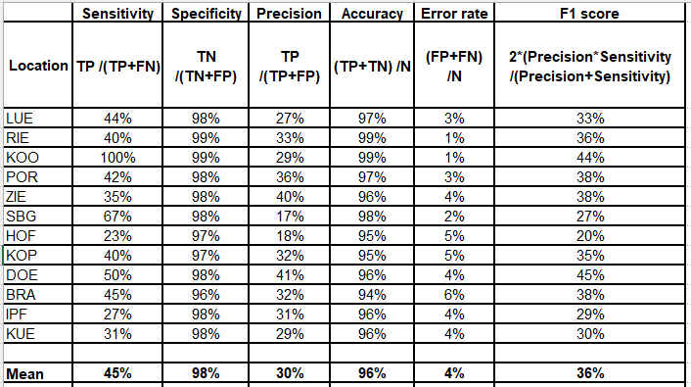

Suppl. Table 4b: Auchenorrhyncha

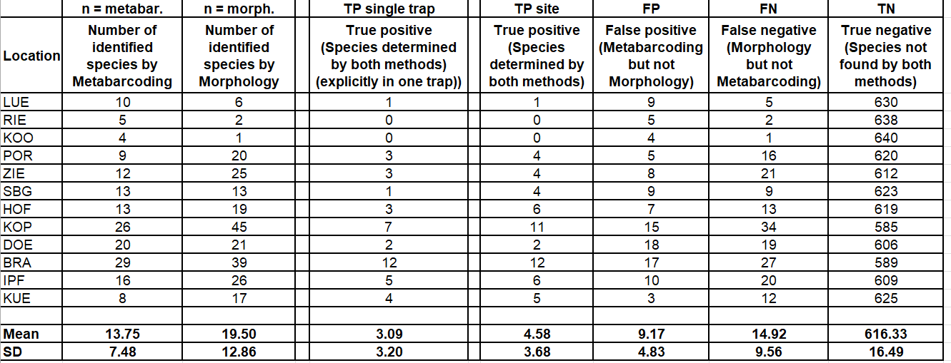
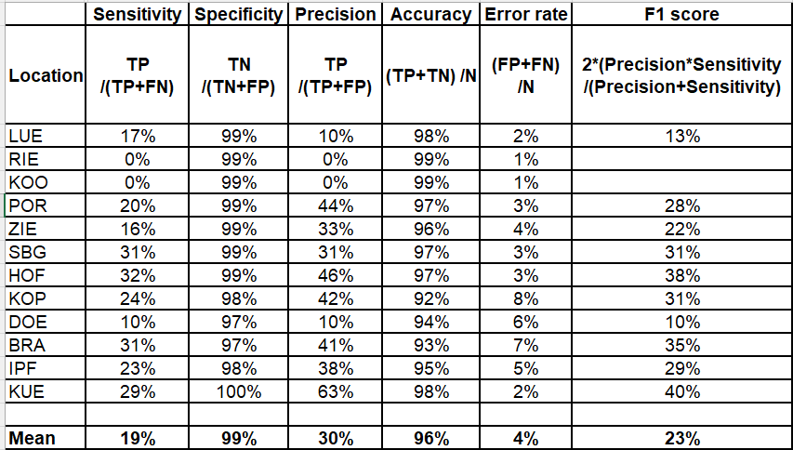

Suppl. Table 4c: Orthoptera

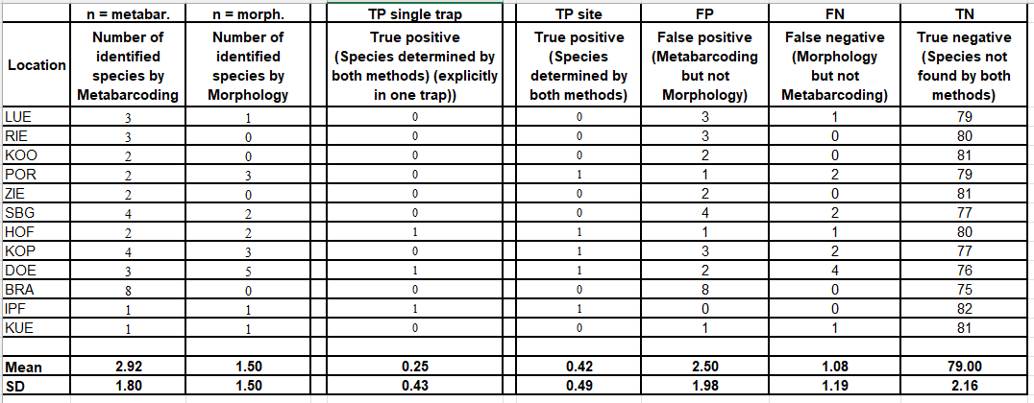
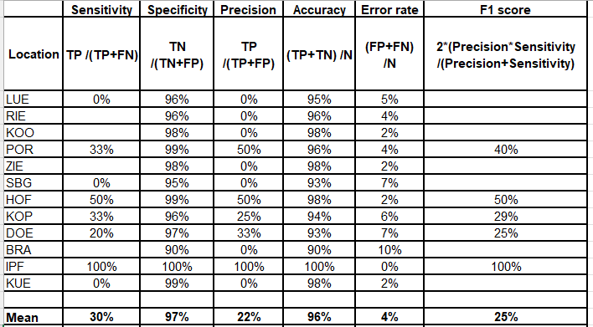

Suppl. Table 5: Confusion matrices
 | Species level
 | 1.1 Confusion matrix based on 60 malaise traps, based on the species level and single trap matches
 |  | Sensitivity | Specificity | Precision | Accuracy | Error rate | F1 score
 |  | / % | / % | / % | / % | %
 |  | TP /(TP+FN) | TN /(TN+FP) | TP /(TP+FP) | (TP+TN) /N | (FP+FN)/N
single trap | Syrphidae | 31.53% | 93.38% | 18.77% | 90.52% | 9.48% | 0.24
single trap | Orthoptera | 17.39% | 96.98% | 8.89% | 95.65% | 4.35% | 0.12
single trap | Auchenorrhyncha | 18.62% | 96.85% | 30.16% | 91.53% | 8.47% | 0.23
 | 1.2 Confusion matrix based on 60 malaise traps, based on the species level and matches across the 5 traps
 |  | Sensitivity | Specificity | Precision | Accuracy | Error rate | F1 score
 |  | / % | / % | / % | / % | %
 |  | TP /(TP+FN) | TN /(TN+FP) | TP /(TP+FP) | (TP+TN) /N | (FP+FN)/N
single site | Syrphidae | 39.13% | 85.04% | 30.51% | 78.44% | 21.56% | 0.34
single site | Orthoptera | 27.78% | 88.37% | 14.29% | 84.42% | 15.58% | 0.19
single site | Auchenorrhyncha | 23.93% | 90.96% | 33.94% | 80.07% | 20.18% | 0.28
 | 1.3 Confusion matrix based on 60 malaise traps, based on the species level and matches across all sites
 |  | Sensitivity | Specificity | Precision | Accuracy | Error rate | F1 score
 |  | / % | / % | / % | / % | %
 |  | TP /(TP+FN) | TN /(TN+FP) | TP /(TP+FP) | (TP+TN) /N | (FP+FN)/N
all sites | Syrphidae | 44.00% | 13.33% | 45.83% | 32.50% | 67.50% | 0.45
all sites | Orthoptera | 30.00% | 15.38% | 21.43% | 21.74% | 78.26% | 0.25
all sites | Auchenorrhyncha | 35.56% | 33.33% | 61.54% | 35.00% | 65.00% | 0.45

Genus level
2.1 Confusion matrix based on 60 malaise traps, based on the genus level and single trap matches
 | Sensitivity | Specificity | Precision | Accuracy | Error rate | F1 score
 | / % | / % | / % | / % | %
 | TP /(TP+FN) | TN /(TN+FP) | TP /(TP+FP) | (TP+TN) /N | (FP+FN)/N
Syrphidae | 61.81% | 88.28% | 31.70% | 86.14% | 13.86% | 0.42
Orthoptera | 28.00% | 94.87% | 12.73% | 93.12% | 6.88% | 0.18
Auchenorrhyncha | 47.64% | 95.39% | 51.33% | 90.96% | 9.04% | 0.49
2.2 Confusion matrix based on 60 malaise traps, based on the genus level and matches across the 5 traps
 | Sensitivity | Specificity | Precision | Accuracy | Error rate | F1 score
 | / % | / % | / % | / % | %
 | TP /(TP+FN) | TN /(TN+FP) | TP /(TP+FP) | (TP+TN) /N | (FP+FN)/N
Syrphidae | 75.00% | 78.65% | 49.69% | 77.85% | 22.15% | 0.60
Orthoptera | 47.37% | 82.66% | 23.08% | 79.17% | 20.83% | 0.31
Auchenorrhyncha | 51.38% | 88.19% | 50.27% | 81.25% | 18.75% | 0.51
2.3 Confusion matrix based on 60 malaise traps, based on the genus level and matches across all sites
 | Sensitivity | Specificity | Precision | Accuracy | Error rate | F1 score
 | / % | / % | / % | / % | %
 | TP /(TP+FN) | TN /(TN+FP) | TP /(TP+FP) | (TP+TN) /N | (FP+FN)/N
Syrphidae | 82.14% | 23.08% | 69.70% | 63.41% | 36.59% | 0.75
Orthoptera | 50.00% | 12.50% | 36.36% | 31.25% | 68.75% | 0.42
Auchenorrhyncha | 55.17% | 31.82% | 68.09% | 48.75% | 51.25% | 0.61

Family level
3.1 Confusion matrix based on 60 malaise traps, based on the family level and single trap matches
 | Sensitivity | Specificity | Precision | Accuracy | Error rate | F1 score
 | / % | / % | / % | / % | %
 | TP /(TP+FN) | TN /(TN+FP) | TP /(TP+FP) | (TP+TN) /N | (FP+FN)/N
Syrphidae | NA | NA | NA | NA | NA
Orthoptera | 69.23% | 80.62% | 16.98% | 80.00% | 20.00% | 0.27
Auchenorrhyncha | 72.55% | 88.58% | 59.68% | 85.56% | 14.44% | 0.65
3.2 Confusion matrix based on 60 malaise traps, based on the family level and matches across the 5 traps
 | Sensitivity | Specificity | Precision | Accuracy | Error rate | F1 score
 | / % | / % | / % | / % | %
 | TP /(TP+FN) | TN /(TN+FP) | TP /(TP+FP) | (TP+TN) /N | (FP+FN)/N
Syrphidae | NA | NA | NA | NA | NA
Orthoptera | 92.86% | 54.35% | 38.24% | 63.33% | 36.67% | 0.54
Auchenorrhyncha | 79.41% | 78.38% | 62.79% | 78.70% | 21.30% | 0.70
3.3 Confusion matrix based on 60 malaise traps, based on the family level and matches across all sites
 | Sensitivity | Specificity | Precision | Accuracy | Error rate | F1 score
 | / % | / % | / % | / % | %
 | TP /(TP+FN) | TN /(TN+FP) | TP /(TP+FP) | (TP+TN) /N | (FP+FN)/N
Syrphidae | NA | NA | NA | NA | NA
Orthoptera | NA | NA | NA | NA | NA
Auchenorrhyncha | 57.14% | 0% | 66.67% | 44.44% | 55.56% | 0.62

Suppl. Table 6: Species of Syrphidae, Auchenorrhyncha and Orthoptera listed on the German Red List (RL) and detected by DNA metabarcoding and/or morphological identification. RL categories: 2 = highly threatened, 3= threatened, G = threat of unknown extent, R = extremely rare, V = near threatened. Matches between Metabarcoding and Morphological Determination are analyzed on the focus of all sites combined.

Order | Family | Taxon | RL category | DNA | Morphology
Diptera | Syrphidae | Brachymyia floccosa | G | x
Diptera | Syrphidae | Brachyopa scutellaris | V | x
Diptera | Syrphidae | Cheilosia aerea | G | x
Diptera | Syrphidae | Eumerus tricolor | 3 | x | x
Diptera | Syrphidae | Meligramma guttatum | G |  | x
Diptera | Syrphidae | Microdon devius | V |  | x
Diptera | Syrphidae | Paragus albifrons | 3 | x | x
Diptera | Syrphidae | Paragus bicolor | V | x
Diptera | Syrphidae | Paragus finitimus | G |  | x
Diptera | Syrphidae | Pipizella zeneggenensis | V |  | x
 |  |  | 10 | 6 | 6
Orthoptera | Acrididae | Chorthippus vagans | 3 | x
Orthoptera | Acrididae | Myrmeleotettix maculatus | V |  | x
Orthoptera | Acrididae | Pseudochorthippus montanus | 3 | x
Orthoptera | Tetrigidae | Tetrix tenuicornis | V | x
Orthoptera | Tettigoniidae | Decticus verrucivorus | 3 | x
Orthoptera | Tettigoniidae | Metrioptera brachyptera | V |  | x
 |  |  | 6 | 4 | 2
Auchenorrhyncha | Aphrophoridae | Lepyronia coleoptrata | V | x
Auchenorrhyncha | Cercopidae | Cercopis sanguinolenta | 3 | x
Auchenorrhyncha | Cicadellidae | Arboridia pusilla | 3 | x
Auchenorrhyncha | Cicadellidae | Edwardsiana ulmiphagus | V |  | x
Auchenorrhyncha | Cicadellidae | Eupelix cuspidate | V | x | x
Auchenorrhyncha | Cicadellidae | Eupteryx adspersa | 3 | x | x
Auchenorrhyncha | Cicadellidae | Eupteryx origani | 2 | x
Auchenorrhyncha | Cicadellidae | Eupteryx tenella | V | x
Auchenorrhyncha | Cicadellidae | Megophthalmus scabripennis | R | x | x
Auchenorrhyncha | Cicadellidae | Penthimia nigra | 3 | x
Auchenorrhyncha | Cicadellidae | Planaphrodes trifasciata | 3 |  | x
Auchenorrhyncha | Cicadellidae | Psammotettix cephalotes | 3 | x
Auchenorrhyncha | Cicadellidae | Rhopalopyx vitripennis | V | x
Auchenorrhyncha | Cicadellidae | Zygina nigritarsis | 2 | x
Auchenorrhyncha | Cicadellidae | Zygina rubrovittata | 3 | x | x
Auchenorrhyncha | Cicadellidae | Zygina suavis | V | x
Auchenorrhyncha | Cicadidae | Cicadetta montana | G | x
Auchenorrhyncha | Cixiidae | Cixius cambricus | 3 | x
Auchenorrhyncha | Cixiidae | Cixius similis | 2 |  | x
Auchenorrhyncha | Cixiidae | Pentastiridius leporinus | 3 |  | x
Auchenorrhyncha | Cixiidae | Reptalus panzer | 3 | x | x
Auchenorrhyncha | Delphacidae | Delphacinus mesomelas | 2 |  | x
Auchenorrhyncha | Delphacidae | Kelisia sabulicola | 2 |  | x
Auchenorrhyncha | Delphacidae | Xantodelphax straminea | V | x
Auchenorrhyncha | Dictyopharidae | Dictyophara europaea | 3 |  | x
Auchenorrhyncha | Tettigometridae | Tettigometra impressopunctata | 2 |  | x
 |  |  | 26 | 18 | 13

