Supplemental Online Material
Eosinopenia Predicts Prognosis in Severe Community-Acquired Pneumonia

Catia Cillóniz^{1,2,5*}, Tatiana Castañeda⁴*, Antonio Campanella³, Riccardo Guglielmi³, Albert Gabarrús¹, Sara Granero⁷, Cristina Calvo-García⁷ Maria Angeles Marcos⁶, Antoni Torres^{1,2,4}
¹ August Pi i Sunyer Biomedical Research Institute–IDIBAPS, Barcelona, Spain.
² Ciber de Enfermedades Respiratorias (CIBERES), Barcelona, Spain
³ Department of Medical –Surgical Sciences and Translational Medicine, Sapienza University of Rome, Italy
⁴ University of Barcelona, Barcelona, Spain
⁵ Faculty of Health Sciences, Continental University, Huancayo, Peru
⁶ Microbiology Department, Hospital Clinic of Barcelona, Spain
⁷Respiratory Intensive Care Unit, Hospital Clinic of Barcelona, Spain
*Equal contribution as first author

Correspondence: Prof. Antoni Torres (primary) or Dr Catia Cillóniz (alternative)
August Pi i Sunyer Biomedical Research Institute–IDIBAPS
C/ Villarroel 170, 08036 Barcelona, Spain
Tel: (+34) 93-227-5779
Email: atorres@recerca.clinic.cat (primary) or cilloniz@recerca.clinic.cat (alternative)

Data collection, evaluation, and microbiological diagnosis
The aetiology was considered definite if one of the following criteria was met: (1) a positive blood culture (in the absence of an apparent extra-pulmonary focus); (2) a positive bacterial culture of pleural fluid or transthoracic needle aspiration samples; (3) elevated serum levels of IgM against Chlamydophila pneumoniae (≥1:64), Coxiella burnetii (≥1:80) and Mycoplasma pneumoniae (any positive titre); (4) seroconversion (i.e., a fourfold increase in IgG titres) for C. pneumoniae and L. pneumophila > 1:128, C. burnetii > 1:80 and respiratory viruses (influenza viruses A and B, parainfluenza viruses 1–3, respiratory syncytial virus, adenovirus); (5) positive urinary antigen for L. pneumophila (Binax Now L. pneumophila urinary Antigen Test; Trinity Biotech, Bray, Ireland); (6) positive urinary antigen for S. pneumoniae (Binax Now Streptococcus pneumoniae urinary Antigen Test; Emergo Europe, The Hague, The Netherlands); (7) bacterial growth in cultures of TBAS (≥105 cfu/ml), in protected specimen brush (≥103 cfu/ml), and BAL (≥104 cfu/ml); (8) detection of antigens by IFA plus virus isolation or detection by reverse transcriptase polymerase chain reaction (RT-PCR) testing for respiratory virus (influenza viruses A and B, parainfluenza virus 1–3, respiratory syncytial virus, rhinovirus, adenovirus).
The aetiology of pneumonia was classified as presumptive when a predominant microorganism was isolated from a purulent sample (leukocytes > 25 per high power microscopic field and few epithelial cells < 10 per high power microscopic field) and the findings of Gram staining were compatible. For the purpose of this study, presumptive and definitive diagnoses were analyzed together.

Supplementary Table 1. Linear regression analyses showing the association of log-transformed eosinophil counts with lymphocyte, leukocyte, neutrophil, and C-reactive protein levels, including interaction with systemic corticosteroid use
model | dependent.variable | term | estimate | std.error | statistic | p.value
1 | Log10(Lymphocytes [×10⁹/L] + 0.01) | (Intercept) | 3.092228074 | 0.042458026 | 72.83023615 | <0.001
 |  | log_eosinof1 | 0.218534696 | 0.032230242 | 6.78042374 | <0.001
 |  | cortisistrSí | 0.225585952 | 0.139947414 | 1.611933694 | 0.108
 |  | log_eosinof1:cortisistrSí | 0.185167987 | 0.117736554 | 1.572731508 | 0.116
2 | Log10(Leukocytes [×10⁹/L] + 0.01) | (Intercept) | 4.291530862 | 0.036102543 | 118.8705976 | <0.001
 |  | log_eosinof1 | 0.247125393 | 0.027405741 | 9.017285422 | <0.001
 |  | cortisistrSí | 0.103826544 | 0.118998879 | 0.872500184 | 0.383
 |  | log_eosinof1:cortisistrSí | 0.027457321 | 0.100112732 | 0.274264032 | 0.784
3 | Log10(Neutrophils [×10⁹/L] + 0.01) | (Intercept) | 4.197862899 | 0.041763766 | 100.5144729 | <0.001
 |  | log_eosinof1 | 0.25189149 | 0.031941487 | 7.886029034 | <0.001
 |  | cortisistrSí | 0.076041869 | 0.137172948 | 0.55435033 | 0.580
 |  | log_eosinof1:cortisistrSí | -0.010644498 | 0.115460389 | -0.09219177 | 0.927
4 | Log10(C-reactive protein [mg/L] + 0.01) | (Intercept) | 1.11635808 | 0.045557602 | 24.50432044 | <0.001
 |  | log_eosinof1 | -0.065763148 | 0.034176726 | -1.924208536 | 0.055
 |  | cortisistrSí | -0.143217614 | 0.154960323 | -0.924221184 | 0.356
 |  | log_eosinof1:cortisistrSí | 0.085300757 | 0.126986379 | 0.671731544 | 0.502

Linear regression models were fitted with log-transformed eosinophil counts (log₁₀[eosinophils + 0.01]) as the main independent variable. Dependent variables were the log-transformed counts of lymphocytes, leukocytes, neutrophils, and C-reactive protein (CRP). An interaction term between eosinophil counts and systemic corticosteroid use was included to evaluate potential effect modification. Positive coefficients indicate a direct association between eosinophil counts and the corresponding hematological parameter. p-values <0.05 were considered statistically significant.

Supplementary Table 2. Internal validation of the prediction model for 30-day mortality using nonparametric bootstrap technique
Variable | Original | Bias | SE | P-value | 95% BCa CI
Age ≥65 years | 1.072 | 0.035 | 0.302 | 0.001 | 0.513 to 1.774
Chronic liver disease | 1.163 | -0.006 | 0.341 | 0.001 | 0.441 to 1.823
Fever | -0.486 | 0.014 | 0.252 | 0.044 | -1.006 to 0.038
Eosinopenia (<0.05 x10⁹/L) | 0.681 | 0.014 | 0.250 | 0.005 | 0.193 to 1.198
Abbreviations. BCa indicates adjusted bootstrap; CI, confidence interval; SE, standard error.

Supplementary Figure 1
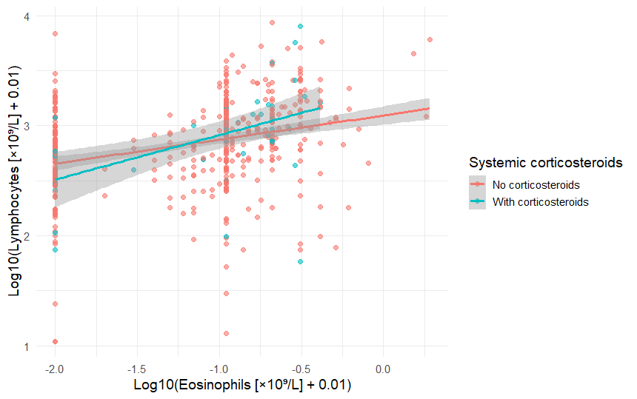

Supplementary Figure 2
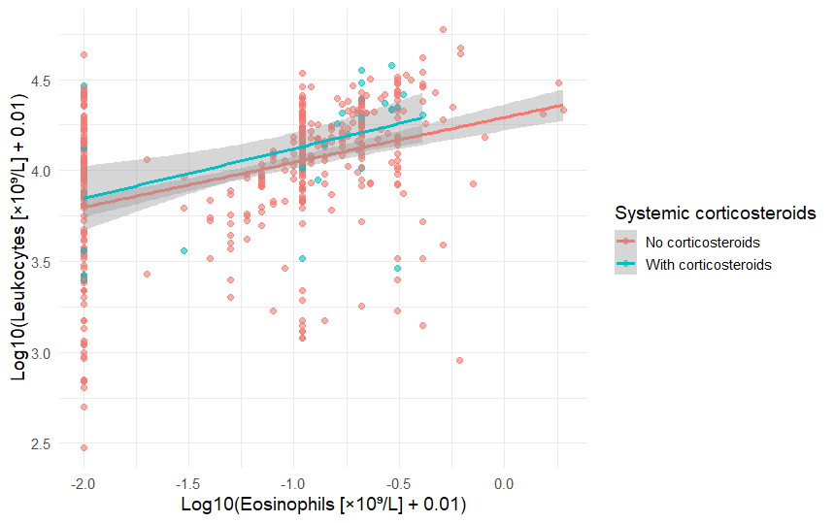

Supplementary Figure 3
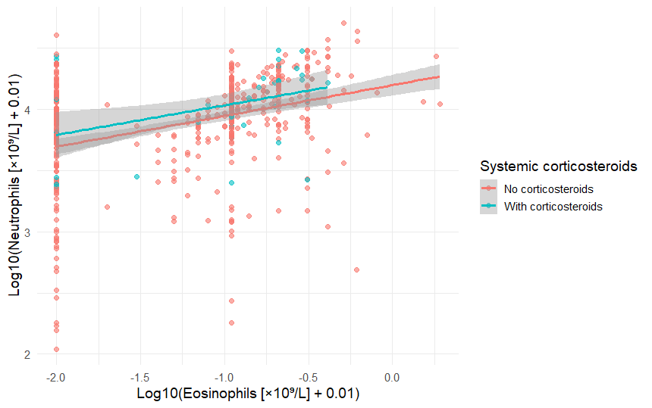

Supplementary Figure 4
