Supporting Information
Construction of paper-based long-life room temperature phosphorescence probe for tetracycline detection using nitrogen and phosphorus co doped corn whiskers carbon dots

Yuting Xu, Yuxin Zheng, Kamile Arkin, Xue Jiang, Kexin Li, Qingkun Shang *
School of Chemistry, Northeast Normal University, Changchun, 130024

*Corresponding author: Prof. Qingkun Shang, shangqk995@nenu.edu.cn

Figure S1. The XPS high-resolution P 2p (a) and B 1s (b) spectra of NP-CDs and NP-CDs@matrix
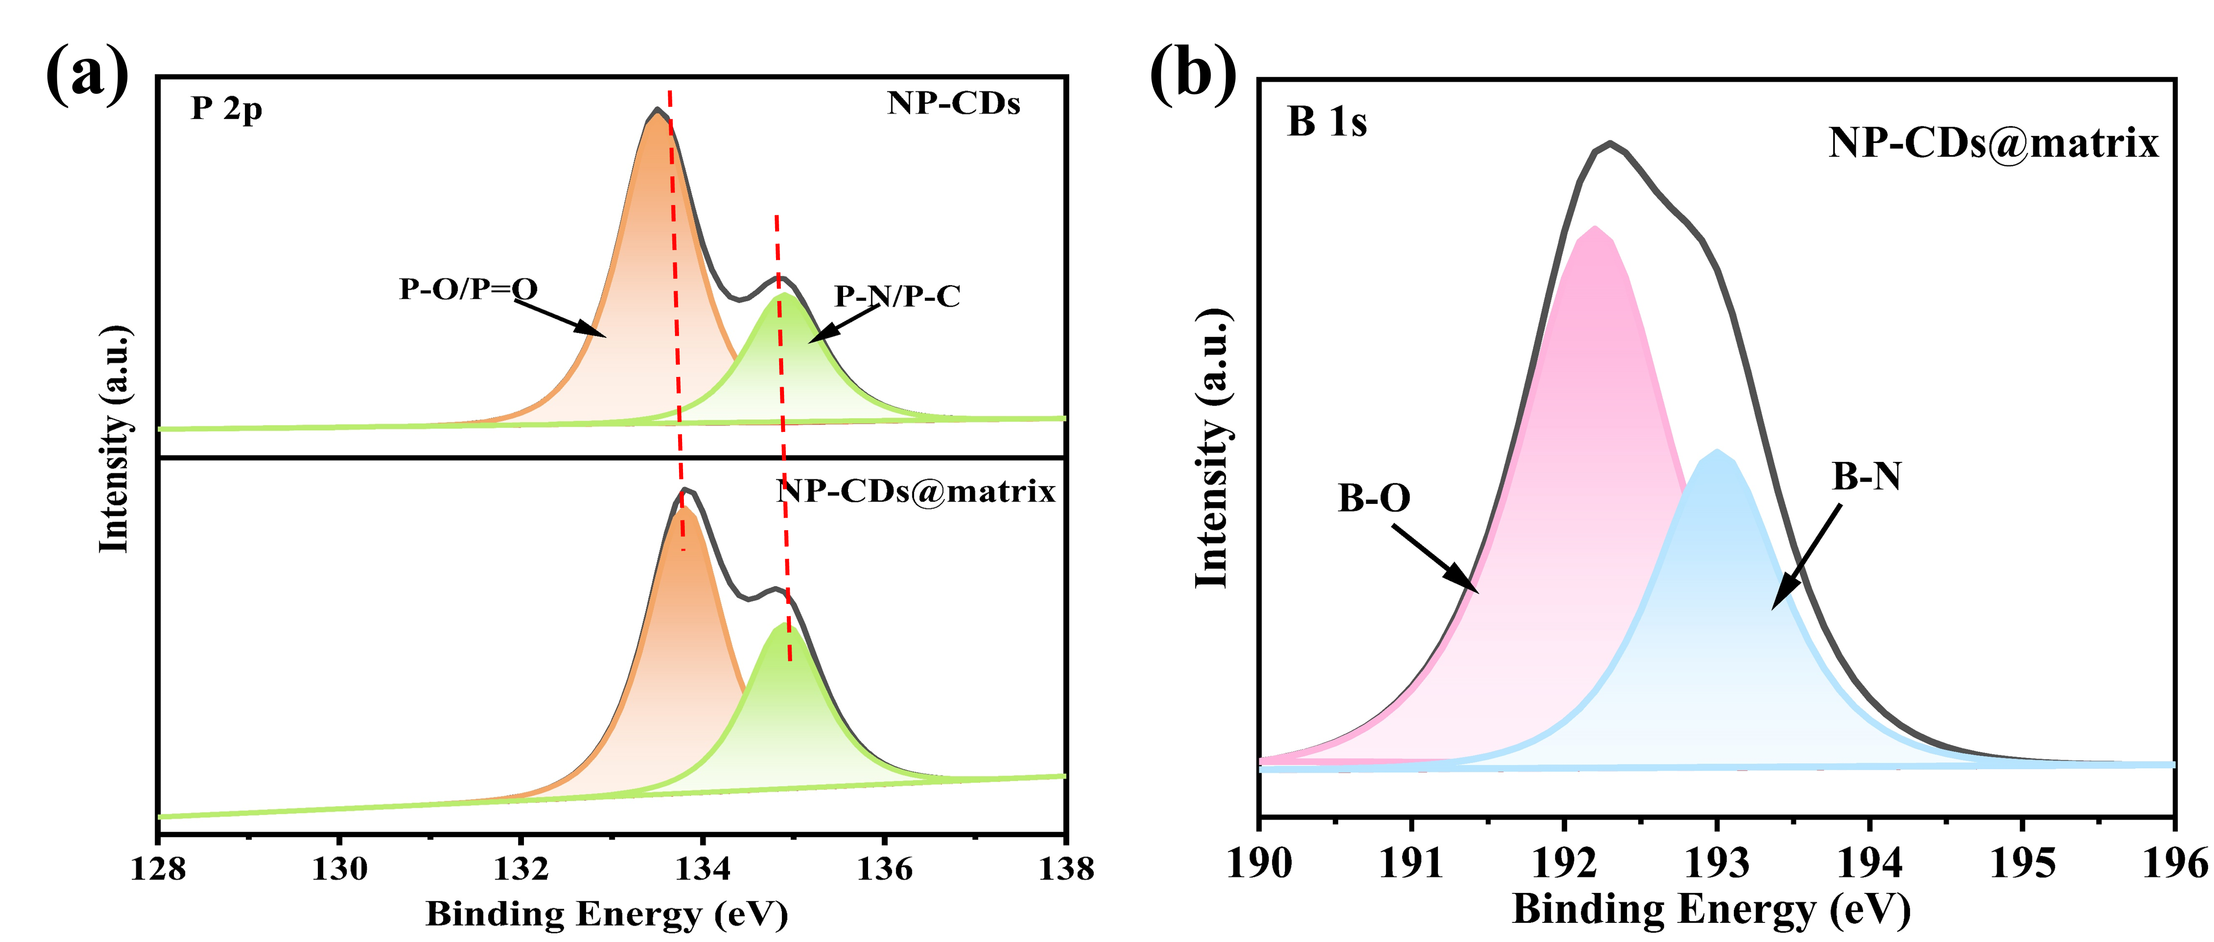

Figure S2. UV–Vis spectra (a ,c), and fluorescence spectra (b, d) of CDs and NP-CDs.
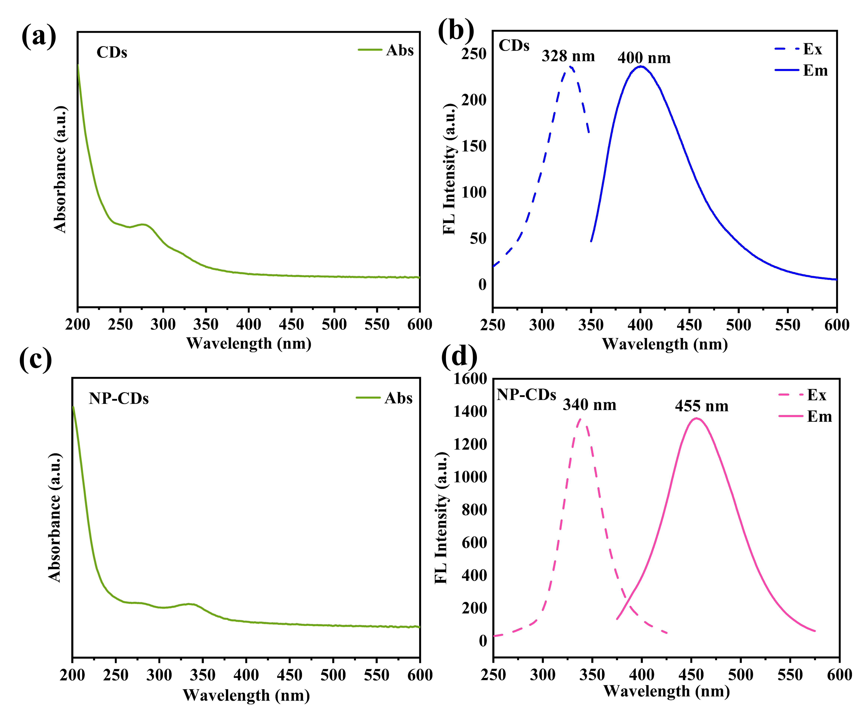

Figure S3. Phosphorescence emission spectra of NP-CDs@matrix under different excitation wavelength.
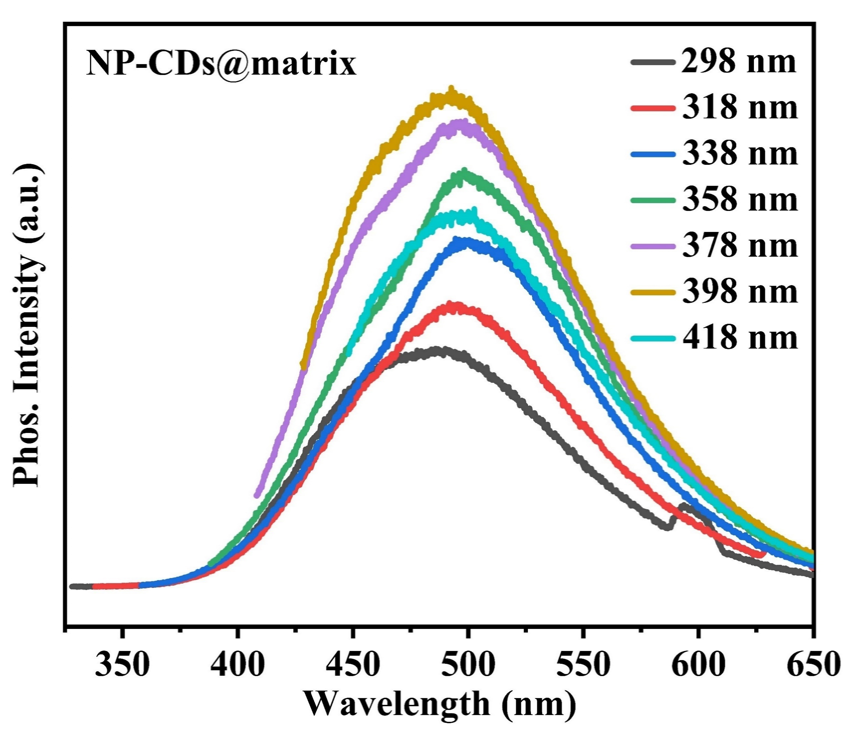

Figure S4. Phosphorescence spectra of NP-CDs@matrix, matrix(B), matrix(U) and matrix.
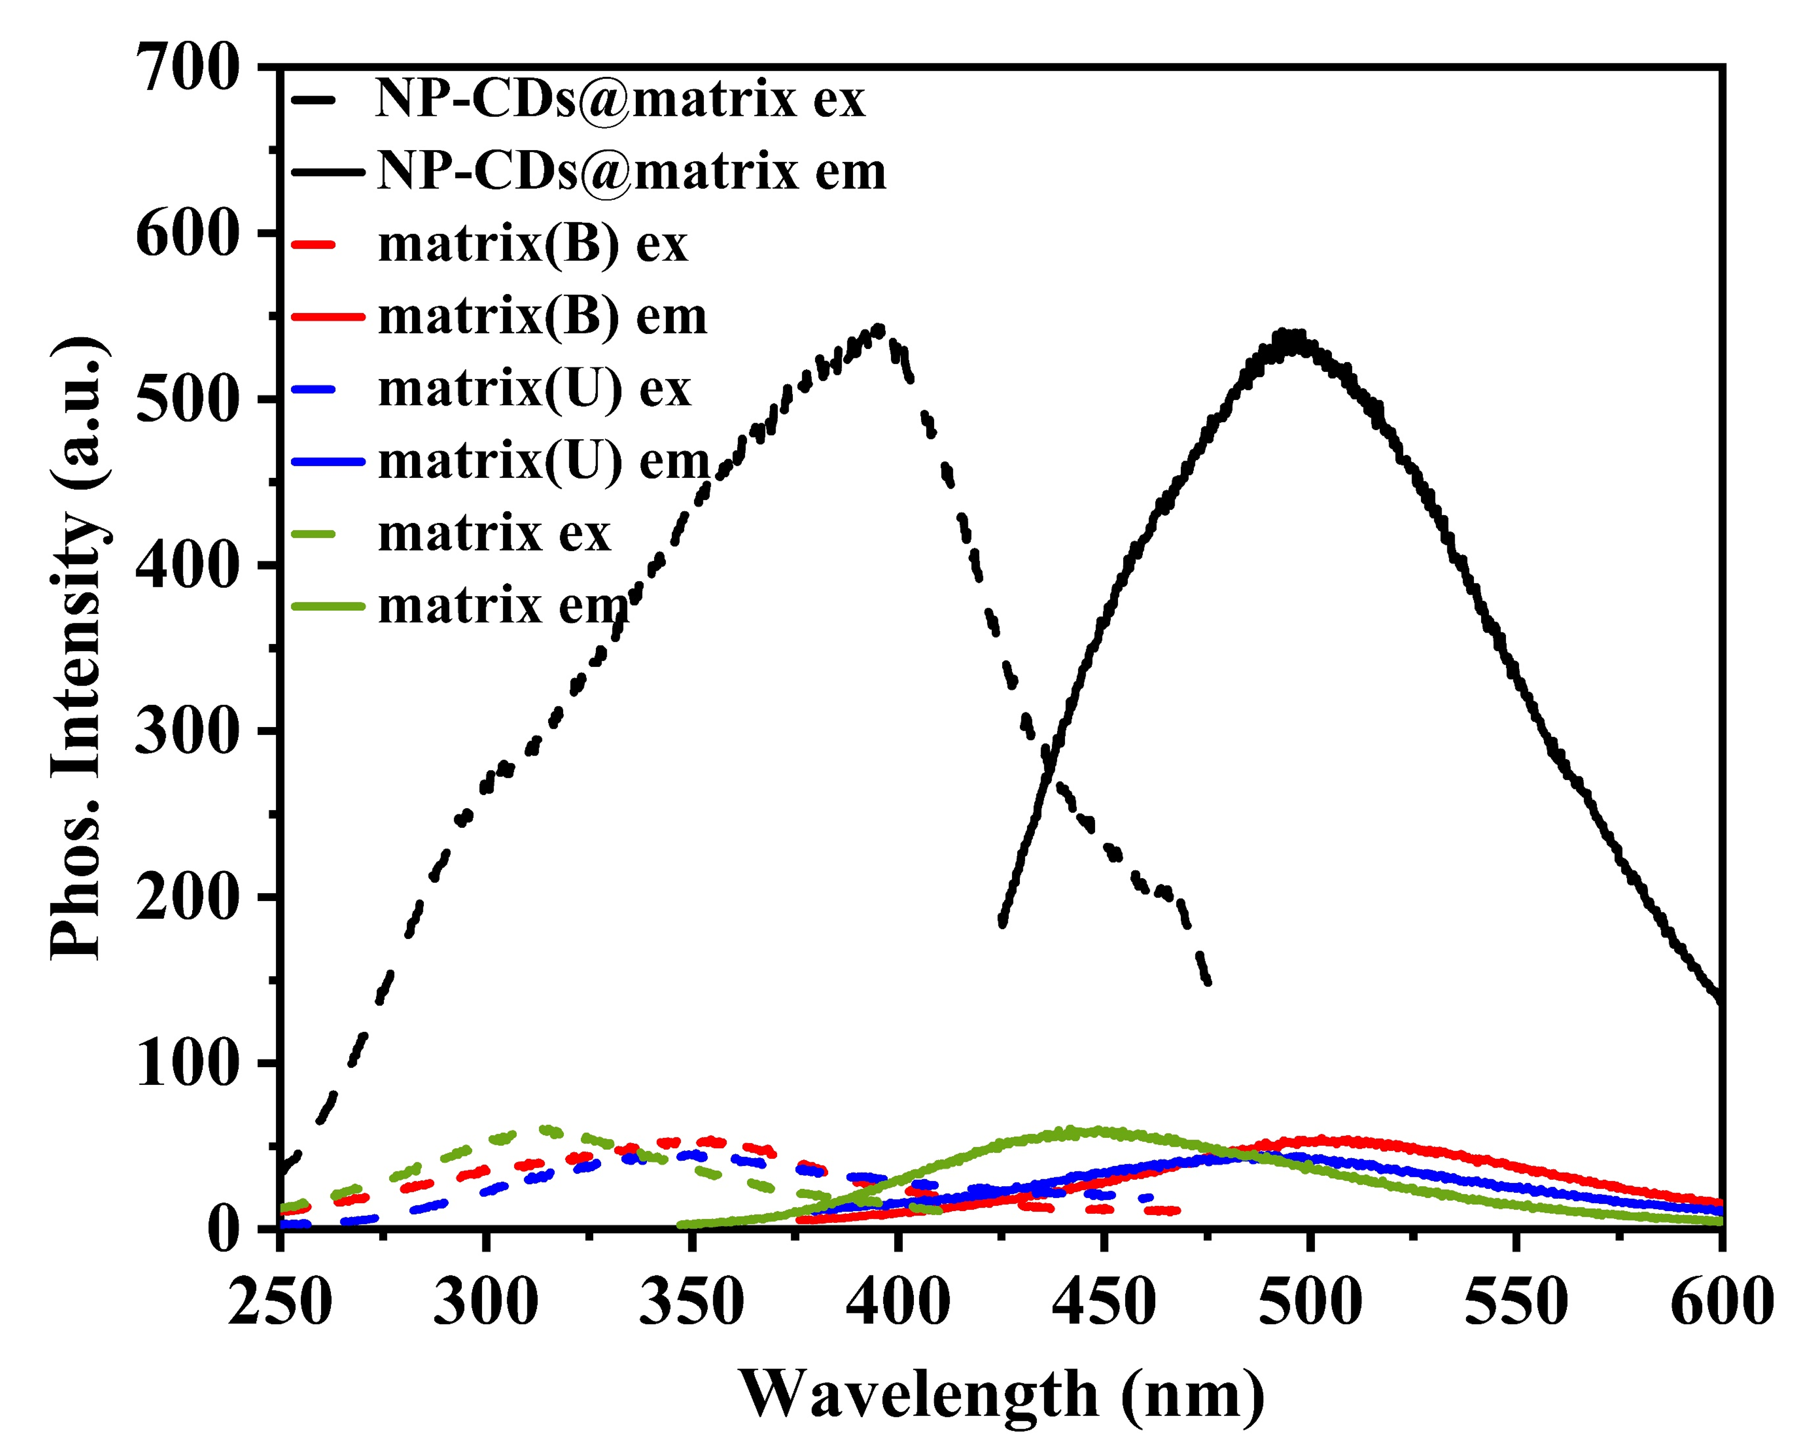

Figure S5. Effect of irradiation time (a) and storage time (b) on the phosphorescent intensity of the NP-CDs@matrix.
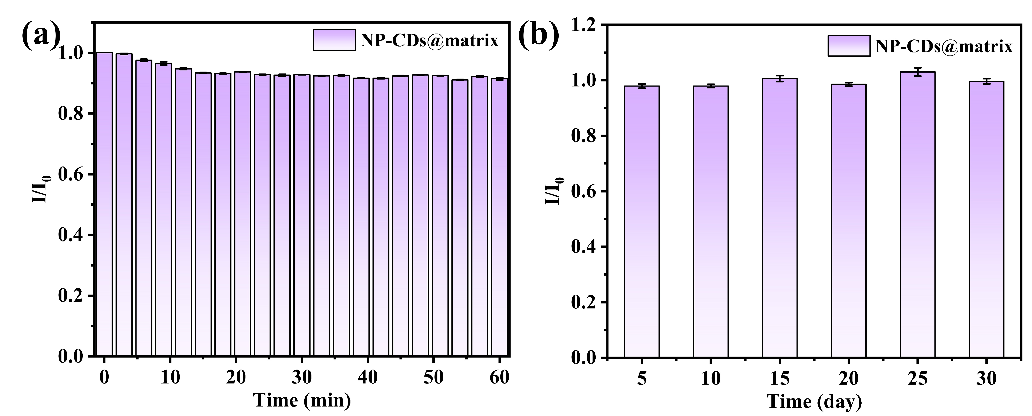

Figure S6. Effect of irradiation time (a), salt resistance(b) and storage time (c) on the phosphorescent intensity of the NP-CDs@matrix@paper.
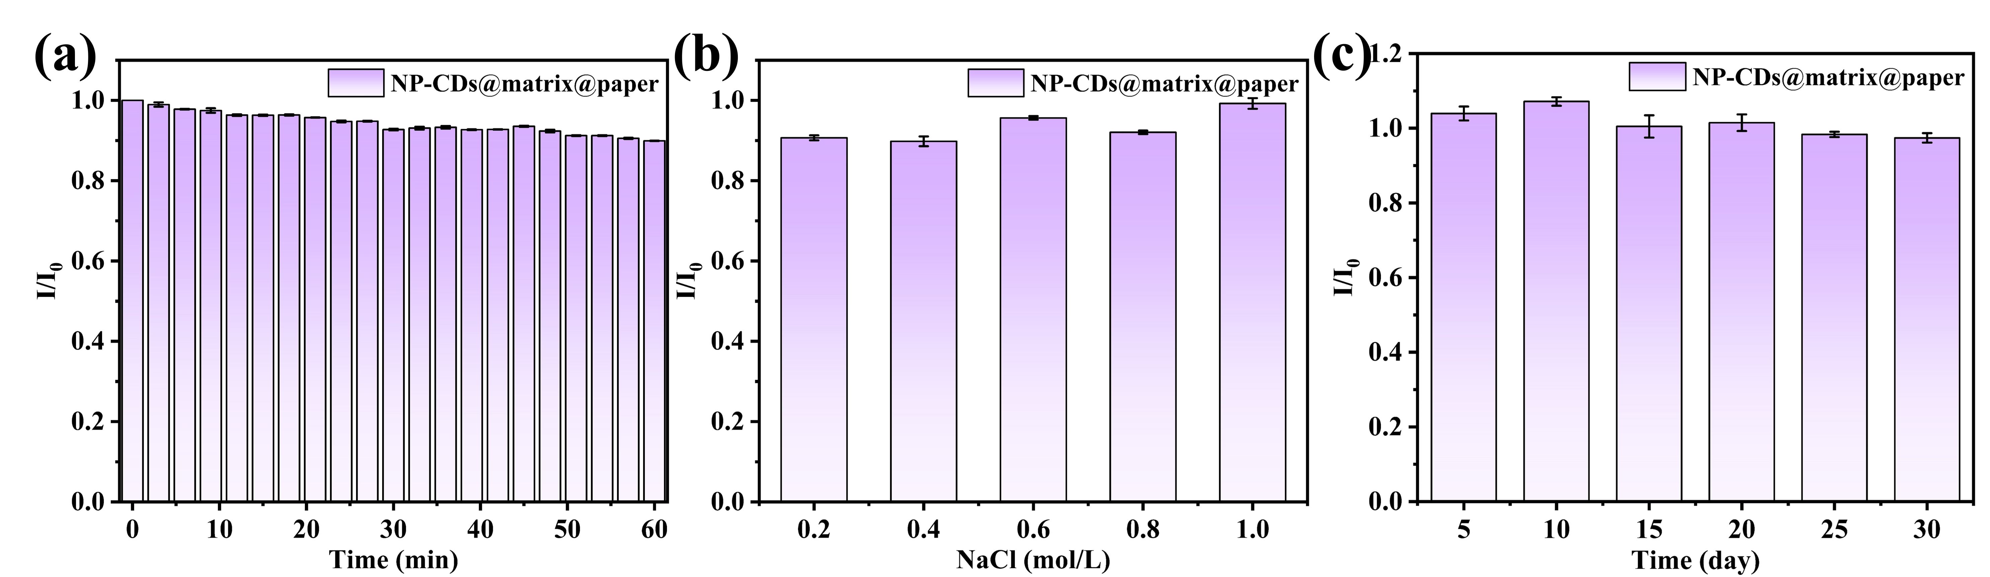

Figure S7. 3D waterfall (a, c, e) and histogram (b, d, f) of the selectivity of the probe for different cations, anions and amino acids.
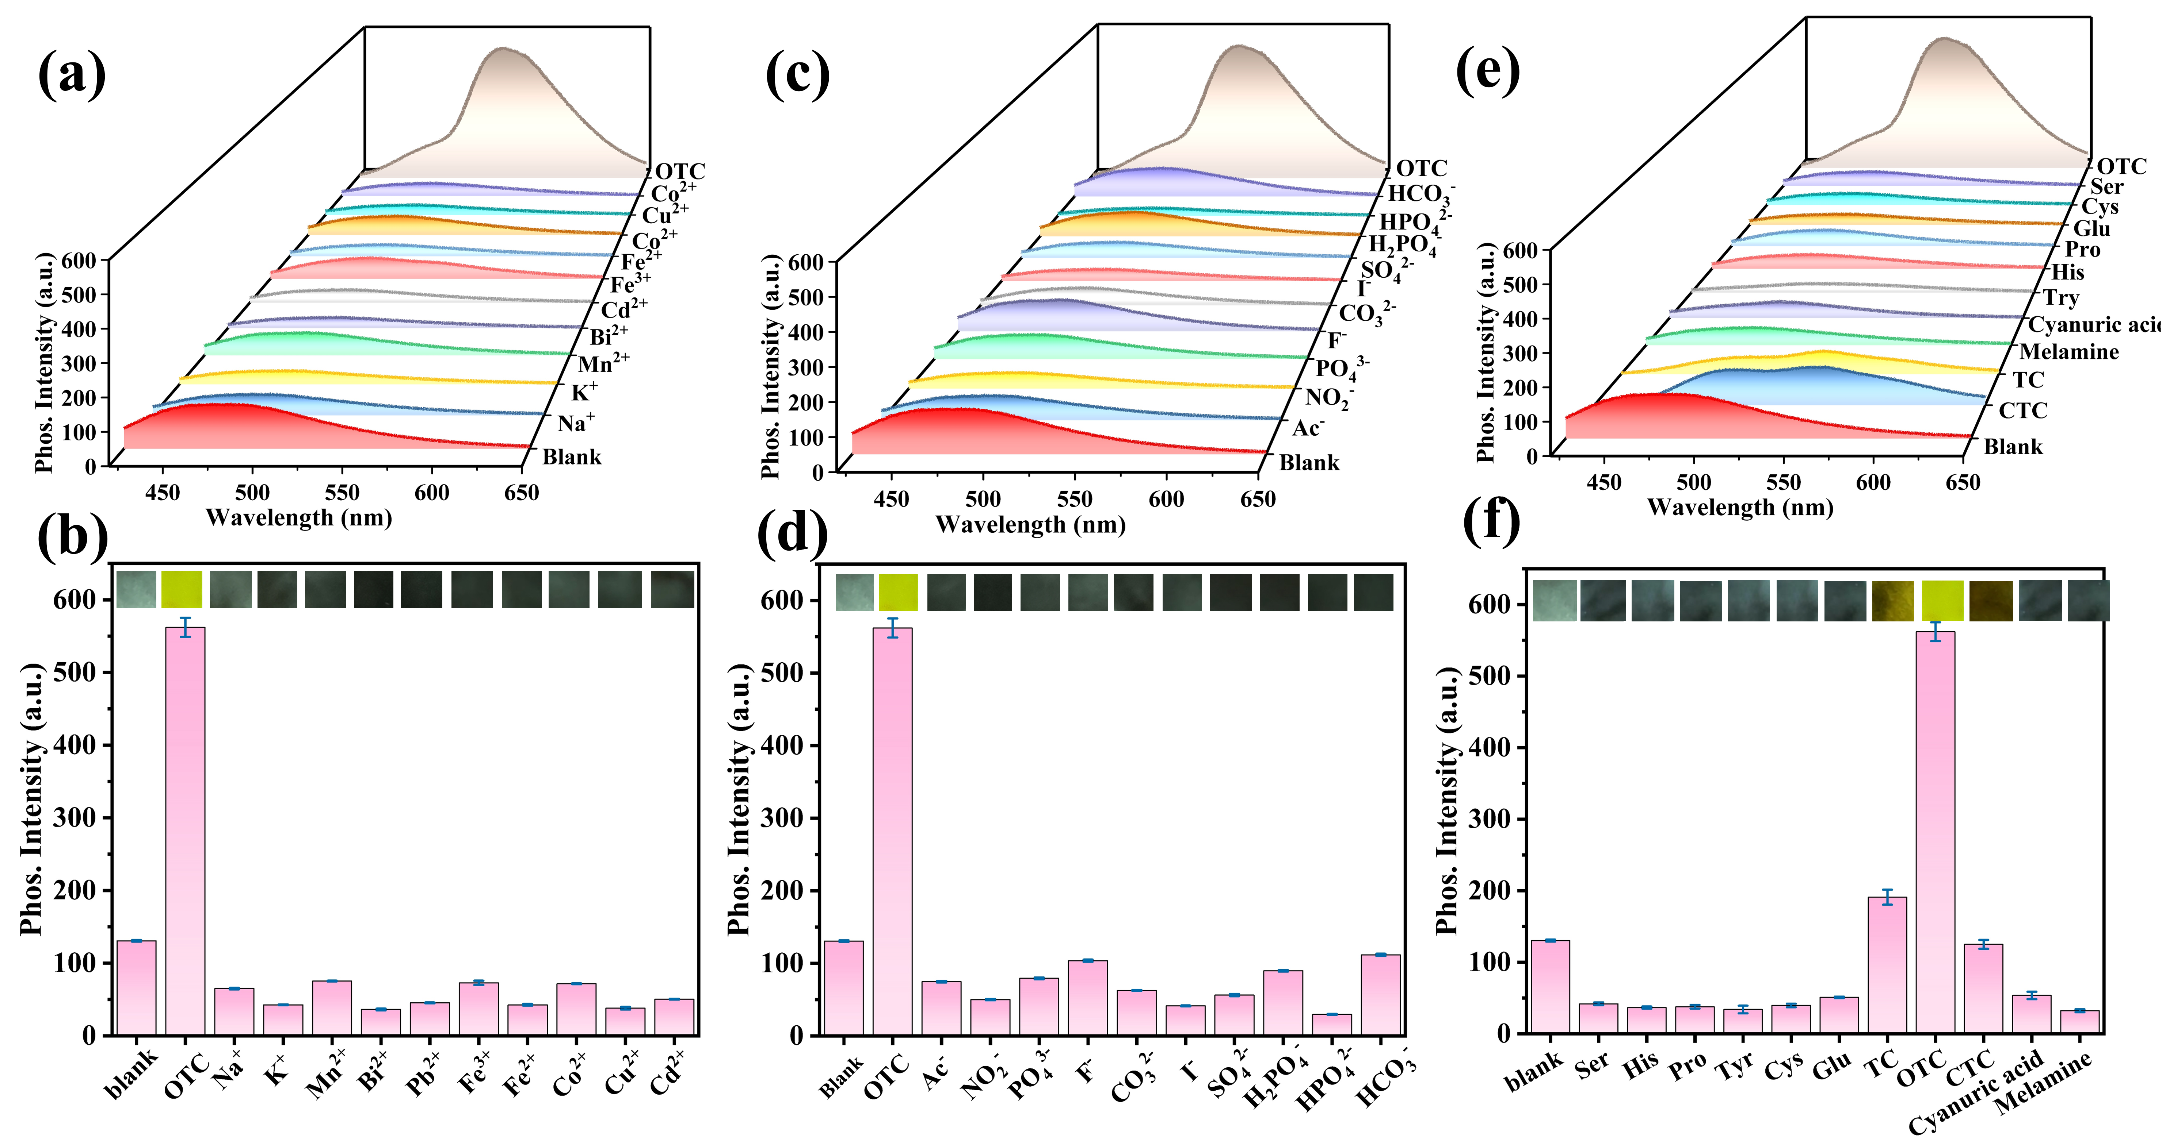

Figure S8. Fluorescence spectra (a), UV-visible diffuse reflectance spectroscopy (b) and FTIR spectra (c) of probe and probe+OTC.
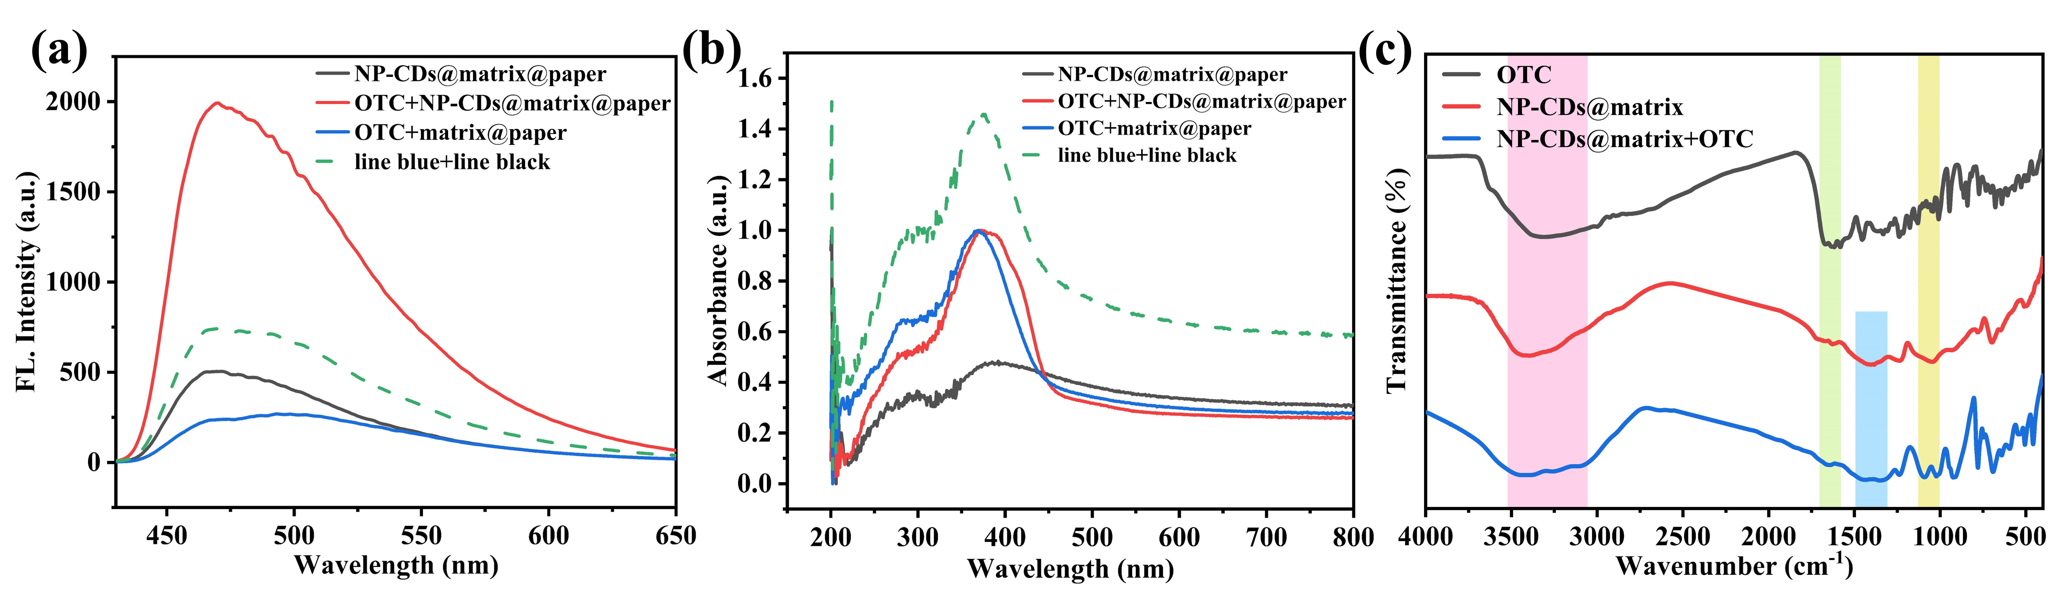

Figure S9. Phosphorescence spectra (a) and histograms (b) of the probe (NP-CDs@matrix@paper) under different pH conditions. Phosphorescence spectra (c, d) and line plots(e) of probe and probe plus OTC at different excitation wavelengths.
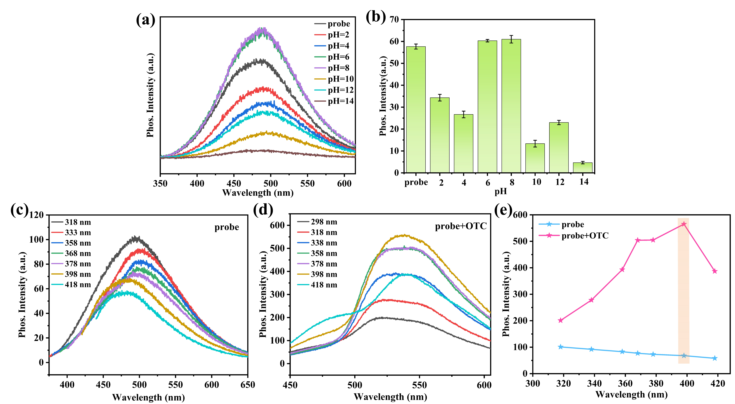

Table S1 Comparison with other sensing methods
Methods | Probe | Range | LOD | Ref.
Fluorometric  Fluorometric  Fluorometric  Fluorometric  Fluorometric  Fluorometric  Fluorometric  Phosphorescence  Phosphorescence | MIP-coated CDs  CD@AMP/EuNCPs  Stalk-Trp CDs  ATOCN/Eu(DPA)₃/CD  B-CDs  N-CDs  Eu-CDs  CDs@LP  NP-CDs@matrix@paper | 50-900  (ng/mL)  0.2-60  (μmol/L)  6-100  (μmol/L)  0-6  (mg/L)  0.2-60  (μg/L)  0.1-45  (μmol/L)  1-603.75  (μmol/L)  1-100  (μmol/L)  2-800  (μmol/L) | 15.3  (ng/mL⁻¹)  23  (nmol/L)  18  (nmol/L)  0.019  (mg/L)  0.1  (μg/L)  0.017  (μmol/L)  9.5  (nmol/L)  0.27  (μmol/L)  1.17  (μmol/L) | [1]  [2]  [3]  [4]  [5]  [6]  [7]  [8]  This work
References
[1] Liu H, Ding L, Chen L, et al. A facile, green synthesis of biomass carbon dots coupled with molecularly imprinted polymers for highly selective detection of oxytetracycline [J]. Journal of Industrial and Engineering Chemistry, 2019, 69: 455-63.
[2] Chen L, Xu H, Wang L, et al. Portable ratiometric probe based on the use of europium(III) coordination polymers doped with carbon dots for visual fluorometric determination of oxytetracycline [J]. Microchimica Acta, 2020, 187(2).
[3] Arkin K, Zheng Y, Bei Y, et al. Construction of dual-channel ratio sensing platform and molecular logic gate for visual detection of oxytetracycline based on biomass carbon dots prepared from cherry tomatoes stalk [J]. Chemical Engineering Journal, 2023, 464.
[4] Yue Y, Gu J, Cheng W, et al. Solid–liquid convertible hydrogel mediated by dual-functional cellulose nanofiber/Eu–dipicolinic acid/carbon dot complexes for high-precision sequential luminescence detection of cupric ion and oxytetracycline [J]. Composites Science and Technology, 2023, 232.
[5] Li Z, Li S, Jiang L, et al. High enrichment and sensitive measurement of oxytetracycline in tea drinks by thermosensitive magnetic molecular imprinting based magnetic solid phase extraction coupled with boron doped carbon dots [J]. Food Chemistry, 2024, 447.
[6] Wu H, Chen Y, Xu M, et al. Dual-response fluorescent probe based on nitrogen-doped carbon dots and europium ions hybrid for ratiometric and on-site visual determination of oxytetracycline and tetracycline [J]. Science of The Total Environment, 2023, 860.
[7] Fan Y J, Wang Z G, Su M, et al. A dual-signal fluorescent colorimetric tetracyclines sensor based on multicolor carbon dots as probes and smartphone-assisted visual assay [J]. Analytica Chimica Acta, 2023, 1247.
[8] Wang Q, Tan Q, Zhao S, et al. Dual-responsive carbon dots-based luminophore for ratiometric fluorescence and room-temperature phosphorescence detection of oxytetracycline [J]. Chemical Engineering Journal, 2023, 470.

