Supplemental material
Supplement 1: Standardization of the workflow for recording multiscan tomographic ultrasound volumes. On the left side, the starting position of the ultrasound probes to record a comprehensive liver scan is illustrated. On the right side, representative tomographic ultrasound images are displayed in the transverse (middle) and sagittal planes (right side). 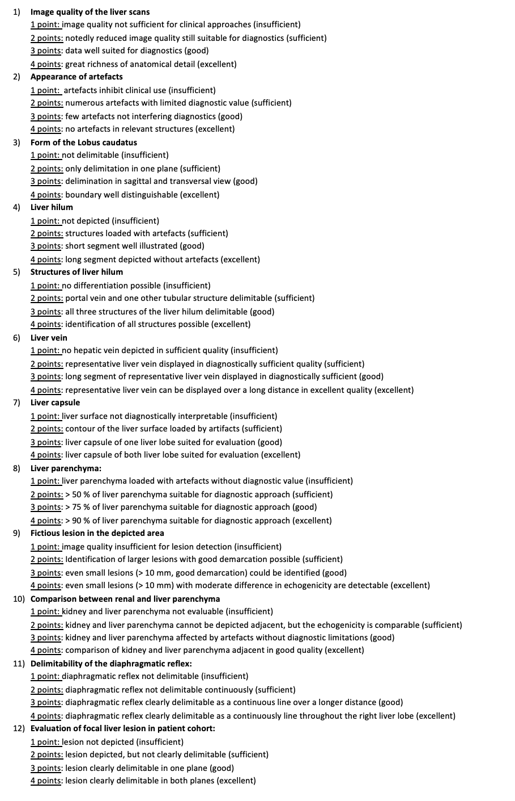Supplement 2: Definition of the criteria for the evaluation of conventional and tomographic ultrasound images.

Rating of average image quality of t3DUS compared to conUS (reference) in 22 healthy volunteers
Total  (Scan1-6) |  | Scan1 | Scan2 | Scan3 | Scan4 | Scan5 | Scan6
Image quality (mean) | 74% | 69% | 70% | 79% | 69% | 67% | 91%
Image quality of the liver | 65% | 55% | 61% | 68% | 59% | 62% | 87%
Presentability of  lobus caudatus | 75% | 65% | 64% | 88% | 70% | 65% | 97%
Visualization of liver hilum | 80% | 77% | 70% | 86% | 80% | 68% | 99%
Identifiability of liver veins | 77% | 72% | 84% | 72% | 64% | 84% | 88%
Presentability of liver capsule | 75% | 72% | 66% | 86% | 74% | 61% | 92%
Quality of Liver parenchyma | 71% | 67% | 74% | 79% | 64% | 60% | 85%
Identifiability of a fictious lesion in the left liver lobe | 63% | 58% | 68% | 73% | 59% | 42% | 80%
Identifiability of a fictious lesion in the right liver lobe | 70% | 62% | 66% | 71% | 66% | 71% | 84%
Comparability between renal/liver parenchyma | 80% | 75% | 72% | 83% | 75% | 77% | 99%
Visibility of the diaphragmatic reflex | 89% | 92% | 89% | 88% | 82% | 86% | 99%
 | Total  (Scan1-6) | Scan1 | Scan2 | Scan3 | Scan4 | Scan5 | Scan6
Completeness of (mean) | 74% | 75% | 75% | 76% | 79% | 69% | 73%
Left liver lobe | 73% | 75% | 81% | 80% | 72% | 55% | 73%
Right liver lobe | 70% | 77% | 83% | 61% | 66% | 66% | 65%
Gallbladder | 75% | 81% | 71% | 79% | 98% | 59% | 61%
Pancreas | 95% | 98% | 98% | 96% | 98% | 87% | 94%
Right kidney | 72% | 70% | 70% | 67% | 73% | 71% | 78%
Left kidney | 36% | 34% | 29% | 38% | 34% | 46% | 35%
Aorta abdominalis | 83% | 77% | 78% | 91% | 92% | 80% | 80%
VCI | 93% | 88% | 89% | 95% | 95% | 91% | 100%

Supplement 3: Quality and completeness of different scanning procedures in healthy volunteers.
Tomographic three-dimensional ultrasound (t3DUS); conventional ultrasound (conUS).
 | Image quality of t3DUS compared to conUS in patients with liver diseases
 | Total Scan A-C | ScanA |  | ScanB |  | ScanC
Overall image quality | 81% |  | 75% |  | 75% |  | 93%
Subcohort MASLD | 87% | 81% |  | 86% |  | 95%
Subcohort Cirrhosis | 75% | 67% |  | 67% |  | 94%
Subcohort FNH | 82% | 77% |  | 74% |  | 94%
Subcohort Hemangioma | 80% | 73% |  | 74% |  | 92%
Overall completeness | 70% |  | 69% |  | 75% |  | 65%
MASLD – image quality of
Liver margin | 53% | 60% |  | 80% |  | 20%
Echogenicity compared to renal parenchyma | 93% | 80% |  | 100% |  | 100%
Attenuation of ultrasound signal | 80% | 80% |  | 80% |  | 80%
Visibility of the diaphragmatic reflex | 40% | 40% |  | 40% |  | 40%
Liver veins | 100% | 100% |  | 100% |  | 100%
Average (total) | 73% | 72% |  | 80% |  | 68%
Cirrhosis – image quality of
Liver capsule | 93% | 80% |  | 100% |  | 100%
Liver parenchyma | 93% | 100% |  | 80% |  | 100%
Boundary of liver veins | 73% | 60% |  | 60% |  | 100%
Visibility of peripheral intrahepatic vessels | 67% | 80% |  | 60% |  | 60%
Measurement of lobus caudatus (mm) | 91%* | 89% |  | 91%* |  | 92%
Average (total) | 80% | 78% |  | 76% |  | 89%
FNH – image quality of
Measurement diameter of lesion (mm) | 85% | 88% |  | 80% |  | 86%
Echogenicity of lesion | 93% | 100% |  | 80% |  | 100%
Boundary of lesion | 100% | 100% |  | 100% |  | 100%
Visibility of lesion in two planes | 85% | 85% |  | 80% |  | 90%
Average (total) | 93% | 95% |  | 88% |  | 95%
Haemangioma – image quality of
Measurement diameter of lesion (mm) | 88%* | 88% |  | 86% |  | 88%*
Echogenicity of lesion | 81% | 86% |  | 71% |  | 86%
Boundary of lesion | 95% | 100% |  | 100% |  | 86%
Visibility of lesion in two planes | 85% | 86% |  | 79% |  | 92%
Average (total) | 88% | 89% |  | 87% |  | 87%
*: excluding 1 patient where data is not available

Supplement 4: Quality and completeness of tomographic three-dimensional ultrasound (t3DUS) in patients with liver diseases according to the scanning procedure.
Conventional ultrasound (conUS). Focal nodular hyperplasia (FNH)
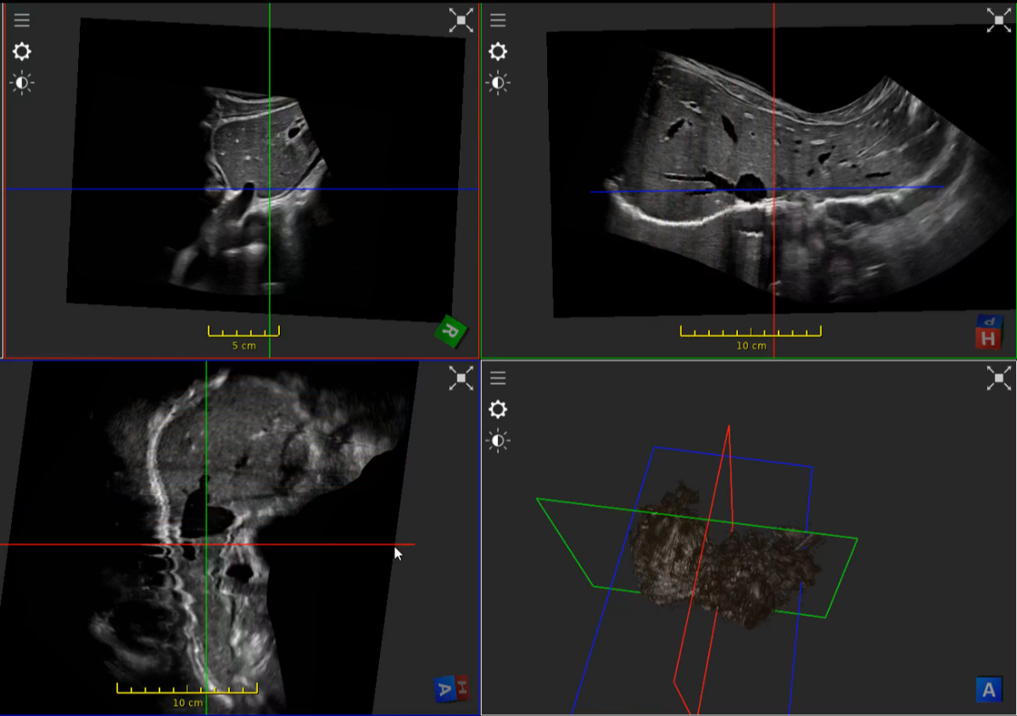
Supplement 5 Tomographic ultrasound scan of a comprehensive liver examination (Movie).
The upper left corner shows the conventional fundamental ultrasound data equipped with spatial information. Multiple view planes illustrate the calculated tomographic ultrasound data.
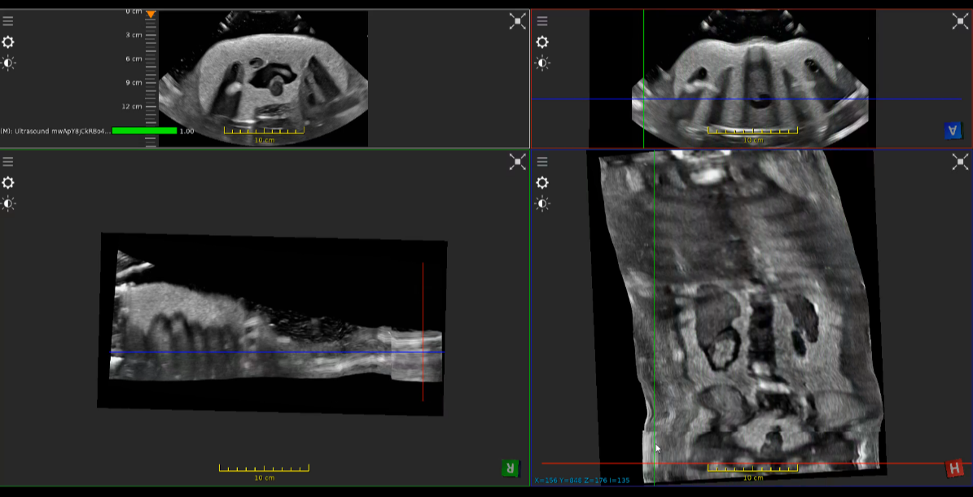
Supplement 6 Tomographic ultrasound scan of a paediatric ultrasound phantom (Movie).
The upper left corner shows the conventional fundamental ultrasound data equipped with spatial information. Multiple view planes illustrate the calculated tomographic ultrasound data.

