Engineering biochar through surface oxygenation: a green approach for sustainable environmental applications

Ziwei Lee ª, Rosazlin Abdullah ^{a,b,*}, Jamilah Syafawati Yaacob ^{a,b,*}, Noor Sharina Mohd Rosli ª

ª Institute of Biological Sciences, Faculty of Science, University of Malaya, 50603, Kuala Lumpur, Malaysia
^{b} Centre for Research in Biotechnology for Agriculture (CEBAR), Institute of Biological Sciences, Faculty of Science, University of Malaya, 50603, Kuala Lumpur, Malaysia

Corresponding authors:
Associate Professor Dr. Rosazlin Abdullah, PhD
Institute of Biological Sciences, Faculty of Science, University of Malaya, 50603, Kuala Lumpur, Malaysia
Email: rosazlin@um.edu.my
ORCID: 0000-0002-3444-8933

Author(s) E-mail:
Lee Ziwei
Email: ziweilee0719@gmail.com

Noor Sharina Mohd Rosli
Email: noorsharinarosli@gmail.com

Supplementary Materials

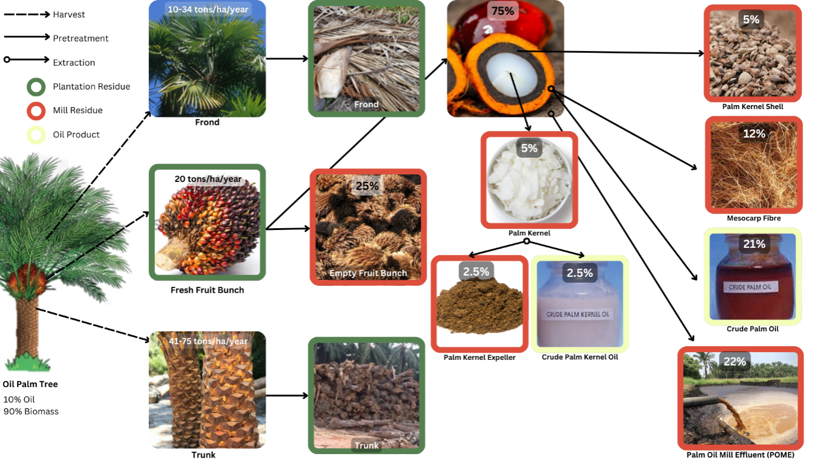Supplementary Figure SI
Schematic diagram illustrates the biomass distribution and processing of oil palm residues.

Description:
This schematic diagram presents an overview of biomass distribution in the oil palm industry, highlighting the proportion of various residues and oil products derived from oil palm trees. The diagram shows the harvesting and processing pathways of different parts of the oil palm, including fronds, trunks, fresh fruit bunches, and kernels. It categorizes residues into plantation residues (green), mill residues (red), and oil products (yellow). Key by-products include palm kernel shells, mesocarp fiber, empty fruit bunches, palm kernel expeller, and palm oil mill effluent (POME), while crude palm oil and crude palm kernel oil represent the extracted oil fractions.

