Supplementary Figures
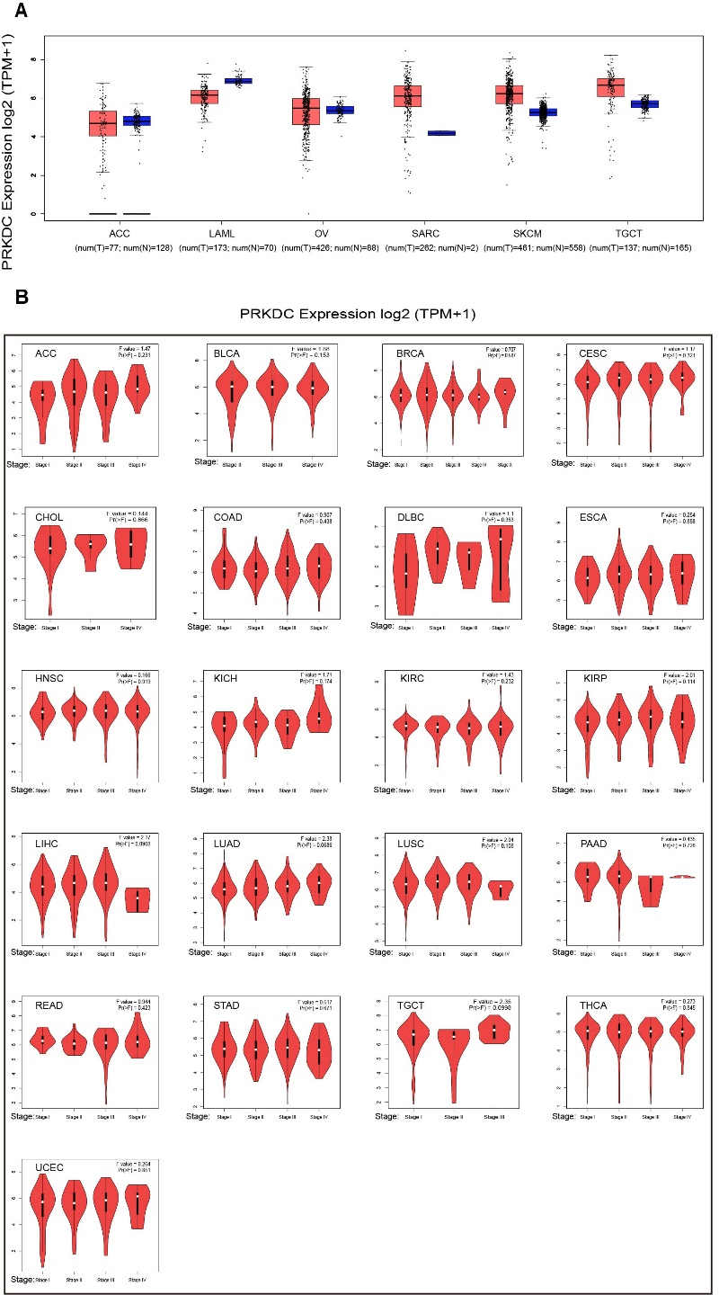
Figure S1. PRKDC expression in different tumors and pathological stages (*: p-value < 0.05; **: p-value <0.01; ***: p-value <0.001). (A) For ACC, LAML, OV, SARC, SKCM and TGCT in the GTEx database, we did not obtain a significant difference between tumor and normal tissue. T: tumor, N: normal. (B) Violin plots of the PRKDC expression according to pathological stages (stage 0, stage I, stage II, stage III, and stage IV) for most tumors were not statistically significant. TPM values were transformed into a log2(TPM+1) scale.
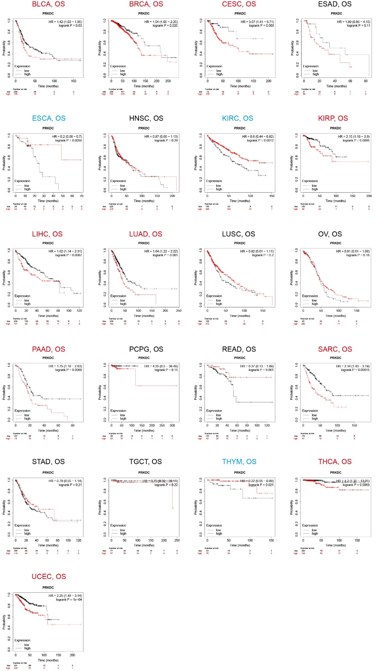
Figure S2. Kaplan-Meier survival curves comparing OS between high and low PRKDC expression groups in different type of tumors in Kaplan-Meier Plotter. Red curve represents patients with high expression of PRKDC. OS, overall survival.
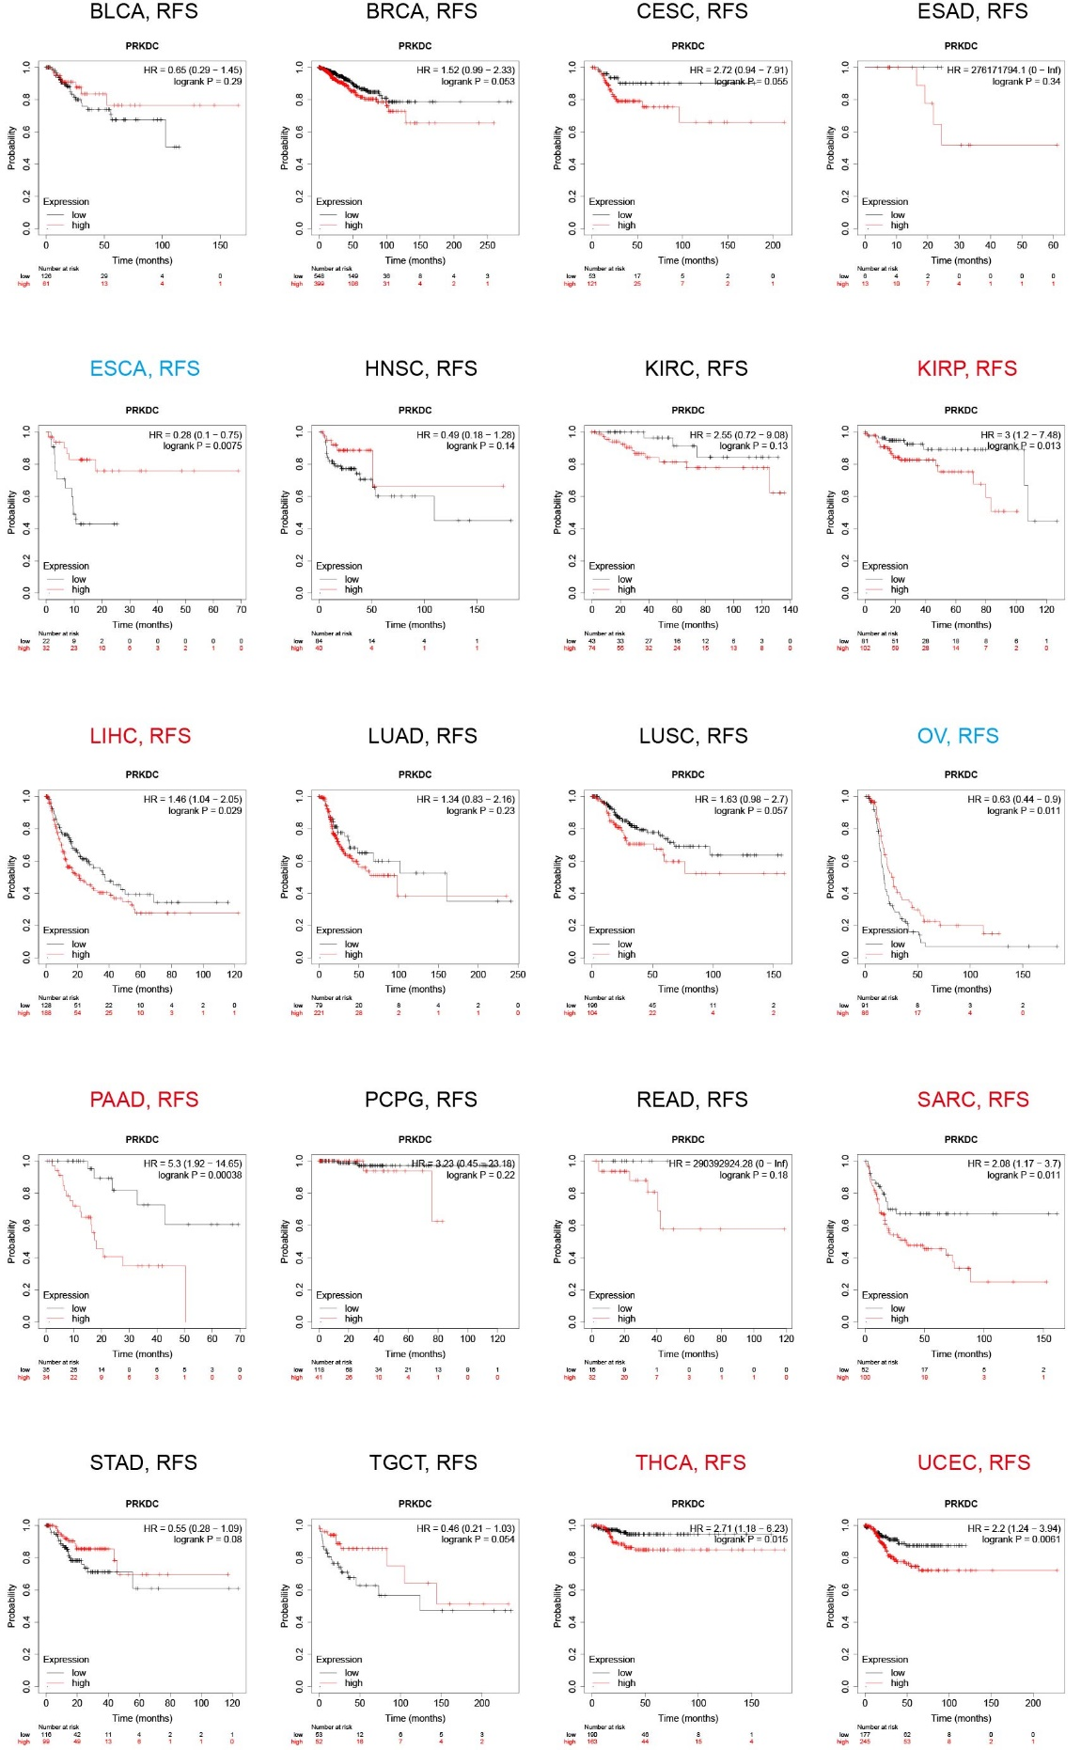
Figure S3. Kaplan-Meier survival curves comparing RFS between high and low PRKDC expression groups in different type of tumors in Kaplan-Meier Plotter. Red curve represents patients with high expression of PRKDC. RFS, relapse-free survival.
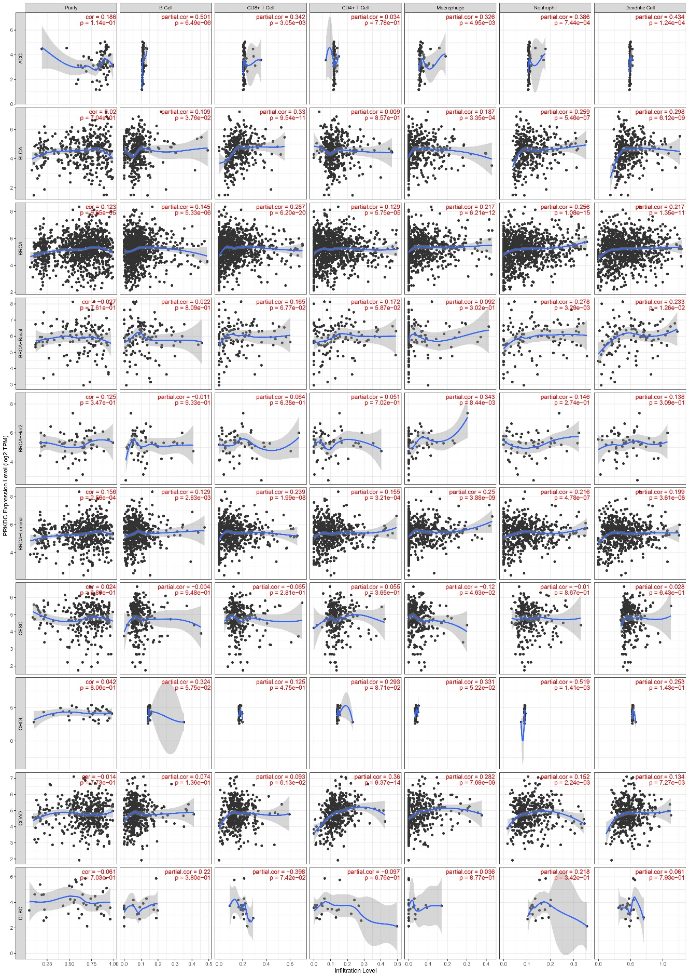
Figure S4. Correlation of PRKDC expression with immune infiltration level in ACC, BLCA, BRCA, BRCA-Basal, BRCA-Her2, BRCA-luminal, CESC, CHOL, COAD and DLBC.
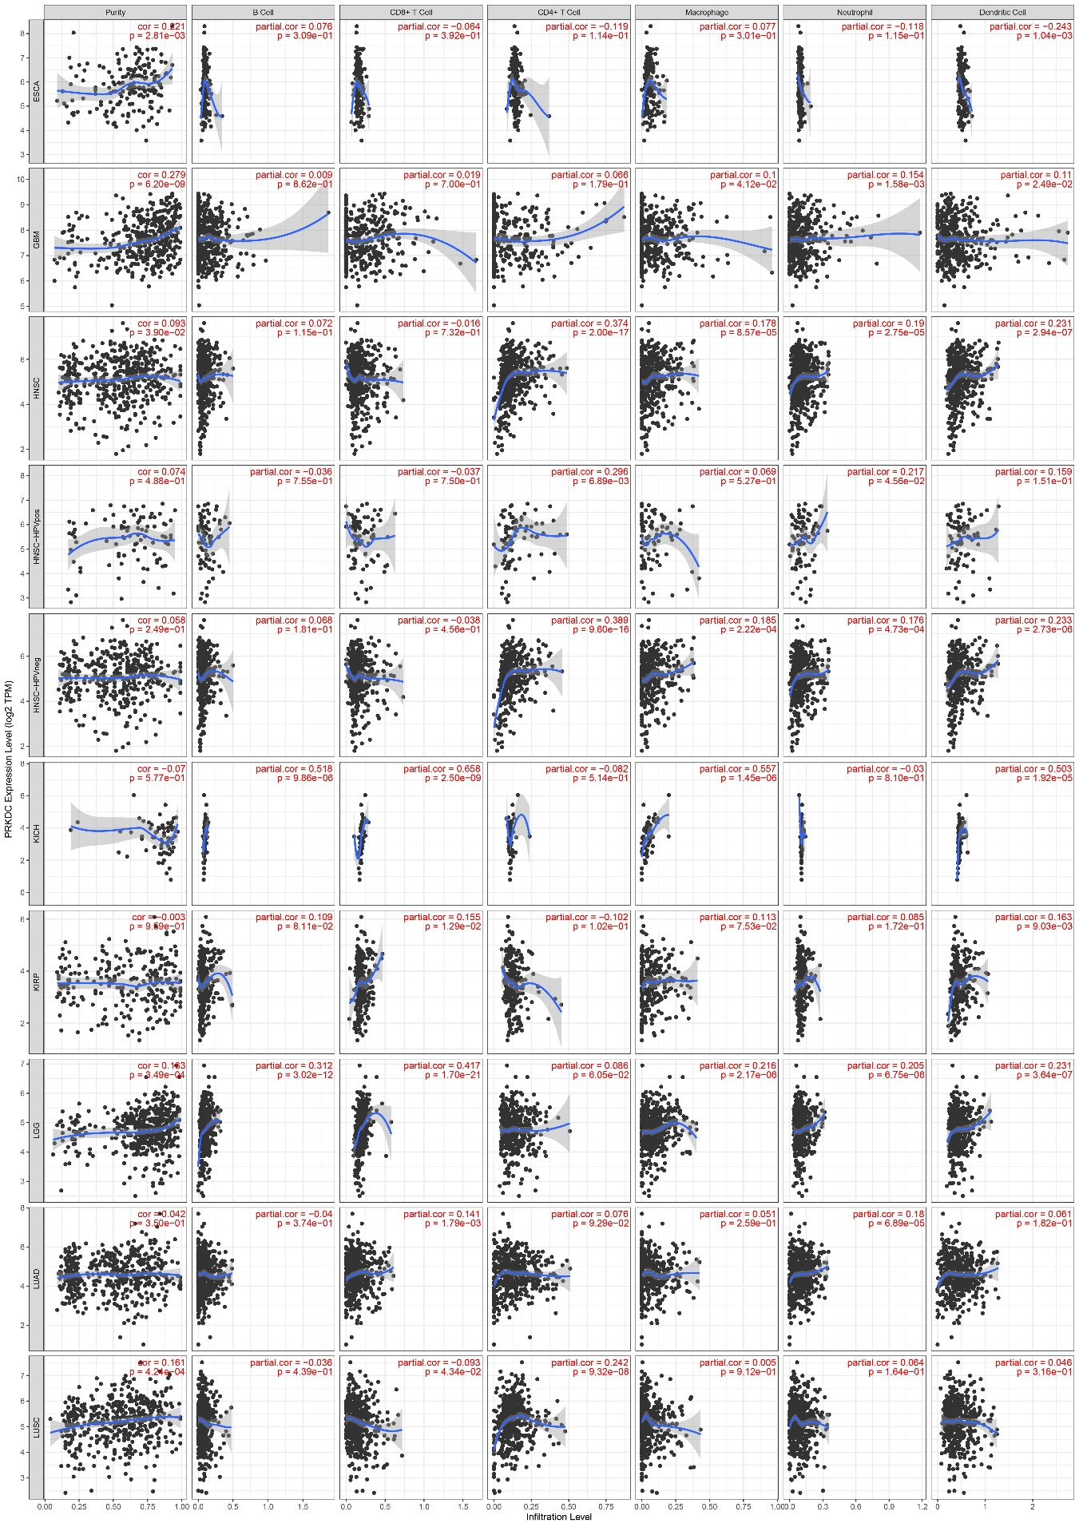
Figure S5. Correlation of PRKDC expression with immune infiltration level in ESCA, EBM, HNSC, HNSC-HPVpos, HNSC-HPVneg, KICH, KIRP, LGG, LUAD and LUSC.
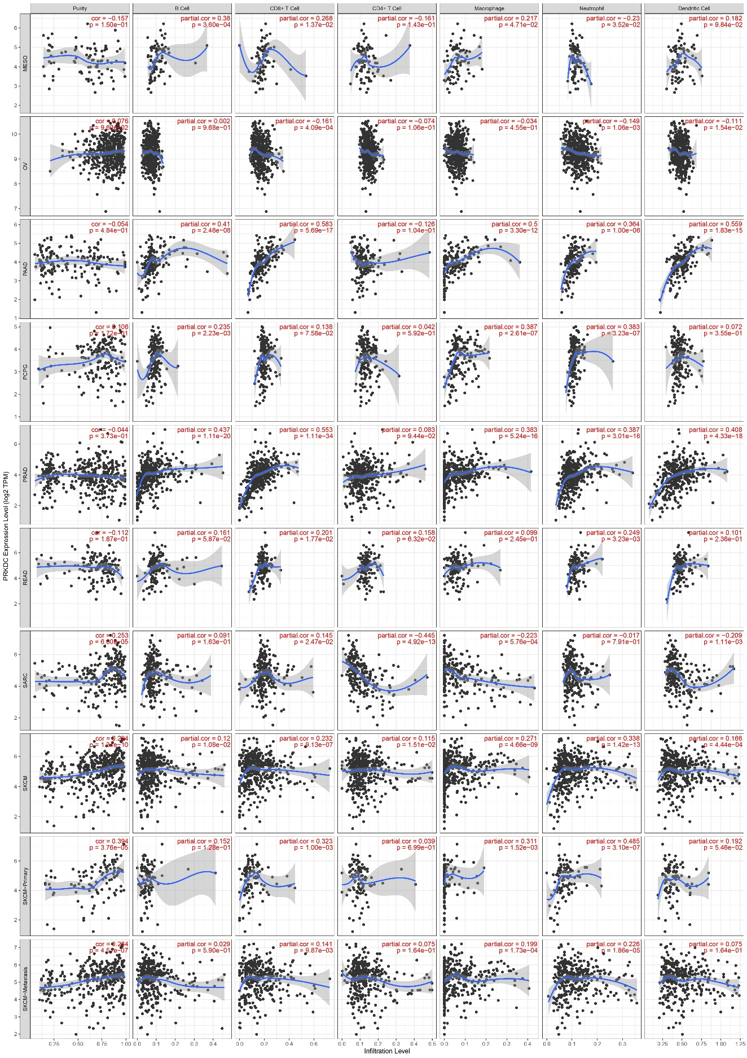
Figure S6. Correlation of PRKDC expression with immune infiltration level in MESO, OV, PAAD, PCPG, PRAD, READ, SARC, SKCM, SKCM-Primary and SKCM-Metastasis.
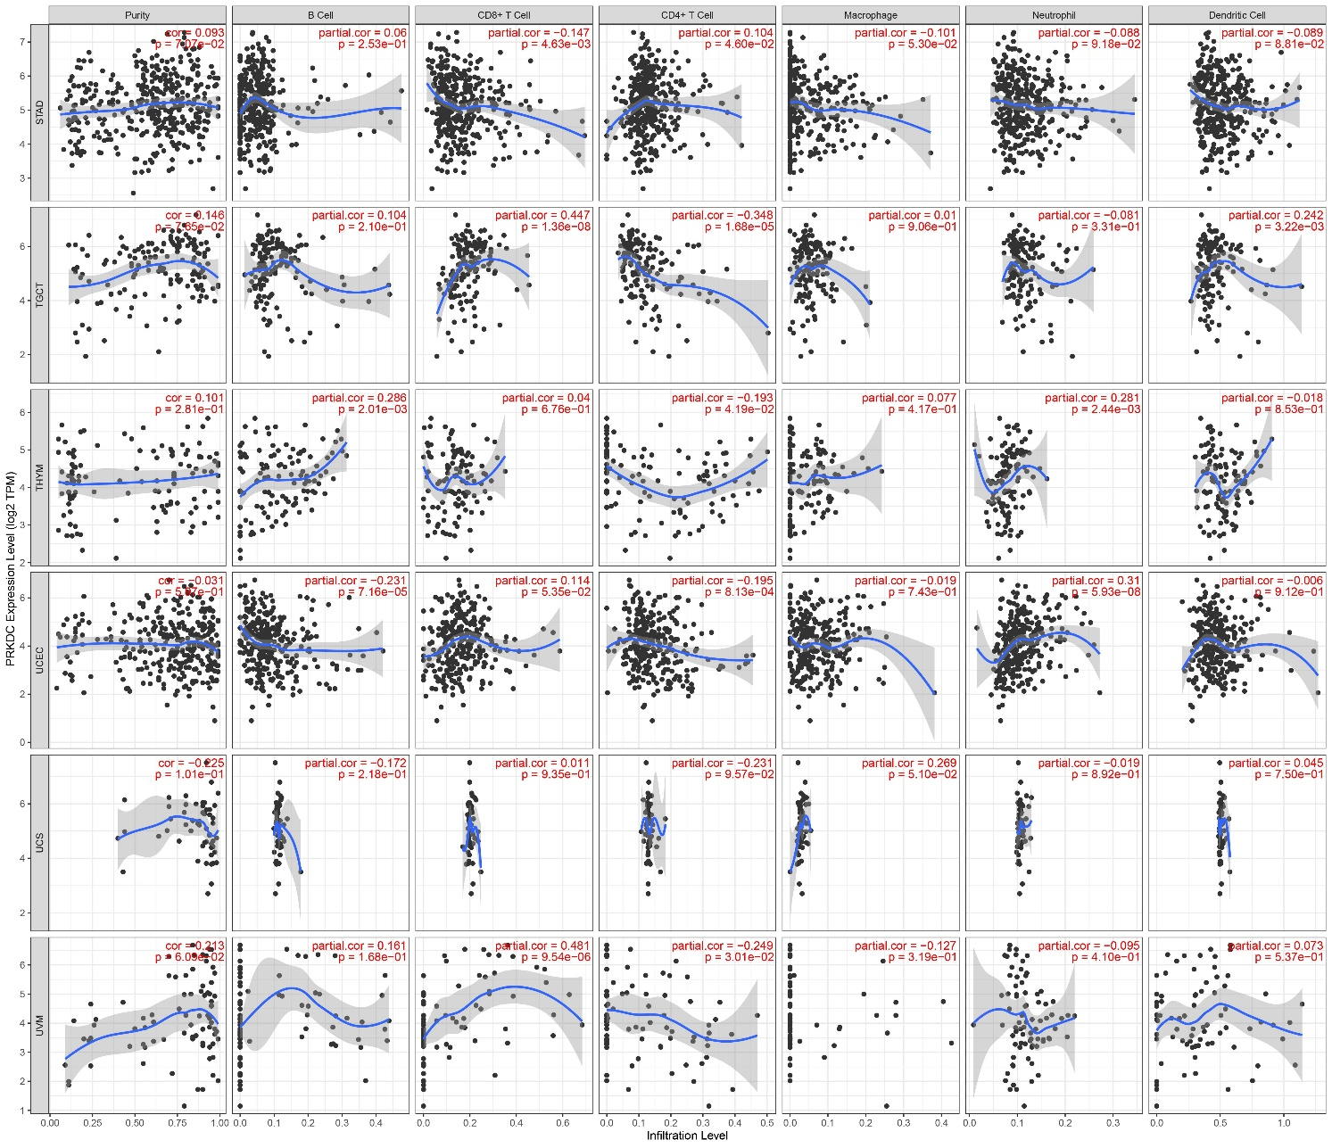
Figure S7. Correlation of PRKDC expression with immune infiltration level in STAD, TGCT, THYM, UCEC, UCS and UVM.

