Appendix A

Test items
- The professor, along with his assistants, ___ planning to organise a seminar on modern literature next month.
a) are
b) is
c) were
d) be

- After the lecture, the students were eager to discuss the topics that ___ covered in class.
a) was
b) were
c) is
d) be

- The new library, which ___ built last year, has become a popular spot for students to study.
a) was
b) is
c) has
d) were

- Although the cafeteria was crowded, there ___ still a few tables available near the windows.
a) is
b) are
c) was
d) were

- The student council president announced that there ___ be a meeting next Friday to discuss upcoming events.
a) will
b) would
c) shall
d) should

- The research paper, which all students must complete by the end of the semester, ___ an important part of their final grade.
a) constitute
b) constitutes
c) is constituting
d) constituted

- The new science building, which ___ several advanced laboratories, is now open to students.
a) contain
b) contains
c) containing
d) contained

- Each of the classrooms ___ equipped with a smartboard and projector.
a) is
b) are
c) were
d) be

- If I ___ more time, I would join the student club activities.
a) have
b) had
c) will have
d) having

- The students were told that they ___ submit their assignments online by midnight.
a) has to
b) have to
c) had to
d) having to

- The group project that we are working on ___ due next Monday.
a) is
b) are
c) was
d) were

- Neither the professor nor the students ___ aware of the schedule change.
a) is
b) are
c) was
d) were

- The library's policy states that no food or drink ___ allowed inside.
a) is
b) are
c) was
d) were

- After finishing their presentations, the students ___ asked to provide feedback to their peers.
a) was
b) were
c) is
d) are

- Each student ___ required to complete a research paper by the end of the semester.
a) is
b) are
c) were
d) was

- Yesterday, the professor ___ an important announcement at the end of the class.
a) make
b) makes
c) made
d) making

- The campus garden has a variety of ___ that bloom in the spring.
a) flower
b) flowers
c) flower's
d) flowers'

- The library ___ its doors at 9 AM every weekday.
a) open
b) opens
c) opened
d) opening

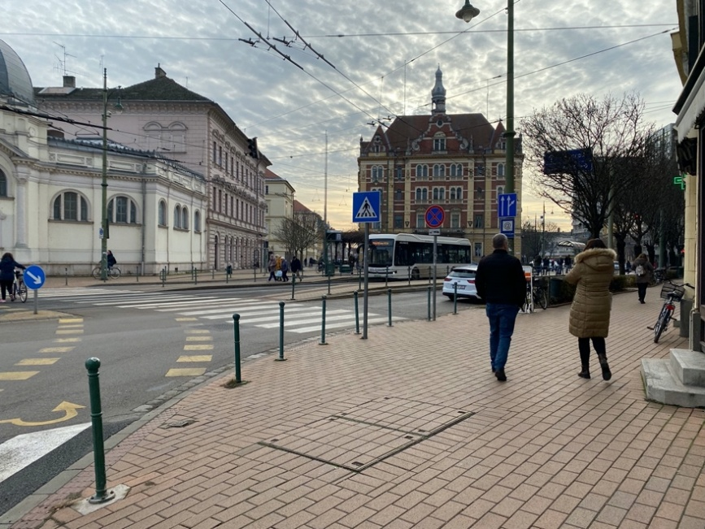

- What is the likely setting of the conversation between the couple of adults?
a) At a park
b) Near a zebra crossing
c) Inside a café
d) In a shopping mall

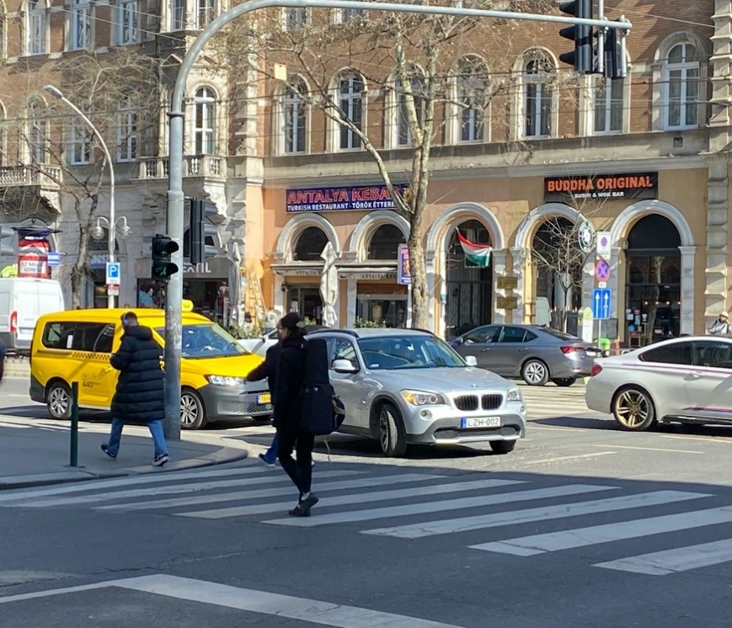
- What can be inferred about the safety measures on campus if several people are crossing the road using a crosswalk?
a) There are no crosswalks on campus.
b) The campus does not prioritise pedestrian safety.
c) The campus provides crosswalks to ensure pedestrian safety.
d) People are not allowed to cross the road on campus.

- If you see several people crossing the road using a crosswalk on campus, it is most likely that ___ .
a) The road is closed to vehicles.
b) Pedestrians have the right of way.
c) There are no traffic rules on campus.
d) The crosswalk is not in use.

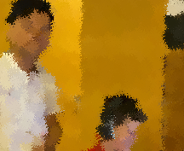
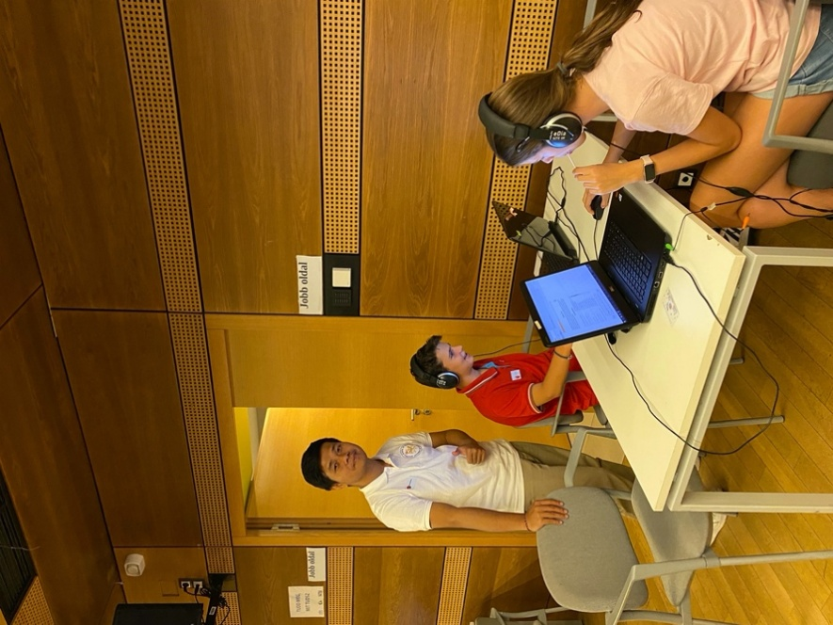
- What are the two students trying to do in front of the computer?
a) Play a video game
b) Complete an assignment
c) Watch a movie
d) Browse social media
- What is the most likely role of the person observing the students?
a) A supervisor ensuring the task is done correctly
b) A friend providing moral support
c) A passer-by interested in their work
d) A family member checking on their progress

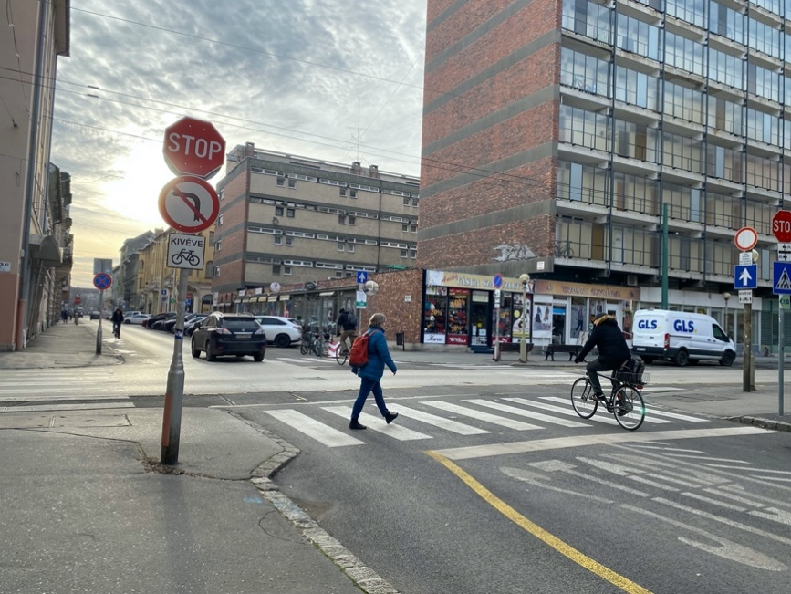
- What is the restriction on the cyclist’s movement?
a) The cyclist is not allowed to turn left
b) The cyclist is not allowed to turn right
c) The cyclist is not allowed to go straight
d) The cyclist is not allowed to stop
- What might the cyclist do because they cannot turn left?
a) Continue straight or turn right
b) Make a U-turn
c) Turn around and head back
d) Stop and wait
- If the pedestrian is crossing the road, what should the cyclist be cautious about?
a) Not making a left turn
b) Wait and make sure the pedestrian crosses safely
c) Riding faster
d) Turning right
- Why might the cyclist be near the pedestrian if they cannot turn left?
a) The cyclist is waiting for an opportunity to turn right
b) The cyclist is following the pedestrian’s route
c) The cyclist is navigating around the restriction
d) The cyclist is preparing to make a left turn
- What might the person crossing the road and the man on the bicycle be doing?
a) They are both heading to the same destination
b) They are avoiding each other to prevent an accident
c) The person is waiting for the cyclist to pass before crossing
d) The cyclist is guiding the pedestrian across the road
- How might the presence of the man on the bicycle affect the person crossing the road?
a) The pedestrian might need to adjust their speed or path to avoid the cyclist
b) The pedestrian might signal the cyclist to follow them
c) The pedestrian might ask the cyclist for directions
d) The cyclist should wait for the pedestrian to cross before continuing

- What might the person crossing the road and the cyclist do once they are past each other?
a) The pedestrian may continue walking while the cyclist rides away
b) The pedestrian may stop to chat with the cyclist
c) The cyclist might offer the pedestrian a ride
d) The pedestrian and the cyclist may both wait for a signal to proceed

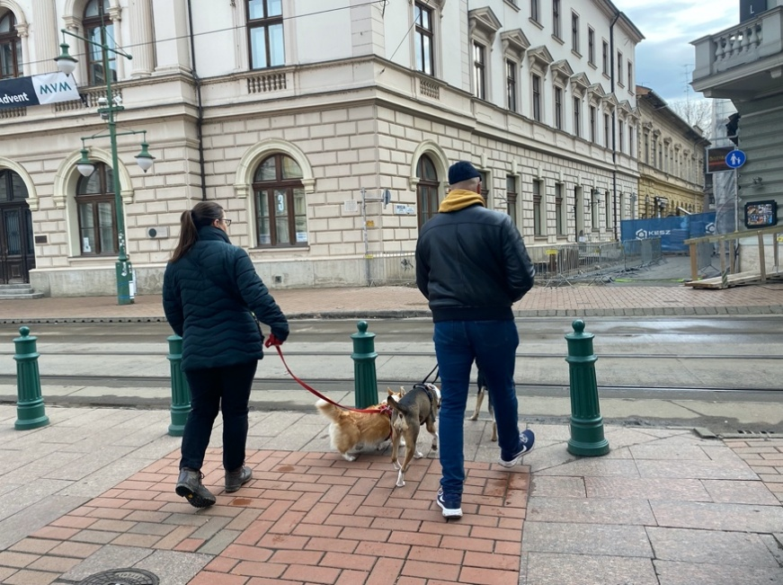
- What is in front of the man and woman as they try to cross the road?
a) A pedestrian bridge
b) Rail trams
c) A traffic signal
d) A crosswalk
- What might the man and woman need to do before crossing the road?
a) Wait for the rail trams to pass
b) Find a different route
c) Take a photo of the trams
d) Call for assistance

- How many dogs are with the man and woman?
a) One
b) Two
c) Three
d) Four
- What action are the man and woman planning to take with their dogs?
a) They want to cross the road
b) They want to walk along the rail trams
c) They want to visit a tram station
d) They want to wait for a tram
- What might be a necessary safety measure for the man and woman before crossing?
a) Checking for oncoming trams
b) Checking for pedestrians
c) Looking for a place to sit
d) Securing the dogs with a leash
- How could the presence of the rail trams affect the man and woman’s decision on how to cross the road?
a) They might choose to wait until the trams pass to ensure safety and avoid accidents
b) They might decide to cross immediately to avoid missing the trams
c) They might try to cross the road regardless of the trams’ presence
d) They might decide to go back and find an alternate route away from the trams
- How might the man and woman’s behavior need to change if they see a tram approaching while they are preparing to cross?
a) They would need to pause and wait until the tram has safely passed before continuing
b) They would need to hurry across to avoid missing the tram
c) They would need to find an alternate route that bypasses the tram tracks
d) They would need to signal the tram driver to stop
- In what ways could the presence of the rail trams influence the man and woman’s choice of where to cross the road?
a) They might choose to cross at a designated pedestrian crossing to ensure safety and clear visibility
b) They might cross at the nearest point to avoid a long walk
c) They might choose a spot with the least visibility to avoid waiting
d) They might choose to cross where there are no trams even if it’s inconvenient

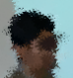
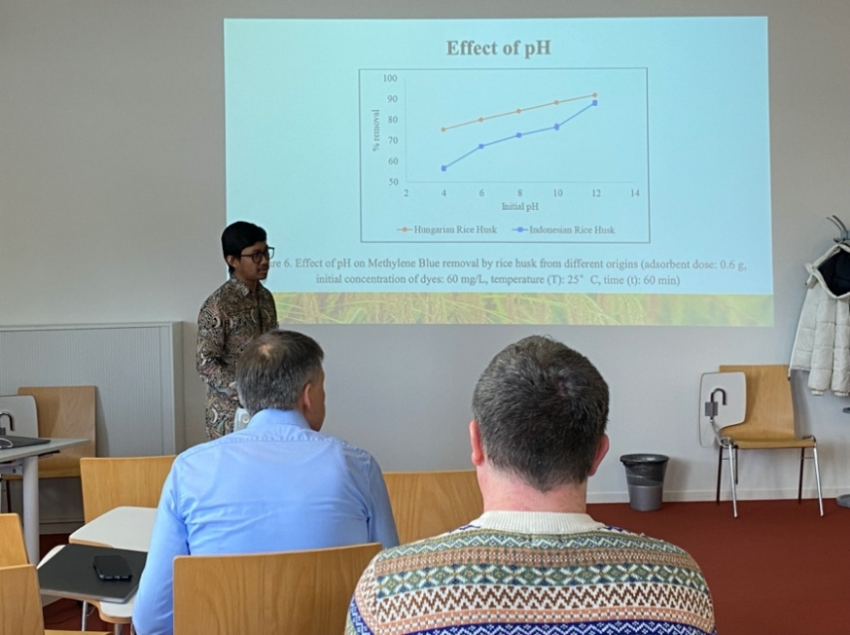

Audio from number 39 – 43:

- What is the man presenting?
A) A bar chart
B) A pie chart
C) A line graph
D) A scatter plot
- Who is the man presenting to?
A) A group of students
B) Two panellists
C) An audience of ten people
D) His family
- Where is the rubbish bin located?
A) Behind the man
B) In front of the audience
C) Outside the room
D) Next to the door
- What is beside the chair?
A) A table
B) A projector
C) A jacket
D) A bag
- How many panelists are in the room?
A) One
B) Two
C) Three
D) Four

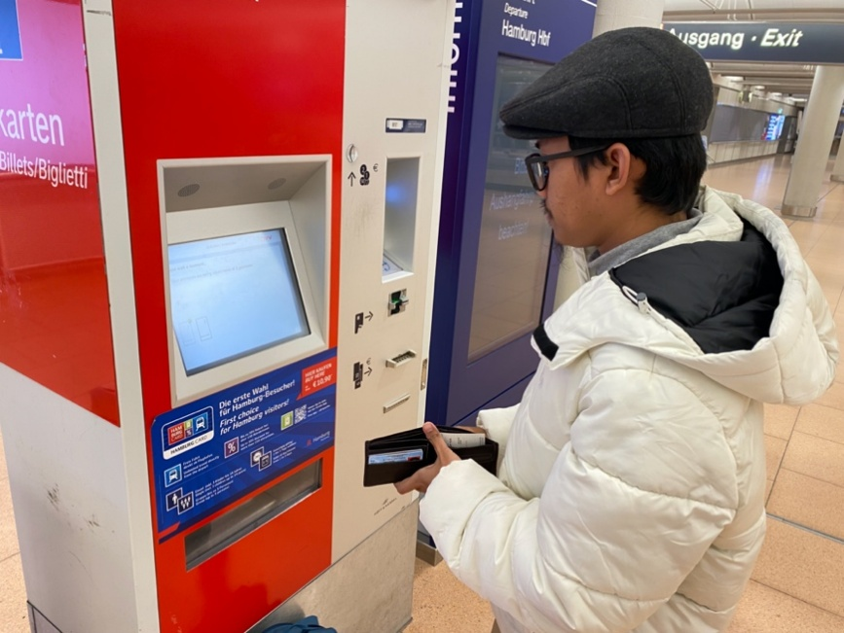
- What is the man holding in front of the ticket machine?
A) A book
B) A phone
C) A wallet
D) A ticket
- Where is the man waiting for the ticket?
A) At a bus stop
B) In front of a ticket machine
C) At a restaurant
D) At home
- When will the ticket come out of the machine?
A) Immediately after payment
B) After one hour
C) At the end of the day
D) It never comes out
- Who is waiting for the ticket?
A) A woman
B) A child
C) A man
D) A dog
- How is the man holding his wallet?
A) In his left hand
B) In his right hand
C) On his head
D) In his pocket
- If the man realizes the ticket machine is not functioning, what could be an effective course of action?
A) Inform the nearest staff member or customer service
B) Abandon his plans and go home
C) Continue waiting indefinitely
D) Leave without addressing the issue
- If the nearest staff member is unavailable, what should the man do to address the issue with the ticket machine?
A) Leave the location
B) Attempt to fix the machine
C) Ask a fellow passenger for assistance
D) Write a complaint and leave it at the station

