Appendix
Annex I
The list of NTFP species with their uses in the present study.
S.N. | Locally name/Nepali name | Botanical name of species | Uses
1 | Guddhe | Ageratum conyzoides L. | Plant juice is applied in cuts to stop bleeding.
2 | Saranchi | Alternanthera sessilis (L.) DC. | Decoction taken to cure fever. Used as vegetable.
3 | Pansan | Anaphalis contorta (D.Don) Hook.f. | Used to repel cockroaches from the house. Used as tinder for fire. Used for nose bleeds.
4 | Titepati | Artemisia dubia var. dubia | Leaves and twigs are used as insecticides. Dried leaves are burned to repel mosquitoes.
5 | Kurilo | Asparagus racemosus Willd. | Young twigs are cooked and taken as tonic.
6 | Meemee | Azadirachta indica A.Juss. | Cooked with rice and eaten during the name giving ceremony. Taken as blood purifier. Used as insecticide.
7 | Makar kach | Begonia picta Sm. | Juice applied as an anti-leech agent.
8 | Chutro/Musa lede | Berberis asiatica Roxb. ex DC. | Fruits eaten raw. Juice taken in diarrhoea and dysentery. Roots source of dye.
9 | Jamane mandro | Berberis napaulensis (DC.) Spreng. | Plant used for fencing. Fruit used in the treatment of urinary disorders.
10 | Pakhnabed | Bergenia ciliata (Haw.) Sternb. | Root juice used for urinary troubles, roundworms and fever.
11 | Lekh painu/Saur | Betula alnoides Buch.-Ham. ex D.Don | Paste applied on snake bite. Chewed as a substitute of betel nut.
12 | Kalo Kuro | Bidens pilosa L. | The juice of the plant is applied to fresh cuts and wounds.
13 | Simal | Bombax ceiba L. | The cotton is used for stuffing mattresses and pillows. Flower used in snake bites. Roots to enhance immunity booster.
14 | Bhang | Cannabis sativa L. | Fresh twigs are given to cattle to treat diarrhoea. In Hindu culture taken as Ghotta during Shivaratri.
15 | Simrayo | Cardamine hirsuta L. | Shoot eaten to lower blood pressure and in cardiac problems. Edible as vegetable.
16 | Tejpat | Cinnamomum tamala (Buch.-Ham.) T.Nees & C.H.Eberm. | Used as condiments. Leaves used as medicine for digestive problems.
17 | Junge lahara | Clematis montana Buch.-Ham. ex DC. | Juice used in sinusitis.
18 | Sunakhari | Coelogyne cristata Lindl. | Paste used in sores and boils.
19 | Dhursil | Colebrookea oppositifolia Sm. | Root is used in epilepsy. Leaf are applied to wounds and bruises.
20 | Lekh katus | Corylus ferox Wall. | Nuts are edible.
21 | Pribi | Cotoneaster microphyllus Wall. ex Lindl. | Used as astrigent.
22 |  | Cyathula capitata Moq. | Used as fodder. Roots is used to make a medicine for boils. Steroids potential as insecticides.
23 | Dubo | Cynodon dactylon (L.) Pers. | Plant juice is used in burning sensation, cuts and wounds.
24 | Seto Lokta | Daphne bholua Buch.-Ham. ex D.Don | Bark used in manufacture of hand made paper.
25 | Gofatdothrabithai | Datura stramonium L. | Used to treat scabies.
26 | Githa/ Ban Tarul | Dioscorea bulbifera L. | Boiled and eaten after submerging them whole night in cold water. Used for washing clothes, contraceptive pills.
27 | Sano Nigalo | Drepanostachyum falcatum (Nees) Keng f. | Used to make basket, trays, livestock shelters and temporary dwellings.
28 | Gathihare | Duhaldea cappa (Buch.-Ham. ex D.Don) Pruski & Anderb. | Juice used in fever, indigestion and other stomach disorders.
29 | Chhinki | Elsholtzia fruticosa (D.Don) Rehder | Religious value. Used as incense. Given against tonsilitis.
30 | Kurkure jhar | Equisetum ramosissimum Desf. | Used as clotting agent for wound, nose bleeding.
31 | Aankle jhar | Euphorbia hirta L. | Extraction given to lactating mother to increase the milk production.
32 | Thangnum | Euphorbia pseudosikkimensis (Hurus. & Yu.Tanaka) Radcl.-Sm. | Latex has an important ecological function for pathogen protection.
33 | Siude | Euphorbia royleana Boiss. | Applied to cure swelling of skin due to cutaneous and sub-cutaneous infection. Used in home to protect from evils.
34 | Phapar | Fagopyrum esculentum Moench | Juice taken orally during stomachache and gastritics.
35 | Ban Timilo | Ficus sarmentosa Buch.-Ham. ex Sm. | Fruit edible. Used in treatment of ulcers.
36 | Khaniu | Ficus semicordata Buch.-Ham. ex Sm. | Fruits are given in small ulcers in groups in the mouth or in tongue. Leaves as fodder. Fruits edible.
37 | Bhui ainselu | Fragaria nubicola (Lindl. ex Hook.f.) Lacaita | Ripen fruits consumed. Leaves used as diuretic for cattle.
38 | Chitlange jhar | Galinsoga parviflora Cav. | Used as fodder. Juice is used to help clot blood.
39 | Dhasingre | Gaultheria fragrantissima Wall. | Used as antiseptic, fodder and ritual ceremony.
40 | Allo | Girardinia diversifolia (Link) Friis | Young shoots eaten as green vegetables.Flowers taken to treat blood pressure.Used in cloth.
41 | Ban Karela | Herpetospermum pedunculosum (Ser.) C.B.Clarke | Fruit used to treat bile diseases.
42 | Nigalo/Pareng | Himalayacalamus hookerianus (Munro) Stapleton | Used to make basket and hut construction.
43 | Doli phul | Hypericum hookerianum Wight & Arn. | Leaves and fruits consumed by livestock.
44 | Okhar | Juglans regia L. | For curing toothache. Fruit edible. Used in Hindu festivals.
45 | Asuro | Justicia adhatoda L. | For curing cough, fever, asthma and dysentery
46 | Siltimur | Lindera neesiana (Wall. ex Nees) Kurz | Used as aromatic and carminative. Used to cook mushroom as vegetable.
47 | Khursani ful | Malvaviscus arboreus var. arboreus | Fruits edible. Used in horticulture. Good for attracting birds, butterflies, honey bees.
48 | Khasre buti | Mazus surculosus D.Don | Juice is used to treat acidity.
49 | Kafal | Myrica esculenta Buch.-Ham. ex D.Don | Fruits are consumed.
50 | Pani amala | Nephrolepis cordifolia (L.) C.Presl | Tuber juice is useful in dehydration. Used as fodder. Used in decoration.
51 | Angeri | Osbeckia stellata Buch.-Ham. ex D.Don | Root juice used in stomachache.
52 | Chari amilo | Oxalis corniculata L. | Used as vegetable.Rich in Vitamin C.
53 | Lek angeri | Pieris formosa (Wall.) D.Don | Leaf extract used as anthelminthic/rheumatism.
54 | Kamale | Pilea symmeria Wedd. | Used as vegetable. Used in facture parts. Used as fodder.
55 | Gobre salla | Pinus wallichiana A.B.Jacks. | The resinous wood yields turpentine and tar. Honey-dew from aphid infested leaves is eaten.
56 | Bajradanti | Potentilla fulgens Wall. ex Sims | Juice taken to treat stomach trouble, cough and cold.
57 | Simful | Primula denticulata Sm. | Used for decoration.
58 | Phekray/Dhatelo | Prinsepia utilis Royle | Oil consumed.
59 | Payun | Prunus cerasoides Buch.-Ham. ex D.Don | Fruit edible. Stem applied on factured bone and toothache. Used in religious event.
60 | Mayal | Pyrus pashia Buch.-Ham. ex D.Don | Taken to cure menstrual disorders. Used to make comb.
61 | Lali gurans | Rhododendron arboreum Sm. | Flower used to treat headache and make an alcohol.
62 | Bhakimlo | Rhus chinensis Mill. | Fruit edible, used as medicine. Used to extract dye.
63 | Sewa/Darimpate | Rosa sericea Lindl. | Paste of flower is applied to treat headaches and given in liver complaints.
64 | Majitho | Rubia manjith Roxb. | Root paste for curing scabies and skin diseases.Plant is used as dye.
65 | Aiselu | Rubus ellipticus Sm. | Used as spices and edible.
66 | Kalo ainselu | Rubus pedunculosus D.Don | Fruits edible. Young leaves for stomach disorders. Used as fodder.
67 | Kans | Saccharum spontaneum L. | Leaves consumed by livestock and an efficient soil binder.
68 | Chile kath | Sarcococca hookeriana Baill. | Root is applied externally to treat gout. Wood is used to make walking sticks. Valued as ground cover for fragrant flower.
69 | Chopchini | Smilax aspera L. | Applied to the skin to alleviate scabies.
70 | Kali gadi | Solanum americanum Mill. | Fruit edible and cooked into jam. Used to treat cancer of the cervix.
71 | Dhude jhar | Sonchus wightianus DC. | Taken in jaundice.
72 | Rate Bakhre Ghas | Sunhangia elegans (DC.) H.Ohashi & K.Ohashi | Used in the treatment of peptic ulcers.
73 | Tida/Chraito | Swertia chirayita (Roxb.) H.Karst. | For curing fever.
74 | Khenpa-Karpo | Taraxacum tibetanum Hand.-Mazz. | Used as medicine.
75 | Dampate | Thalictrum foliolosum DC. | Root used for curing gastritis.
76 | Amriso | Thysanolaena latifolia (Roxb. ex Hornem.) Honda | Used as abortifacient. Inflorescence used to make broom.
77 | Seto Behuli | Trifolium repens L. | Valued as protein rich livestock forage. Used to make a healthy tea.
78 | Sisnu | Urtica dioica L. | Leaves cooked and taken to maintain blood pressure. Young shoots as vegetables. Used as healing ceremonies.
79 | Ashare | Viburnum erubescens Wall. ex DC. | Seeds is eaten fresh or cooked. Juice from the root is used to treat coughs.
80 | Ban fasa/Ghatte ghas | Viola pilosa Blume | Root is used to treat stomach disorders.
81 | Dudhe | Youngia japonica (L.) DC. | Eaten as energy giving green vegetable. Used as remedy for indigestion.
82 | Boke Timur | Zanthoxylum acanthopodium DC. | Taken in indigestion, used as spices.
83 | Parpare Timur | Zanthoxylum armatum DC. | Decoction used to treat toothache, fever, cough. Fruit used as spice.
84 | Hade Bayer | Ziziphus incurva Roxb. | Fruits edible. Used in diarrhoea treatment. Used as fodder. In religious event. Making fences

Annex II
Inventory form used in data collection.

Quadrat /Transect No.:
NTFP species associated in each Plots and sub plots:
 | Date:2025.03. |  | Aspect: |  |  | Lat: N |  |  | VDC: Chumnubri,03
 | Altitude: |  | Slope: ̊ |  |  | Log: E |  |  | Forest Type:
S.N | Name of species |  | Presence and Number in |  |  |  |  | For Trees >10 cm dbh
S.N |  |  | 10*10 m plot |  | 5*5 m sub-plot |  | 1*1 m sub-plot | Average Trunk Perimeter (cm) |  | Average Height from the ground (m)
1
2
3
4
5
6
7
8
9
10
11
12
13
14
15
16
17
18
19
20
21
22
23
24
25
Annex III
Ethnobotanical survey data form:
S.N. | Name of the Species | Parts Used | Category uses | Method of use (if any) | Area of availability (altitudinal range, specific area) | Resources availability  (Increasing, Decreasing, as it is). Reasons?
Economic survey
S.N. | Name of the Species | Parts Used | Uses | Did you sell this NTFP? (KG) | Selling price/KG | Remarks
1
2
3
4
5
Questionnaire
Date-
Name of respondent-
Gender-
Age-
Occupation-
Education-
Ethnicity-
What is the value of NTFP species in meeting the daily family needs? (High/Medium/Low)
……………………….
Can you please name the common NTFP species mostly found in your community along their uses?
…………………………
Which are the common medicinal plants utilized in your family?
…………………………
Do these medicinal plants have a contribution to your health? (Agree/ Neutral/Disagree)
…………………………
How much income on average does HHs generate annually from the trade of NTFP species?
…………………………
Have you cultivated NTFP species in your farmland? (Yes/No)
…………………………
Where do you collect NTFP species mostly from? (Specific area/ Range/ Altitude)
…………………………

Annex IV
Research permit for the study.
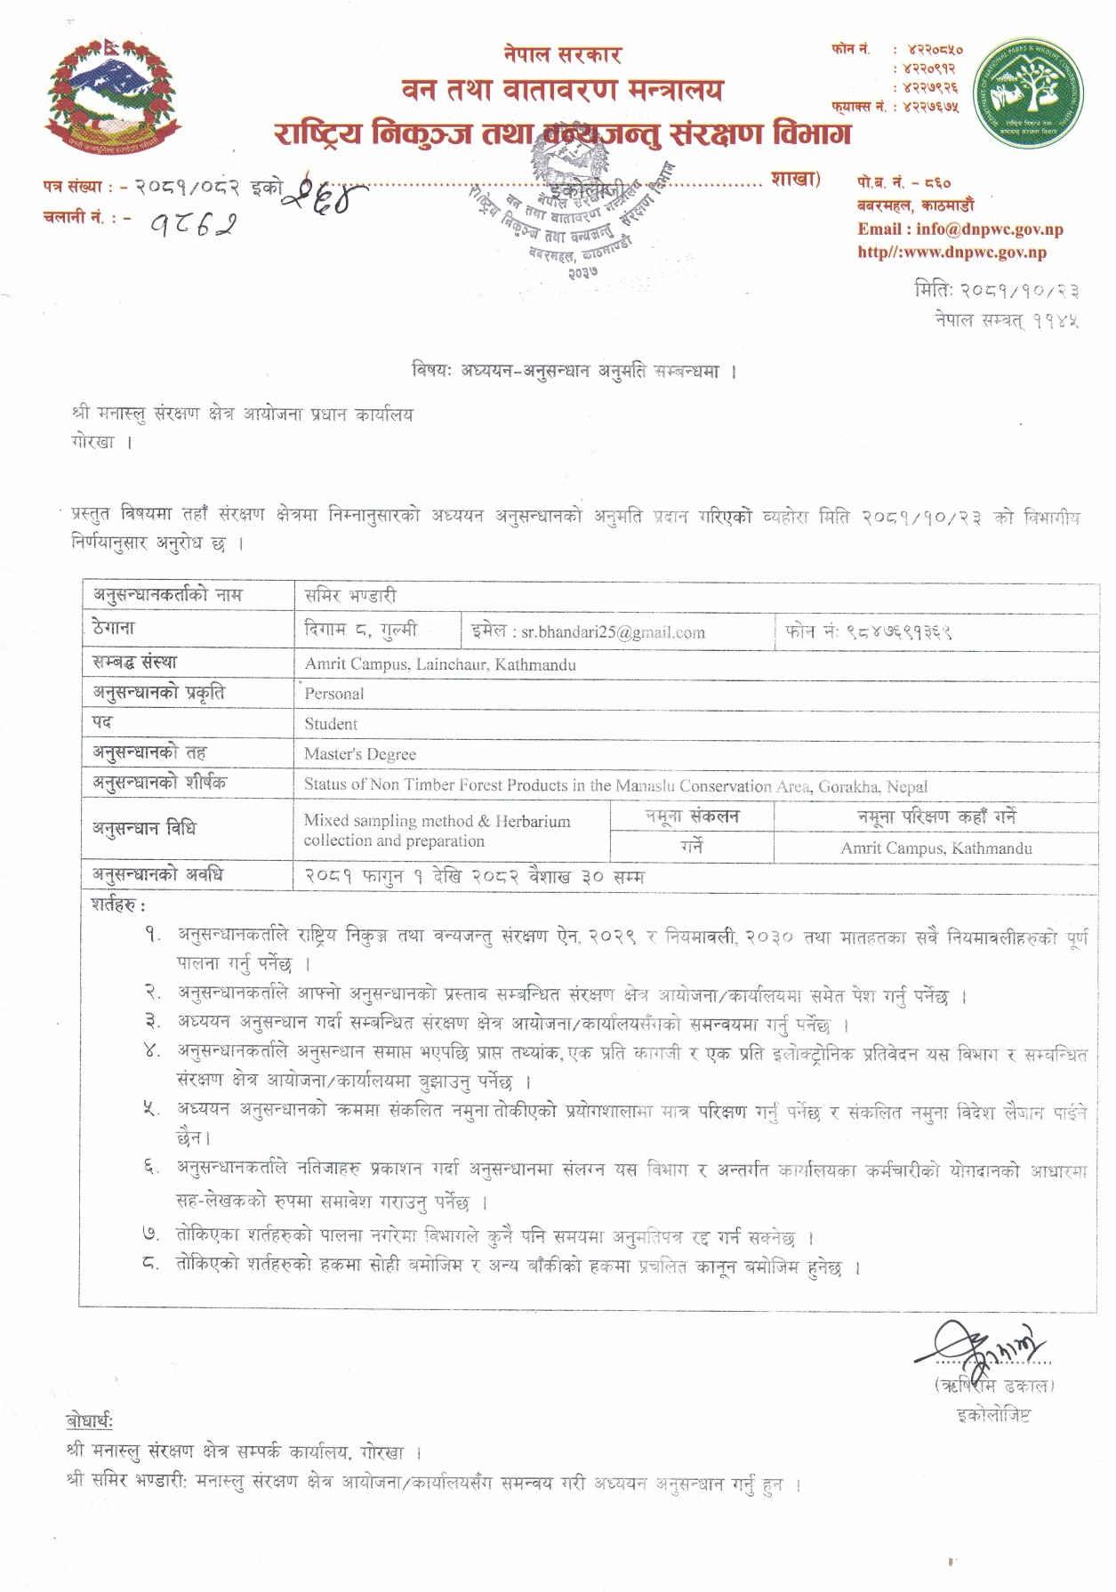
Annex IV
Table 7: The IVI of Tree species in Pangsing.
S.N. | Botanical name of species | F | RF | D | RD | DO | RDO | IVI
1 | Pinus wallichiana A.B.Jacks. | 26.67 | 30.77 | 33.33 | 29.41 | 0.34 | 34.06 | 94.24
2 | Rhododendron arboreum Sm. | 20.00 | 23.08 | 26.67 | 23.53 | 0.32 | 32.49 | 79.09
3 | Azadirachta indica A.Juss. | 13.33 | 15.38 | 26.67 | 23.53 | 0.06 | 6.07 | 44.99
4 | Rhus chinensis Mill. | 6.67 | 7.69 | 6.67 | 5.88 | 0.12 | 12.13 | 25.70
5 | Bombax ceiba L. | 6.67 | 7.69 | 6.67 | 5.88 | 0.11 | 11.13 | 24.70
6 | Ficus semicordata Buch.-Ham. ex Sm. | 6.67 | 7.69 | 6.67 | 5.88 | 0.03 | 3.36 | 16.93
7 | Ziziphus incurva Roxb. | 6.67 | 7.69 | 6.67 | 5.88 | 0.01 | 0.77 | 14.35
Table 8: The IVI of Tree species in Nyaak.
S.N. | Botanical name of species | F | RF | D | RD | DO | RDO | IVI
1 | Pinus wallichiana A.B.Jacks. | 26.67 | 18.18 | 46.67 | 31.82 | 0.58 | 27.84 | 77.84
2 | Rhododendron arboreum Sm. | 26.67 | 18.18 | 40.00 | 27.27 | 0.55 | 26.35 | 71.80
3 | Lindera neesiana (Wall. ex Nees) Kurz | 13.33 | 9.09 | 13.33 | 9.09 | 0.07 | 3.29 | 21.47
4 | Prunus cerasoides Buch.-Ham. ex D.Don | 13.33 | 9.09 | 13.33 | 9.09 | 0.05 | 2.59 | 20.77
5 | Myrica esculenta Buch.-Ham. ex D.Don | 6.67 | 4.55 | 6.67 | 4.55 | 0.22 | 10.76 | 19.86
6 | Cinnamomum tamala (Buch.-Ham.) T.Nees & C.H.Eberm. | 13.33 | 9.09 | 13.33 | 9.09 | 0.03 | 1.59 | 19.77
7 | Juglans regia L. | 6.67 | 4.55 | 6.67 | 4.55 | 0.22 | 10.44 | 19.53
8 | Betula alnoides Buch.-Ham. ex D.Don | 6.67 | 4.55 | 6.67 | 4.55 | 0.17 | 8.28 | 17.37
9 | Corylus ferox Wall. | 6.67 | 4.55 | 13.33 | 9.09 | 0.07 | 3.45 | 17.09
10 | Azadirachta indica A.Juss. | 6.67 | 4.55 | 6.67 | 4.55 | 0.03 | 1.59 | 10.68
11 | Pyrus pashia Buch.-Ham. ex D.Don | 6.67 | 4.55 | 6.67 | 4.55 | 0.03 | 1.41 | 10.50
12 | Pieris formosa (Wall.) D.Don | 6.67 | 4.55 | 6.67 | 4.55 | 0.03 | 1.29 | 10.38
13 | Ficus sarmentosa Buch.-Ham. ex Sm. | 6.67 | 4.55 | 6.67 | 4.55 | 0.02 | 1.12 | 10.21
Table 9: The IVI of Shrub species in Pangsing.
S.N. | Botanical name of species | F | RF | D | RD | C | RC | IVI
1 | Rubus pedunculosus D.Don | 20.00 | 15.00 | 186.67 | 16.67 | 30.17 | 9.30 | 40.97
2 | Zanthoxylum armatum DC. | 6.67 | 5.00 | 266.67 | 23.81 | 37.50 | 11.56 | 40.37
3 | Prinsepia utilis Royle | 20.00 | 15.00 | 133.33 | 11.90 | 31.17 | 9.61 | 36.52
4 | Berberis napaulensis (DC.) Spreng. | 13.33 | 10.00 | 133.33 | 11.90 | 26.50 | 8.17 | 30.08
5 | Colebrookea oppositifolia Sm. | 6.67 | 5.00 | 80.00 | 7.14 | 37.50 | 11.56 | 23.70
6 | Elsholtzia fruticosa (D.Don) Rehder | 13.33 | 10.00 | 53.33 | 4.76 | 15.50 | 4.78 | 19.54
7 | Osbeckia stellata Buch.-Ham. ex D.Don | 6.67 | 5.00 | 26.67 | 2.38 | 37.50 | 11.56 | 18.94
8 | Hypericum hookerianum Wight & Arn. | 6.67 | 5.00 | 53.33 | 4.76 | 15.50 | 4.78 | 14.54
9 | Rubus ellipticus Sm. | 6.67 | 5.00 | 53.33 | 4.76 | 15.50 | 4.78 | 14.54
10 | Daphne bholua Buch.-Ham. ex D.Don | 6.67 | 5.00 | 26.67 | 2.38 | 15.50 | 4.78 | 12.16
11 | Datura stramonium L. | 6.67 | 5.00 | 26.67 | 2.38 | 15.50 | 4.78 | 12.16
12 | Euphorbia royleana Boiss. | 6.67 | 5.00 | 26.67 | 2.38 | 15.50 | 4.78 | 12.16
13 | Malvaviscus arboreus var. arboreus | 6.67 | 5.00 | 26.67 | 2.38 | 15.50 | 4.78 | 12.16
14 | Viburnum erubescens Wall. ex DC. | 6.67 | 5.00 | 26.67 | 2.38 | 15.50 | 4.78 | 12.16
Table 10: The IVI of Shrub species in Nyaak.
S.N. | Botanical name of species | F | RF | D | RD | C | RC | IVI
1 | Zanthoxylum acanthopodium DC. | 13.33 | 9.09 | 186.67 | 14.58 | 62.50 | 14.69 | 38.36
2 | Daphne bholua Buch.-Ham. ex D.Don | 20.00 | 13.64 | 186.67 | 14.58 | 15.50 | 3.64 | 31.86
3 | Sunhangia elegans (DC.) H.Ohashi & K.Ohashi | 13.33 | 9.09 | 240.00 | 18.75 | 15.50 | 3.64 | 31.48
4 | Berberis asiatica Roxb. ex DC. | 13.33 | 9.09 | 133.33 | 10.42 | 26.50 | 6.23 | 25.74
5 | Zanthoxylum armatum DC. | 13.33 | 9.09 | 53.33 | 4.17 | 50.00 | 11.75 | 25.01
6 | Rubus pedunculosus D.Don | 13.33 | 9.09 | 133.33 | 10.42 | 15.50 | 3.64 | 23.15
7 | Colebrookea oppositifolia Sm. | 6.67 | 4.55 | 80.00 | 6.25 | 37.50 | 8.81 | 19.61
8 | Sarcococca hookeriana Baill. | 6.67 | 4.55 | 26.67 | 2.08 | 50.00 | 11.75 | 18.38
9 | Cotoneaster microphyllus Wall. ex Lindl. | 6.67 | 4.55 | 53.33 | 4.17 | 37.50 | 8.81 | 17.53
10 | Duhaldea cappa (Buch.-Ham. ex D.Don) Pruski & Anderb. | 6.67 | 4.55 | 26.67 | 2.08 | 37.50 | 8.81 | 15.44
11 | Prinsepia utilis Royle | 6.67 | 4.55 | 53.33 | 4.17 | 15.50 | 3.64 | 12.35
12 | Elsholtzia fruticosa (D.Don) Rehder | 6.67 | 4.55 | 26.67 | 2.08 | 15.50 | 3.64 | 10.27
13 | Gaultheria fragrantissima Wall. | 6.67 | 4.55 | 26.67 | 2.08 | 15.50 | 3.64 | 10.27
14 | Justicia adhatoda L. | 6.67 | 4.55 | 26.67 | 2.08 | 15.50 | 3.64 | 10.27
15 | Rubus ellipticus Sm. | 6.67 | 4.55 | 26.67 | 2.08 | 15.50 | 3.64 | 10.27
Table 11: The IVI of Herb species in Pangsing.
S.N. | Botanical name of species | F | RF | D | RD | C | RC | IVI
1 | Anaphalis contorta (D.Don) Hook.f. | 6.67 | 7.14 | 7555.6 | 15.38 | 11.17 | 4.44 | 26.96
2 | Cannabis sativa L. | 4.44 | 4.76 | 4888.9 | 9.95 | 26.50 | 10.52 | 25.24
3 | Artemisia dubia var. dubia | 6.67 | 7.14 | 5111.1 | 10.41 | 15.50 | 6.15 | 23.70
4 | Thysanolaena latifolia (Roxb. ex Hornem.) Honda | 2.22 | 2.38 | 2444.4 | 4.98 | 37.50 | 14.89 | 22.25
5 | Euphorbia pseudosikkimensis (Hurus. & Yu.Tanaka) Radcl.-Sm. | 6.67 | 7.14 | 3333.3 | 6.79 | 11.17 | 4.44 | 18.37
6 | Trifolium repens L. | 4.44 | 4.76 | 3555.6 | 7.24 | 15.50 | 6.15 | 18.16
7 | Cynodon dactylon (L.) Pers. | 4.44 | 4.76 | 5333.3 | 10.86 | 2.50 | 0.99 | 16.61
8 | Sonchus wightianus DC. | 4.44 | 4.76 | 1777.8 | 3.62 | 9.00 | 3.57 | 11.96
9 | Girardinia diversifolia (Link) Friis | 2.22 | 2.38 | 1111.1 | 2.26 | 15.50 | 6.15 | 10.80
10 | Ageratum conyzoides L. | 4.44 | 4.76 | 1111.1 | 2.26 | 9.00 | 3.57 | 10.60
11 | Equisetum ramosissimum Desf. | 2.22 | 2.38 | 3333.3 | 6.79 | 2.50 | 0.99 | 10.16
12 | Cardamine hirsuta L. | 2.22 | 2.38 | 666.7 | 1.36 | 15.50 | 6.15 | 9.89
13 | Herpetospermum pedunculosum (Ser.) C.B.Clarke | 2.22 | 2.38 | 666.7 | 1.36 | 15.50 | 6.15 | 9.89
14 | Rosa sericea Lindl. | 2.22 | 2.38 | 666.7 | 1.36 | 15.50 | 6.15 | 9.89
15 | Urtica dioica L. | 2.22 | 2.38 | 666.7 | 1.36 | 15.50 | 6.15 | 9.89
16 | Saccharum spontaneum L. | 4.44 | 4.76 | 666.7 | 1.36 | 9.00 | 3.57 | 9.69
17 | Bidens pilosa L. | 4.44 | 4.76 | 1111.1 | 2.26 | 2.50 | 0.99 | 8.02
18 | Oxalis corniculata L. | 4.44 | 4.76 | 1111.1 | 2.26 | 2.50 | 0.99 | 8.02
19 | Galinsoga parviflora Cav. | 4.44 | 4.76 | 888.9 | 1.81 | 2.50 | 0.99 | 7.56
20 | Primula denticulata Sm. | 4.44 | 4.76 | 888.9 | 1.81 | 2.50 | 0.99 | 7.56
21 | Alternanthera sessilis (L.) DC. | 2.22 | 2.38 | 888.9 | 1.81 | 2.50 | 0.99 | 5.18
22 | Mazus surculosus D.Don | 2.22 | 2.38 | 444.4 | 0.90 | 2.50 | 0.99 | 4.28
23 | Asparagus racemosus Willd. | 2.22 | 2.38 | 222.2 | 0.45 | 2.50 | 0.99 | 3.83
24 | Fagopyrum esculentum Moench | 2.22 | 2.38 | 222.2 | 0.45 | 2.50 | 0.99 | 3.83
25 | Pilea symmeria Wedd. | 2.22 | 2.38 | 222.2 | 0.45 | 2.50 | 0.99 | 3.83
26 | Youngia japonica (L.) DC. | 2.22 | 2.38 | 222.2 | 0.45 | 2.50 | 0.99 | 3.83
Table 12: The IVI of Herb species in Nyaak.
S.N. | Botanical name of species | F | RF | D | RD | C | RC | IVI
1 | Drepanostachyum falcatum (Nees) Keng f. | 6.67 | 6.52 | 12444.44 | 21.88 | 97.50 | 21.13 | 49.52
2 | Himalayacalamus hookerianus (Munro) Stapleton | 2.22 | 2.17 | 3555.56 | 6.25 | 85.50 | 18.53 | 26.95
3 | Pinus wallichiana A.B.Jacks. | 2.22 | 2.17 | 888.89 | 1.56 | 37.50 | 8.13 | 11.86
4 | Anaphalis contorta (D.Don) Hook.f. | 4.44 | 4.35 | 3111.11 | 5.47 | 9.00 | 1.95 | 11.77
5 | Bidens pilosa L. | 4.44 | 4.35 | 1777.78 | 3.13 | 15.50 | 3.36 | 10.83
6 | Urtica dioica L. | 4.44 | 4.35 | 1555.56 | 2.73 | 15.50 | 3.36 | 10.44
7 | Euphorbia hirta L. | 2.22 | 2.17 | 2222.22 | 3.91 | 15.50 | 3.36 | 9.44
8 | Girardinia diversifolia (Link) Friis | 2.22 | 2.17 | 2222.22 | 3.91 | 15.50 | 3.36 | 9.44
9 | Trifolium repens L. | 2.22 | 2.17 | 2222.22 | 3.91 | 15.50 | 3.36 | 9.44
10 | Thalictrum foliolosum DC. | 4.44 | 4.35 | 1555.56 | 2.73 | 9.00 | 1.95 | 9.03
11 | Alternanthera sessilis (L.) DC. | 2.22 | 2.17 | 1777.78 | 3.13 | 15.50 | 3.36 | 8.66
12 | Nephrolepis cordifolia (L.) C.Presl | 2.22 | 2.17 | 1777.78 | 3.13 | 15.50 | 3.36 | 8.66
13 | Sonchus wightianus DC. | 4.44 | 4.35 | 1777.78 | 3.13 | 2.50 | 0.54 | 8.01
14 | Taraxacum tibetanum Hand.-Mazz. | 4.44 | 4.35 | 1777.78 | 3.13 | 2.50 | 0.54 | 8.01
15 | Bergenia ciliata (Haw.) Sternb. | 2.22 | 2.17 | 1333.33 | 2.34 | 15.50 | 3.36 | 7.88
16 | Ageratum conyzoides L. | 4.44 | 4.35 | 1333.33 | 2.34 | 2.50 | 0.54 | 7.23
17 | Fragaria nubicola (Lindl. ex Hook.f.) Lacaita | 2.22 | 2.17 | 888.89 | 1.56 | 15.50 | 3.36 | 7.10
18 | Myrica esculenta Buch.-Ham. ex D.Don | 2.22 | 2.17 | 888.89 | 1.56 | 15.50 | 3.36 | 7.10
19 | Rhododendron arboreum Sm. | 2.22 | 2.17 | 666.67 | 1.17 | 15.50 | 3.36 | 6.70
20 | Cynodon dactylon (L.) Pers. | 2.22 | 2.17 | 2222.22 | 3.91 | 2.50 | 0.54 | 6.62
21 | Begonia picta Sm. | 2.22 | 2.17 | 1333.33 | 2.34 | 2.50 | 0.54 | 5.06
22 | Artemisia dubia var. dubia | 2.22 | 2.17 | 1111.11 | 1.95 | 2.50 | 0.54 | 4.67
23 | Coelogyne cristata Lindl. | 2.22 | 2.17 | 888.89 | 1.56 | 2.50 | 0.54 | 4.28
24 | Cyathula capitata Moq. | 2.22 | 2.17 | 888.89 | 1.56 | 2.50 | 0.54 | 4.28
25 | Viola pilosa Blume | 2.22 | 2.17 | 888.89 | 1.56 | 2.50 | 0.54 | 4.28
26 | Euphorbia pseudosikkimensis (Hurus. & Yu.Tanaka) Radcl.-Sm. | 2.22 | 2.17 | 666.67 | 1.17 | 2.50 | 0.54 | 3.89
27 | Solanum americanum Mill. | 2.22 | 2.17 | 666.67 | 1.17 | 2.50 | 0.54 | 3.89
28 | Asparagus racemosus Willd. | 2.22 | 2.17 | 444.44 | 0.78 | 2.50 | 0.54 | 3.50
29 | Clematis montana Buch.-Ham. ex DC. | 2.22 | 2.17 | 444.44 | 0.78 | 2.50 | 0.54 | 3.50
30 | Dioscorea bulbifera L. | 2.22 | 2.17 | 444.44 | 0.78 | 2.50 | 0.54 | 3.50
31 | Galinsoga parviflora Cav. | 2.22 | 2.17 | 444.44 | 0.78 | 2.50 | 0.54 | 3.50
32 | Potentilla fulgens Wall. ex Sims | 2.22 | 2.17 | 444.44 | 0.78 | 2.50 | 0.54 | 3.50
33 | Rosa sericea Lindl. | 2.22 | 2.17 | 444.44 | 0.78 | 2.50 | 0.54 | 3.50
34 | Rubia manjith Roxb. | 2.22 | 2.17 | 444.44 | 0.78 | 2.50 | 0.54 | 3.50
35 | Smilax aspera L. | 2.22 | 2.17 | 444.44 | 0.78 | 2.50 | 0.54 | 3.50
36 | Swertia chirayita (Roxb.) H.Karst. | 2.22 | 2.17 | 444.44 | 0.78 | 2.50 | 0.54 | 3.50
37 | Youngia japonica (L.) DC. | 2.22 | 2.17 | 444.44 | 0.78 | 2.50 | 0.54 | 3.50

Photo plate 1
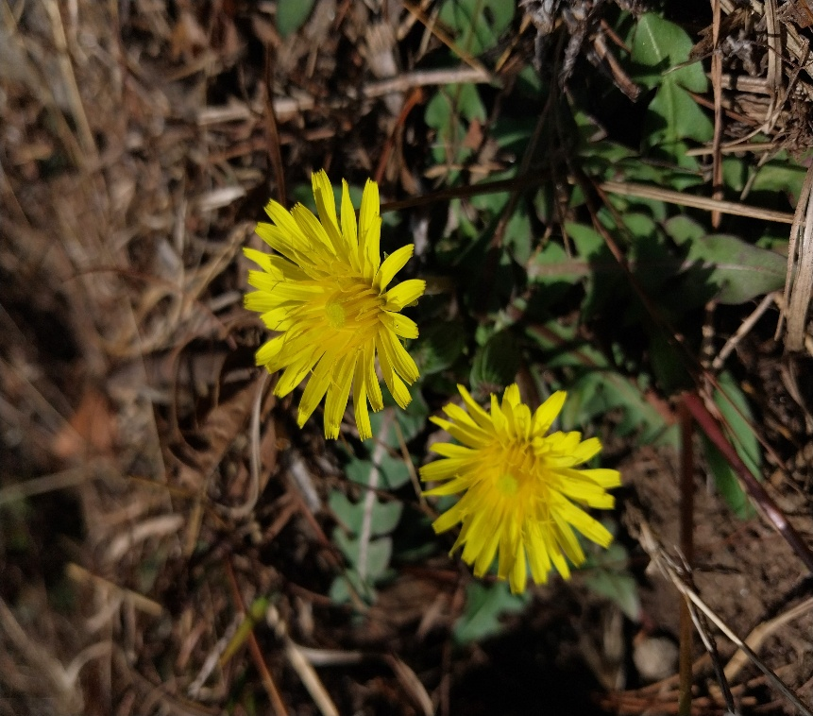 | 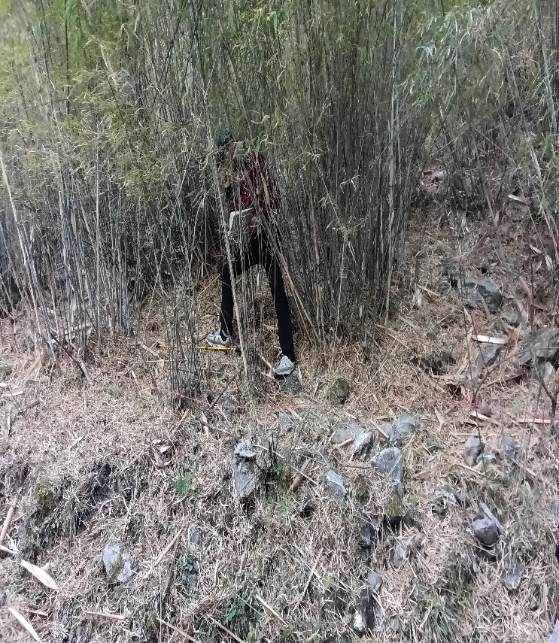
Taraxacum tibetanum Hand.-Mazz. | Himalayacalamus hookerianus (Munro) Stapleton
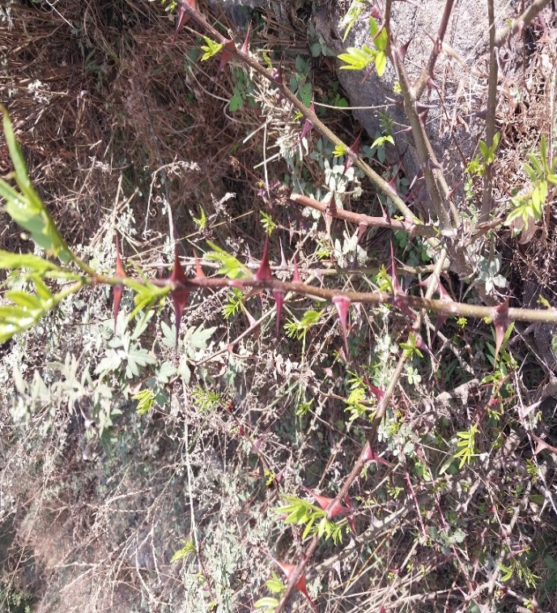 | 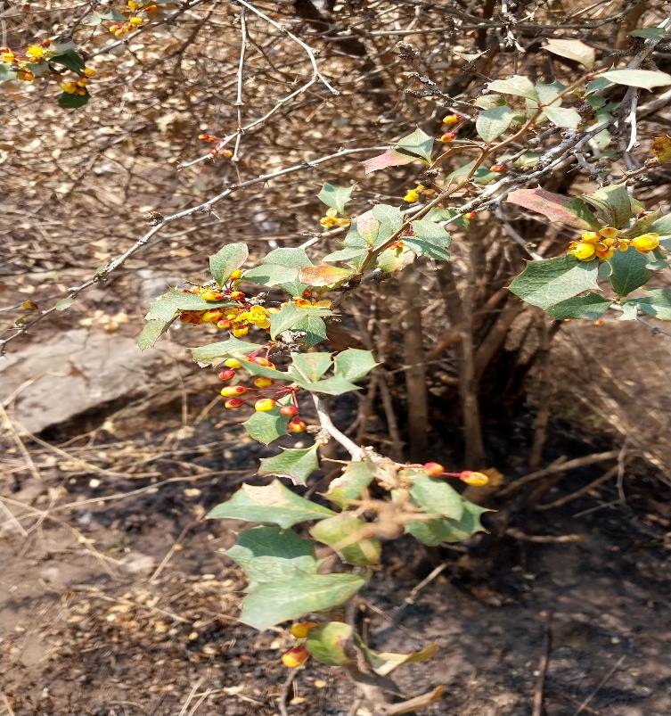
Zanthoxylum armatum DC. | Berberis asiatica Roxb. ex DC.

Photo plate 2
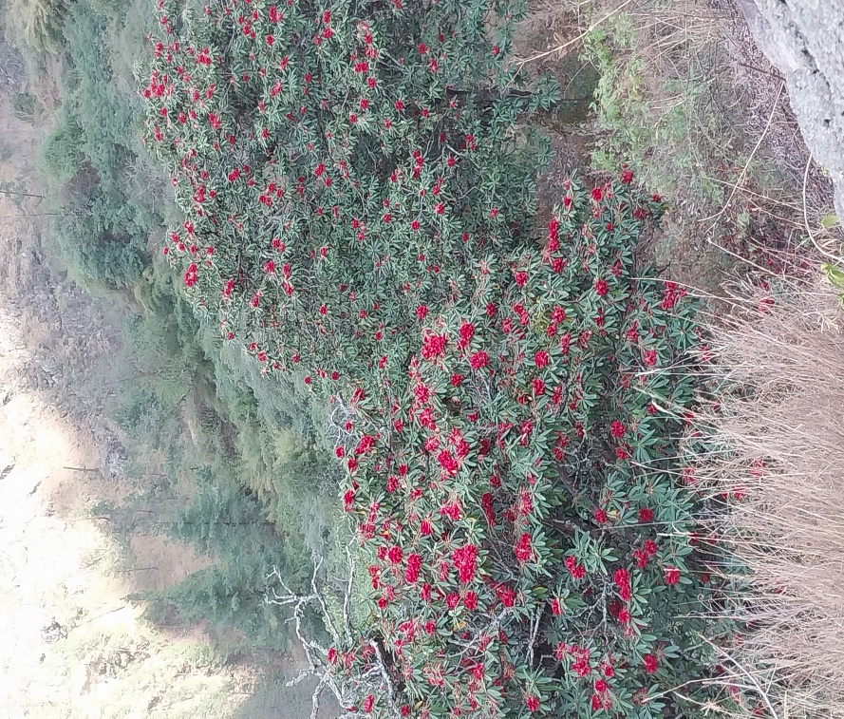 | 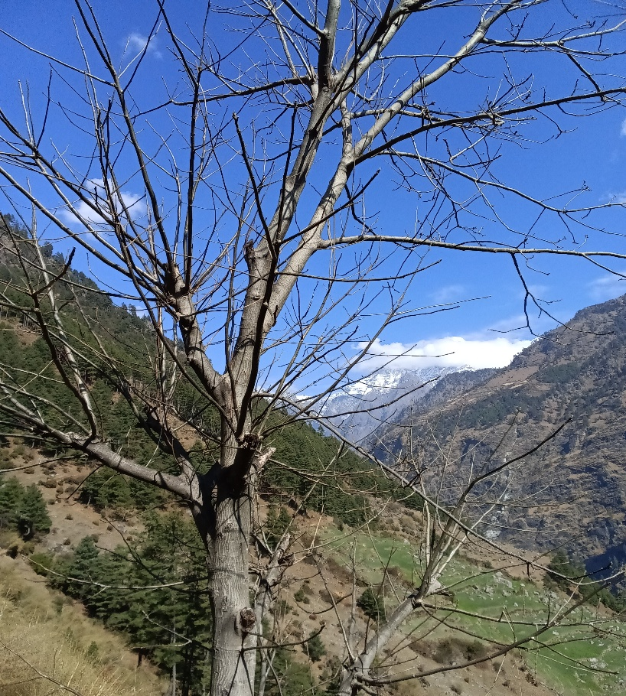
Rhododendron arboreum Sm. | Juglans regia L.
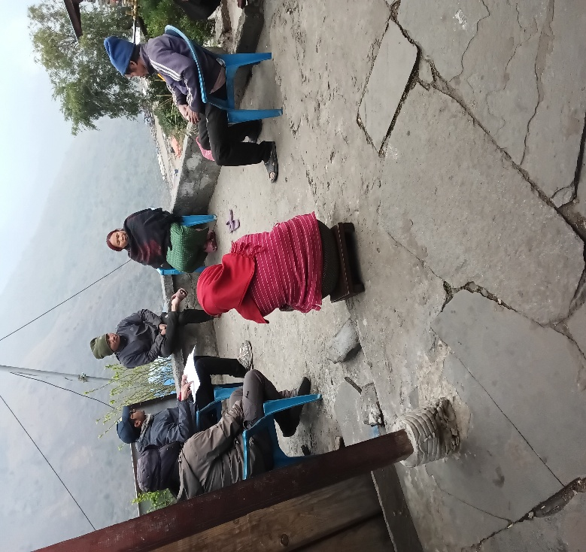 | 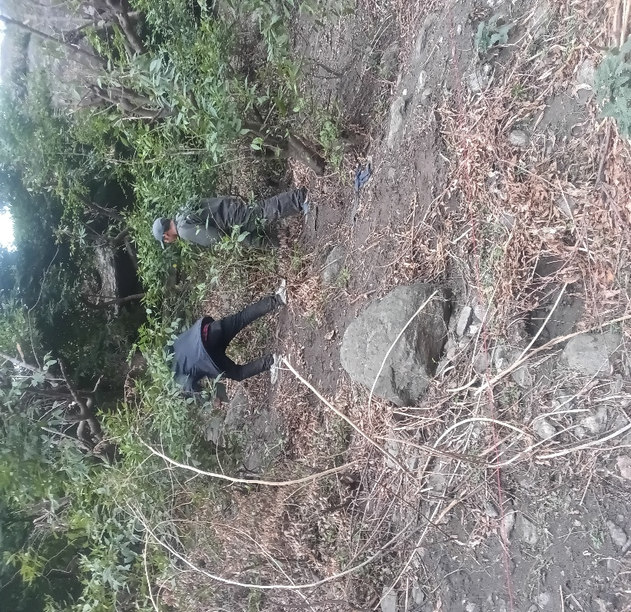
Focus group discussions | Field work in Pansing

