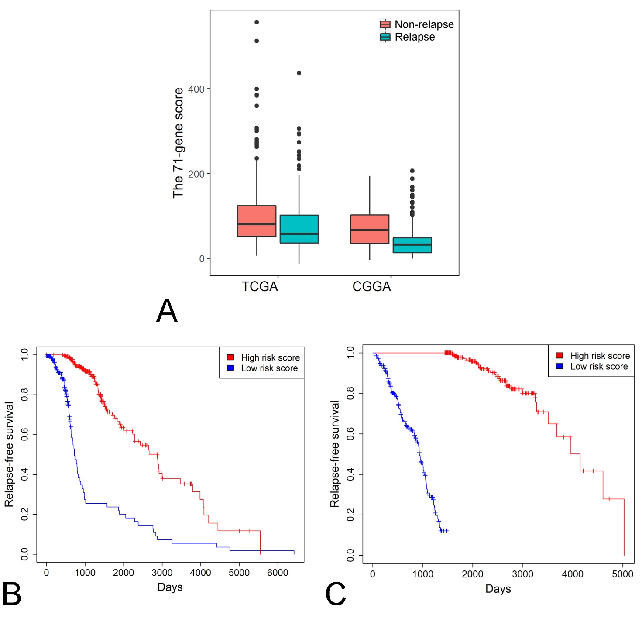
Supplementary Figure1. The 71-gene score is positively associated with RFS in LGG. A. The difference of the 71-gene scores between the LGG patients with relapse and non-relapse in the two cohorts. B. The comparison of Kaplan-Meier survival curves between high and low 71-gene score groups in the TCGA cohort. C. The comparison of Kaplan-Meier survival curves between high and low 71-gene score groups in the CGGA cohort. Risk score : the 71-gene score.

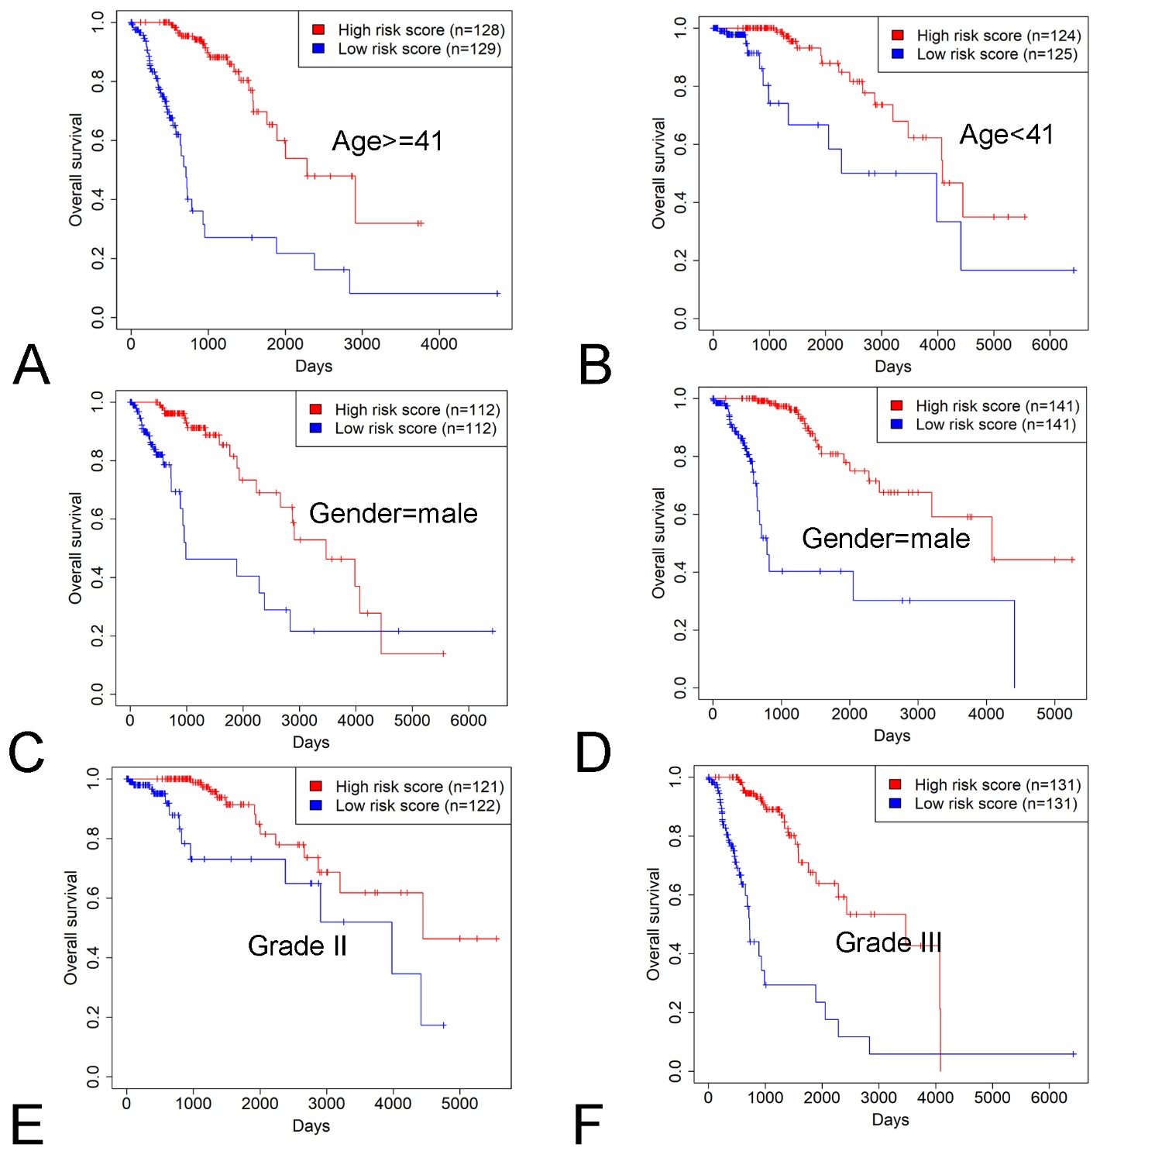
Supplementary Figure2. Kaplan-Meier survival analysis of patients’ OS with the 71-gene score in the subgroups of LGG patients stratified by patient age, gender and histologic grade (A-F) of the TCGA cohort. Risk score : the 71-gene score.

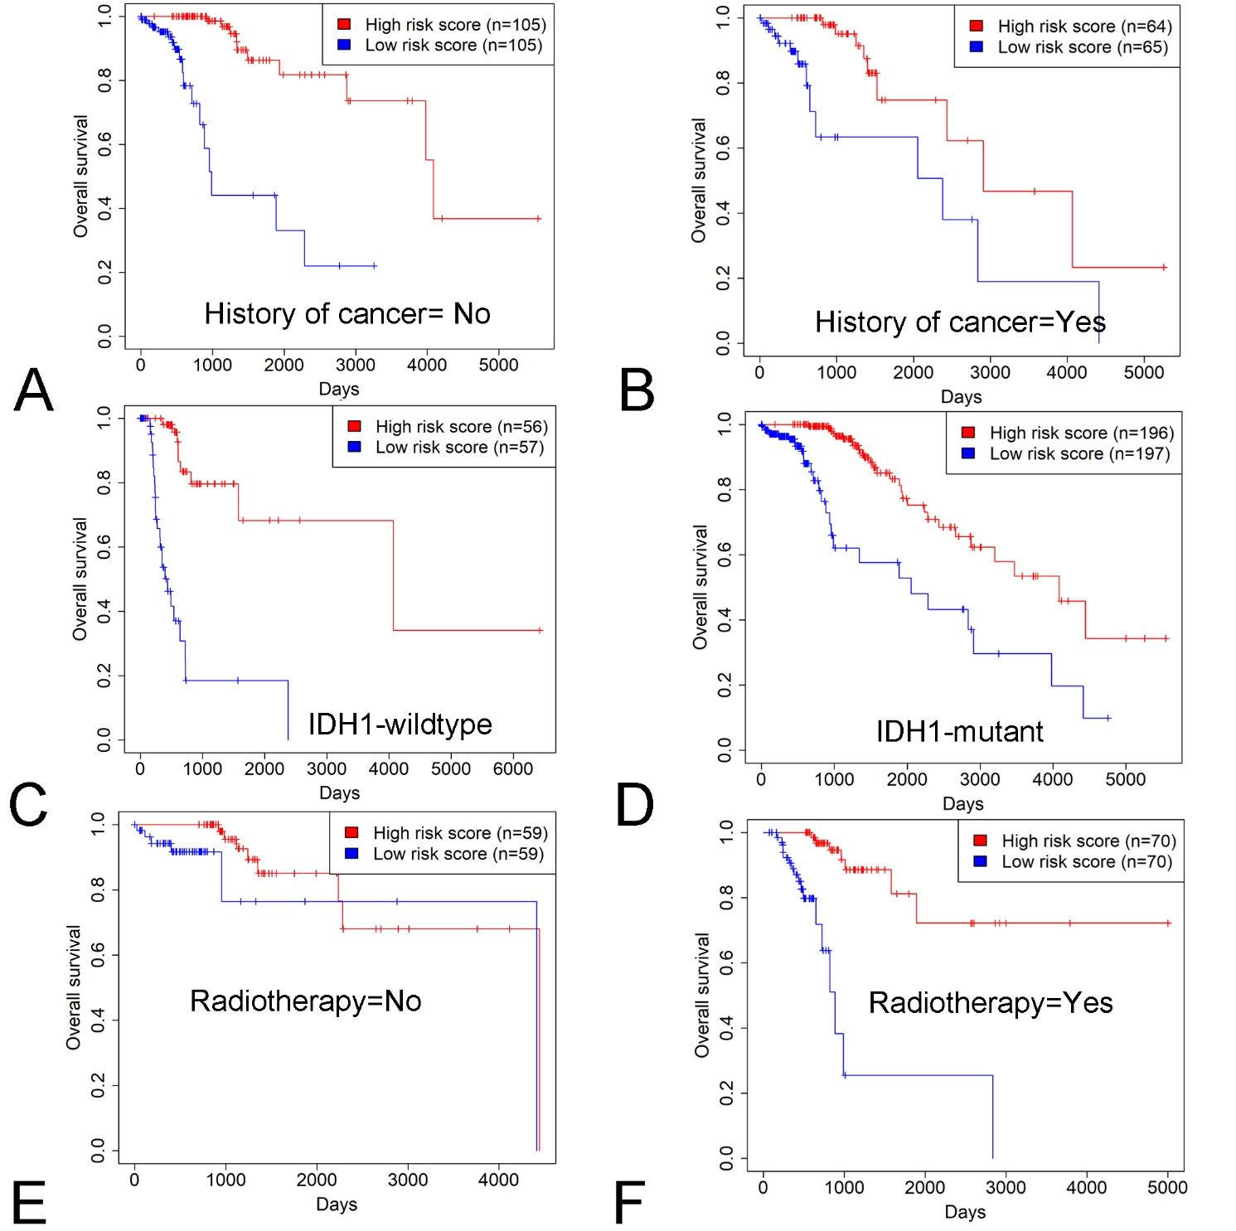
Supplementary Figure3. Kaplan-Meier survival analysis of patients’ OS with the 71-gene score in the subgroups of LGG patients stratified by history of cancer, IDH1 mutation and radiotherapy (A-F) of the TCGA cohort.

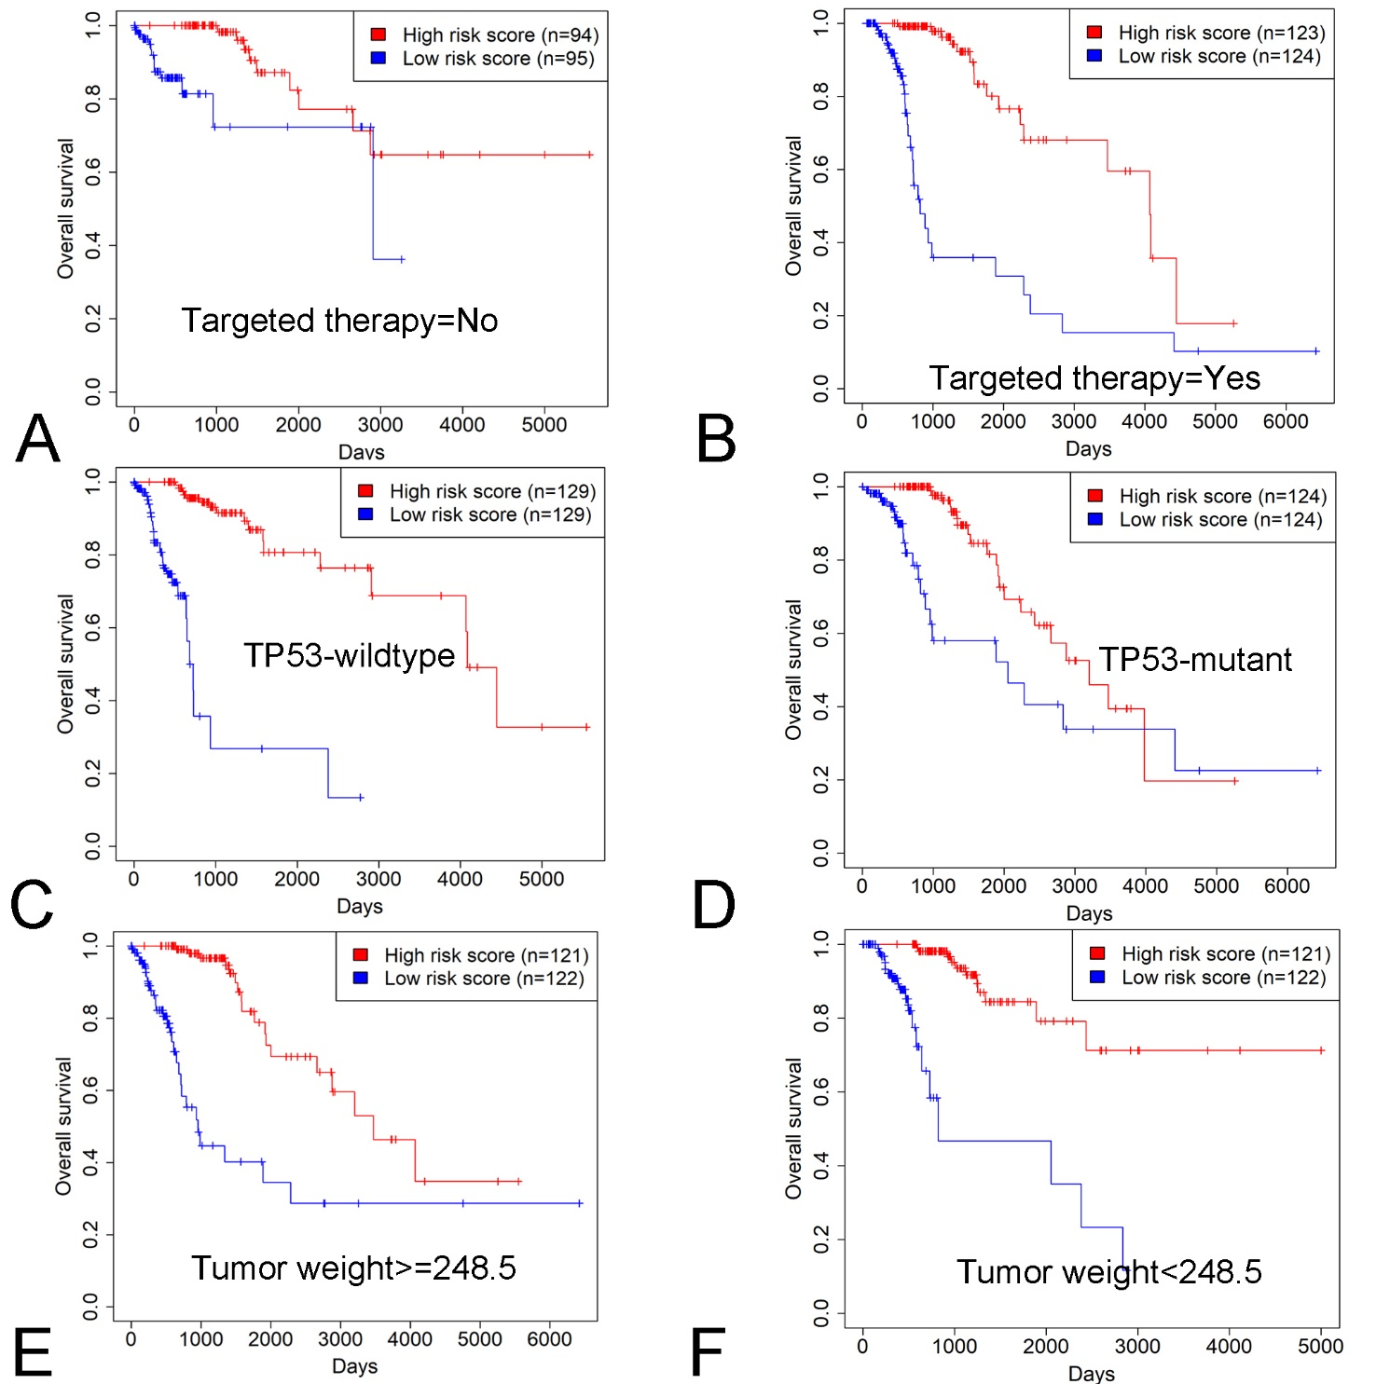
Supplementary Figure4. Kaplan-Meier survival analysis of patients’ OS with the 71-gene score in the subgroups of LGG patients stratified by targeted therapy, TP53 mutation and tumor weight (A-F) of the TCGA cohort.

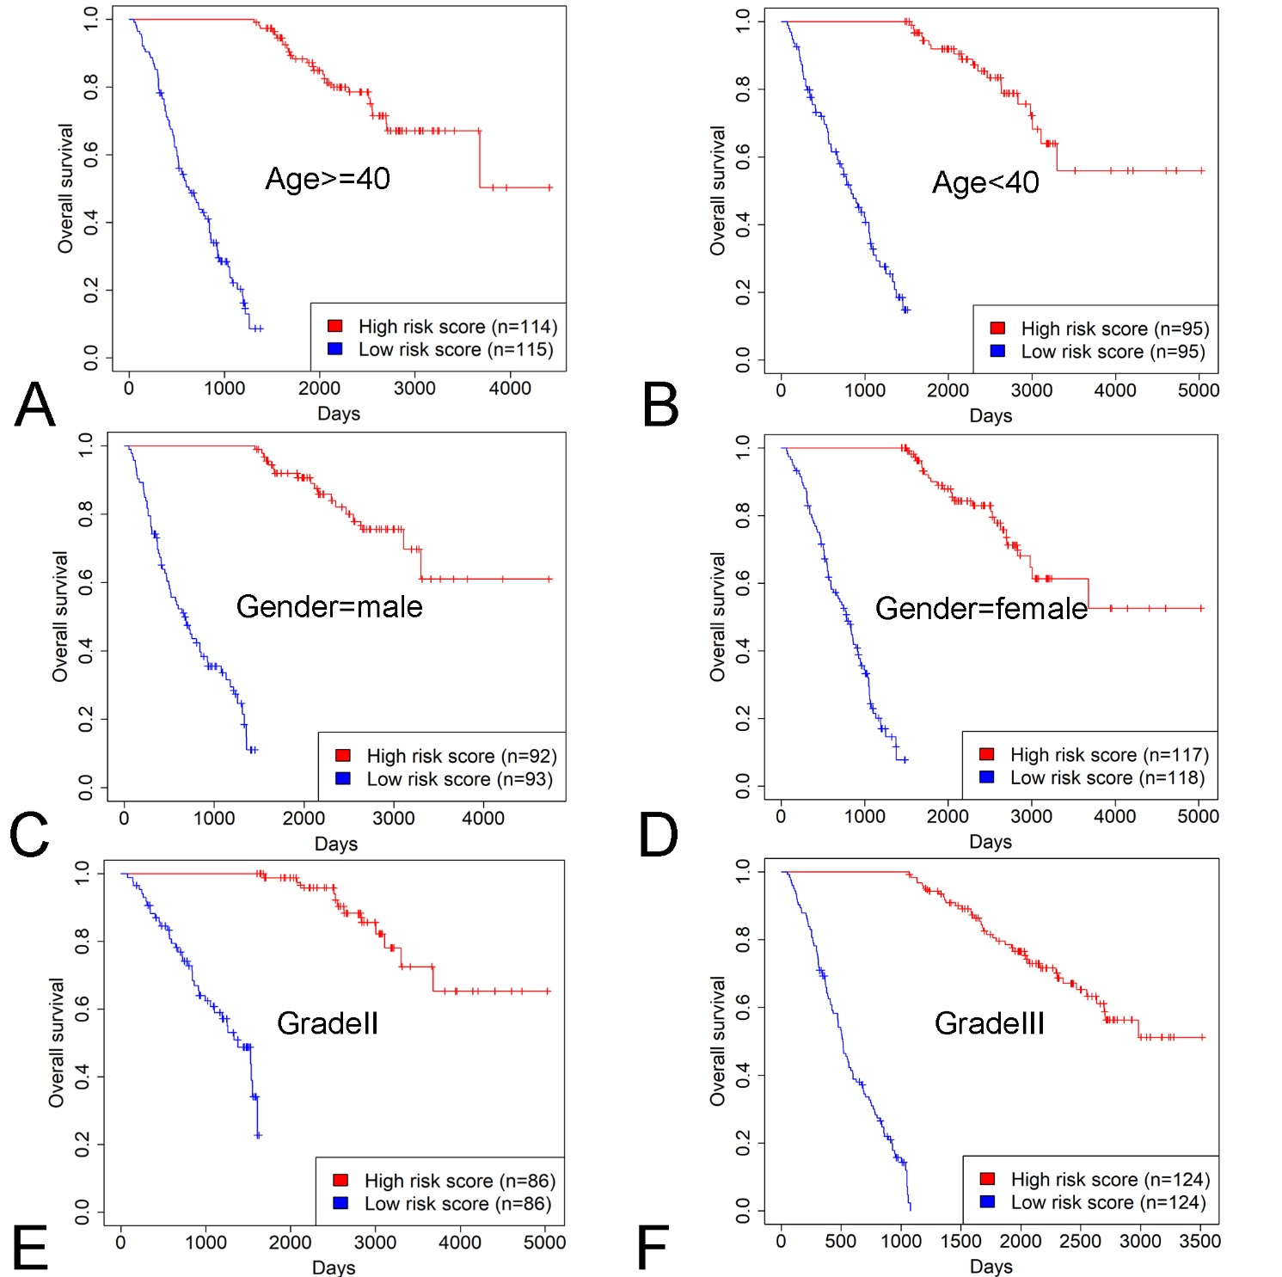
Supplementary Figure5. Kaplan-Meier survival analysis of patients’ OS with the 71-gene score in the subgroups of LGG patients stratified by patient age, gender and histologic grade (A-F) of the CGGA cohort.

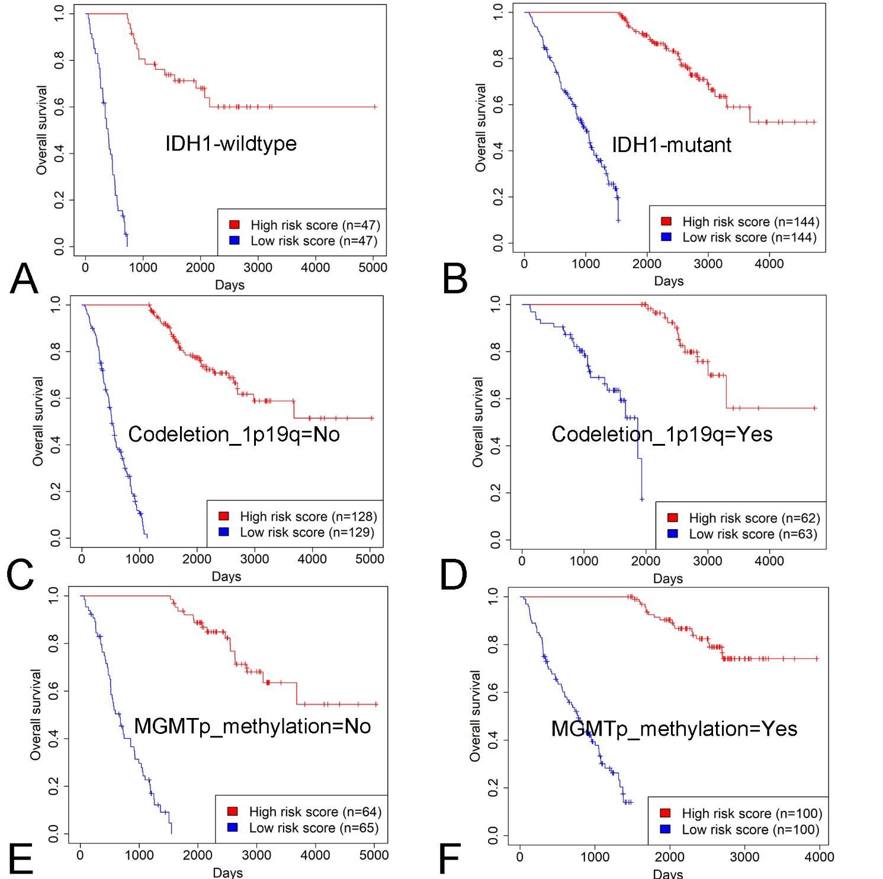
Supplementary Figure6. Kaplan-Meier survival analysis of patients’ OS with the 71-gene score in the subgroups of LGG patients stratified by IDH1 mutation, 1p19q codeletion and MGMTp methylation (A-F) of the CGGA cohort.

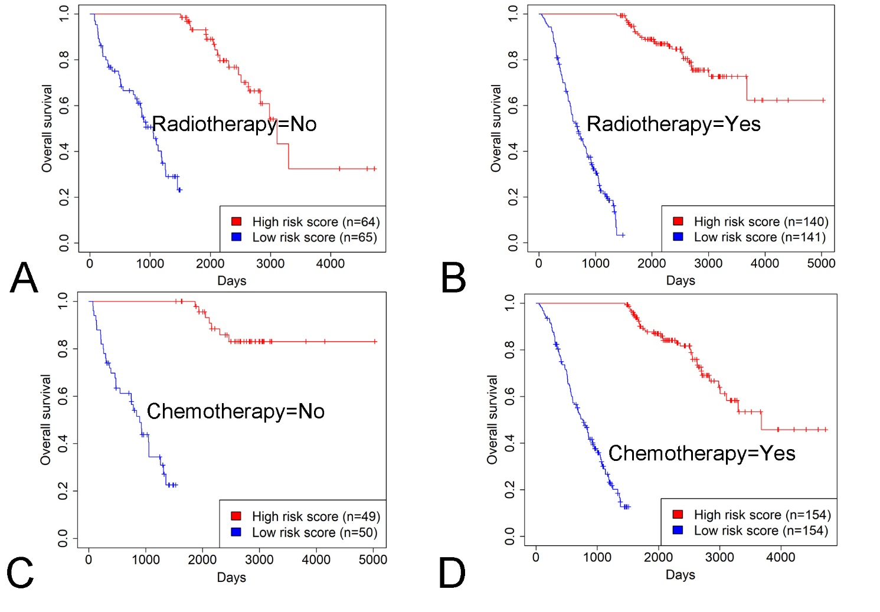
Supplementary Figure7. Kaplan-Meier survival analysis of patients’ OS with the 71-gene score in the subgroups of LGG patients stratified by radiotherapy and chemotherapy (A-D) of the CGGA cohort.

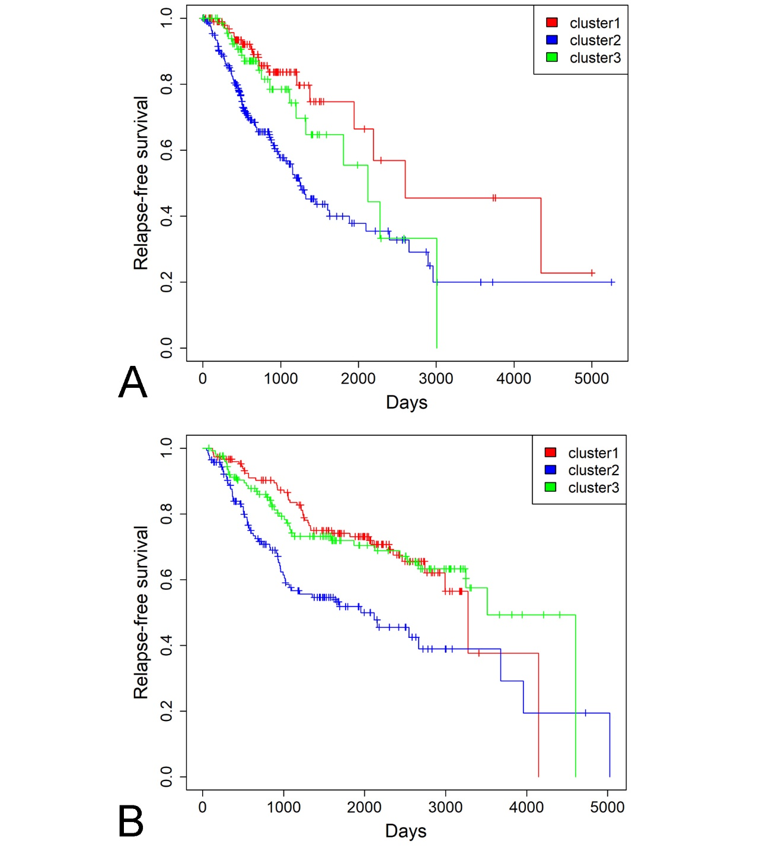
Supplementary Figure8. Kaplan-Meier survival analysis of patients’ RFS with the 71-gene score in three subgroups of LGG patients of the TCGA cohort (A) and CGGA cohort (B).

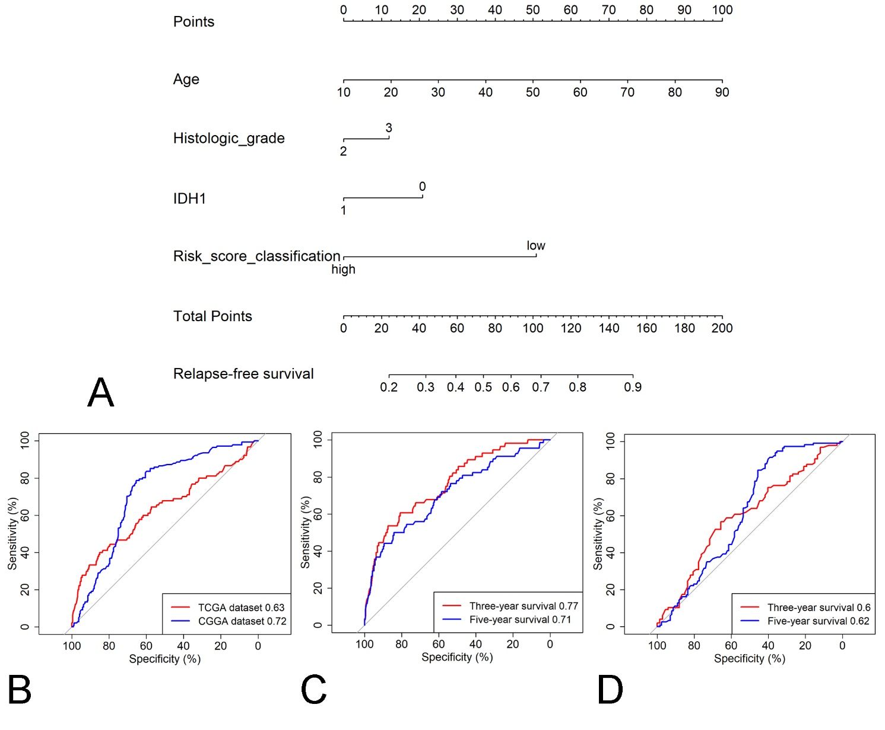
Supplementary Figure9. The 71-gene nomogram to predict the risk of disease in patients with LGG. (A) mRNA nomogram to predict relapse-free survival. 2,3 for histologic grade denote grade II and III respectively. High and low for the 71-gene score represent high and low 71-gene scores respectively stratified by the median 17-gene score. B. The ROC plot for the nomogram in predicting relapse-free survival in the TCGA and CGGA cohorts. C. The ROC plot for the nomogram in predicting 3-year and 5-year relapse-free survival in the TCGA cohort. D. The ROC plot for the nomogram in predicting 3-year and 5-year relapse-free survival in the CGGA cohort.

