April 22, 2021
Re: Regina Summer Student Research Award

Dear Melissa Herdzik,

Congratulations on being awarded a 2021 Regina Summer Student Research Award! An honorarium has been made possible through a generous donation from the College of Medicine and the Saskatchewan Health Authority. You have been matched to a project titled “Systematic review on the effects and associated outcomes with fluid management in the critically ill” supervised by Dr. Eric Sy.

By accepting this award, you agree to the following terms and conditions (please see attached “Award Acceptance Form”):

- The majority of the research will be conducted by you and will take place in Regina;
- The work will begin no sooner than May 1st, 2021 and should be completed no later than August 31st, 2021. Any modifications to this schedule must be pre-approved by your supervisor and the SHA Research Administration department;
- You must commit a total of 8-10 weeks at a minimum of 35 hours/week (or equivalent) to this project during the aforementioned time period;
- Attendance at all training, orientation and educational sessions is mandatory. Exceptions may be granted on a case-by-case basis;
- You must submit mid-point report via Survey Monkey on July 1st, 2021;
- You must submit final report via Survey Monkey and project poster and abstract by email no later than September 22nd, 2021; and,
- You must also present your poster at the Undergraduate Research Showcase on October, 20th, 2021.

You will be issued the total value of the award, $5,000 in June. If you require the release of these funds sooner due to any financial constraints, please reach out to Sandy Kassir (contact information on page 2) to setup alternative arrangements.

Once again, congratulations! We look forward to working with you this summer.

Sincerely,
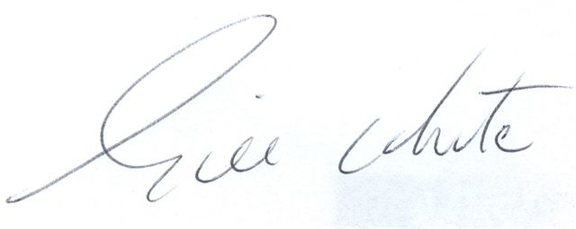
___________________________

Dr. Gill White
Associate Dean - Regina Campus
College of Medicine, University of Saskatchewan
Tel: 306-766-3872

Email: Gill.White@saskhealthauthority.ca

