SUPPLEMENTARY FIGURES

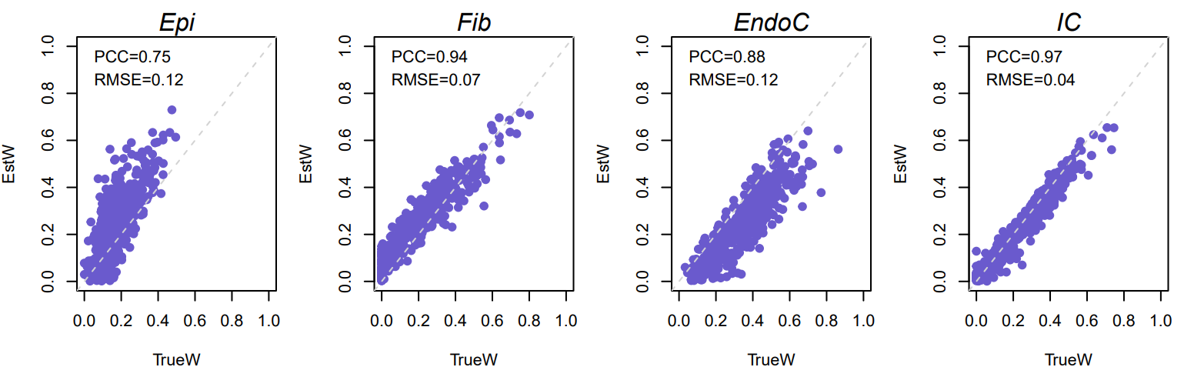

Supplementary Figure 1. Validation of the generic four cell-types panel we developed for deconvoluting epithelial cells, fibroblasts, endothelial cells, and immune cells using 500 in silico mixtures of these four cell types. Note: TrueW, true proportions of cell types in each in silico mixture; EstW, estimated proportions of cell types in each in silico mixture; PCC, pearson correlation coefficient; RMSE, root mean square error.

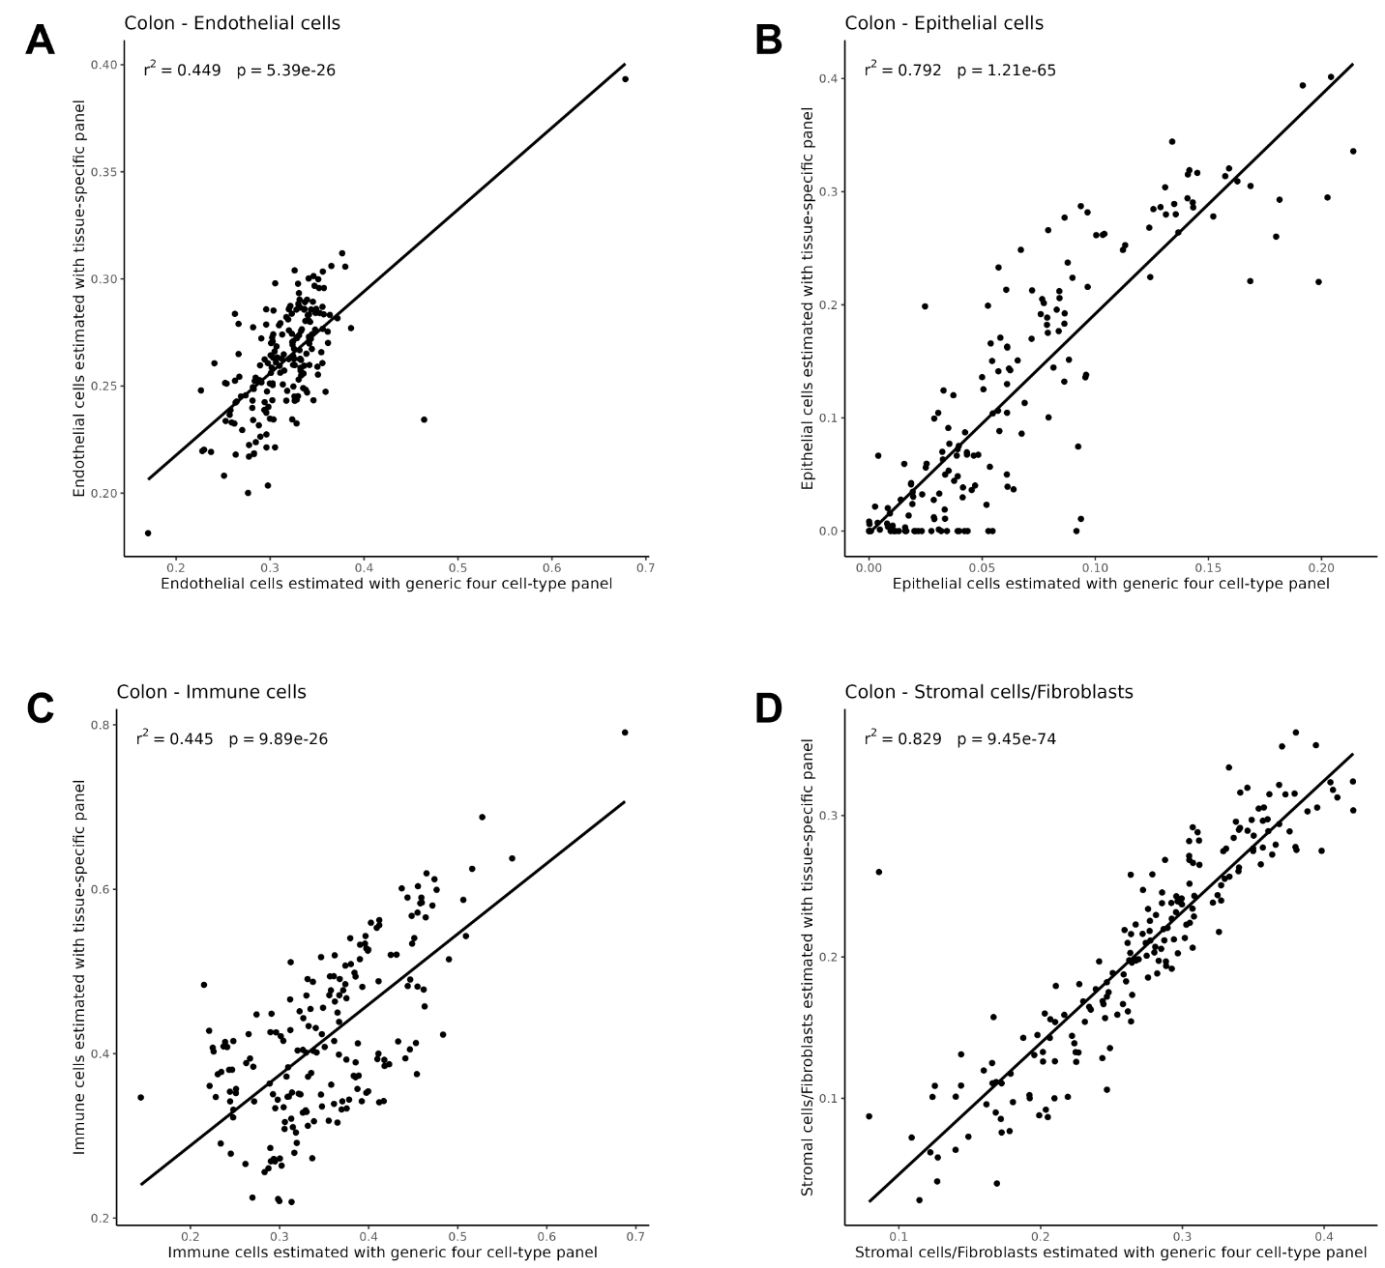

Supplementary Figure 2. Concordance in inferred cell type proportions in colon obtained using the generic four cell-type panel vs. the tissue specific panel for colon. Scatterplots are presented for A) endothelial cells, B) epithelial cells, C) immune cells, and D) stromal cells/fibroblasts.

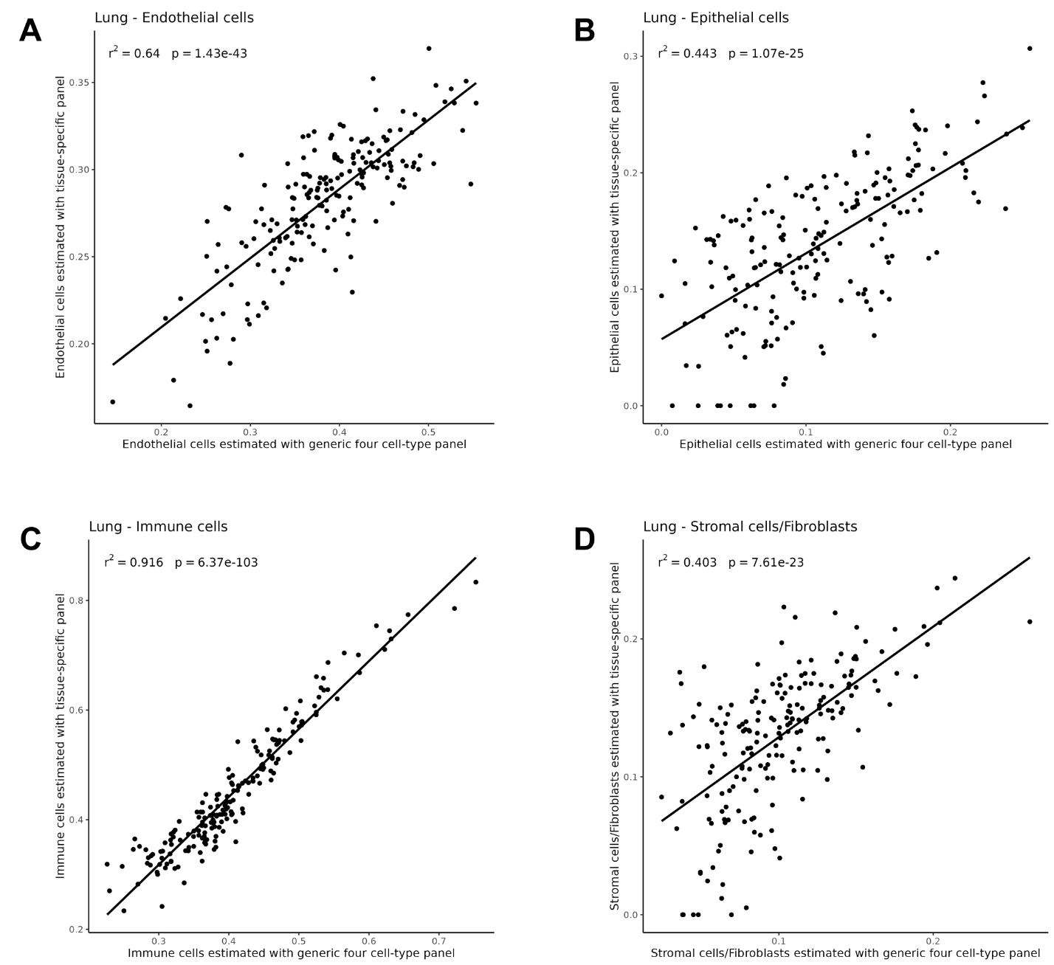

Supplementary Figure 3. Concordance in inferred cell type proportions in lung obtained using the generic four cell-type panel vs. the tissue specific panel for lung. Scatterplots are presented for A) endothelial cells, B) epithelial cells, C) immune cells, and D) stromal cells/fibroblasts.

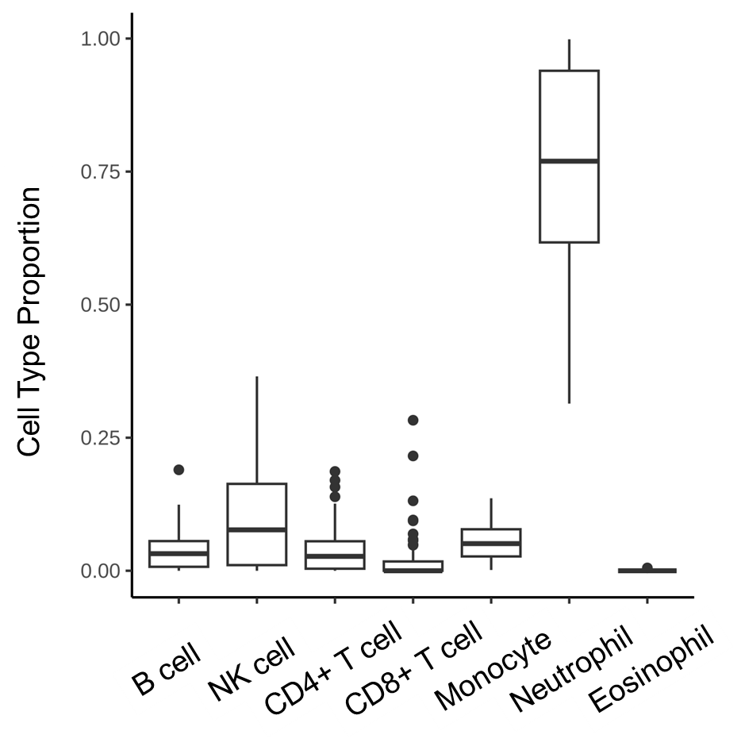

Supplementary Figure 4. Inferred cell type proportions in whole blood samples from GTEx.

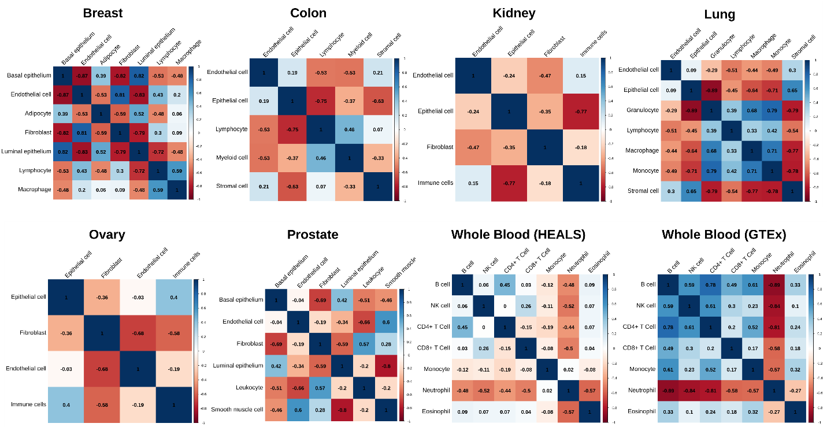

Supplementary Figure 5. Correlations between inferred cell type proportions in each tissue.

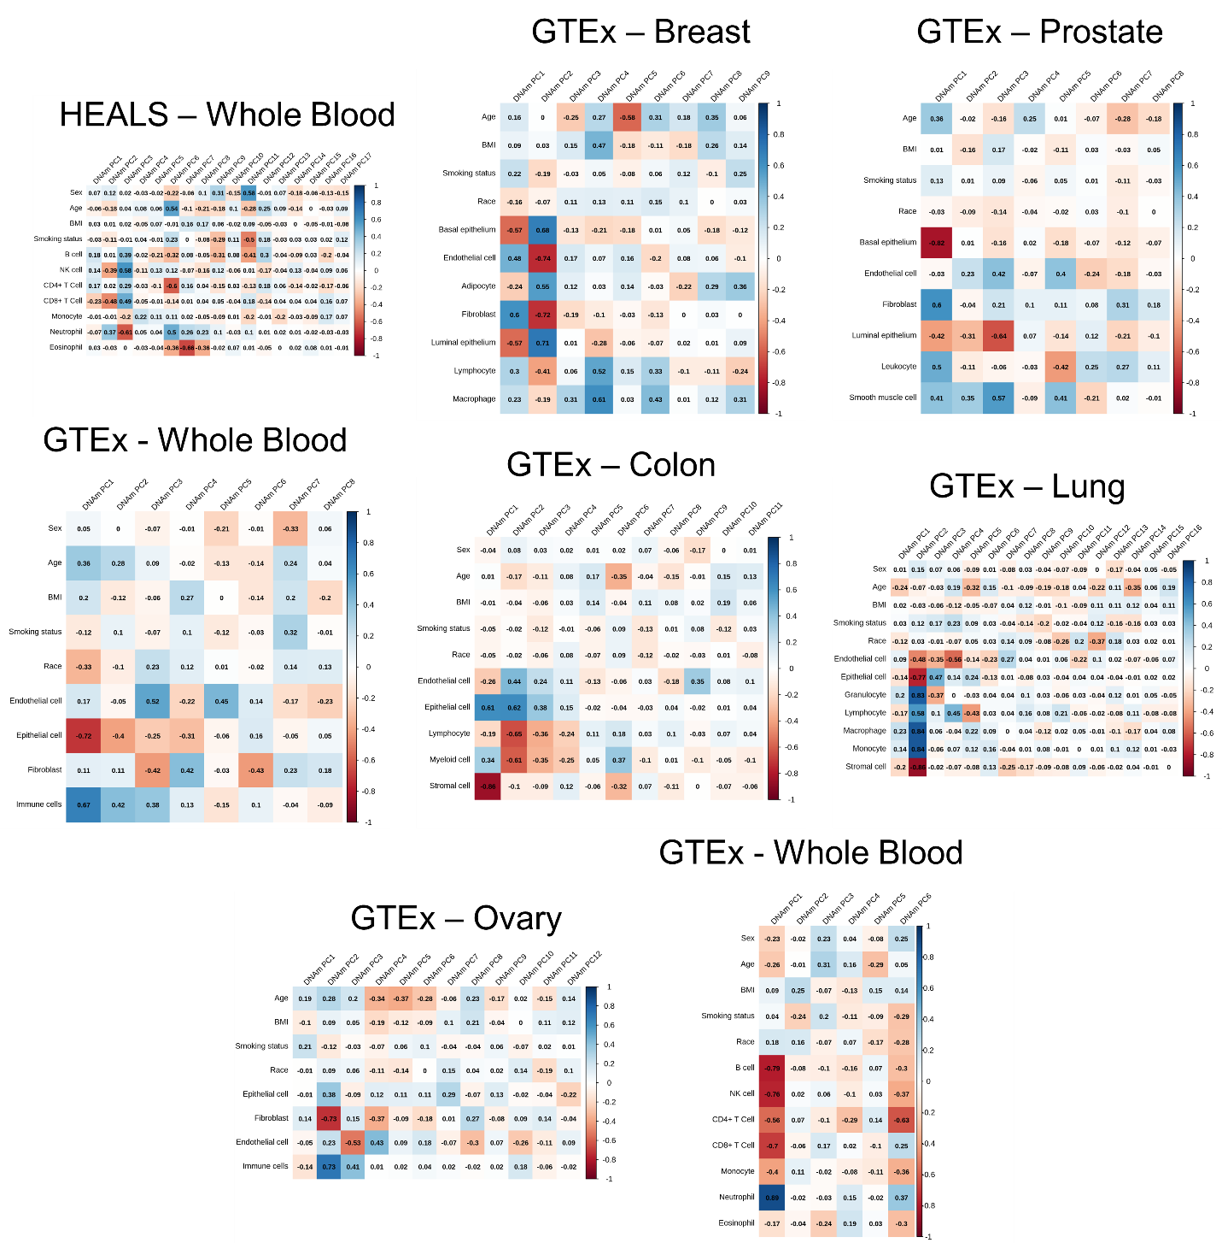

Supplementary Figure 6. Correlations between principal components (PCs) generated from DNA methylation data (columns) and both covariates and inferred cell type proportions (rows). Note: Pearson correlation coefficients are displayed in each tile.

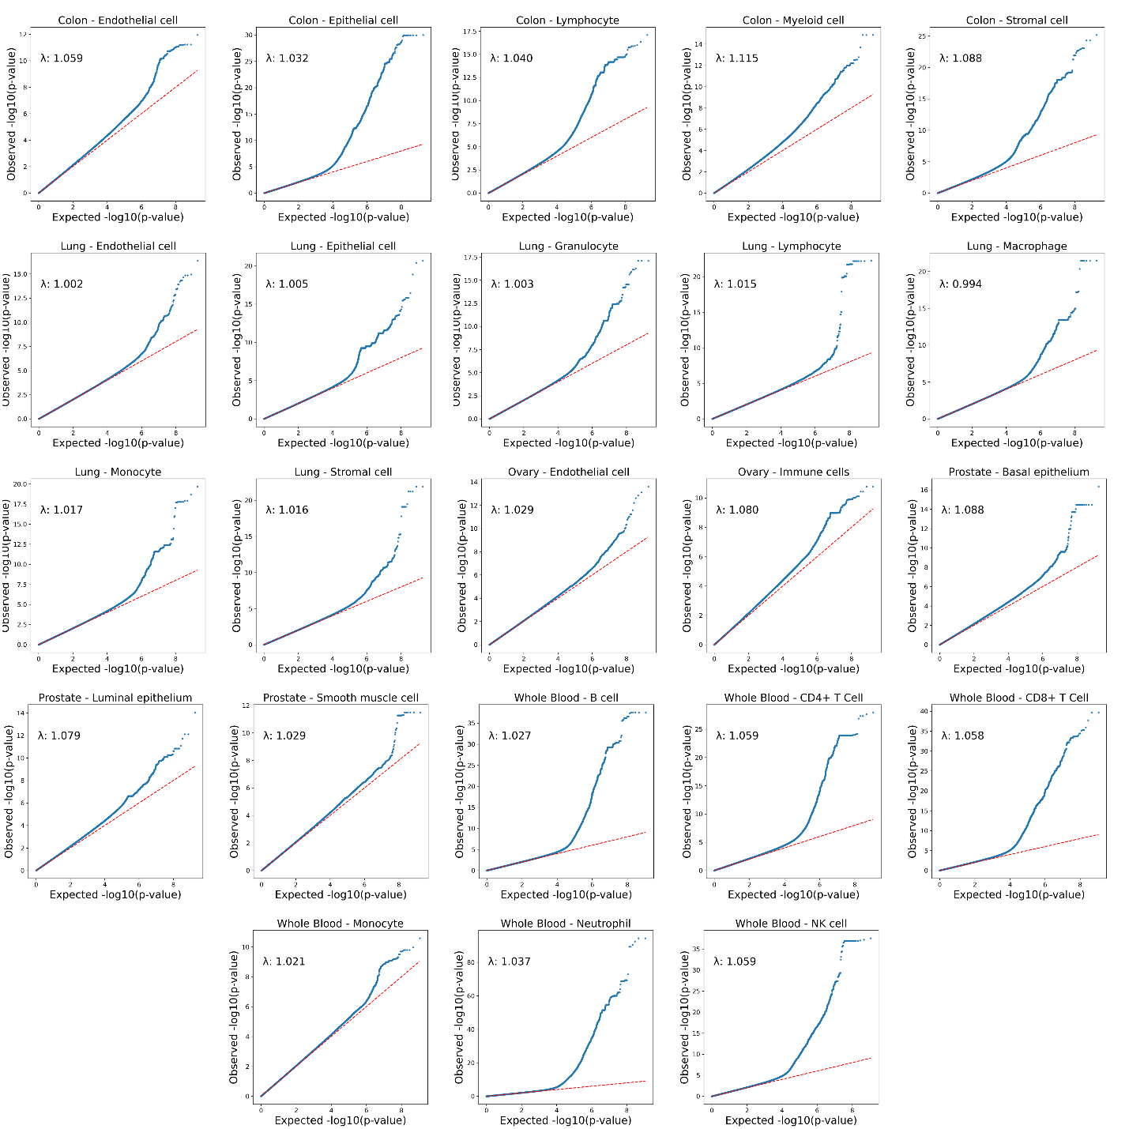

Supplementary Figure 7. QQ-plots and inflation factors of imQTL interaction terms for each cell and tissue type combination.

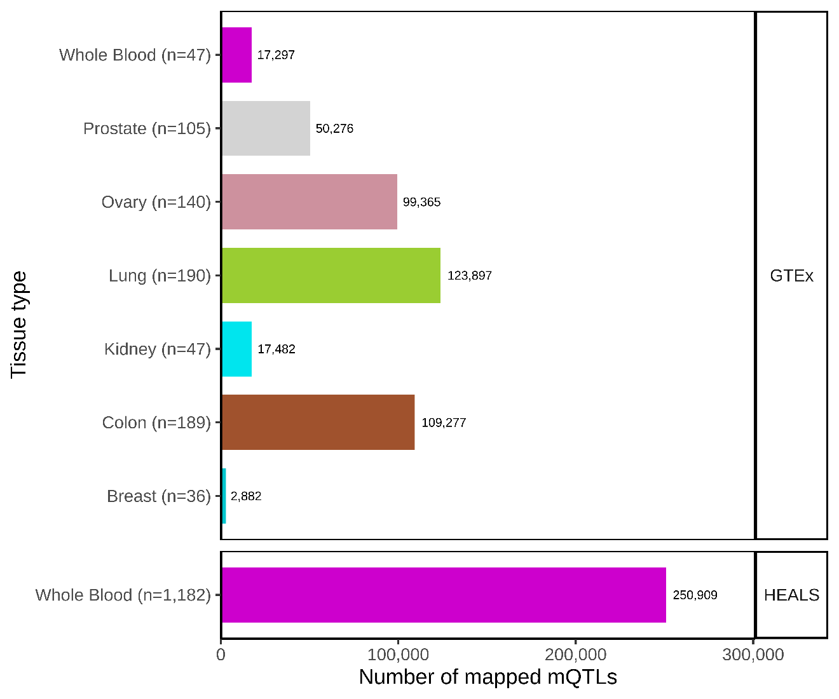

Supplementary Figure 8. Number of mQTLs identified for each tissue type (FDR-adjusted-p-value<0.05 )
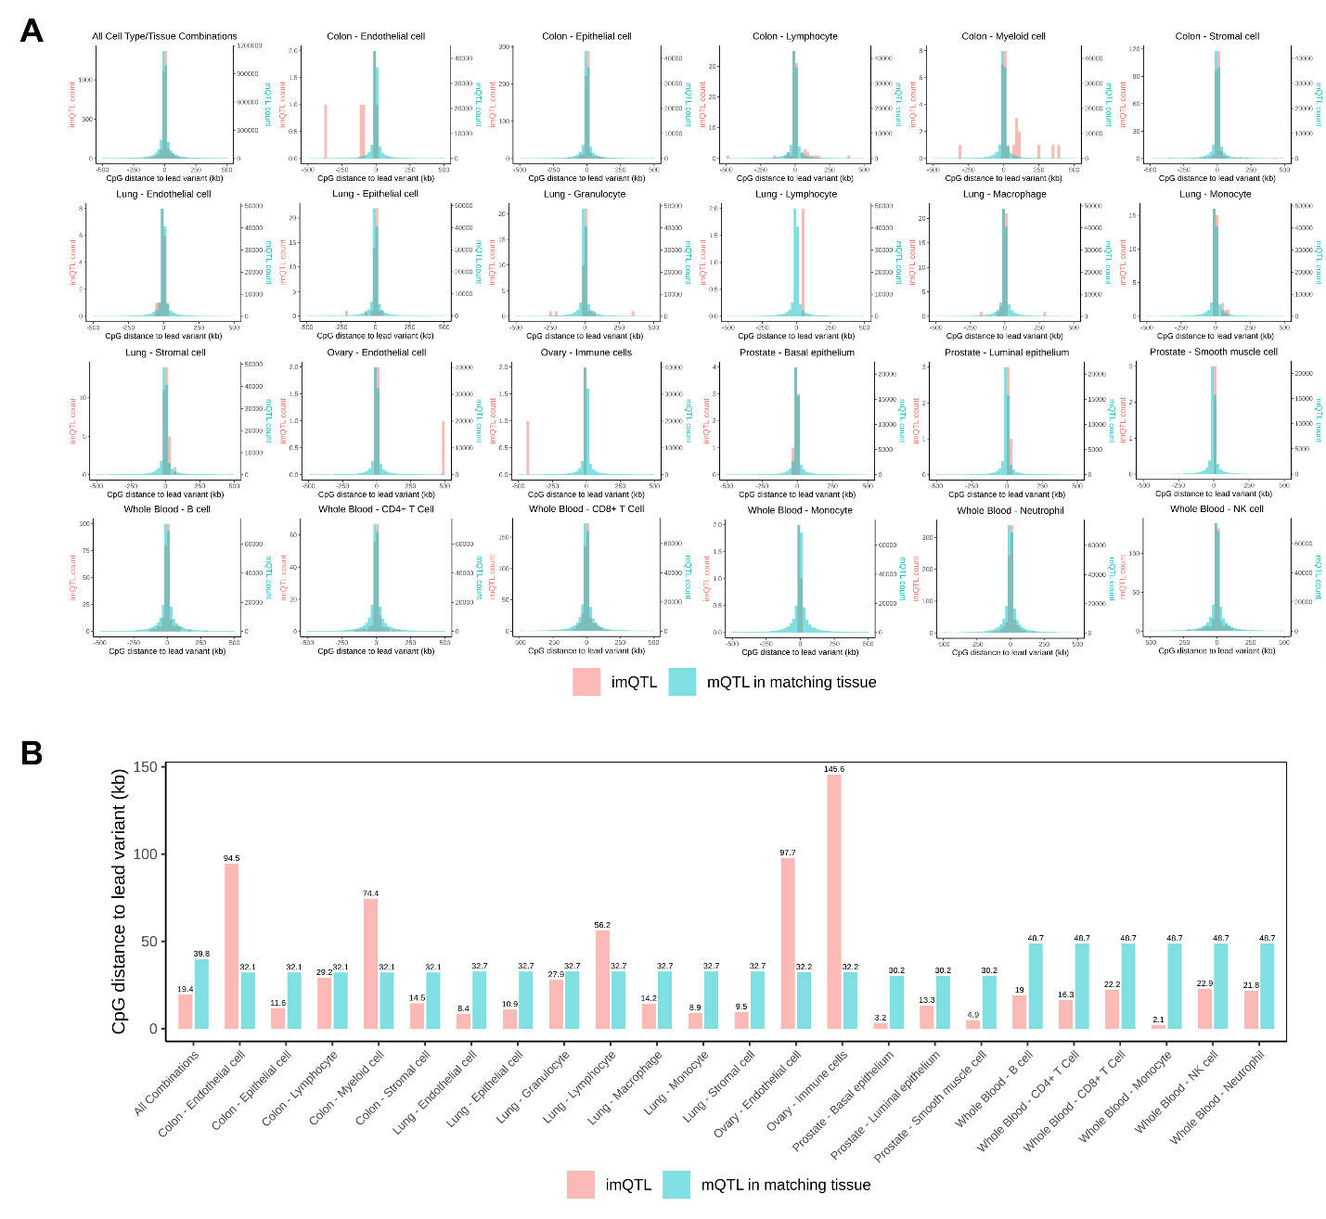

Supplementary Figure 9. Distance from CpG sites to lead variants for imQTLs of each cell type/tissue combination and mQTLs mapped in matching tissues. A) Histogram of distances and B) barplots of mean absolute distances for each cell type/tissue combination.

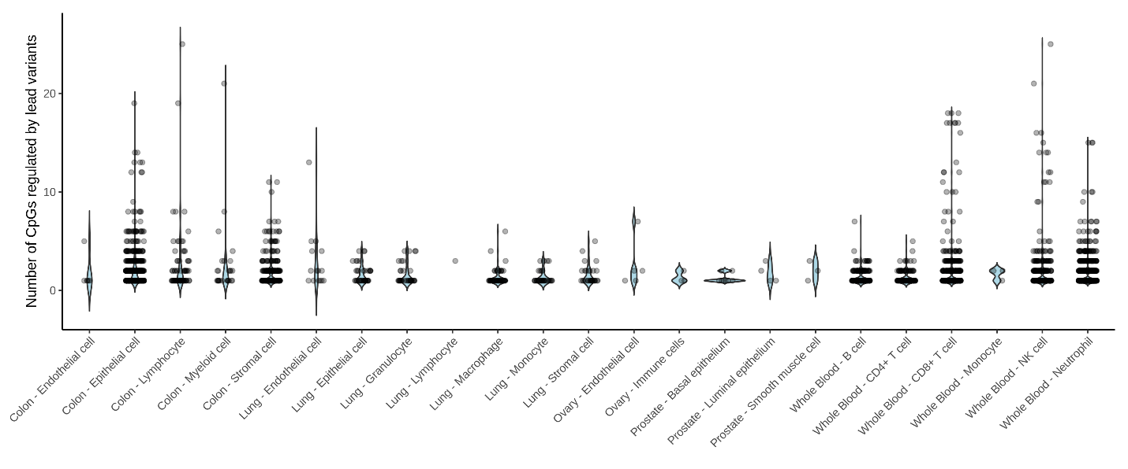

Supplementary Figure 10. Number of CpGs pleiotropically regulated by imQTL lead variants.

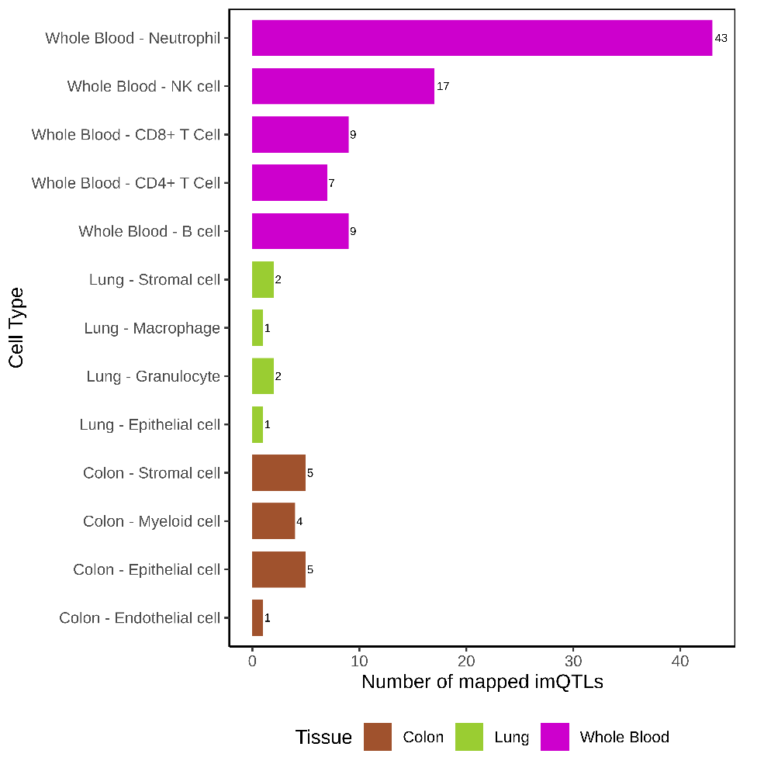

Supplementary Figure 11. Number imQTLs with a nearby independent signal after conditioning on the lead variant.

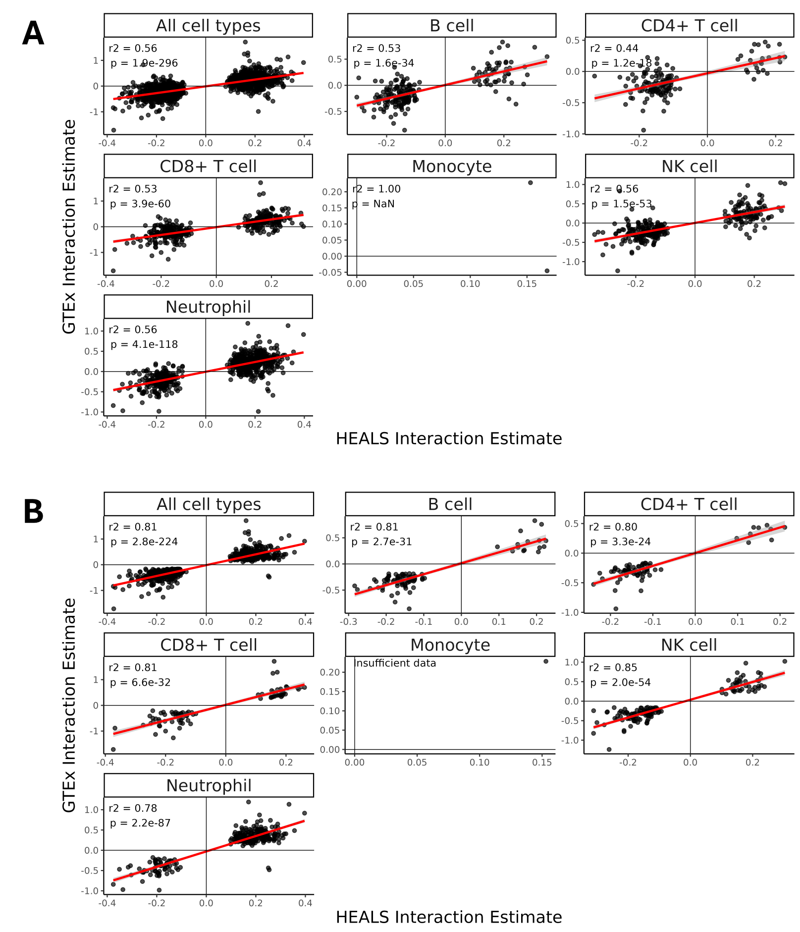
Supplementary Figure 12. Validation of interaction term effect size estimates of imQTLs mapped in HEALS whole blood samples in GTEx whole blood samples. A) Scatterplots of interaction terms for all whole blood imQTLs identified in HEALS between HEALS and GTEx. B) Scatterplots of interaction terms for whole blood imQTLs identified in HEALS that had a p<0.05 in GTEx between HEALS and GTEx.
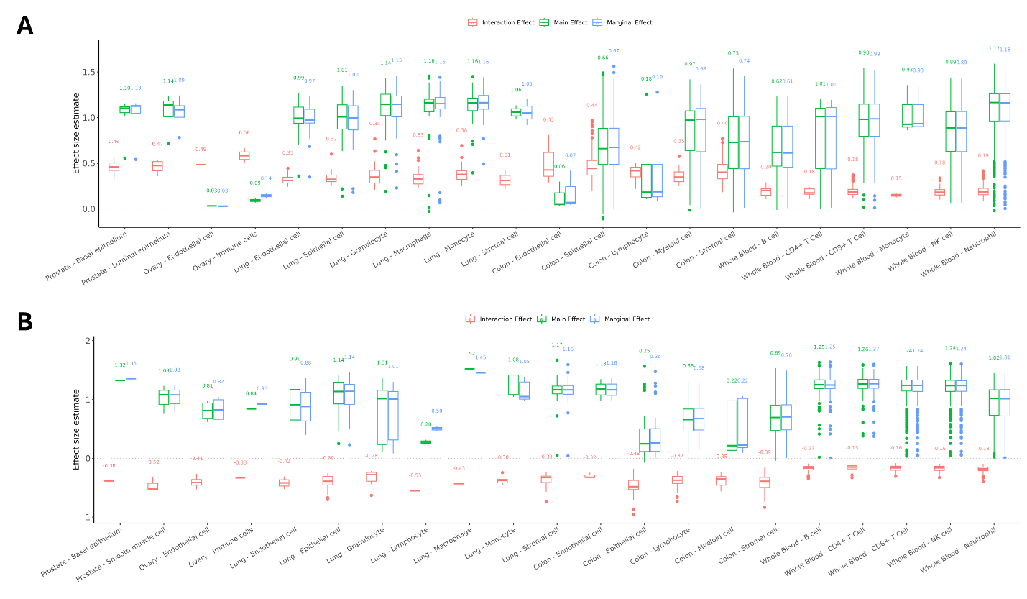

Supplementary Figure 13. Distribution of effect size estimates of interaction, main, and marginal effects for A) imQTLs with consistent directionality between marginal and interaction terms and B) imQTLs with inconsistent directionality between marginal and interaction terms. Note: All interaction terms are standardized to positive estimates in A) and negative estimates in B). Median values are shown above each boxplot.
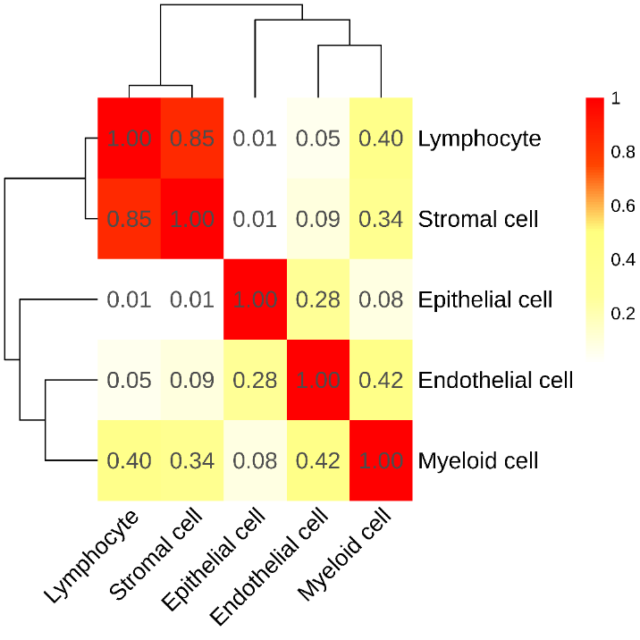

Supplementary Figure 14. Proportion of shared effects of cell type interaction terms across different cell types in colon.
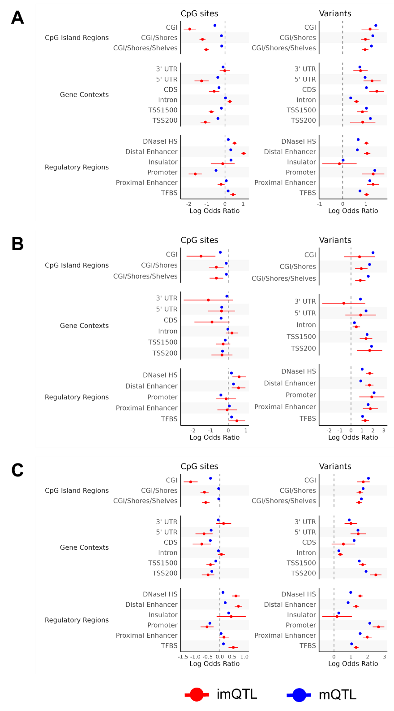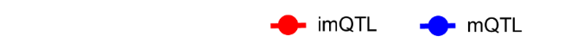
Supplementary Figure 15. Enrichment of CpGs and variants mapped to imQTLs for genomic context and regulatory elements in A) whole blood, B) lung, and C) colon.
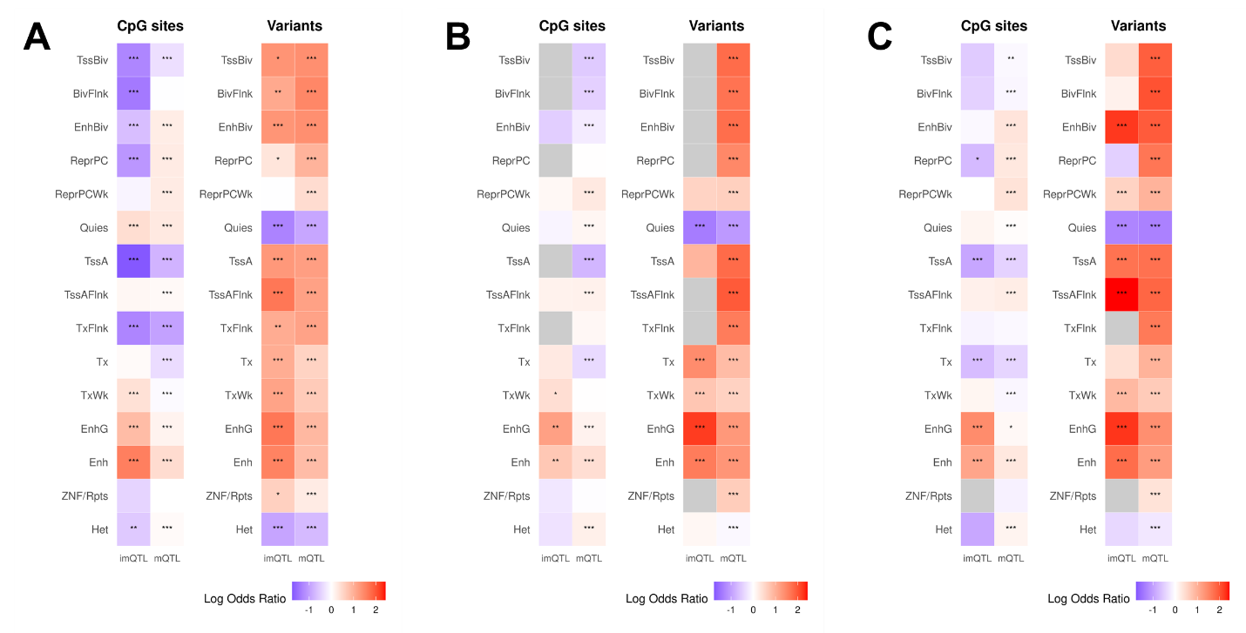
Supplementary Figure 16. Enrichment of CpGs and variants mapped to imQTLs for tissue-specific chromatin segmentation states in A) whole blood, B) lung, and C) colon. * p<0.05, ** p<0.01, *** p<0.001.
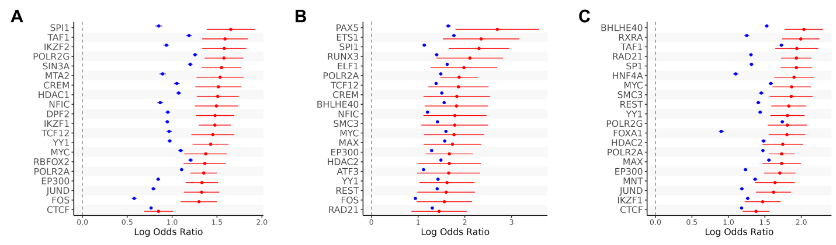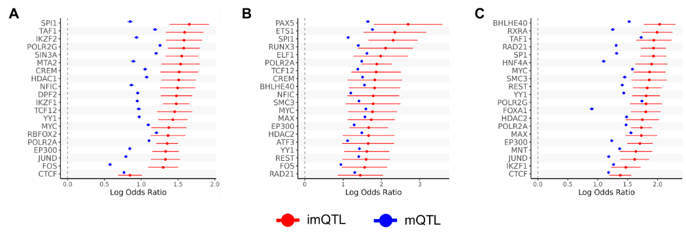
Supplementary Figure 17. Enrichment of variants mapped to imQTLs for transcription binding factor sites (TFBS) in A) whole blood, B) lung, and C) colon. Note: Only the top 20 enriched TFBS for imQTLs are shown in each panel.
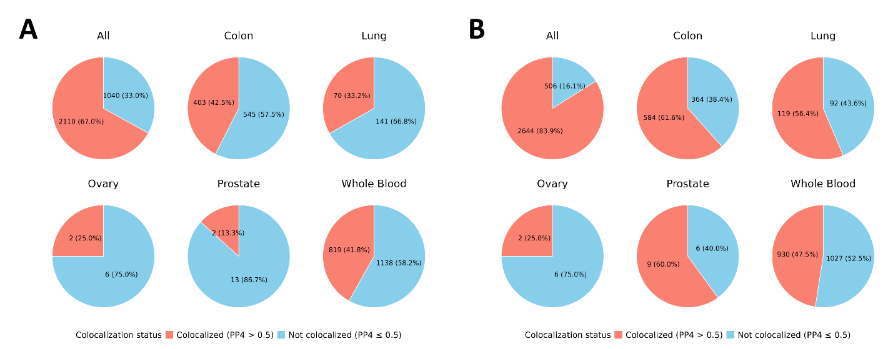

Supplementary Figure 18. Proportion of imQTLs that colocalized with at least one eQTL in the same tissue type (eQTLs identified in colon, lung, ovary, prostate, and whole blood) with a PP4>0.5 and the proportion imQTLs that colocalized with eQTLs of the same tissue type. A) default “coloc” R package priors including p₁=1x10⁻⁴, p₂=1x10⁻⁴, and p₁₂=1x10⁻⁵ and B) biologically informed priors including p₁=5x10⁻⁴, p₂=4.5x10⁻³, and p₁₂=5x10⁻⁴.

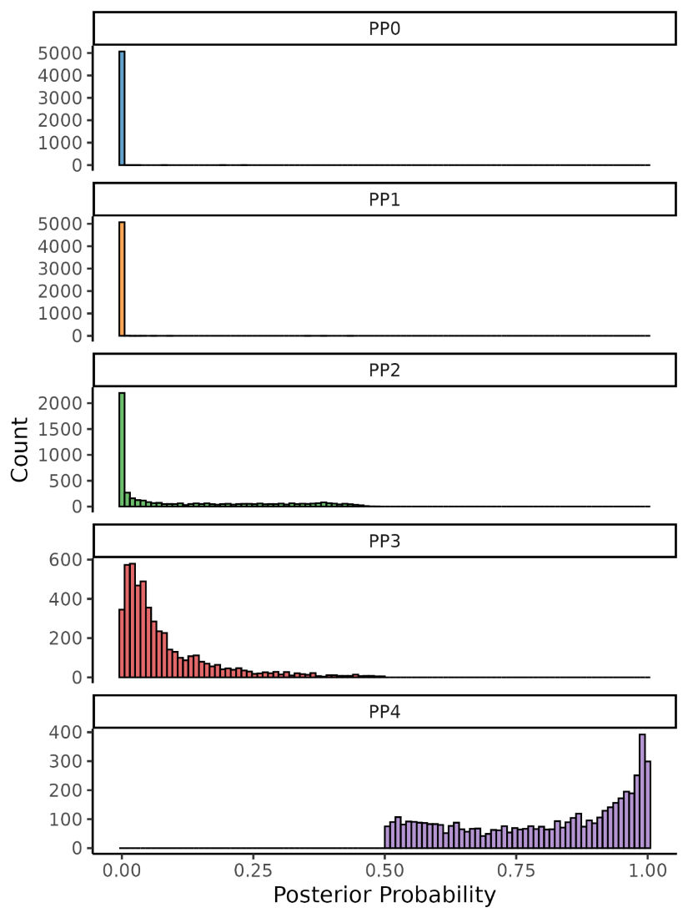

Supplementary Figure 19. Posterior probabilities for imQTL-eQTL colocalizing pairs with a PP4>0.5. Note: PP0, neither eQTL nor imQTL has a genetic association in the region; PP1, only eQTL is associated; PP2, only imQTL is associated; PP3, both eQTL and imQTL are associated, but with different causal variants; PP4, both eQTL and imQTL are associated and share the same causal variant (i.e., colocalization). Default “coloc” R package priors were utilized and included p₁=1x10⁻⁴, p₂=1x10⁻⁴, and p₁₂=1x10⁻⁵.

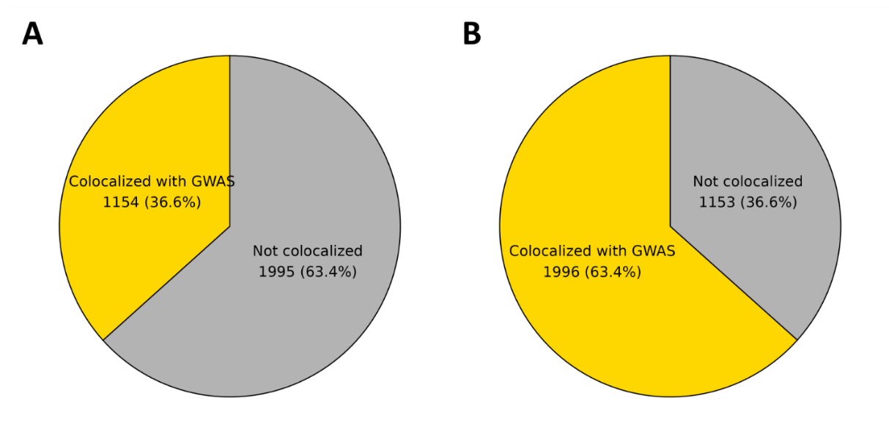
Supplementary Figure 20. Proportion of imQTLs that colocalized with GWAS when utilizing A) default coloc R package priors including p₁=1x10⁻⁴, p₂=1x10⁻⁴, and p₁₂=1x10⁻⁵ and B) biologically informed priors including p₁=1.5x10⁻³, p₂=3.5x10⁻³, and p₁₂=1.5x10⁻³.

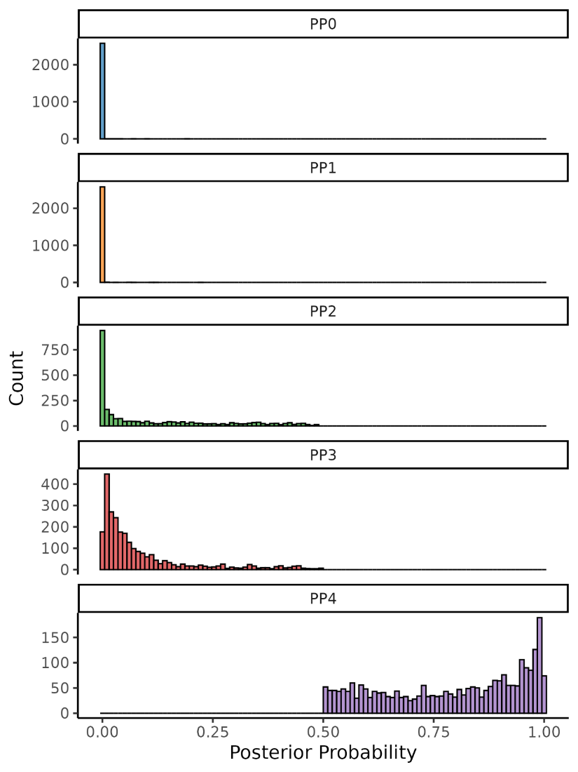

Supplementary Figure 21. Posterior probabilities for imQTL-GWAS colocalizing pairs with a PP4>0.5. Note: PP0, neither GWAS nor imQTL has a genetic association in the region; PP1, only GWAS is associated; PP2, only imQTL is associated; PP3, both GWAS and imQTL are associated, but with different causal variants; PP4, both GWAS and imQTL are associated and share the same causal variant (i.e., colocalization). Default “coloc” R package priors were utilized and included p₁=1x10⁻⁴, p₂=1x10⁻⁴, and p₁₂=1x10⁻⁵.

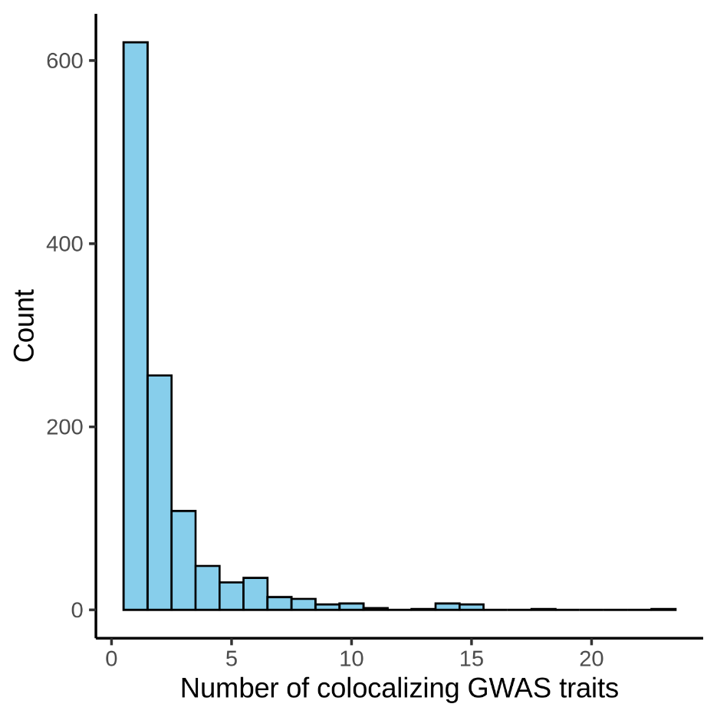

Supplementary Figure 22. Number of GWAS traits that imQTLs colocalized with among imQTLs that colocalized with at least one GWAS trait with a PP4>0.5.

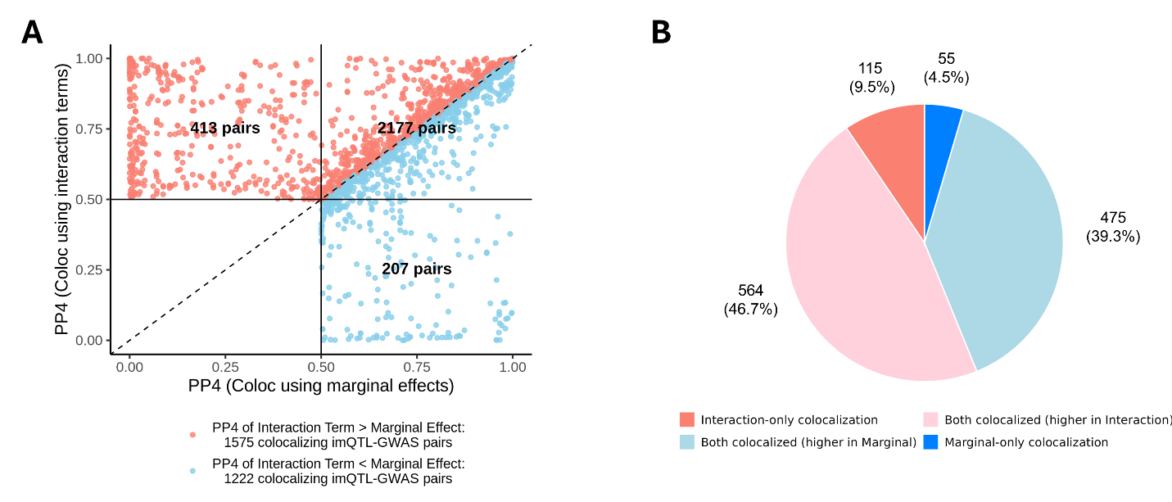

Supplementary Figure 23. Comparison of colocalization PP4 values for imQTLs and GWAS signals between analyses using interaction terms vs. marginal effects. A) PP4 values of imQTL-GWAS pairs that were identified to colocalize either using interaction term or marginal effects (PP4>0.5). B) Proportion of imQTLs where the maximum PP4 from GWAS colocalization was larger using either interaction terms or marginal effects, as well as imQTLs identified only using interaction terms or marginal effects.

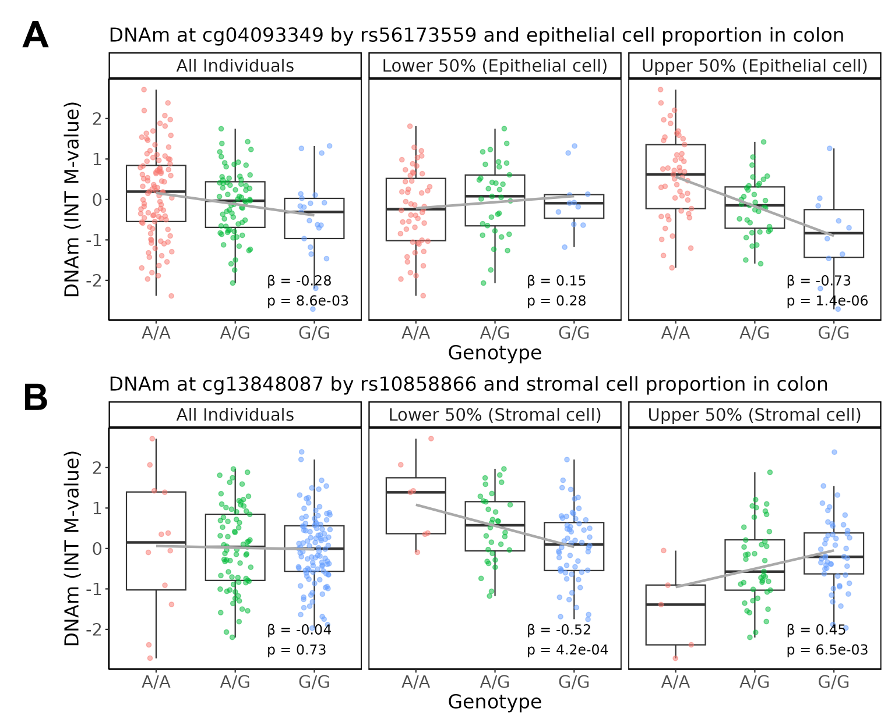

Supplementary Figure 24. Marginal and cell type-stratified associations between DNAm and genotype for two examples of imQTLs exhibiting colocalization with GWAS when utilizing interaction terms but not marginal effects. A) Boxplots for the rs56173559 (chr15:66716105:A:G) and cg04093349 imQTL mapped to epithelial cells in colon. B) Boxplots for the rs10858866 (chr12:89456163:A:G) and cg13848087 imQTL mapped to stromal cells in colon.

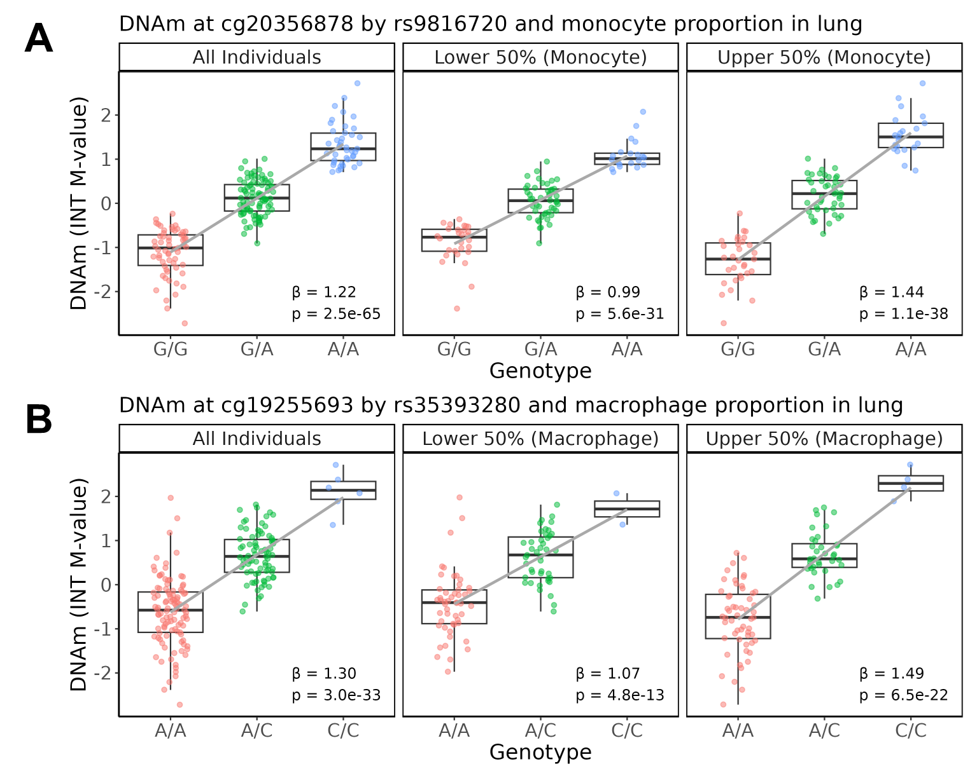

Supplementary Figure 25. Marginal and cell type-stratified associations between DNAm and genotype for two examples of imQTLs exhibiting colocalization with both eQTL and GWAS signals. A) Boxplots for the rs9816720 (chr3:121995837:G:A) and cg20356878 imQTL mapped to monocytes in lung. B) Boxplots for the rs35393280 (chr20:48927097:A:C) and cg19255693 imQTL mapped to macrophages in lung.

