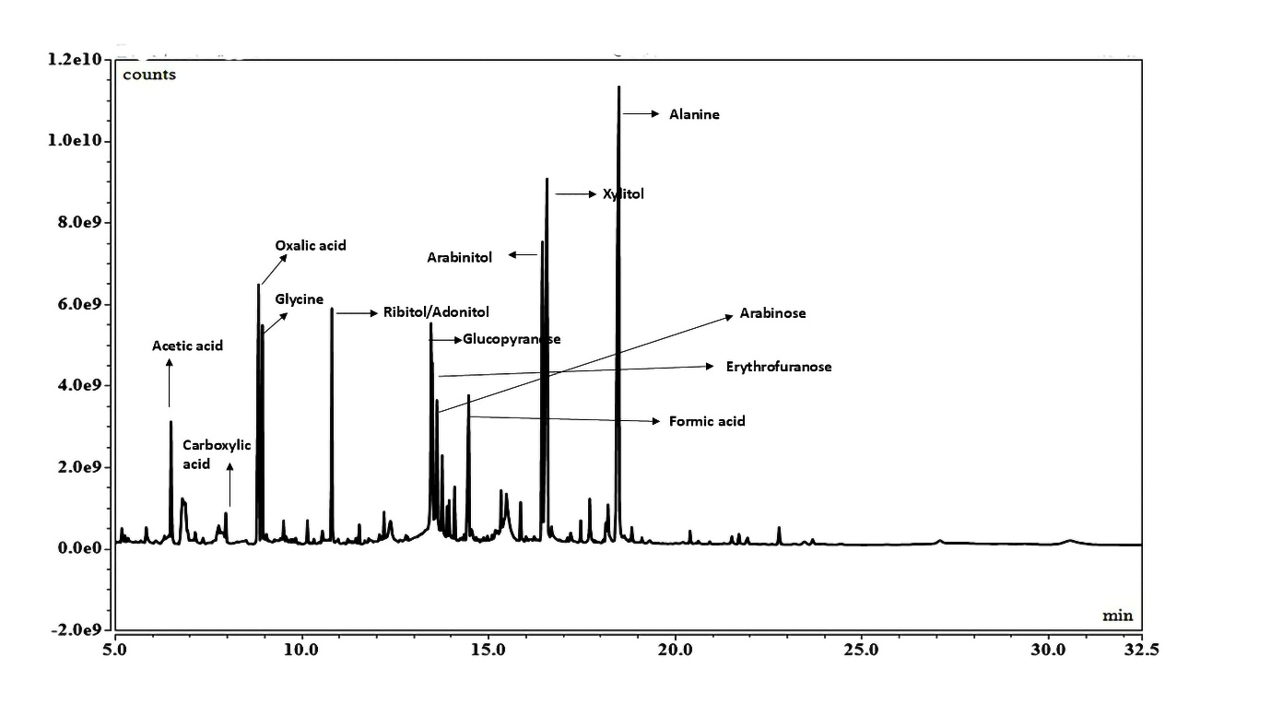
Supplementary information
Fig. S1 Representative chromatogram of GC-MS analysis of biostimulant treated tomato leaf tissue sample under salt stress
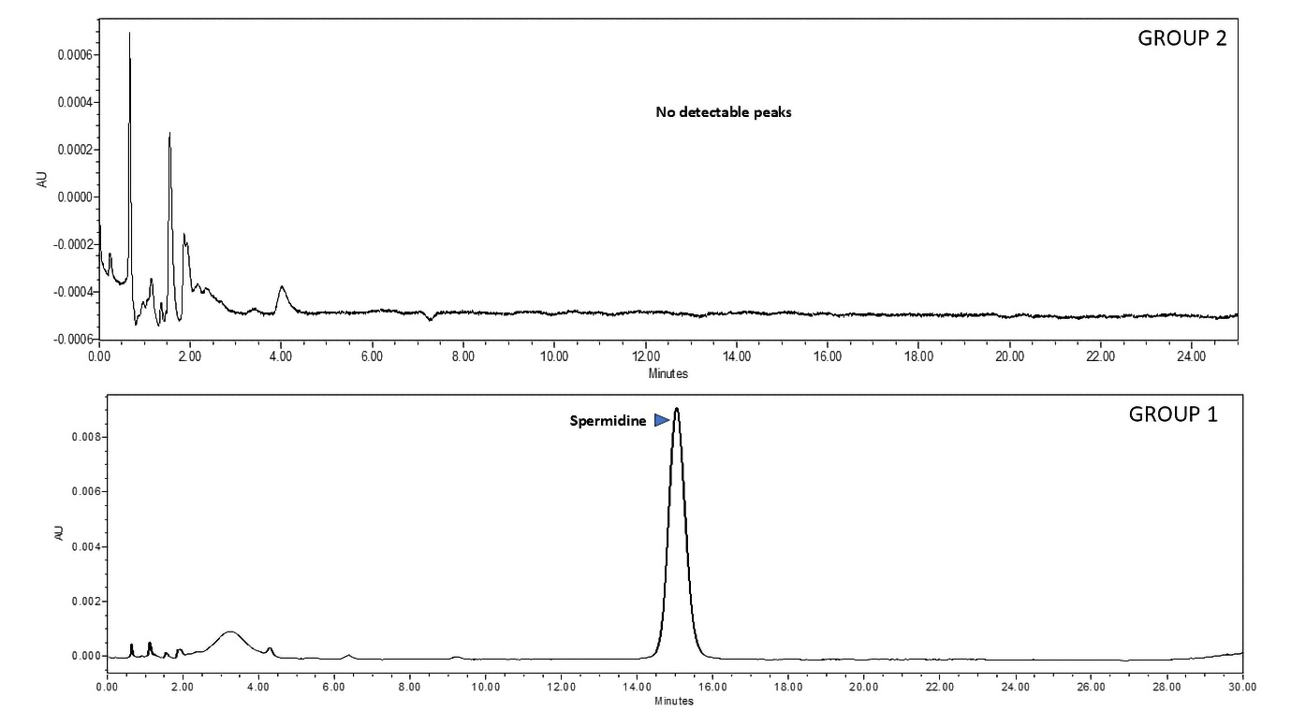
Fig. S2 HPLC chromatogram of spermidine, a major polyamine

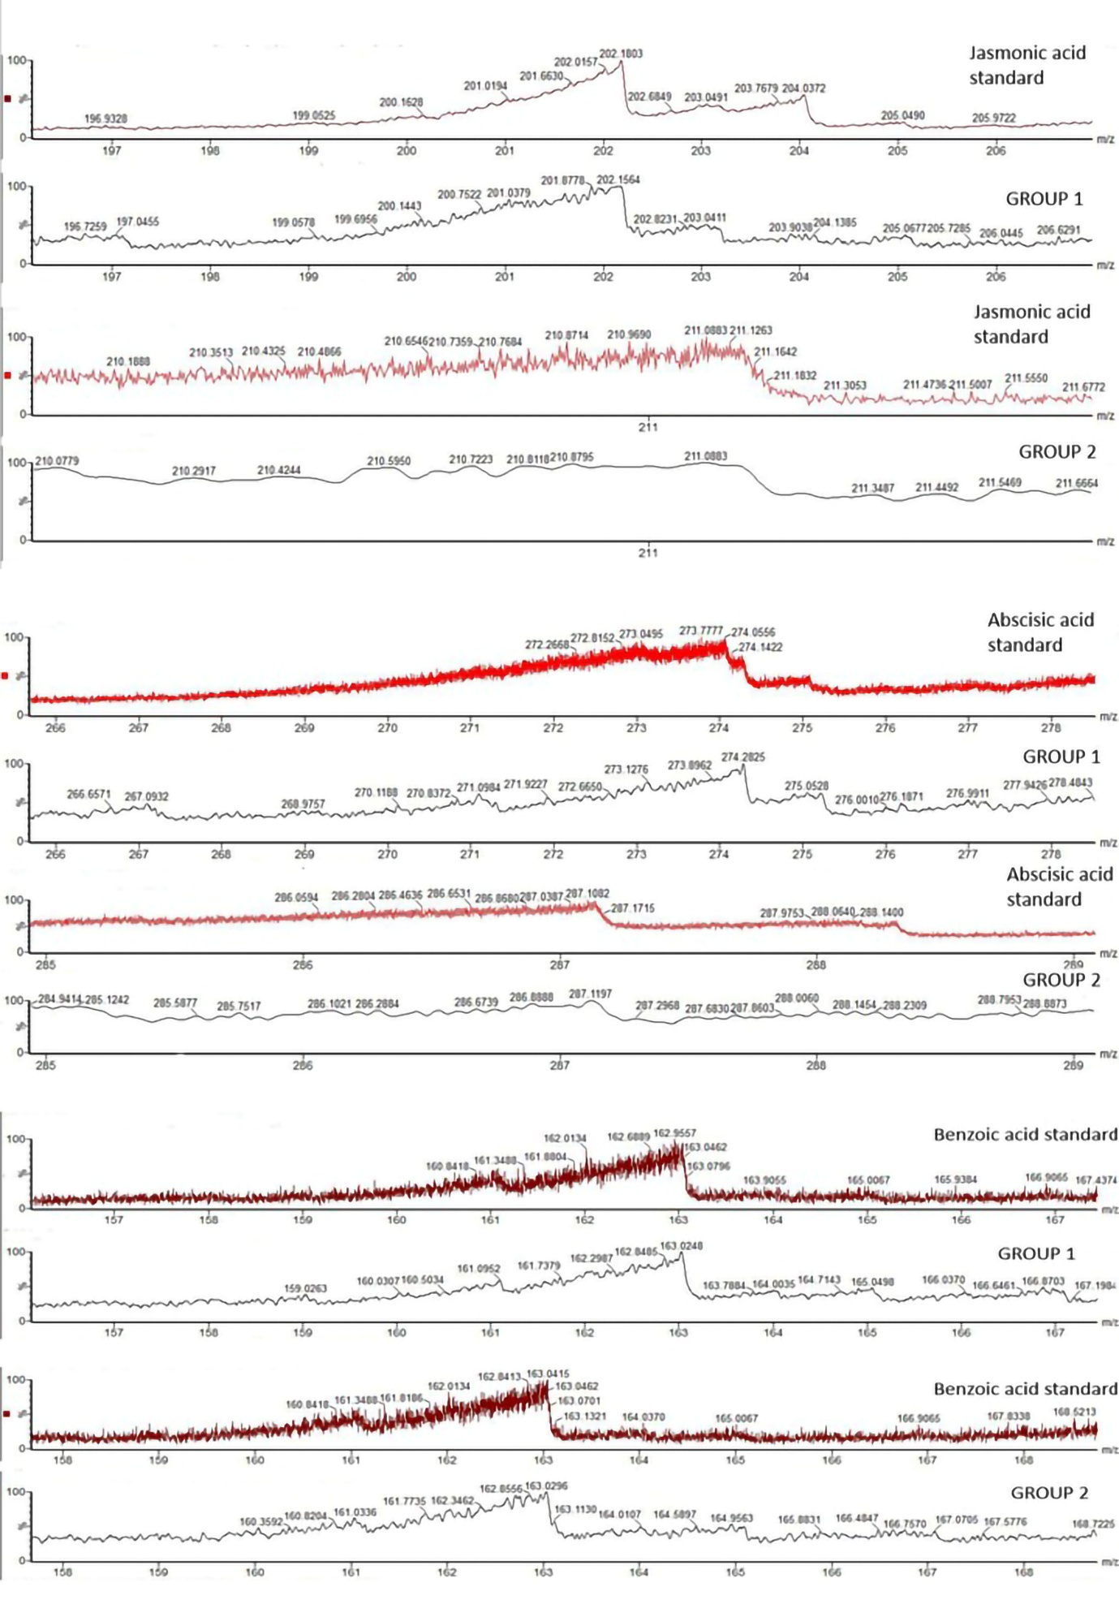Fig. S3 ESI-MS peaks of phytohormone analysis

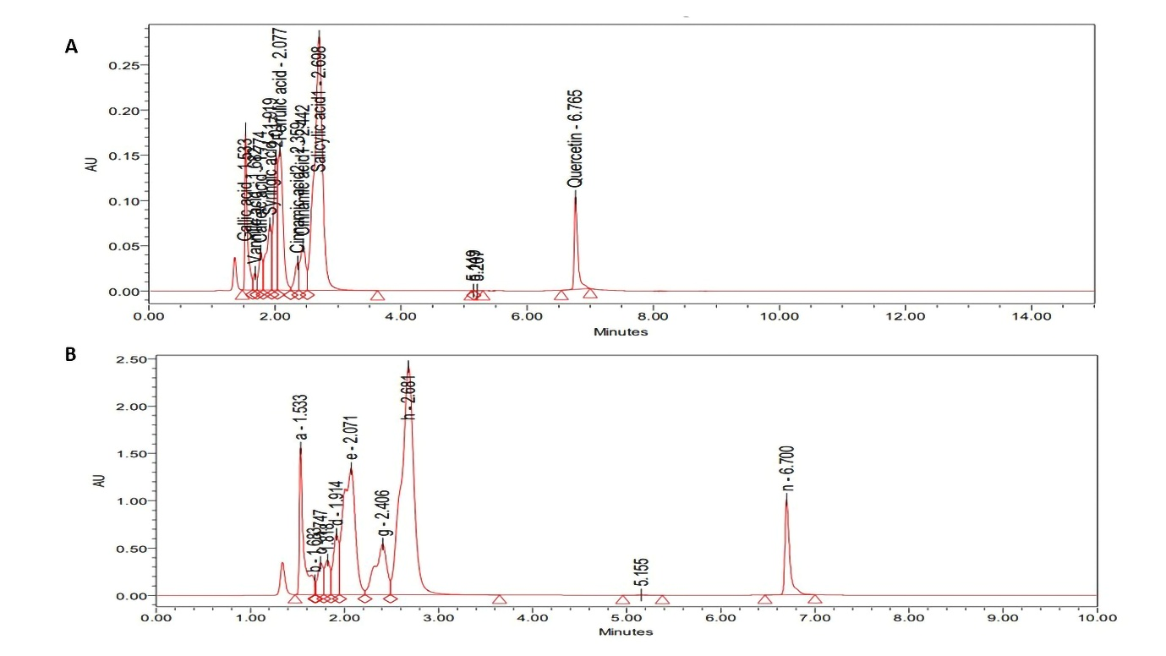
Fig. S4 A: HPLC chromatogram of phenolic compound standards; B: Representative HPLC chromatogram of phenolic compounds found in biostimulant treated tomato leaf tissue sample under salt stress

Table S1 Total variance explained in case of parameters taken for all five treatment groups, extraction method: Principal Component Analysis

Component | Initial Eigenvalues |  |  | Extraction Sums of Squared Loadings |  |  | Rotation Sums of Squared Loadings
Component | Total | % of Variance | Cumulative % | Total | % of Variance | Cumulative % | Total | % of Variance | Cumulative %
1 | 5.548 | 46.237 | 46.237 | 5.548 | 46.237 | 46.237 | 4.958 | 41.314 | 41.314
2 | 3.583 | 29.860 | 76.097 | 3.583 | 29.860 | 76.097 | 2.900 | 24.169 | 65.483
3 | 1.307 | 10.891 | 86.988 | 1.307 | 10.891 | 86.988 | 2.581 | 21.505 | 86.988
4 | .730 | 6.087 | 93.075
5 | .304 | 2.535 | 95.610
6 | .267 | 2.228 | 97.838
7 | .168 | 1.400 | 99.238
8 | .048 | .403 | 99.641
9 | .032 | .267 | 99.908
10 | .008 | .068 | 99.976
11 | .002 | .020 | 99.996
12 | .000 | .004 | 100.000

Component | Initial Eigenvalues |  |  | Extraction Sums of Squared Loadings |  |  | Rotation Sums of Squared Loadings
Component | Total | % of Variance | Cumulative % | Total | % of Variance | Cumulative % | Total | % of Variance | Cumulative %
1 | 17.746 | 77.157 | 77.157 | 17.746 | 77.157 | 77.157 | 17.630 | 76.652 | 76.652
2 | 2.658 | 11.558 | 88.715 | 2.658 | 11.558 | 88.715 | 2.658 | 11.557 | 88.209
3 | 1.479 | 6.432 | 95.147 | 1.479 | 6.432 | 95.147 | 1.596 | 6.938 | 95.147
4 | .759 | 3.298 | 98.445
5 | .358 | 1.555 | 100.000
6 | 1.099E-15 | 4.780E-15 | 100.000
7 | 7.074E-16 | 3.076E-15 | 100.000
8 | 6.416E-16 | 2.790E-15 | 100.000
9 | 4.996E-16 | 2.172E-15 | 100.000
10 | 3.003E-16 | 1.305E-15 | 100.000
11 | 1.858E-16 | 8.079E-16 | 100.000
12 | 1.442E-16 | 6.268E-16 | 100.000
13 | 9.881E-17 | 4.296E-16 | 100.000
14 | 3.166E-17 | 1.377E-16 | 100.000
15 | -1.059E-17 | -4.606E-17 | 100.000
16 | -1.888E-16 | -8.211E-16 | 100.000
17 | -2.487E-16 | -1.081E-15 | 100.000
18 | -3.077E-16 | -1.338E-15 | 100.000
19 | -4.291E-16 | -1.866E-15 | 100.000
20 | -4.418E-16 | -1.921E-15 | 100.000
21 | -5.939E-16 | -2.582E-15 | 100.000
22 | -7.105E-16 | -3.089E-15 | 100.000
23 | -4.605E-15 | -2.002E-14 | 100.000
Table S2 Total variance explained in case of parameters taken for two treatment groups, extraction method: Principal Component Analysis

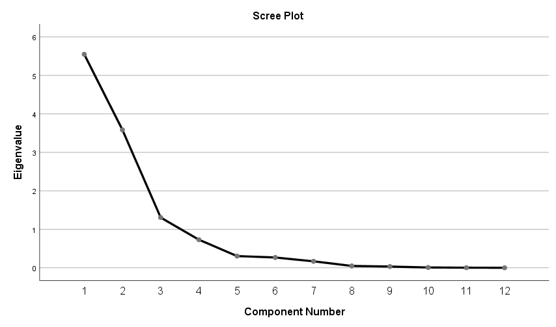
Fig. S5 Scree plot showing that three PCA components had eigen value greater than one in case of parameters taken for all five treatment groups

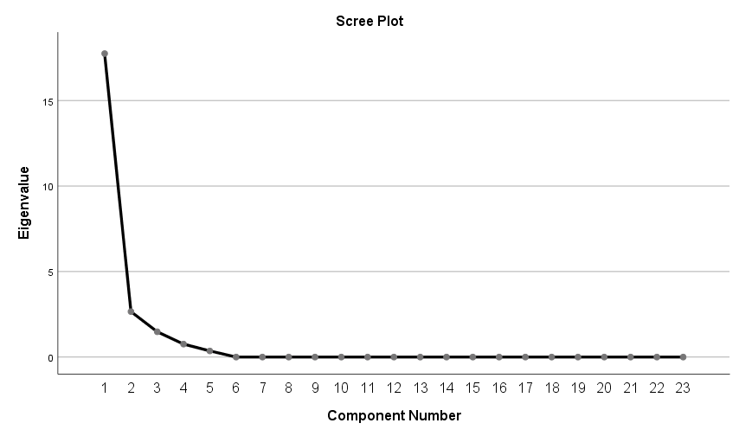

Fig. S6 Scree plot showing that three PCA components had eigen value greater than one in case of parameters taken for two treatment groups

 | Component
 | PC1 | PC2 | PC3
Total_Flavonoids | .934
Proline | .891 | -.417
Total_Phenolics | .842
Glycine_betain | .780 | -.502
Total_Soluble_Sugar | .741 | .526
Total_Protein | .729 |  | -.463
Chlorophyll_a | .670 | .652 | .307
Total_Chlorophyll | .668 | .633
Na+ |  | -.944
K+ | .625 | -.644 | .307
Carotenoids |  | .641 | .692
Chlorophyll_b | .429 | .539 | -.579
Table S3 Component Matrix (3 components extracted) in case of parameters taken for all five treatment groups, extraction method: Principal Component Analysis

 | Component
 | PC1 | PC2 | PC3
Formic_acid | .999
Caffeic_acid | .999
Arabinitol | .998
Salicylic_acid | .997
Carboxylic_acid | .997
Arabinose | .994
Acetic_acid | .993
Xylitol | .988
Pyranose | .986
Benzoic_acid | .986
Quercetin | .985
Cinnamic_acid | .963
Ferulic_acid | .951
Gallic_acid | .948
Furanose | .946
Syringic_acid | .946
Spermidine | .876 | .461
Glycine | .870
Jasmonic_acid |  | .852
Vanillic_acid | -.399 | .801 | .395
Abscisic_acid | .600 | .723
Alanine | -.488 | -.527 | -.390
Oxalic_acid |  |  | .942

Table S4 Component Matrix (3 components extracted) in case of parameters taken for two treatment groups, extraction method: Principal Component Analysis

