Peatland Inception and Development Across Kalimantan, Indonesia
Supplementary Information
Table S1. The average carbon accumulation rates (CAR) in tropical peatlands of Kalimantan during the Late Pleistocene to Holocene epochs.
Type | Epoch | Research Site Location | Mean ± SD (g C m⁻² yr⁻¹)
Coastal Peat | Late Holocene (4,200 -present) | Mempawah, West Kalimantan | 49.0 ± 23.2
Coastal Peat | Late Holocene (4,200 -present) | The Lower Kapuas River, West Kalimantan | 54.9 ± 13.7
Coastal Peat | Middle Holocene (8,200 - 4,200 YBP) | Mempawah, West Kalimantan | 63.2 ± 29.8
Coastal Peat | Middle Holocene (8,200 - 4,200 YBP) | The Lower Kapuas River, West Kalimantan | 71.6 ± 7.6
 |  | The average of Coastal Peat | 57.0 ± 22.2
Inland Peat | Late Holocene (4,200 -present) | The Upper Kapuas River, West Kalimantan | 63.0 ± 22.0
Inland Peat | Middle Holocene (8,200 - 4,200 YBP) | The Upper Kapuas River, West Kalimantan | 53.4 ± 19.9
Inland Peat | Early Holocene (11,700 - 8,200 YBP) | The Upper Kapuas River, West Kalimantan | 55.0 ± 33.9
Inland Peat | Late Pleistocene (41,000 - 11,700 YBP) | The Upper Kapuas River, West Kalimantan | 28.1 ± 7.6
Inland Peat | Late Holocene (4,200 -present) | Lake Siran, East Kalimantan | 58.4 ± 26.9
Inland Peat | Middle Holocene (8,200 - 4,200 YBP) | Lake Siran, East Kalimantan | 89.1 ± 39.3
 |  | The average of Inland Peat | 61.8 ± 34.9
 | The average of coastal and inland peats |  | 60.4 ± 31.8

Table S2. Bulk density (BD) and Total Organic Carbon (TOC) values are used to calculate CAR.
Plot | Depth Interval | BD (g cm-3) | TOC (%) | Research Site location
SW1 | Shallow (0 - <100 cm) | 0.16 | 45.94 | Mempawah, West Kalimantan
SW1 | Moderate (100 - <200 cm) | 0.10 | 51.03 | Mempawah, West Kalimantan
SW1 | Deep (200 - <300m cm) | 0.10 | 56.52 | Mempawah, West Kalimantan
SFC1 | Shallow (0 - <100 cm) | 0.10 | 50.76 | Mempawah, West Kalimantan
SFC1 | Moderate (100 - <200 cm) | 0.10 | 52.68 | Mempawah, West Kalimantan
SFC1 | Deep (200 - <300m cm) | 0.09 | 52.60 | Mempawah, West Kalimantan
SFC1 | Very deep (300 - <500 cm) | 0.11 | 50.66 | Mempawah, West Kalimantan
SBC1 | Shallow (0 - <100 cm) | 0.13 | 50.94 | Mempawah, West Kalimantan
SBC1 | Moderate (100 - <200 cm) | 0.12 | 49.06 | Mempawah, West Kalimantan
SBC1 | Deep (200 - <300m cm) | 0.14 | 45.98 | Mempawah, West Kalimantan
SBC1 | Very deep (300 - <500 cm) | 0.13 | 46.31 | Mempawah, West Kalimantan
SBC1 | Extremely very deep (500 - <700 cm) | 0.11 | 45.75 | Mempawah, West Kalimantan
SBC1 | Extraordinarily very deep (>700 cm) | 0.14 | 45.13 | Mempawah, West Kalimantan
APL1C; KR2; and SF61 | Shallow (0 - <100 cm)* | 0.12 | 52.05 | The Lower Kapuas, West Kalimantan
APL1C; KR2; and SF61 | Moderate (100 - <200 cm)* | 0.12 | 52.05 | The Lower Kapuas, West Kalimantan
APL1C; KR2; and SF61 | Deep (200 - <300m cm)* | 0.12 | 52.05 | The Lower Kapuas, West Kalimantan
APL1C; KR2; and SF61 | Very deep (300 - <500 cm)* | 0.12 | 52.05 | The Lower Kapuas, West Kalimantan
APL1C; KR2; and SF61 | Extremely very deep (500 - <700 cm)* | 0.12 | 52.05 | The Lower Kapuas, West Kalimantan
BL1A and S3.8 | Shallow (0 - <100 cm) | 0.11 | 57.93 | The upper Kapuas, West Kalimantan
BL1A and S3.8 | Moderate (100 - <200 cm) | 0.11 | 57.40 | The upper Kapuas, West Kalimantan
BL1A and S3.8 | Deep (200 - <300m cm) | 0.10 | 56.77 | The upper Kapuas, West Kalimantan
BL1A and S3.8 | Very deep (300 - <500 cm) | 0.10 | 55.87 | The upper Kapuas, West Kalimantan
BL1A and S3.8 | Extremely very deep (500 - <700 cm) | 0.13 | 53.61 | The upper Kapuas, West Kalimantan
BL1A and S3.8 | Extraordinarily very deep (>700 cm) | 0.12 | 55.41 | The upper Kapuas, West Kalimantan
T1P3; T2P3 and T3P3 | Shallow (0 - <100 cm) | 0.20 | 50.65 | The upper Kapuas, West Kalimantan
T1P3; T2P3 and T3P3 | Moderate (100 - <200 cm) | 0.18 | 50.61 | The upper Kapuas, West Kalimantan
T1P3; T2P3 and T3P3 | Deep (200 - <300m cm) | 0.16 | 50.56 | The upper Kapuas, West Kalimantan
T1P3; T2P3 and T3P3 | Very deep (300 - <500 cm) | 0.16 | 51.20 | The upper Kapuas, West Kalimantan
T1P3; T2P3 and T3P3 | Extremely very deep (500 - <700 cm) | 0.15 | 51.14 | The upper Kapuas, West Kalimantan
T1P3; T2P3 and T3P3 | Extraordinarily very deep (>700 cm) | 0.19 | 50.64 | The upper Kapuas, West Kalimantan
MS1;MS2 and MS3 | Shallow (0 - <100 cm) | 0.10 | 52.25 | Lake Siran, East Kalimantan
MS1;MS2 and MS3 | Moderate (100 - <200 cm) | 0.09 | 54.94 | Lake Siran, East Kalimantan
MS1;MS2 and MS3 | Deep (200 - <300m cm) | 0.11 | 55.03 | Lake Siran, East Kalimantan
MS1;MS2 and MS3 | Very deep (300 - <500 cm) | 0.10 | 46.74 | Lake Siran, East Kalimantan
MS1;MS2 and MS3 | Extremely very deep (500 - <700 cm) | 0.08 | 45.55 | Lake Siran, East Kalimantan
MS1;MS2 and MS3 | Extraordinarily very deep (>700 cm) | 0.12 | 37.63 | Lake Siran, East Kalimantan
MS4 | Shallow (0 - <100 cm) | 0.07 | 52.25 | Lake Siran, East Kalimantan
MS4 | Moderate (100 - <200 cm) | 0.07 | 54.94 | Lake Siran, East Kalimantan
Note: * Values of BD and TOC were estimated based on the published data[1–3]

Table S 3. The R programming language was utilized to analyze the Depth-Age Model of 55 radiocarbon dates obtained from 15 peat core samples located in Kalimantan. The analysis was conducted using Rstudio version 2025.09.1+401 by Posit Software, PBC (https://posit.co).
#Rbacon code for analyzing the cores
```{bacon}
#no hiatus, default param thick=5, acc.mean=20, IntCal20, for core with PMC date postbomb curve is added. The postbomb used were depends on the location fo the core.
Bacon("APL1C")
Bacon("BL1A")
Bacon("KR1")
#one PMC date, so it requires post bomb curve 3 = NH3 (northern hemisphere 3), 5= SH3 (southern hermisphere 5)
Bacon("MS1", postbomb = 3)
Bacon("MS2", postbomb = 3)
Bacon("MS3")
Bacon("MS4", postbomb = 3)
Bacon("S3.8", postbomb = 3)
Bacon("SBC1")
Bacon("SF61", postbomb = 5)
Bacon("SFC1", postbomb = 3)
Bacon("SW1", postbomb = 3)
Bacon("T1P3")
Bacon("T2P3")
Bacon("T3P3")

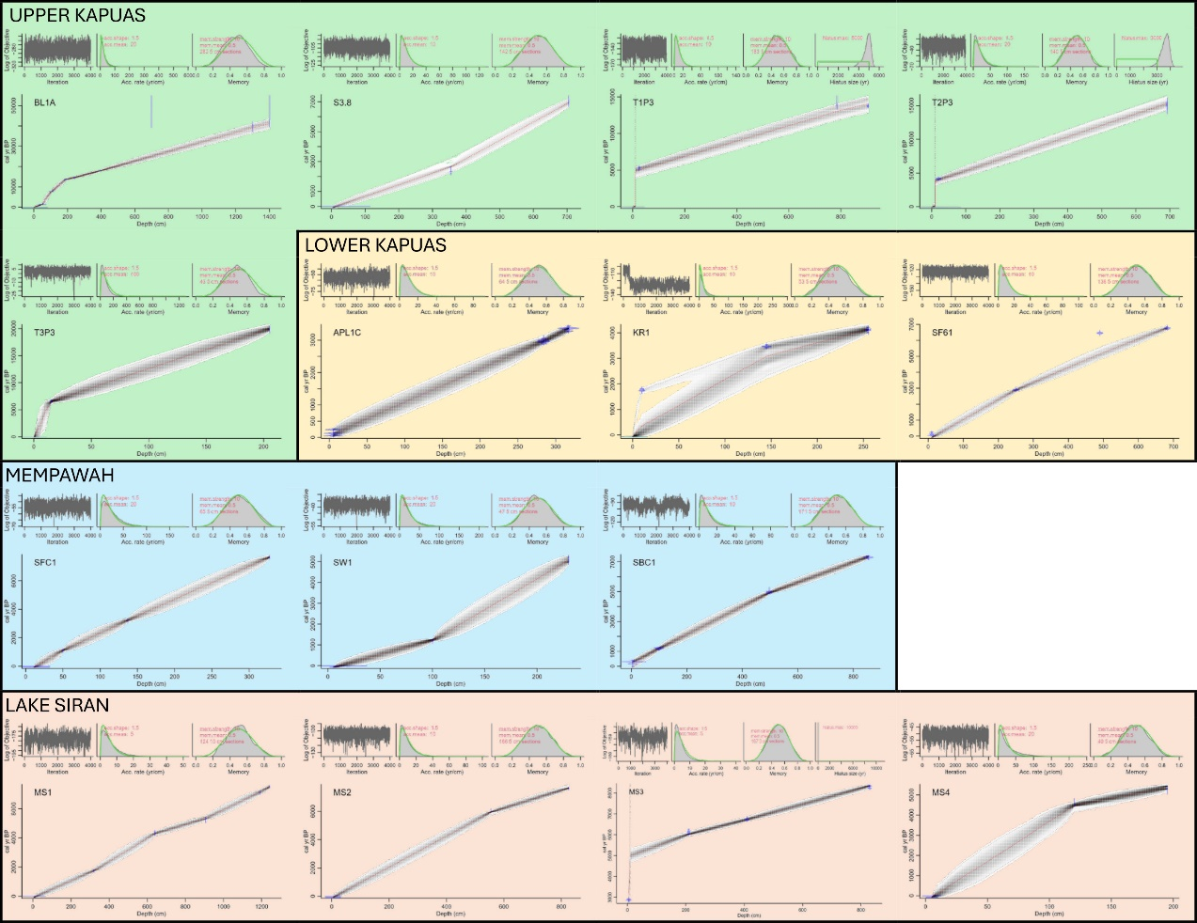
Figure S1. The results of the Bayesian Age-Depth models using the Bacon program (Rstudio version 2025.09.1+401 by Posit Software, PBC, https://posit.co).

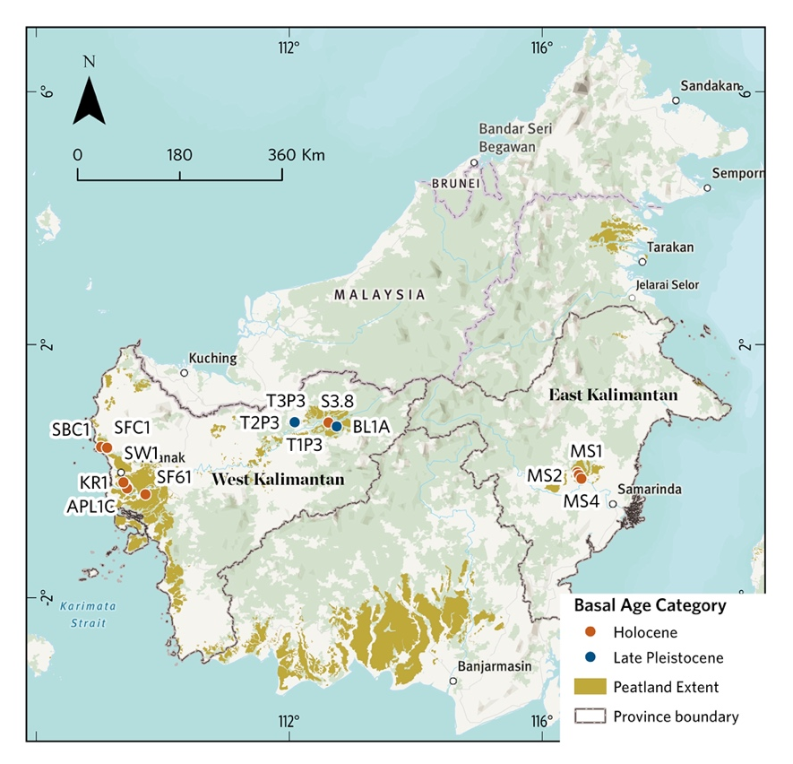
Figure S 2. The basal age of coastal and inland peats in Kalimantan, showing peat initiations in the Late Pleistocene and Holocene in West and East Kalimantan, Indonesia. The base map generated in ArcGIS Pro 3.5 (Esri, https://www.esri.com/en-us/arcgis/products/arcgis-pro/overview) using the TNC World Topographic Map Reference (https://basemaps.arcgis.com/arcgis/rest/services/World_Basemap_v2/VectorTileServer). The description of the basemap is available at: https://www.arcgis.com/home/item.html?id=a67afb8c11d840daaa27702f45a75580. Peatland extent data from Anda et al.[4] and Melton et al.[5].

Reference
1. Anshari, G. et al. Carbon loss from a deforested and drained tropical peatland over four years as assessed from peat stratigraphy. Catena (Amst) 208, 105719 (2022).
2. Hooijer, A. et al. Subsidence and carbon loss in drained tropical peatlands. Biogeosciences 9, 1053–1071 (2012).
3. Anshari et al. Drainage and land use impacts on changes in selected peat properties and peat degradation in West Kalimantan Province, Indonesia. Biogeosciences 7, 3403–3419 (2010).
4. Anda, M. et al. Revisiting tropical peatlands in Indonesia: Semi-detailed mapping, extent and depth distribution assessment. Geoderma 402, 1–14 (2021).
5. Melton, J. R. et al. A map of global peatland extent created using machine learning (Peat-ML). Geosci Model Dev 15, 4709–4738 (2022).

