Supplemental Material

Core reorganisation in food webs buffers ecosystems against warming
Pablo A. Poleto Antiqueira¹, Athen Ma², Pavel Kratina³, Vito Latora², Lachlan G. Burton², Lei Zhao⁴, Eoin J. O’Gorman¹

1 School of Life Sciences, University of Essex, Wivenhoe Park, Colchester, CO4 3SQ, UK
2 Queen Mary University of London, Mile End Road, London, E1 4NS, UK
3 Centre for Biodiversity and Sustainability, School of Biological and Behavioural Sciences, Queen Mary University of London, Mile End Road, London E1 4NS, UK

⁴ Beijing Key Laboratory of Biodiversity and Organic Farming, College of Resources and Environmental Sciences, China Agricultural University, Beijing, China

Table S1. List of species and their trophic category. Their distributions in the core and periphery in Hengill geothermal streams food webs are indicated by the Stream ID.
Species/biological group | Trophic category | Stream ID
 |  | Core | Periphery
Achnanthes | Resource | 1,3,4,5,6,7,9,10,11,12,13,14,16 | 8
Amphora | Resource | 1,4,5,10 | 3,6,7,8,9,11,12,13,14,16
Asterionella | Resource |  | 9
Aulacoseira | Resource |  | 5,6
Caloneis | Resource |  | 3,4,5,12,14
Capnia vidua | Consumer/  Resource | 10,12,13,16
Chaetocladius sp. | Consumer | 3,4,6,9
Clinocera stagnalis | Consumer/  Resource |  | 4,7,10,11,13,14,16
Cocconeis | Resource | 1,3,4,5,6,7,9,10,11,13,14,16 | 8
CPOM | Resource | 4,5,10,11,13,16 | 1,3,6,7,8,9,12,14
Cricotopus sp. A | Consumer | 5,8,13
Cricotopus sp. B | Consumer | 3,7,11,14
Cymbella | Resource | 3,4,5,10 | 6,7,8,9,11,12,13,14,16
Cyclotella | Resource |  | 5,8,9
Diamesa bertrami | Consumer | 7,10,13,14,16
Diamesa zernyi | Consumer | 7,10,13,14,16
Diatoma | Resource | 3,4,5,6,7,8,9,10,11,12,13,14,16
Dicranota exclusa | Consumer | 7,10,11,13
Diploneis | Resource |  | 4,5,6,11,12,16
Epithemia | Resource | 3,4,5,6,9,11,12,14,16
Eukiefferiella claripennis | Consumer | 3
Eukiefferiella minor | Consumer | 1,4,5,6,7,8,9,10,11,12,13,14,16
Eunotia | Resource |  | 1,9,11,13
Filamentous algae | Resource |  | 1,3,4,5,6,7,8,9,10,11,12,13,14,16
FPOM | Resource | 1,3,4,5,6,7,9,10,11,12,13,14,16 | 8
Fragilaria | Resource | 1,4,5,6,7,9,10,11,13,14,16 | 3,8,12
Frustulia | Resource | 4 | 1,12,13,14
Gomphonema | Resource | 1,3,4,5,6,7,9,10,11,12,14,16 | 8
Green algae | Resource |  | 1,3,4,5,6,7,8,9,10,11,12,13,14,16
Hebridae | Consumer |  | 8
Helobdella stagnalis | Consumer/  Resource |  | 1
Hemiptera | Consumer |  | 3
Hydrellia sp. | Consumer | 5
Limnophora riparia | Consumer/  Resource | 1,3,4,5,6,8,9,14,16 | 11,12
Limoniinae sp. | Consumer | 6,10
Macropelopia sp. | Consumer | 3,12
Macrophytes | Resource | 9,11 | 1,3,6,7,8,12,13,14
Melosira | Resource | 3,4,5,9,10,11,12 | 1,6,8,14
Meridion | Resource | 1,3,4,5,6,7,9,10,11,12,13,14,16 | 8
Mesoveliidae spA | Consumer |  | 5,7,11,13
Mesoveliidae spB | Consumer | 5 | 5
Metriocnemus sp. A | Consumer | 7,9,13
Metriocnemus sp. B | Consumer | 3,4,7,16
Micropsectra atrofasciata | Consumer | 1,3,4,5,6,7,8,9,10,11,13,14,16
Naucoridae | Consumer |  | 8
Navicula | Resource | 1,3,4,5,10 | 6,7,8,9,11,12,13,14,16
Nitzschia | Resource | 1,4,5,10 | 3,6,7,8,9,11,12,13,14,16
Notonectidae | Consumer |  | 11
Oligochaeta sp | Consumer/  Resource | 1,3,4,5,6,7,8,9,10,11,12,13,14,16
Opephora | Resource |  | 5,10,16
Orthocladius sp. | Consumer/  Resource | 1,5,8,12,13,14
Paracladopelma sp. | Consumer/  Resource | 3
Paracricotopus sp. | Consumer/  Resource | 10
Pinnularia | Resource | 3 | 1,4,6,9,10,11,12,13,14,16
Pisidium sp. | Consumer/  Resource | 1
Potamophylax cingulatus | Consumer/  Resource | 7,9,11,12,13,14,16
Prionocera turcica | Consumer | 12,13
Procladius islandicus | Consumer/  Resource | 4,6,9
Prosimulium ursinum | Consumer/  Resource | 7
Radix balthica | Consumer/  Resource | 1,3,4,5,6,7,8,9,11,12,16
Rheocricotopus effesus | Consumer/  Resource | 4,7,9,10,11,12,13,14,16
Rhoicosphenia | Resource | 1,3,4,5,6 | 7,8,9,11,12,14,16
Rhopalodia | Resource | 1,3,4,5,6,9,11,12,14,16 | 7,8
Salmo trutta | Consumer | 1,3,5,6,12,16 | 8
Scatella sp. | Consumer |  | 4,7,11
Simulium aureum | Consumer/  Resource | 1,3,4,5,6,7,8,9,10,11,12,14,16
Simulium vittatum | Consumer/  Resource | 1,3,4,5,6,7,8,9,10,11,14,16
Sperchon glandulosus | Consumer/  Resource |  | 1,3,4,5,6,7,9,10,11,12,13,14,16
Stauroneis | Resource |  | 5,7
Surirella | Resource |  | 4,12,16
Synedra | Resource | 4,5,6,7,8,9,11,12,13,14,16
Terrestrial resources | Resource |  | 1,3,4,5,6,7,8,9,10,11,12,13,14,16
Tetracyclus | Resource |  | 1
Thienemanniella sp. | Consumer/  Resource | 1,4,5,6,7,9,10,11,12,13,14,16
Turbellaria | Consumer |  | 5

Figure S1. Core-Periphery structure of ecological networks sorted by temperature. Core-periphery structure of multiple ecological networks from 14 study streams, ordered by increasing temperature. Each network is plotted in a circular layout with nodes positioned according to their connectivity. Core nodes (highly connected species) are represented as circles in the inner ring are surrounded by peripheral species (less connected species) as squares in the outer ring.

A)  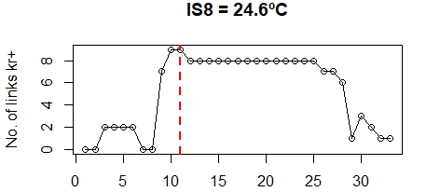 | B)  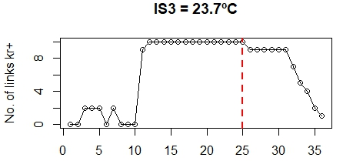
C)  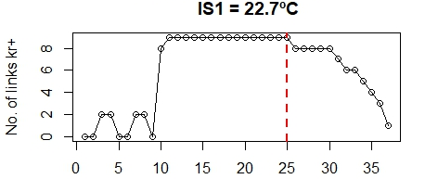 | D)  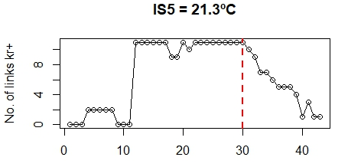
E)  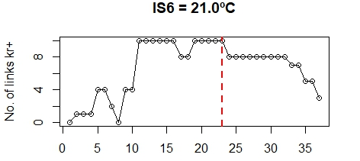 | F)  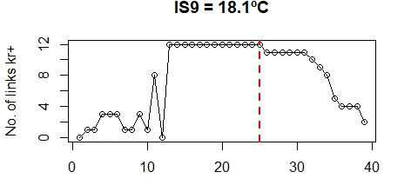
G)  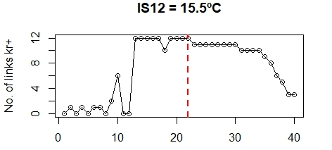 | H)  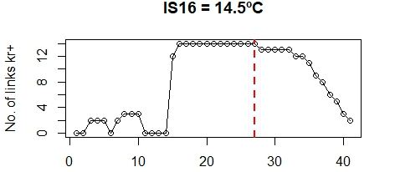
I)  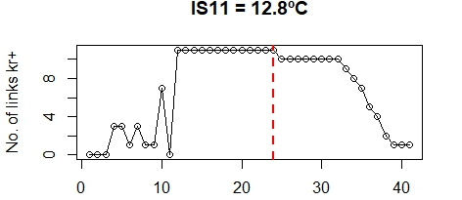 | J)  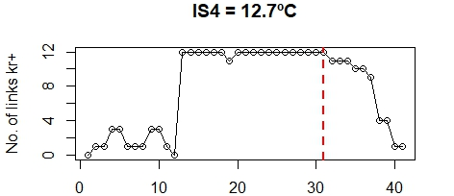
K)  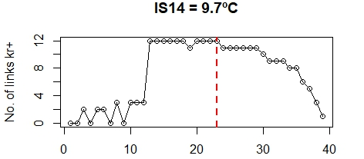 | L)  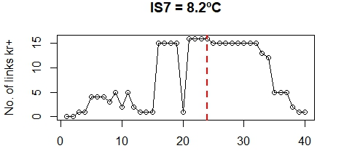
M)  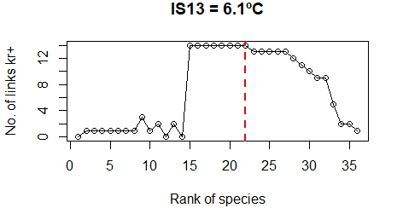 | N)  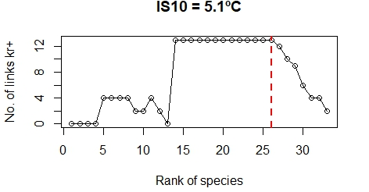
Figure S2. Comparisons of core profiles from 14 geothermal streams food webs in a decreasing order of temperature (a-n). Nodes are ranked by their decreasing order of degree and plotted by the number of links with nodes of a higher rank, 𝑘⁺_{r}. The maximum of the curve 𝑘⁺_{r*} defines the boundary of the core, which is indicated by a vertical red line.

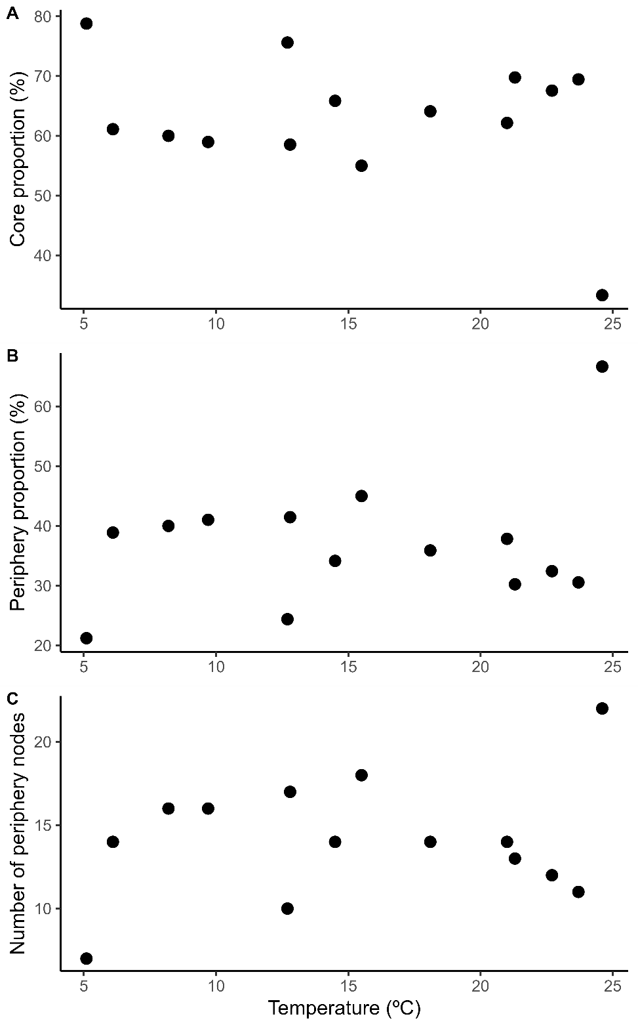
Fig. S3. Temperature effects on core–periphery structure in stream food webs. (A) Proportion of core species, (B) proportion of peripheral species, and (C) absolute number of peripheral nodes plotted against stream temperature (°C). Each point represents a food web from a distinct stream site.

A) | B)  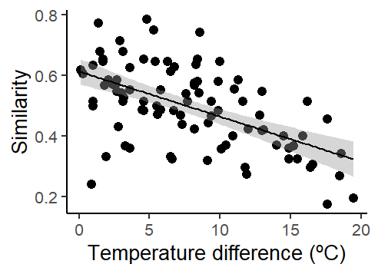
C)  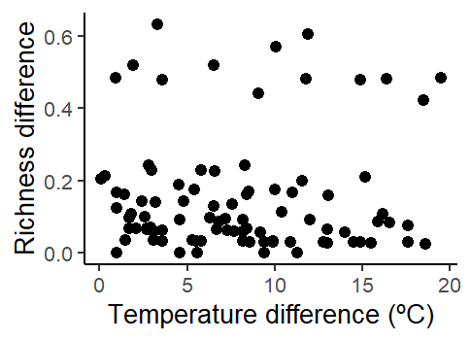 | D)  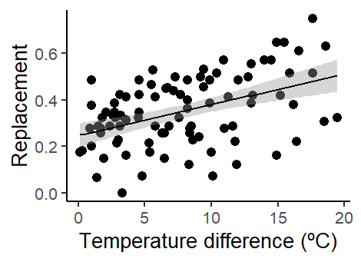
Figure S4. Temperature-driven variation in presence–absence-based beta diversity of core food web nodes. a) SDR‐simplex plots generated from pairwise comparisons between sites sampled in the 14 geothermal streams in Hengill valley Island, showing values for the species similarity (1- total β diversity), species replacement, and species richness difference components of core nodes β diversity. Each point represents a pair of sites. The large central dot in the triangle represents the centroid of the points. The values are based on the Jaccard dissimilarity matrix for species occurrence data (presence/absence). B-D) Beta diversity across the temperature gradient: b) total beta diversity, c) richness difference component of beta diversity and d) species replacement component of beta diversity.

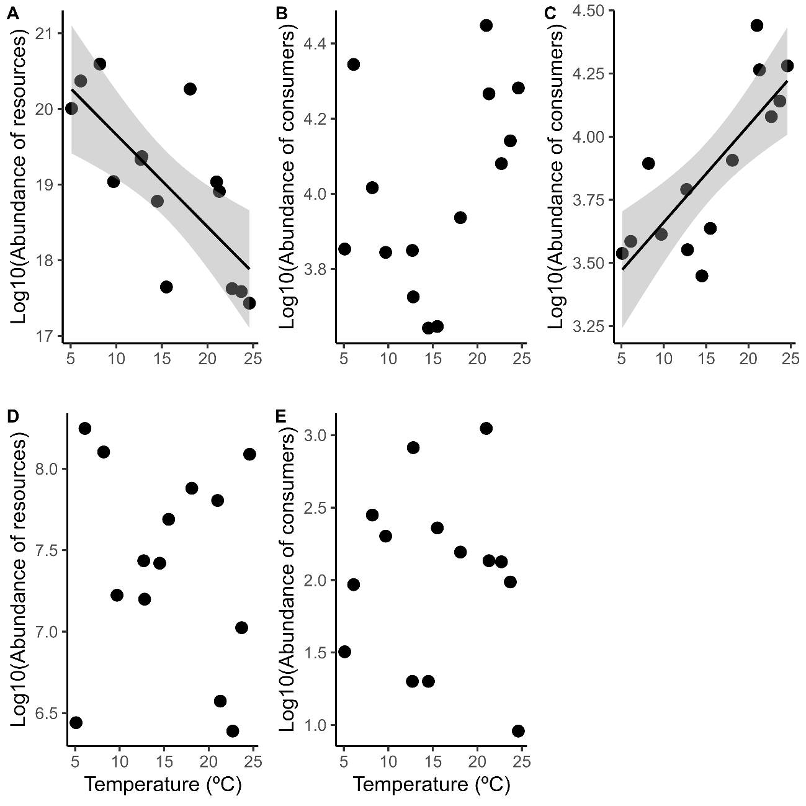
Figure S5. Changes in the abundance of consumers and resources in the core and periphery. (a) There was a significant decrease in the abundance of core resources with increasing temperature (Linear Model, P=0.002, R²=0.51). (b) There was no change in the abundance of core consumers with increasing temperature (Linear Model, P=0.173, R²=0.17), however, when (c) the super-abundant chironomid Eukiefferiella minor was removed, there was a significant increase in core consumers with increasing temperature (Linear Model, P=0.003, R²=0.50). (d) There was no change in the abundance of periphery resources with increasing temperature (Linear Model, P=0.651, R²=0.06). (e) There was no change in the abundance of periphery consumers with increasing temperature (Linear Model, P=0.947, R²=0.08).

A) | B)  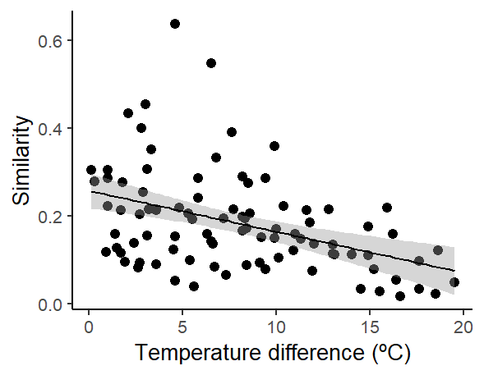
C)  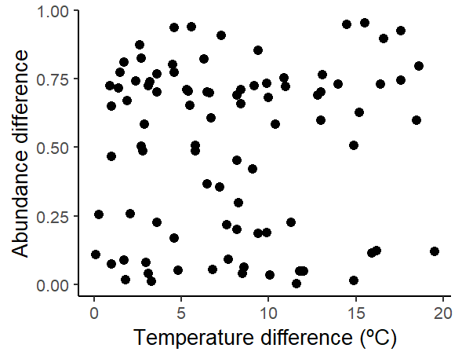 | D)  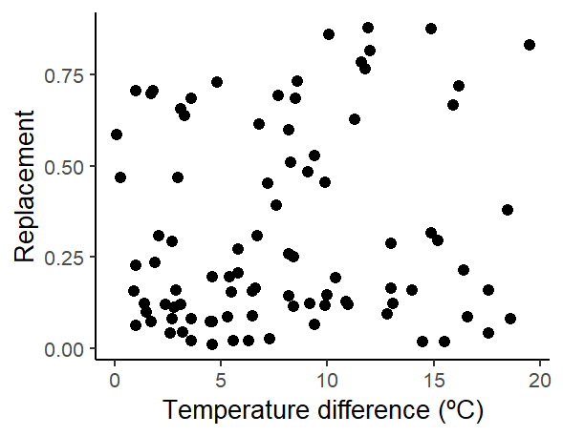
Figure S6. Temperature-driven variation in abundance-based beta diversity of entire food webs. a) SDR-simplex plots based on comparisons of whole food web nodes (not just core) across 14 geothermal streams, partitioned into species similarity (1 – β diversity), abundance difference, and abundance replacement. Values use the Ruzicka dissimilarity matrix for abundance data. Each point represents a pair of sites. The large central dot in the triangle represents the centroid of the points. The values are based on the Ruzicka dissimilarity matrix for abundance data. B-D) Beta diversity across the temperature gradient: b) total similarity (total β diversity – 1), c) abundance difference component of beta diversity and d) abundance replacement component of beta diversity.

A) | B)  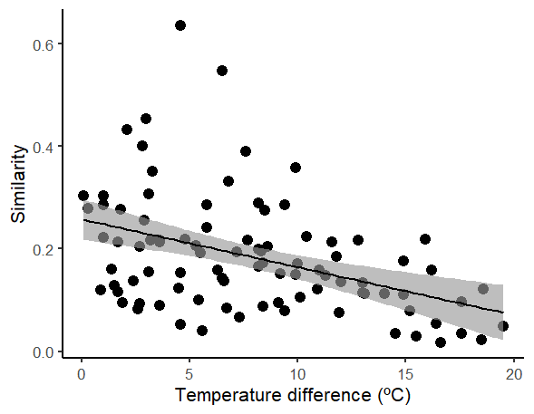
C)  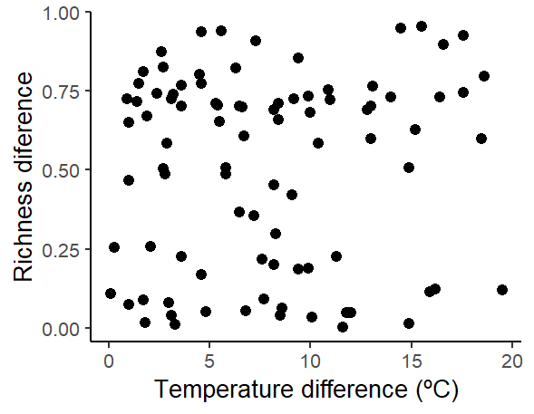 | D)
Figure S7. Temperature-driven variation in presence–absence-based beta diversity of entire food webs. a) SDR‐simplex plots generated from pairwise comparisons between sites sampled in the 14 geothermal streams in Hengill valley Island, showing values for the spatial similarity (1- total β diversity), species replacement, and species richness difference components of complete food web nodes β diversity. Each point represents a pair of sites. The large central dot in the triangle represents the centroid of the points. The values are based on the Jaccard dissimilarity matrix for species occurrence data (presence/absence). B-D) Beta diversity across the temperature gradient: b) total beta diversity, c) richness difference component of beta diversity and d) species replacement component of beta diversity.

Figure S8. Structural equation model linking temperature, node dissimilarity, total connectance, total energy flux and robustness in stream food webs. Standardised path coefficients from piecewise structural equation modelling (pSEM) illustrate the direct and indirect effects of temperature (°C) on food web node dissimilarity (β_{lcbd}), food web connectance, total energy flux and robustness. Black end red arrows denote positive and negative relationships respectively; grey arrows denote non-significant relationships. Arrow thickness corresponds to the magnitude of standardised effects, with asterisks indicating statistical significance (*P < 0.05, **P < 0.01). R²s for component models are given on the boxes of endogenous variables.

Figure S9. Structural equation model linking temperature, periphery node dissimilarity, total connectance, total energy flux and robustness in stream food webs. Standardised path coefficients from piecewise structural equation modelling (pSEM) illustrate the direct and indirect effects of temperature (°C) on periphery node dissimilarity (β_{lcbd}), food web connectance, total energy flux and robustness. Black end red arrows denote positive and negative relationships respectively; grey arrows denote non-significant relationships. Arrow thickness corresponds to the magnitude of standardised effects, with asterisks indicating statistical significance (*P < 0.05, **P < 0.01). R²s for component models are given on the boxes of endogenous variables.

