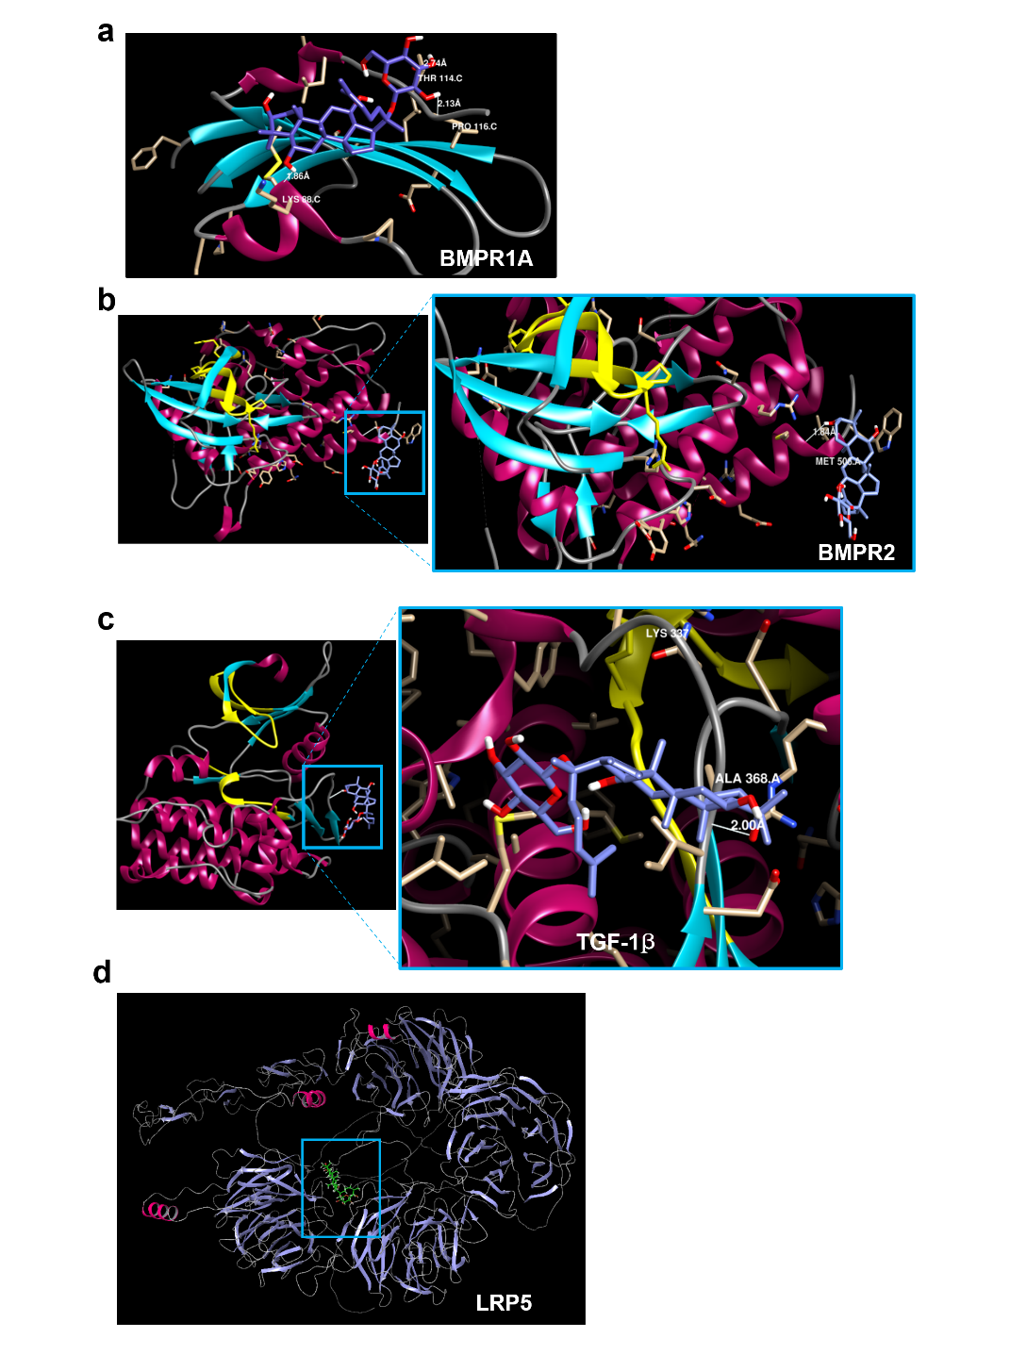
Supplementary Figure 1. Molecular docking analysis of Ginsenoside-F1 ligand binding to receptor proteins (a) BMPR1A, (b) BMPR2, (c) TGF-1β, and (d) LRP5. Molecular docking performed with Schrodinger Suite 2024-3.

Compound | Proteins | ID:pubchem | Binding energy(kcal/mol) | Binding residue
F1 Ginseno-side | BMPR1B | 3MDY | -5.89 | ASP265, ARG198
F1 Ginseno-side | BMPR1A | 2H62 | -3.63 | LYS88, THR14
F1 Ginseno-side | BMPR2 | 3G2F | -3.91 | MET506
F1 Ginseno-side | TGF-1β | 1Py5 | -4.54 | ALA368
F1 Ginseno-side | LRP5 | AF-O75197-alphafold_model | -3.91 | GLN_351

Supplementary Table 1. Molecular docking analysis between F1 and various receptor proteins with binding scores and residues.

