Supplementary figures and Charts

Supplementary figure 1 Annual Scientific Production

Supplementary figure 2 Sources Production Over time
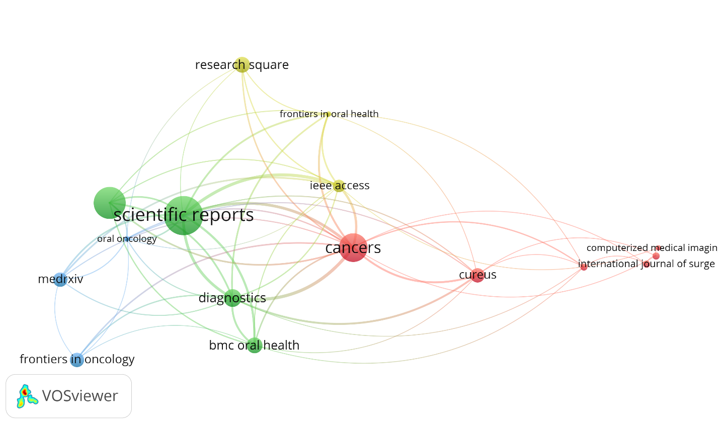
Supplementary figure 3 Citation analysis of sources- Network Visualization. Min documents=3 Min citation=5 provided top 16 items in network. Scientific reports was the highly cited journal with 884 total citations.
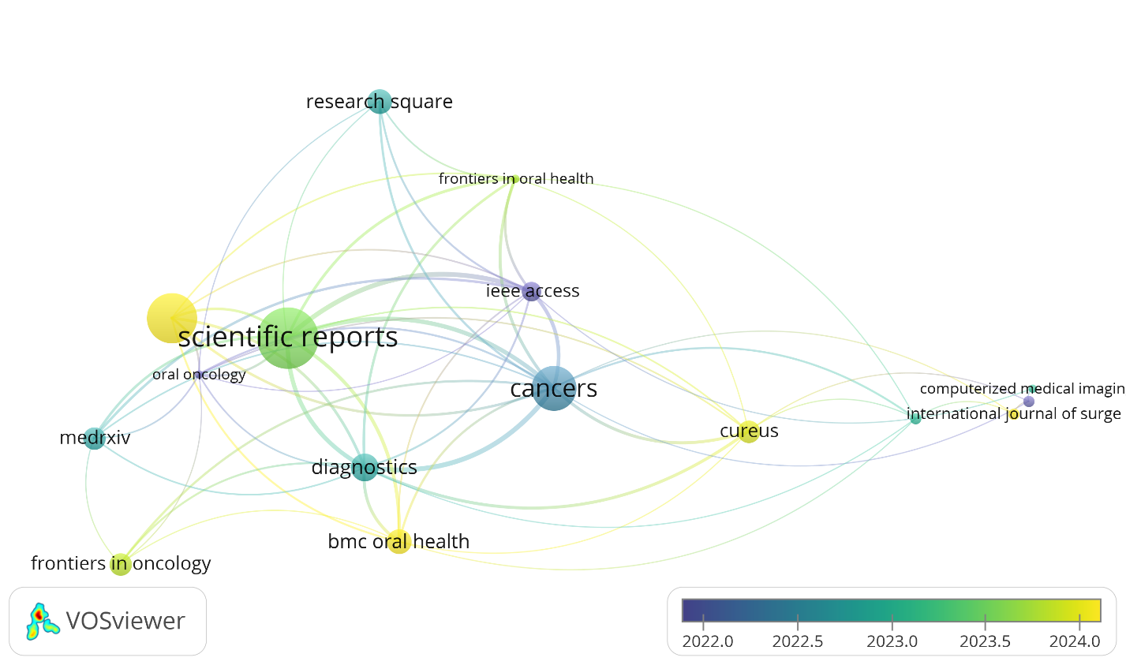
Supplementary figure 4 Citation analysis of sources- Overlay Visualization.
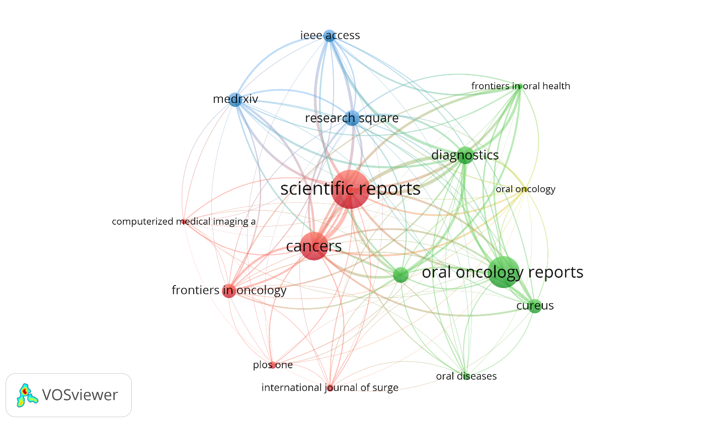
Supplementary figure 5 Bibliographic coupling of sources- Network Visualization. Min documents=3 Min citations=5 provided top 16 items in the network.
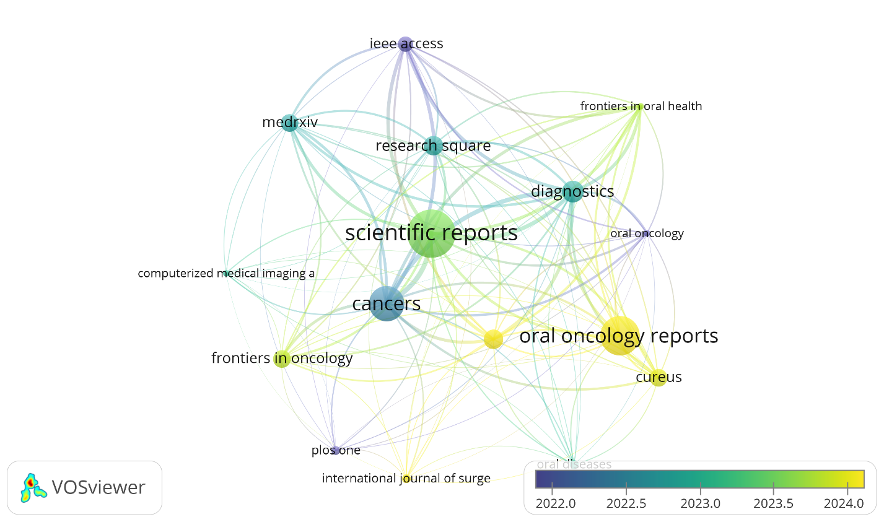
Supplementary figure 6 Bibliographic coupling of sources- Overlay Visualization.
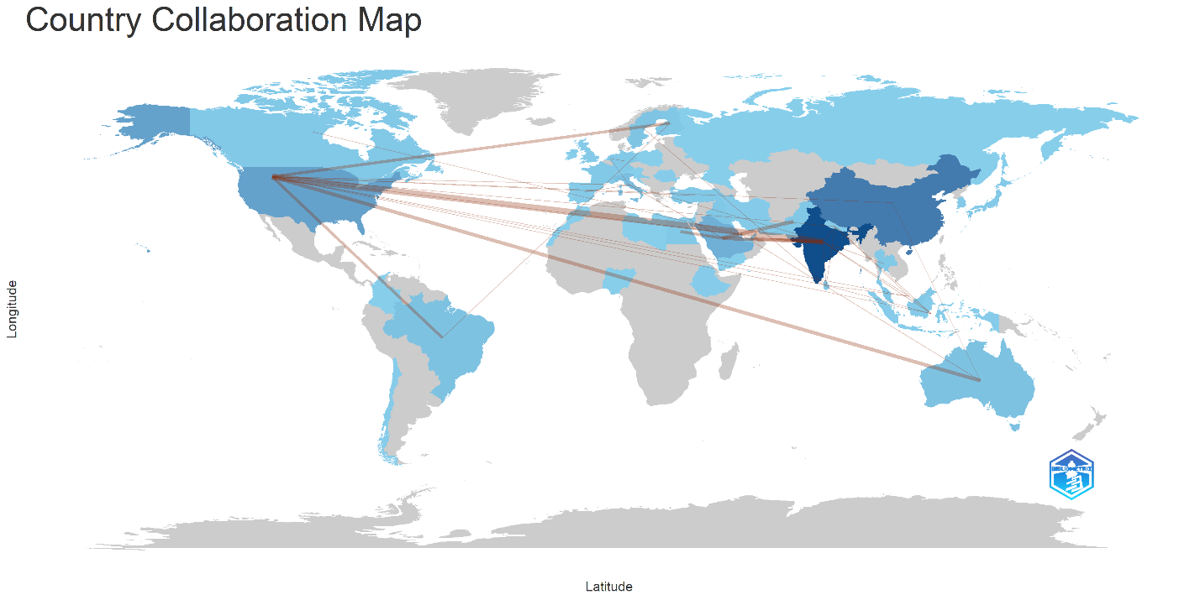
Supplementary figure 7 Country Collaboration Map by Biblioshiny

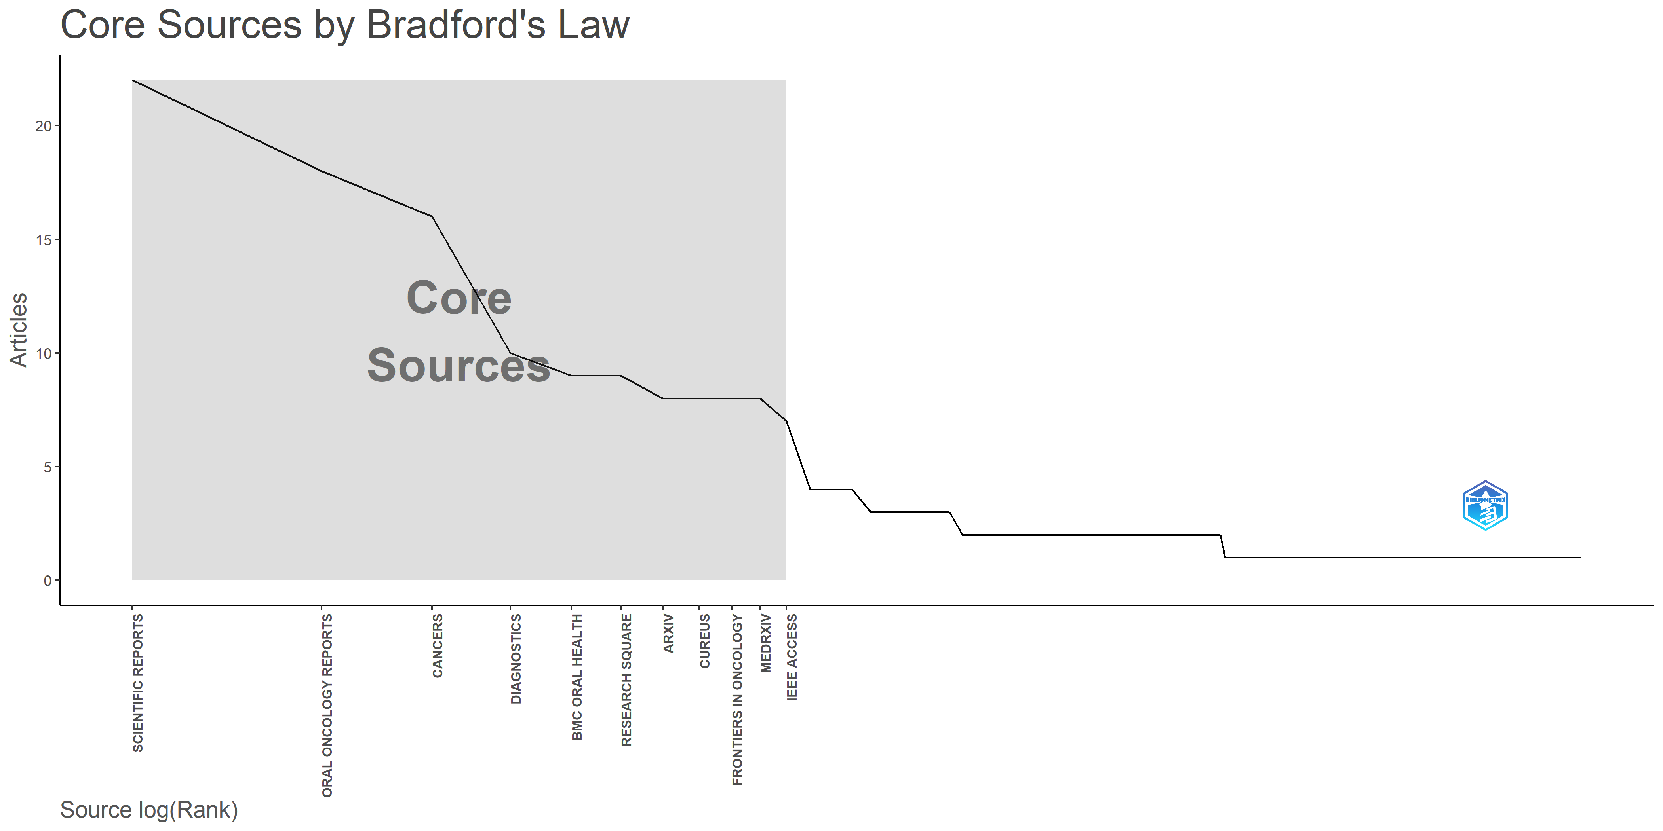
Supplementary figure 8 Core Sources by Bradford's Law by Biblioshiny

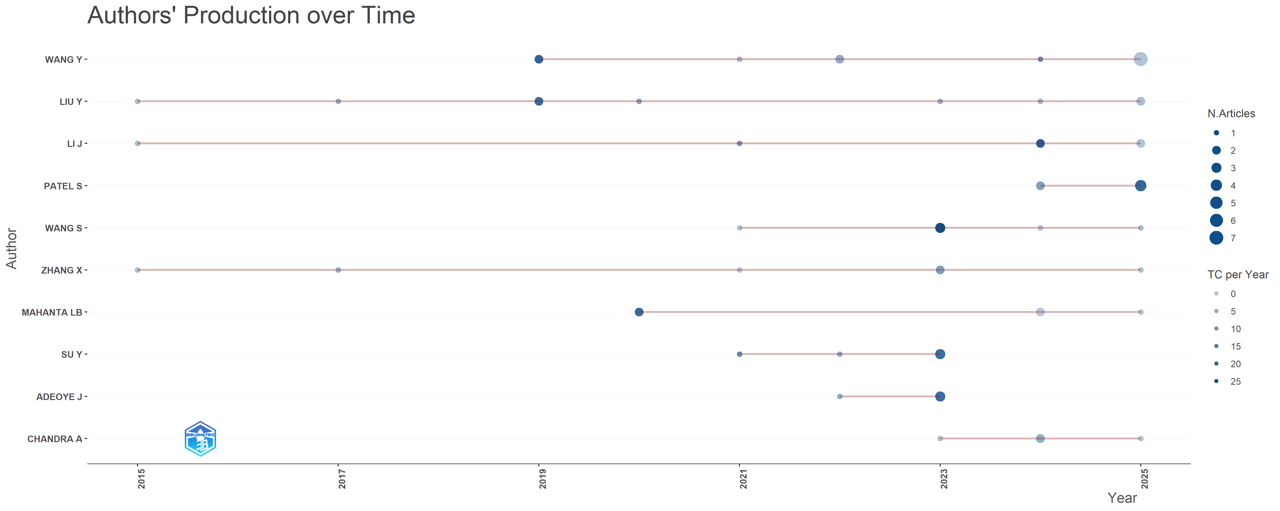
Supplementary figure 9 Authors' Production Over time by Biblioshiny

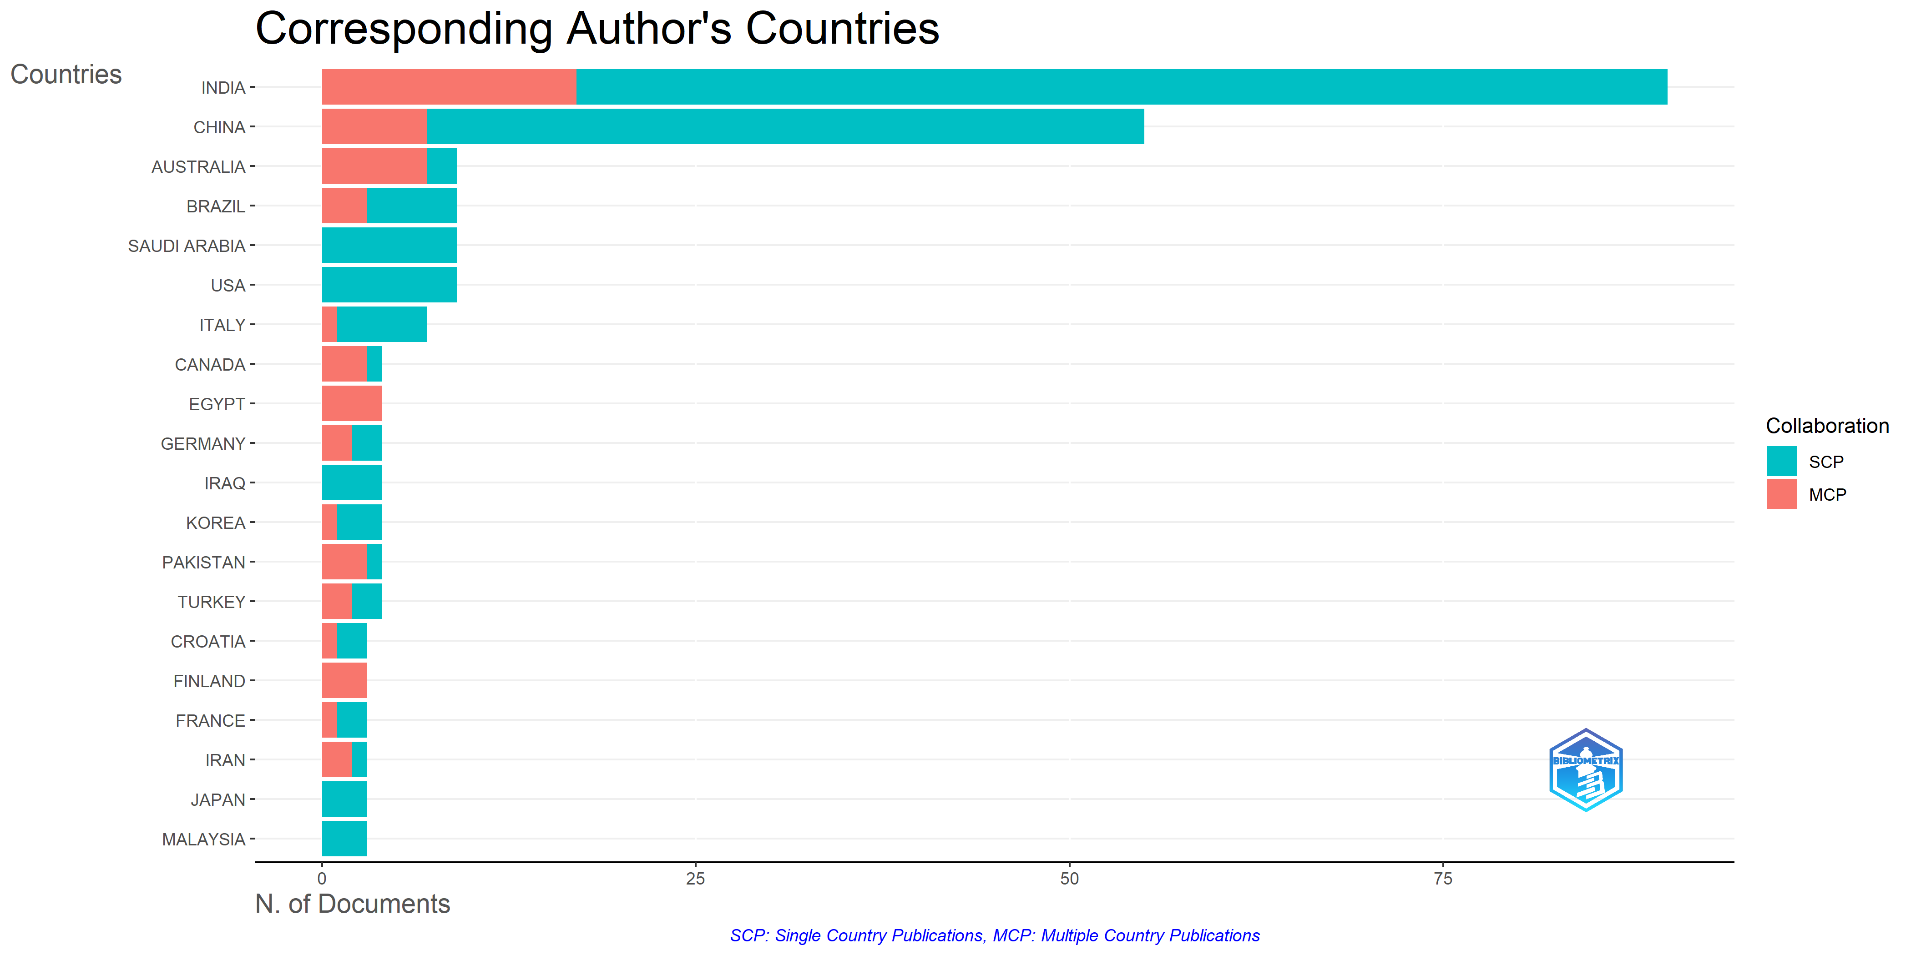
Supplementary figure 10 Corresponding Authors' Countries by Biblioshiny
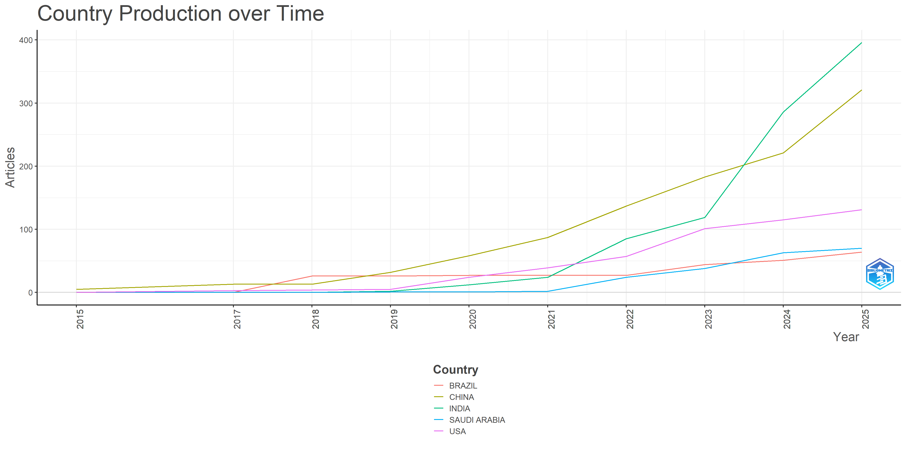
Supplementary figure 11 Country Production over time by Biblioshiny
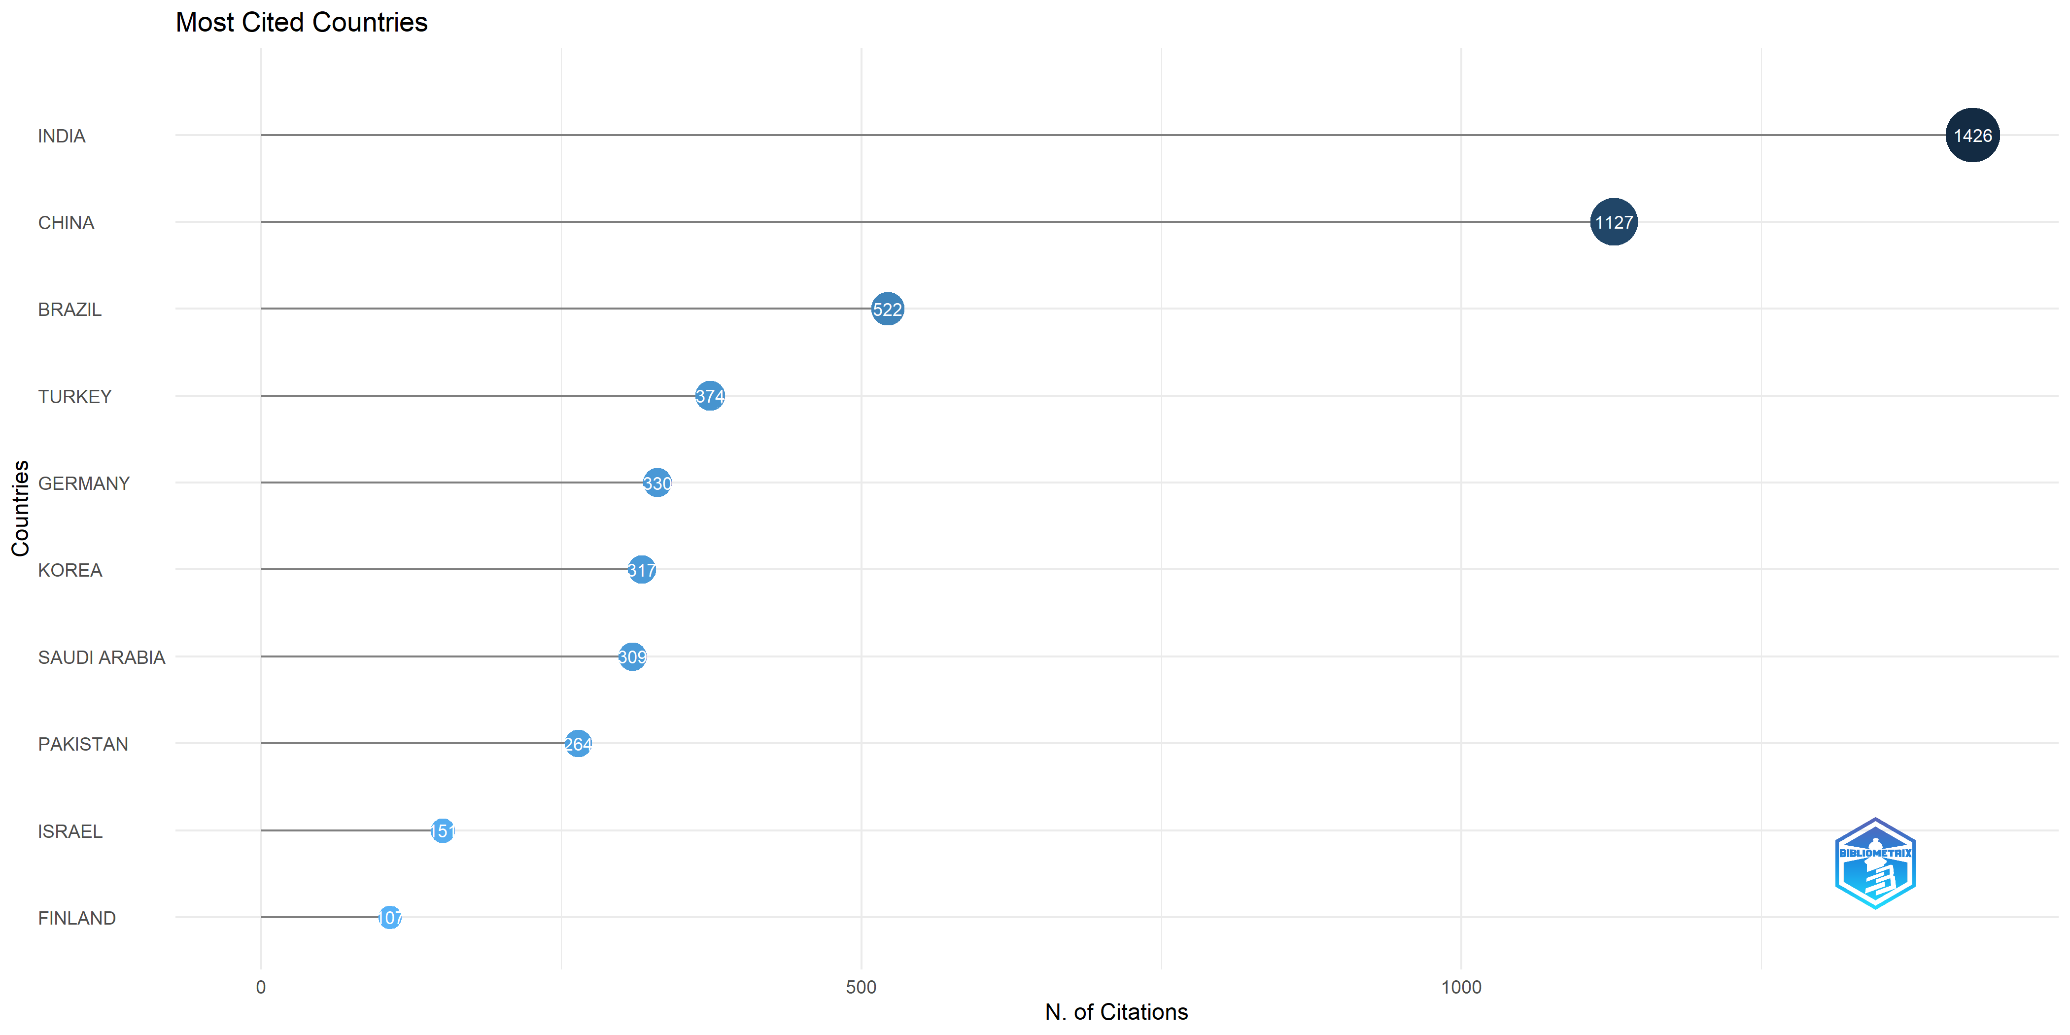
Supplementary figure 12 Most Cited Countries

