Near-term impacts of the 2024 mass coral bleaching event on benthic and fish communities in Okinawa Island, southern Japan
Coral Reefs
Lucas Yutaka Kimura ^{1a*}, Rickdane Gomez ^{1a*}, Takashi Nakamura ^{2,3}
*Corresponding author affiliation:
Graduate School of Engineering and Science, University of the Ryukyus, 1 Senbaru, Nishihara, Okinawa, Japan 903-0213
*Corresponding author emails:
lucaskimura0924@gmail.com
rickdanegomez@gmail.com

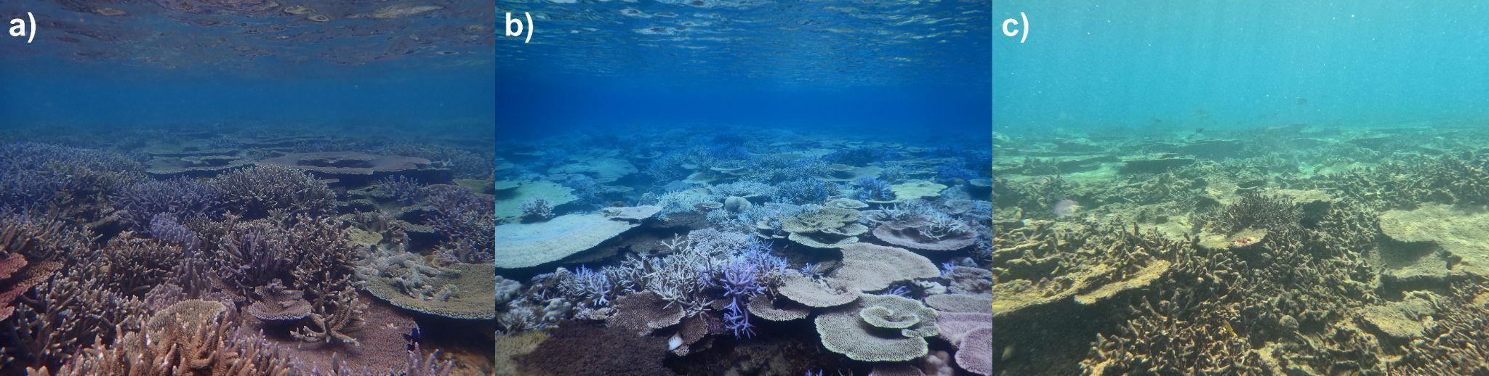
Online Resource 1a Reefscape at one of the survey sites (Kakinouchi) before (January 2024) (a), during (August 2024) (b), and after (March 2025) (c) the 2024 mass bleaching event

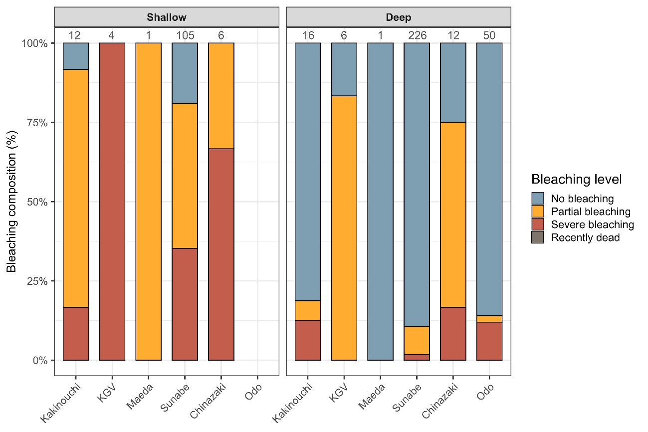
Online resource 1b Stacked composition plot of bleaching status of soft corals across sites per depth zone. Numbers above bars represent the total number of soft coral points assessed from photos at each location. Surveys were conducted in August 2024. Site Nakijin was not assessed during this period. No soft corals were recorded along transects at the shallow zone in Odo

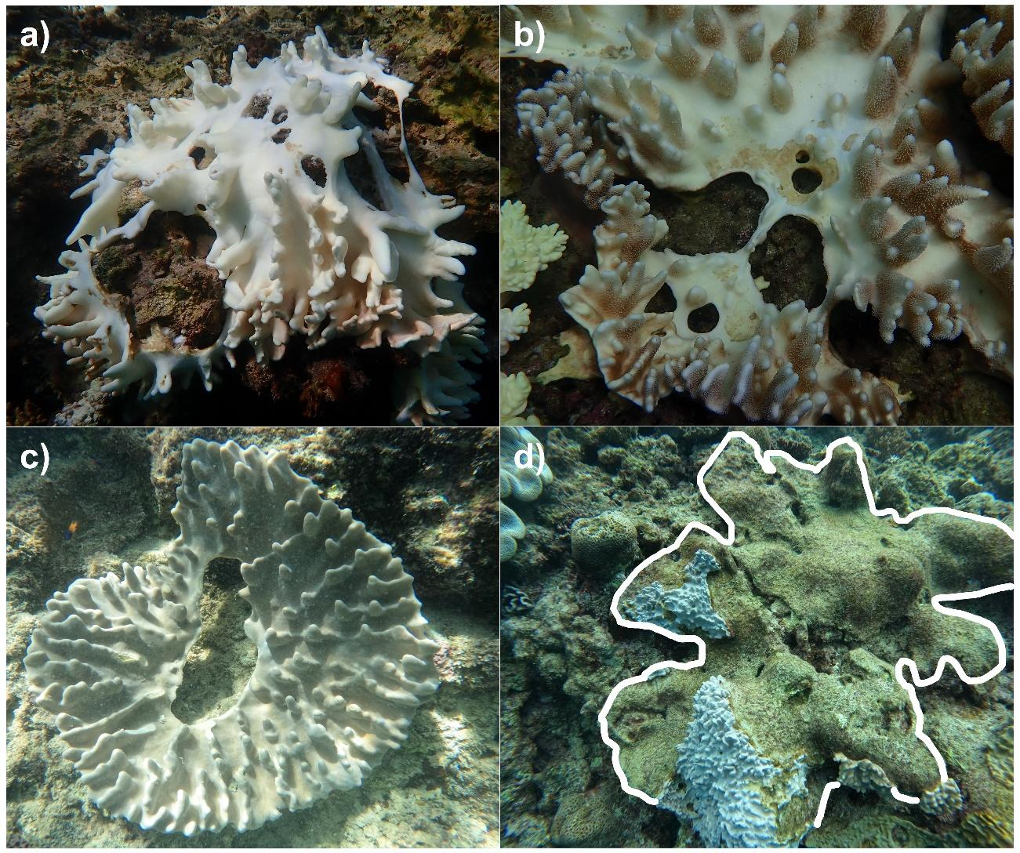
Online resource 1c Representative photos of fragmentation and tissue loss in Lobophytum soft corals during and after the bleaching event. Colonies exhibiting bleaching, tissue dissolution, and fragmentation during the bleaching event (a, b). A colony with regained pigmentation after bleaching, but with tissue loss in the central area (c). A dissolved colony leaving a bare substrate (outlined in white), subsequently overgrown by turf algae (d)
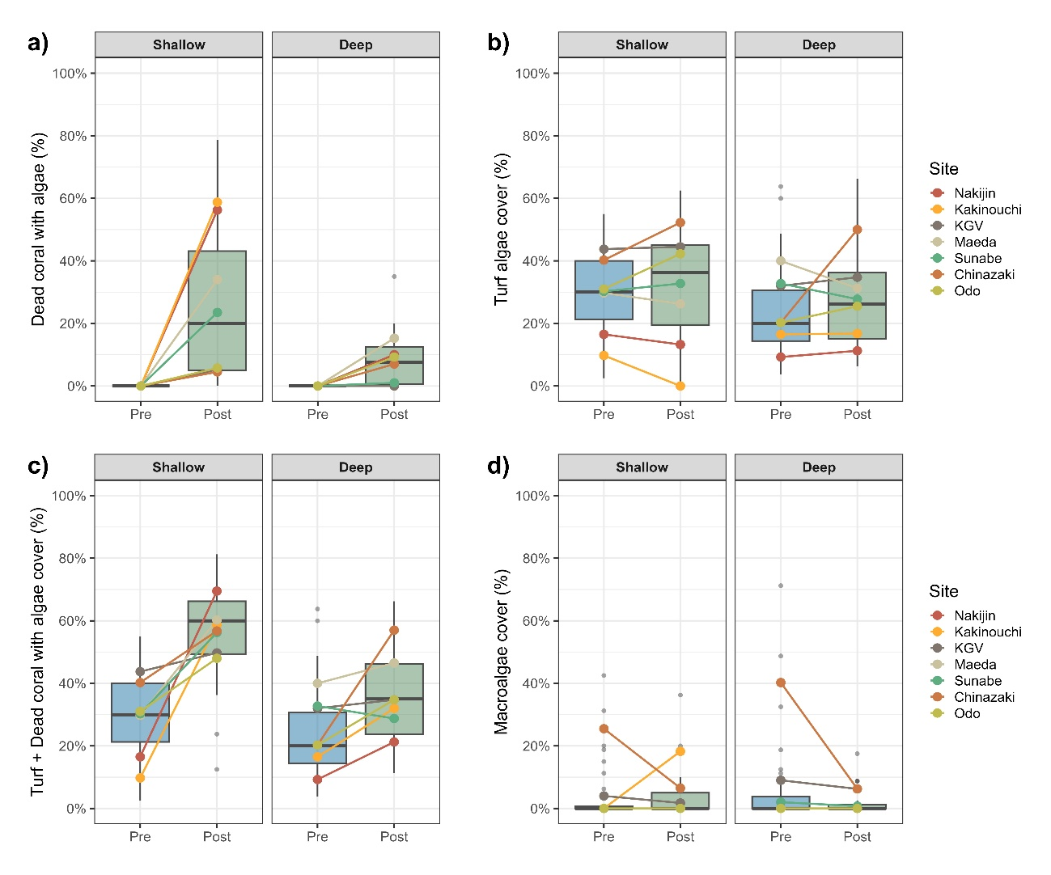
Online resource 1d Changes in the mean cover of algal variables before and after bleaching per depth zone: (a) Dead coral with algae (DCA), (b) Turf algae, (c) combined DCA and turf algae, (d) macroalgae. Boxes represent interquartile ranges, horizontal lines represent the median value across replicates, and points represent site-level means
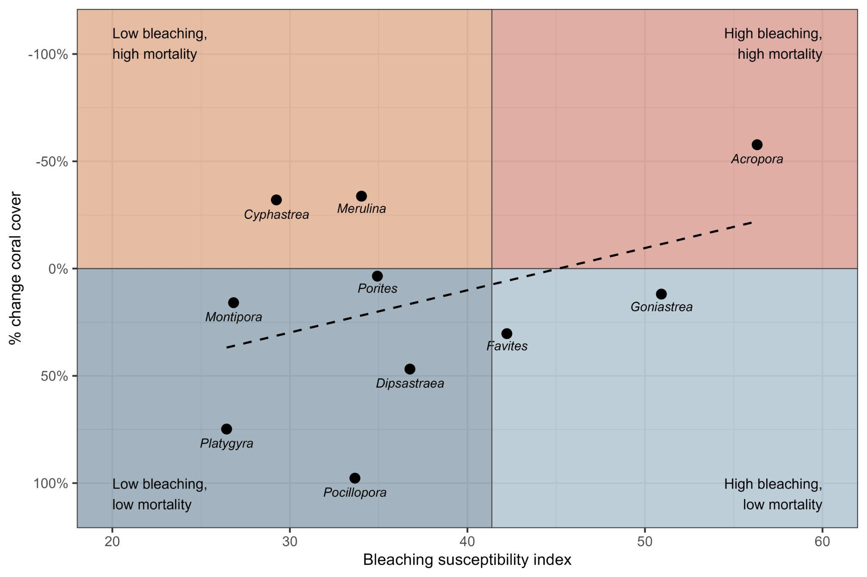
Online Resource 1e Coordinate plot of the Bleaching Susceptibility Index (BSI; adapted from Dalton et al. 2020 and McClanahan et al. 2004) for the ten most abundant coral genera across study sites
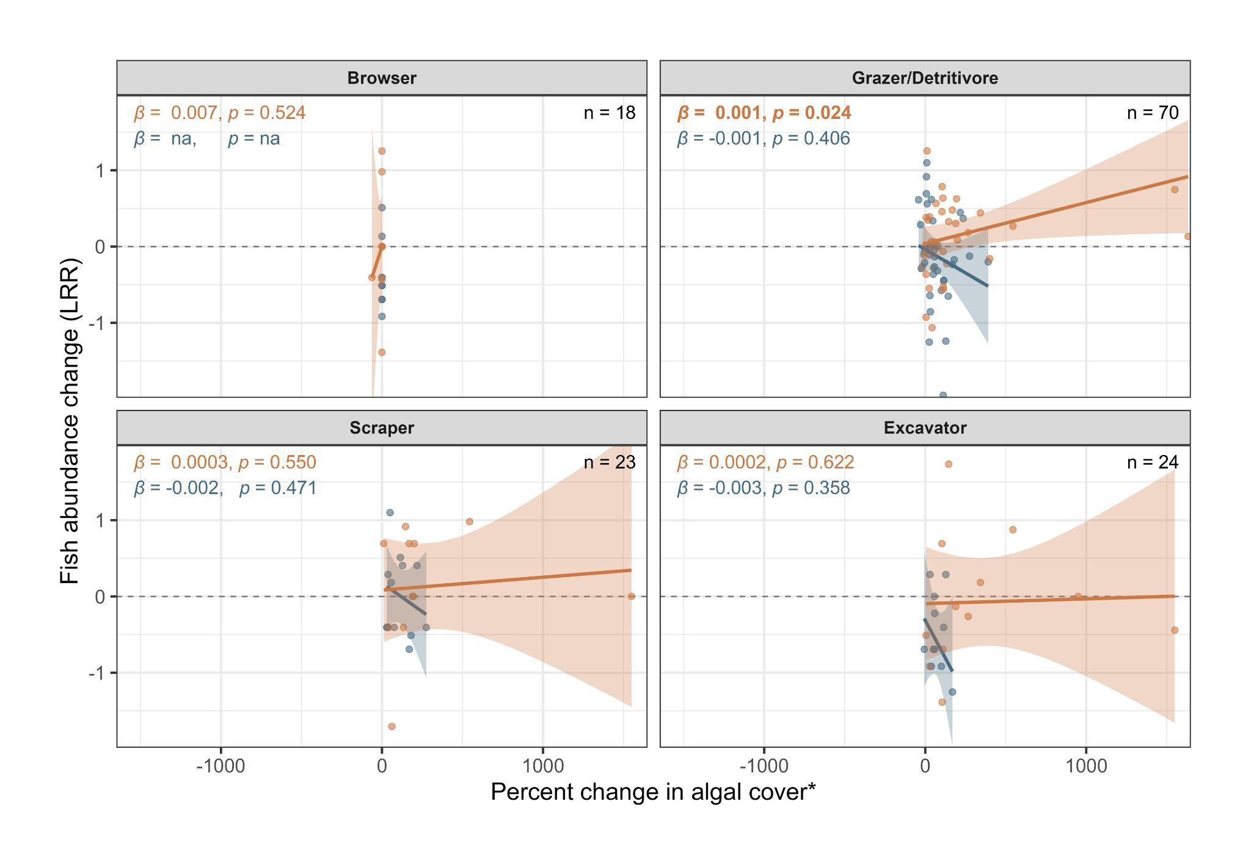
Online Resource 1f GLMM trends showing responses of herbivore functional groups (abundance log response ratio) to percent changes in algal cover: Browser - Macroalgae; Grazer/Detritivore, Scraper, Excavator - combined cover of Turf + Dead Coral with Algae). n represents the number of transects where individuals belonging to specified functional groups were recorded. Model coefficients (ꞵ) and p-values in bold indicate statistically significant changes.

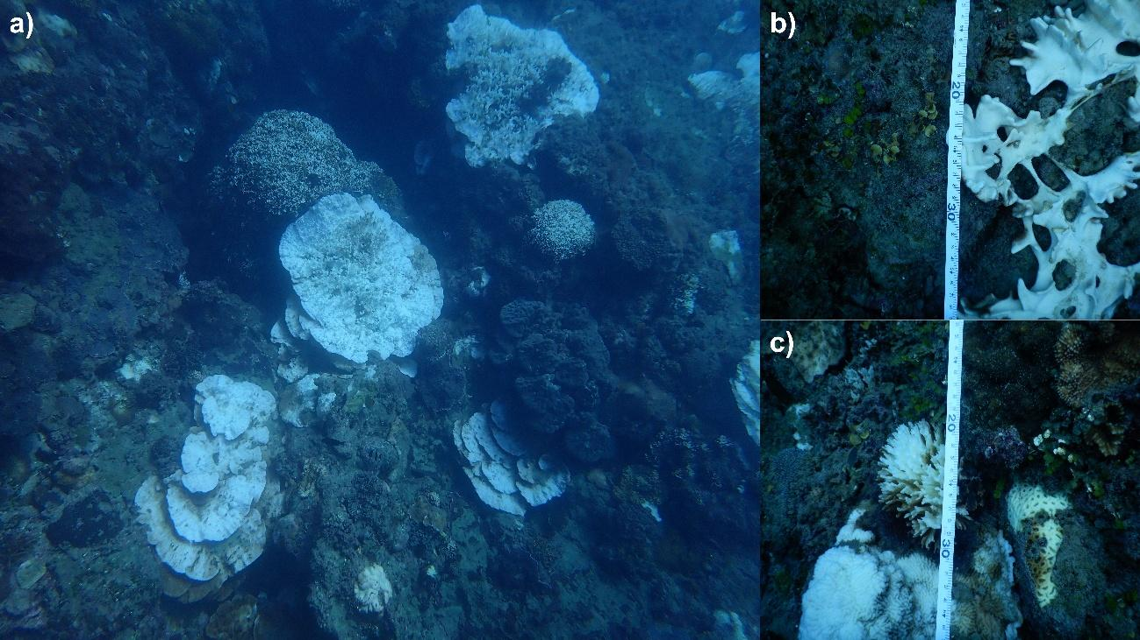
Online resource 1g Representative photos of persistently bleached coral colonies in Chinazaki three months after peak bleaching

