Supplementary information

Table S1 and S2: Travel Speeds Used in Accessibility Analysis[1] in the Unimodel and Bimodal models
Speeds (in km/h) assigned to different land cover classes and road types for the unimodal (walking only) and bimodal (walking + motorized transport) scenarios.

Table S1: Unimodal Scenario (Walking Only)
Class | Label | Speed (km/h) | Mode
0 | Not available | 0.0 | Walking
20 | Shrubs | 3.5 | Walking
30 | Herbaceous vegetation | 3.5 | Walking
40 | Cultivated and managed vegetation | 3.0 | Walking
50 | Urban built-up | 4.0 | Walking
60 | Bare sparse vegetation | 3.5 | Walking
70 | Snow and Ice | 0.0 | Walking
80 | Permanent water bodies | 0.0 | Walking
90 | Herbaceous wetland | 0.5 | Walking
112 | Closed forest evergreen broadleaf | 3.2 | Walking
114 | Closed forest deciduous broadleaf | 3.2 | Walking
116 | Closed forest unknown | 3.2 | Walking
122 | Open forest evergreen broadleaf | 3.2 | Walking
124 | Open forest deciduous broadleaf | 3.2 | Walking
126 | Open forest unknown | 3.2 | Walking
1012 | Residential | 4.0 | Walking
1013 | Living street | 4.0 | Walking
1014 | Service | 4.0 | Walking
1015 | Track | 4.0 | Walking
1016 | Pedestrian | 4.0 | Walking
1017 | Path | 4.0 | Walking
1018 | Footway | 4.0 | Walking
1020 | Bridleway | 4.0 | Walking
1021 | Cycleway | 4.0 | Walking
1022 | Steps | 4.0 | Walking
1023 | Unclassified | 40.0 | Motorized

Table S2: Bimodal Scenario (Walking + Motorized Transport)
Class | Label | Speed (km/h) | Mode
0 | Not available | 0.0 | Walking
20 | Shrubs | 3.5 | Walking
30 | Herbaceous vegetation | 3.5 | Walking
40 | Cultivated and managed vegetation | 3.0 | Walking
50 | Urban built-up | 4.0 | Walking
60 | Bare sparse vegetation | 3.5 | Walking
70 | Snow and Ice | 0.0 | Walking
80 | Permanent water bodies | 0.0 | Walking
90 | Herbaceous wetland | 0.5 | Walking
112 | Closed forest evergreen broadleaf | 3.2 | Walking
114 | Closed forest deciduous broadleaf | 3.2 | Walking
116 | Closed forest unknown | 3.2 | Walking
122 | Open forest evergreen broadleaf | 3.2 | Walking
124 | Open forest deciduous broadleaf | 3.2 | Walking
126 | Open forest unknown | 3.2 | Walking
1000 | Trunk road | 80.0 | Motorized
1001 | Trunk link | 65.0 | Motorized
1002 | Primary road | 54.0 | Motorized
1003 | Primary link | 54.0 | Motorized
1004 | Motorway | 100.0 | Motorized
1005 | Motorway link | 80.0 | Motorized
1006 | Secondary road | 51.0 | Motorized
1007 | Secondary link | 41.0 | Motorized
1008 | Tertiary road | 33.0 | Motorized
1009 | Tertiary link | 33.0 | Motorized
1010 | Road | 30.0 | Motorized
1012 | Residential | 4.0 | Walking
1013 | Living street | 4.0 | Walking
1014 | Service | 4.0 | Walking
1015 | Track | 4.0 | Walking
1016 | Pedestrian | 4.0 | Walking
1017 | Path | 4.0 | Walking
1018 | Footway | 4.0 | Walking
1020 | Bridleway | 4.0 | Walking
1021 | Cycleway | 4.0 | Walking
1022 | Steps | 4.0 | Walking
1023 | Unclassified | 4.0 | Walking

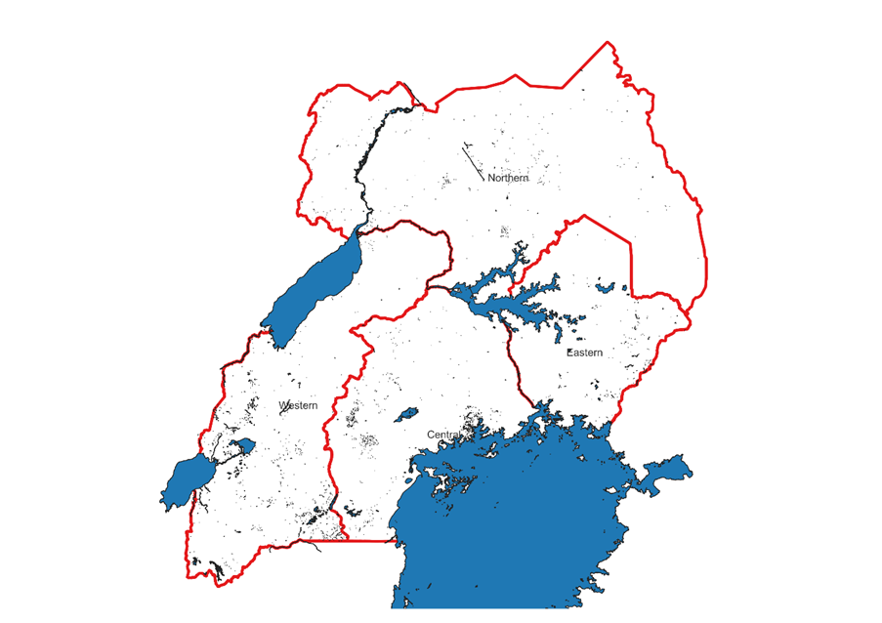
Supplementary Figure S1. Administrative boundaries of Uganda, showing the four regions (Central, Eastern, Northern, and Western) used for stratified analysis.
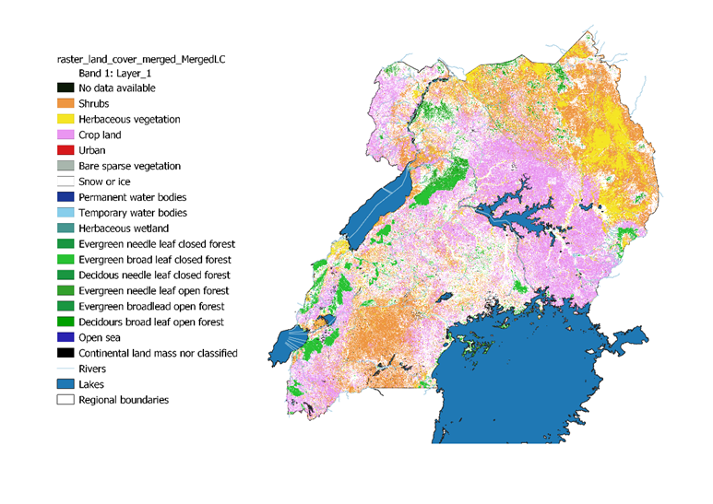
Supplementary Figure S2. Land cover classification of Uganda (100 m resolution) from the Copernicus Global Land Service.
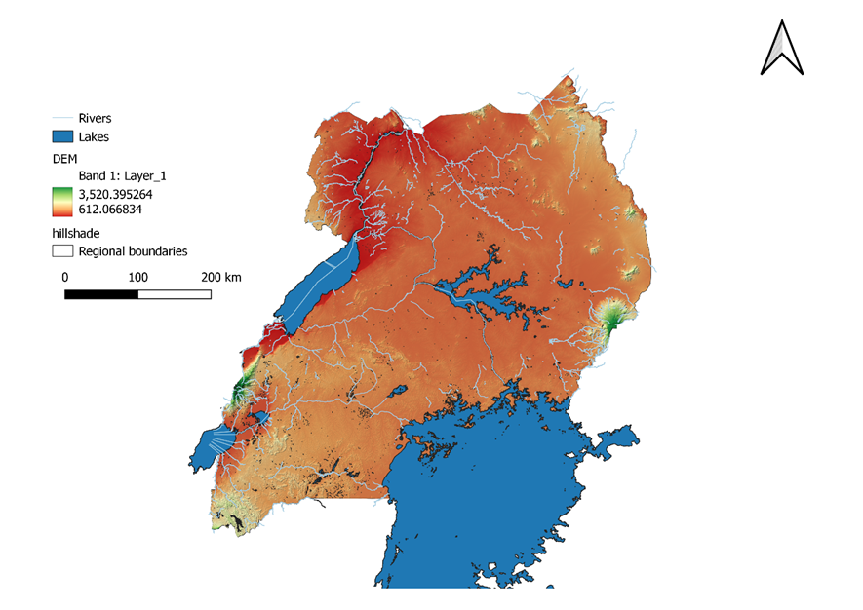
Supplementary Figure S3. Digital Elevation Model (DEM) of Uganda from the Shuttle Radar Topography Mission (SRTM), resampled to 100 m resolution.
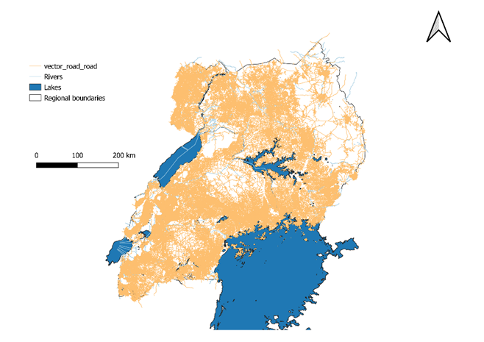
Supplementary Figure S4. Road network of Uganda extracted from OpenStreetMap (2024 build), including trunk, primary, secondary, tertiary, and minor roads.
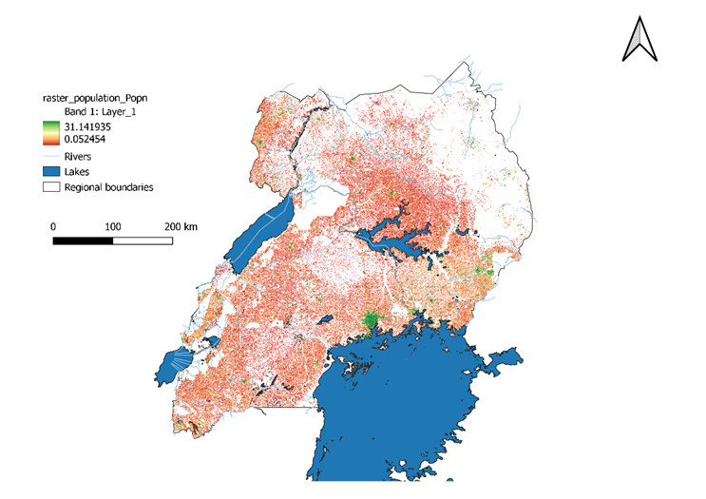

Supplementary Figure S5. Population distribution of Uganda (WorldPop 2020 constrained dataset), displayed at 100 m resolution.

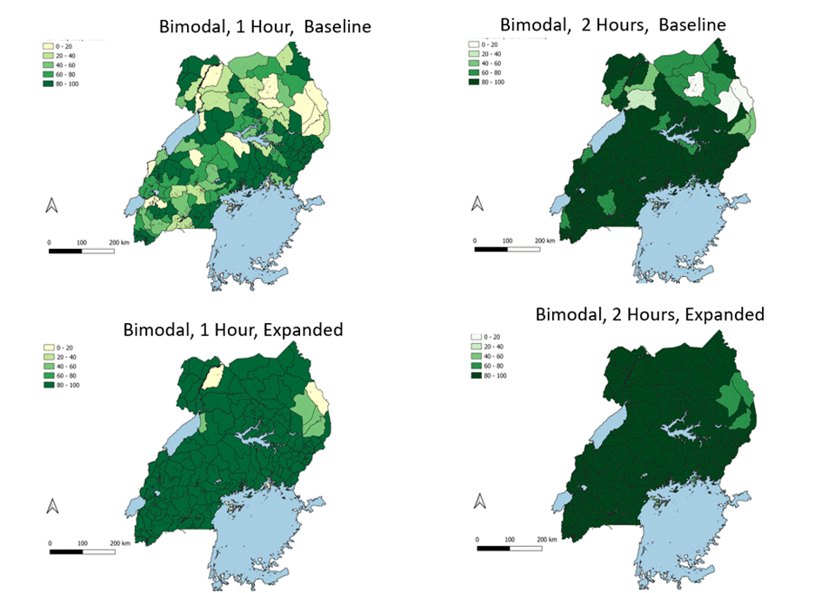
Figure S6: A visual representation of the bimodal model, looking at % Population coverage within 1 hours and 2 hours, with (expanded scenario) and without Health Center IVs (only main hospitals) included

