Supplementary Information

A Coating Strategy for Coevolving Photocatalysis to Stabilise Visible-Light Absorbing Semiconductors
Tianshuo Zhao,^{1,2} Rito Yanagi,^{1,2} Yijie Xu,¹ Yulian He,^{1,2} Yuqi Song,¹ Meiqi Yang,^{1,2} Shu Hu^{1,2*}

1. Department of Chemical and Environmental Engineering, Yale University, New Haven, CT 06520, USA
2. Energy Sciences Institute, Yale University, 810 West Campus Drive, West Haven, CT 06516, USA

* E-mail: shu.hu@yale.edu

Contents
Supplementary Notes
Supplementary Note 1. Stability of the CdS photocatalytic panel.
Supplementary Note 2. Measurement of band energetics for reductive and oxidative sites of the CdS and GaInP₂ photocatalytic panel
Supplementary Note 3. Parameters of the CdS/TiO₂/Rh@CrO_{x} photocatalysts used in semiconductor physics modelling
Supplementary Note 4. Carrier diffusion length of the CdS particle
Supplementary Note 5. Regeneration of sulphide/polysulphide redox couples
Supplementary Figures
Supplementary Fig. S1. Stability measurement apparatus.
Supplementary Fig. S2. X-ray photoelectron spectra (XPS) of the CdS panel before and after the stability test.
Supplementary Fig. S3. Scanning electron microscopy (SEM) images of the CdS panel after the stability test.
Supplementary Fig. S4. Time courses of H₂ evolution from the CdS/TiO₂/Rh@CrO_{x} panel in the [Fe(CN)6]^{3−/4−} aqueous solution.
Supplementary Fig. S5. Local energetics of the TiO₂-coated CdS and GaInP₂.
Supplementary Fig. S6. Band diagram of TiO₂-coated CdS and GaInP₂ under the flat-band condition.
Supplementary Fig. S7. Band diagrams of the HER and SOR surface sites constructed based on the band energetic measurements.
Supplementary Fig. S8. OCP measurements of TiO₂-coated CdS particle-assembled electrodes with Rh loading but without the CrO_{x} shell.
Supplementary Fig. S9. Selectivity of the CdS/TiO₂/Rh@CrO_{x} photocatalytic panel.
Supplementary Fig. S10. Geometry of the CdS/TiO₂/Rh@CrO_{x} powder.
Supplementary Fig. S11. AFM topography of a CdS/TiO₂/Rh panel.
Supplementary Fig. S12. Simulation results of a CdS/3-nm TiO₂/Rh@CrO_{x} particle under 1-sun illumination.
Supplementary Fig. S13. Rates of H₂ evolution from the CdS/TiO₂/Rh@CrO_{x} photocatalytic panel with different TiO₂ thicknesses.
Supplementary Fig. S14. Simulation results of a CdS/10-nm TiO₂/Rh@CrO_{x} particle under 1-sun illumination.
Supplementary Fig. S15. UV-Vis absorption spectrum of the CdS/TiO₂/Rh@CrO_{x} photocatalytic panel.
Supplementary Fig. S16. H₂ evolution rates and AQY of the CdS panels with an increasing number of stacking.
Supplementary Fig. S17. QY simulation of the CdS photocatalysts.
Supplementary Fig. S18. The photovoltaic-driven electrolysis for sulphide/polysulphide regeneration.
Supplementary Tables
Supplementary Table S1. Energetic parameters and corresponding characterisation methods.
Supplementary Table S2. Material parameters used in the simulation.
Supplementary Table S3. Performance of visible-light absorbing photocatalysts for unassisted water splitting or H₂ production.
Supplementary References

Supplementary Notes
Note 1. Stability of the CdS photocatalytic panel
The apparatus for stability measurements are shown in Supplementary Fig. S1. The CdS particulate photocatalytic panel, submerged in 10 mL of 50 mM Na₂S solutions (pH 13), performed hydrogen evolution reaction (HER) in a photoreactor under 1-sun illumination. One portal of the photoreactor acted as the gas outlet and was fed into a centrifuge tube, which was initially filled with DI water and held upside-down. The other portals on the photoreactor allowed injection of Na₂S solutions (50 mM) and extraction of the reacted redox solution after every 8 – 9 hours without unsealing the system. The volume of produced H₂ gas over time was recorded as the volume of displaced water in the tube.
The XPS measurements (Fig. S2) showed that the Rh:Cr elemental ratio increased from 1:12 to 1:0.7 after the 150-h stability testing, suggesting a decrease of the CrO_{x} shell coverage. Since the penetration depth of the X-ray in the measurement is ~3 nm, the Cr signal was predominant when the Rh was surrounded by a CrO_{x} shell of thickness around 2 nm. After the 150-h operation, the CrO_{x} shell became thinner, or a shell was lifted off entirely, such that more Rh was exposed under the X-ray, yielding significantly higher Rh signals. The CrO_{x} shell is critical to establish the barrier-height difference for charge separation (Fig. 2). The decreased activity is probably due to the loss of the CrO_{x} shell, which should be restored by redepositing the CrO_{x} shells on Rh cocatalysts in a K₂CrO₄(aq) solution.
Note 2. Measurement of band energetics for reductive and oxidative sites of the CdS and GaInP₂ photocatalytic panel
(i) CdS panels
The band energetics of two surface sites were obtained through light-intensity dependent OCP measurements and Mott-Schottky (M-S) analysis of CdS particle-assembled electrodes and GaInP₂ photoelectrodes (see Methods). For the CdS/TiO₂ electrode, the M-S plot was obtained through electrochemical impedance measurements in a Fe(CN)₆^{3−/4−} redox solution in the dark (Fig. S5b). The flat-band potential ($E_{FB}$) and electron carrier concentration (N_{D}) of CdS thus can be extrapolated as – 0.60 V vs. Ag/AgCl and $1.3×{10}^{12} {cm}^{-3}$, respectively. According to ${ΔE=E}_{C}-E_{FB}=-kTln(N_{D}/N_{C})$, where k is the Boltzmann constant, T is temperature, E_{C} is the conduction band (CB) edge, and N_{C} is the CB effective density of states, the E_{FB} is 0.38 V below the CB edge. The position of the $E_{FB}$ is consistent with the XPS valence band spectrum (Fig. S6a). The band diagram in the flat-band condition (Fig. S6b) was constructed based on the electrochemical data of TiO₂-coated CdS and the literature values of Ti³⁺-defect band, CB, and VB positions of the TiO₂.¹ The OCP of the particle-assembled electrode measured in the dark, denoted as OCP_{dark}, represented the averaged Fermi level (E_{F}) of the particles ensemble. In equilibrium with the Na₂S solution, a slight downward bending was drawn from the liquid interface to the CdS bulk (Fig. S7a). The barrier height $Φ_{B}$ of the CdS/TiO₂ interface in the S²⁻/S_{n}²⁻ redox solution was found to be 0.60 eV by $Φ_{B}=E_{F}-E_{c}$.
After loading the electrode with Rh and CrO_{x}, the OCP reached a steady-state value with increasing light intensity (OCP_{light}). Measuring OCP_{light} is another approach to estimate the flat-band potential at the CdS/TiO₂/Rh@CrO_{x} site.² The OCP_{light} was at − 0.10 V vs. RHE, consistent with the CB band edge which was independently derived from the Mott-Schottky analysis of the CdS/TiO₂ interface shown above. In other words, the CB edge position was not shifted after loading the Rh@CrO_{x}. Considering the Fermi level and the carrier concentration of the CdS, the CdS band edges were drawn to tilt upwards from the interface to the bulk (Fig. S7b). Therefore, an electric field from the SOR site to the HER site should exist when combining the two surface sites (Fig. 3b). Both the CdS CB edge and the vacuum level dropped by 0.49 V from a SOR site to a neighbouring HER site.
(ii) GaInP₂ panels
Following the same characterisation methods for CdS, we found asymmetry in local barrier heights of the GaInP₂ as well, i.e. small barrier height at the cocatalyst site and large barrier height at the bare TiO₂ site. The $E_{FB}$ and N_{D} of the GaInP₂ were determined to be – 0.30 V vs. RHE and $1.0×{10}^{17} {cm}^{-3}$ from the M-S analysis (Fig. S5d). The N_{D} calculated from the M-S plot is consistent with the specifications provided by the vendor. Therefore, the E_{C} of the GaInP₂ was found to be 0.04 eV above the E_{FB}. Fig. S6c and Fig. S7c show the band diagram of the TiO₂-coated GaInP₂ under the flat-band and equilibrium condition, respectively. The OCP_{dark} of the electrode was measured as 0.38 eV vs. RHE, giving rise to an electron-transfer barrier height $Φ_{B}$ of 0.68 V. After the Rh@CrO_{x} deposition, the $Φ_{B}$ was reduced to 0.14 V (Fig. S5c). The band alignment and barrier energetics for the HER site of GaInP₂ are drawn in Fig. S7d.

Note 3. Parameters of the CdS/TiO₂/Rh@CrO_{x} photocatalysts used in semiconductor physics modelling
The topography of the CdS/TiO₂/Rh panel shown in Supplementary Fig. S11 indicated that the size of every individual Rh site was 10 – 20 nm, and that the CrO_{x} shells likely enclosed multiple smaller Rh sites to form a single Rh/CrO_{x} HER site of 100 nm (Fig. S10b). We thus model the individual HER active site to be a 100-nm Rh/CrO_{x} disc. It reasonably represented the encapsulated and discrete Rh sites of 10 – 20 nm sizes, which should exhibit the same barrier energetics as the Rh/CrO_{x} site in our modelling.
The length scale of the Rh sites is 10 – 100 nm mostly, such that their local barrier heights are not influenced by CdS/TiO₂ surroundings. The sizes of Rh sites are not too small to be influenced, or “pinched-off”, by the surrounding high barrier-height CdS/TiO₂/redox liquid interfaces.^{3–5}
Transmission electron microscopy (TEM) with energy-dispersive X-ray spectroscopy (EDS) characterised the elemental composition of CdS/TiO₂/Rh@CrO_{x} particles (Fig. S10c – 10d). The EDS spectra confirm the presence of Ti, Rh, and Cr elements on the CdS. The mapping of Rh and Cr signals showed spatial overlap, indicating the formation of Rh@CrO_{x} core-shell structures.

Note 4. Carrier diffusion length of the CdS particle
Based on the measured carrier lifetime of 0.1 ns, the carrier diffusion length was estimated to be ~ 20 nm from $L=\sqrt{\frac{kT}{q}∙μ∙τ}$, where k is the Boltzmann constant, T is temperature, $μ$ is the carrier mobility, and $τ$ is lifetime. The short diffusion length alone does not justify the 44.3% conversion efficiency of the absorbed photons in a 1-μm thick CdS powder film. It rather suggested that the charge collection occurred mostly within the region under a built-in electric field, which further supported our proposed charge separation by barrier-height asymmetry.

Note 5. Regeneration of sulphide/polysulphide redox couples
As shown in Supplementary Fig. S18a, the two compartments of the PVE device conducted polysulphide reduction and oxygen evolution reaction (OER), respectively. The sulphide/polysulphide (S²⁻/S_{n}²⁻) redox solution was circulated between the photoreactor and the cathodic chamber by a peristaltic pump. Pt on carbon cloth (The Fuel Cell Store) was used as the cathode. On the anodic side, IrO_{x} nanoparticles deposited carbon paper was pressed against the cation exchange membrane (CEM) for the oxidation of pure water (see Methods). The CEM limited crossover of gas and redox molecules between the two compartments. When a triple-junction (3-J) amorphous silicon (a-Si) solar cell was used to power the device, protons generated during OER transported from the anolyte to the catholyte through the CEM; and the electrons transferred from the anode to the cathode for polysulphide reduction through the external circuit.
As part of the reactor stability evaluation, three repeating cycles of redox regeneration processes were performed. The PVE device operated under a potential of −1.4 V and a current of ca. −1 mA (Supplementary Fig. S18b). After ~ 6 h of operation, a total charge of 22.2 C was passed through the anode, evolving O₂ and regenerating the S²⁻/S_{n}²⁻ redox couple. The regenerated redox solution showed a negligible absorption feature for the polysulphide (Supplementary Fig. S18c). It also showed the same redox potential as that of the original Na₂S solution (Supplementary Fig. S18d). Both observations supported that the S_{n}²⁻ species have been effectively and completely reduced to S²⁻.

Supplementary Figures
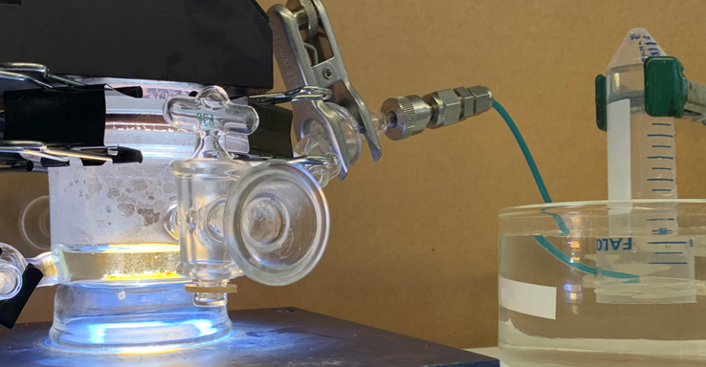
Supplementary Fig. S1. Stability measurement apparatus. Photo of the photocatalyst stability measurement apparatus, including the photoreactor (left) and the H₂-collecting tube (right).
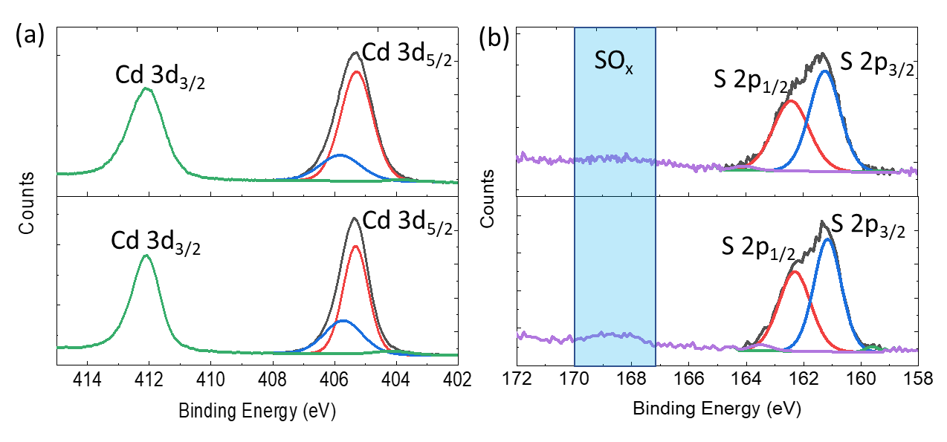
Supplementary Fig. S2. X-ray photoelectron spectra (XPS) of the CdS panel before and after the stability test. (a) Cd 3d and (b) S 2p core-level spectra for the CdS/TiO₂/Rh@CrO_{x} photocatalytic panel before (bottom) and after (top) the 150-h stability test. The CdS particulate panel was coated by 3-nm TiO₂ and decorated by Rh@CrO_{x} core@shell cocatalysts.

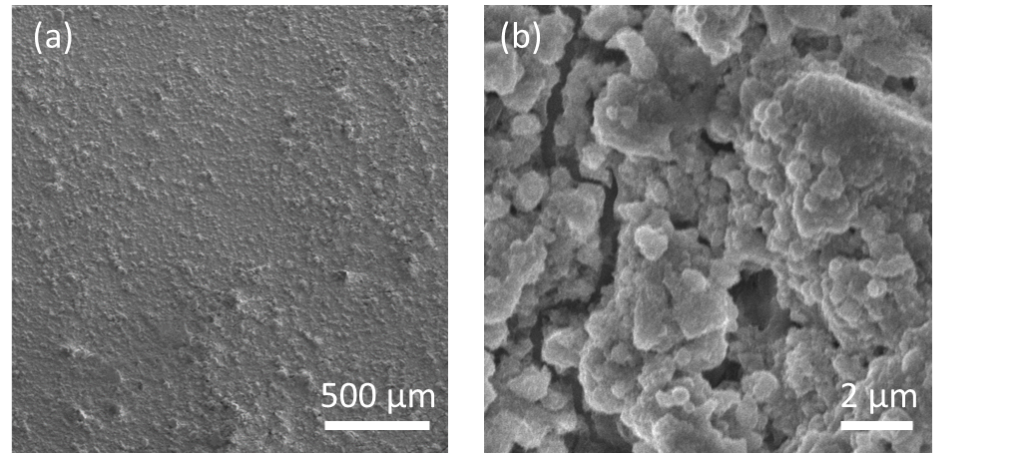
Supplementary Fig. S3. Scanning electron microscopy (SEM) images of the CdS panel after the stability test. (a) Low and (b) high magnification scanning SEM images of the CdS/TiO₂/Rh@CrO_{x} particulate panel after the 150-h stability test.
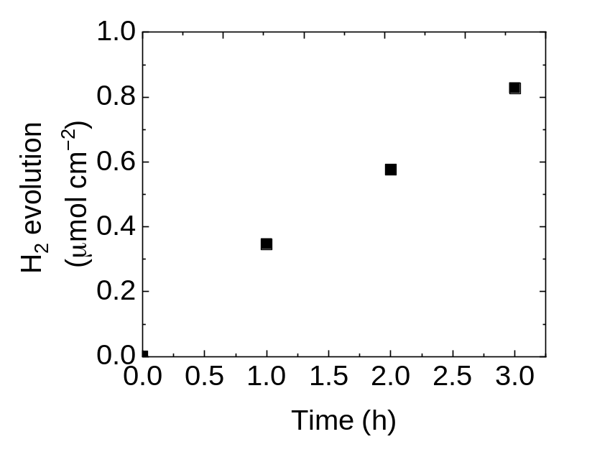
Supplementary Fig. S4. Time courses of H₂ evolution from the CdS/TiO₂/Rh@CrO_{x} panel in the [Fe(CN)₆]^{3−/4−} aqueous solution (50 mM K₄Fe(CN)₆ in DI water).
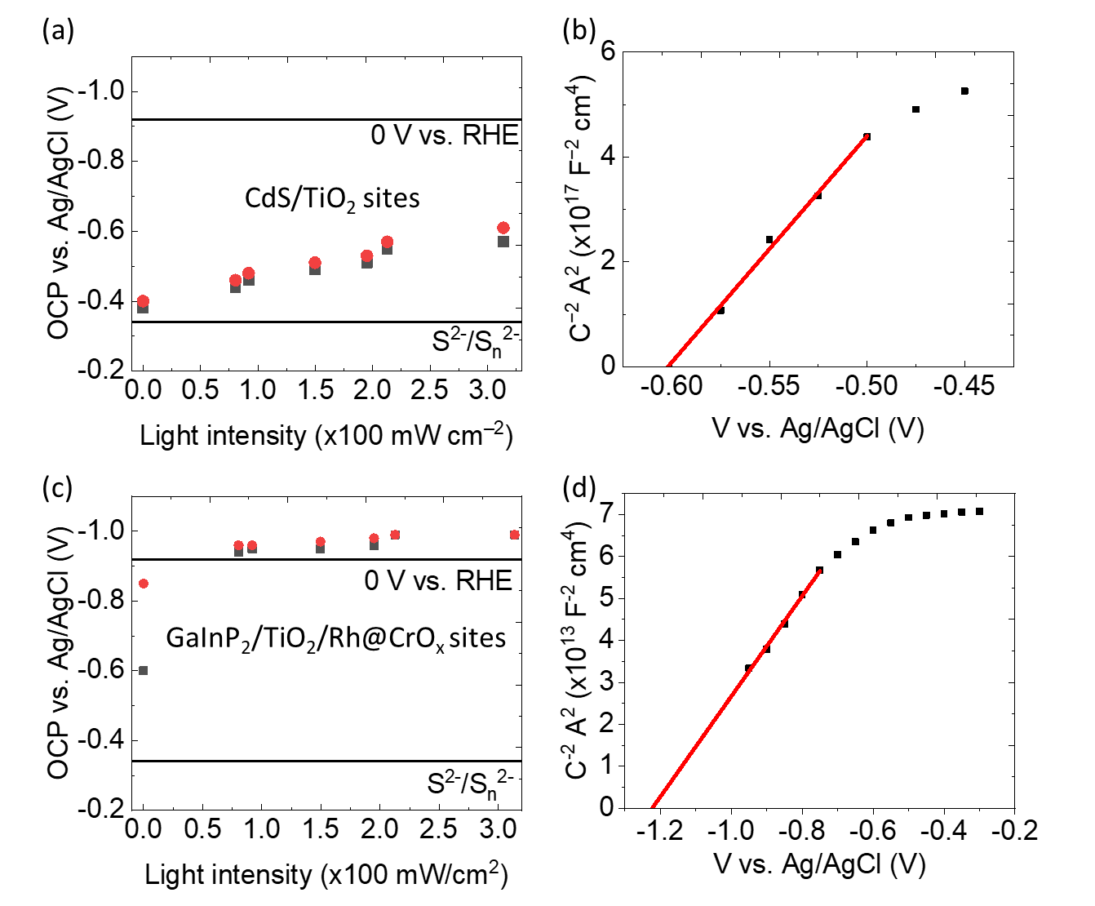
Supplementary Fig. S5. Local energetics of the TiO₂-coated CdS and GaInP₂. (a) Light intensity-dependent OCPs and (b) Mott-Schottky (M-S) plot of the CdS/TiO₂ particle-assembled photoelectrode. (c) Light intensity-dependent OCPs and (d) M-S plot of the GaInP₂/TiO₂/Rh@CrO_{x} photoelectrode. The OCP measurements of (a) and (c) were conducted in a 10 mM Na₂S aqueous solution without (black dots) and with (red dots) H₂ purging. The OCP measured at 0 mW cm⁻² represents the dark condition, denoted as OCP_{dark}. The impedance measurements of (b) and (d) were performed in a [Fe(CN)₆]^{3−/4−} solution at pH=12.

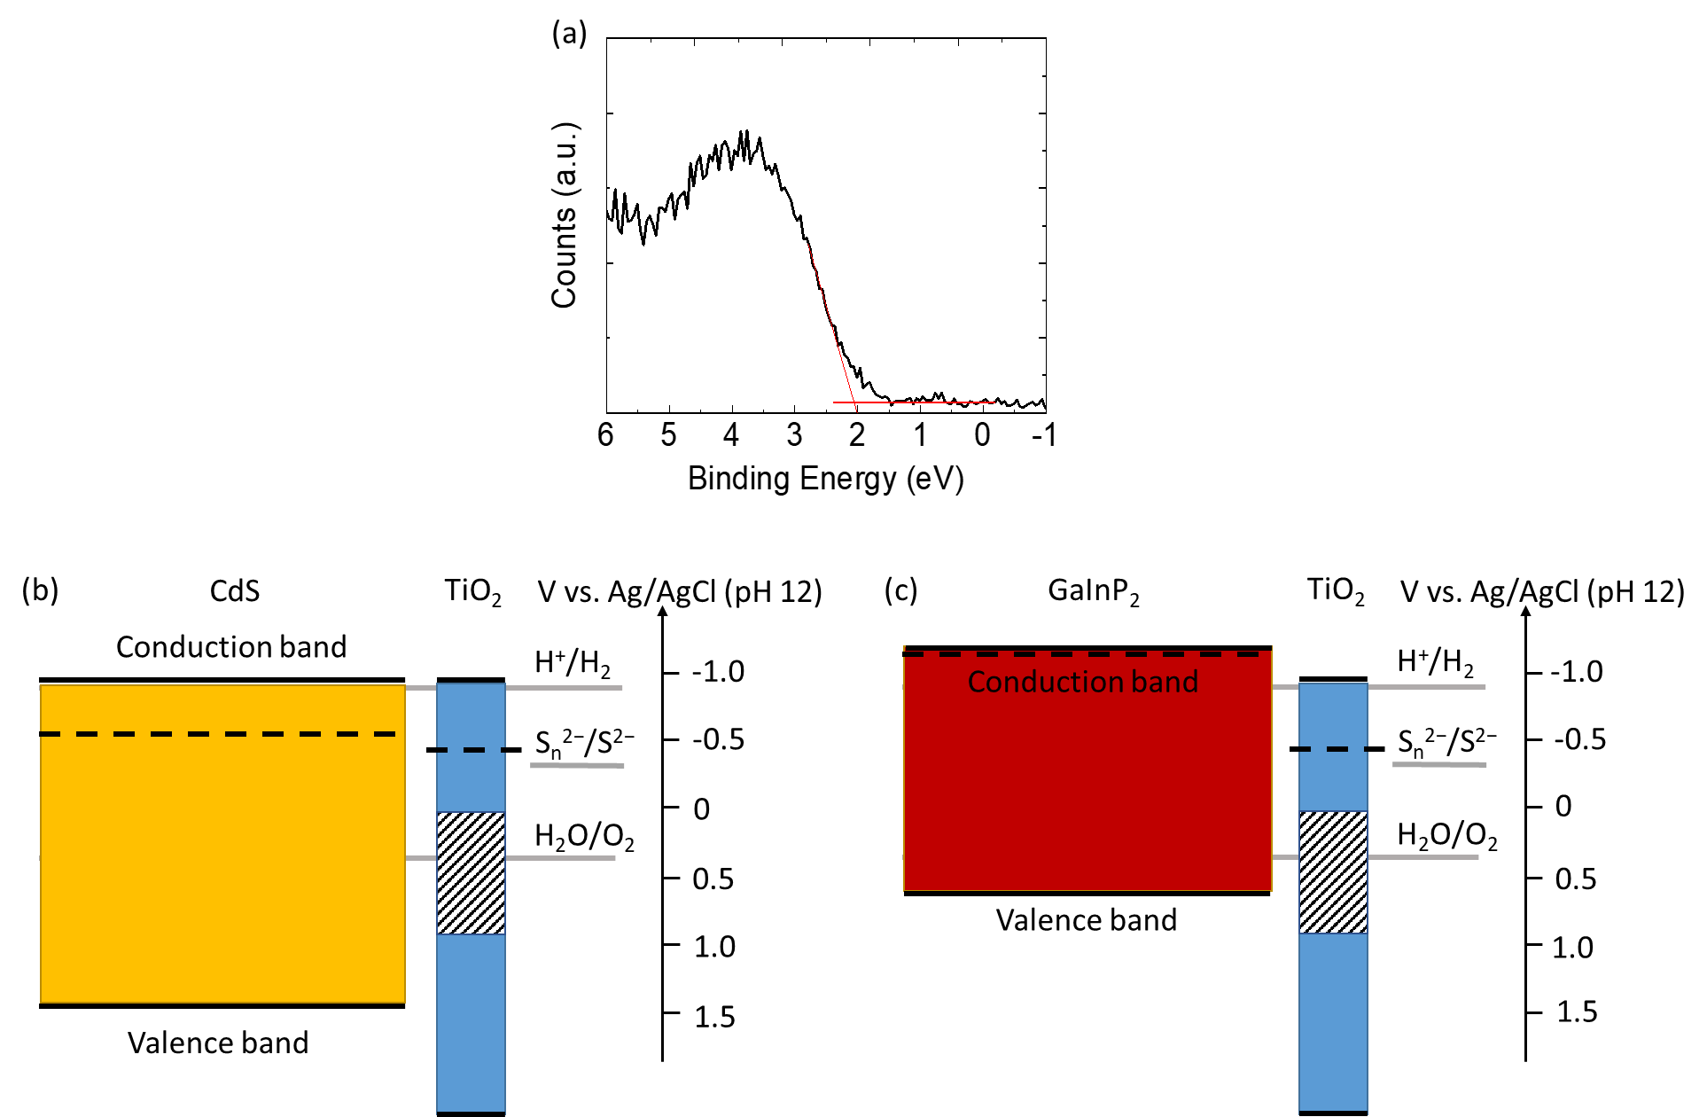
Supplementary Fig. S6. Band diagram of TiO₂-coated CdS and GaInP₂ under the flat-band condition. (a) Valence band XPS spectrum of CdS powders. Band diagram of (b) TiO₂-coated CdS and (c) TiO₂-coated GaInP₂ and TiO₂ under flat-band conditions at pH=12.
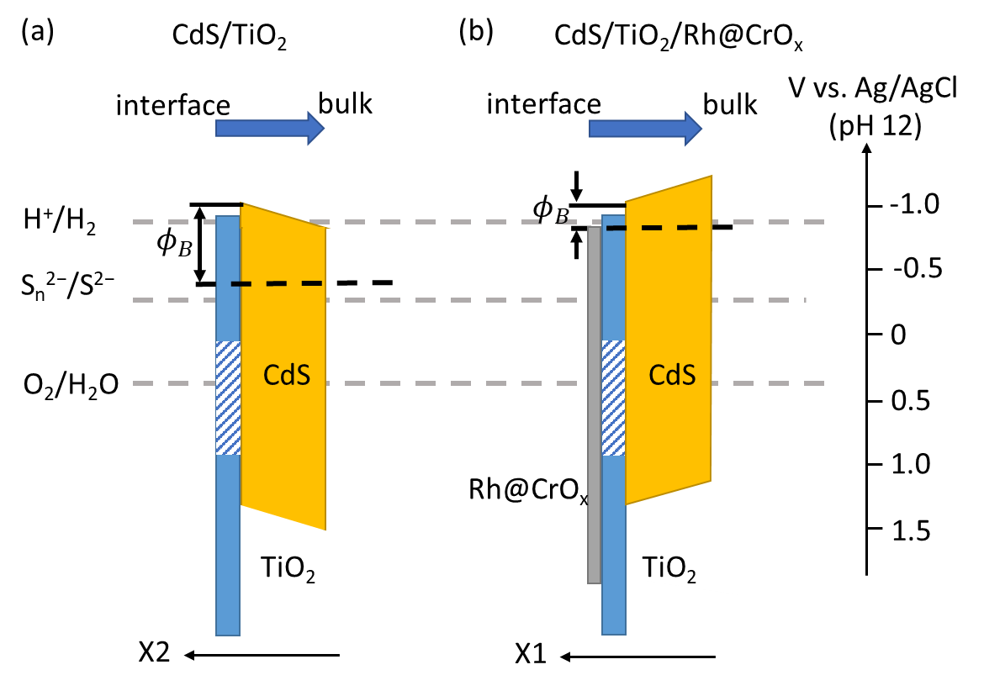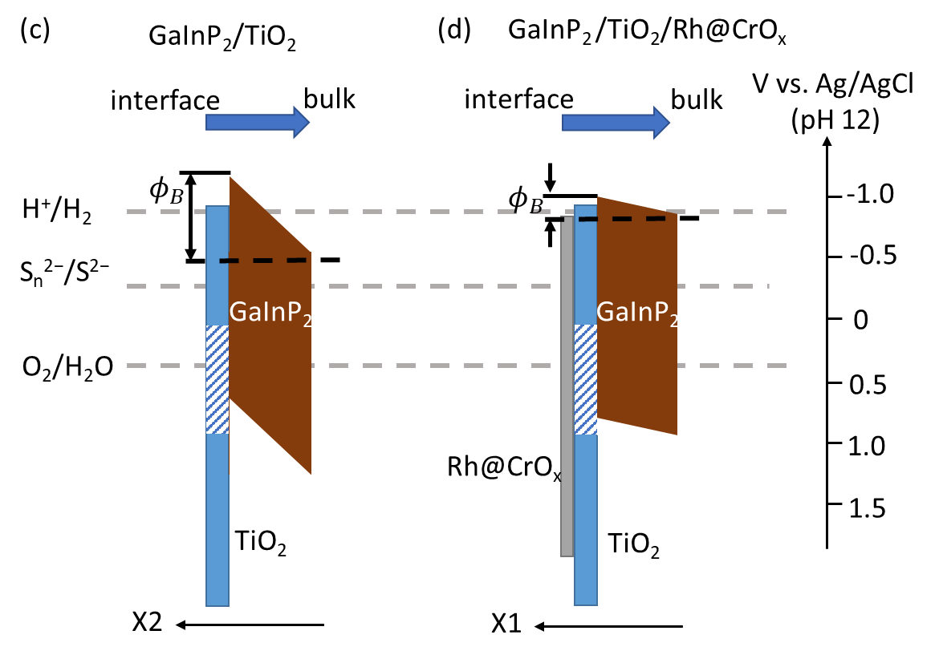
Supplementary Fig. S7. Band diagrams of the HER and SOR surface sites constructed based on the band energetic measurements. Band diagrams of (a) CdS/TiO₂, (b) CdS/TiO₂/Rh@CrO_{x}, (c) GaInP₂/TiO₂, and (d) GaInP₂/TiO₂/Rh@CrO_{x} when in equilibrium with a Na₂S solution in the dark. $ϕ_{B}$ indicates the barrier height of electron transfer at the liquid interface. X1 and X2 axes represent the radial direction from the bulk of CdS to the HER and SOR sites, respectively. The shaded region in the TiO₂ band diagram indicates a Ti³⁺-defect band for hole charge transport.

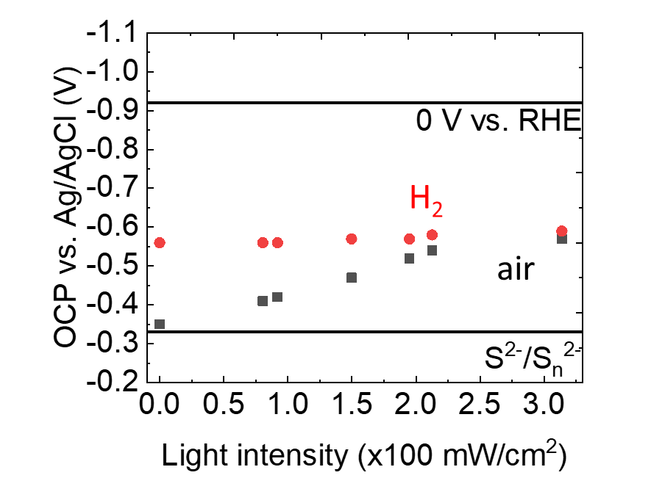
Supplementary Fig. S8. OCP measurements of TiO₂-coated CdS particle-assembled electrodes with Rh loading but without the CrO_{x} shell. Light intensity-dependent OCPs measured in 10 mM Na₂S solutions without (black dots) and with (red dots) H₂ purging. The OCP measured at 0 mW cm⁻² represents the dark condition.

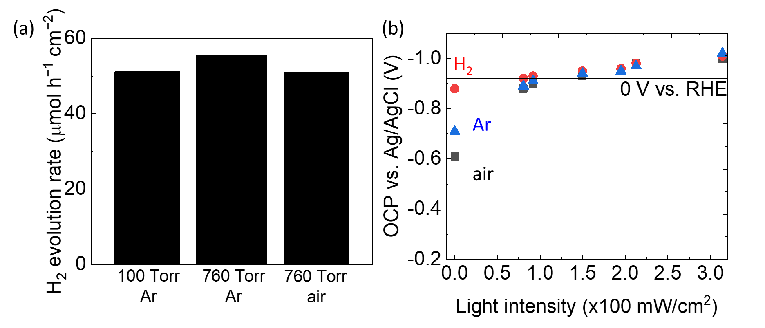
Supplementary Fig. S9. Selectivity of the CdS/TiO₂/Rh@CrO_{x} photocatalytic panel. (a) H₂ evolution rates under different base pressures and gas environments in 100 mM Na₂S solutions. (b) Light-intensity dependent OCPs of the CdS/TiO₂/Rh@CrO_{x} particle-based electrodes in air (black dots), under Ar (blue dots), and under H₂ (red dots) purging of 10 mM Na₂S solutions. 0 mW cm⁻² of light intensity represents the dark condition.

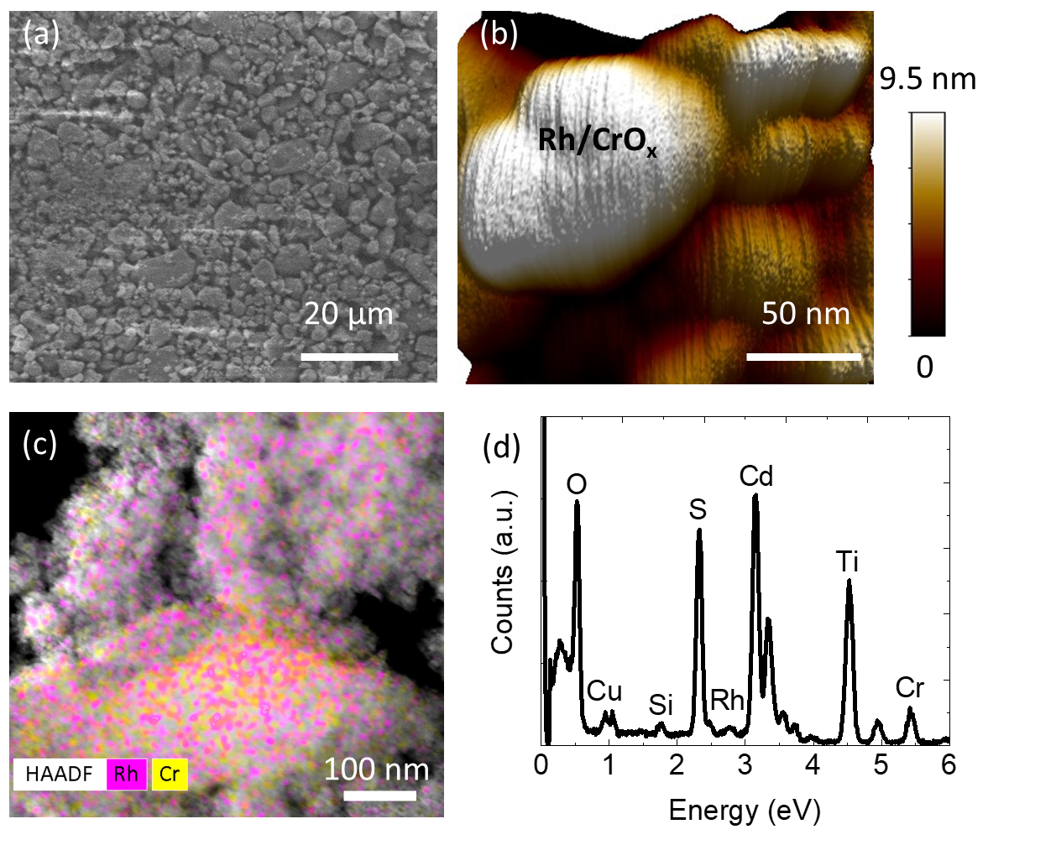
Supplementary Fig. S10. Geometry of the CdS/TiO₂/Rh@CrO_{x} powder. (a) SEM and (b) AFM characterisations for the morphology of TiO₂-coated CdS and the nanoscale topography of Rh@CrO_{x} cocatalysts, respectively. (c) High-angle annular dark-field (HAADF) transmission electron microscopy (TEM) image, which is overlaid with Rh and Cr elemental mapping by energy-dispersive X-ray spectroscopy (EDS), and (d) EDS spectrum of CdS/TiO₂/Rh@CrO_{x} powders of the same region as (c).
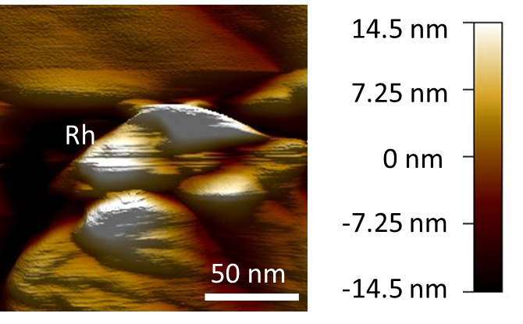
Supplementary Fig. S11. AFM topography of a CdS/TiO₂/Rh panel.

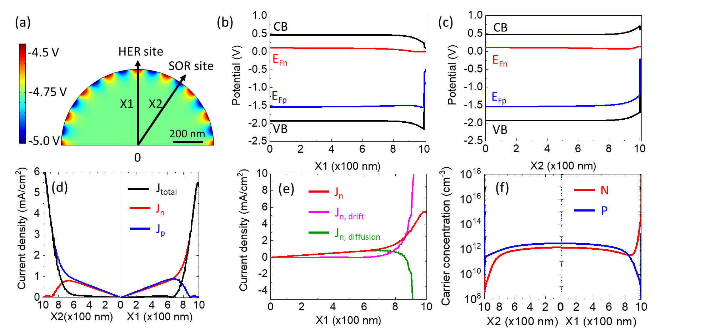
Supplementary Fig. S12. Simulation results of a CdS/3-nm TiO₂/Rh@CrO_{x} particle under 1-sun illumination. (a) Simulated CB edge positions with two axes pointing to the HER and SOR sites, denoted as X1 and X2, respectively, and simulated band diagrams along the (b) X1 and (c) X2 axes. The conduction band (CB) and valence band (VB) edges (black), and electron (E_{Fn}, red) and hole (E_{Fp}, blue) quasi-Fermi levels are labelled. (d) Electron (J_{n}, red), hole (J_{p}, blue), and total current density (J_{total}, black) profiles plotted along the X1 and X2 axes. (e) Electron drift current density (J_{n, drift}, purple), electron diffusion current density (J_{n, diffusion}, green), and total electron current density (J_{n,} red) profiles plotted along the X1 axis. (f) Electron (N, red) and hole (P, blue) concentration profiles plotted along the X1 and X2 axes.

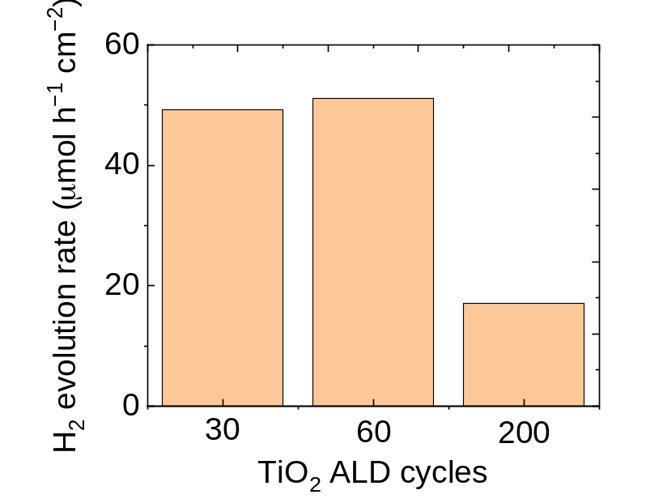
Supplementary Fig. S13. Rates of H₂ evolution from the CdS/TiO₂/Rh@CrO_{x} photocatalytic panel with different TiO₂ thicknesses. The rates were measured in 100 mM Na₂S solutions for the 30, 60, and 200 cycles of ALD TiO₂, which correspond to 1.5 nm, 3 nm, and 10 nm thickness, respectively.

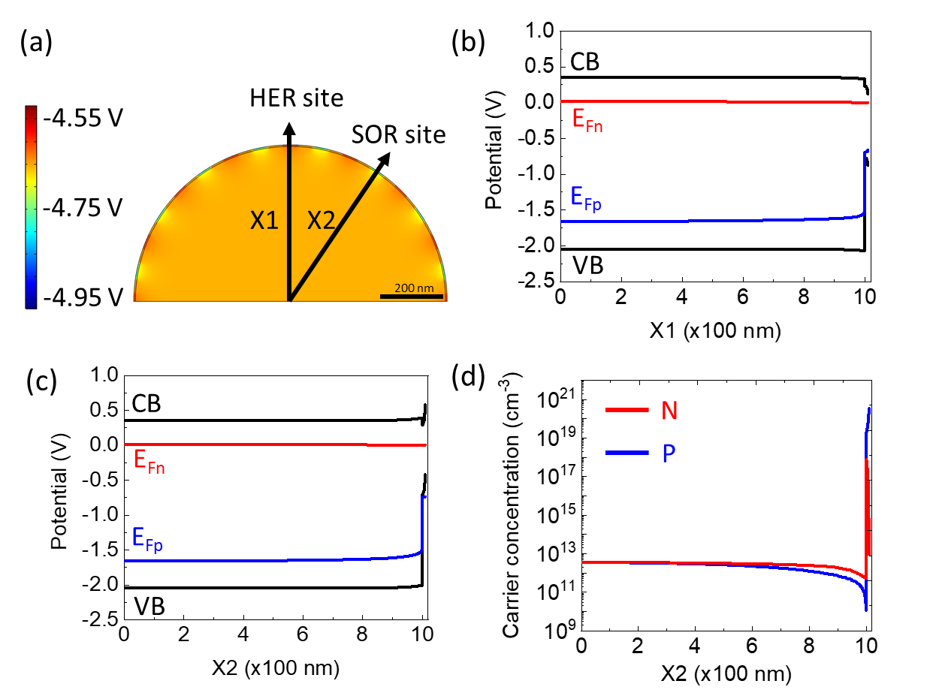
Supplementary Fig. S14. Simulation results of a CdS/10-nm TiO₂/Rh@CrO_{x} particle under 1-sun illumination. (a) Simulated CB edge positions with two axes pointing to the HER and SOR sites, denoted as X1 and X2, respectively, and simulated band diagrams along the (b) X1 and (c) X2 axes. The conduction band (CB) and valence band (VB) edges (black), and electron (E_{Fn}, red) and hole (E_{Fp}, blue) quasi-Fermi levels are labelled. (d) Electron (N, red) and hole (P, blue) concentration profiles plotted along the X2 axis.

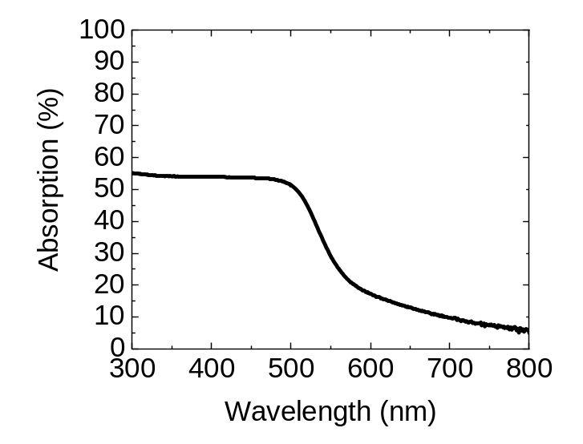
Supplementary Fig. S15. UV-Vis absorption spectrum of the CdS/TiO₂/Rh@CrO_{x} photocatalytic panel. Absorption (%) = 100% – reflection (%) – transmission (%), where reflection and transmission of the panel were measured by using diffused reflectance spectroscopy (DRS).

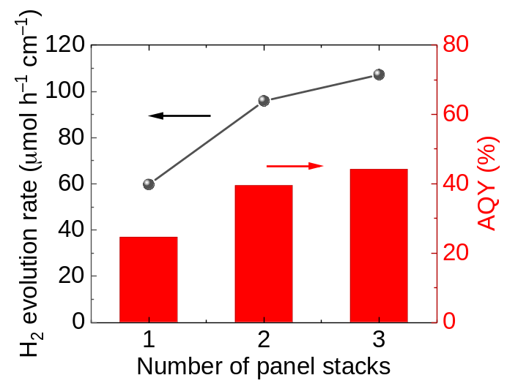
Supplementary Fig. S16. H₂ evolution rates and AQY of the CdS panels with an increasing number of stacking.

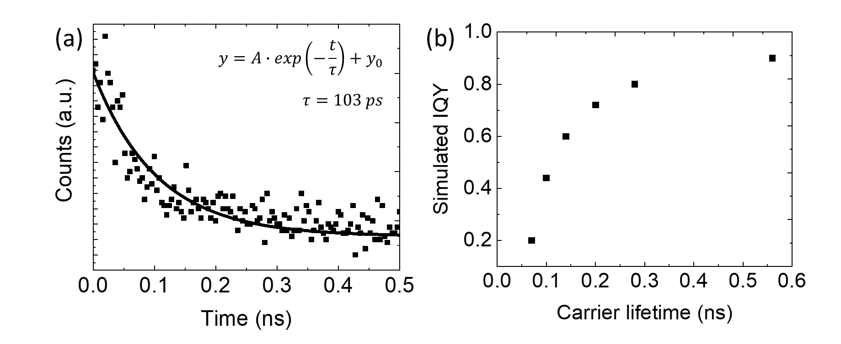
Supplementary Fig. S17. QY simulation of CdS photocatalysts. (a) Time-resolved photoluminescence (TRPL) spectrum of the commercial CdS powders. A single exponential decay model with $y=A∙\exp\left(-\frac{t}{τ}\right)+y_{0}$ (solid line) was used to fit the PL spectrum and to obtain a carrier lifetime of $τ=103 ps$. (b) Simulated IQY as a function of CdS carrier lifetime.

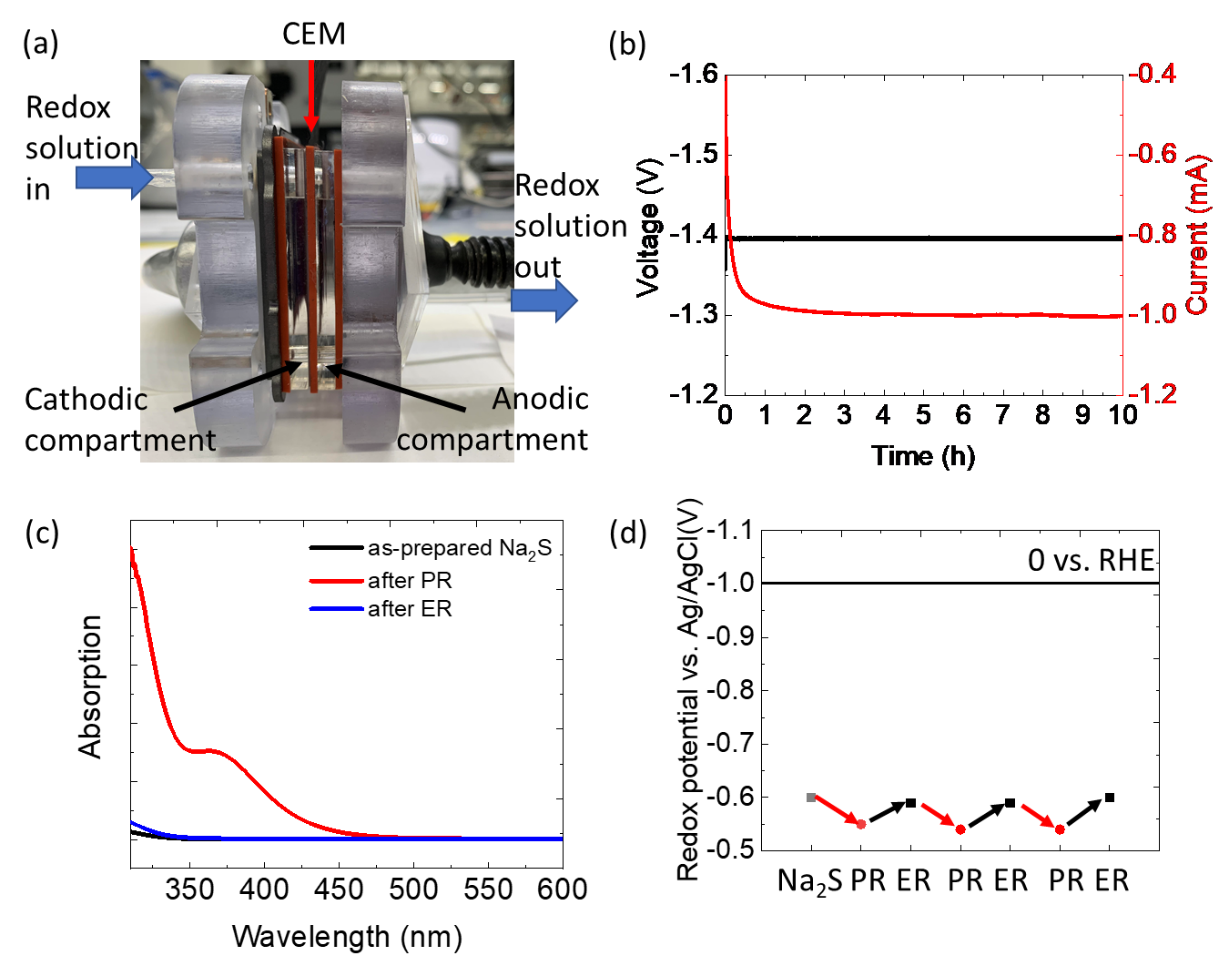
Supplementary Fig. S18. The photovoltaic-driven electrolysis for sulphide/ polysulphide regeneration. (a) Picture of the membrane-electrode assembly for the photovoltaic-electrolysis (PVE) process. (b) Applied bias and current by the solar cell across the PVE device during the redox regeneration. (c) UV-Vis absorption spectra of the as-prepared Na₂S solution (black), after photoreactions (PR, red) and after regeneration (ER, blue). (d) Solution redox potentials vs. an Ag/AgCl reference electrode, characterised by the open-circuit potentials of a Pt wire in the solution, for the as-prepared 100 mM Na₂S solution (grey dot), and the solutions after photoreaction (PR, red dots) and after regeneration (ER, black dots).

Table S1. Energetic parameters and corresponding characterisation methods
Energetic parameters | Characterisation method | CdS/TiO₂/ redox | CdS/TiO₂/Rh@CrO_{x} | GaInP₂/TiO₂/ redox | GaInP₂/TiO₂/Rh@CrO_{x}
Fermi level (E_{F}) in equilibrium with Na₂S in the dark | Steady-state OCP in the dark | E_{F}= − 0.38 V  vs. Ag/AgCl | E_{F}= − 0.89 V  vs. Ag/AgCl | E_{F}= − 0.54 V  vs. Ag/AgCl | E_{F}= − 0.85 V  vs. Ag/AgCl
Flat-band potential | Mott-Schottky plot | E_{FB}= − 0.60 V  vs. Ag/AgCl |  | E_{FB}= − 1.22 V  vs. Ag/AgCl
 | Light intensity-dependent OCP |  | E_{FB}= − 1.00 V  vs. Ag/AgCl |  | E_{FB}= − 0.99 V  vs. Ag/AgCl
Carrier concentration (N_{D}) in the semiconductor bulk | Mott-Schottky plot | N_{D}  =$1.3×{10}^{12} {cm}^{-3}$ | N_{D}  =$1.3×{10}^{12} {cm}^{-3}$ | N_{D}  =$1.0×{10}^{17} {cm}^{-3}$ | N_{D}  =$1.0×{10}^{17} {cm}^{-3}$
Fermi level position relative to the CB edge in the bulk | $${ΔE=E}_{C}-E_{FB} \\ =-kTln(N_{D}/N_{C})$$ | − 0.38 V | − 0.38 V | − 0.04 V | − 0.04 V
Conduction band edge position | $E_{C}={ΔE+E}_{FB}$ (dark)  $E_{C}=E_{FB}$ (light) | − 0.98 V  vs. Ag/AgCl | − 1.00 V  vs. Ag/AgCl | − 1.26 V  vs. Ag/AgCl | − 0.99 V  vs. Ag/AgCl
Barrier height for electron transfer under illumination | $$ϕ_{B}=E_{F}-E_{C}$$ | 0.60 V | 0.11 V | 0.68 V | 0.14 V

Table S2. Material parameters used in the simulation
Material parameters | CdS | TiO₂^{1,6}
Thickness | 1 μm in radius | 3 nm
HER site size | NA | 100 nm
OER site size | NA | 100 nm
Relative permittivity | 12.5 | 112
Bandgap (eV) | 2.4 | 1.0ª
Electron affinity (eV) | 4.3 | 4.4
Conduction band effective density of states, N_{C} (cm⁻³) | 2.4x10¹⁸ | 1x10²²
Valence band effective density of states, N_{V} (cm⁻³) | 1.5x10¹⁹ | 1x10¹⁹
Electron mobility (cm² V⁻¹ s⁻¹) | 10 ⁷ | $$1×{10}^{-4}$$
Hole mobility (cm² V⁻¹ s⁻¹) | 5 | $$1×{10}^{-4}$$
Electron concentration (cm⁻³) | 1.3x10¹² | 1.0x10¹⁶
Surface recombination velocity, electrons (cm s⁻¹) ^{b} | NA | 1
Surface recombination velocity, holes (cm s⁻¹) ^{b} | NA | 1
ª The TiO₂ bandgap of 1.0 eV indicates energy difference between the conduction band edge and the upper edge of the Ti³⁺-defect band, which defines the hole-transfer energy level;
^{b} The kinetics of electron injection and hole injection are modelled by the respective surface recombination velocity.
Table S3. Performance of visible-light absorbing photocatalysts for unassisted water splitting or H₂ production
Photocatalysts | Redox mediator | Stability  hours | H₂ evolution rate | AQY%  (wavelength) | STH% | H₂:O₂  molar ratio | Ref
photosystem II  -CdS hybrid cell | quinone/hydroquinone and ferricyanide/ferrocyanide | 1.5 | 11.2 μmol⁻¹ h⁻¹ cm⁻²  = 0.6 mA cm⁻² | 25  (420 nm) | 0.34% | 2:1 | 8
CdS nanorods | None | 2 | 4.5 mmol⁻¹ h⁻¹ g⁻¹ | 4.9  (460 nm) | NA | 30:1 | 9
Y₂Ti₂O₅S₂ | None | >20 | 0.013 mmol⁻¹h⁻¹g⁻¹ | 0.4  (450 nm) | 0.007% | 2:1 | 10
Ta₃N₅ | None | >15 | 0.023 mmol⁻¹h⁻¹g⁻¹ | 0.22  (420 nm) | 0.014% | ~2:1 | 11
CdS/TiO₂/Rh@CrO_{x} | S_{n}²⁻/S²⁻ | 150 | 40.8 mmol⁻¹ h⁻¹ g⁻¹  = 90.6 μmol⁻¹ h⁻¹ cm⁻²  = 4.9 mA cm⁻² | 44.2  (438 nm) | 5.9% | 2:1 | This work
GaInP₂/TiO₂/Rh@CrO_{x} | S_{n}²⁻/S²⁻ |  | 144.7 μmol h⁻¹ cm⁻²  = 7.8 mA cm⁻² |  | 9.4% | 2:1 | This work

Supplementary References
1. Nunez, P. et al. Characterization of electronic transport through amorphous TiO₂ produced by atomic layer deposition. J. Phys. Chem. C 123, 20116–20129 (2019).
2. Pan, Z. et al. Mutually-dependent kinetics and energetics of photocatalyst/co-catalyst/two-redox liquid junctions. Energy Environ. Sci. 13, 162–173 (2020).
3. Rossi, R. C. & Lewis*, N. S. Investigation of the size-scaling behavior of spatially nonuniform barrier height contacts to semiconductor surfaces using ordered nanometer-scale nickel arrays on silicon electrodes. J. Phys. Chem. B 105, 12303–12318 (2001).
4. Garcia-Esparza, A. T. & Takanabe, K. A simplified theoretical guideline for overall water splitting using photocatalyst particles. J. Mater. Chem. A 4, 2894–2908 (2016).
5. Laskowski, F. A. L. et al. Nanoscale semiconductor/catalyst interfaces in photoelectrochemistry. Nat. Mater. 19, 69–76 (2020).
6. Hu, S. et al. Electrical, photoelectrochemical, and photoelectron spectroscopic investigation of the interfacial transport and energetics of amorphous TiO₂/Si heterojunctions. J. Phys. Chem. C 120, 3117–3129 (2016).
7. Walker, B. et al. Solution-processed CdS transistors with high electron mobility. RSC Adv. 4, 3153–3157 (2014).
8. Li, Z. et al. Biomimetic electron transport via multiredox shuttles from photosystem II to a photoelectrochemical cell for solar water splitting. Energy Environ. Sci. 10, 765–771 (2017).
9. Wolff, C. M. et al. All-in-one visible-light-driven water splitting by combining nanoparticulate and molecular co-catalysts on CdS nanorods. Nat. Energy 3, 862–869 (2018).
10. Wang, Q. et al. Oxysulfide photocatalyst for visible-light-driven overall water splitting. Nat. Mater. 18, 827–832 (2019).
11. Wang, Z. et al. Overall water splitting by Ta₃N₅ nanorod single crystals grown on the edges of KTaO₃ particles. Nat. Catal. 1, 756–763 (2018).

