Appendix
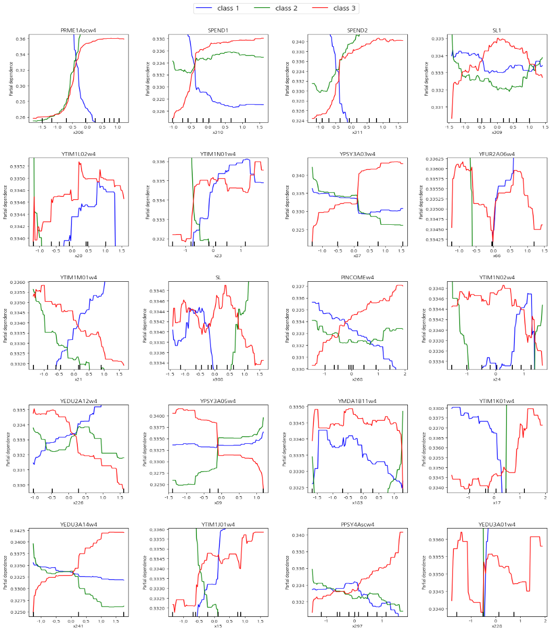
Fig 2. Partial dependence plots of the top 20 predictive factors
Note. Class1: Cognitively Engaged but Emotionally Detached Group, Class 2: Emotionally Sensitive but Socially Withdrawn Group, Class3: Holistically Competent and Well-Adjusted Group

