Supplementary information

Nicotinonitrile-Based Dual Inhibitors of Tubulin and Topoisomerase II: Design, Synthesis, and Anticancer Evaluation

Eman Samir^{1,3}, Abdalla E. A. Hassan^{1,2}, Shaikha Alneyadi⁴, Yassir S. Raouf⁴, Hanem M. Awad⁵, Zakaria K.M. Abdel-Samii³, Amany M.M. Al-Mahmoudy³, Reham A. Abou-elkhair^{1,2}.

¹Applied Nucleic Acids Research center, Zagazig University, Zagazig Egypt. ²Department of Chemistry, Faculty of Science, Zagazig University, Zagazig, Egypt. ³Department of Pharmaceutical Organic Chemistry, Faculty of Pharmacy, Zagazig University, Zagazig, Egypt. ⁴Department of Chemistry, College of Science, United Arab Emirates University, P.O. Box 15551, Al Ain, UAE. ⁵National Research Center, Tanning Materials & Proteins Department, Dokki, Giza 12622, Egypt.

NMR spectra

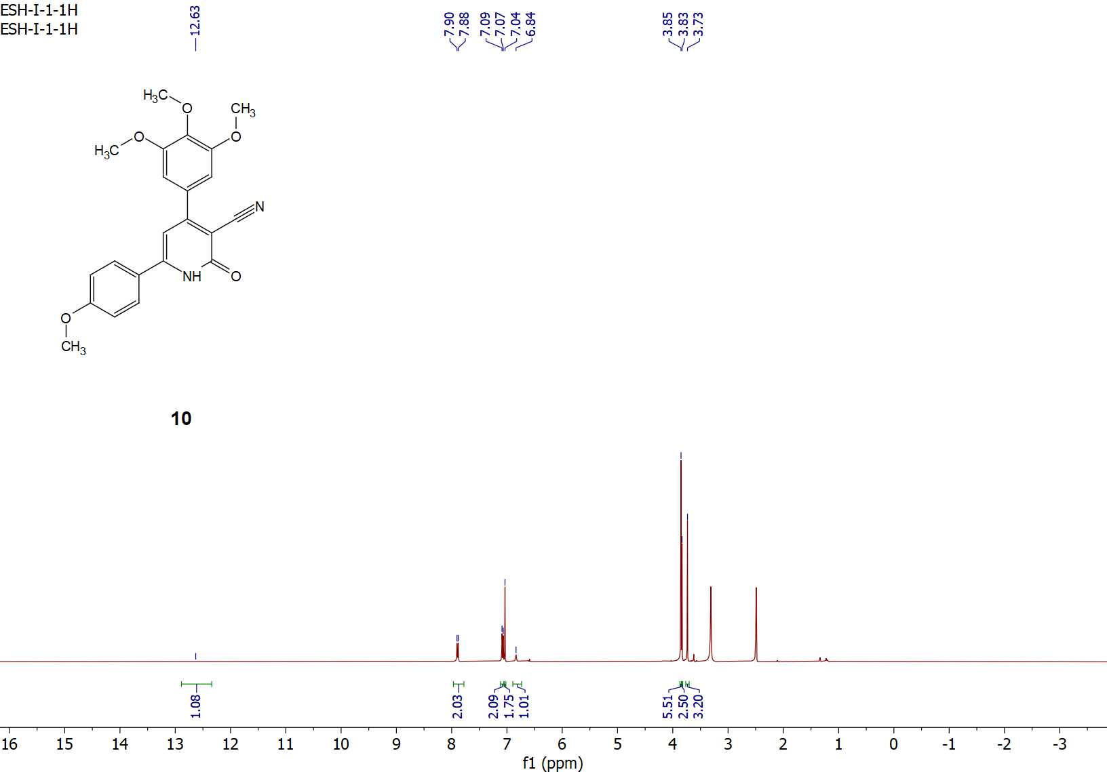
Figure S1: ¹H-NMR spectrum of compound 10.
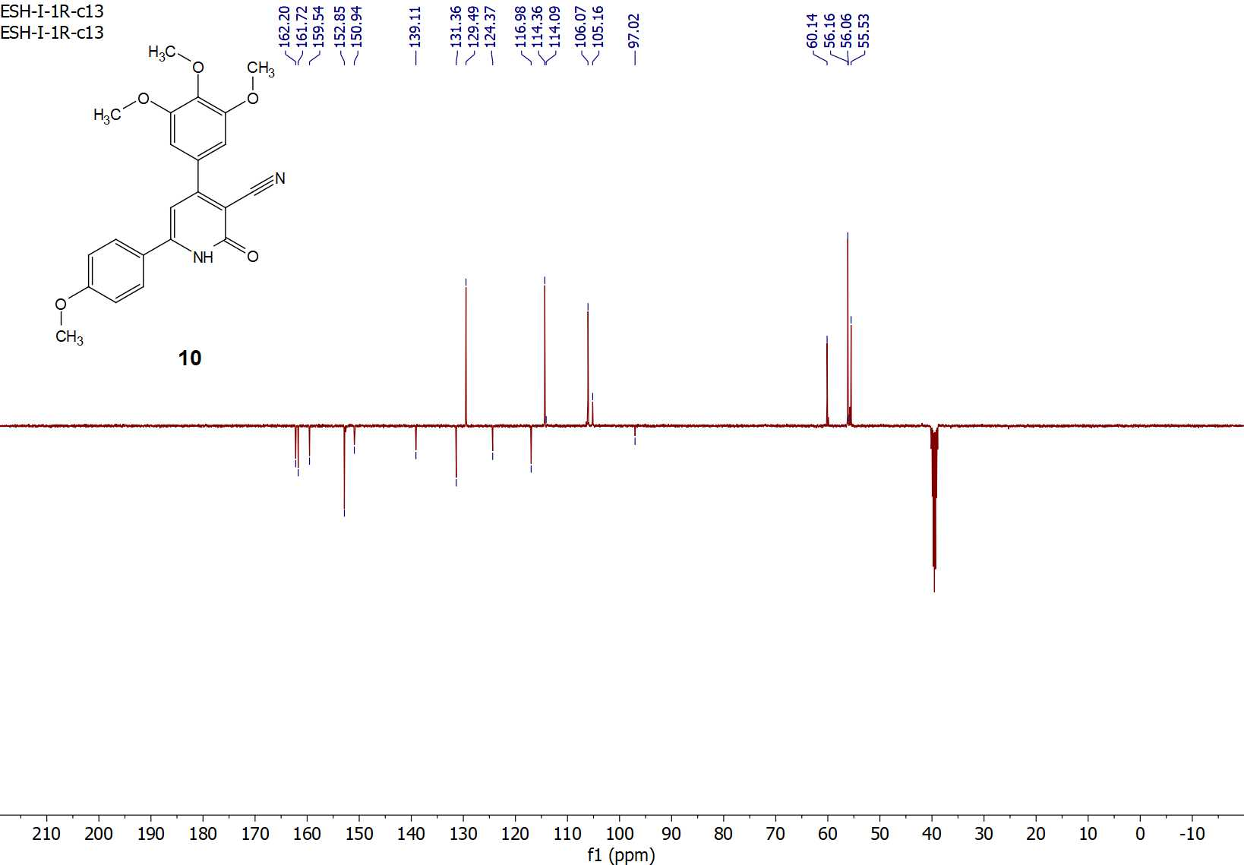
Figure S2: ¹³C-APT NMR spectrum of compound 10.

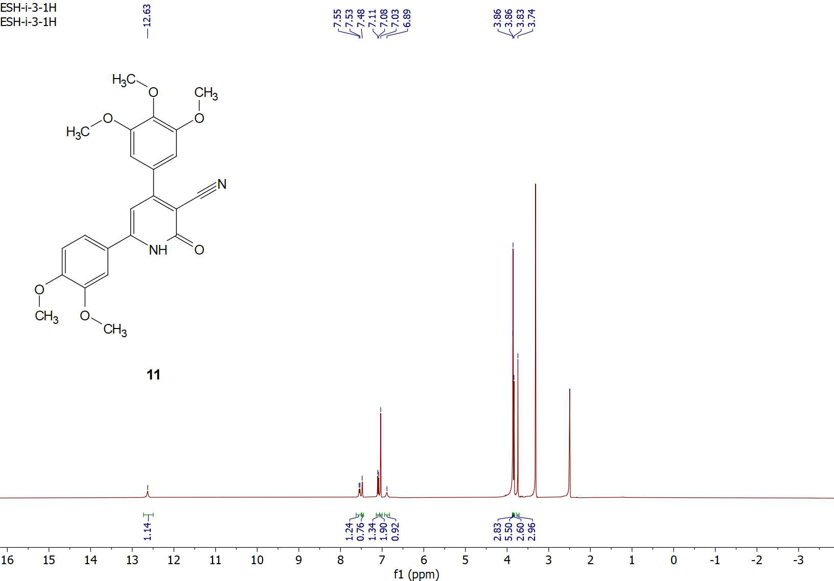
Figure S3: ¹H-NMR spectrum of compound 11.

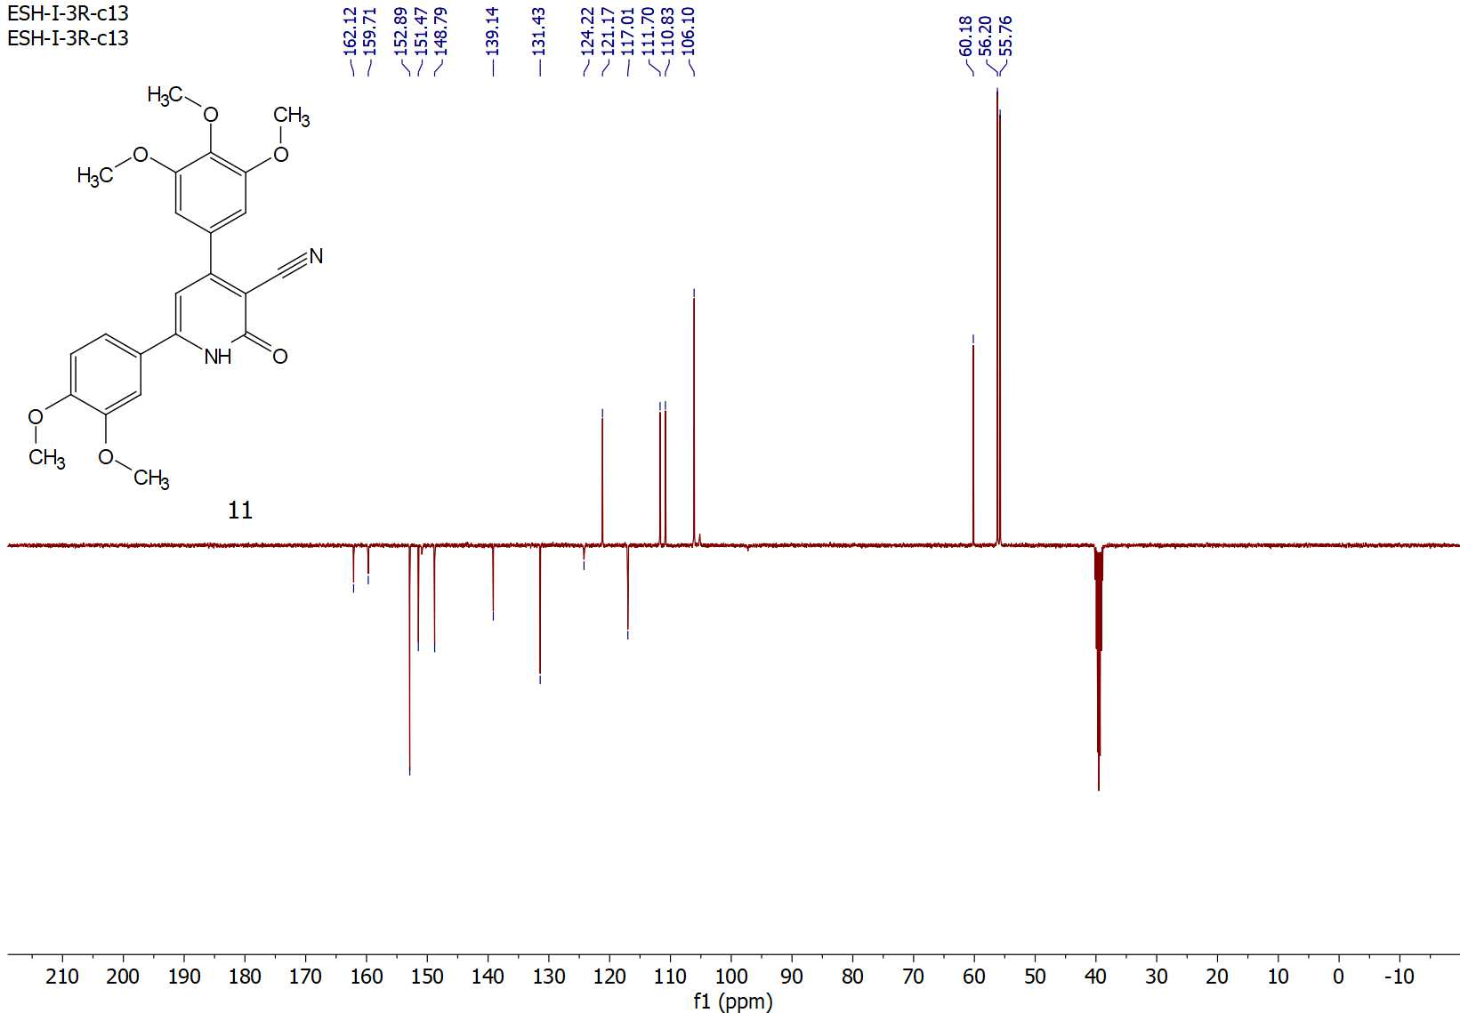
Figure S4: ¹³C-APT NMR spectrum of compound 11.

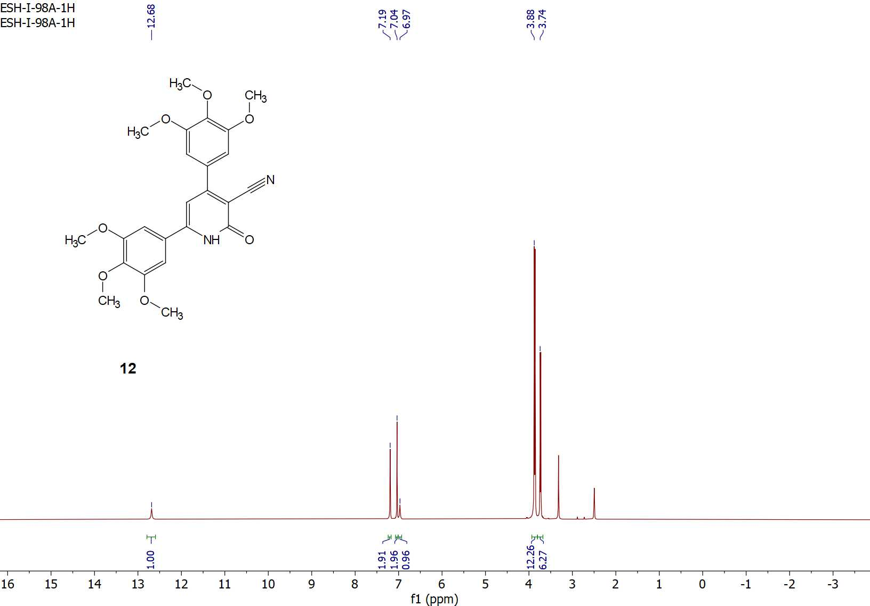
Figure S5: ¹H-NMR spectrum of compound 12.

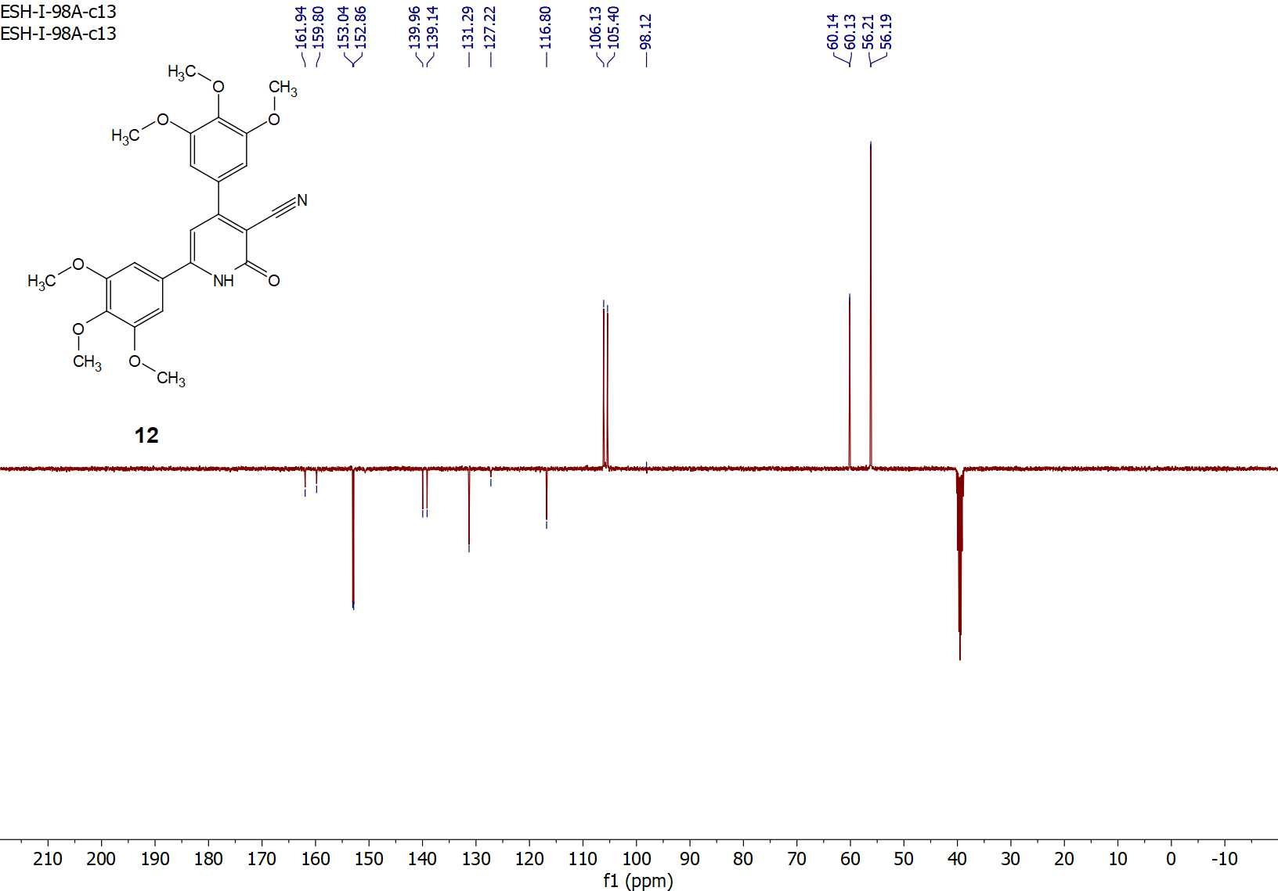
Figure S6: ¹³C-APT NMR spectrum of compound 12.

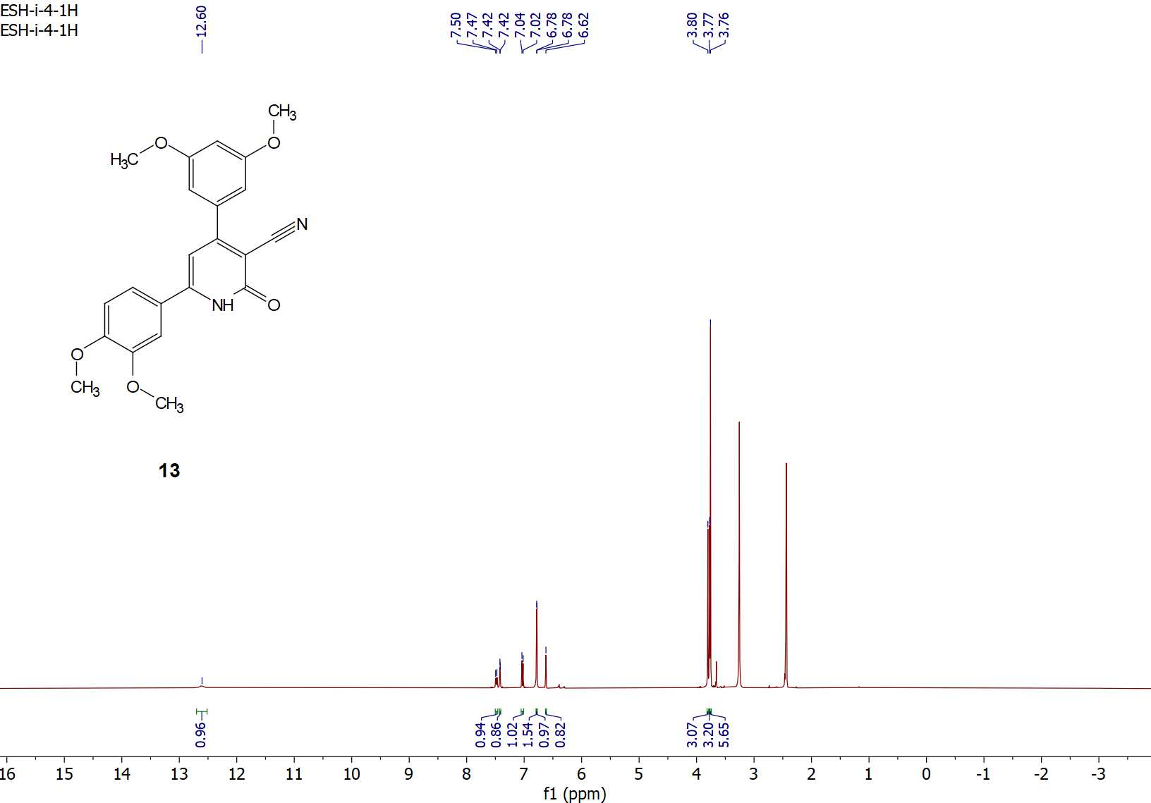
Figure S7: ¹H-NMR spectrum of compound 13.

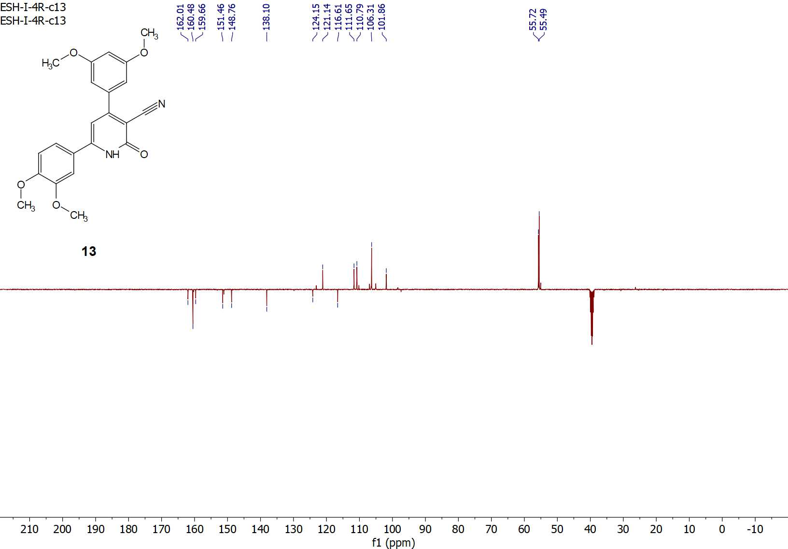
Figure S8: ¹³C-APT NMR spectrum of compound 13.
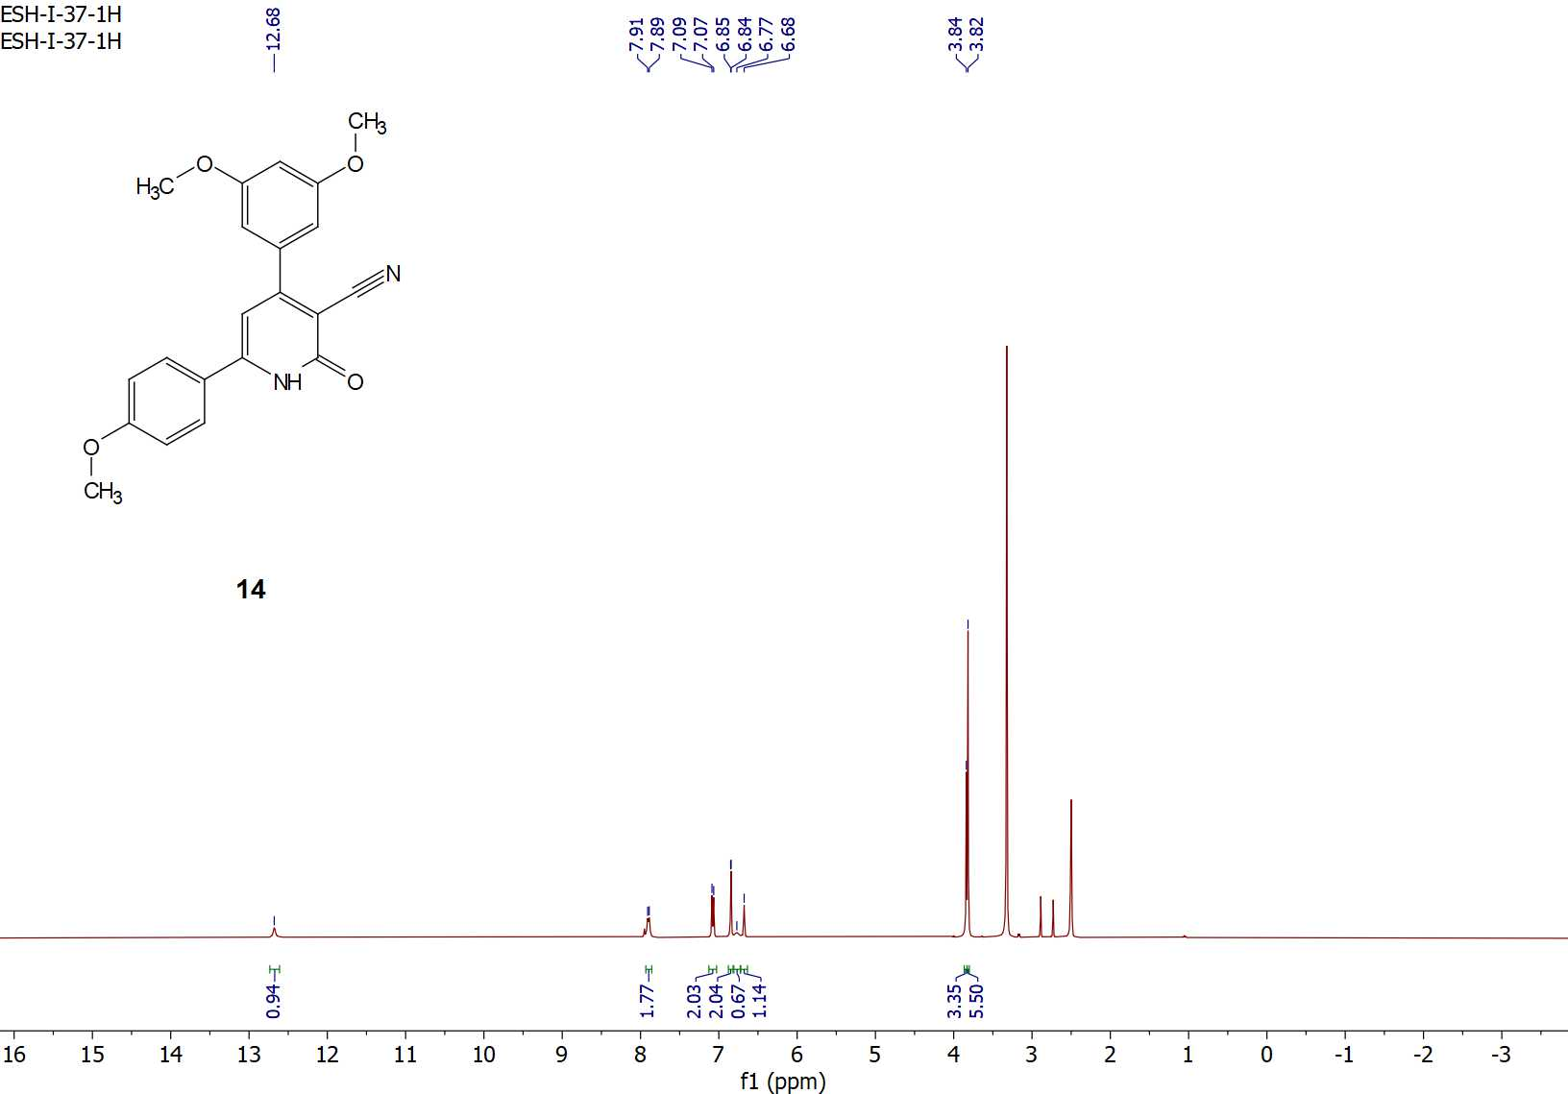
Figure S9: ¹H-NMR spectrum of compound 14.

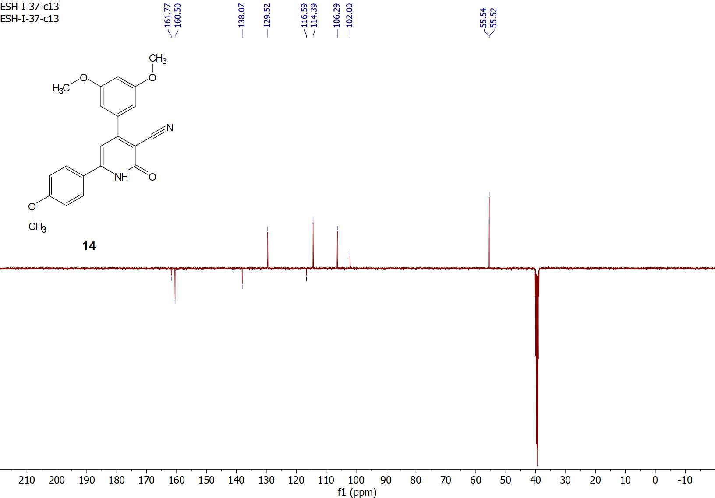
Figure S10: ¹³C-APT NMR spectrum of compound 14.

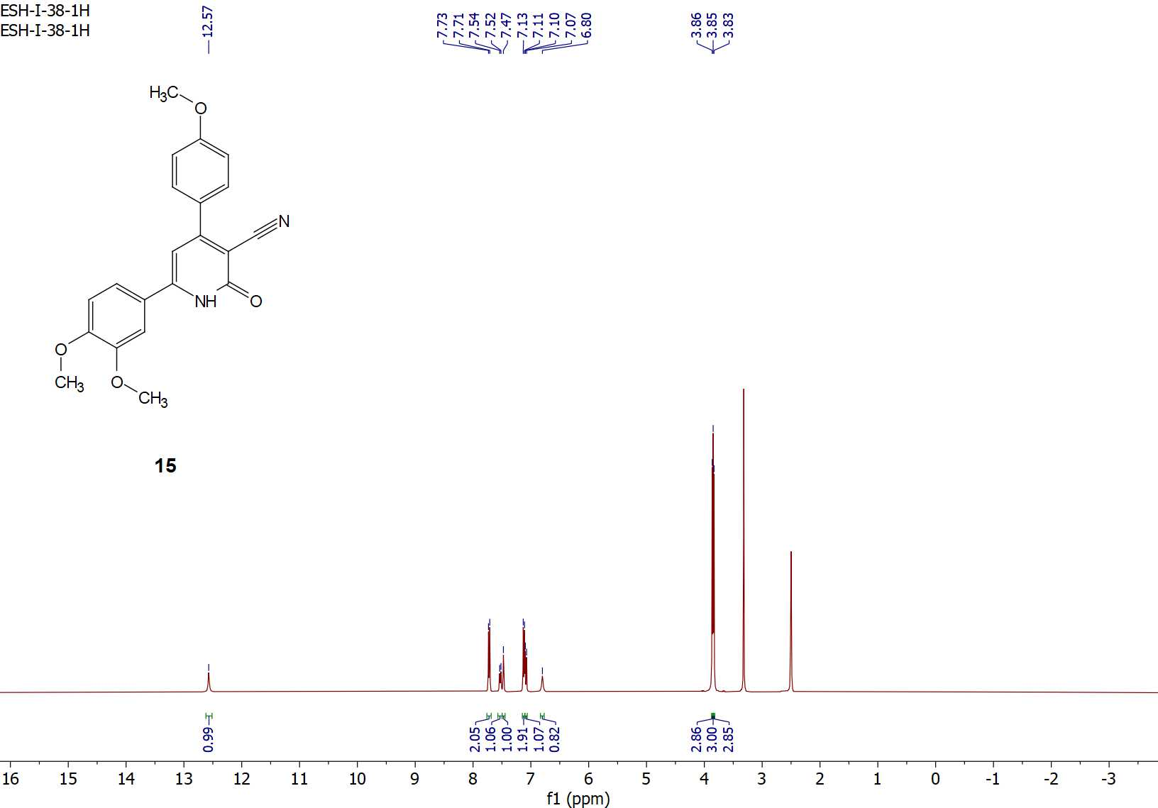
Figure S11: ¹H-NMR spectrum of compound 15.

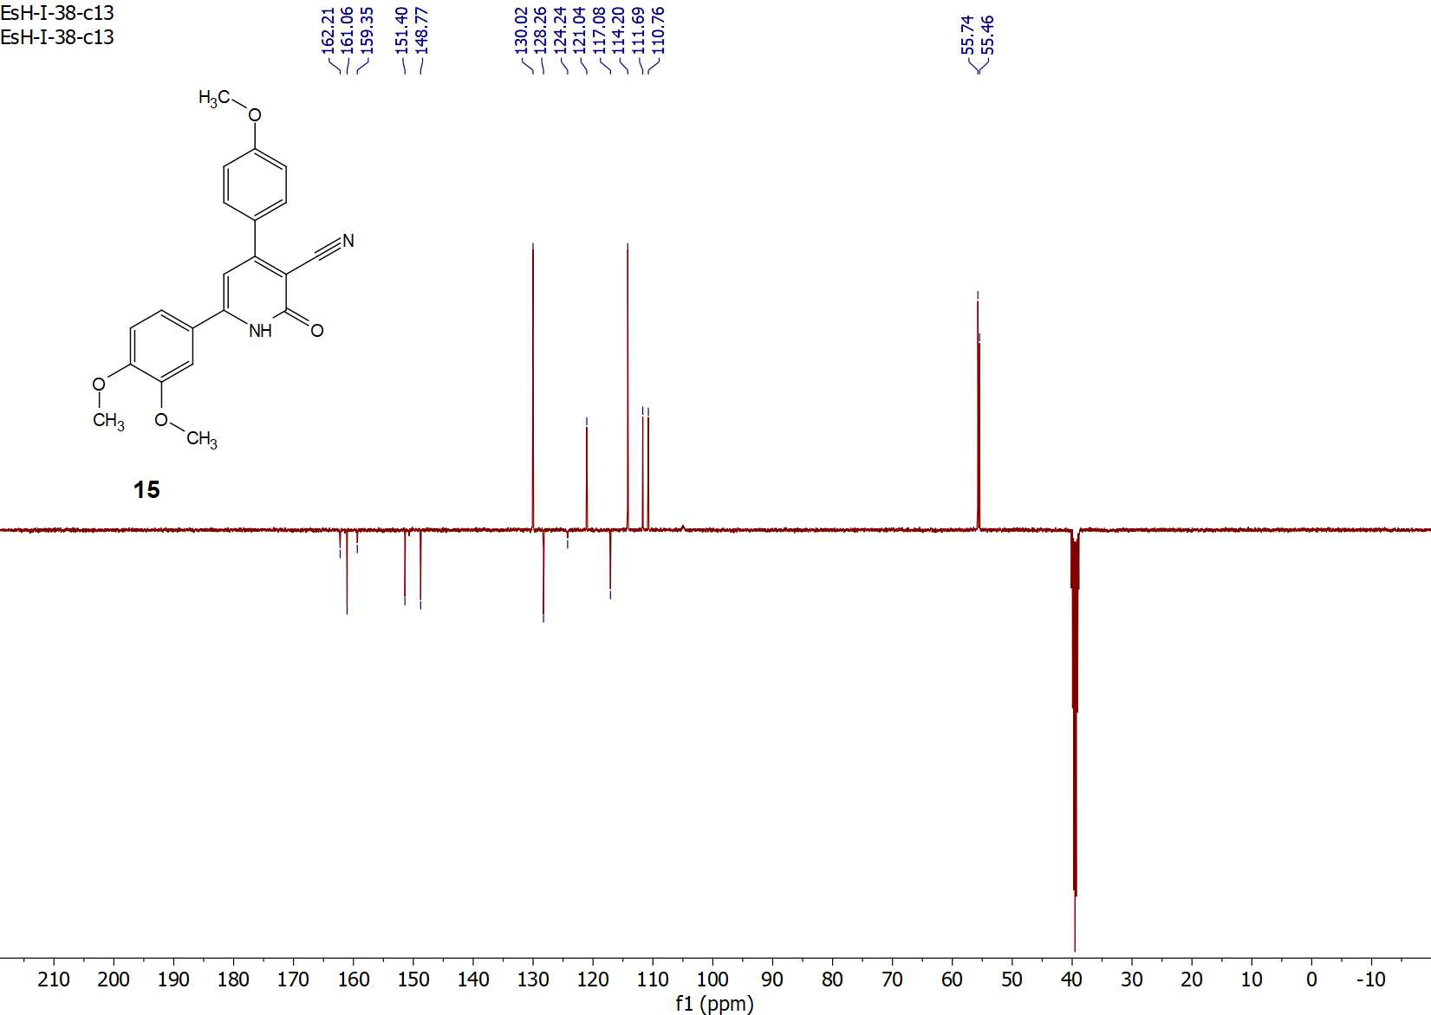
Figure S12: ¹³C-APT NMR spectrum of compound 15.
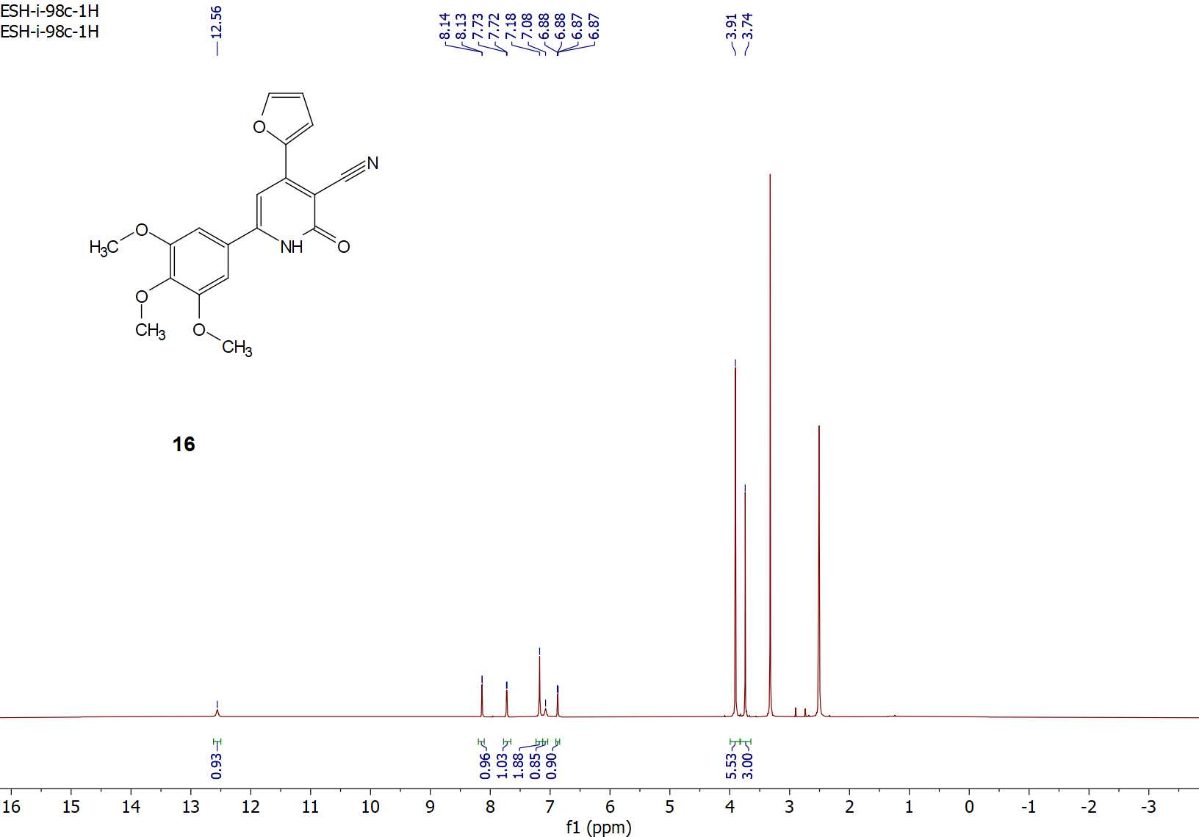
Figure S13: ¹H-NMR spectrum of compound 16.
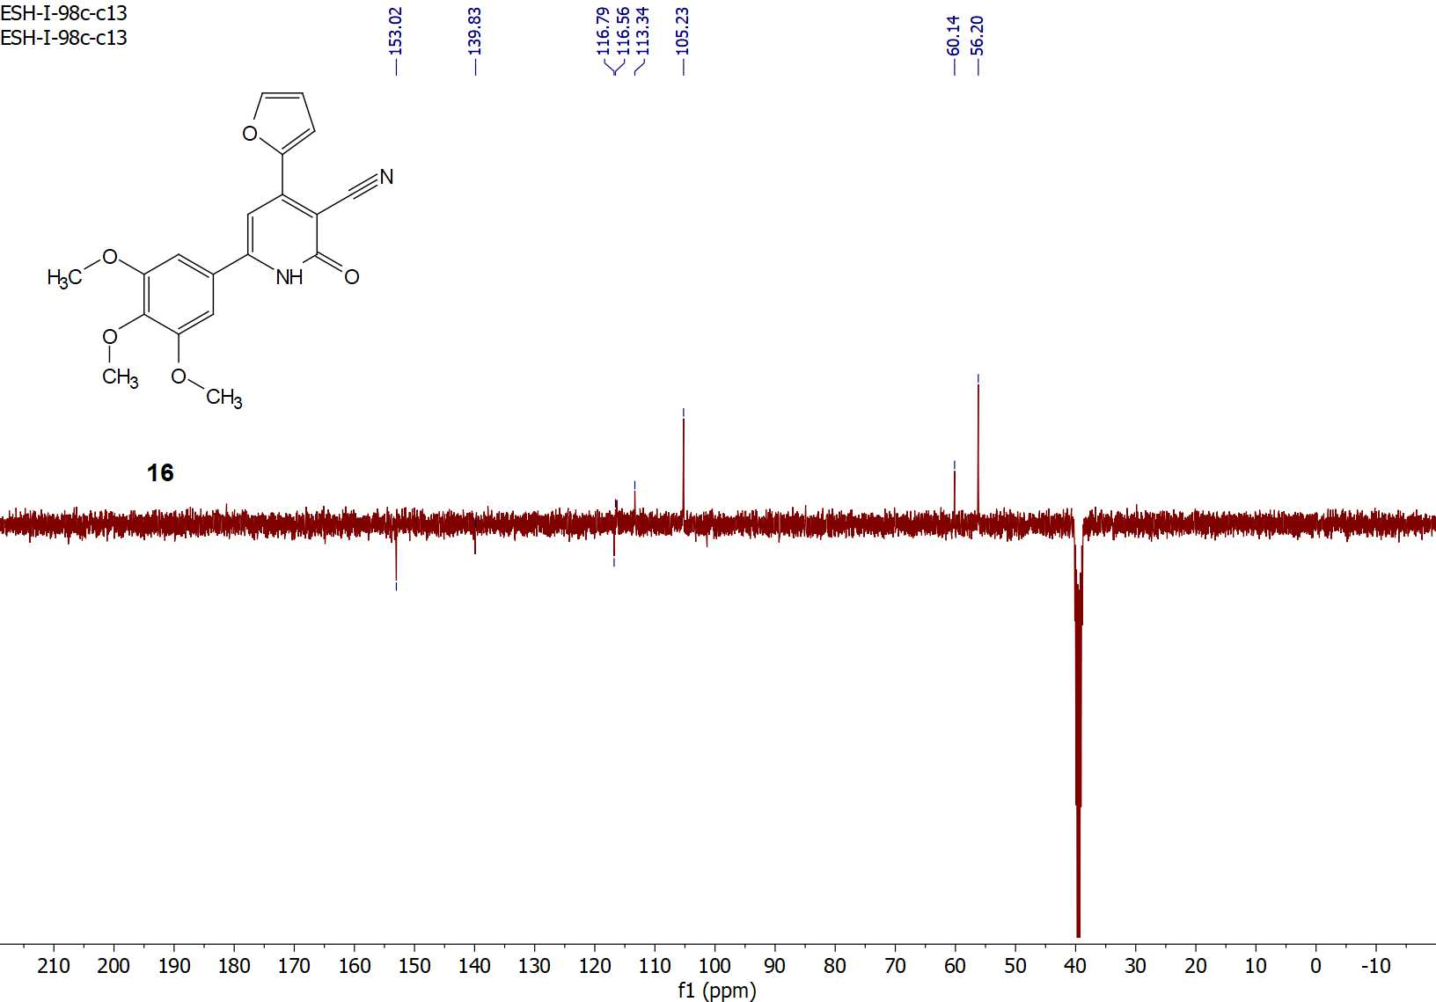
Figure S14: ¹³C-APT NMR spectrum of compound 16.

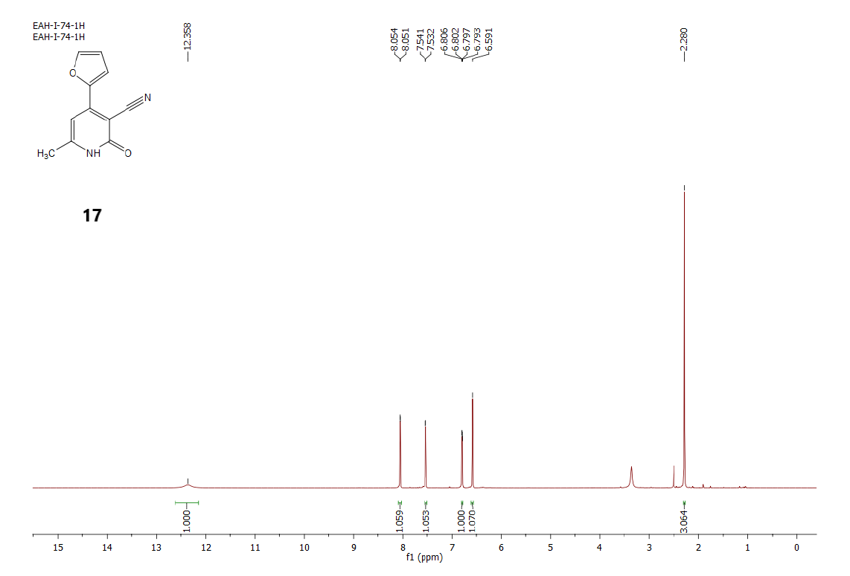
Figure S15: ¹H-NMR spectrum of compound 17.

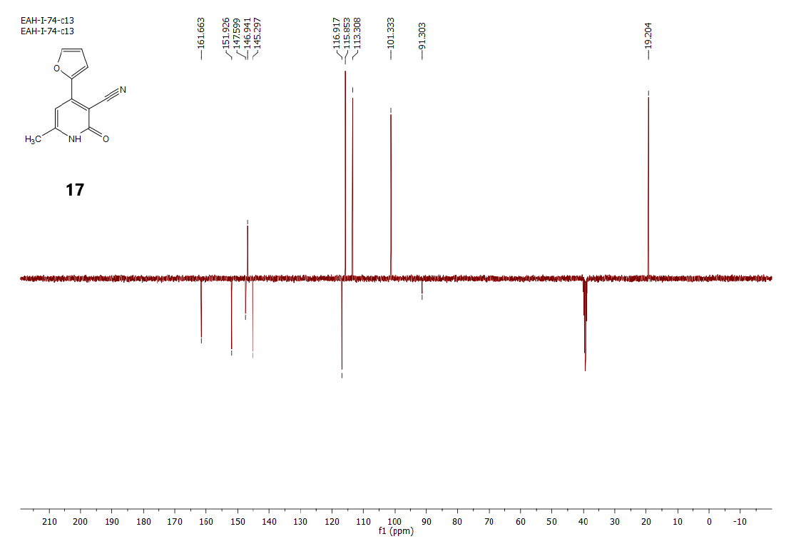
Figure S16: ¹³C-APT NMR spectrum of compound 17.

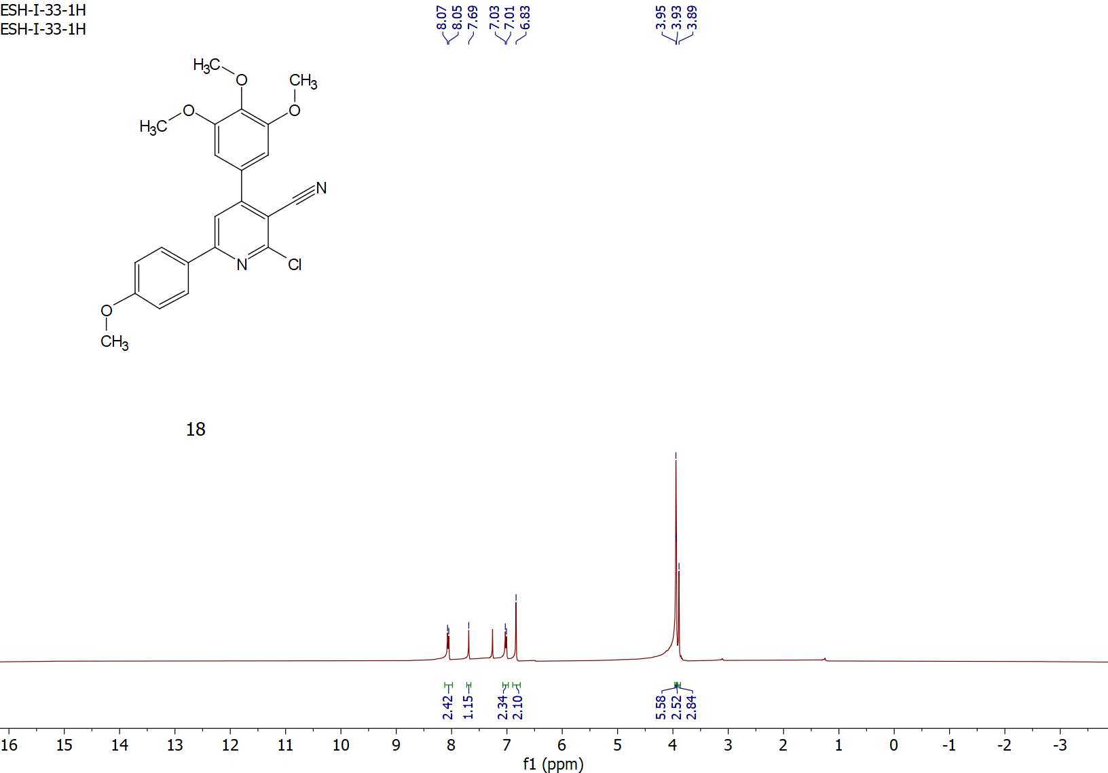
Figure S17: ¹H-NMR spectrum of compound 18.

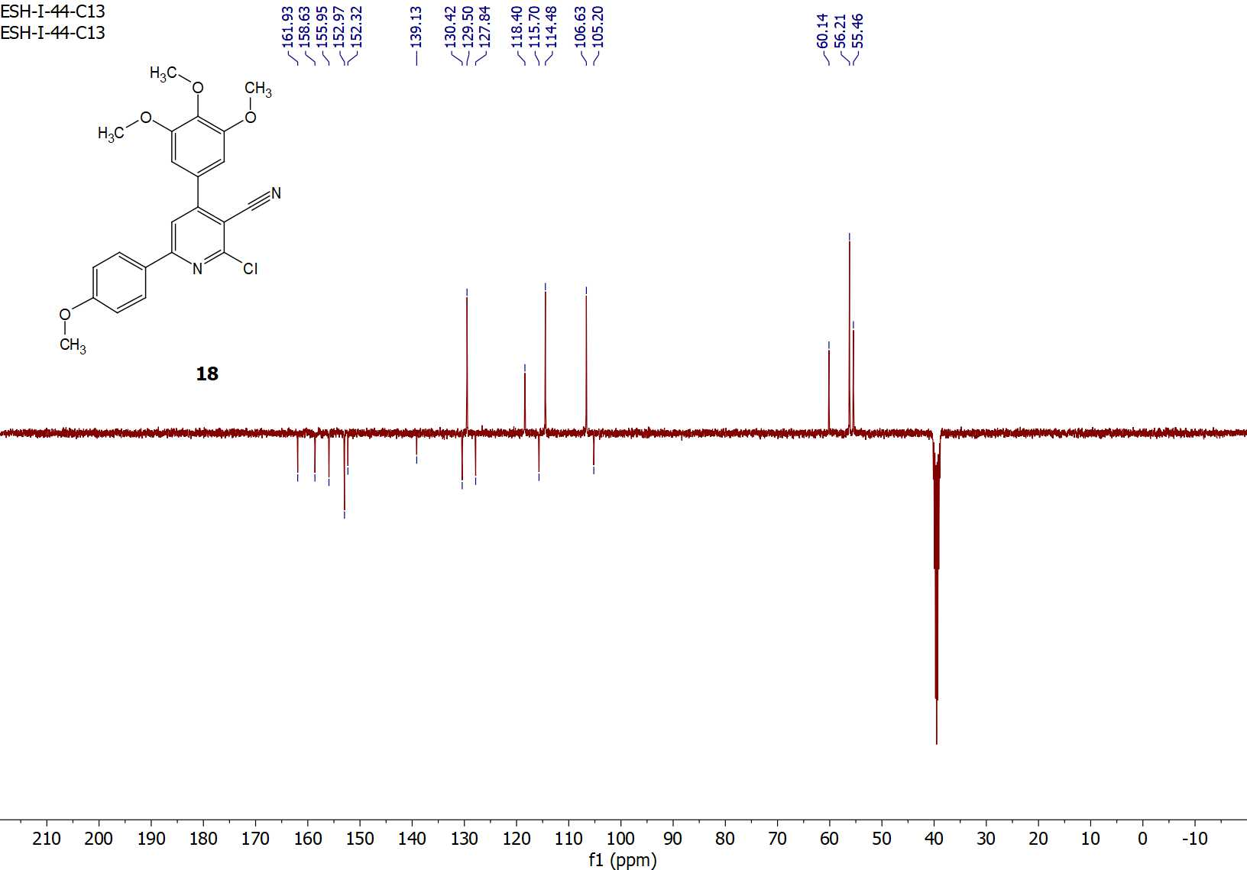
Figure S18: ¹³C-APT NMR spectrum of compound 18.

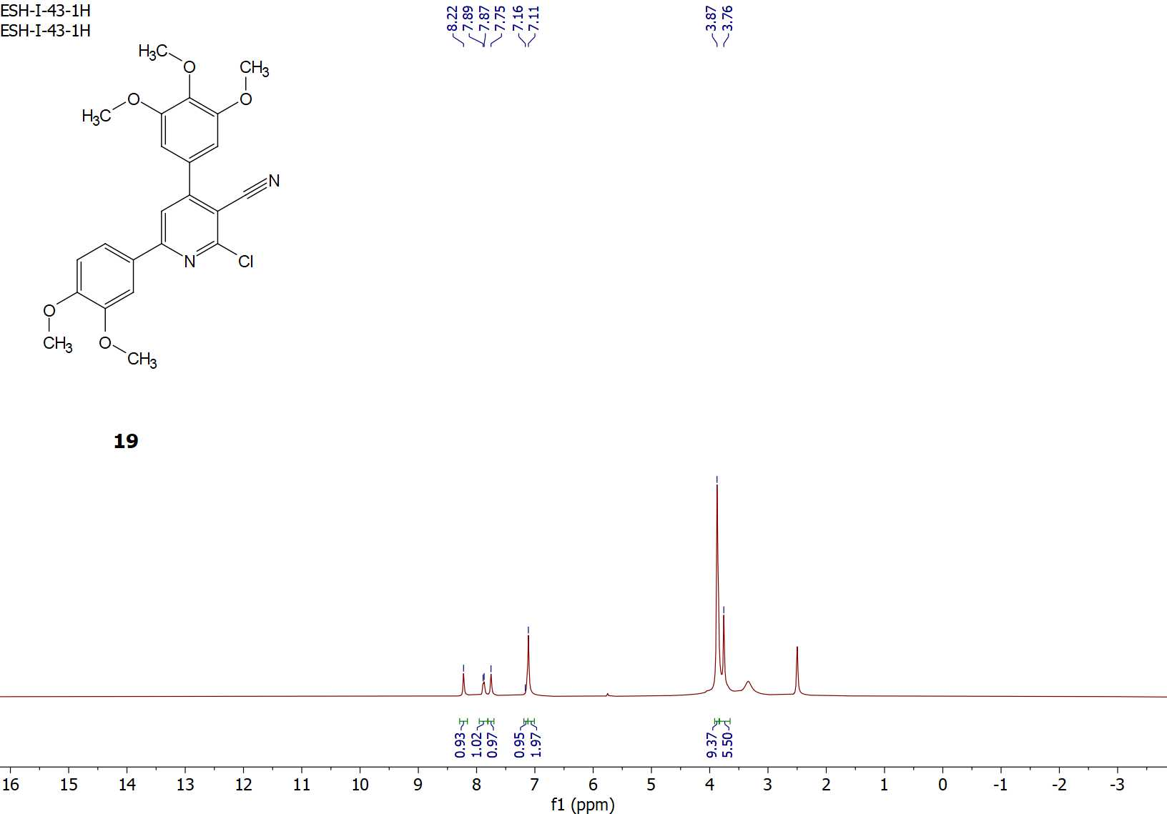
Figure S19: ¹H-NMR spectrum of compound 19.

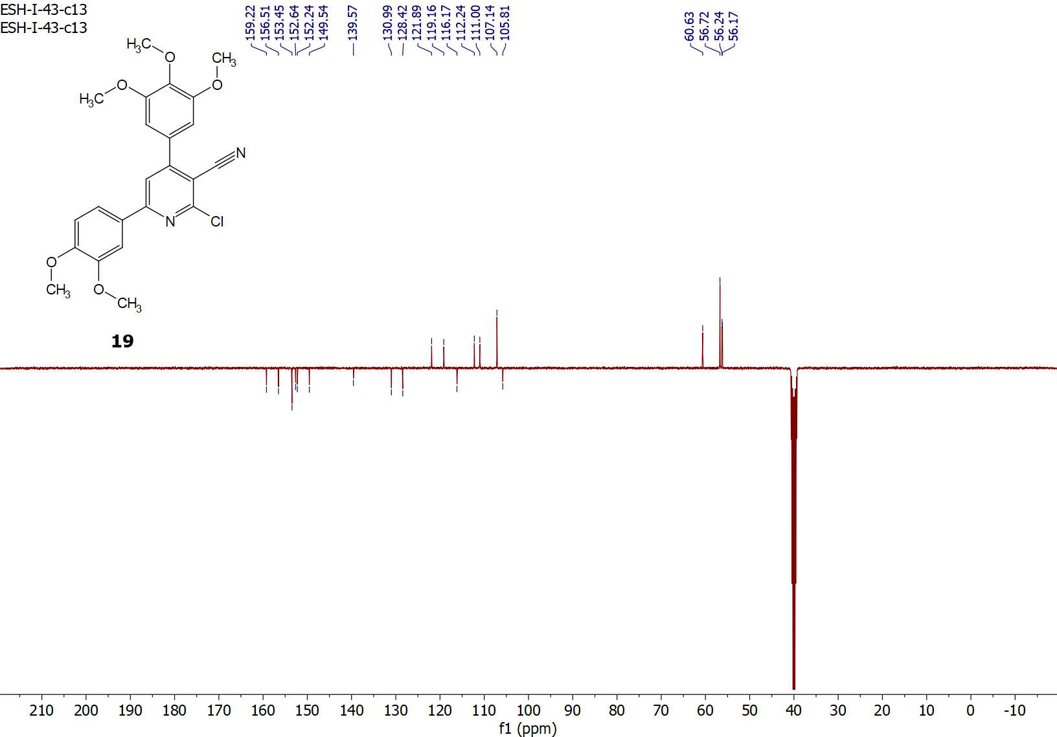
Figure S20: ¹³C-APT NMR spectrum of compound 19.

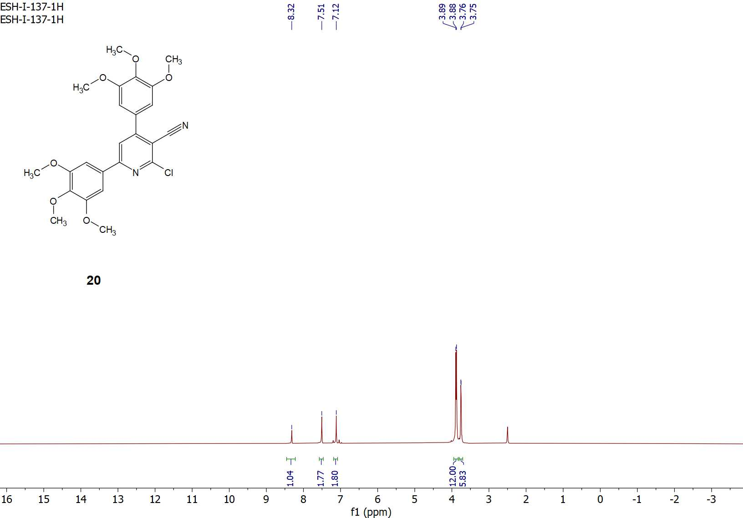
Figure S21: ¹H-NMR spectrum of compound 20.

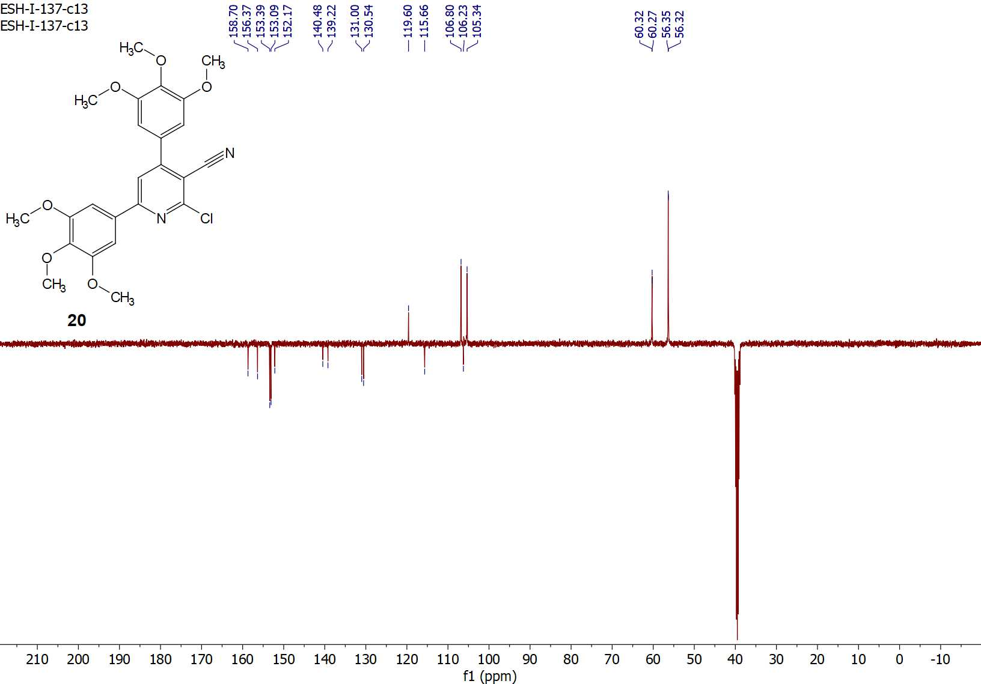
Figure S22: ¹³C-APT NMR spectrum of compound 20.

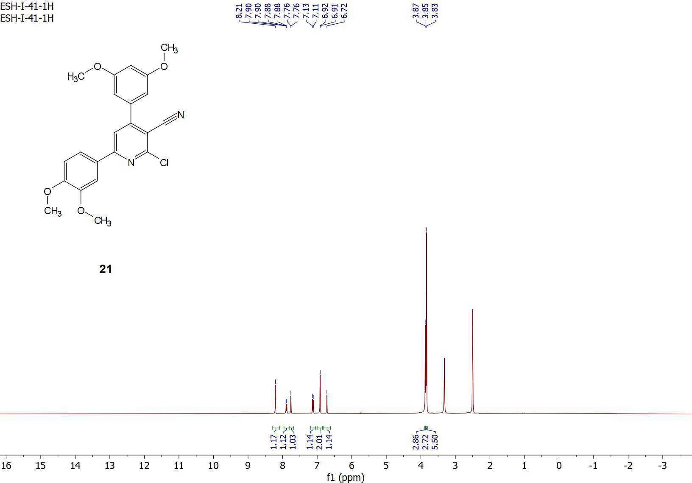
Figure S23: ¹H-NMR spectrum of compound 21.

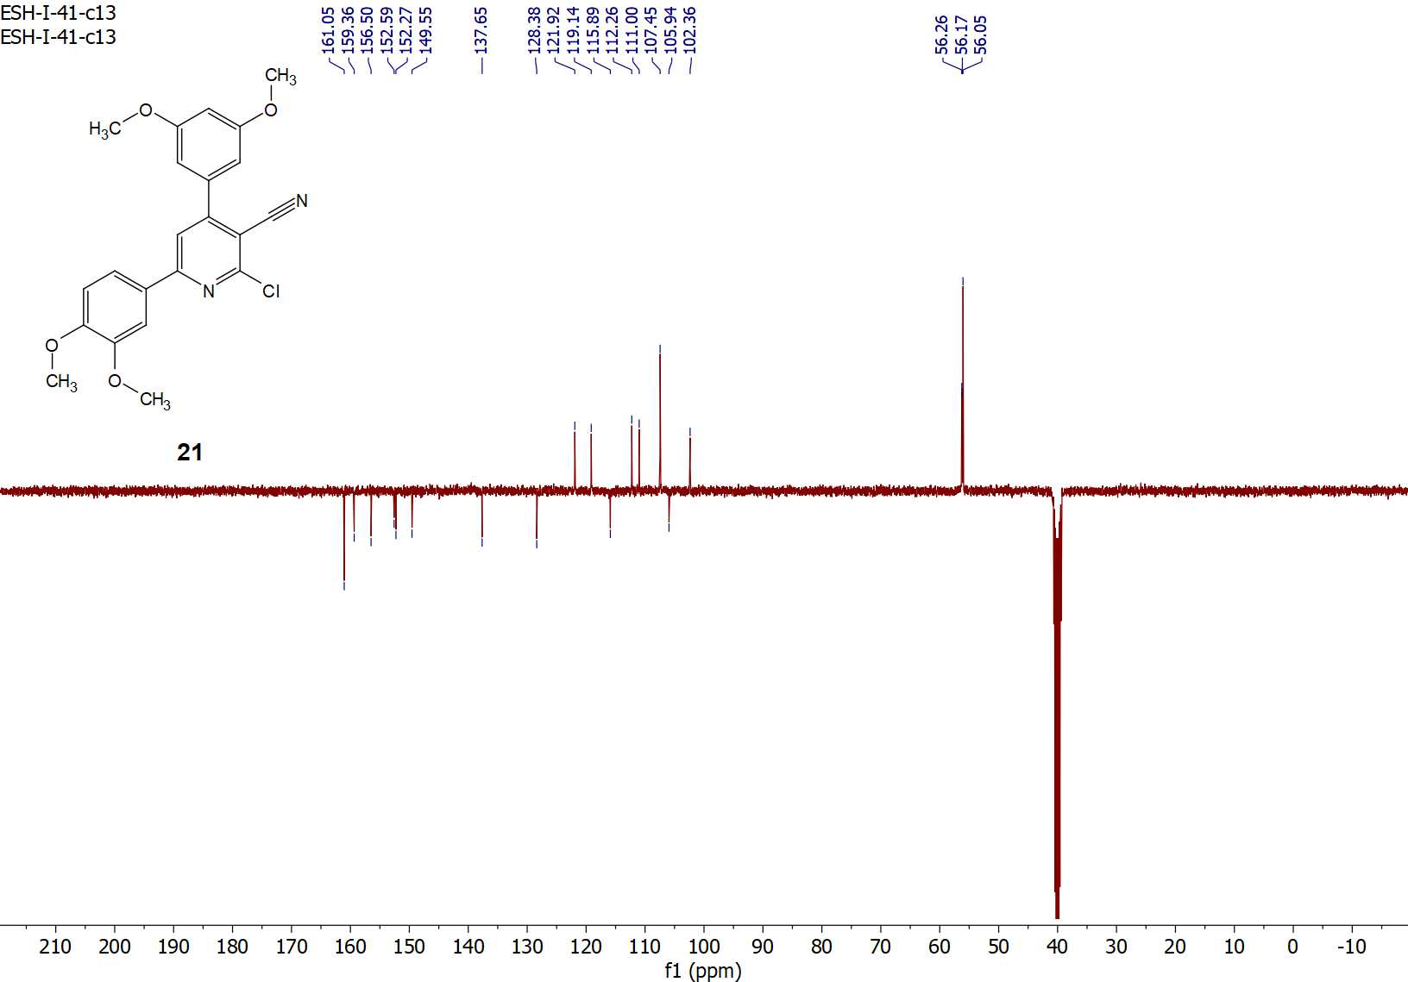
Figure S24: ¹³C-APT NMR spectrum of compound 21.

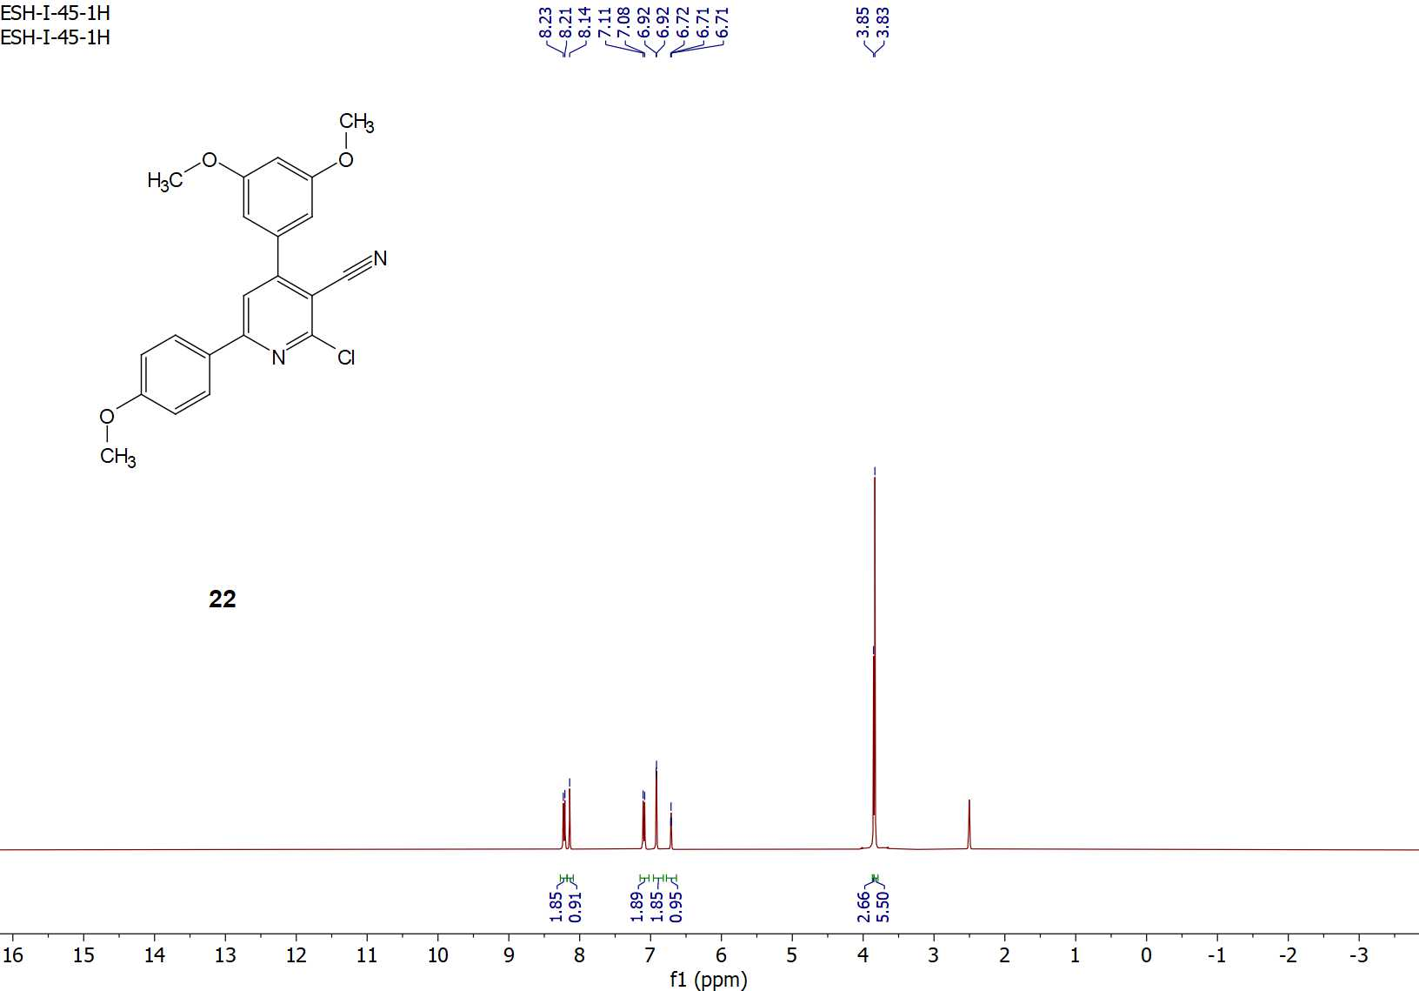
Figure S25: ¹H-NMR spectrum of compound 22.

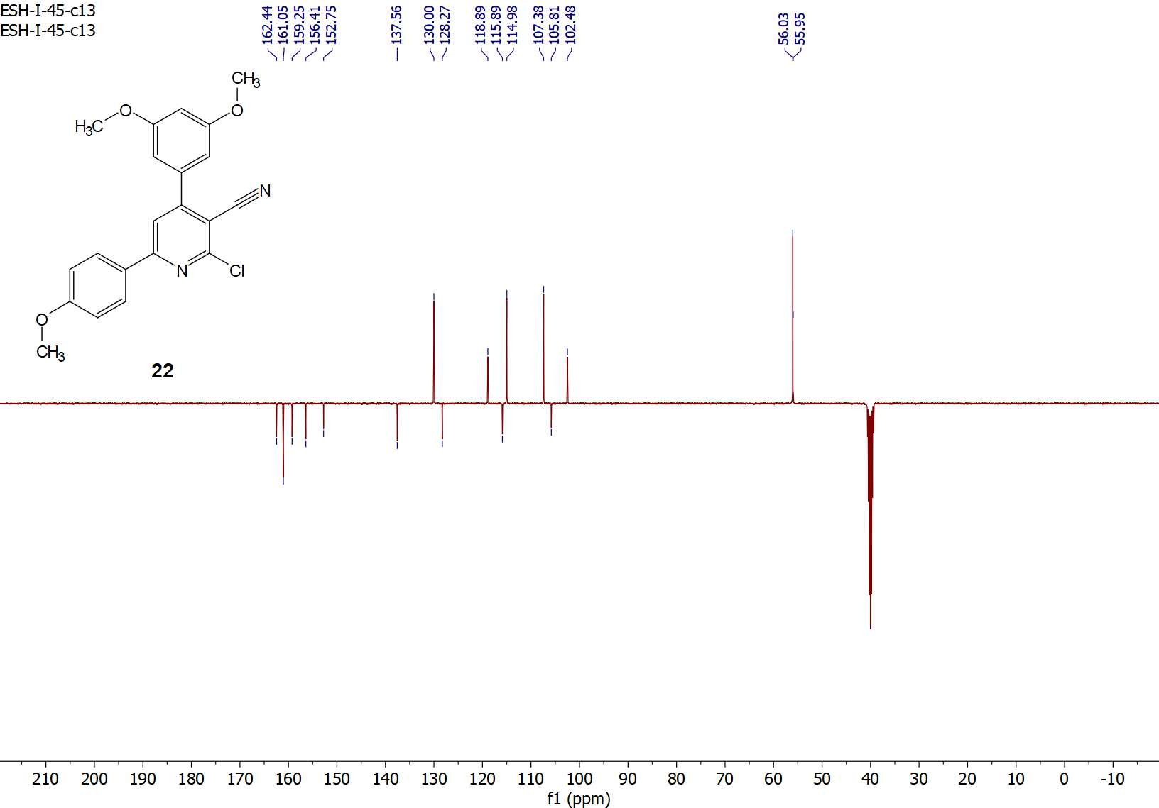

Figure S26: ¹³C-APT NMR spectrum of compound 22.

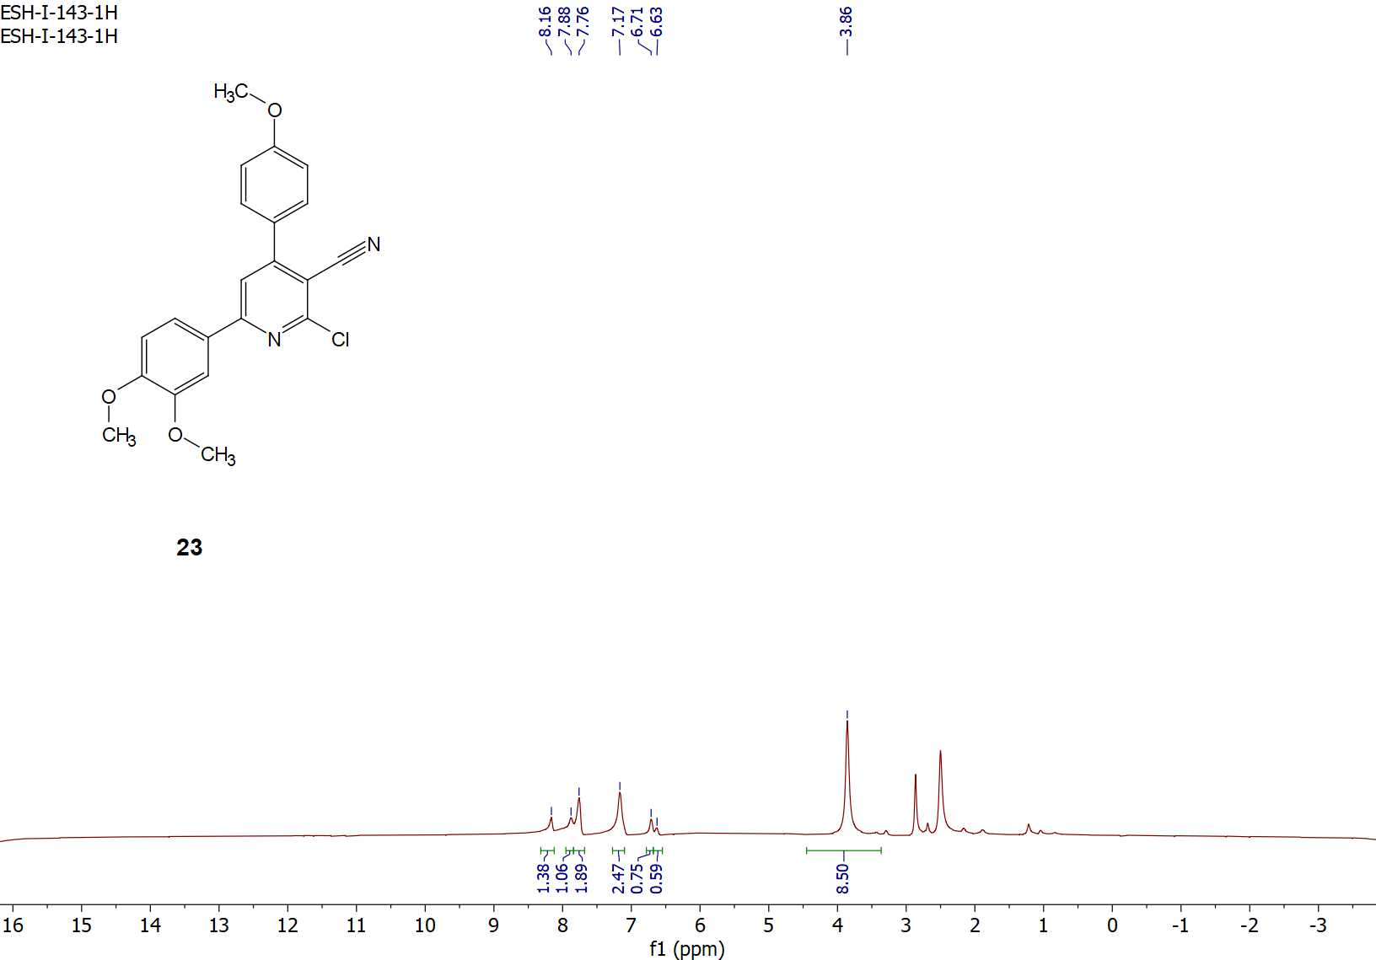
Figure S27: ¹H-NMR spectrum of compound 23.
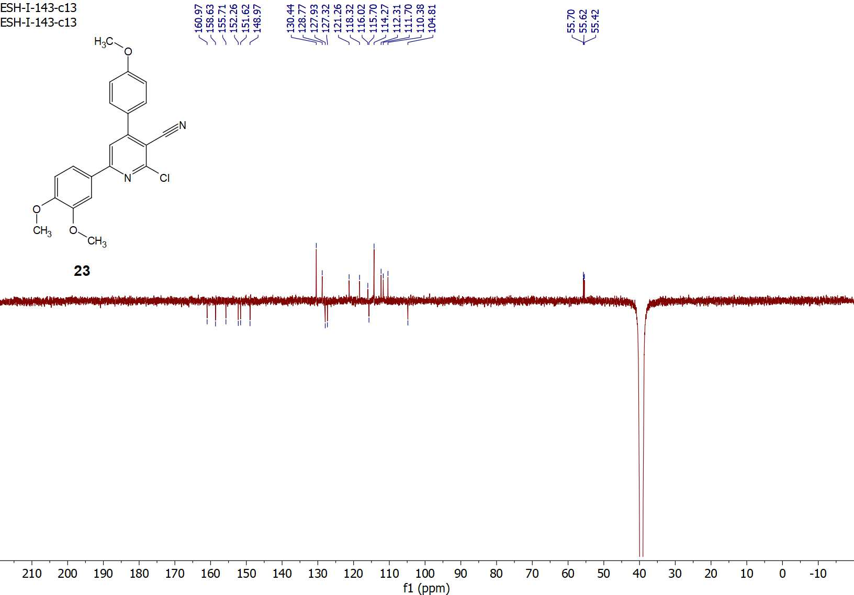
Figure S28: ¹³C-APT NMR spectrum of compound 23.
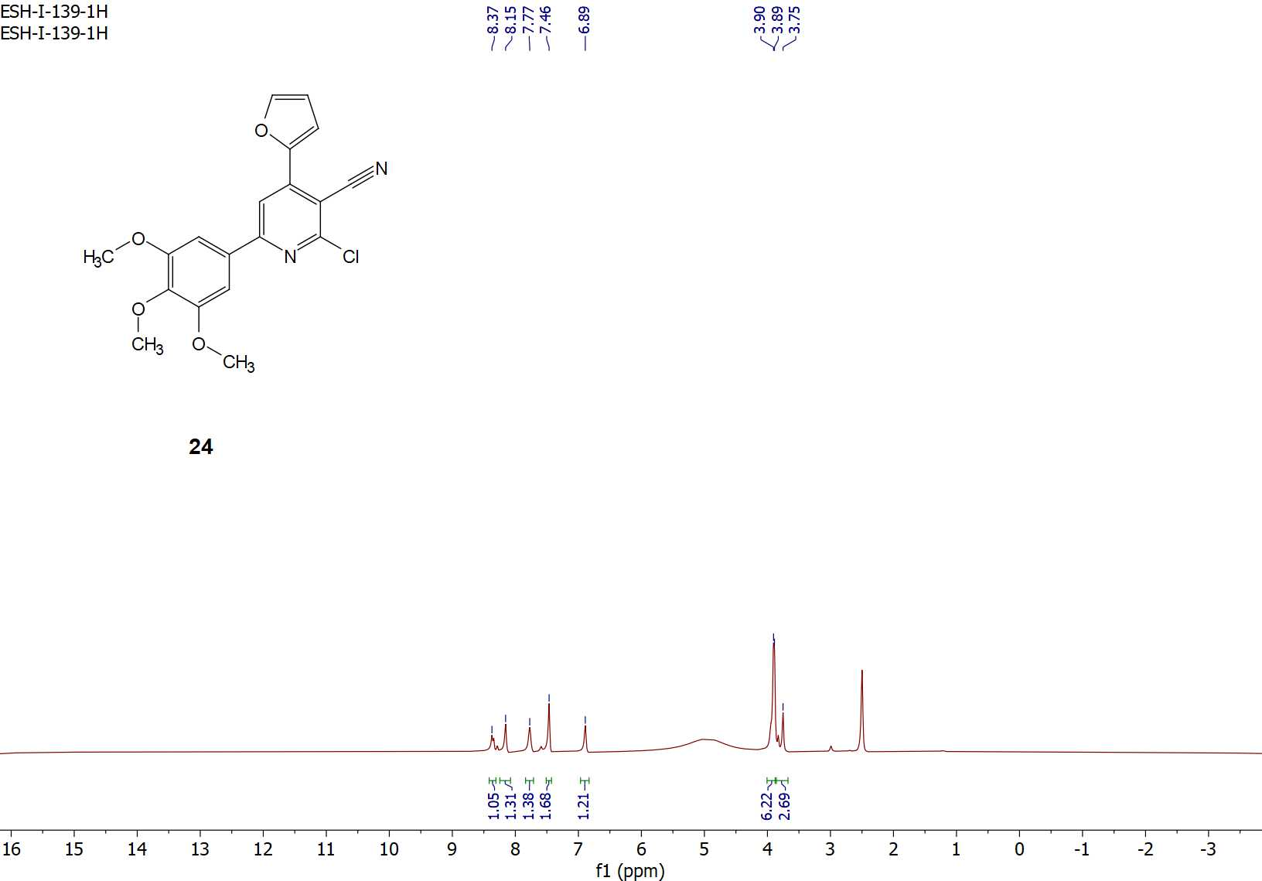
Figure S29: ¹H-NMR spectrum of compound 24.

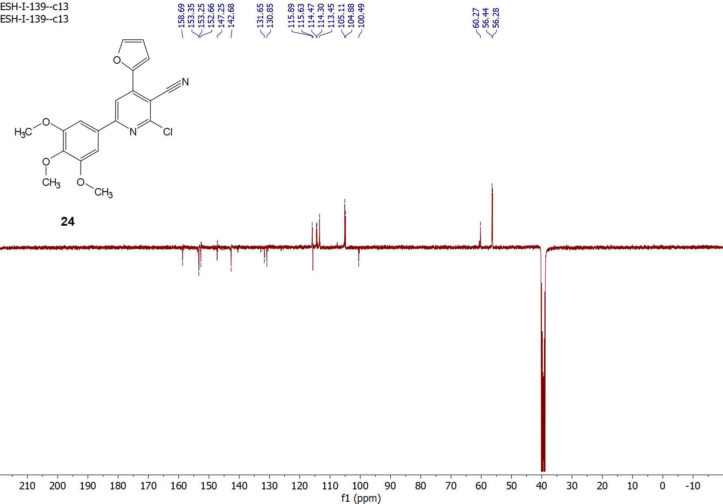
Figure S30: ¹³C-APT NMR spectrum of compound 24.

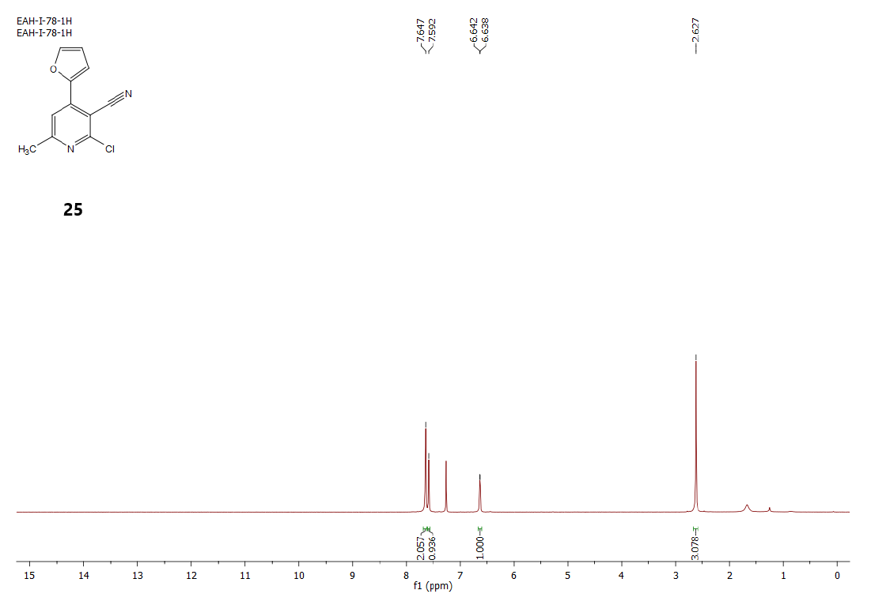
Figure S31: ¹H-NMR spectrum of compound 25.

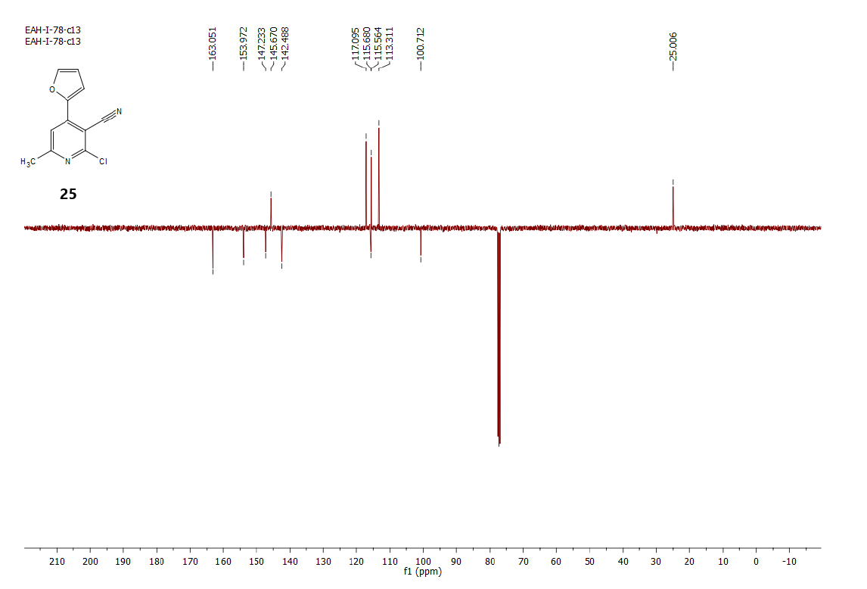
Figure S32: ¹³C-APT NMR spectrum of compound 25.

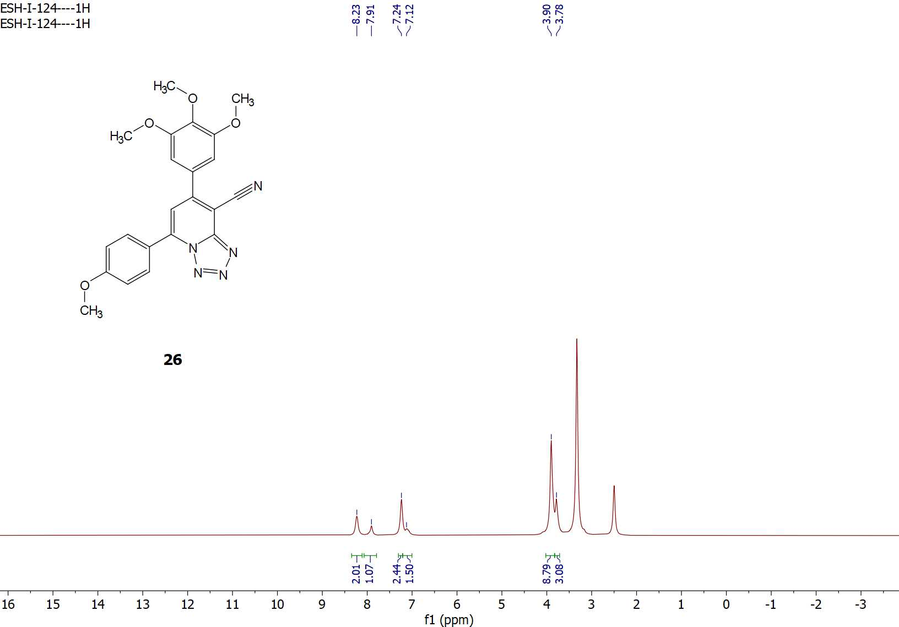
Figure S33: ¹H-NMR spectrum of compound 26.

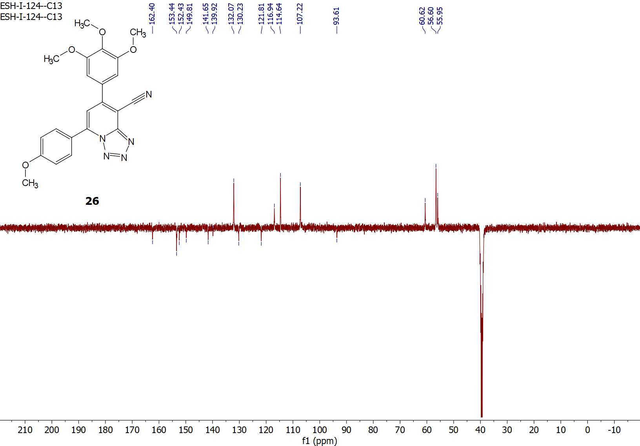
Figure S34: ¹³C-APT NMR spectrum of compound 26.

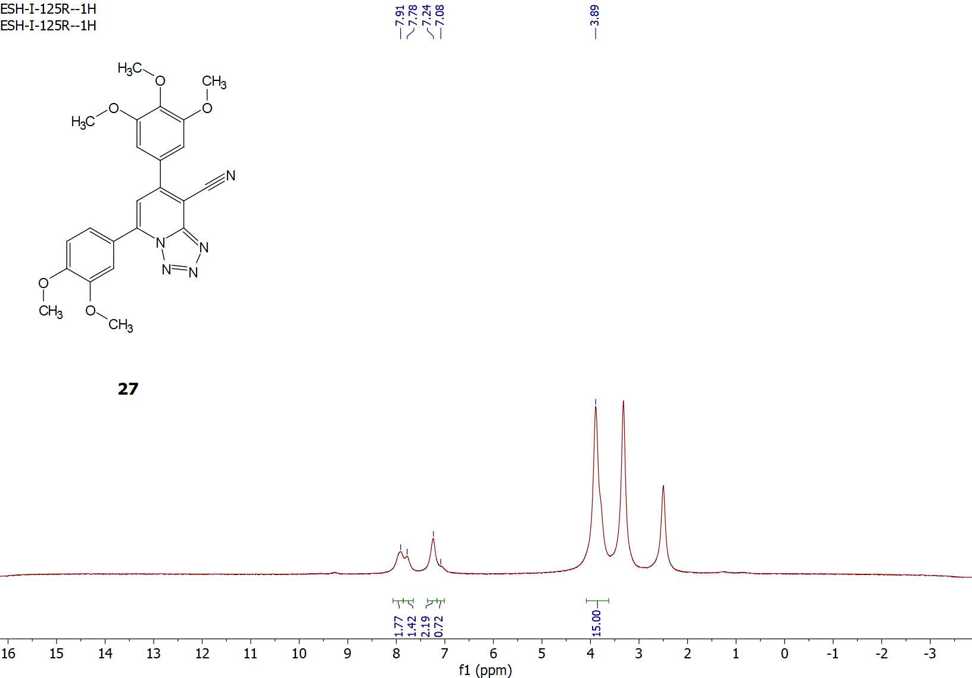
Figure S35: ¹H-NMR spectrum of compound 27.

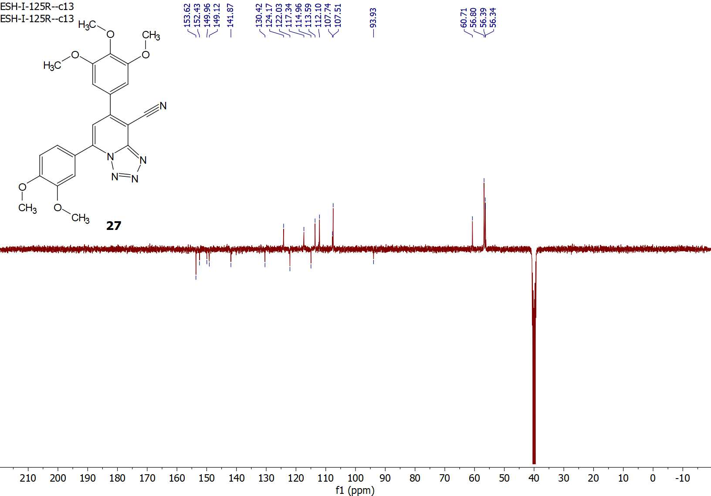
Figure S36: ¹³C-APT NMR spectrum of compound 27.

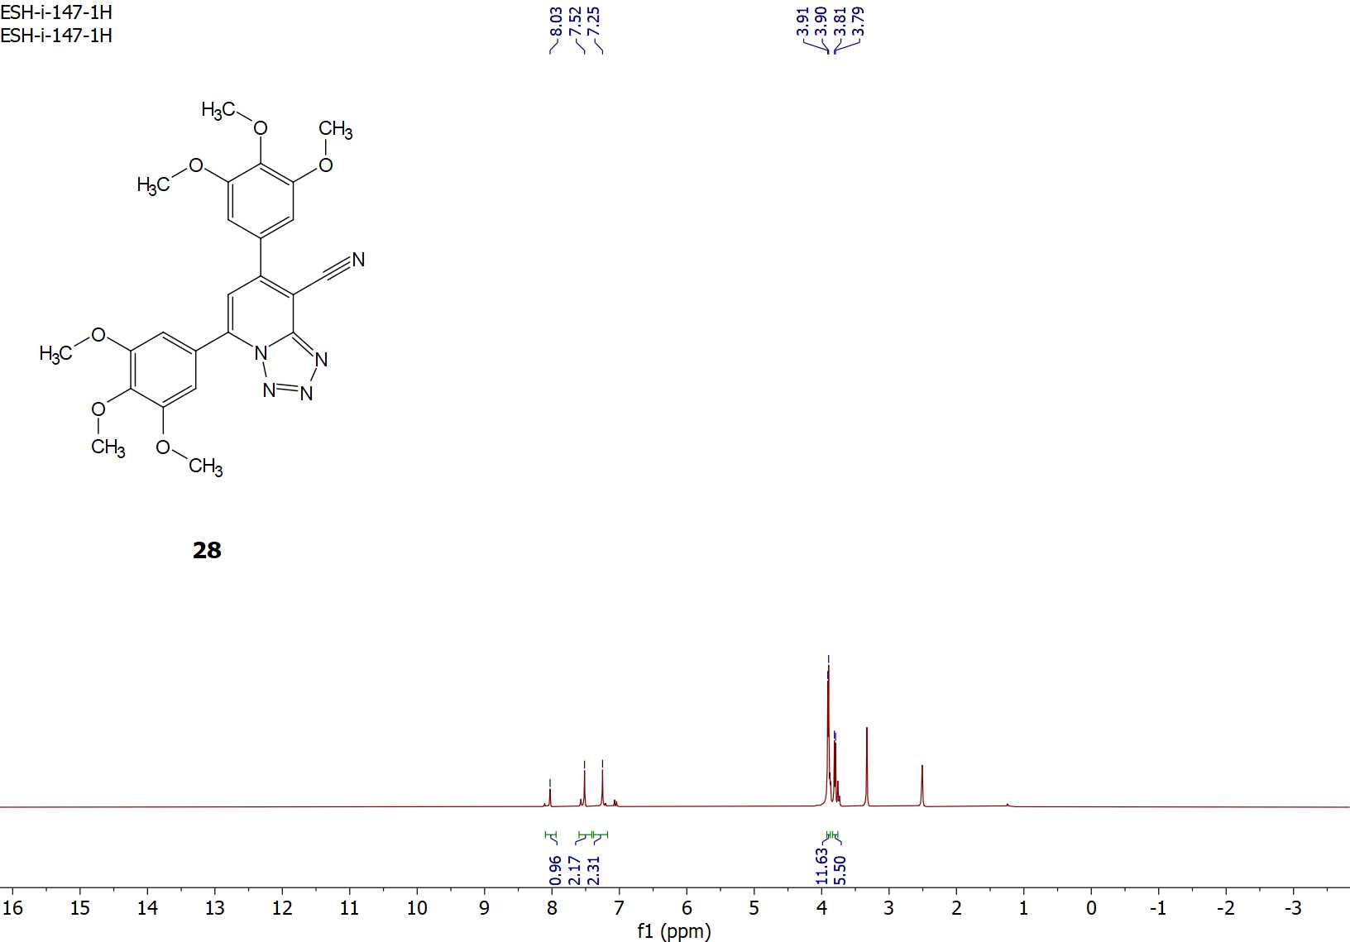
Figure S37: ¹H-NMR spectrum of compound 28.

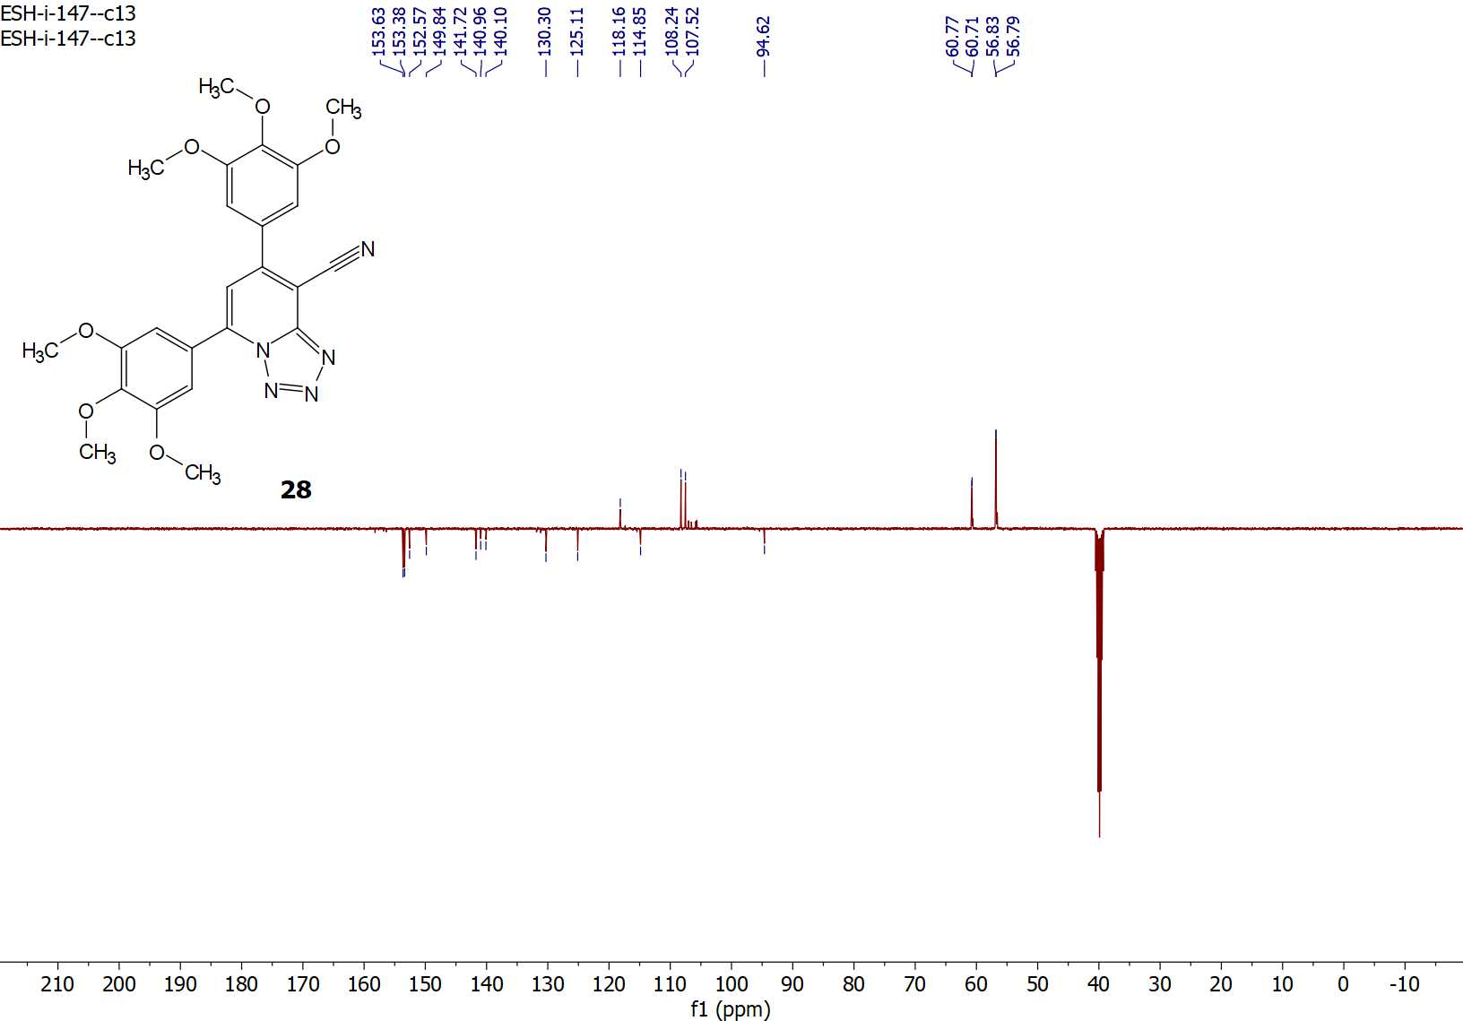
Figure S38: ¹³C-APT NMR spectrum of compound 28.

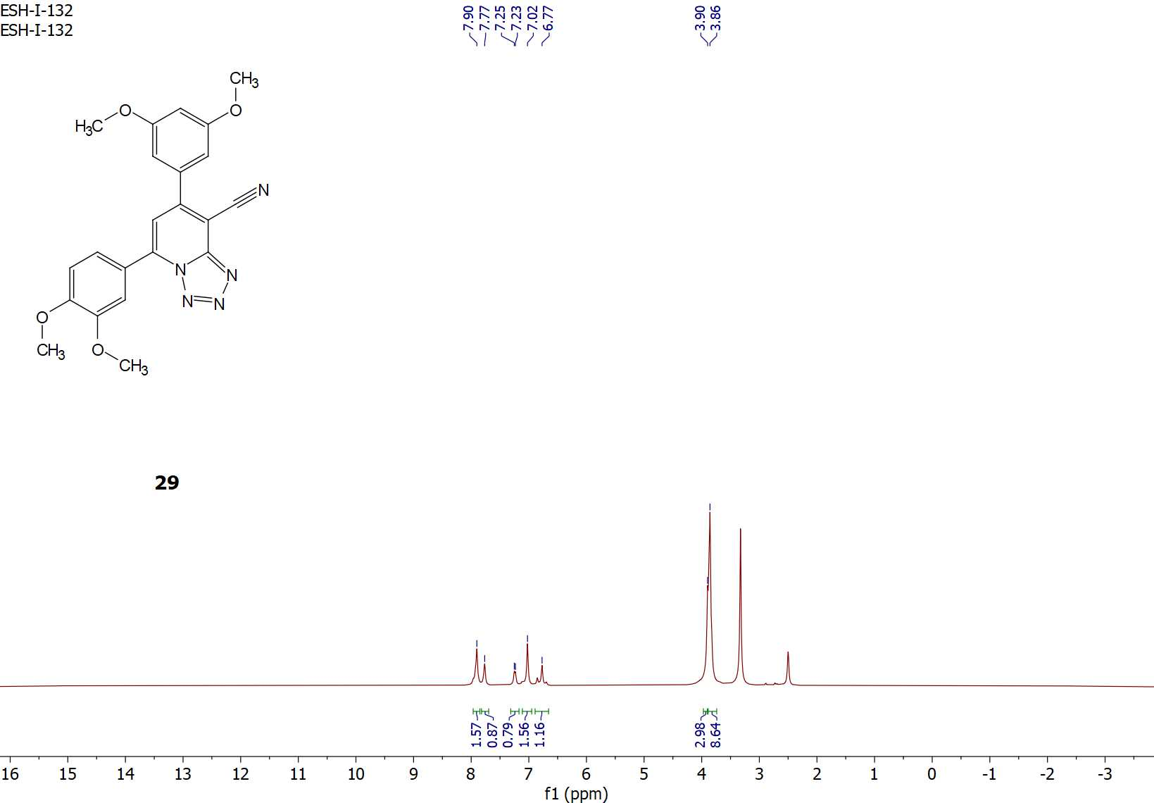
Figure S39: ¹H-NMR spectrum of compound 29.

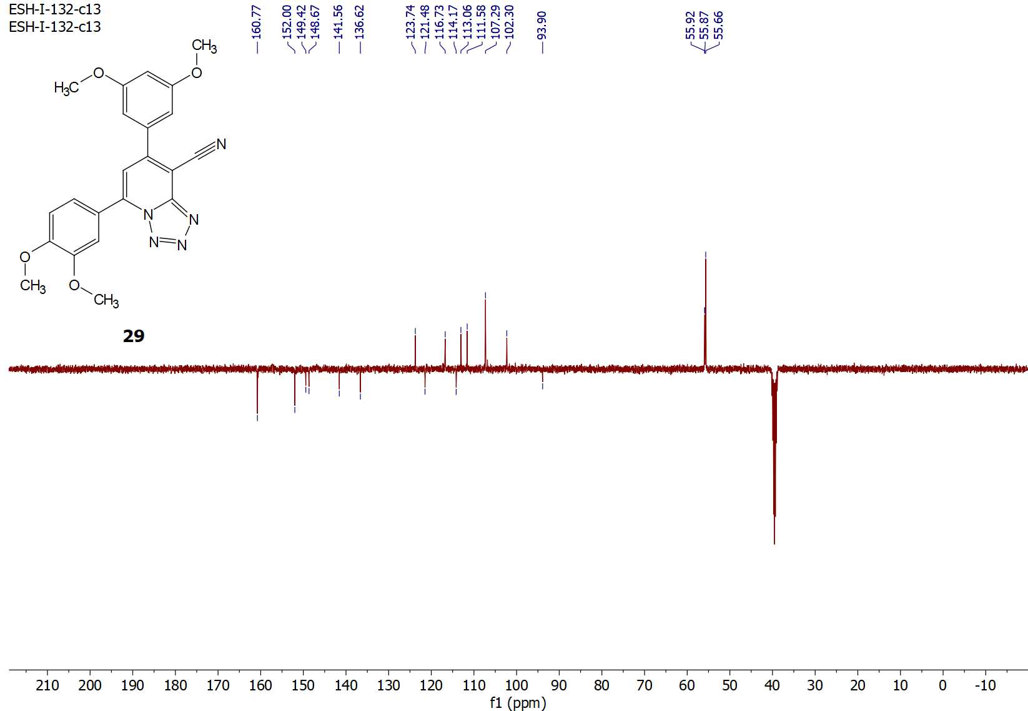
Figure S40: ¹³C-APT NMR spectrum of compound 29.

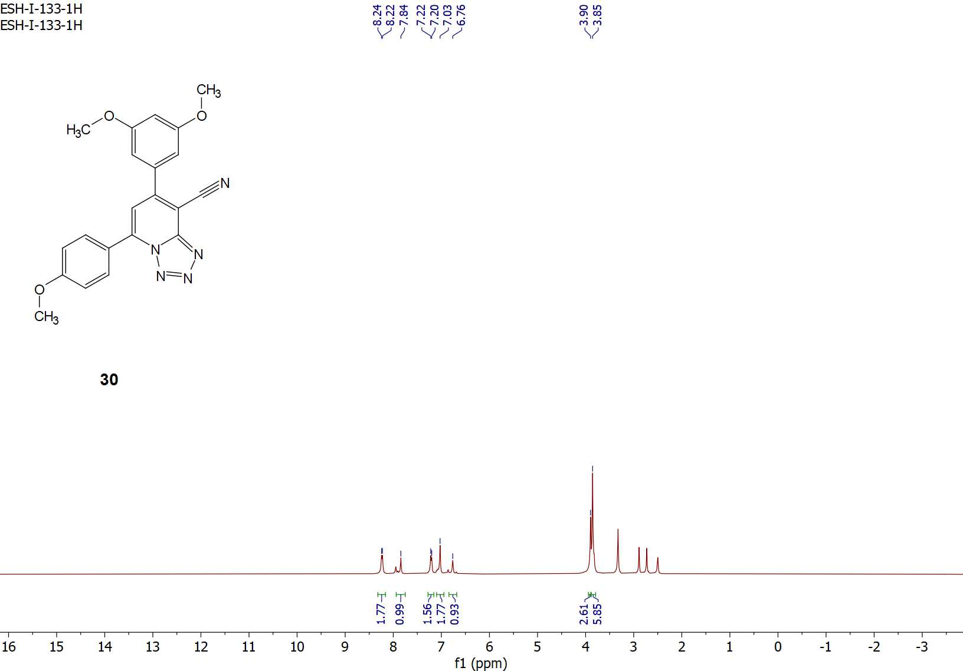
Figure S41: ¹H-NMR spectrum of compound 30.

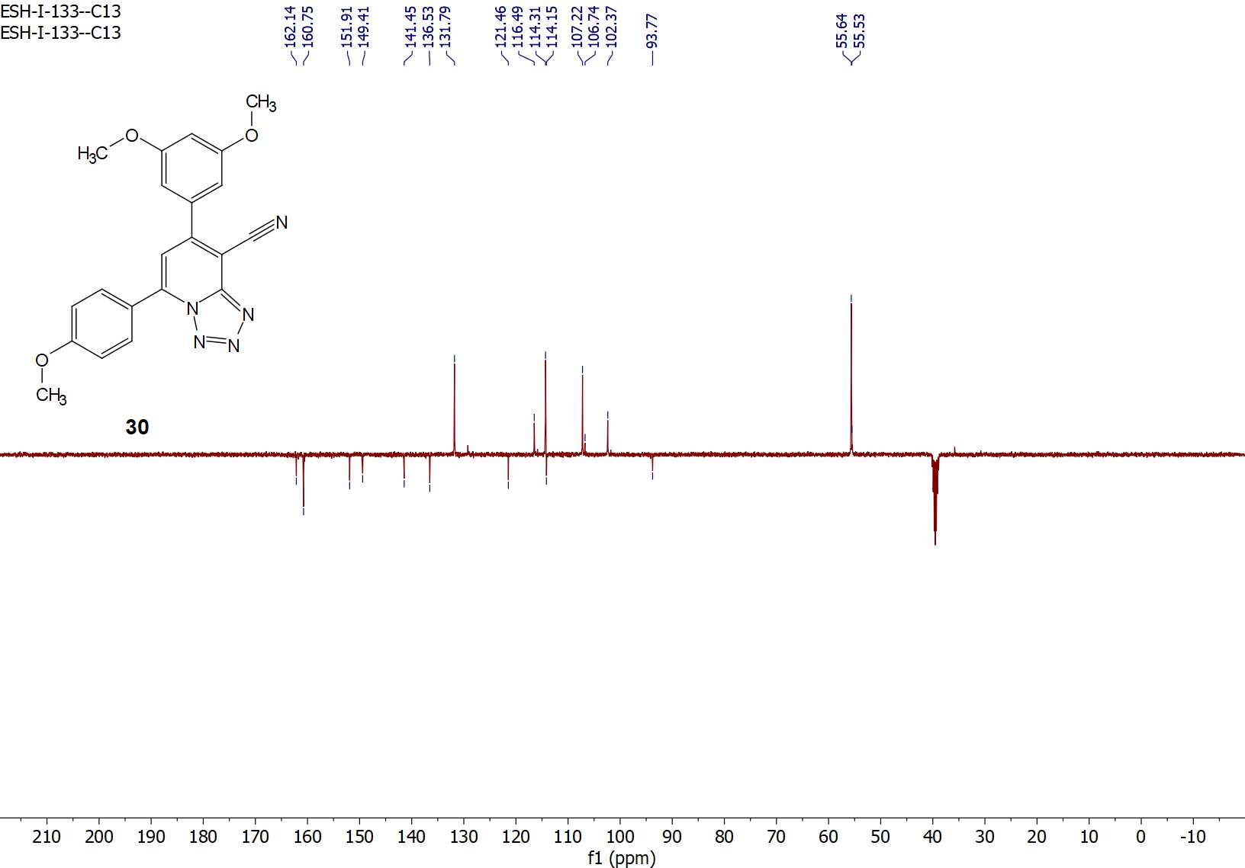
Figure S42: ¹³C-APT NMR spectrum of compound 30.

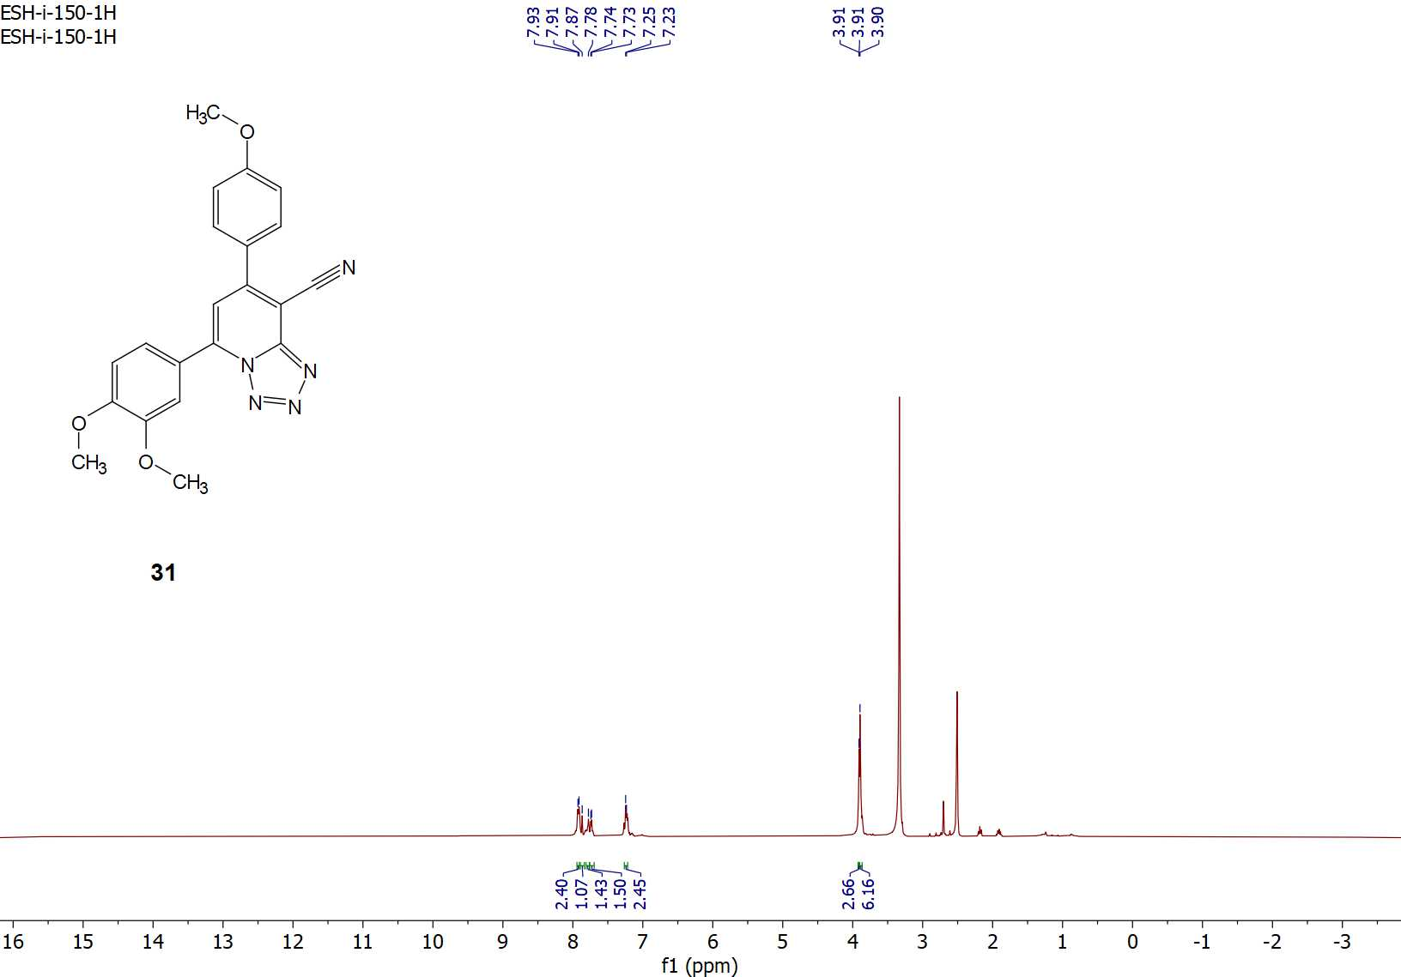
Figure S43: ¹H-NMR spectrum of compound 31.

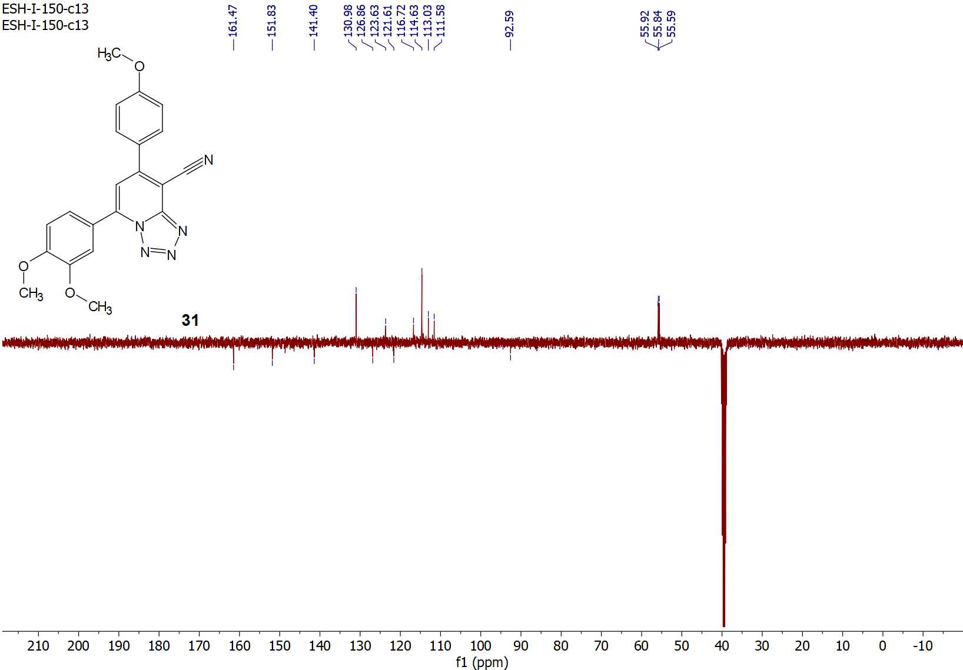
Figure S44: ¹³C-APT NMR spectrum of compound 31.

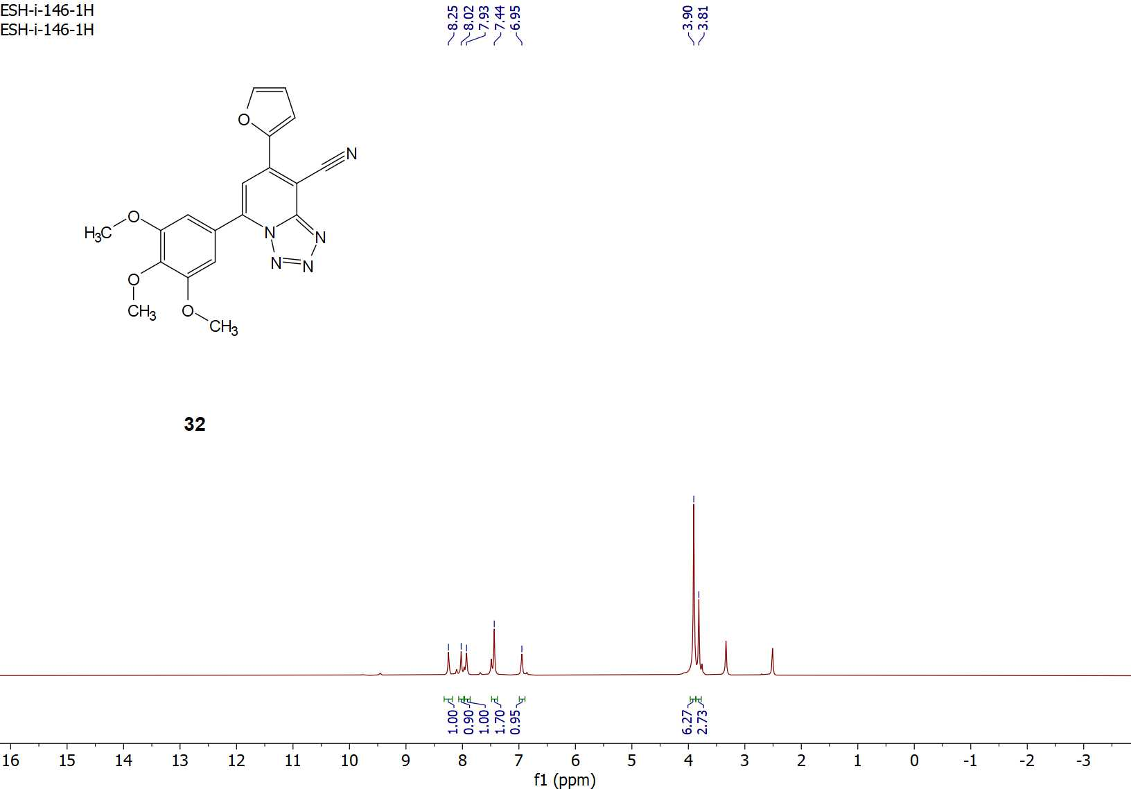
Figure S45: ¹H-NMR spectrum of compound 32.

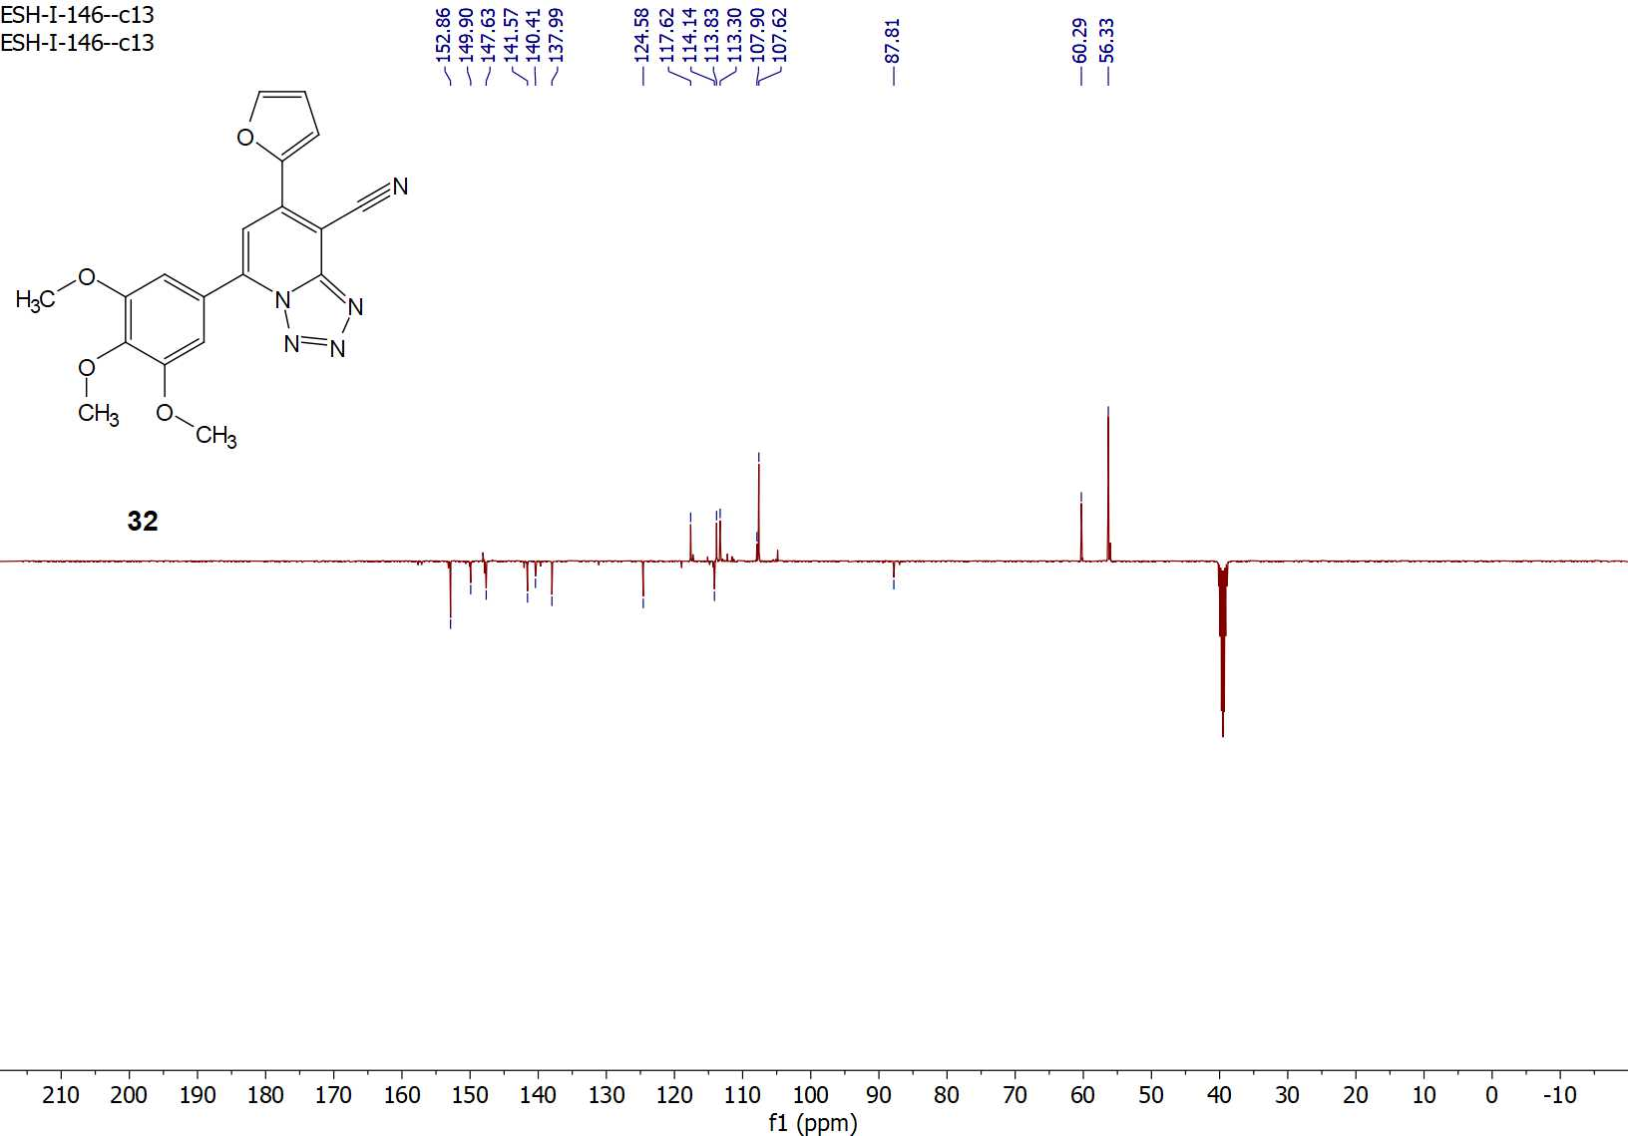
Figure S46: ¹³C-APT NMR spectrum of compound 32.

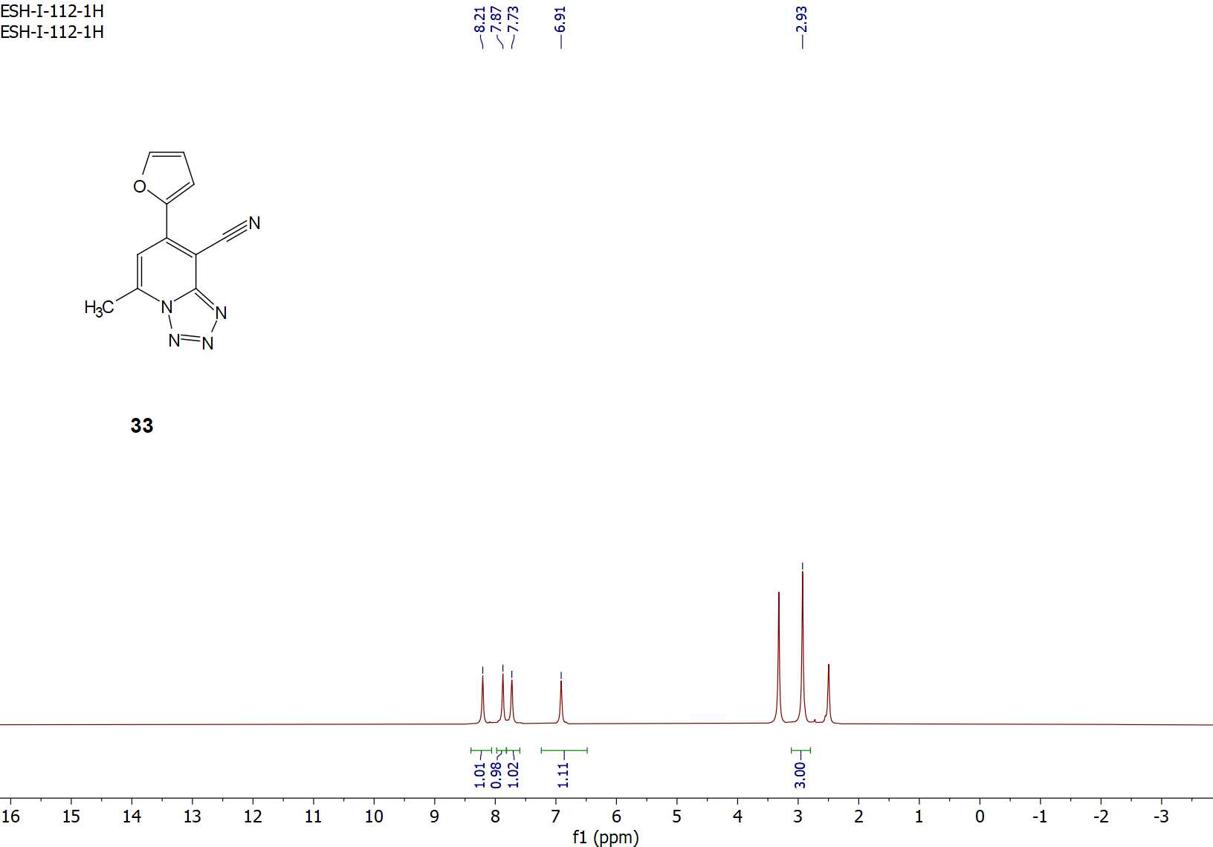
Figure S47: ¹H-NMR spectrum of compound 33.

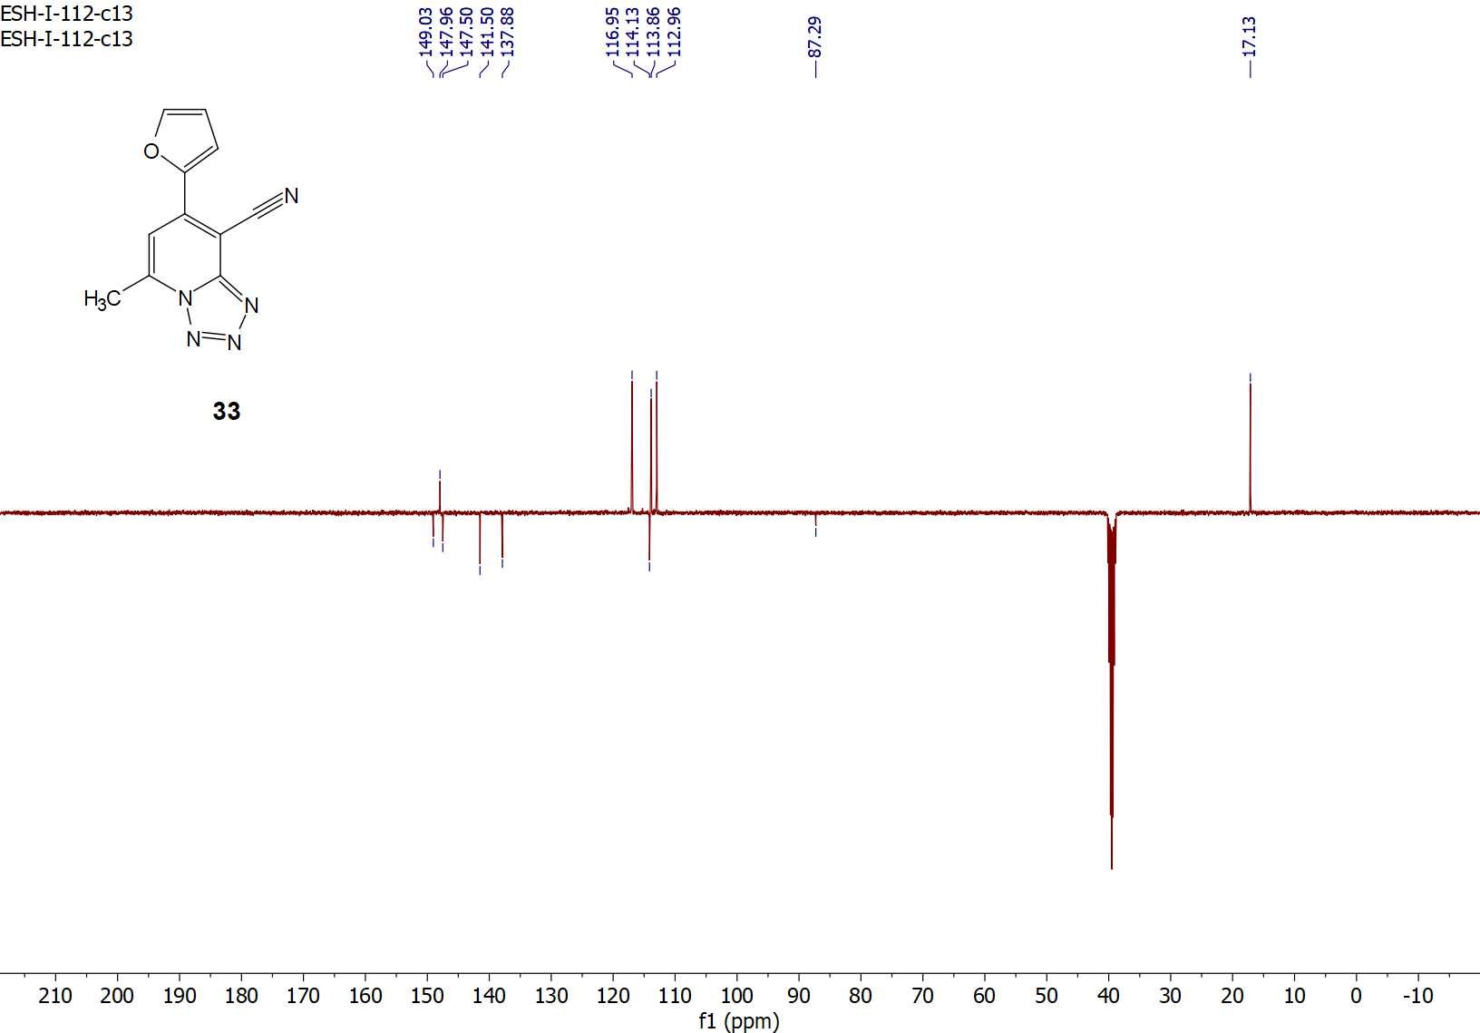
Figure S48: ¹³C-APT NMR spectrum of compound 33.

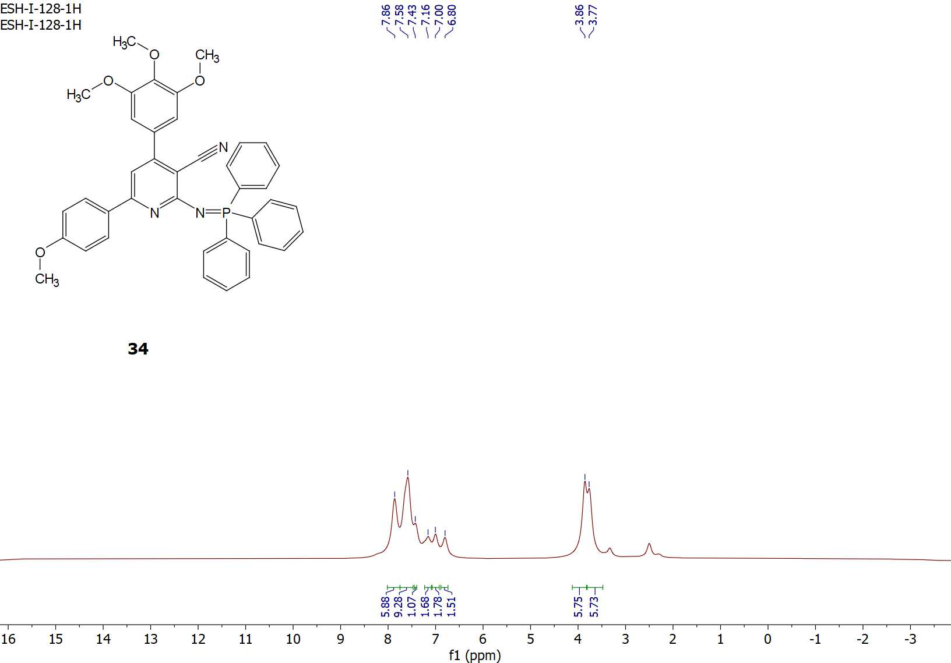
Figure S49: ¹H-NMR spectrum of compound 34.

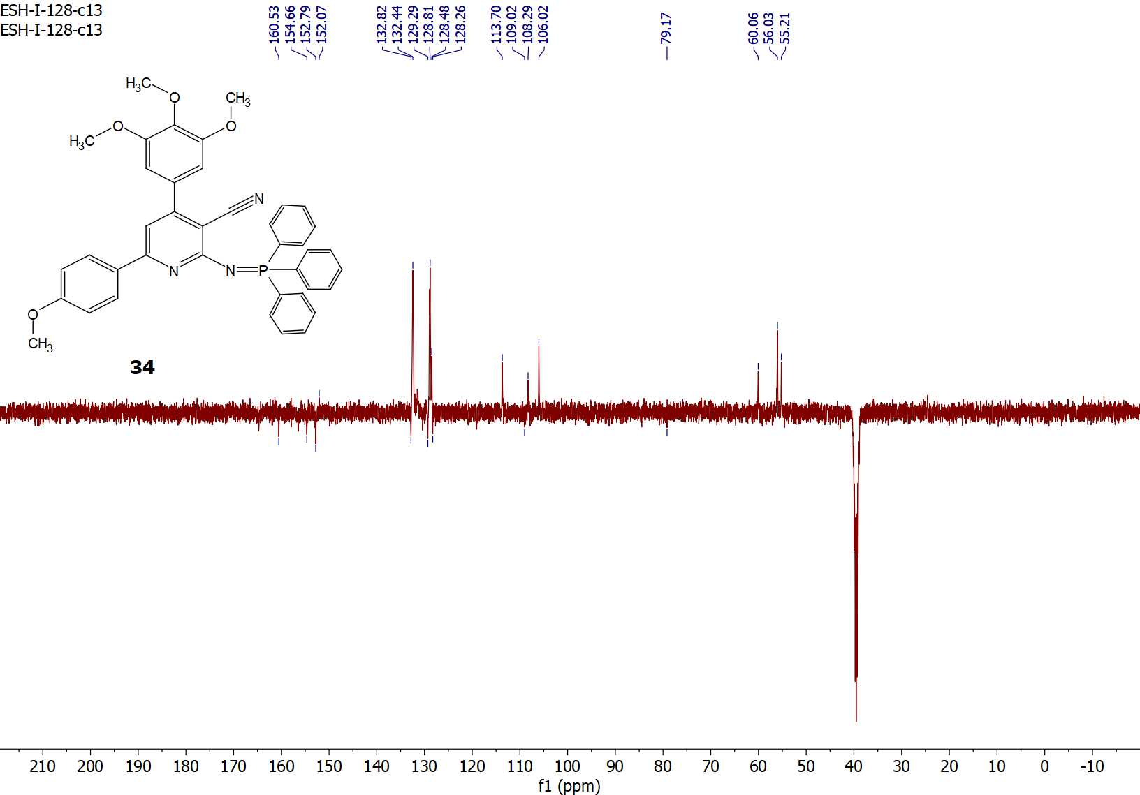
Figure S50: ¹³C-APT NMR spectrum of compound 34.

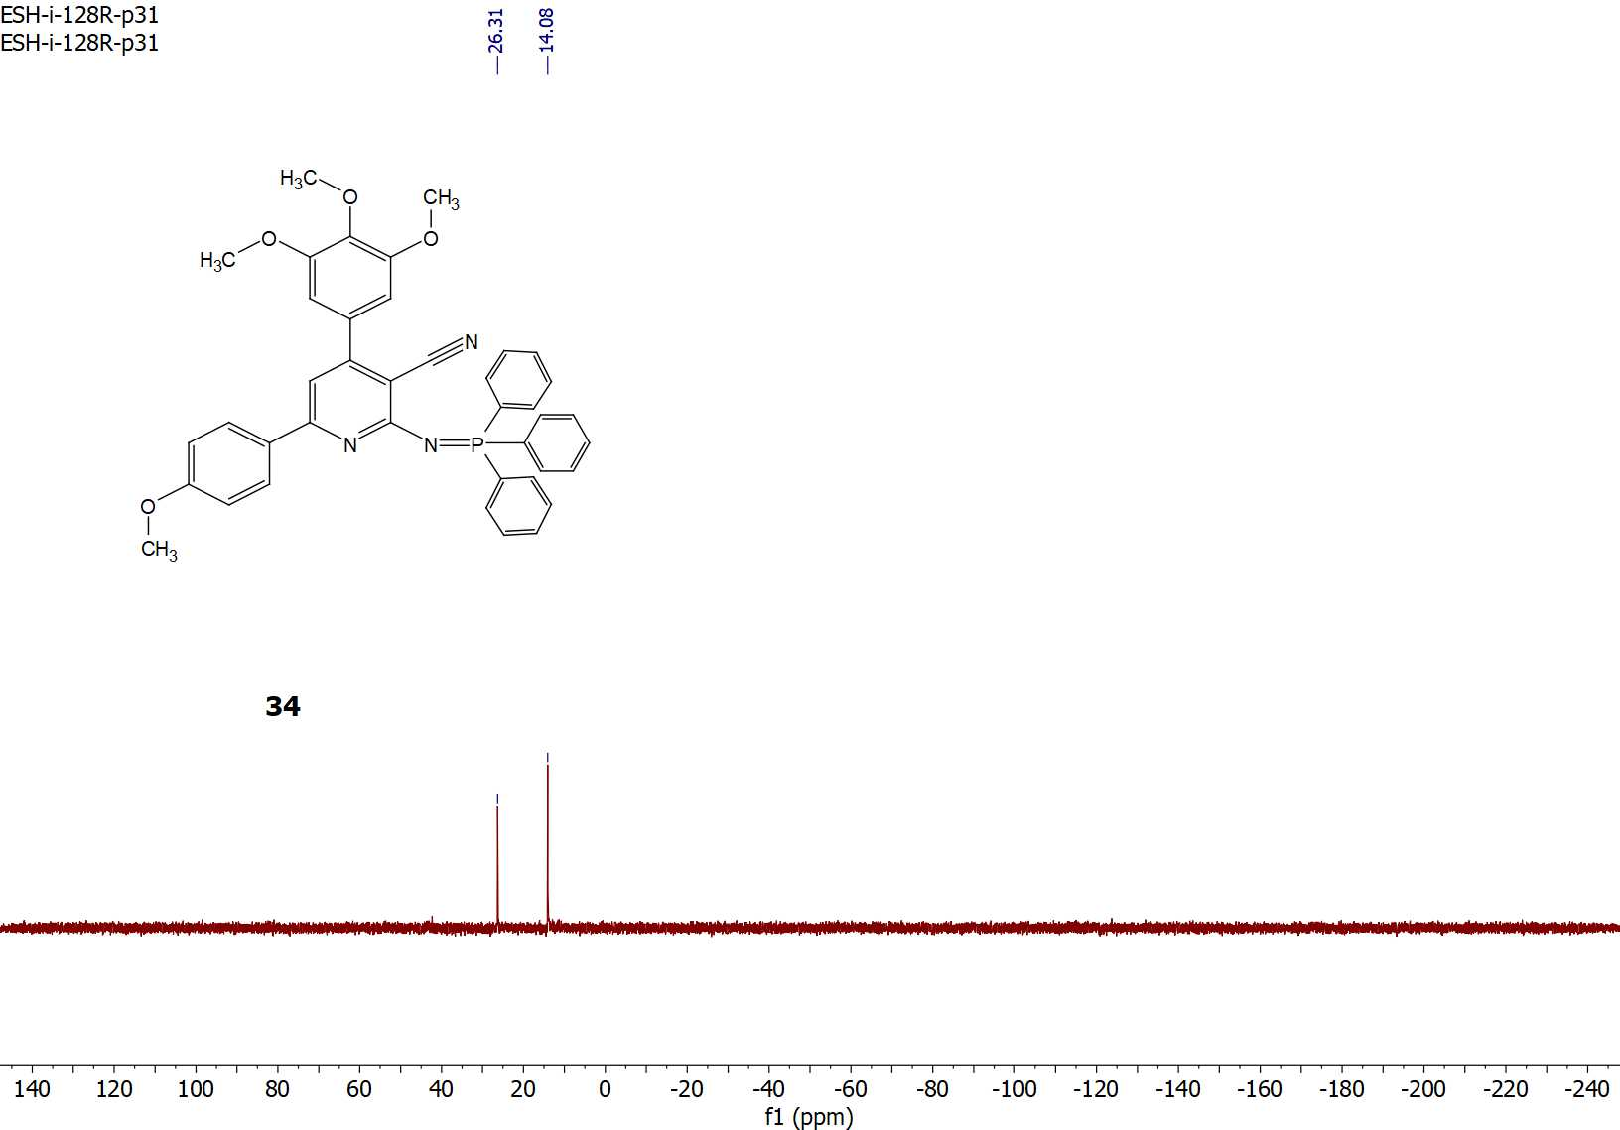
Figure S51: ³¹P-NMR spectrum of compound 34.

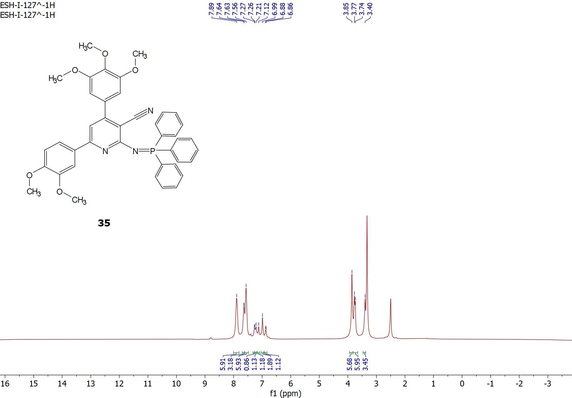
Figure S52: ¹H-NMR spectrum of compound 35.

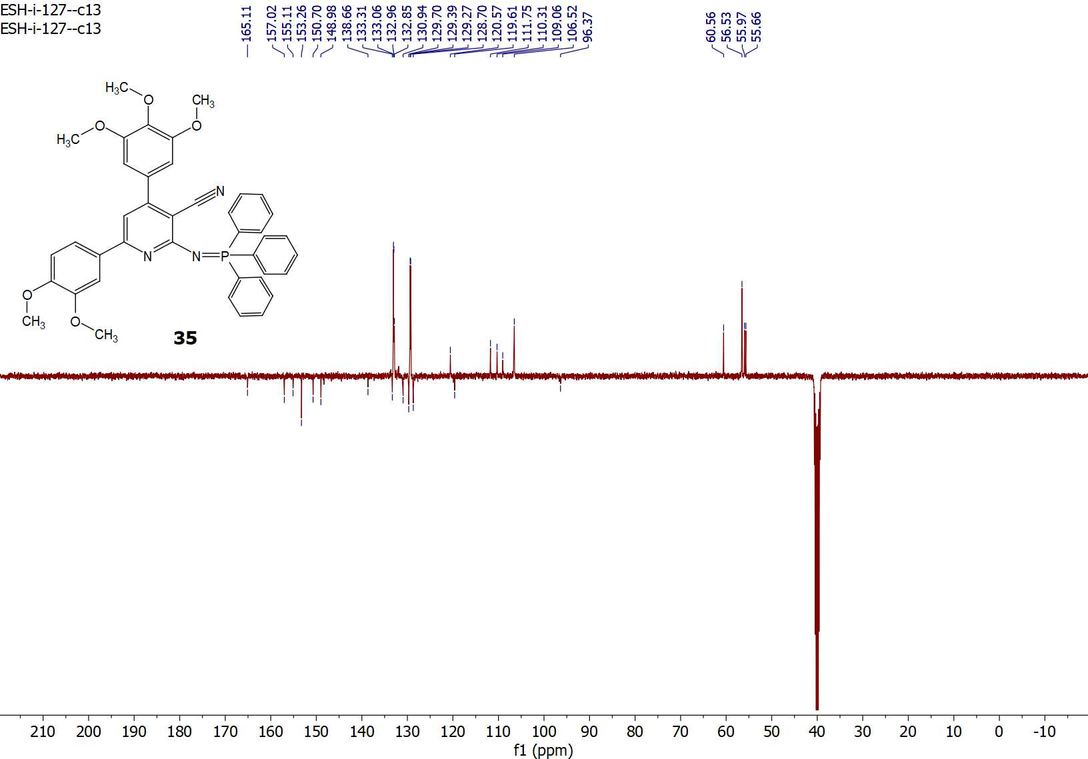
Figure S53: ¹³C-APT NMR spectrum of compound 35.

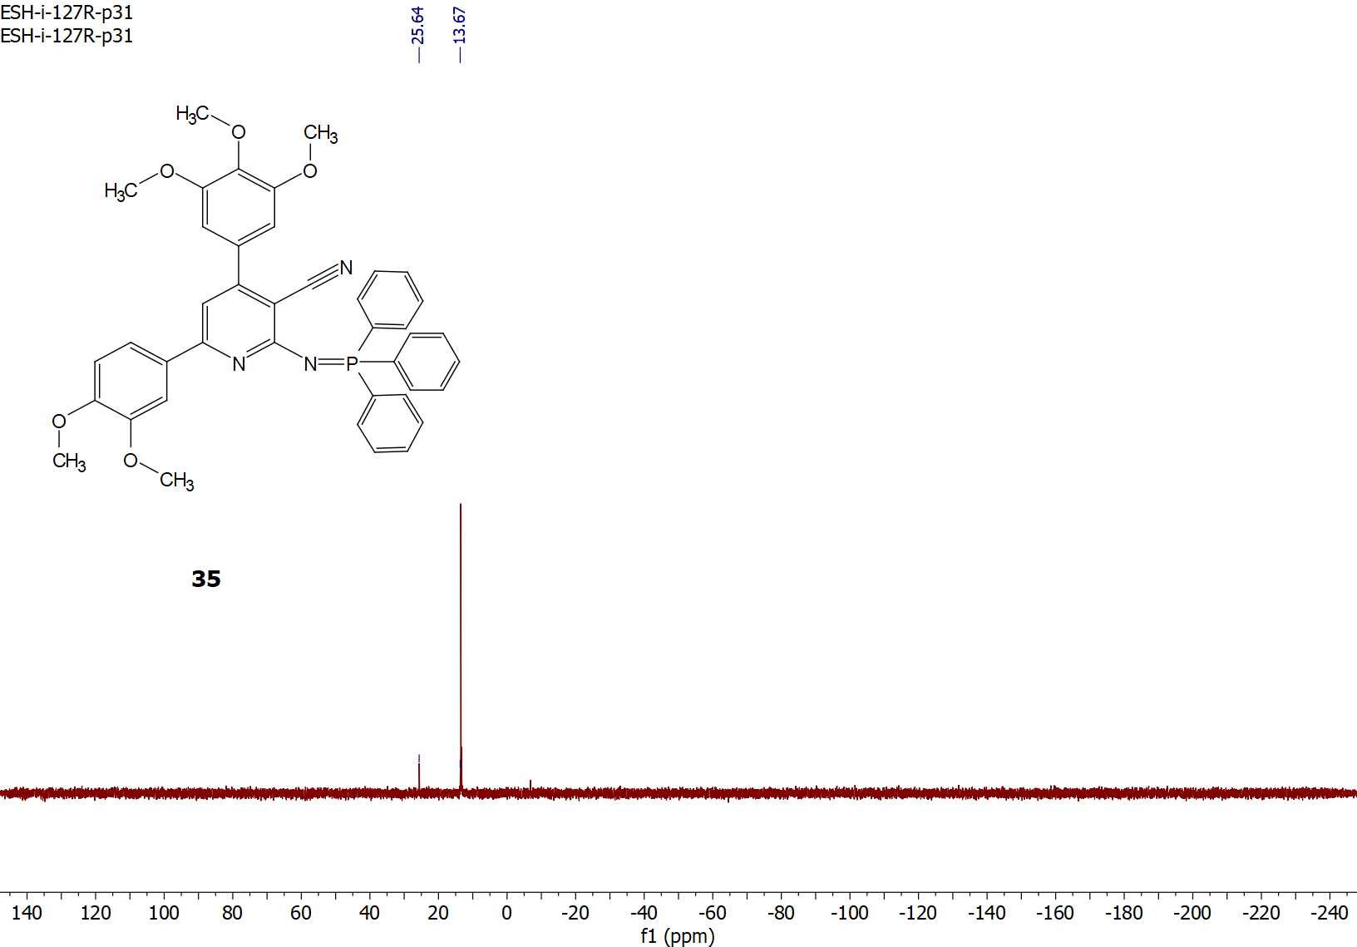
Figure S54: ³¹P-NMR spectrum of compound 35.
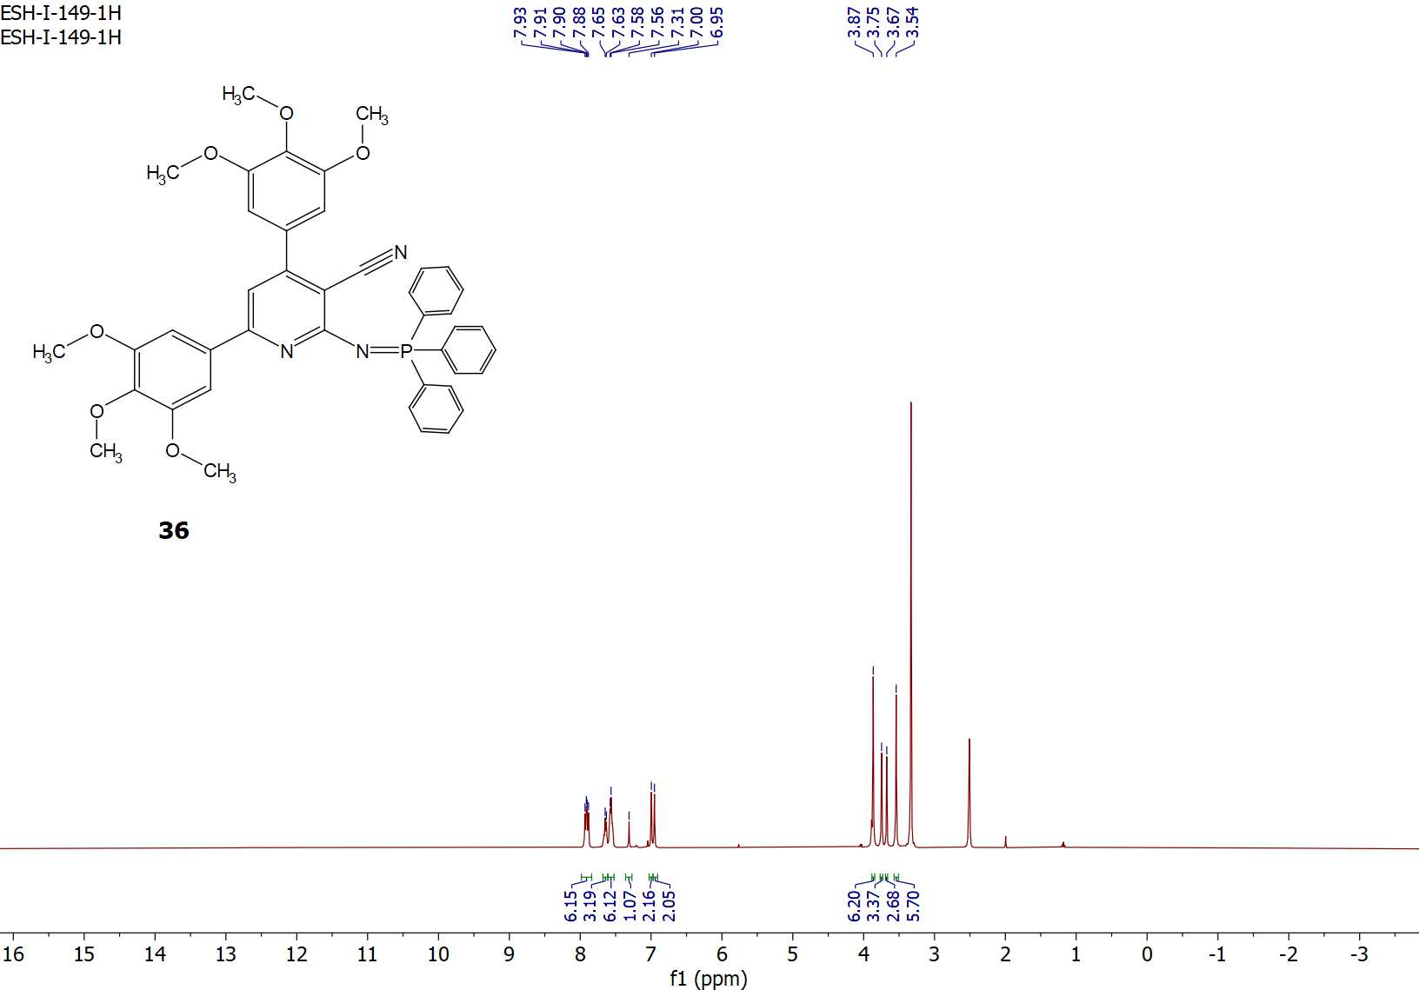
Figure S55: ¹H-NMR spectrum of compound 36.

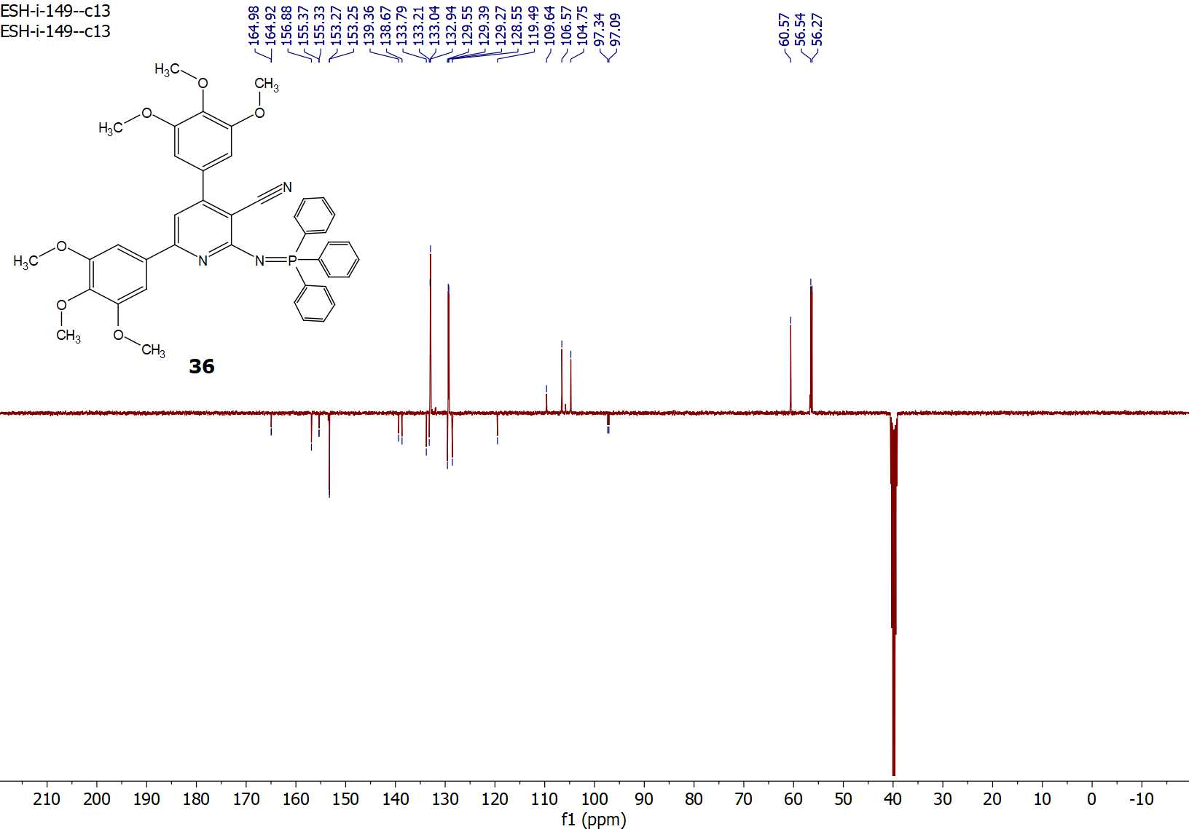
Figure S56: ¹³C-APT NMR spectrum of compound 36.

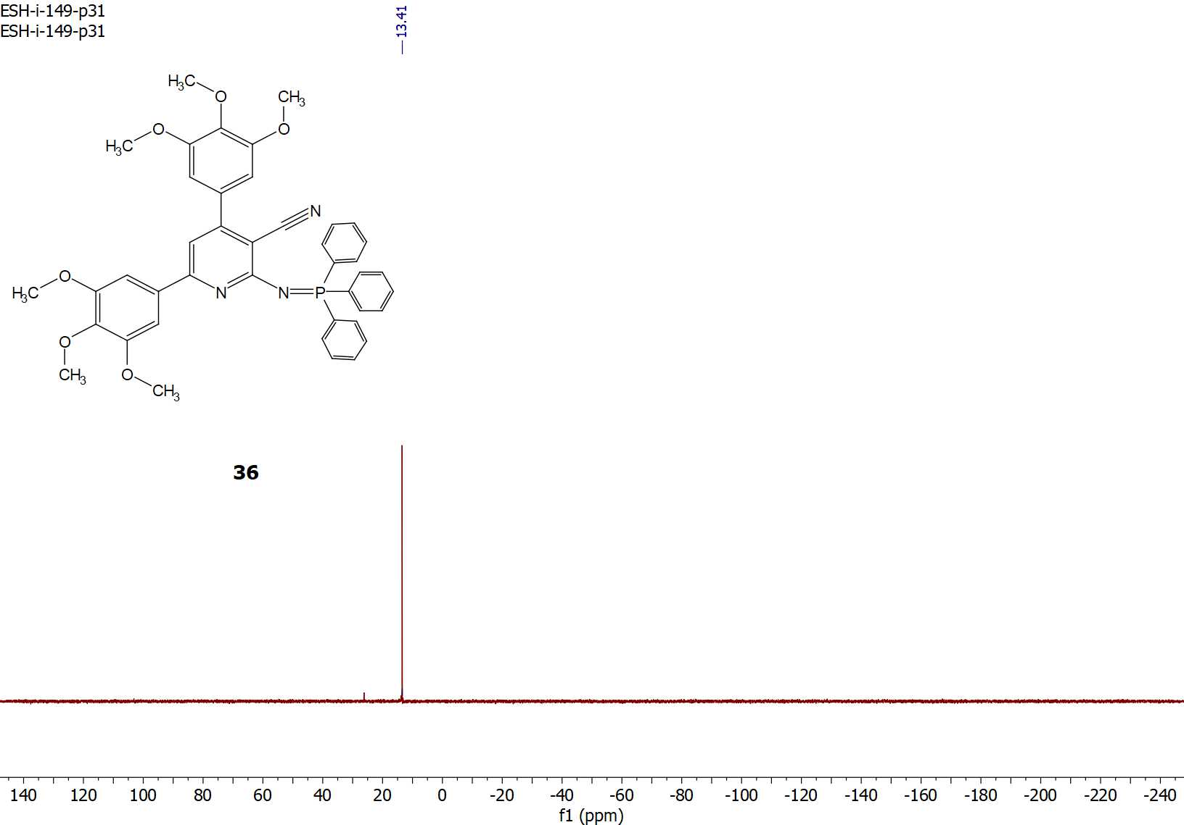
Figure S57: ³¹P-NMR spectrum of compound 36.

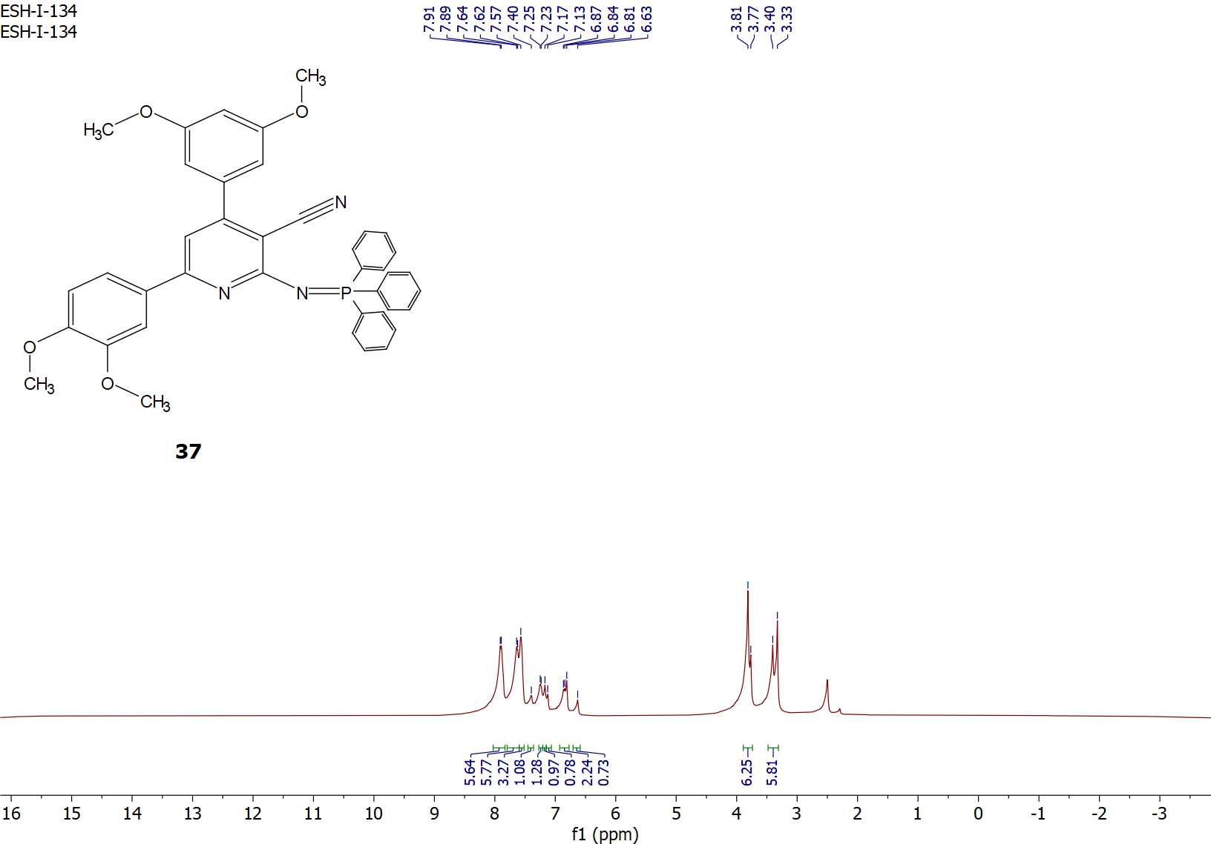
Figure S58: ¹H-NMR spectrum of compound 37.

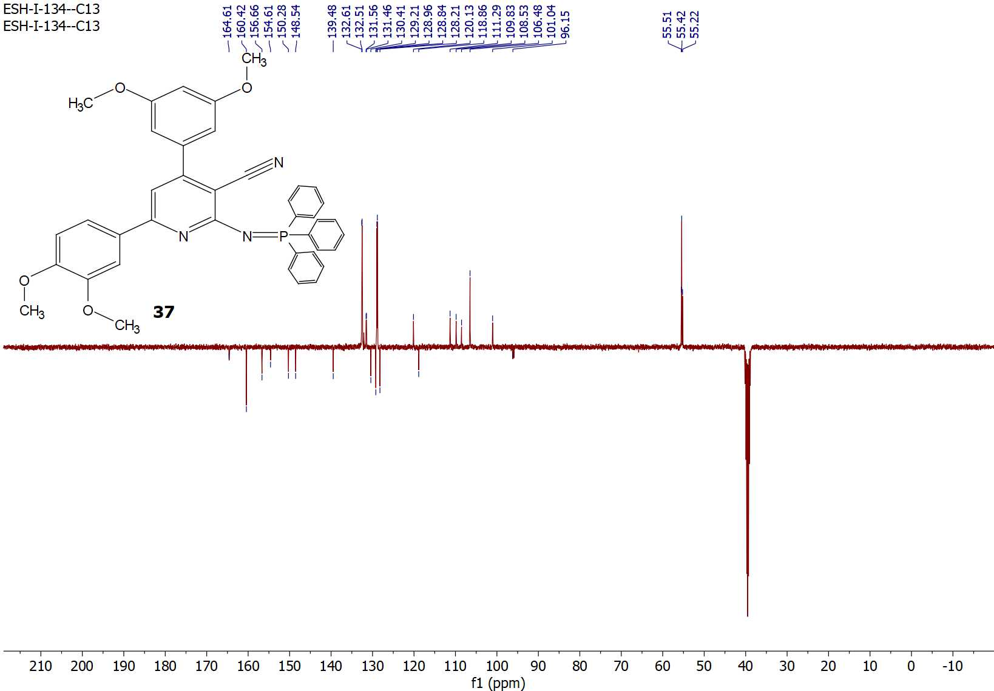
Figure S59: ¹³C-APT NMR spectrum of compound 37.

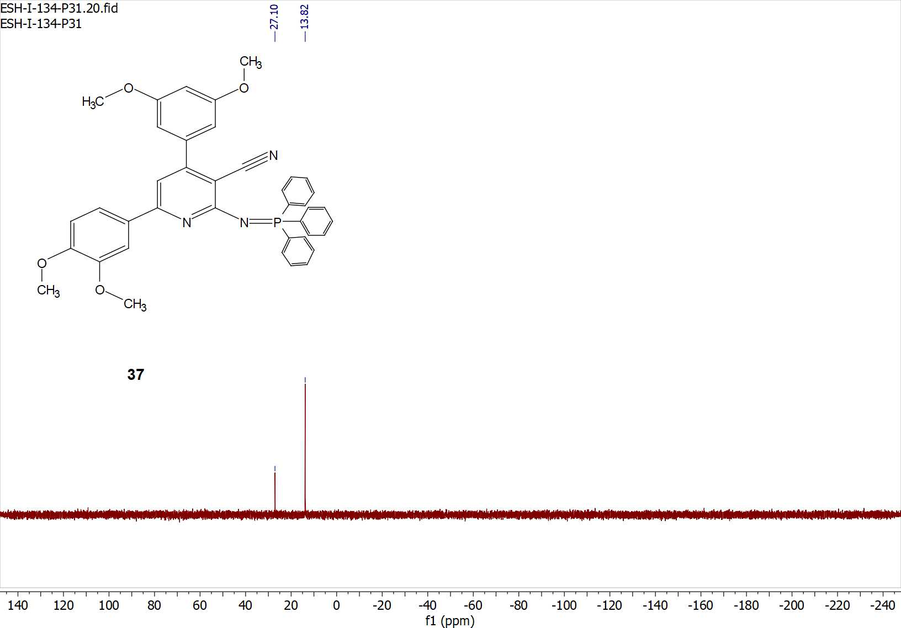
Figure S60: ³¹P-NMR spectrum of compound 37.

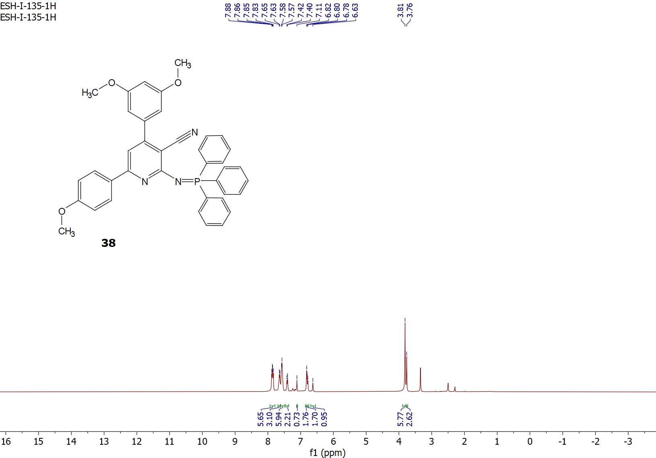
Figure S61: ¹H-NMR spectrum of compound 38.

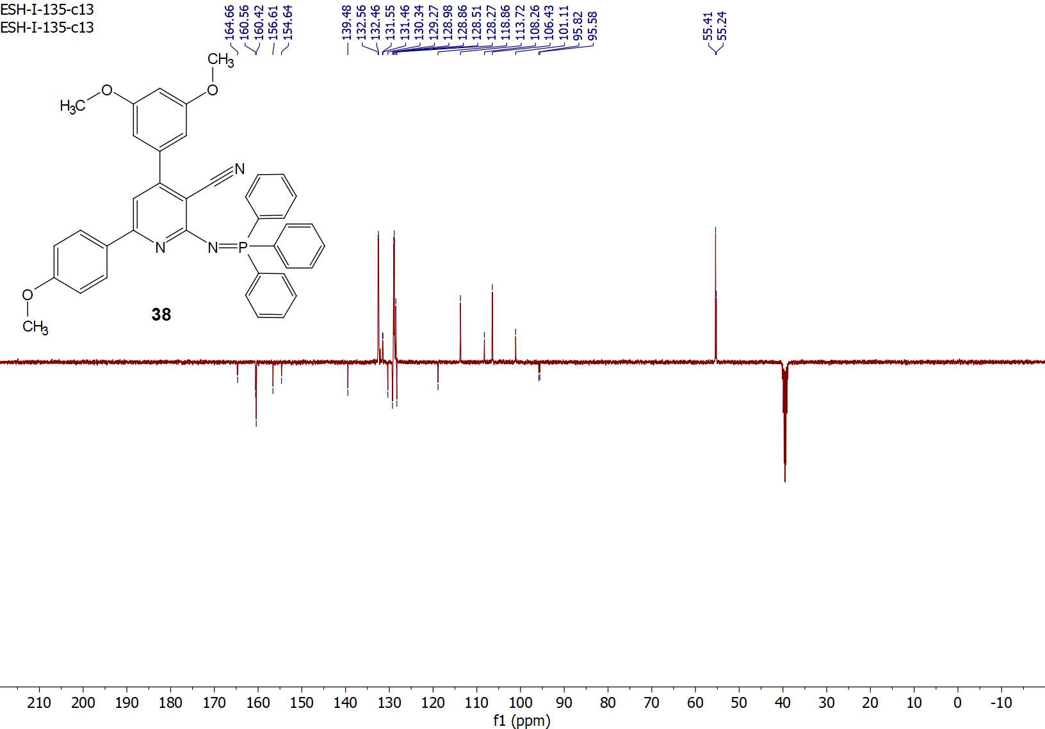
Figure S62: ¹³C-APT NMR spectrum of compound 38.

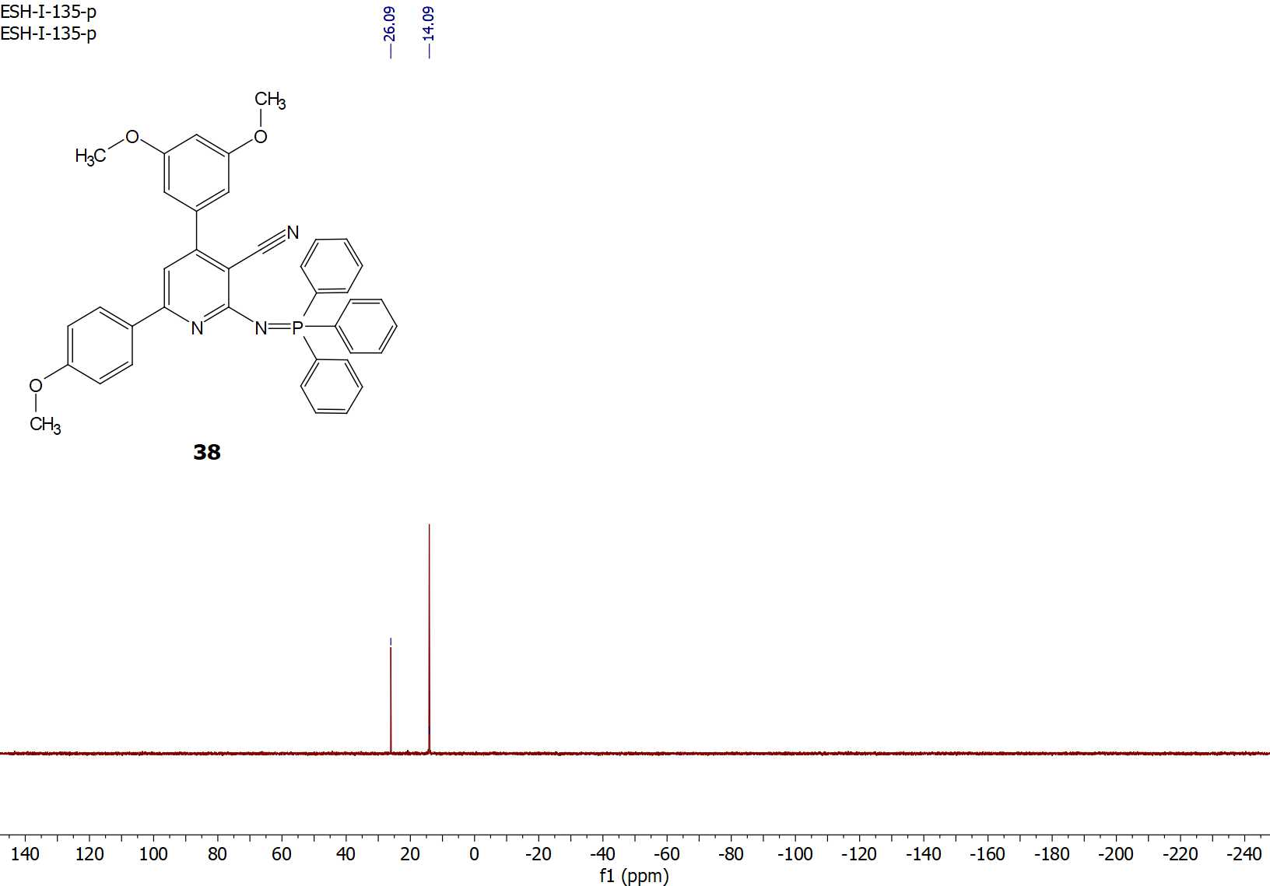
Figure S63: ³¹P-NMR spectrum of compound 38.

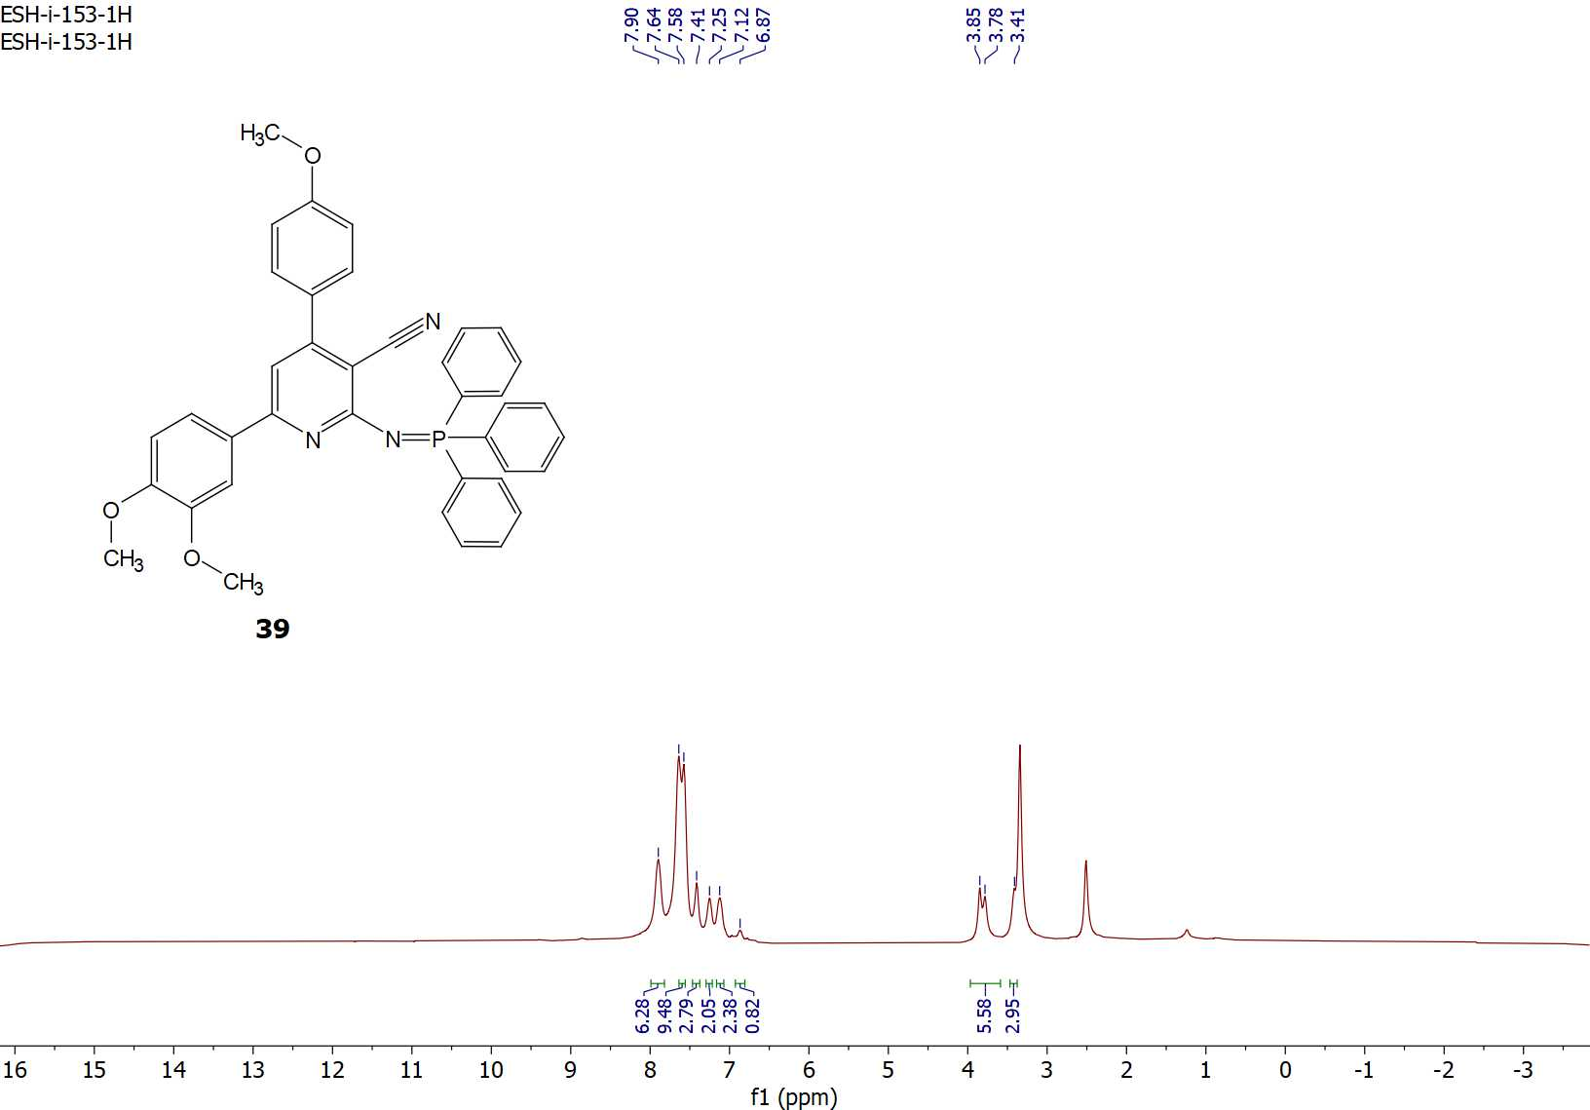
Figure S64: ¹H-NMR spectrum of compound 39.

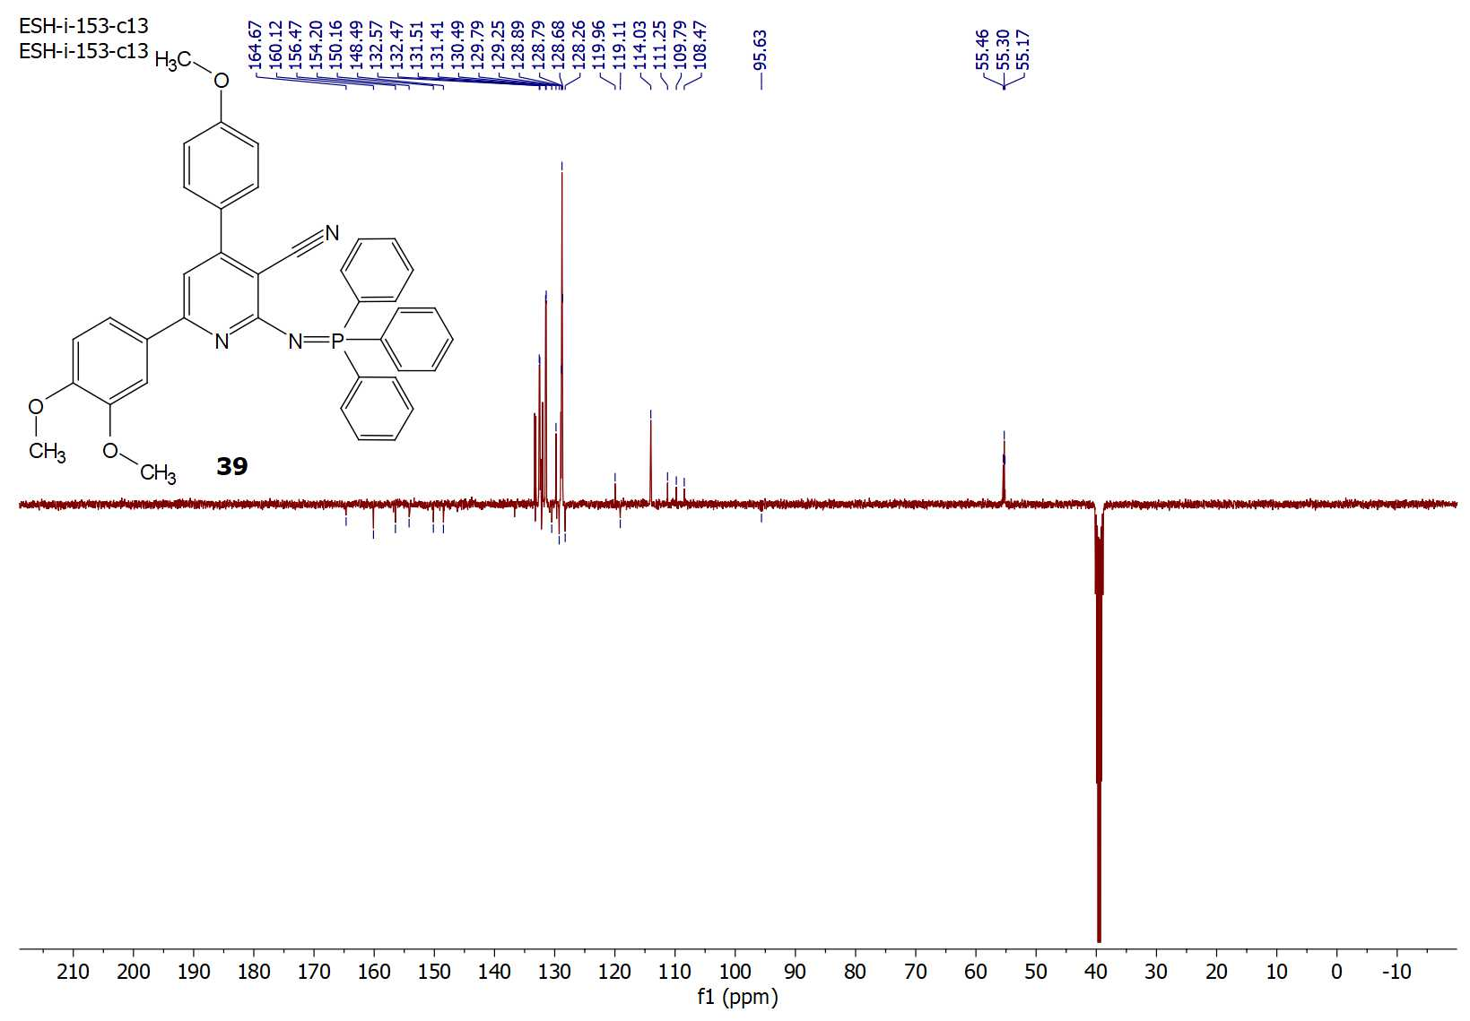
Figure S65: ¹³C-APT NMR spectrum of compound 39.

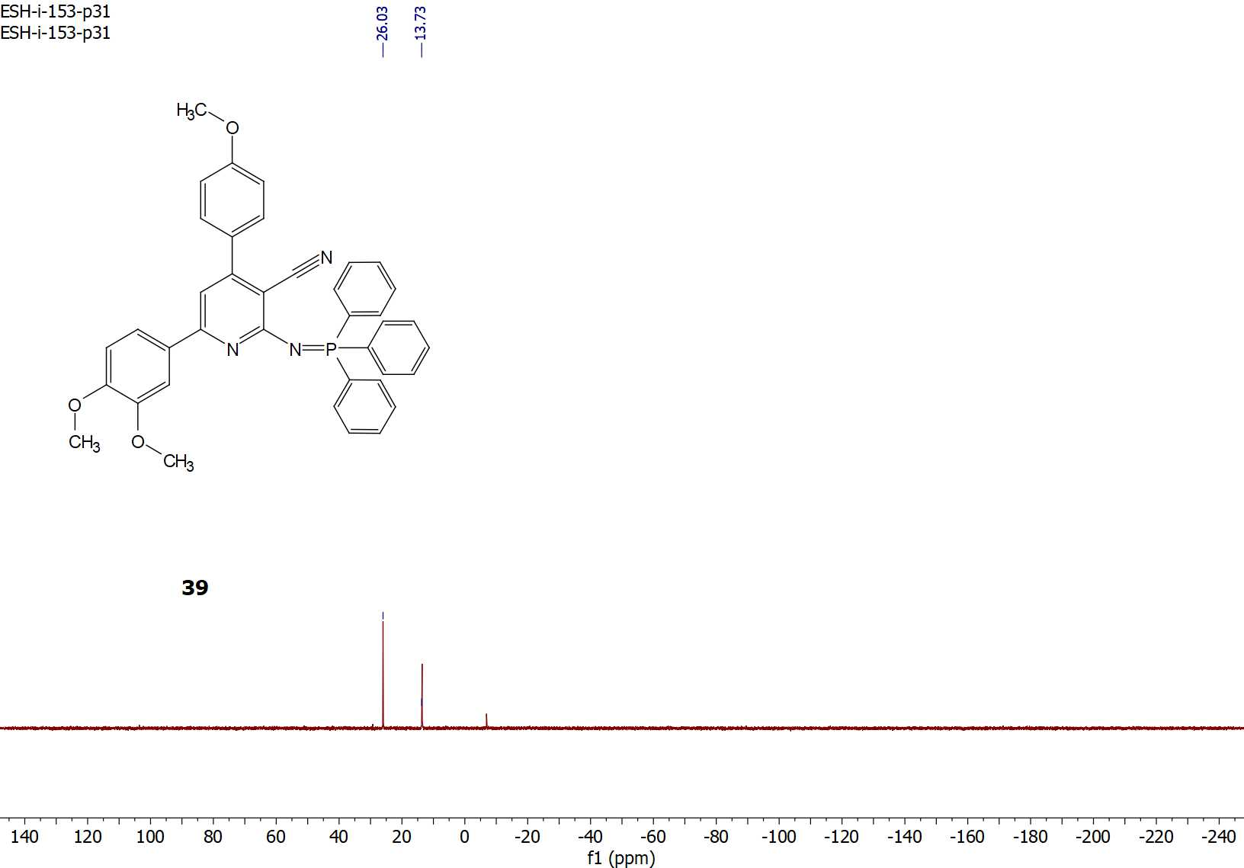
Figure S66: ³¹P-NMR spectrum of compound 39.

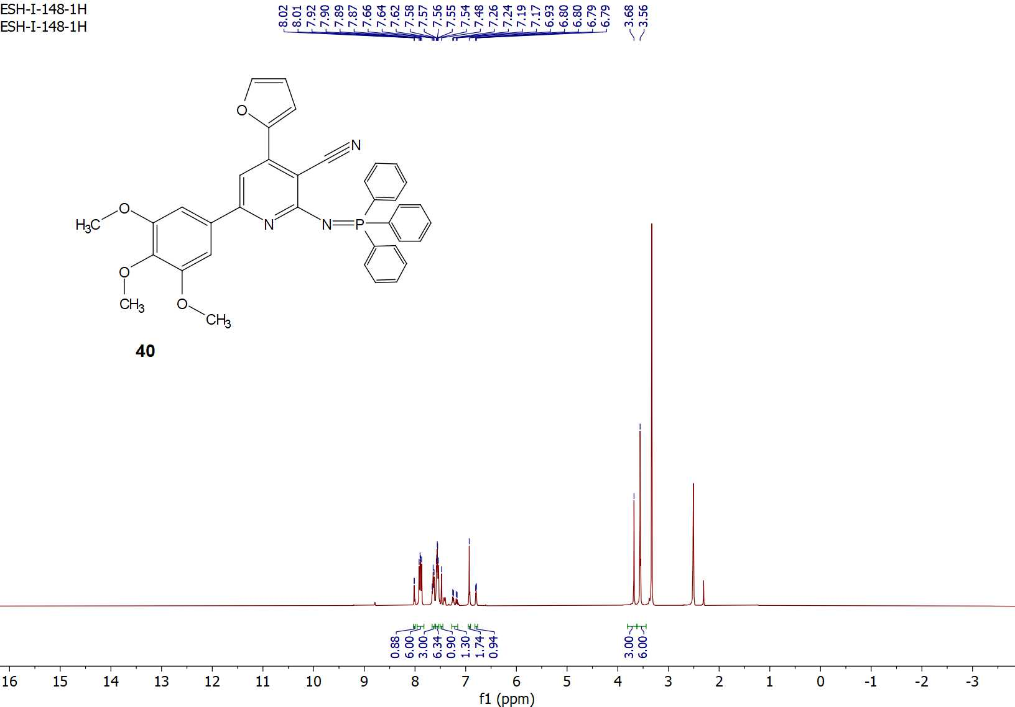
Figure S67: ¹H-NMR spectrum of compound 40.

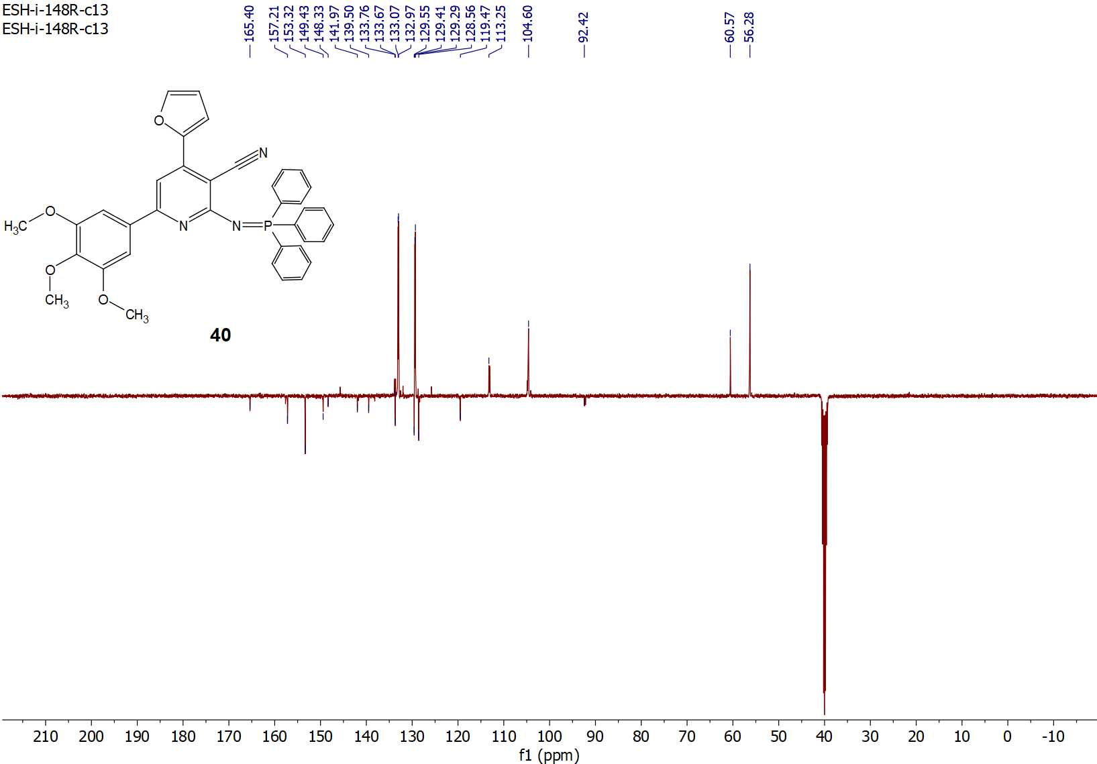
Figure S68: ¹³C-APT NMR spectrum of compound 40.

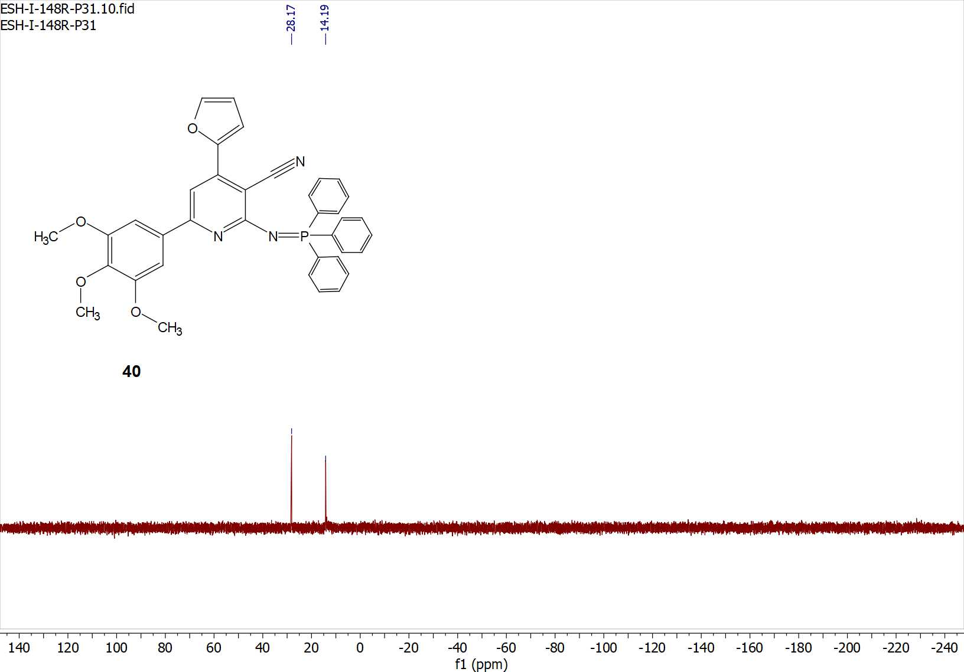
Figure S69: ³¹P-NMR spectrum of compound 40.

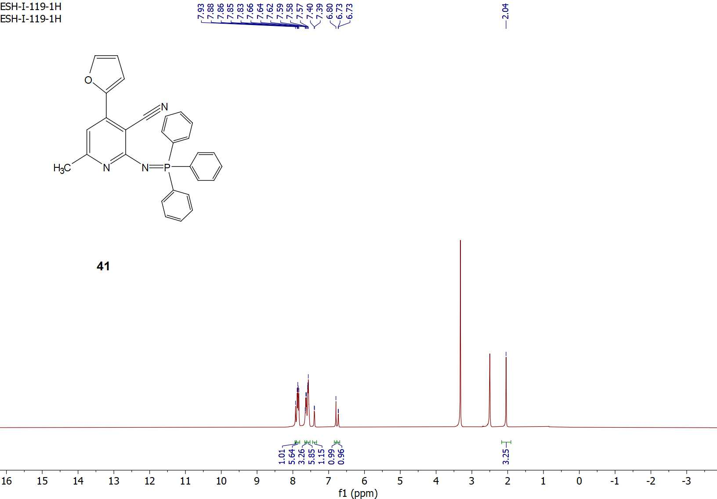
Figure S70: ¹H-NMR spectrum of compound 41.

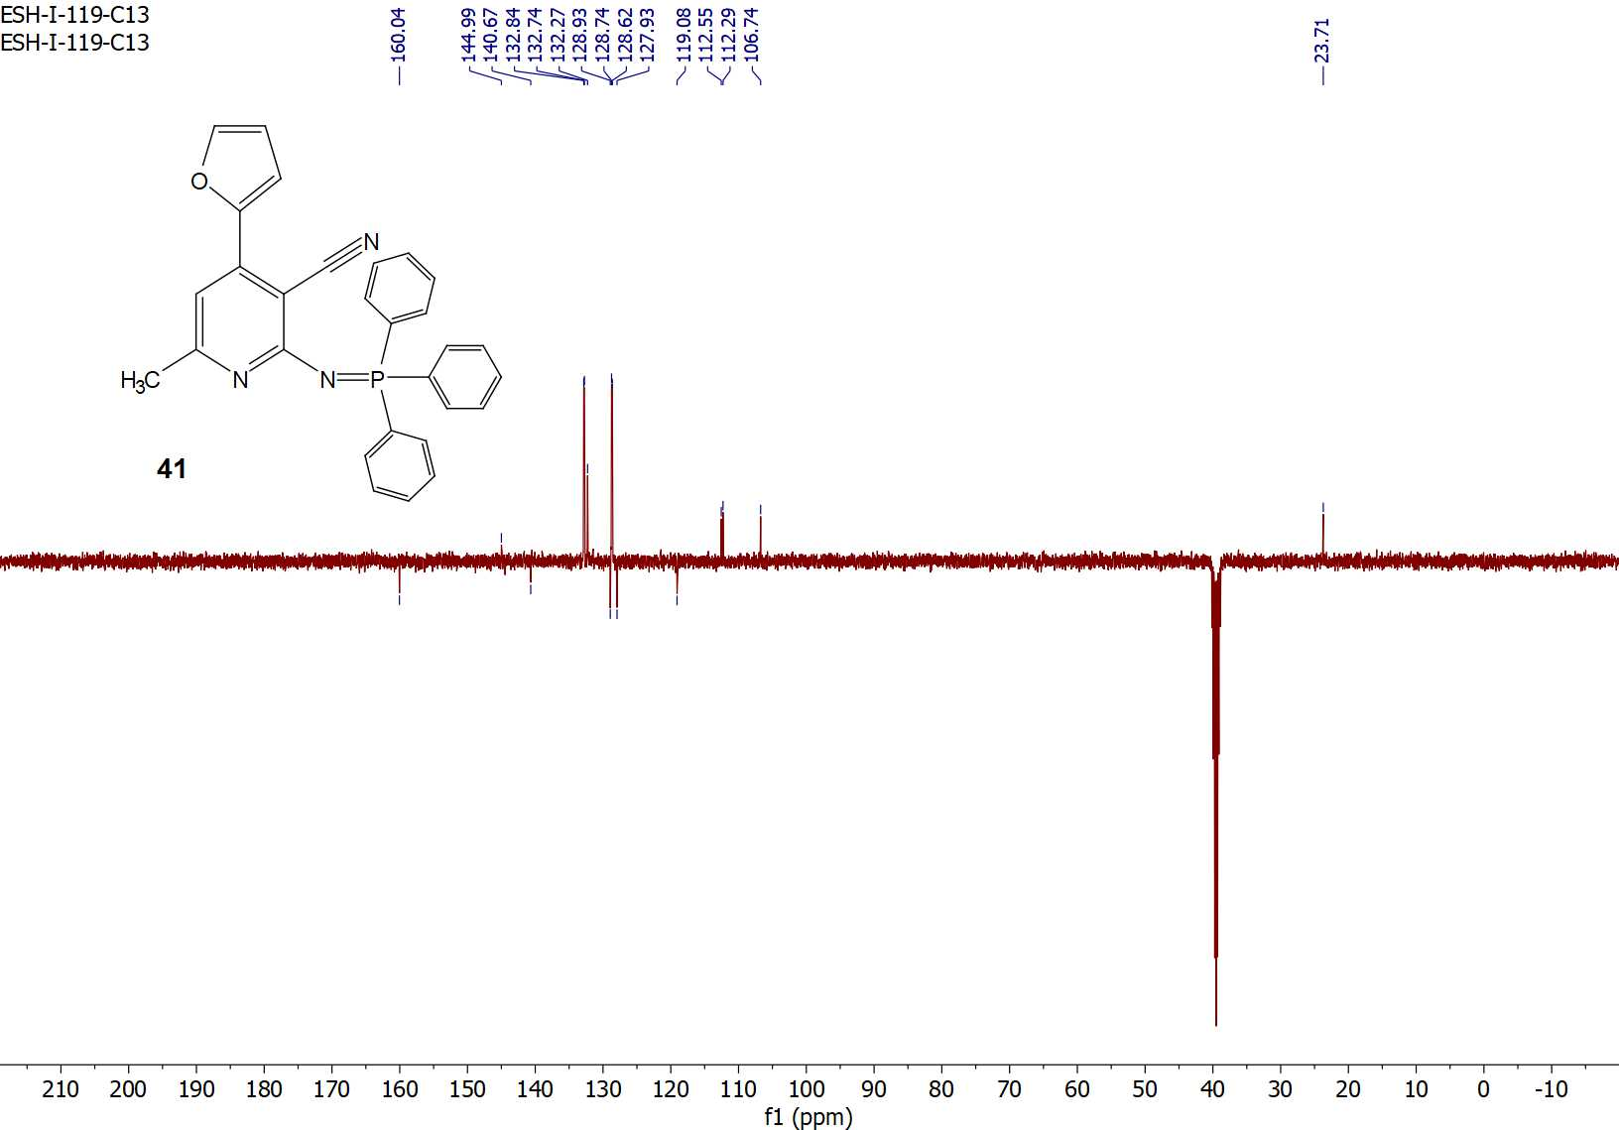
Figure S71: ¹³C-APT NMR spectrum of compound 41.

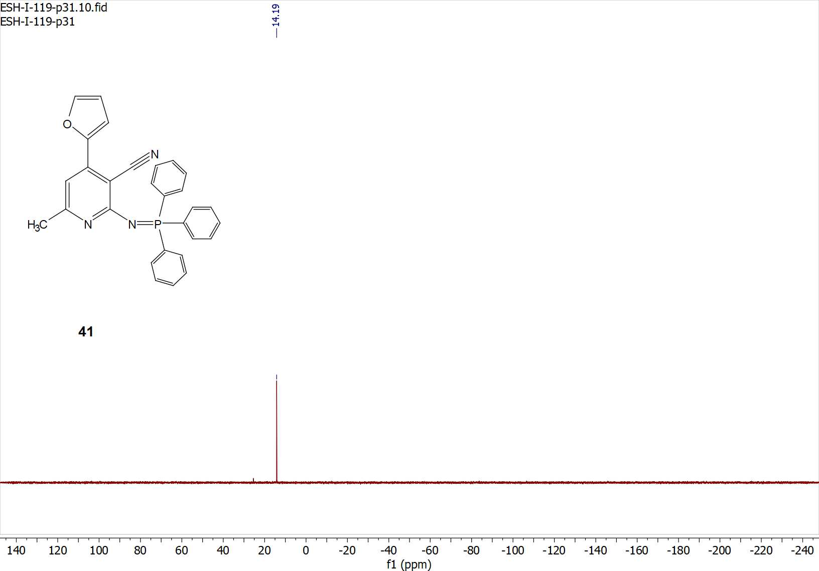
Figure S72: ³¹P-NMR spectrum of compound 41.

Compounds’ codes in paper | Corresponding codes in elemental analysis and mass spectroscopy
13 | ESH-4
14 | ESH-37
16 | ESH-98C
18 | ESH-33
19 | ESH-43
20 | ESH-137
21 | ESH-41
22 | ESH-45
23 | ESH-143
24 | ESH-139
26 | ESH-124
27 | ESH-125
28 | ESH-147
29 | ESH-132
30 | ESH-133
31 | ESH-150
32 | ESH-146
33 | ESH-112
34 | ESH-128
35 | ESH-127
36 | ESH-149
37 | ESH-134
38 | ESH-135
39 | ESH-153
40 | ESH-148
41 | ESH-119
Elemental analysis and Mass spectroscopy

Table S1: Compounds’ codes and their corresponding codes in elemental analysis and mass spectroscopy figures.
Elemental analysis
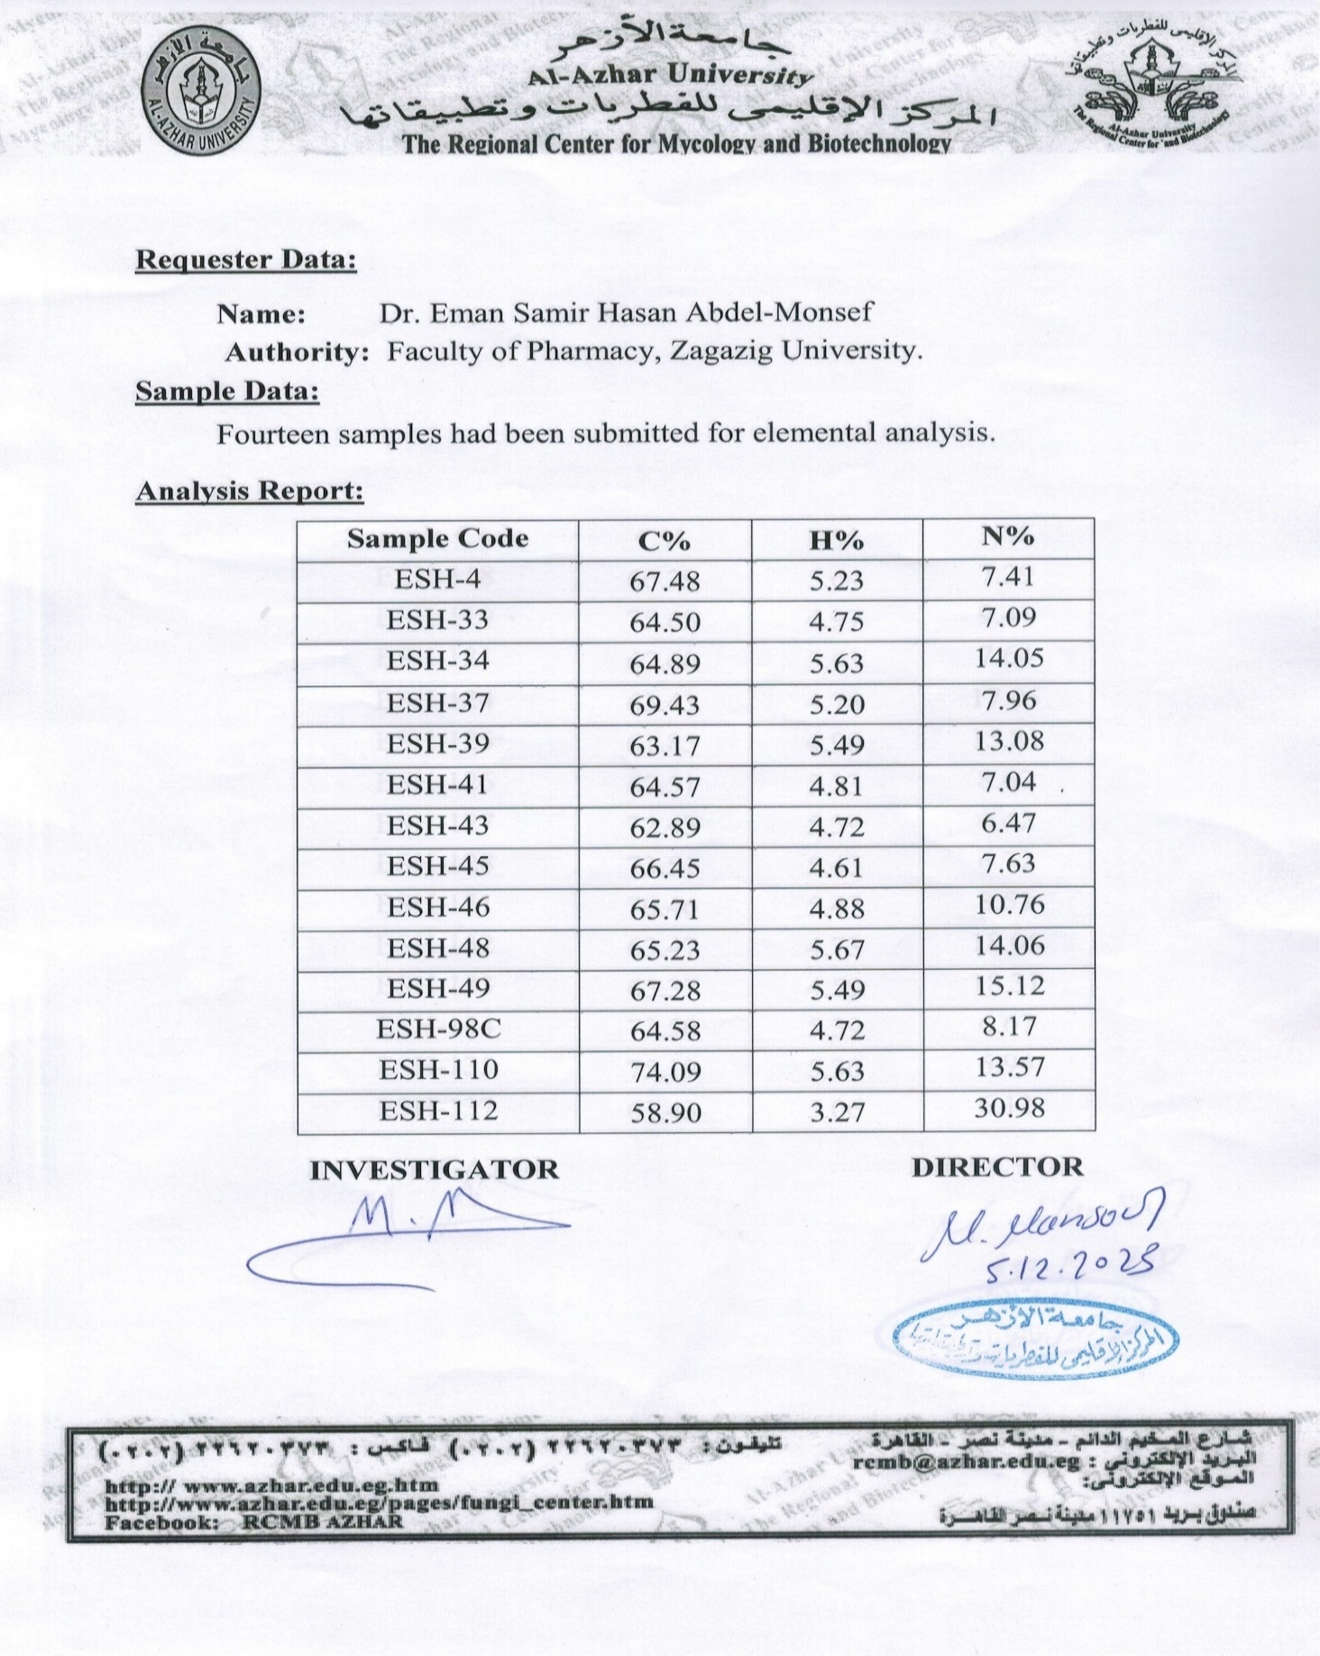
Figure S73: Elemental analysis of compounds 13, 14, 16, 18, 19, 21, 22, 33.
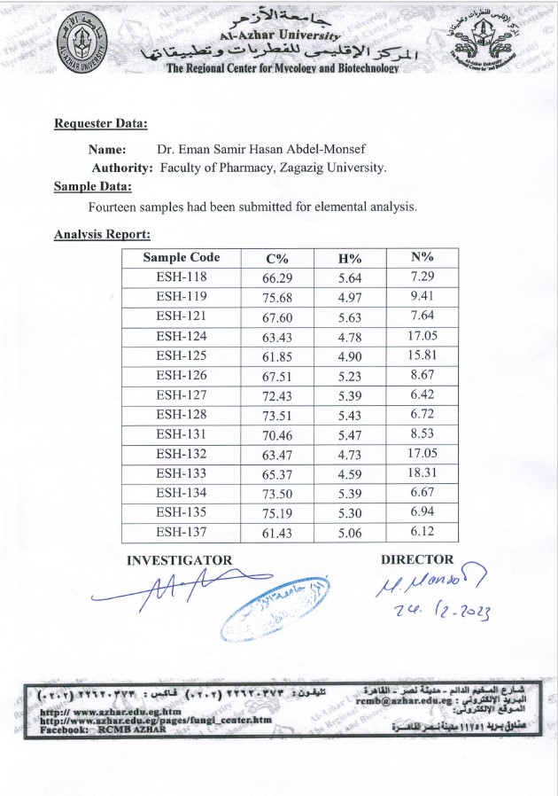
Figure S74: Elemental analysis of compounds 20, 26, 27, 29, 30, 34, 35, 37, 38, 41.

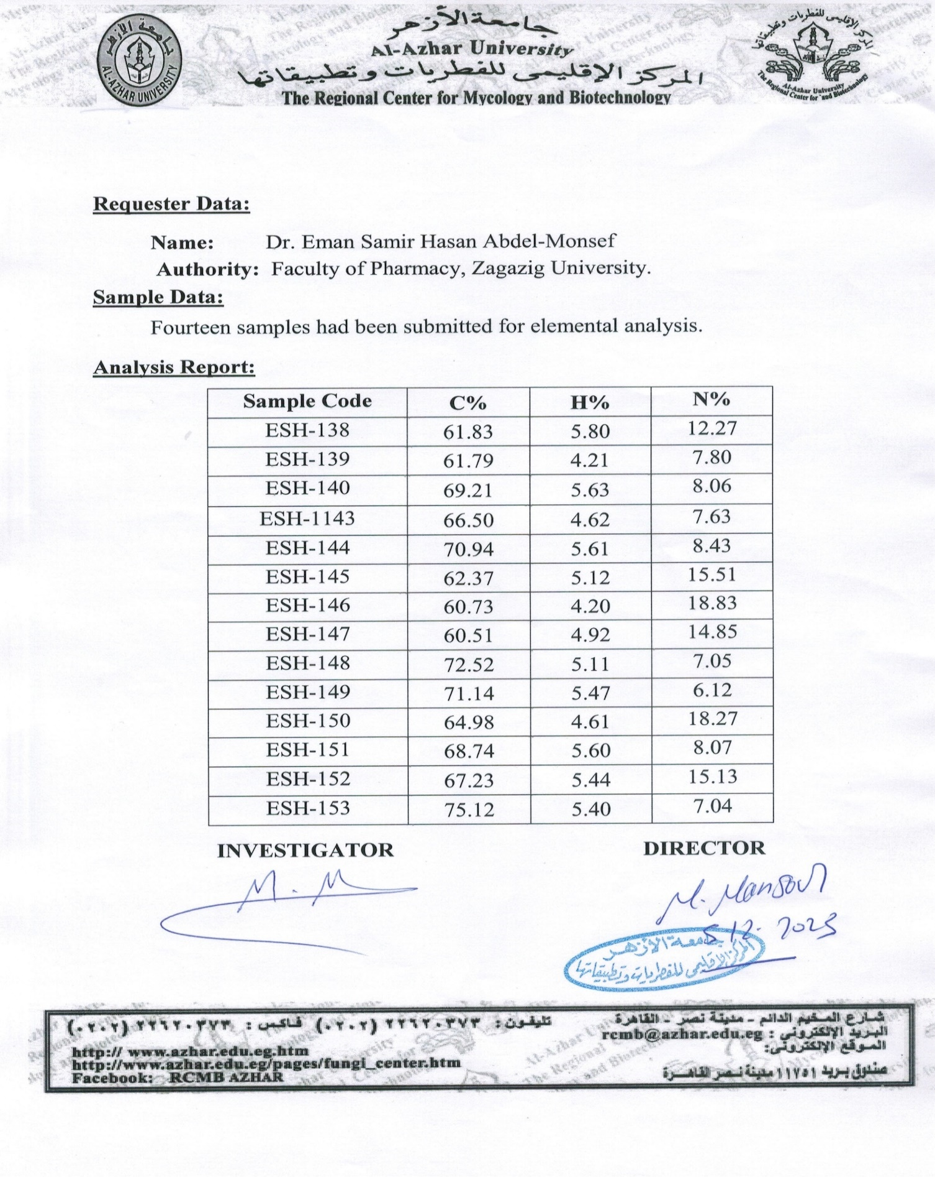
Figure S75: Elemental analysis of compounds 23, 24, 28, 31, 32, 36, 39, 40.
Mass spectroscopy
Figure S76: Mass spectrum of compound 13.
Figure S77: Mass spectrum of compound 14.
Figure S78: Mass spectrum of compound 16.
Figure S79: Mass spectrum of compound 18.
Figure S80: Mass spectrum of compound 19.
Figure S81: Mass spectrum of compound 20.
Figure S82: Mass spectrum of compound 21.
Figure S83: Mass spectrum of compound 22.
Figure S84: Mass spectrum of compound 23.
Figure S85: Mass spectrum of compound 24.
Figure S86: Mass spectrum of compound 26.
Figure S87: Mass spectrum of compound 27.

Figure S88: Mass spectrum of compound 28.
Figure S89: Mass spectrum of compound 29.
Figure S90: Mass spectrum of compound 30.
Figure S91: Mass spectrum of compound 31.
Figure S92: Mass spectrum of compound 32.

Figure S93: Mass spectrum of compound 33.

Figure S94: Mass spectrum of compound 34.

Figure S95: Mass spectrum of compound 35.

Figure S96: Mass spectrum of compound 36.
Figure S97: Mass spectrum of compound 37.
Figure S98: Mass spectrum of compound 38.
Figure S99: Mass spectrum of compound 39.
Figure S100: Mass spectrum of compound 40.
Figure S101: Mass spectrum of compound 41.
IR spectra

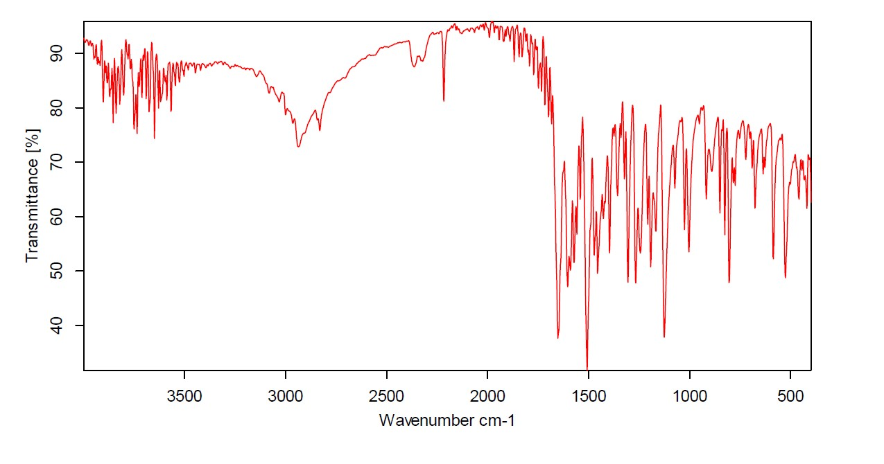
Figure S102: IR spectrum of compound 10

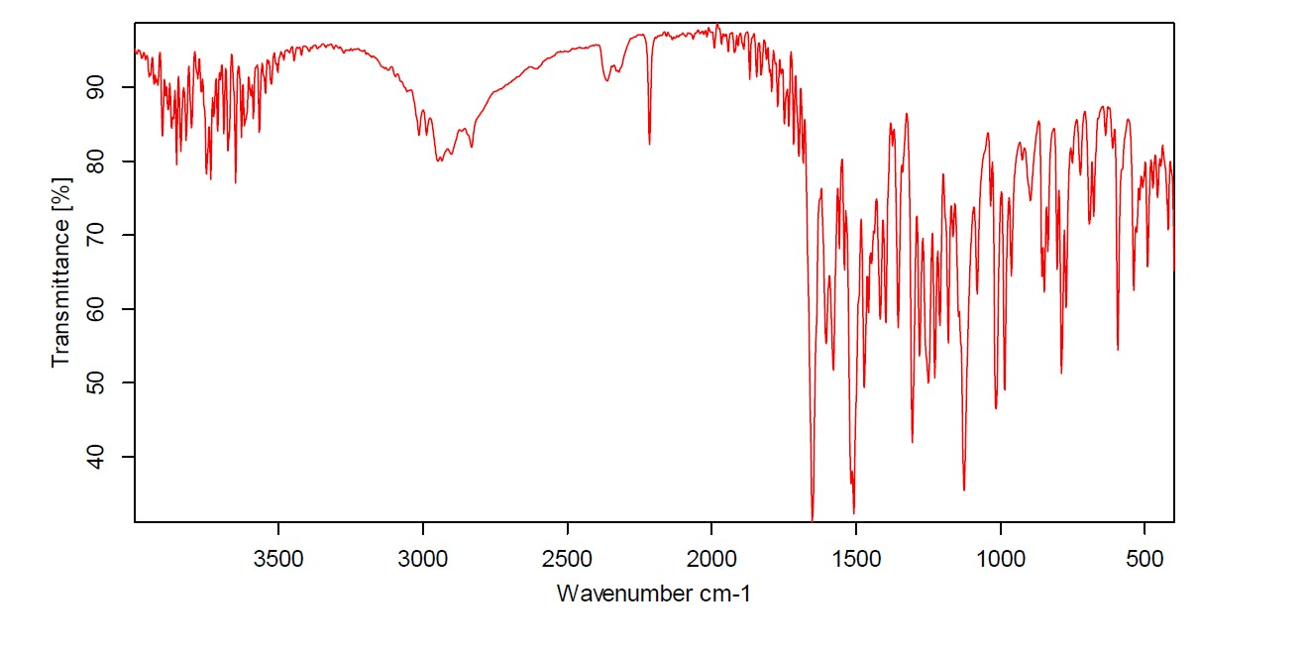
Figure S103: IR spectrum of compound 11.

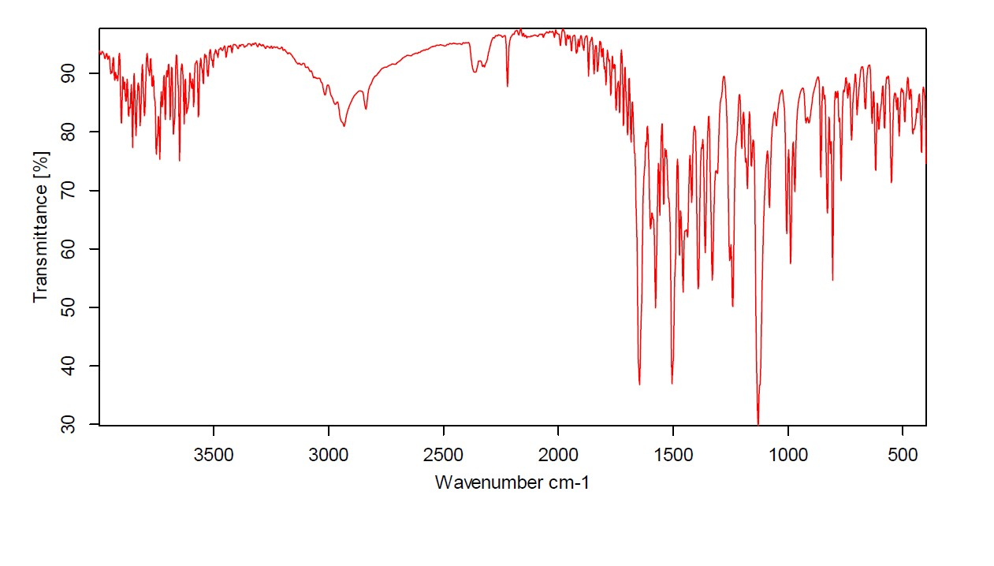
Figure S104: IR spectrum of compound 12.

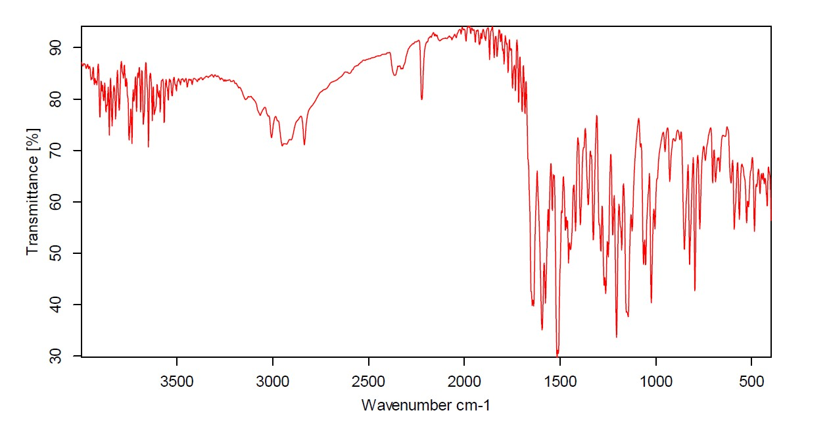
Figure S105: IR spectrum of compound 13.

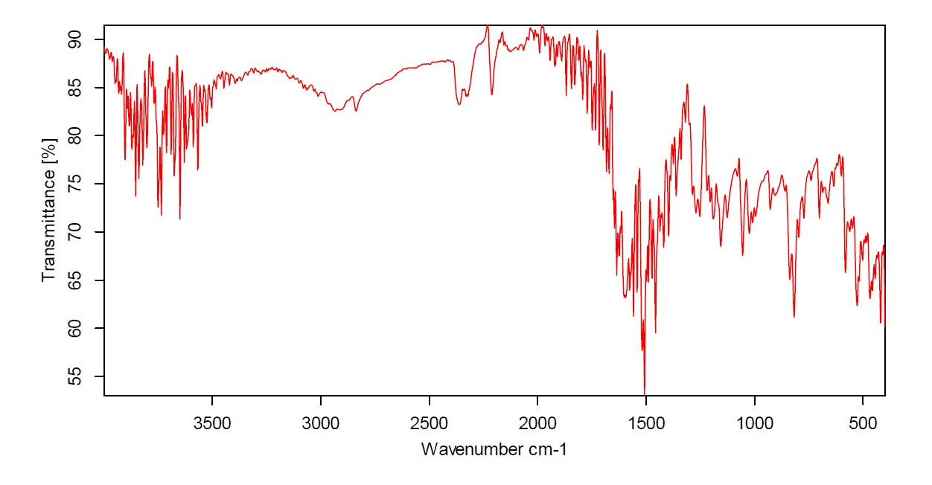
Figure S106: IR spectrum of compound 14.

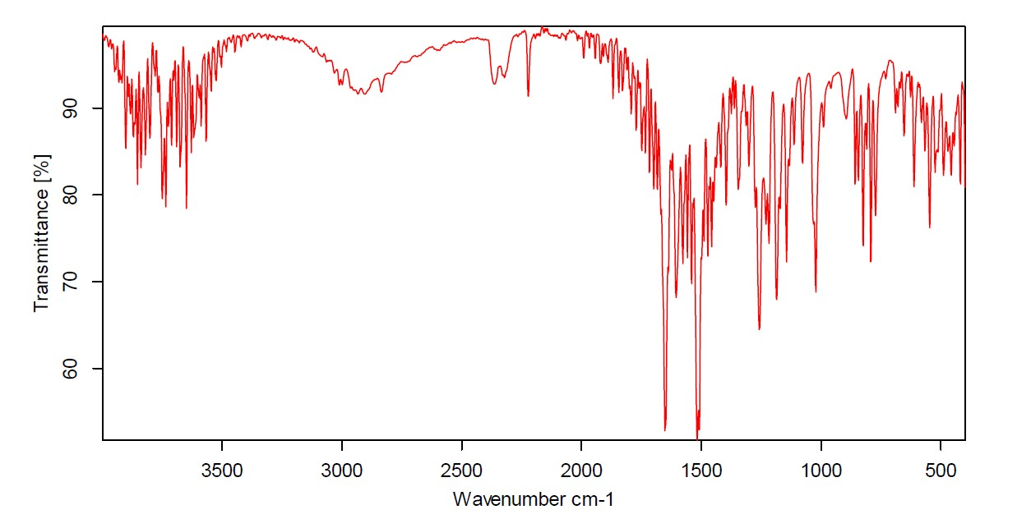
Figure S107: IR spectrum of compound 15.
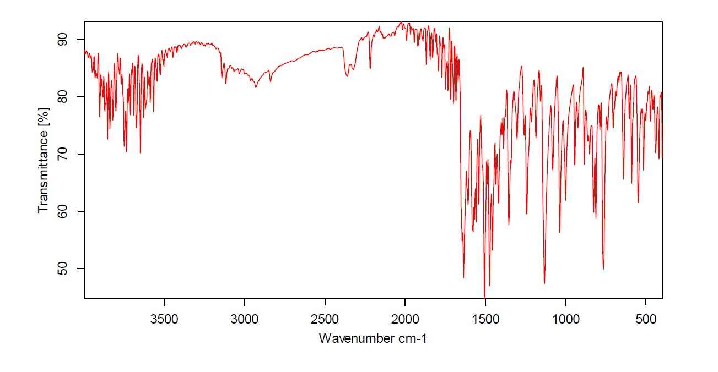
Figure S108: IR spectrum of compound 16.

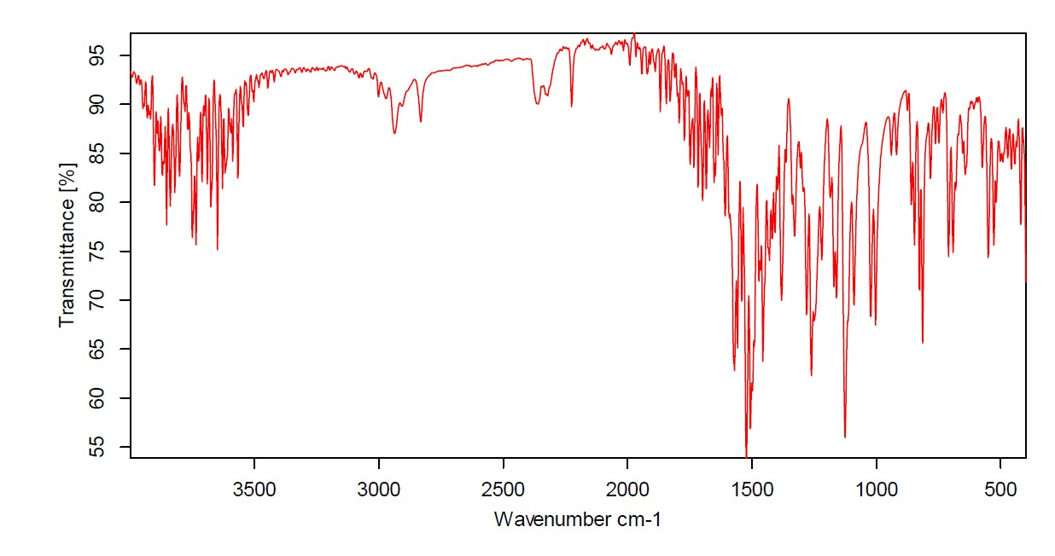
Figure S109: IR spectrum of compound 18.

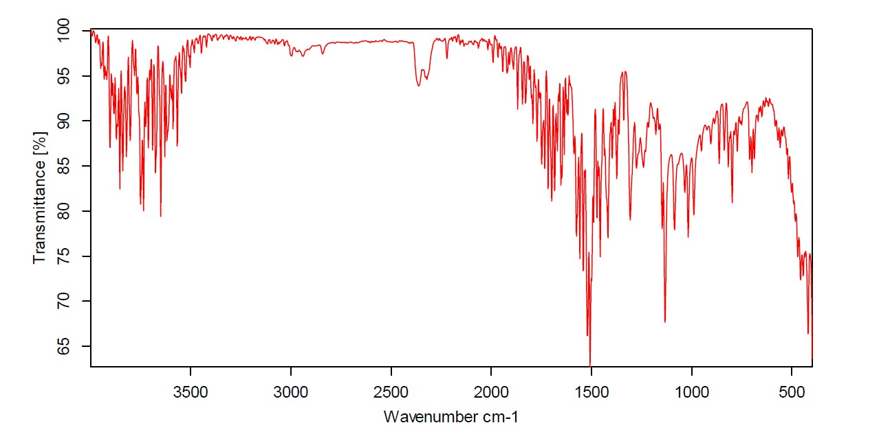
Figure S110: IR spectrum of compound 19.

Figure S111: IR spectrum of compound 20.

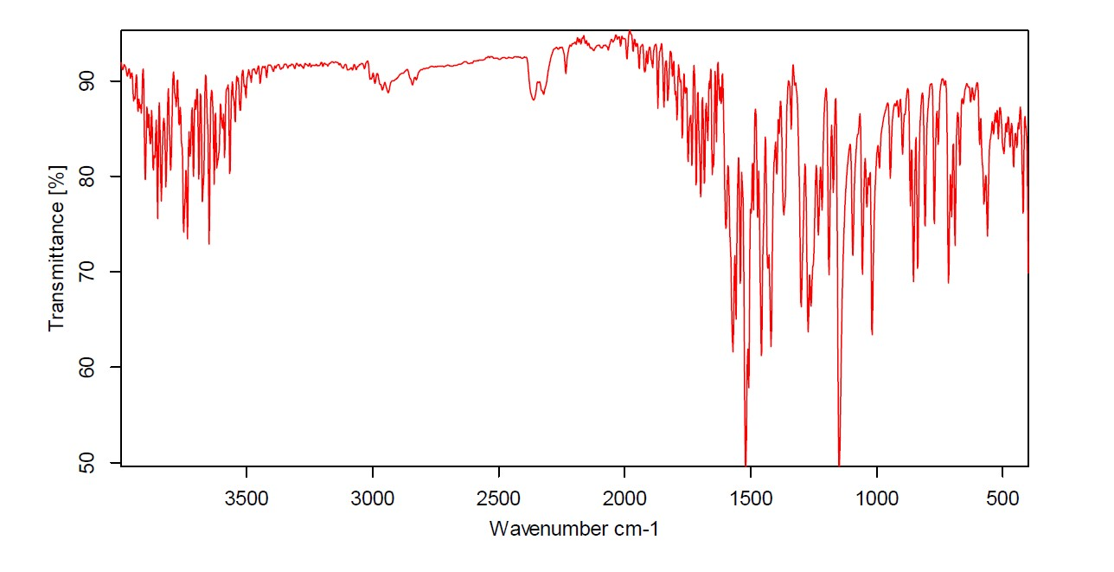
Figure S112: IR spectrum of compound 21.

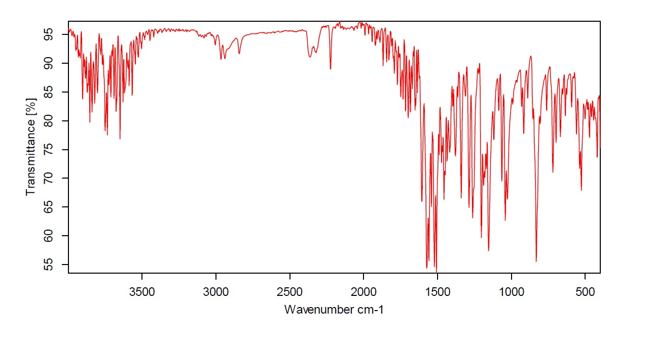
Figure S113: IR spectrum of compound 22.

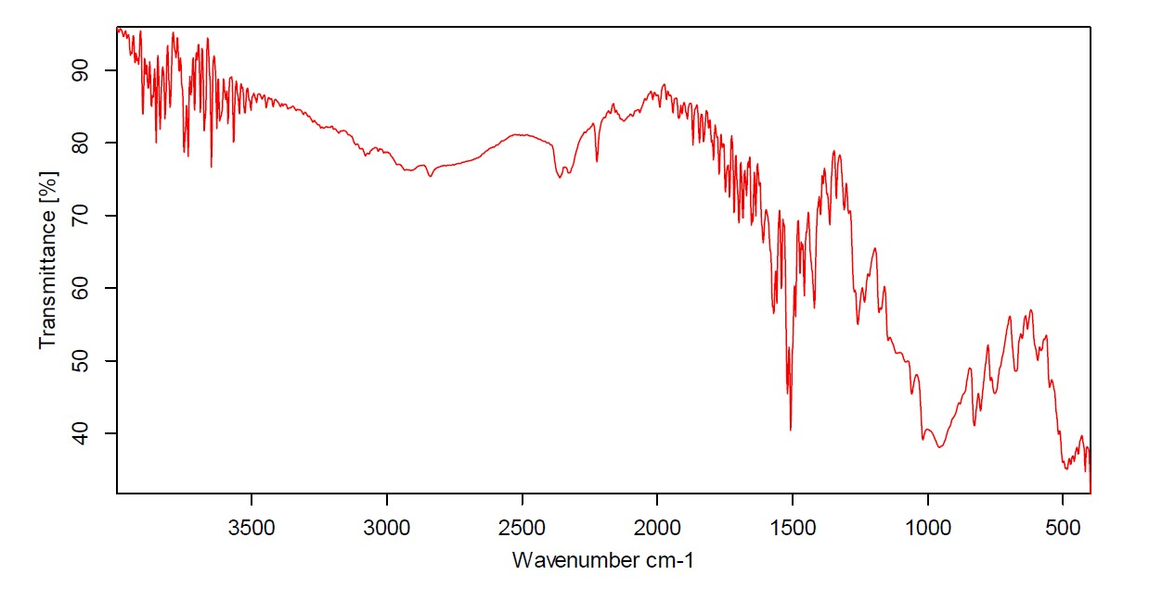
Figure S114: IR spectrum of compound 23.

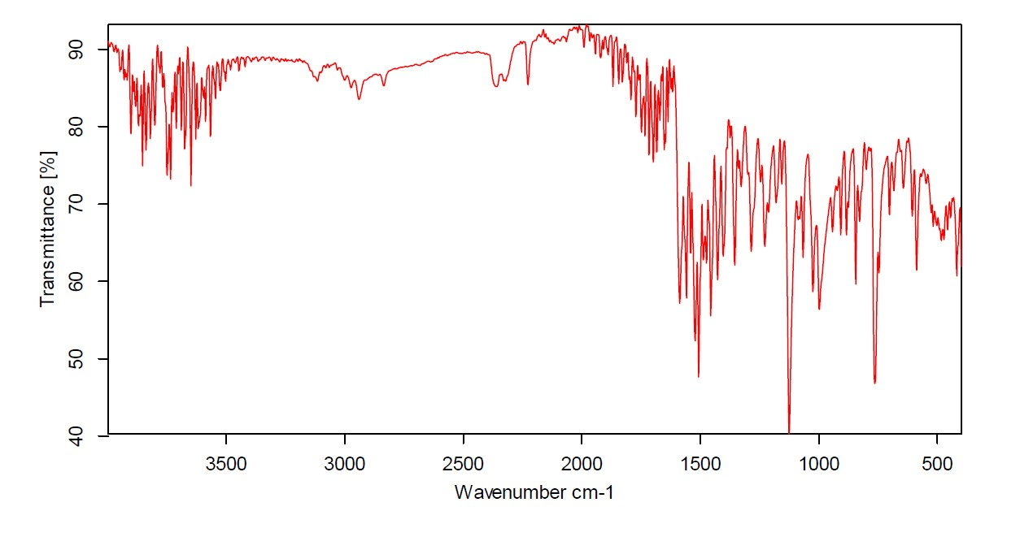
Figure S115: IR spectrum of compound 24.

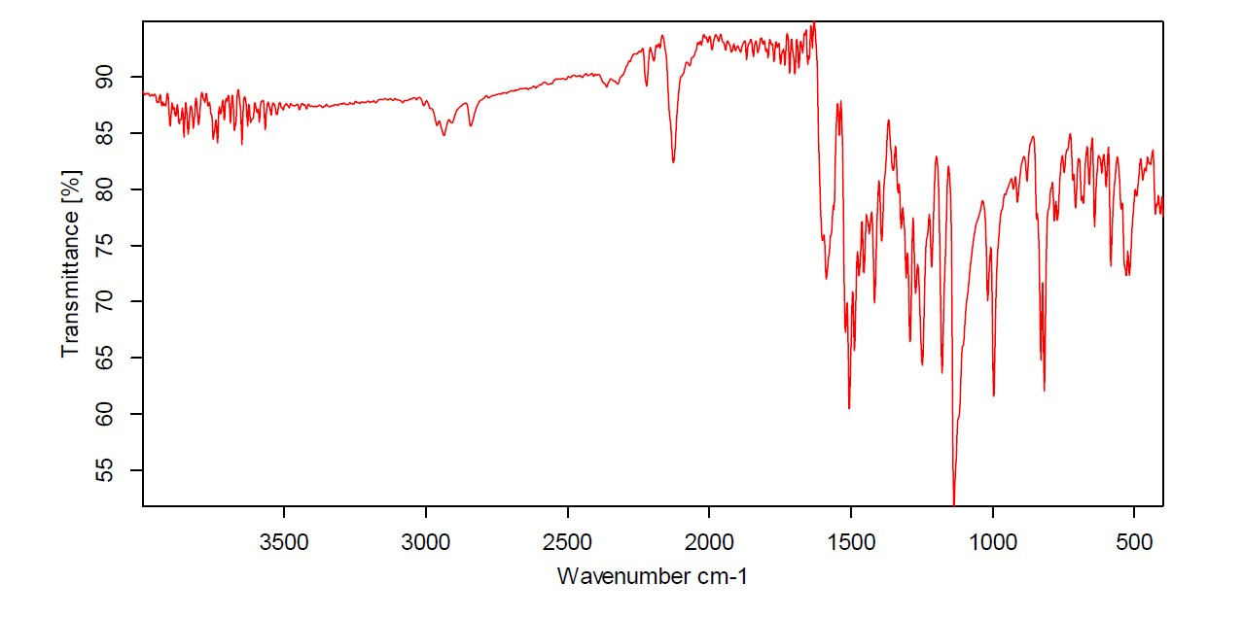
Figure S116: IR spectrum of compound 26.

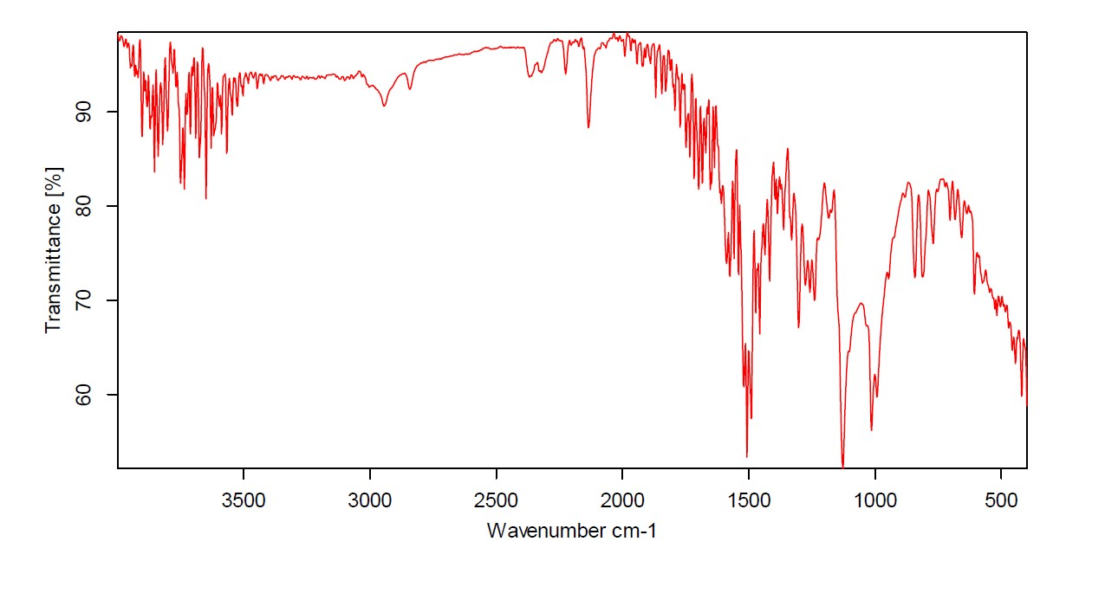
Figure S117: IR spectrum of compound 27.
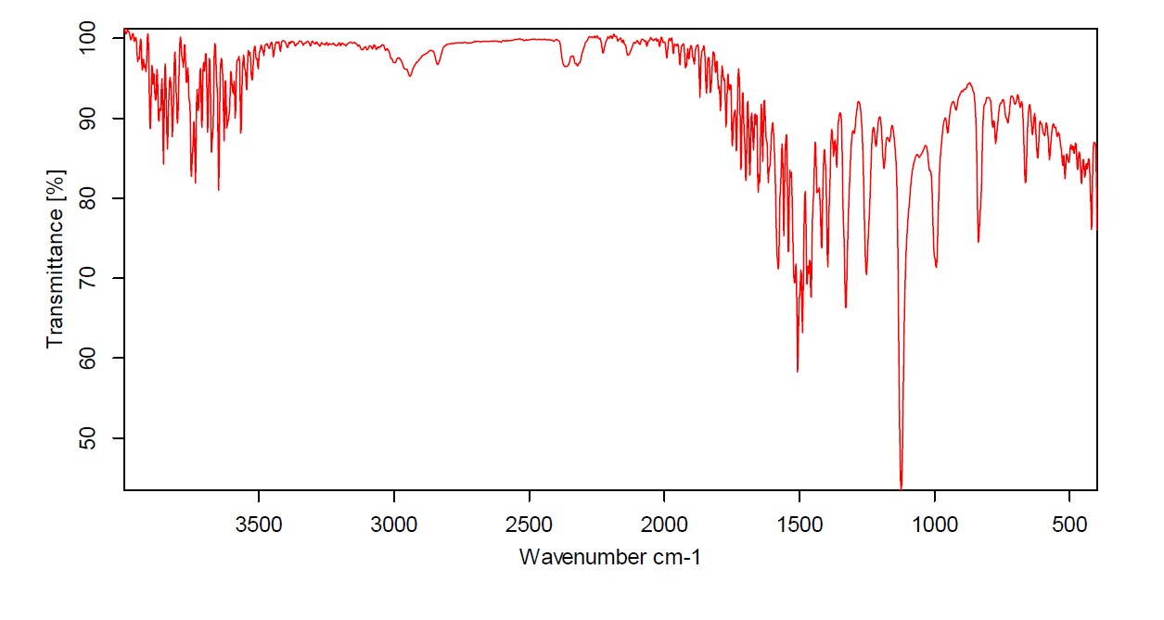
Figure S118: IR spectrum of compound 28.

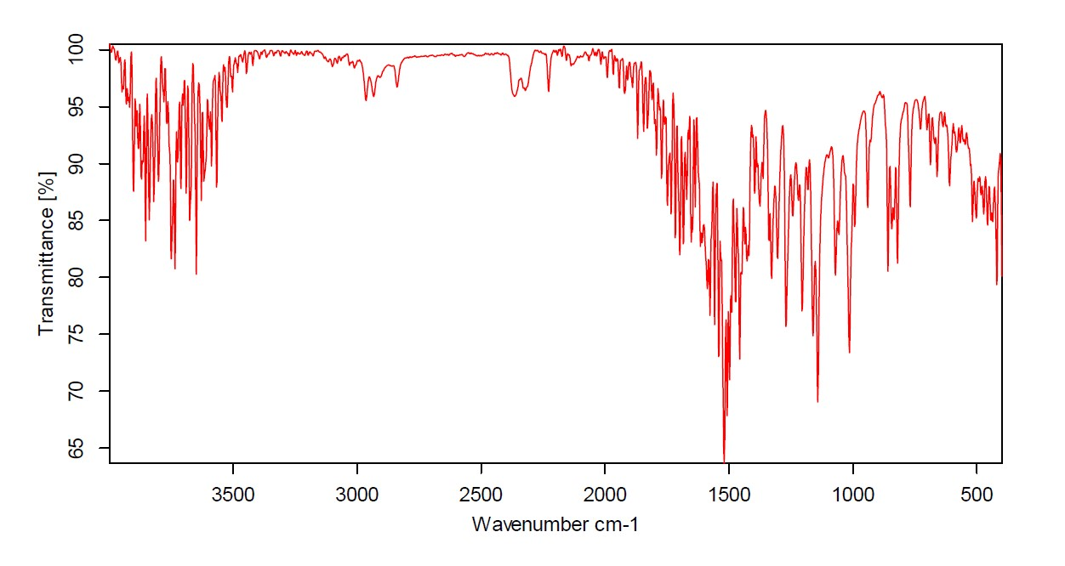
Figure S119: IR spectrum of compound 29.
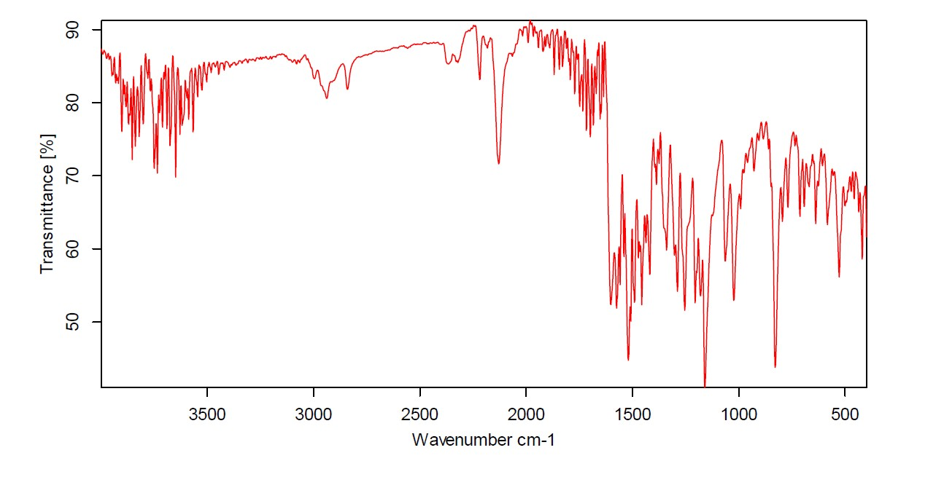
Figure S120: IR spectrum of compound 30.

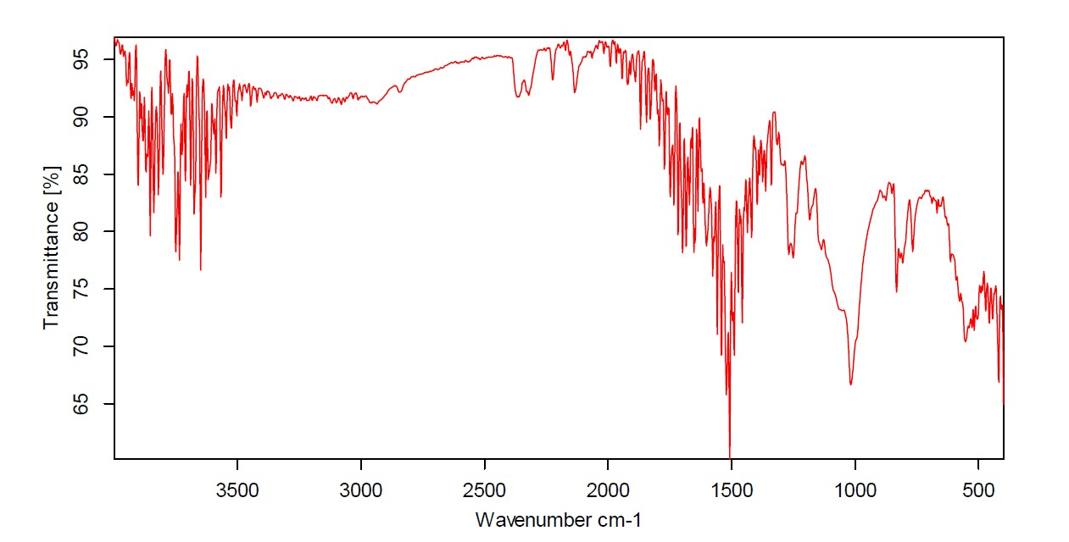
Figure S121: IR spectrum of compound 31.

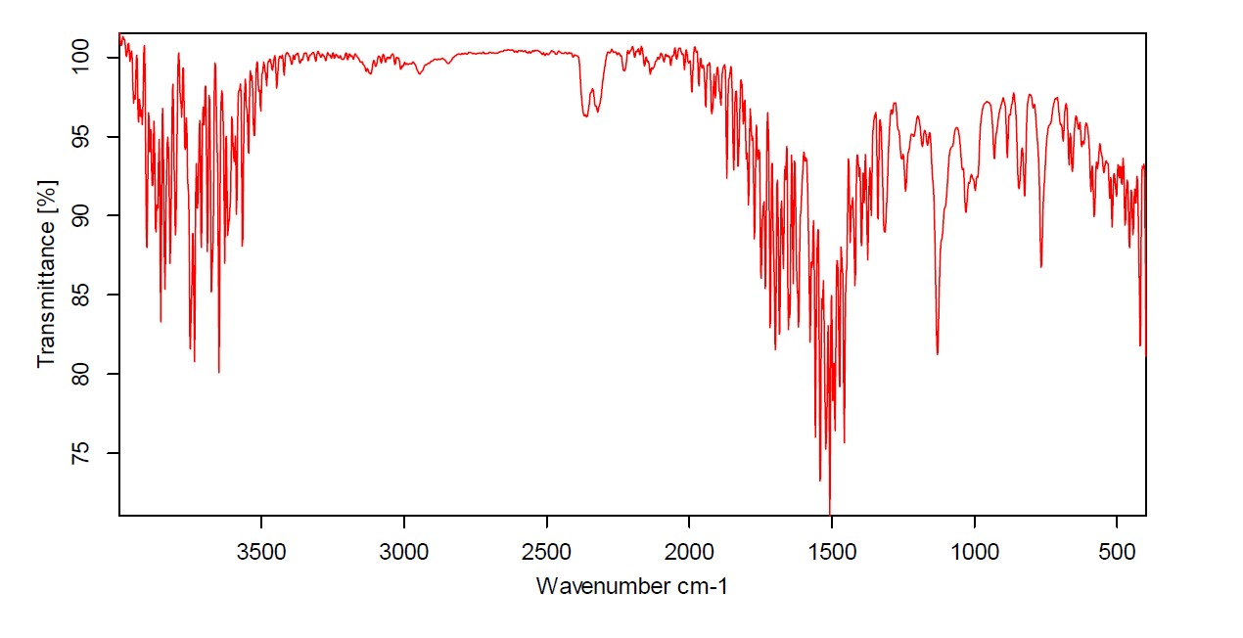
Figure S122: IR spectrum of compound 32.

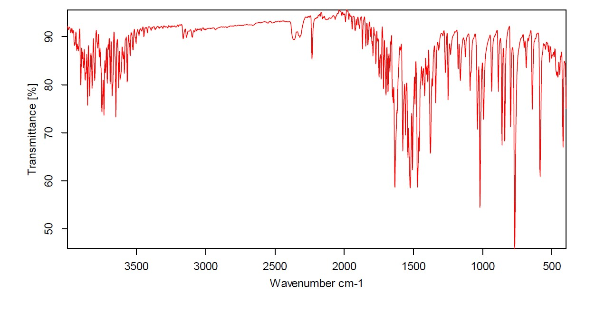
Figure S123: IR spectrum of compound 33.

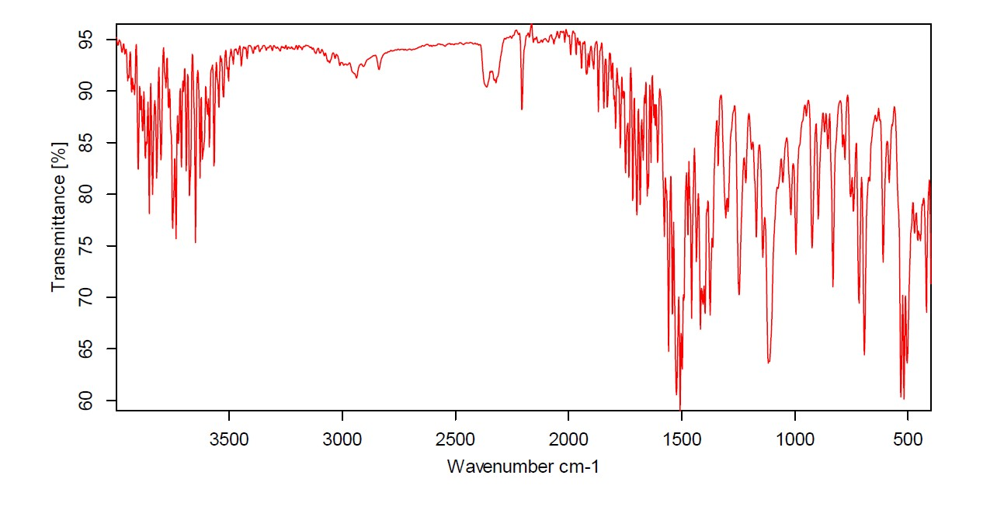
Figure S124: IR spectrum of compound 34.

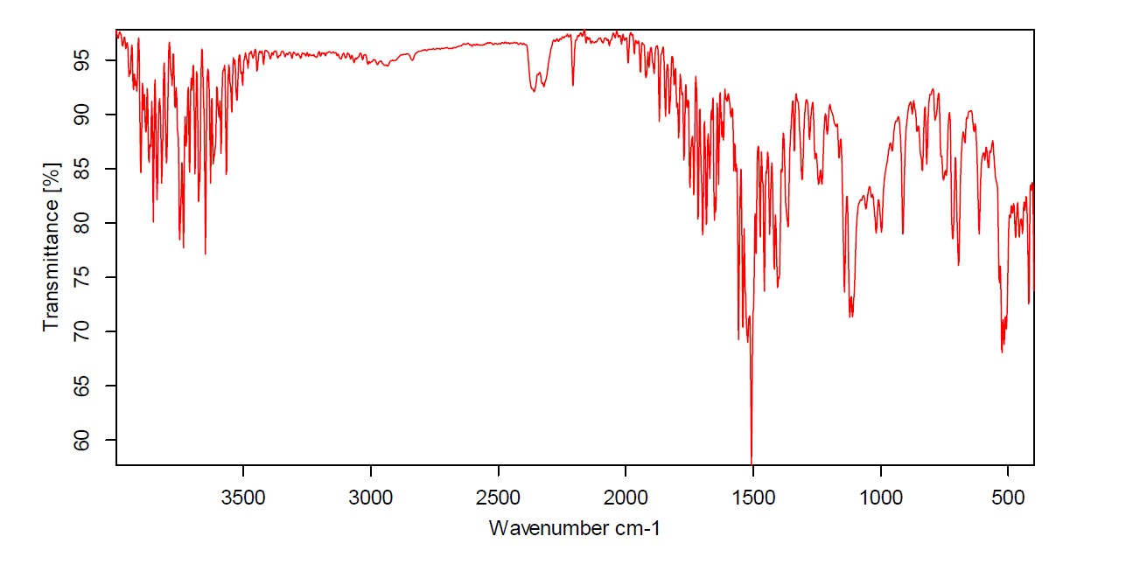
Figure S125: IR spectrum of compound 35.

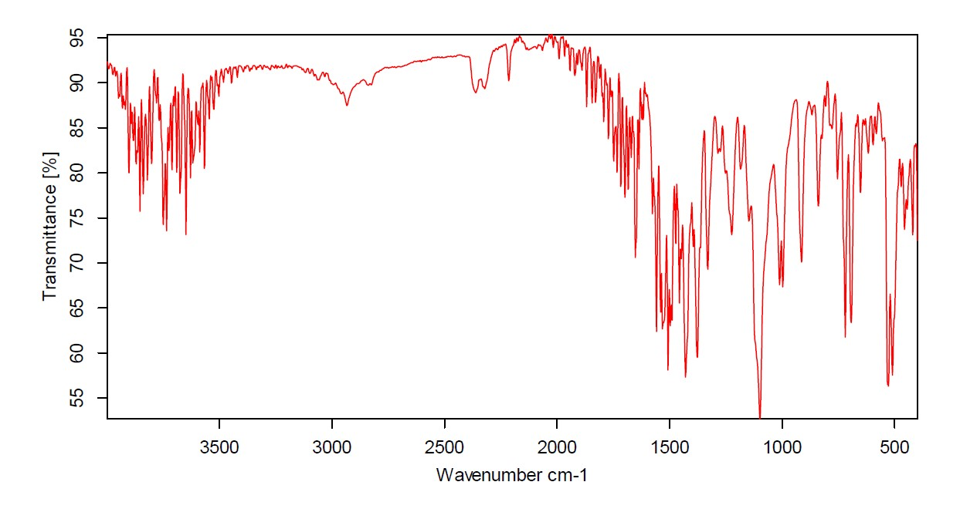
Figure S126: IR spectrum of compound 36.

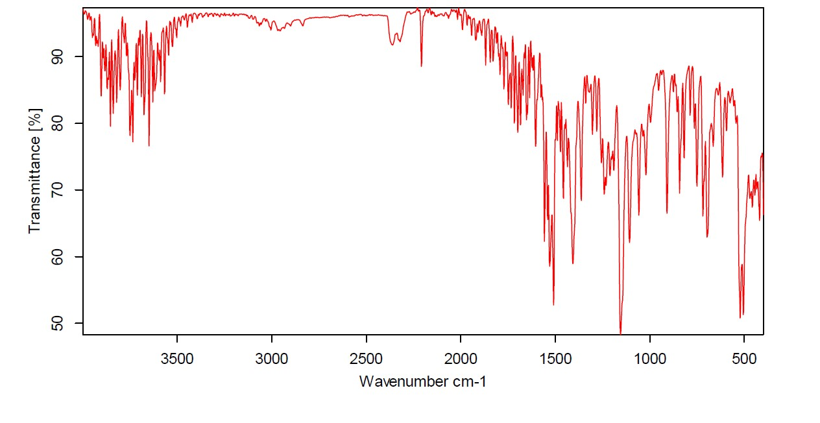
Figure S127: IR spectrum of compound 37.

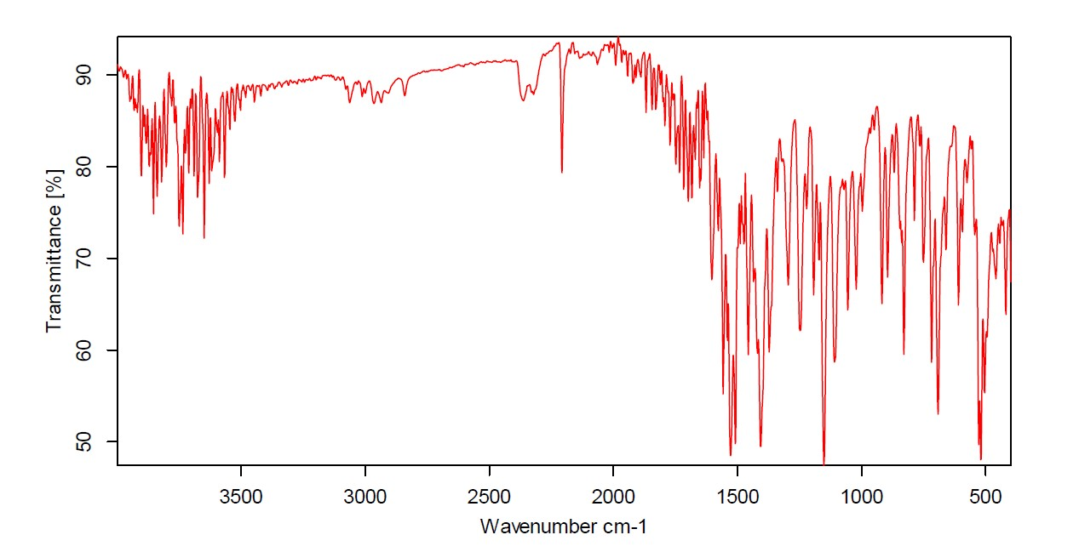
Figure S128: IR spectrum of compound 38.

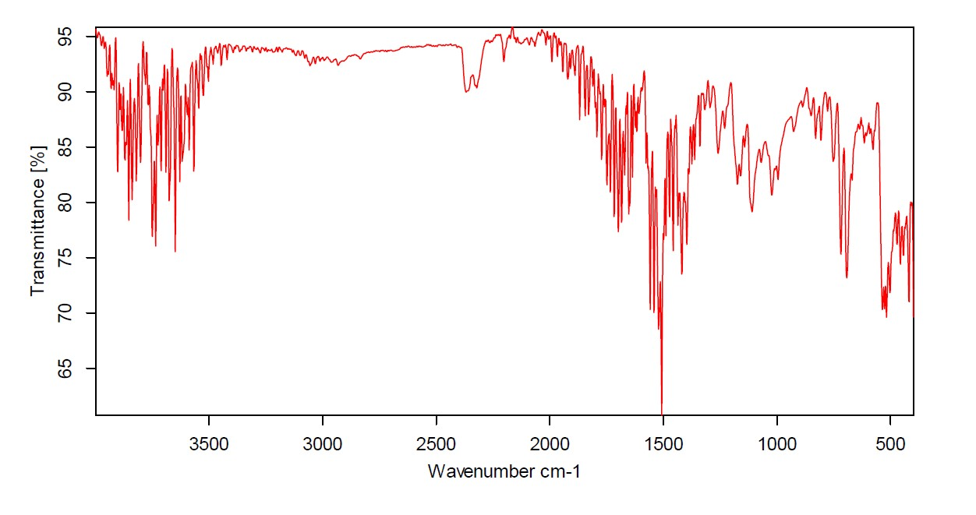
Figure S129: IR spectrum of compound 39.

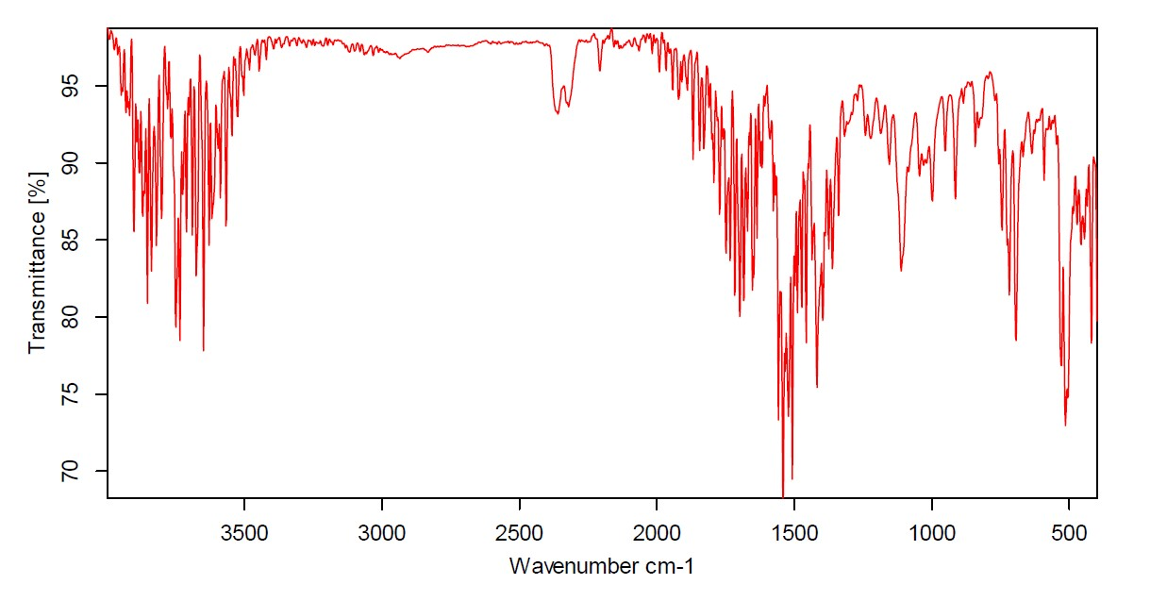
Figure S130: IR spectrum of compound 40.

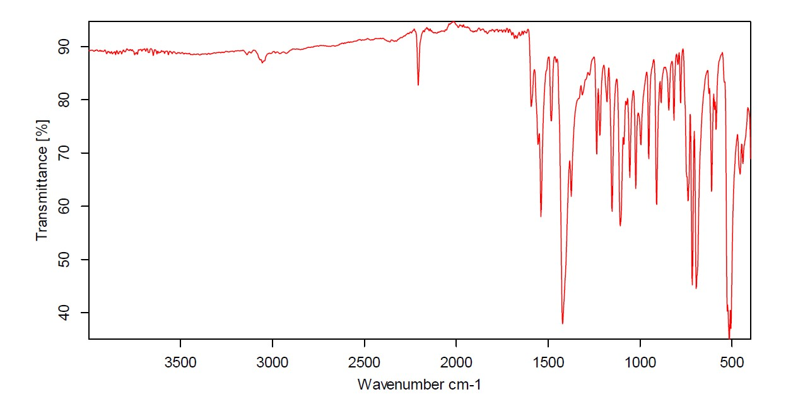
Figure S131: IR spectrum of compound 41.

UV-Vis analyses

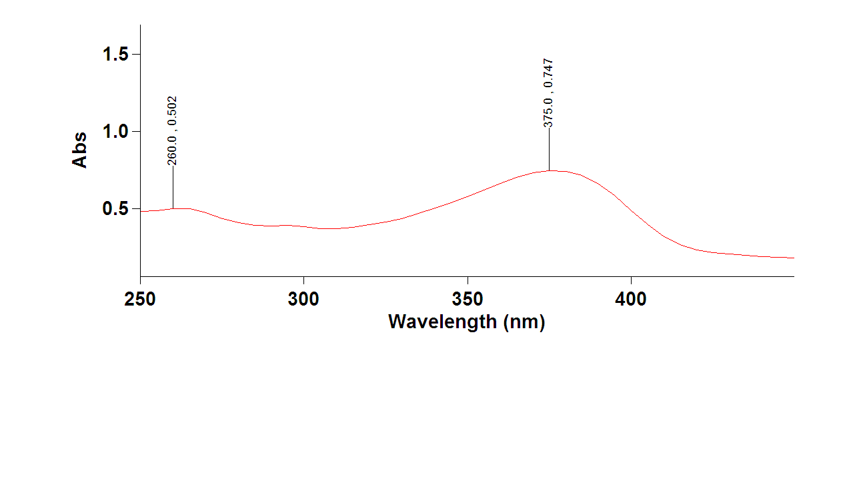Figure S132: UV spectrum of compound 10.
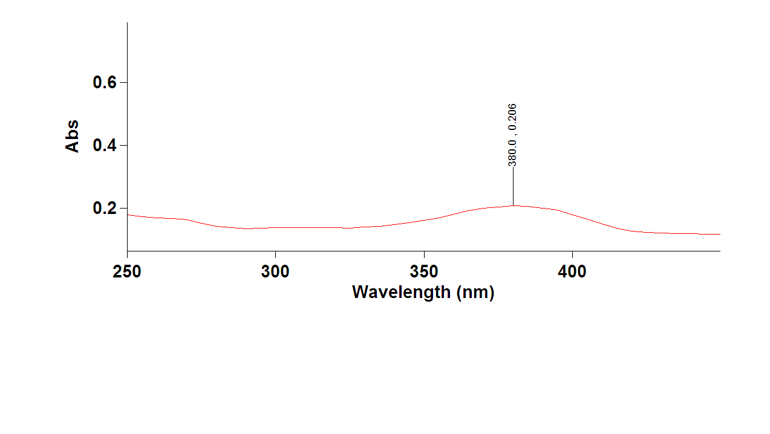
Figure S133: UV spectrum of compound 11.
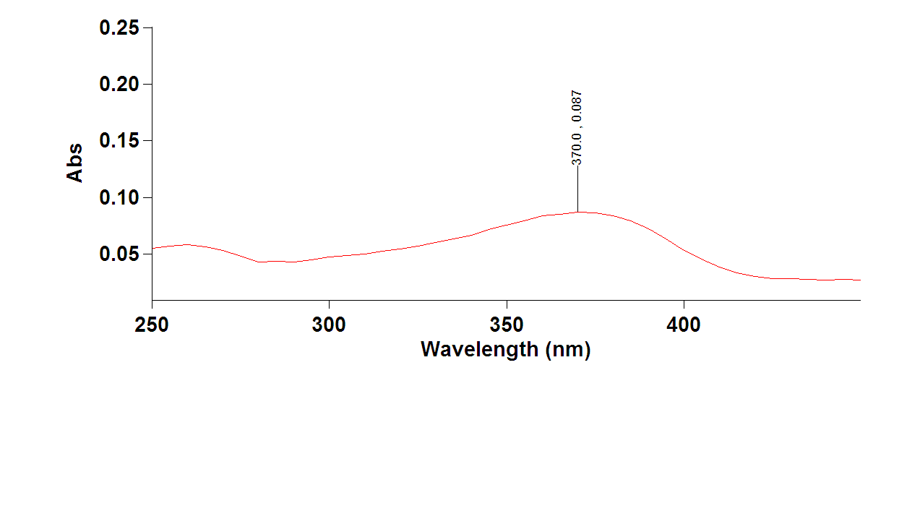
Figure S134: UV spectrum of compound 12.

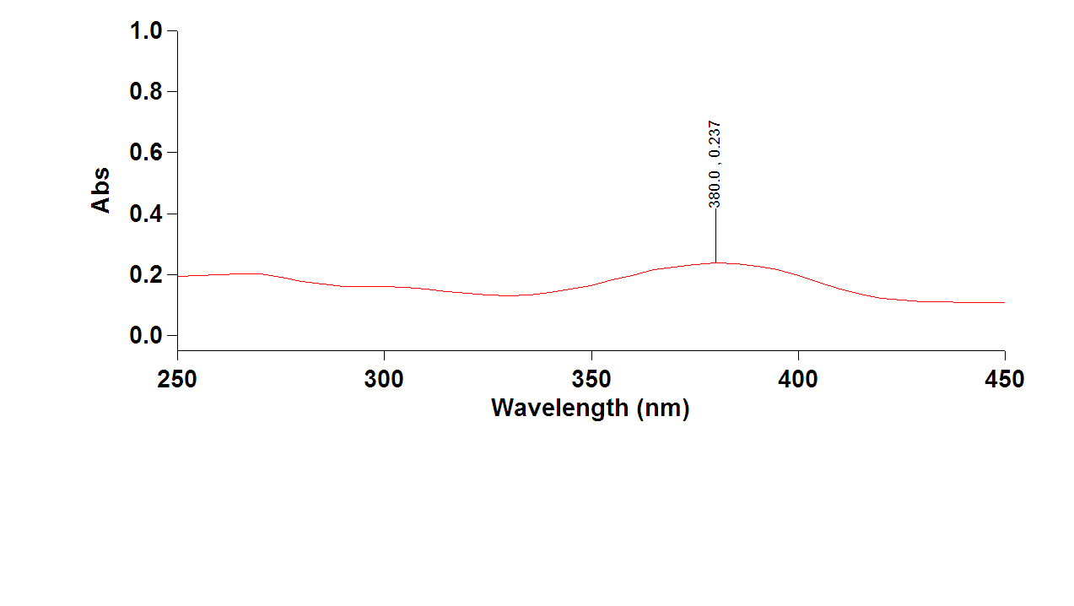
Figure S135: UV spectrum of compound 13.

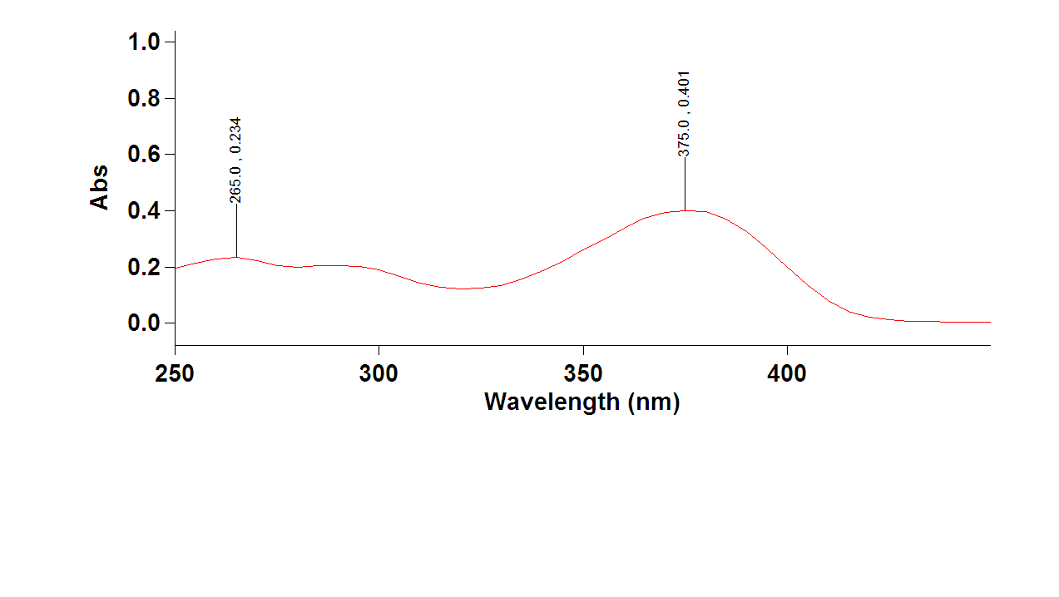
Figure S136: UV spectrum of compound 14.
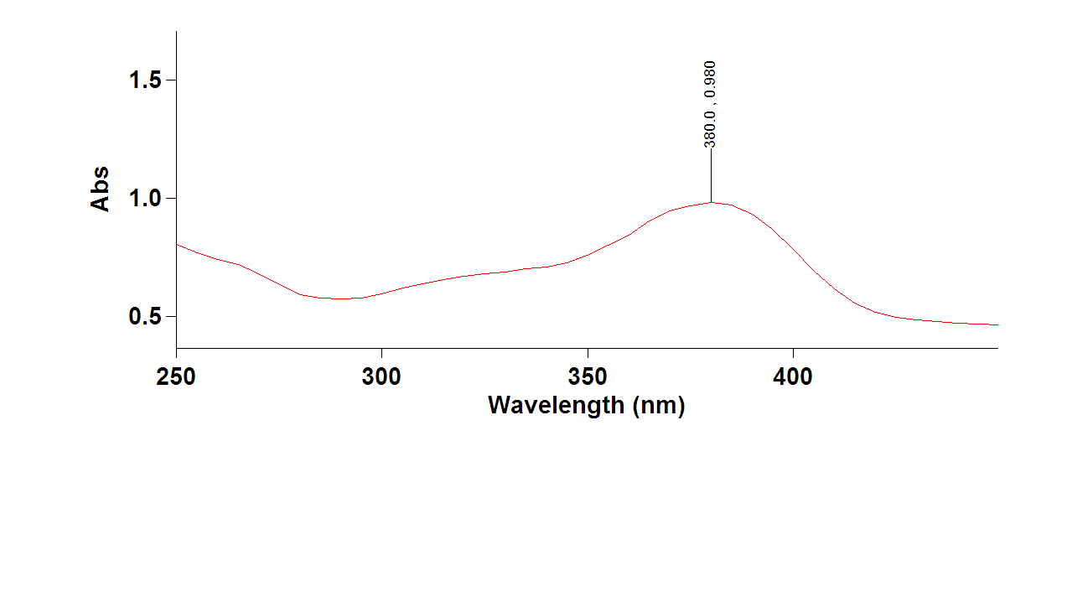
Figure S137: UV spectrum of compound 15.
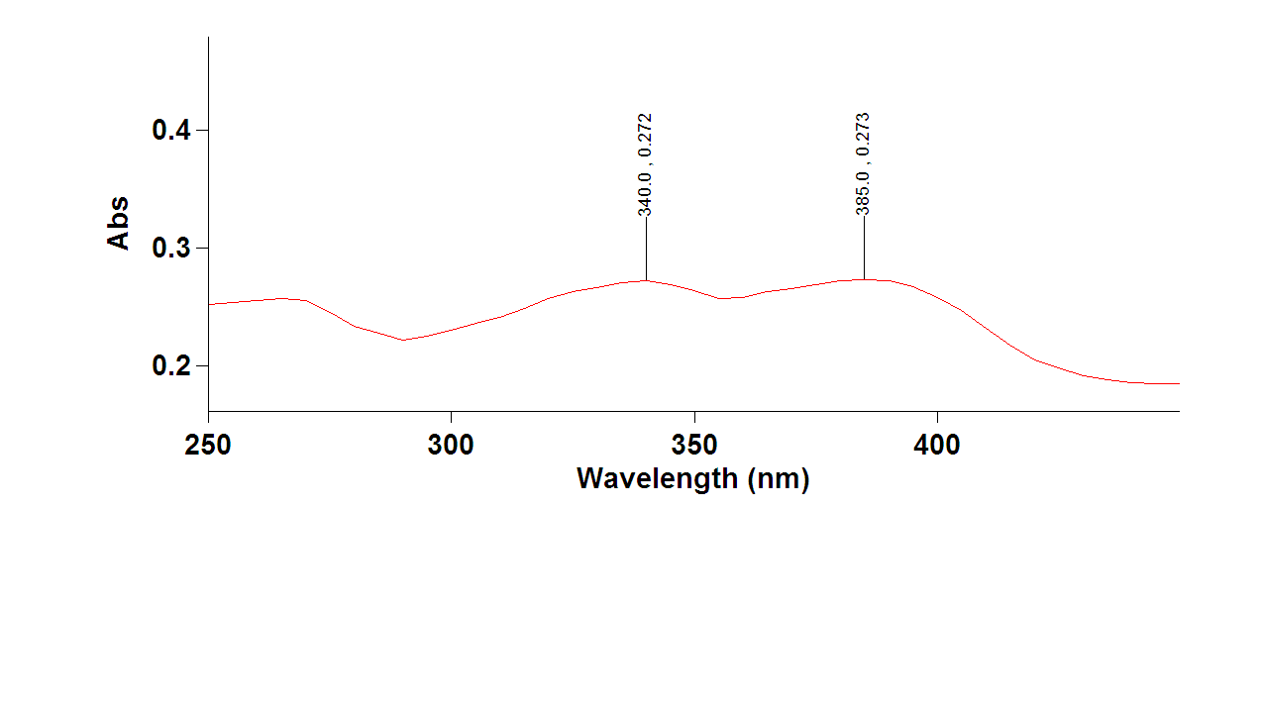
Figure S138: UV spectrum of compound 16.

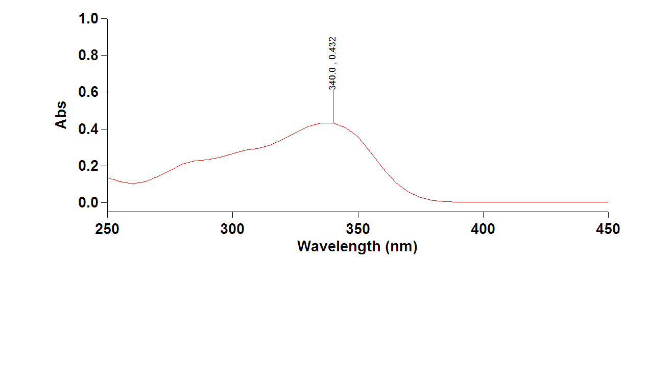
Figure S139: UV spectrum of compound 18.
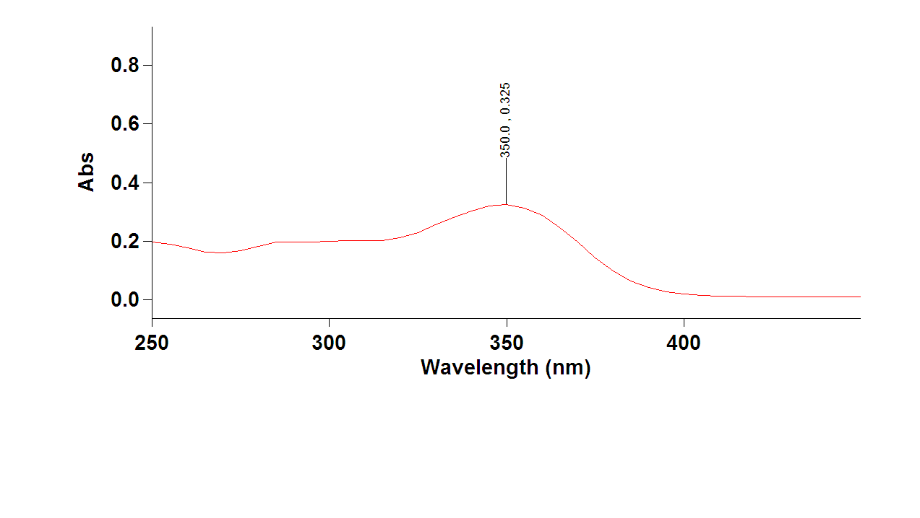
Figure S140: UV spectrum of compound 19.

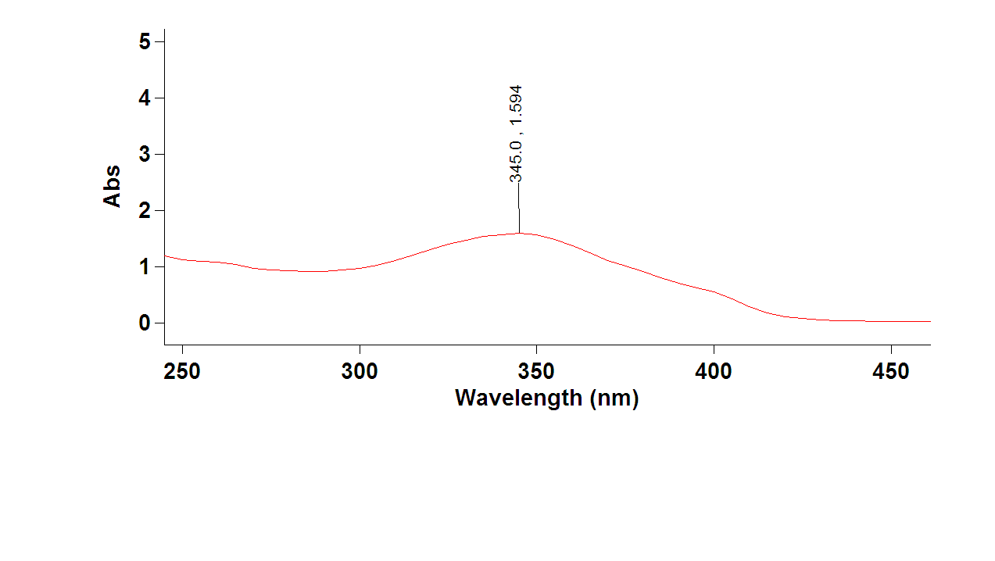
Figure S141: UV spectrum of compound 20.
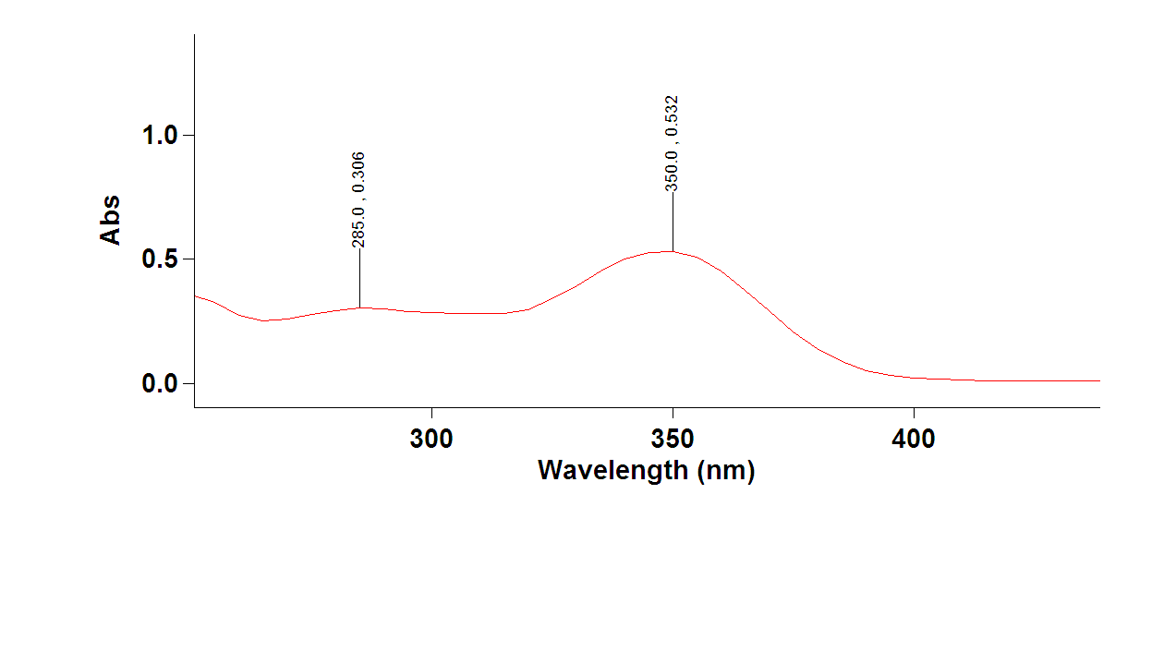
Figure S142: UV spectrum of compound 21.
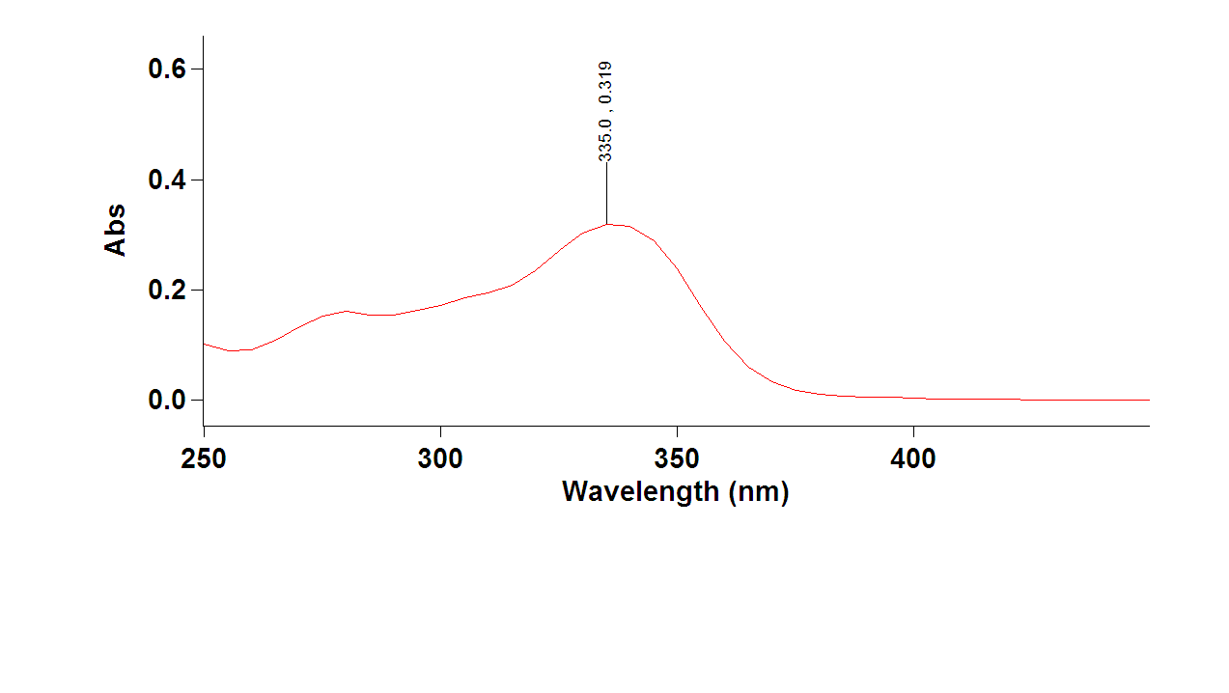
Figure S143: UV spectrum of compound 22.
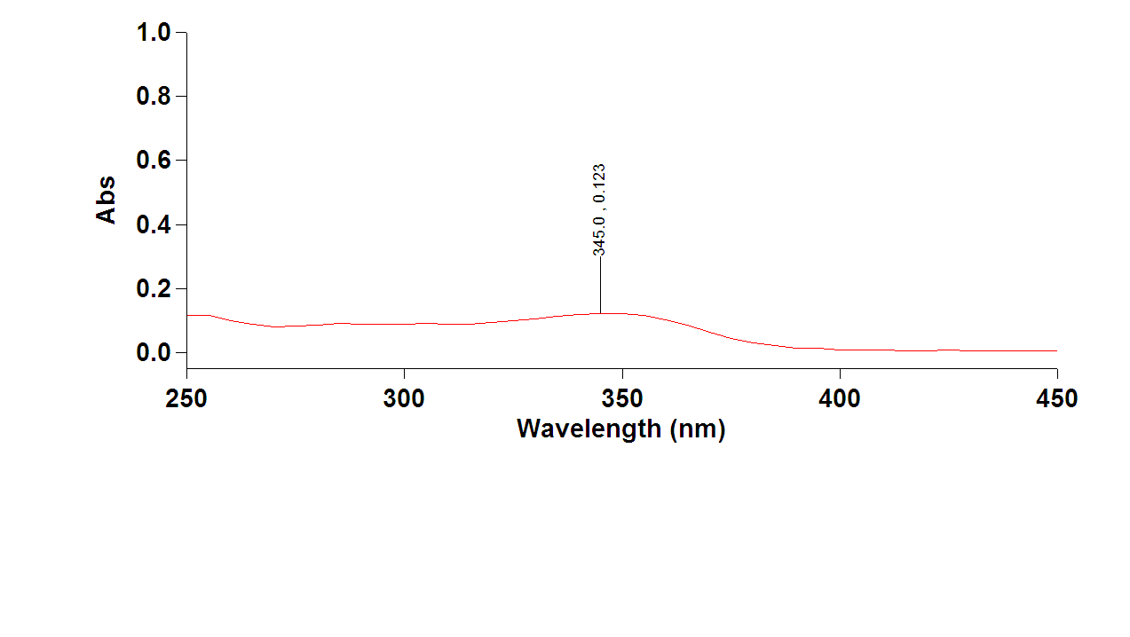
Figure S144: UV spectrum of compound 23.
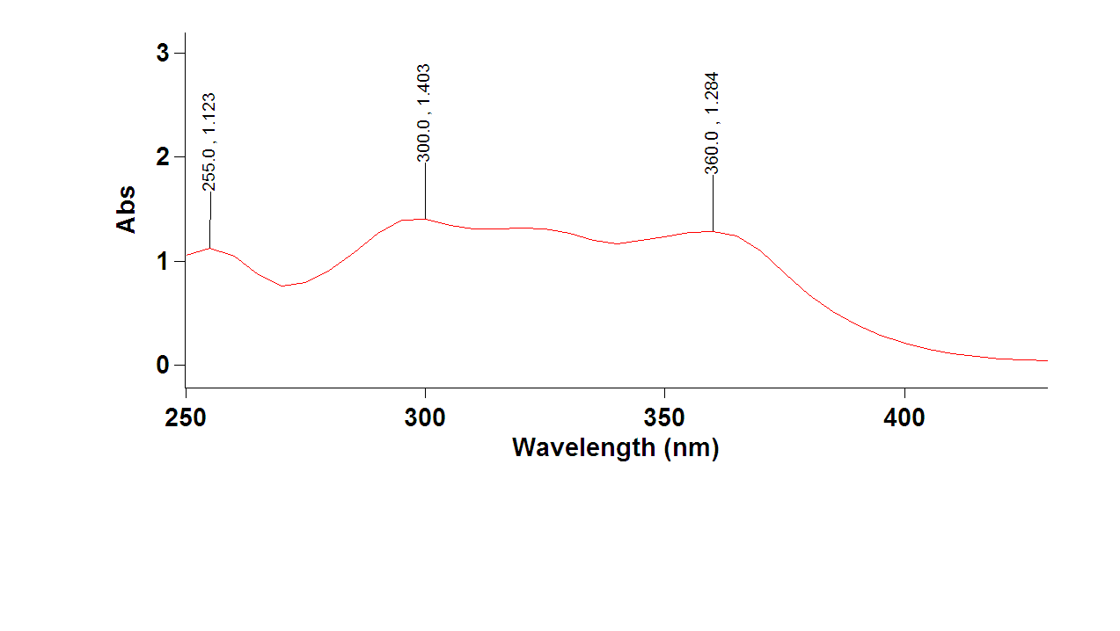
Figure S145: UV spectrum of compound 24.
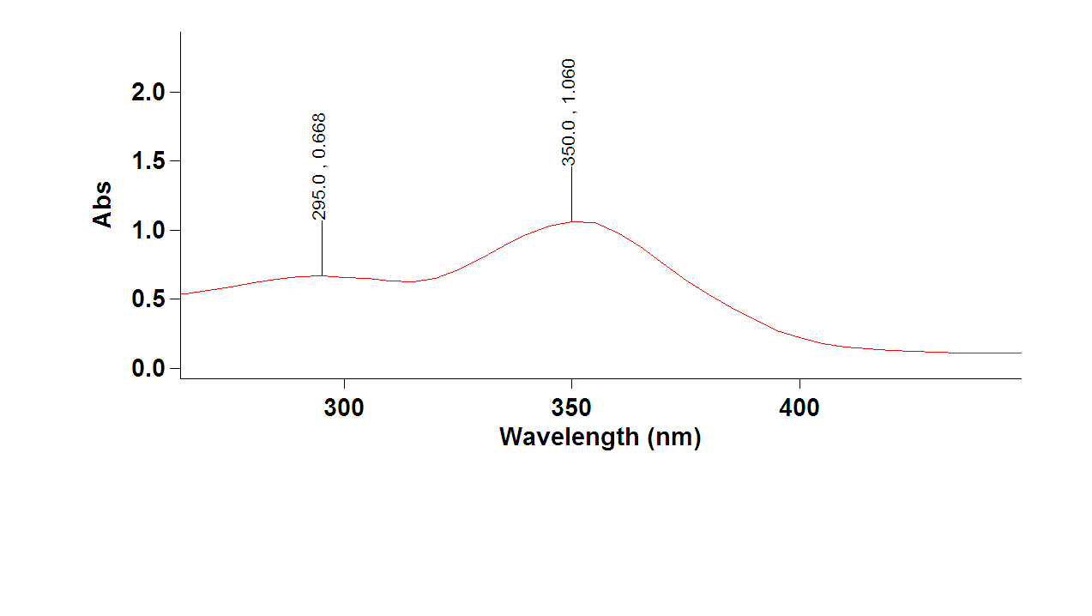
Figure S146: UV spectrum of compound 26.
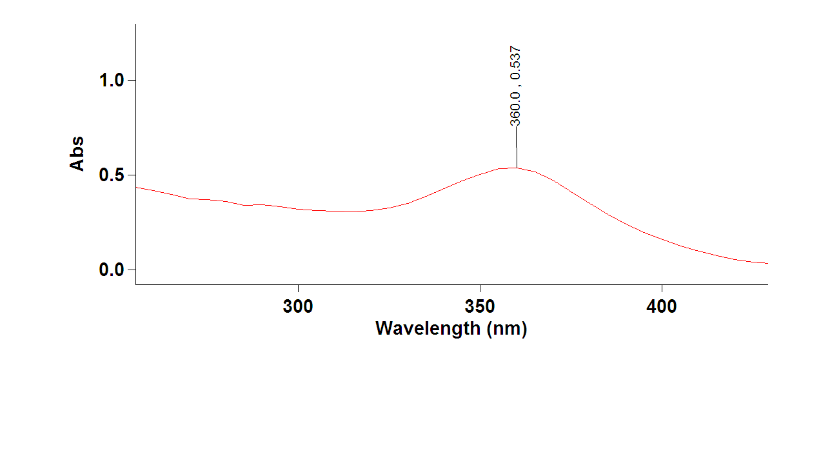
Figure S147: UV spectrum of compound 27.
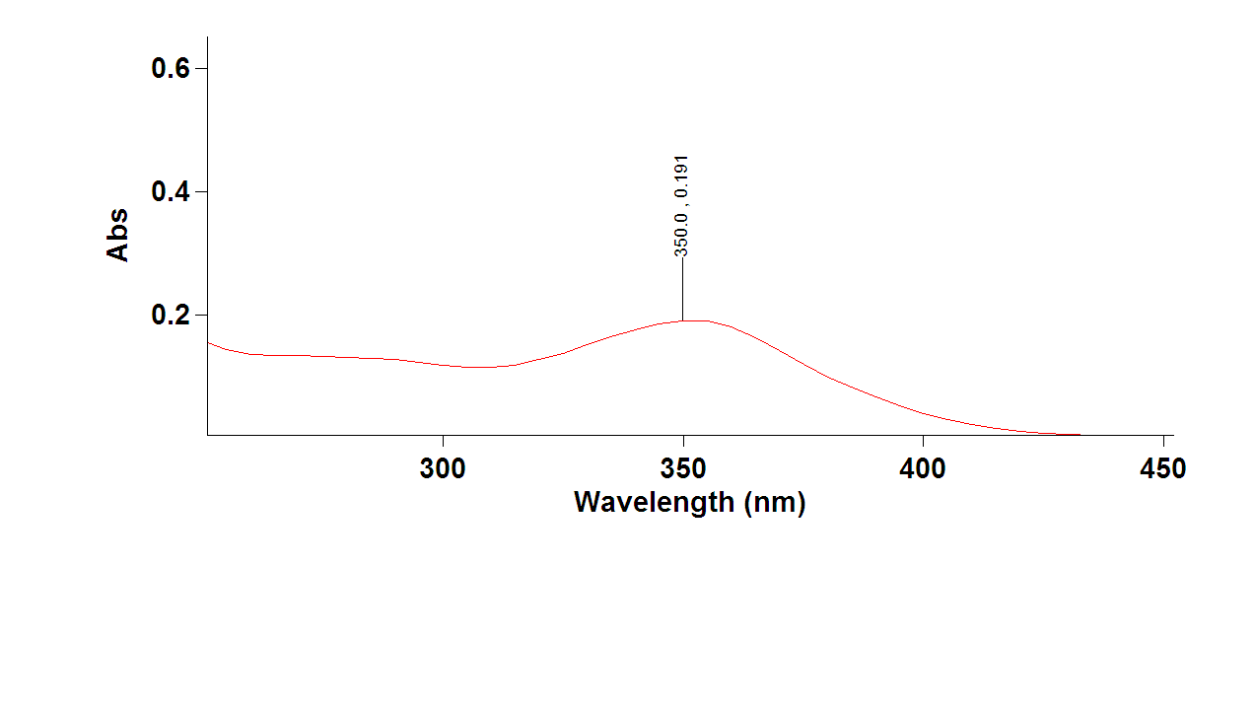
Figure S148: UV spectrum of compound 28.
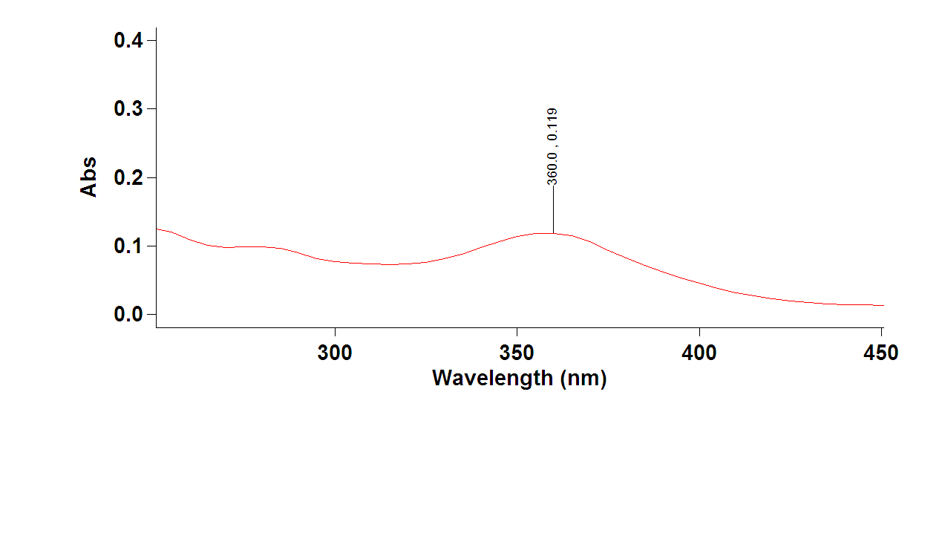
Figure S149: UV spectrum of compound 29.
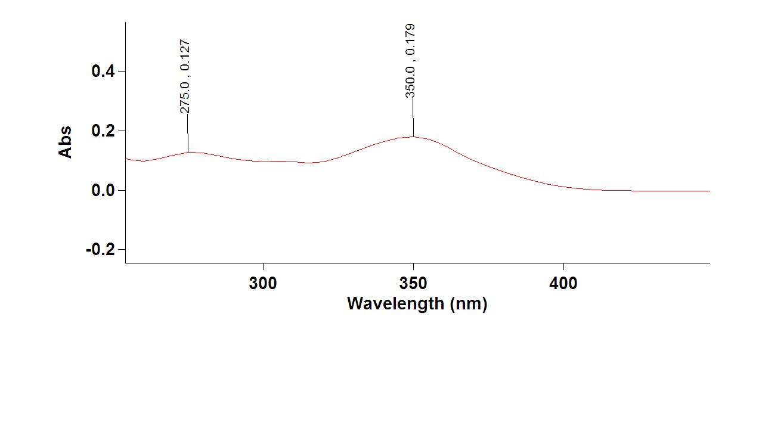
Figure S150: UV spectrum of compound 30.
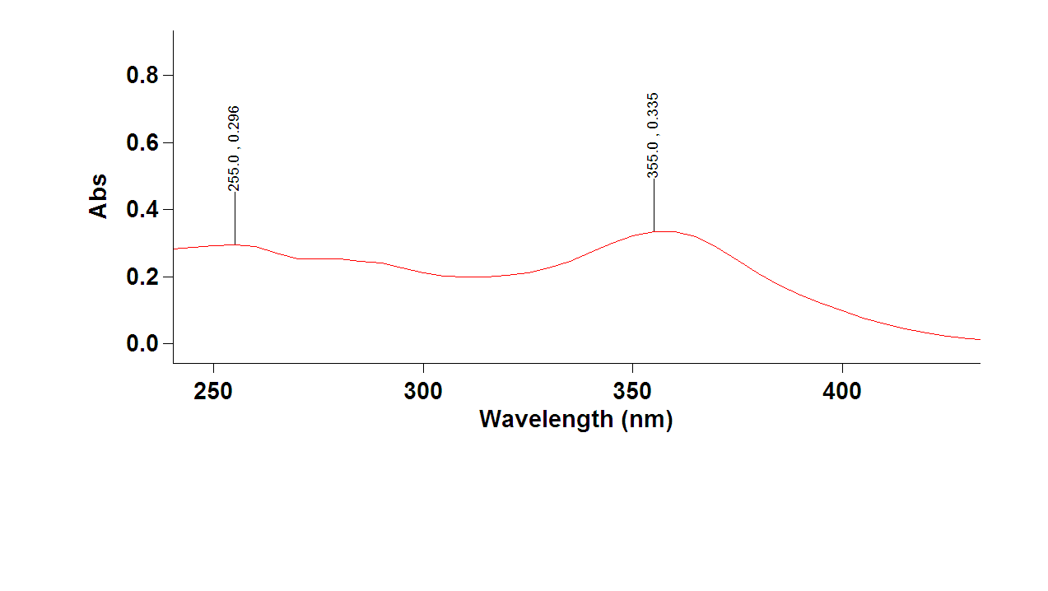
Figure S151: UV spectrum of compound 31.
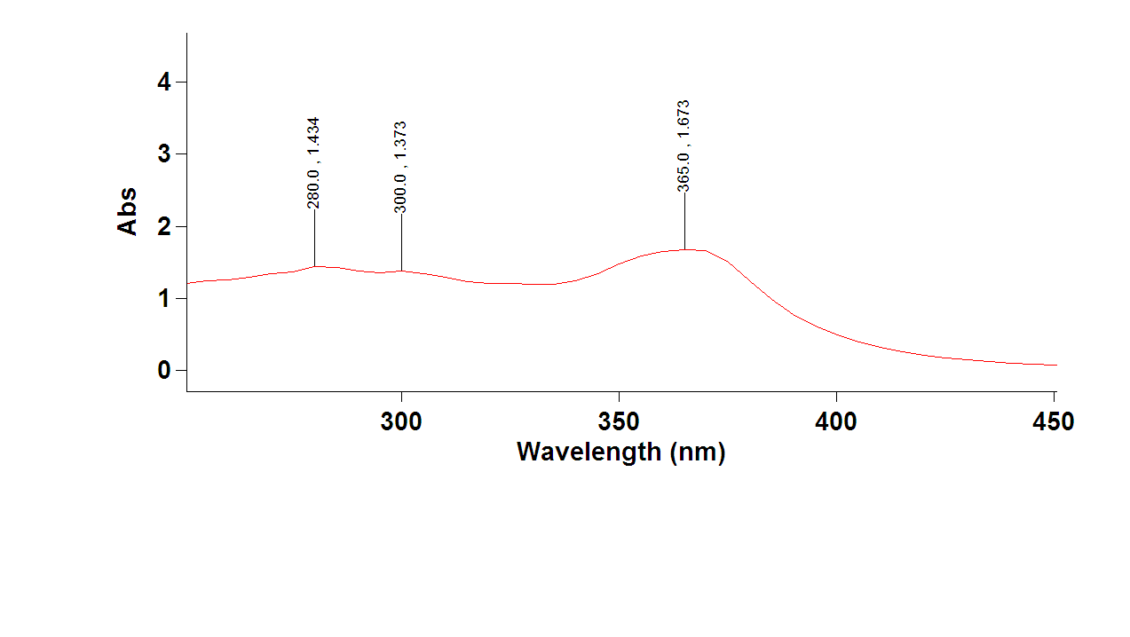
Figure S152: UV spectrum of compound 32.
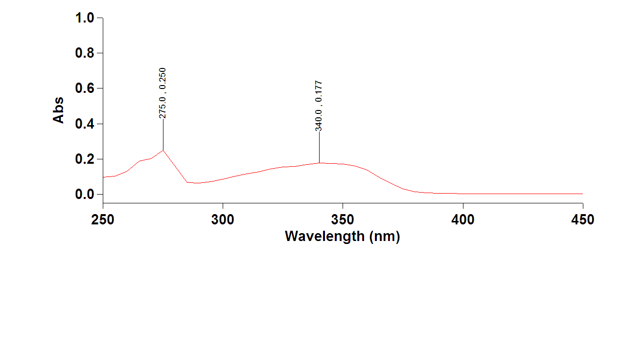
Figure S153: UV spectrum of compound 33.
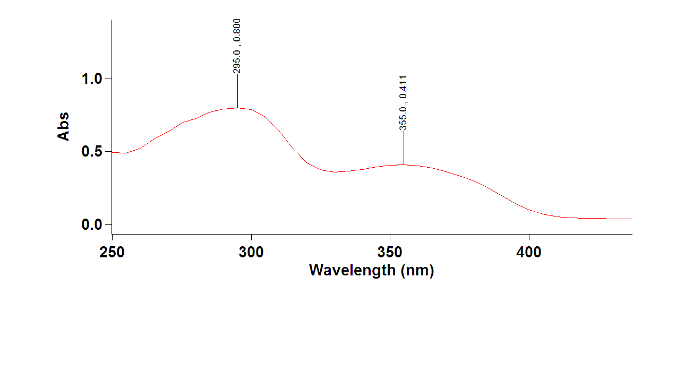
Figure S154: UV spectrum of compound 34.
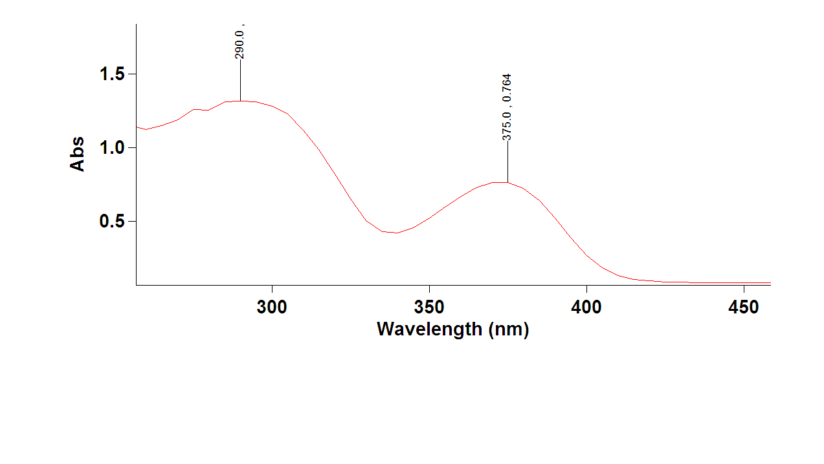
Figure S155: UV spectrum of compound 35.
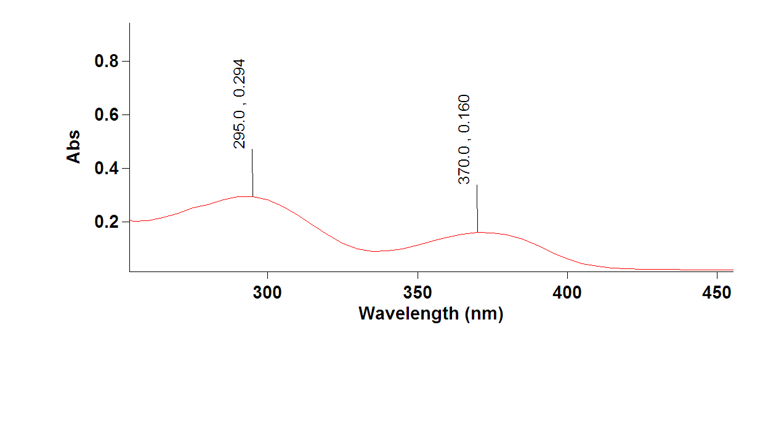

Figure S156: UV spectrum of compound 36.
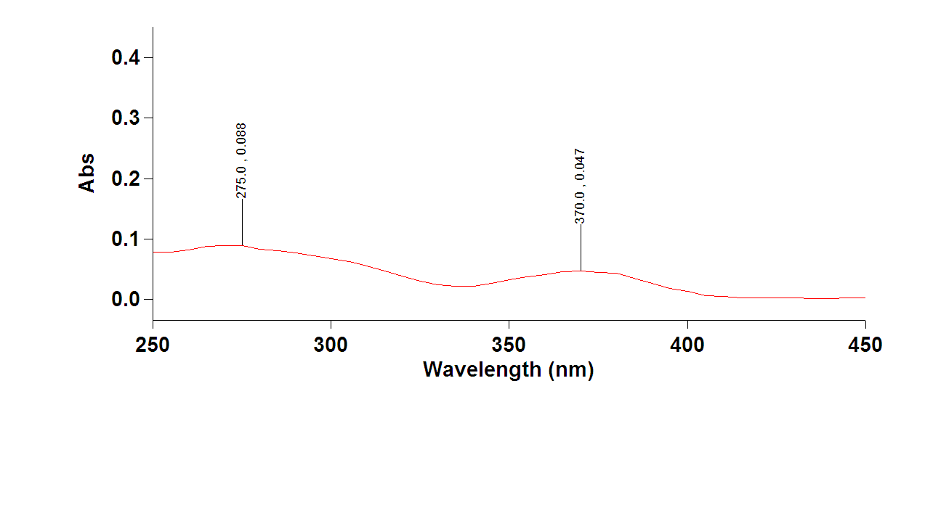
Figure S157: UV spectrum of compound 37.
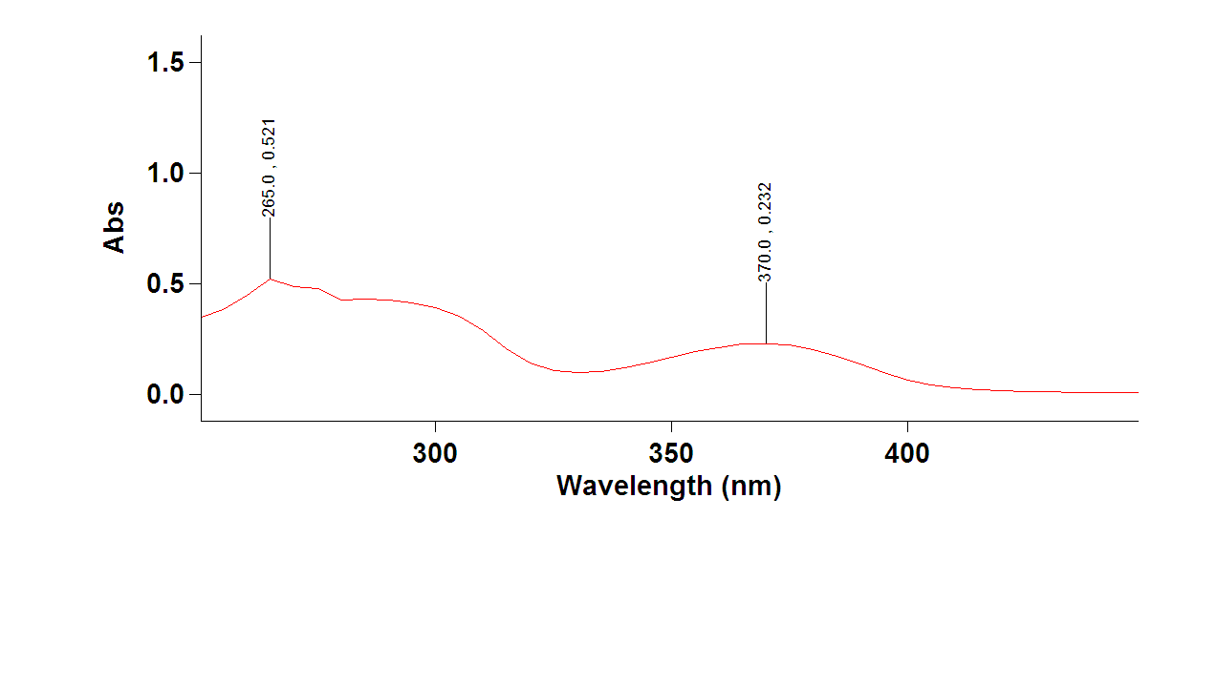

Figure S158: UV spectrum of compound 38.
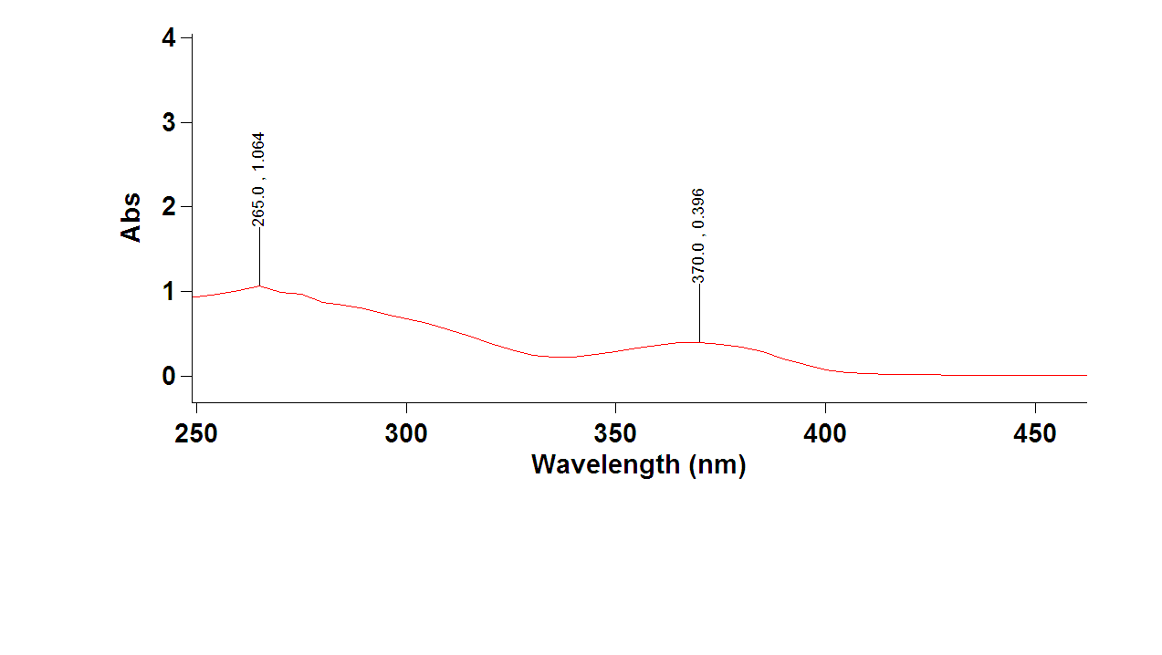
Figure S159: UV spectrum of compound 39.
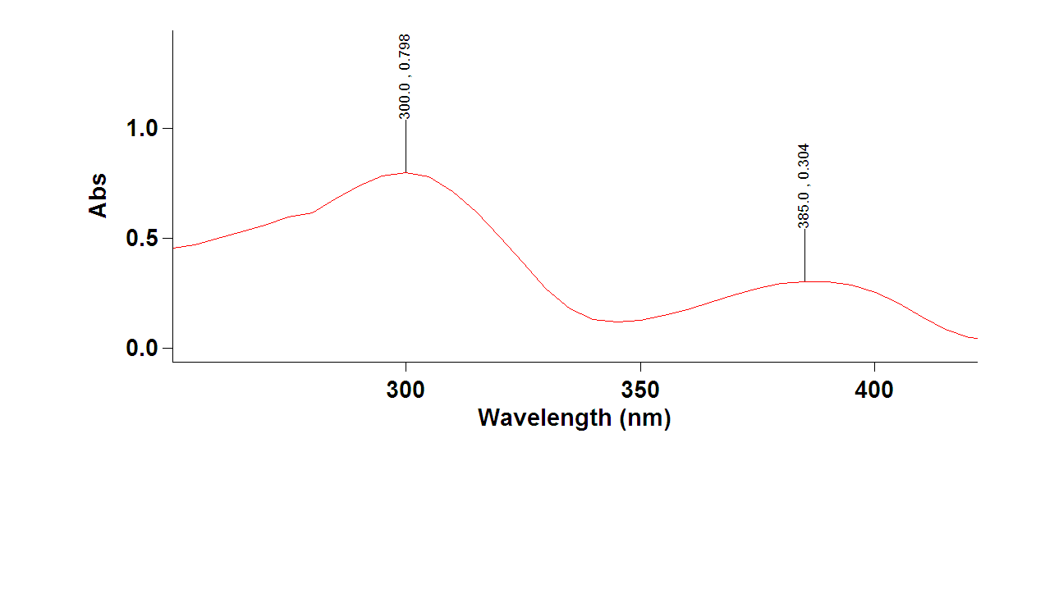
Figure S160: UV spectrum of compound 40.
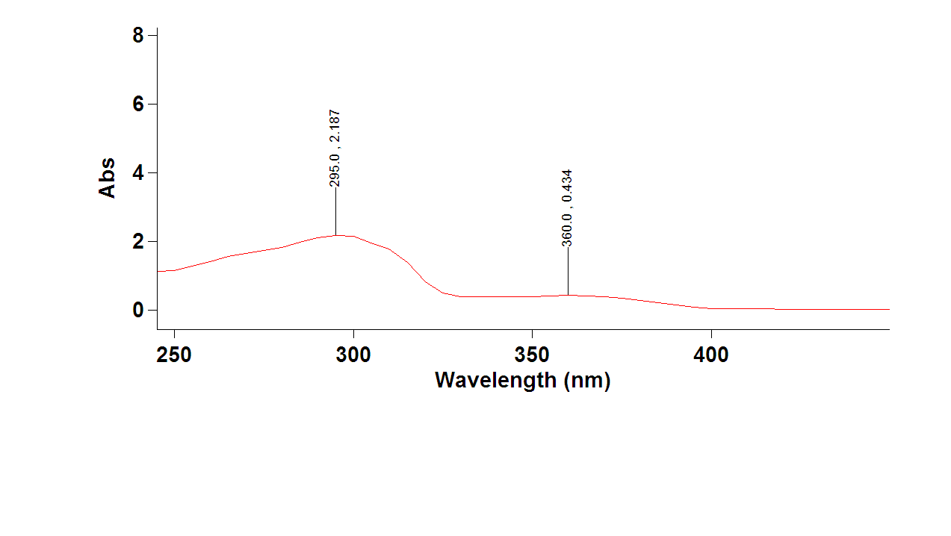
Figure S161: UV spectrum of compound 41.

S4.2.6. In silico study
S4.2.6.1. Density Functional Theory (DFT) Calculations:
All quantum chemical calculations were performed using the Schrödinger Maestro 2025-2 suite with the Jaguar module. Initial geometries of the azide and tetrazole tautomeric forms were built and pre-optimized in Maestro. Full geometry optimizations were then carried out at the B3LYP-D3/6-31G** level of theory with implicit solvation in water using the polarizable continuum model (PCM). Single-point energy refinements were subsequently performed at the B3LYP-D3/6-31+G** level of theory in the same solvent model (PCM, water), using the optimized geometries from the prior step.
Relative free energies (ΔG, kcal·mol⁻¹) between azide and tetrazole forms were calculated as the electronic energy difference between tautomeric pairs, converted from Hartree to kcal·mol⁻¹ (1 Ha = 627.5095 kcal·mol⁻¹).
Equilibrium constants (K) were determined using the Boltzmann relationship:
K = ${e }^{-∆G/RT}$
Where R = 1.987 cal K⁻¹ mol⁻¹ and T = 298 K
Population distributions (%) for each tautomer were derived from the Boltzmann weights of the two-state system. All reported values correspond to solution-phase free energies at 298 K.
This was done on three compounds (26, 27, 33) containing an azido-functional group with an ortho-pyridyl nitrogen, enabling the tautomerization into a tetrazole form
Raw Data (after B3LYP-D3/6-31G** geometry optimizations):

compound | Solution-phase energy (Hartree)
33 (Az) | -722.331647
33 (Tet) | -722.329822
26 (Az) | -1424.437278
26 (Tet) | -1424.439053
27 (Az) | -1538.965887
27 (Tet) | -1538.966820

Table S2. Solution-phase energies in Hartree after geometry optimization (26, 27, 33)

Sample Calculation of relative free energies and tautomeric populations (Az vs. Tet):
Input data (solution-phase single-point energies, Hartree):
- Azide 26: E_{Az} = -1424.437278 Ha
- Tetrazole 26: E_{Tet} = -1424.439053 Ha
Step 1. Energy difference (Hartree):
ΔE = E_{Tet} - E_{Az} = -1424.439053 - (- 1424.437278) = - 0.001775 Ha
Step 2. Convert to kcal mol⁻¹:
Conversion factor: 1 Ha = 627.5095 kcal mol⁻¹

ΔG = -0.001775 Ha x 627.5095 = - 1.11 kcal mol⁻¹
Step 3. Convert to kJ mol⁻¹:
ΔG = -1.11 kcal mol⁻¹ x 4.184 kJ mol⁻¹ = - 4.66 kJ mol⁻¹
Step 4. Equilibrium constant (at 298 K):
K = ${e }^{-∆G/RT}$
Where R = 1.987 cal K⁻¹ mol⁻¹ and T = 298 K
K = e^{−(−1.11/0.5929)} = 6.55
Step 5. Population distribution:
P_{Az} = 1/(1+K) = 1/(1+6.55) = 0.132 = 13.2%

P_{Tet} = 100% - 13.2% = 86.8%
- ΔG = −1.11 kcal·mol⁻¹ (tetrazole lower)
- Populations: Azide 13.2%, Tetrazole 86.8%

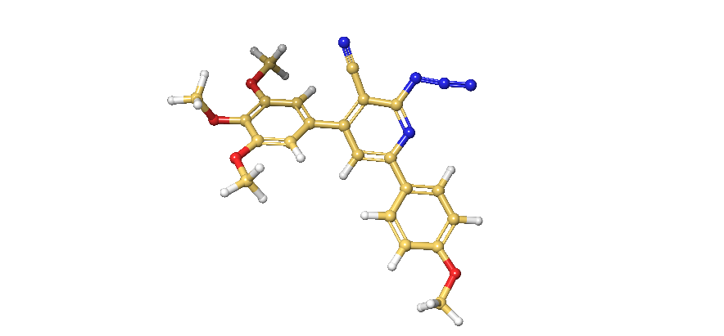
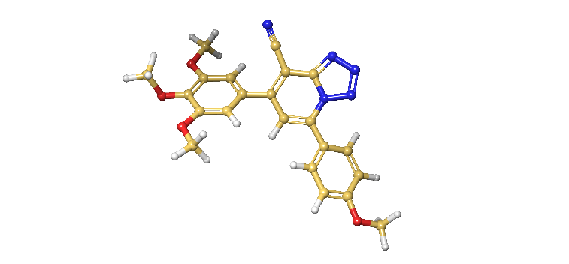

26 (Tet)
26 (Az)

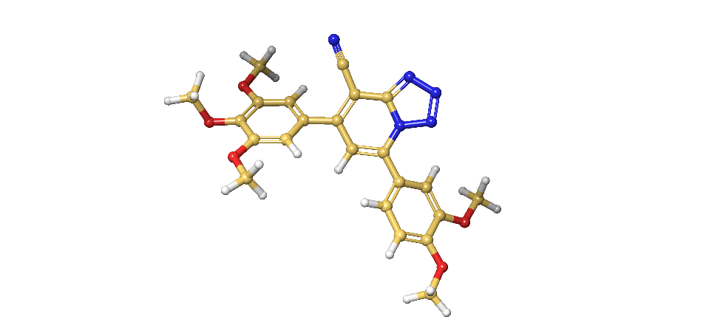
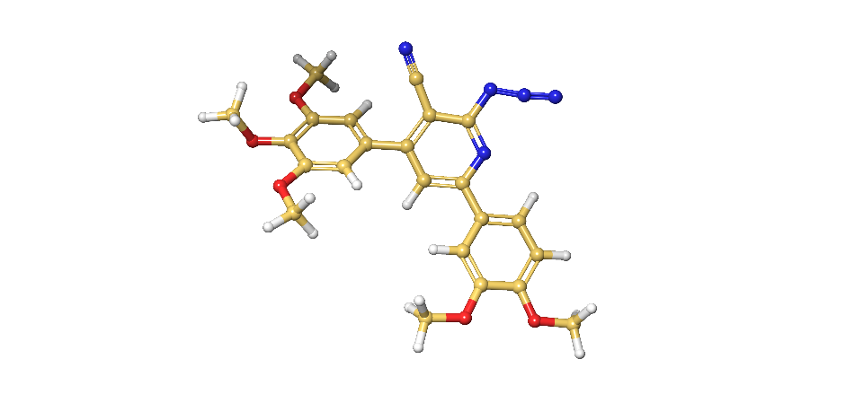

27 (Tet)
27 (Az)
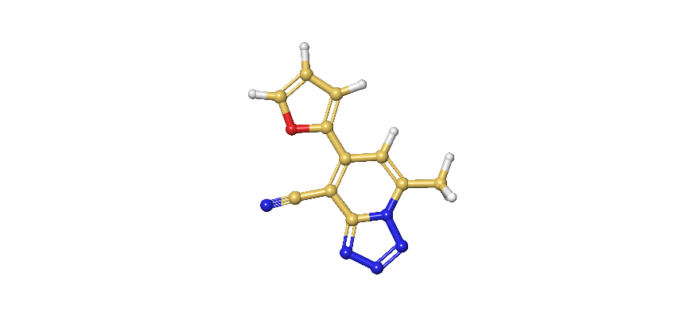
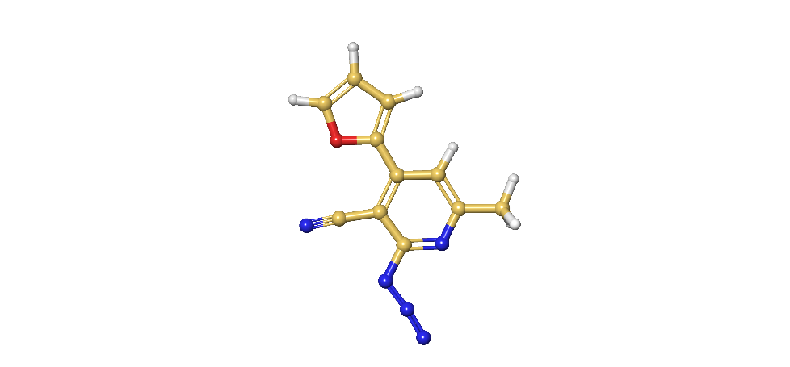

33 (Tet)
33 (Az)

Figure S162: DFT-based low energy conformations of azide/tetrazole tautomers

S4.2.6.2. Computational Modelling & Docking:
The computational studies described involved the use of Schrödinger’s Maestro v14.2.1 (2025-3) with access provided under a single academic user license. Calculations used the following modules: ConfGen, Epik, Glide, LigPrep, MacroModel, Prime, ProtPrep, SiteMap and the Optimized Potential for Liquid Simulations (OPLS5e) force field. A pH of 7.00 ± 2.00 was set when appropriate along with the use of H₂O (solvation parameter). Other software used include ChemDraw Professional v25.0 and the RSCB protein data bank (www.rcsb.org/).
To start, three relevant target crystals were selected and downloaded from the PDB. These included human TopII ATPase domain bound to AMP-PNP (PDB 1ZXM), human TopII in complex with DNA and anti-cancer agent etoposide (PDB 3QX3), and the tubulin-RB3-SLD-TTL complex bound to ABI-274. These three proteins underwent a standard ProtPrep workflow, which adds hydrogens, assigns bond orders, and optimizes H-bond networks. Ramachandran plots confirmed appropriate protein backbone geometries (Figure S162). This step was followed by a standard receptor grid generation workflow, where the relative bound ligands (AMP-PMP, etoposide, ABI-274) were used as the center coordinate to produce a relative docking grid (10x10x10 Å). Once completed, the targets were now prepared for subsequent docking studies. The various ligands of interest: 20, 22, 24, 26, 27, 33, 35, 37, 38, 41 (and 26_tet, 27_tet, 33_tet tautomers) were manually drawn using the Maestro 2D sketcher module before a LigPrep workflow, involving low energy minimizations, Epik ionization step (pH 7.00 ± 2.00), adding hydrogens, assigning bond orders, checking tautomers, and generating relevant physiological states.
At this stage, the prepared ligands underwent a standard Glide docking workflow using Maestro’s OPLS force-field (Extra Precision) looking at the top 10 binding poses across the generated grids of TopII (catalytic site), TopII (DNA interface), and Tubulin (colchicine-binding site). In each case, a quantitative docking score (in kcal/mol) was calculated to prioritize ligands. This was followed by visual inspection of poses to analyze intermolecular forces driving molecular recognition. A doxorubicin control was used in all dockings against the 3 targets.

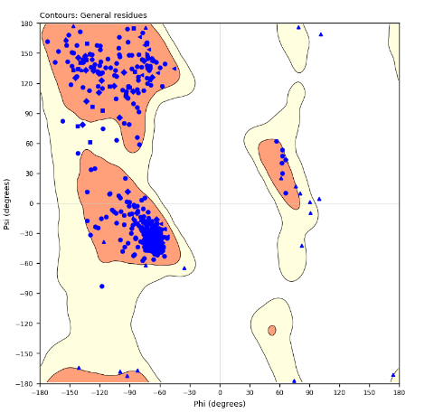
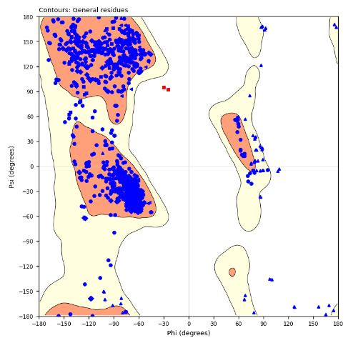
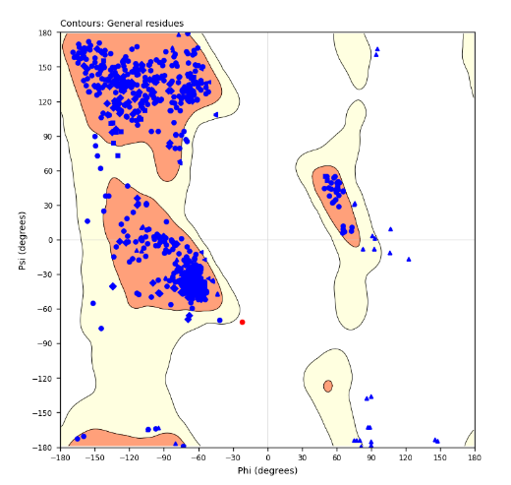

TopII-DNA (3QX3)
Tubulin (6PC4)
TopII (1ZXM)

Figure S163: Ramachandran plots of TopII ATPase (1ZXM), TopII-DNA (3QX3), and Tubulin (6PC4) highlighting optimal protein preparation via phi/psi angles. In all three cases, >95% of residues are in the allowed regions. Any residue outside represents flexible amino acids: Gly, Pro, Pre-Pro, Pre-Gly.

Figure S164: Docking scores of ligands against TopII (1ZXM), TopII-DNA (3QX3), and tubulin (6PC4).

