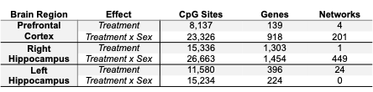
Table 1. Psilocybin effects on DNA methylation. Number of CpG sites (p<0.05), genes (q<0.05), and functional enrichment networks affected by psilocybin treatment in aging male and female mice. Treatment effects that were modified by a Treatment by Sex interaction are only counted for the interaction.

