SUPPLEMENTAL MATERIALS

IMPACT OF THE COVID-19 PANDEMIC ON THE EPIDEMIOLOGY OF OUT-OF-HOSPITAL CARDIAC ARREST: A SYSTEMATIC REVIEW AND META-ANALYSIS

- Appendix I – Expanded Methods

- Online Supplemental Tables

- Online Supplemental Figures

- Online Supplemental Data

1. Appendix I – Expanded Methods

Appendix I. Full Search Phrases Used for the Five Respective Databases.
PubMed |  |  |  | 165 articles
((sudden cardiac arrest[Title/Abstract]) OR (sudden cardiac death[Title/Abstract]) OR (out of hospital cardiac arrest[Title/Abstract]) OR (out-of-hospital cardiac arrest[Title/Abstract]) OR (cardiac arrest[Title/Abstract]) OR (OHCA[Title/Abstract]) OR (OOHCA[Title/Abstract]) OR (“heart arrest”[Mesh])) AND ((covid-19[Title/Abstract]) OR (coronavirus[Title/Abstract]) OR (SARS-CoV-2[Title/Abstract]))
EMBASE |  |  |  | 345 articles
Heart arrest concept

1 | ‘cardiac arrest’:ti,ab,kw
2 | ‘sudden cardiac arrest’:ti,ab,kw
3 | ‘sudden cardiac death’:ti,ab,kw
4 | ‘out of hospital cardiac arrest’:ti,ab,kw
5 | ‘out-of-hospital cardiac arrest’:ti,ab,kw
6 | OOHCA:ti,ab,kw
7 | OHCA:ti,ab,kw
8 | ‘heart arrest’/exp
9 | #1 OR #2 OR #3 OR #4 OR #5 OR #6 OR #7 OR #8
COVID-19 concept

10 | covid-19:ti,ab,kw
11 | coronavirus:ti,ab,kw
12 | SARS-CoV-2:ti,ab,kw
13 | #10 OR #11 OR #12
Combined

14 | #9 AND #13
Web of Science |  |  | 43 articles
Heart arrest concept
1 | TI=(sudden cardiac death OR sudden cardiac arrest OR OOHCA OR OHCA OR out of hospital cardiac arrest OR out-of-hospital cardiac arrest OR cardiac arrest)
2 | AB=(sudden cardiac death OR sudden cardiac arrest OR OOHCA OR OHCA OR out of hospital cardiac arrest OR out-of-hospital cardiac arrest OR cardiac arrest)
3 | #1 AND #2
COVID-19 concept
4 | TI=(coronavirus OR covid-19 OR sars-cov-2)
5 | AB=(coronavirus OR covid-19 OR sars-cov-2)
6 | #4 AND #5
Combined
7 | #3 AND #6
SCOPUS |  | 408 articles
Heart arrest concept
1 | TITLE-ABS-KEY ( ( "OOHCA" OR "OHCA" OR "out of hospital cardiac arrest" OR "out-of-hospital cardiac arrest" OR "sudden cardiac arrest" OR "sudden cardiac death" OR "cardiac arrest" ) )
COVID-19 concept
2 | TITLE-ABS-KEY ( ( "covid-19" OR "coronavirus" OR "SARS-CoV-2" ) )
Combined
3 | #1 AND #2
Cochrane Controlled Register of Trials (CENTRAL) |  |  | 5 articles
Heart arrest concept

1 | (cardiac arrest):ti,ab,kw
2 | (sudden cardiac arrest):ti,ab,kw
3 | (sudden cardiac death):ti,ab,kw
4 | (out of hospital cardiac arrest):ti,ab,kw
5 | (out-of-hospital cardiac arrest):ti,ab,kw
6 | (OOHCA):ti,ab,kw
7 | (OHCA):ti,ab,kw
8 | MeSH descriptor: [Heart arrest] explode all trees
9 | #1 OR #2 OR #3 OR #4 OR #5 OR #6 OR #7 OR #8
COVID-19 concept

10 | (covid-19):ti,ab,kw
11 | (coronavirus):ti,ab,kw
12 | (SARS-CoV-2):ti,ab,kw
13 | #10 OR #11 OR #12
Combined

14 | #9 AND #13

Date searched: May 3, 2021
Total articles: 966
After endnote deduplication: 546

2. Online Supplemental Tables

Supplemental Table 1. Newcastle-Ottawa Scale (NOS) for Risk of Bias Assessment of Studies Included in the Meta-Analysis
Study | Selection |  |  |  |  |  |  |  | Comparability |  | Outcomes |  |  |  |  |  | Total
 | Representativeness of exposed cohort |  | Selection of nonexposed cohort |  | Ascertainment of exposure |  | Outcome not present at the start of the study |  | Comparability on the basis of the design or analysis |  | Assessment of outcomes |  | Length of follow-up |  | Adequacy of follow-up
 | SET | YM | SET | YM | SET | YM | SET | YM | SET | YM | SET | YM | SET | YM | SET | YM | SET | YM
Baert et al, 2020²³ | * | * | * | * | * | * | * | * | ** | ** | * | * | * | * |  |  | ******** | ********
Baldi et al, 2020²⁴ | * | * | * | * | * | * | * | * | ** | ** | * | * | * | * | * | * | ********* | *********
Ball et al, 2020⁷ | * | * | * | * | * | * | * | * | * | * |  | * | * | * | * | * | ******** | ********
Cho et al, 2020²⁵ | * | * | * | * | * | * |  | * | * | ** | * | * | * |  | * |  | ******** | *******
Elmer et al, 2020²⁶ | * | * | * | * | * | * | * | * | ** | ** | * | * |  | * | * | * | ******** | *********
Lai et al, 2020²⁷ | * | * | * | * | * | * | * | * | ** | * | * | * | * | * | * | * | ********* | ********
Marijon et al, 2020⁶ | * | * | * | * | * | * | * | * | ** | ** | * | * | * | * | * | * | ********* | *********
Ortiz et al, 2020²⁸ | * | * | * | * | * | * |  | * | * | ** | * | * | * | * | * | * | ******* | *********
Paoli et al, 2020²⁹ | * | * | * | * | * | * | * | * | ** | ** | * | * | * | * |  | * | ******** | *********
Sayre et al, 2020³⁰ |  | * | * | * | * | * | * | * | ** | * | * | * | * | * | * | * | ******** | ********
Semeraro et al, 2020³¹ | * | * | * | * | * | * | * | * | ** | ** | * | * | * |  |  |  | ******** | *******
Chan et al, 2021³² | * | * | * | * | * | * | * | * | * | * | * | * |  | * | * | * | ******* | ********
de Koning et al, 2021³³ | * | * | * | * | * | * |  | * | ** | ** | * | * | * | * |  |  | ******* | ********
Fothergill et al, 2021⁸ | * | * | * | * | * | * | * | * | ** | ** | * | * | * | * | * | * | ********* | *********
Glober et al, 2021³⁴ |  | * | * | * |  | * | * | * | ** | ** | * | * | * | * | * | * | ******* | *********
Lim et al, 2021³⁵ | * | * | * | * | * | * | * | * | ** | * | * | * | * | * | * | * | ********* | ********
Mathew et al, 2021³⁶ | * | * | * | * | * | * | * | * | * | ** | * | * | * | * | * | * | ******** | *********
Nickles et al, 2021³⁷ | * | * | * | * | * | * | * | * | ** | ** | * | * | * |  |  |  | ******** | *******
Sultanian et al, 2021³⁸ | * | * | * | * | * | * | * | * | ** | * | * | * | * | * | * | * | ********* | ********
Uy-Evanado et al, 2021³⁹ | * | * | * | * | * | * | * | * | * | ** |  | * | * | * | * | * | ******* | *********

Supplemental Table 2. Summary of Primary and Secondary Outcomes
Study | Time Period | Annual OHCA# Incidence (per 100,000 population) | Case Fatality Rate, N* (%) | Termination of Resuscitation, N* (%) | ROSC**, N* (%) | Survival to Hospital Admission, N* (%) | Survival to Hospital Discharge, N* (%)
Baert et al, 2020²³ | Pre-COVID-19|| | NR† | 1521/1620  (93.9%) | NR† | 409/1616 (25.3%) | NR† | 99/1546  (6.4%)
Baert et al, 2020²³ | COVID-19|| | NR† | 979/1005  (97.4%) | NR† | 195/999 (19.5%) | NR† | 26/937  (2.8%)
Baldi et al, 2020²⁴ | Pre-COVID-19|| | 125 | 300/321 (93.5%) | 156/222§  (70.3%) | 44/222§  (19.8%) | NR† | 21/222§  (9.5%)
Baldi et al, 2020²⁴ | COVID-19|| | 190 | 474/490 (96.7%) | 253/314  (80.6%) | 27/314 (8.6%) | NR† | 16/314  (5.1%)
Ball et al, 2020⁷ | Pre-COVID-19|| | 81 | 1076/1218 (88.3%) | NR† | 416/1218 (34.2%) | 359/1218 (29.5%) | 142/1218 (11.7%)
Ball et al, 2020⁷ | COVID-19|| | 88 | 358/380 (94.2%) | NR† | 112/380 (29.5%) | 92/380  (24.2%) | 22/380  (5.8%)
Cho et al, 2020²⁵ | Pre-COVID-19|| | NR† | 144/158 (91.1%) | NR† | 15/158 (9.5%) | 49/158  (31.0%) | 14/158  (8.9%)
Cho et al, 2020²⁵ | COVID-19|| | NR† | 163/171 (95.3%) | NR† | 8/171  (4.7%) | 39/171  (22.8%) | 8/171  (4.7%)
Elmer et al, 2020²⁶ | Pre-COVID-19|| | NR† | NR† | NR† | 1529/12252 (12.5%) | 5950/12252 (48.6%) | NR†
Elmer et al, 2020²⁶ | COVID-19|| | NR† | NR† | NR† | 95/683 (13.9%) | 354/683 (51.8%) | NR†
Lai et al, 2020²⁷ | Pre-COVID-19|| | NR† | NR† | 999/1336 (74.8%) | 463/1336 (34.7%) | NR† | NR†
Lai et al, 2020²⁷ | COVID-19|| | NR† | NR† | 3566/3986 (89.5%) | 727/3989 (18.2%) | NR† | NR†
Marijon et al, 2020⁶ | Pre-COVID-19|| | 62 | 2888/3052 (94.6%) | NR† | NR† | 695/3052 (22.8%) | 164/3052 (5.4%)
Marijon et al, 2020⁶ | COVID-19|| | 90 | 505/521 (96.9%) | NR† | NR† | 67/521  (12.9%) | 16/517  (3.1%)
Ortiz et al, 2020²⁸ | Pre-COVID-19|| | NR† | 1555/1723  (90.2%) | NR† | 525/1723 (30.5%) | 563/1718  (32.8%) | 168/1723 (9.8%)
Ortiz et al, 2020²⁸ | COVID-19|| | NR† | 1338/1446  (92.5%) | NR† | 290/1446 (20.1%) | 395/1433  (27.6%) | 108/1446 (7.5%)
Paoli et al, 2020²⁹ | Pre-COVID-19|| | 132 | NR† | NR† | 4/206  (1.9%) | 6/206  (2.9%) | NR†
Paoli et al, 2020²⁹ | COVID-19|| | 128 | NR† | NR† | 2/200  (1.0%) | 6/200  (3.0%) | NR†
Sayre et al, 2020³⁰ | Pre-COVID-19|| | 160 | NR† | NR† | NR† | NR† | NR†
Sayre et al, 2020³⁰ | COVID-19|| | 198 | NR† | NR† | NR† | NR† | NR†
Semeraro et al, 2020³¹ | Pre-COVID-19|| | NR† | 541/563 (96.1%) | NR† | 54/563 (9.6%) | 42/110§  (38.2%) | 22/110§  (20.0%)
Semeraro et al, 2020³¹ | COVID-19|| | NR† | 601/624 (96.3%) | NR† | 38/624 (6.1%) | 31/95  (32.6%) | 23/95  (24.2%)
Chan et al, 2021³² | Pre-COVID-19|| | NR† | 9108/9440 (96.5%) | 3768/9440 (39.9%) | 2813/9440 (29.8%) | NR† | 332/3393 (9.8%)
Chan et al, 2021³² | COVID-19|| | NR† | 9624/9863 (97.6%) | 5314/9863 (53.9%) | 2268/9863 (23.0%) | NR† | 239/3632 (6.6%)
de Koning et al, 2021³³ | Pre-COVID-19|| | 51 | NR† | NR† | NR† | NR† | NR†
de Koning et al, 2021³³ | COVID-19|| | 63 | NR† | NR† | NR† | NR† | NR†
Fothergill et al, 2021⁸ | Pre-COVID-19|| | 77 | 1654/1724 (95.9%) | 318/683§  (46.6%) | 224/683§ (32.8%) | NR† | 70/658§  (10.6%)
Fothergill et al, 2021⁸ | COVID-19|| | 139 | 3073/3122 (98.4%) | 798/1135 (70.3%) | 213/1135 (18.8%) | NR† | 49/1108  (4.4%)
Glober et al, 2021³⁴ | Pre-COVID-19|| | 183 | NR† | NR† | NR† | NR† | NR†
Glober et al, 2021³⁴ | COVID-19|| | 214 | NR† | NR† | NR† | NR† | NR†
Lim et al, 2021³⁵ | Pre-COVID-19|| | 63 | NR† | NR† | 160‡/1190 (13.4%) | 1190/1280  (93.0%) | NR†
Lim et al, 2021³⁵ | COVID-19|| | 69 | NR† | NR† | 131/1238 (10.6%) | 1238/1400  (88.4%) | NR†
Mathew et al, 2021³⁶ | Pre-COVID-19|| | NR† | NR† | 64/180  (35.6%) | 29/180 (16.1%) | 85/180  (47.2%) | NR†
Mathew et al, 2021³⁶ | COVID-19|| | NR† | NR† | 200/291  (68.7%) | 32/291 (11.0%) | 50/291  (17.2%) | NR†
Nickles et al, 2021³⁷ | Pre-COVID-19|| | 72 | NR† | NR† | NR† | NR† | NR†
Nickles et al, 2021³⁷ | COVID-19|| | 115 | NR† | NR† | NR† | NR† | NR†
Sultanian et al, 2021³⁸ | Pre-COVID-19|| | NR† | 865/930 (93.0%) | NR† | 310/930 (33.3%) | NR† | 65/930  (7.0%)
Sultanian et al, 2021³⁸ | COVID-19|| | NR† | 999/1016 (98.3%) | NR† | 297/1016 (29.2%) | NR† | 17/1016  (1.7%)
Uy-Evanado et al, 2021³⁹ | Pre-COVID-19|| | NR† | 197/231 (85.3%) | NR† | 95/231 (41.1%) | 74/231  (32.0%) | 34/231  (14.7%)
Uy-Evanado et al, 2021³⁹ | COVID-19|| | NR | 256/278 (92.1%) | NR | 95/278 (34.2%) | 65/278  (23.4%) | 22/278  (7.9%)
Legend: *N, Number; †NR, Not Reported; ||COVID-19, coronavirus disease 2019; #OHCA, Out-of-Hospital Cardiac Arrest; **ROSC, Return of Spontaneous Circulation; ‡Among those who were transported to the Emergency Department; §Among those in whom resuscitation was attempted by the Emergency Medical Services

Supplemental Table 3. Characteristics of Patients with Out-of-Hospital Cardiac Arrest in the Pre-COVID-19 and COVID-19 Time Periods in the Included Studies
Study | Time Period | Age (Years), Mean (SD#) | Male Gender, N* (%) | Shockable Rhythm, N* (%) | Etiology, N* (%)
 |  |  |  |  | Medical | Traumatic | Drowning | Overdose | Asphyxial
Baert et al, 2020²³ | Pre-COVID-19|| | 69.0  (17.0) | 1071/1620 (66.1%) | 145/1615 (9.0%) | NR† | NR† | NR† | NR† | NR†
Baert et al, 2020²³ | COVID-19|| | 68.0  (17.0) | 676/1005 (67.3%) | 87/1003 (8.7%) | NR† | NR† | NR† | NR† | NR†
Baldi et al, 2020²⁴ | Pre-COVID-19|| | 77.3  (14.2) | 188/321  (58.6%) | 37/321 (11.5%) | 287/321 (89.4%) | 28/321  (8.7%) | NR† | 1/321  (0.3%) | 5/321 (1.6%)
Baldi et al, 2020²⁴ | COVID-19|| | 77.0  (14.1) | 321/490  (65.5%) | 36/490  (7.3%) | 465/490  (94.9%) | 13/490  (2.7%) | NR† | 1/490 (0.2%) | 11/490  (2.2%)
Ball et al, 2020⁷ | Pre-COVID-19|| | 65.7 (19.3) | 845/1218 (69.4%) | 318/1218 (26.1%) | 929/1218 (76.3%) | 60/1218 (4.9%) | NR† | 58/1218 (4.8%) | 94/1218 (7.7%)
Ball et al, 2020⁷ | COVID-19|| | 67.7 (19.4) | 250/380 (65.8%) | 90/380 (23.7%) | 269/380 (70.8%) | 22/380 (5.8%) | NR† | 18/380 (4.7%) | 39/380 (10.3%)
Cho et al, 2020²⁵ | Pre-COVID-19|| | 72.8 (15.3) | 103/158 (65.2%) | 19/158 (12.0%) | NR† | NR† | NR† | NR† | NR†
Cho et al, 2020²⁵ | COVID-19|| | 72.0  (13.5) | 108/171 (63.2%) | 15/171 (8.8%) | NR† | NR† | NR† | NR† | NR†
Elmer et al, 2020²⁶ | Pre-COVID-19|| | 63.0  (19.0) | 7700/12252  (62.8%) | NR† | 11153/12252 (91.0%) | 1099/12252 (9.0%) | NR† | NR† | NR†
Elmer et al, 2020²⁶ | COVID-19|| | 64.0  (19.0) | 430/683 (63.0%) | NR† | 643/683 (94.1%) | 40/683 (5.9%) | NR† | NR† | NR†
Lai et al, 2020²⁷ | Pre-COVID-19|| | 68.0  (19.0) | 752/1336 (56.3%) | 38/345§  (11.0%) | NR† | NR† | NR† | NR† | NR†
Lai et al, 2020²⁷ | COVID-19|| | 72.0  (18.0) | 2183/3989 (54.7%) | 45/1254 (3.6%) | NR† | NR† | NR† | NR† | NR†
Marijon et al, 2020⁶ | Pre-COVID-19|| | 68.5  (18.0) | 1826/3052 (59.8%) | 472/2471 (19.1%) | NR† | NR† | NR† | NR† | NR†
Marijon et al, 2020⁶ | COVID-19|| | 69.7  (17.0) | 334/521 (64.1%) | 46/500 (9.2%) | NR† | NR† | NR† | NR† | NR†
Ortiz et al, 2020²⁸ | Pre-COVID-19|| | 65.6 (16.9) | 1210/1723 (70.2%) | 386/1675 (23.0%) | NR† | NR† | NR† | NR† | NR†
Ortiz et al, 2020²⁸ | COVID-19|| | 64.4 (16.5) | 1028/1446 (71.1%) | 282/1392 (20.3%) | NR† | NR† | NR† | NR† | NR†
Paoli et al, 2020²⁹ | Pre-COVID-19|| | 77.0  (14.0) | NR† | NR† | 179/206 (86.9%) | 17/206 (8.3%) | NR† | 1/206 (0.5%) | 7/206  (3.4%)
Paoli et al, 2020²⁹ | COVID-19|| | 79.0  (17.0) | NR† | NR† | 175/200 (87.5%) | 15/200 (7.5%) | 1/200 (0.5%) | NR† | 6/200  (3.0%)
Sayre et al, 2020³⁰ | Pre-COVID-19|| | NR† | NR† | NR† | NR† | NR† | NR† | NR† | NR†
Sayre et al, 2020³⁰ | COVID-19|| | NR† | NR† | NR† | NR† | NR† | NR† | NR† | NR†
Semeraro et al, 2020³¹ | Pre-COVID-19|| | 82.7 (13.4) | 284/563 (50.4%) | 34/110‡  (30.9%) | 99/563 (17.6%) | 6/563  (1.1%) | 1/563  (0.2%) | 4/563  (0.7%) | NR†
Semeraro et al, 2020³¹ | COVID-19|| | 82.7 (13.4) | 318/624 (51.0%) | 33/95 (34.7%) | 89/624 (14.3%) | 4/624  (0.6%) | NR† | 2/624  (0.3%) | NR†
Chan et al, 2021³² | Pre-COVID-19|| | 62.2 (19.2) | 5922/9440 (62.7%) | 1774/9440 (18.8%) | 7957/9440 (84.3%) | NR† | NR† | 582/9440 (6.2%) | 769/9440  (8.1%)
Chan et al, 2021³² | COVID-19|| | 62.6 (19.6) | 6040/9863 (61.2%) | 1423/9836 (14.5%) | 7935/9863 (80.5%) | NR† | NR† | 614/9863 (6.2%) | 878/9863  (8.9%)
de Koning et al, 2021³³ | Pre-COVID-19|| | 70.0  (12.0) | 31/45 (68.9%) | 18/45 (40.0%) | NR† | NR† | NR† | NR† | NR†
de Koning et al, 2021³³ | COVID-19|| | 70.0  (14.0) | 32/56 (57.1%) | 15/56 (26.8%) | NR† | NR† | NR† | NR† | NR†
Fothergill et al, 2021⁸ | Pre-COVID-19|| | 68.0  (20.0) | 1069/1724 (62.0%) | 142/683‡  (20.8%) | 646/1724  (37.5%) | 37/1724  (2.1%) | NR† | NR† | NR†
Fothergill et al, 2021⁸ | COVID-19|| | 71.0  (19.0) | 1839/3122 (58.9%) | 168/1135 (14.8%) | 1107/3122  (35.5%) | 28/3122  (0.9%) | NR† | NR† | NR†
Glober et al, 2021³⁴ | Pre-COVID-19|| | 61.5  (18.1) | 544/884 (61.5%) | NR† | NR† | NR† | NR† | NR† | NR†
Glober et al, 2021³⁴ | COVID-19|| | 59.7  (18.5) | 622/1034 (60.2%) | NR† | NR† | NR† | NR† | NR† | NR†
Lim et al, 2021³⁵ | Pre-COVID-19|| | 71.3 (17.1) | 818/1280 (63.9%) | 198/1280 (15.5%) | NR† | NR† | NR† | NR† | NR†
Lim et al, 2021³⁵ | COVID-19|| | 72.3 (17.8) | 882/1400 (63.0%) | 206/1400 (14.7%) | NR† | NR† | NR† | NR† | NR†
Mathew et al, 2021³⁶ | Pre-COVID-19|| | 58.5 (19.8) | 93/180 (51.7%) | 20/180 (11.1%) | NR† | NR† | NR† | NR† | NR†
Mathew et al, 2021³⁶ | COVID-19|| | 64.5 (18.1) | 165/291 (56.7%) | 24/291 (8.2%) | NR† | NR† | NR† | NR† | NR†
Nickles et al, 2021³⁷ | Pre-COVID-19|| | NR† | 662/1162 (57.0%) | NR† | 930/1162 (80.0%) | NR† | NR† | 59/1162 (5.1%) | 71/1162  (6.1%)
Nickles et al, 2021³⁷ | COVID-19|| | NR† | 1083/1854 (58.4%) | NR† | 1502/1854 (81.0%) | NR† | NR† | 68/1854 (3.7%) | 141/1854  (7.6%)
Sultanian et al, 2021³⁸ | Pre-COVID-19|| | 70.8 (16.6) | 604/930 (64.9%) | 168/930 (18.1%) | 785/930 (84.4%) | 19/930 (2.0%) | 1/930 (0.1%) | 26/930 (2.8%) | NR†
Sultanian et al, 2021³⁸ | COVID-19|| | 69.6 (17.8) | 697/1016 (68.6%) | 170/1016 (16.7%) | 640/1016 (63.0%) | 26/1016 (2.6%) | 12/1016 (1.2%) | 34/1016 (3.3%) | NR†
Uy-Evanado et al, 2021³⁹ | Pre-COVID-19|| | 69.1 (17.4) | 137/231 (59.3%) | 64/231 (27.7%) | NR† | NR† | NR† | NR† | NR†
Uy-Evanado et al, 2021³⁹ | COVID-19|| | 64.9 (18.3) | 174/278 (62.6%) | 64/278 (23.0%) | NR† | NR† | NR† | NR† | NR†
Legend: *N, Number; †NR, Not Reported; ||COVID-19, coronavirus disease 2019; #SD, Standard Deviation; ‡Among those in whom resuscitation was attempted by the Emergency Medical Services; §Among those with Advanced Life Support attempted at the scene

3. Online Supplemental Figures

Supplemental Figure 1. Funnel Plots based on (A) Mortality and (B) Return of Spontaneous Circulation
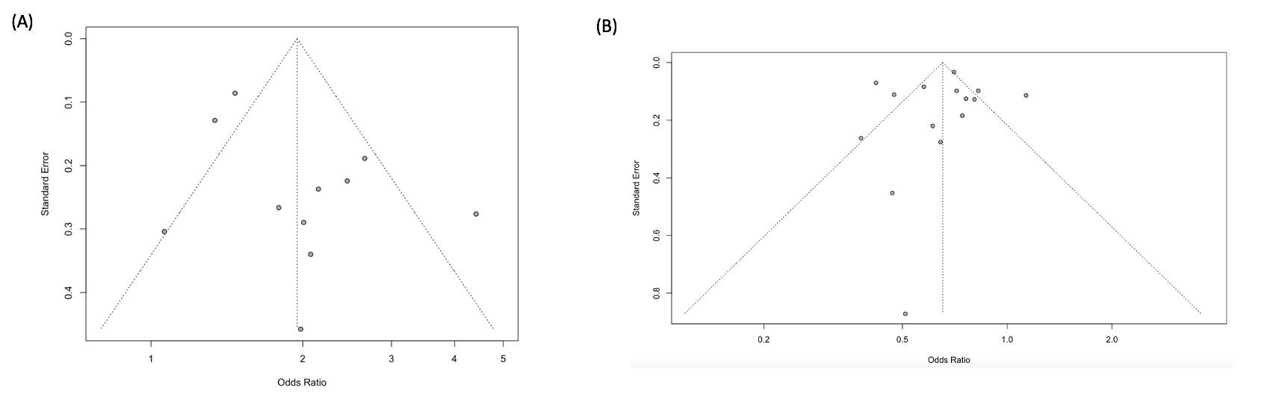
Supplemental Figure 2. Influential Diagnostic Plot for Mortality
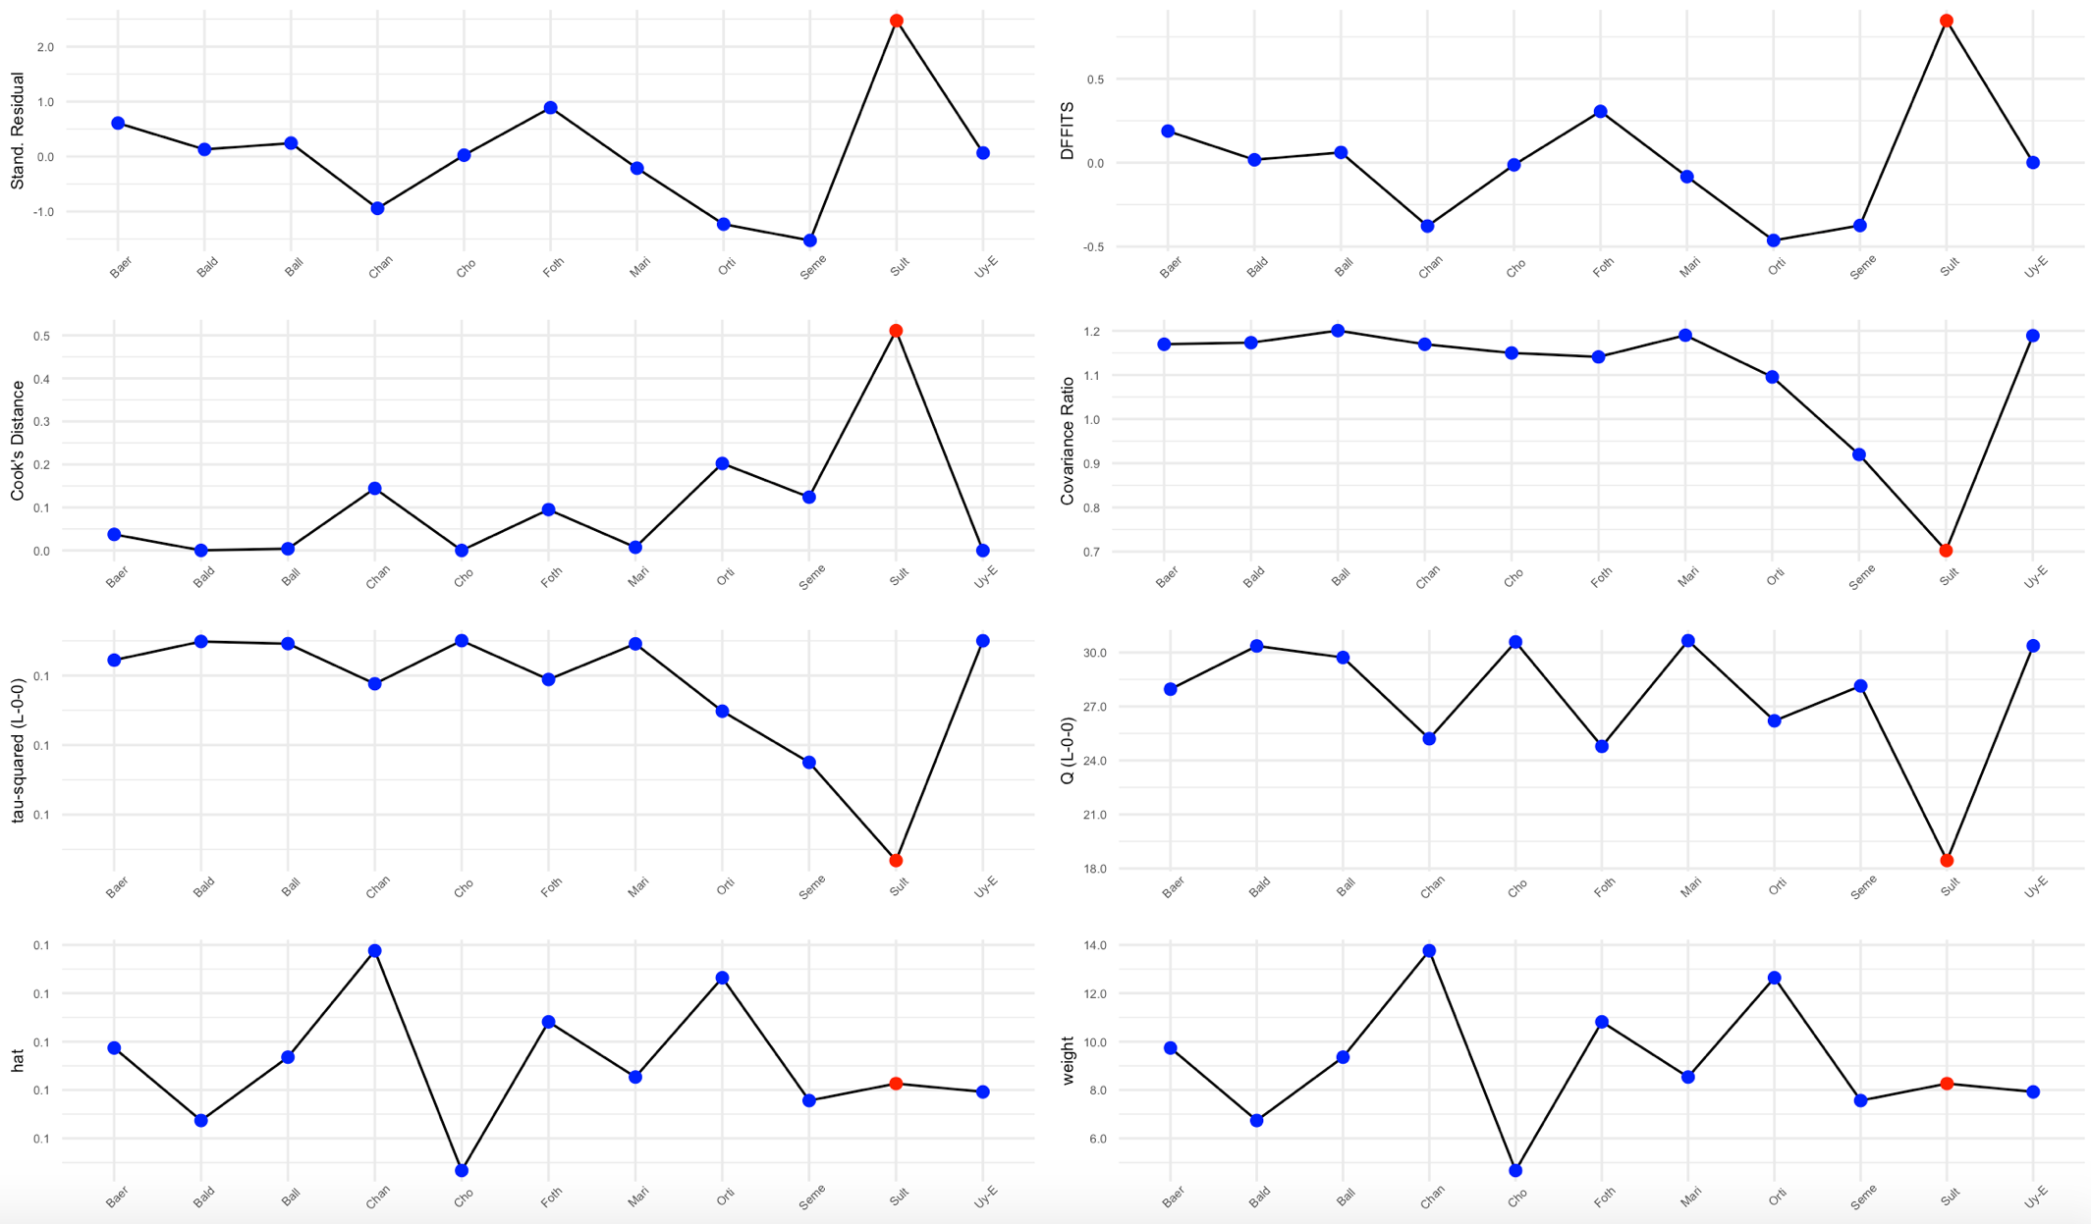

Supplemental Figure 3. Baujat Plot for Mortality

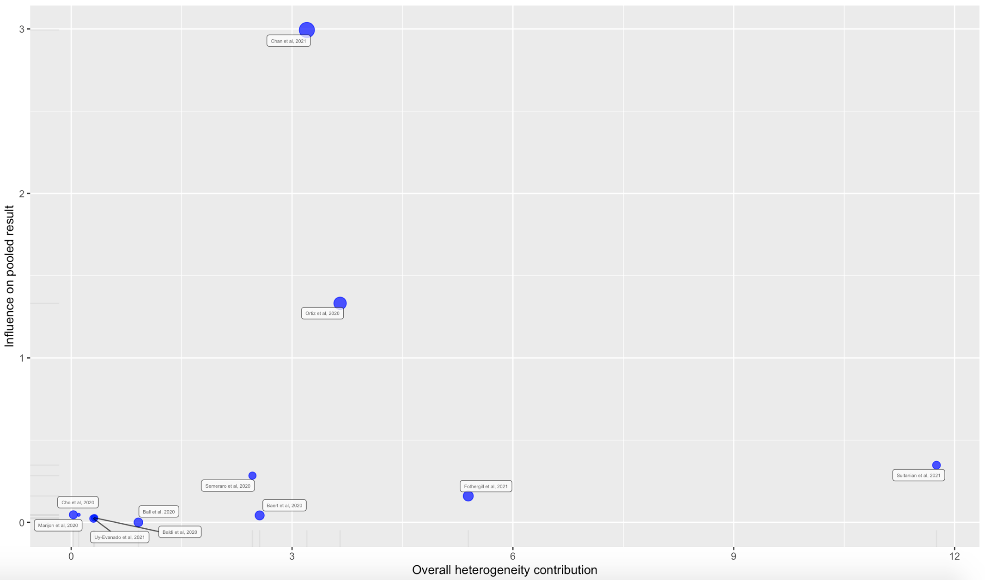
Supplemental Figure 4. Leave-One-Out Analysis For Mortality

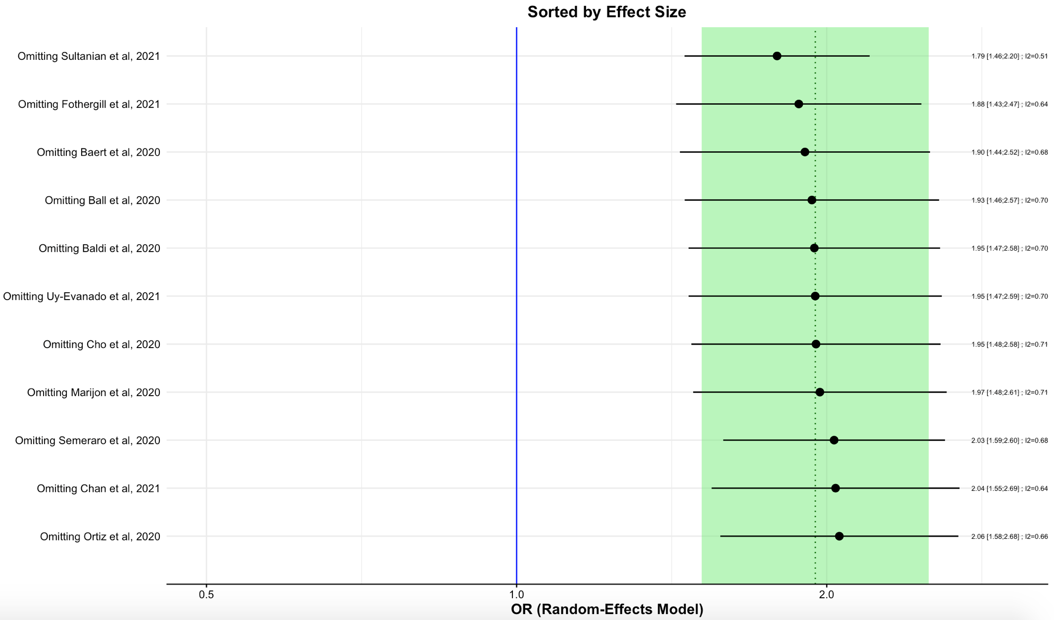
Supplemental Figure 5. Influential Diagnostic Plot for Termination of Resuscitation in the Field
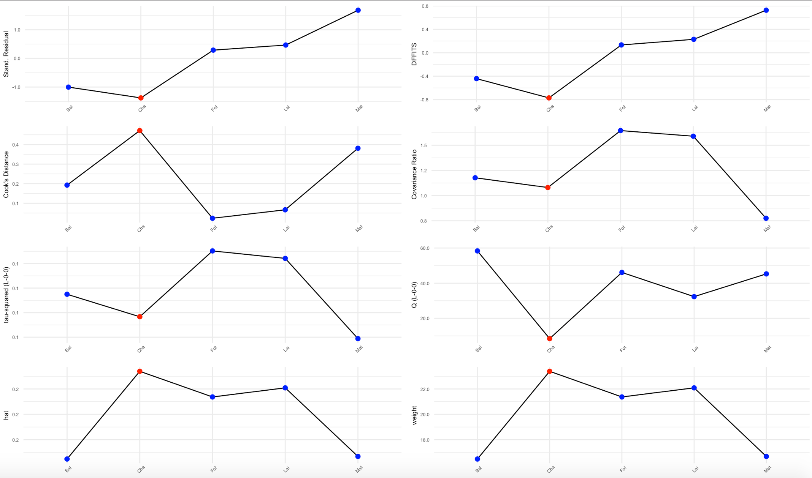
Supplemental Figure 6. Baujat Plot for Termination of Resuscitation in the Field
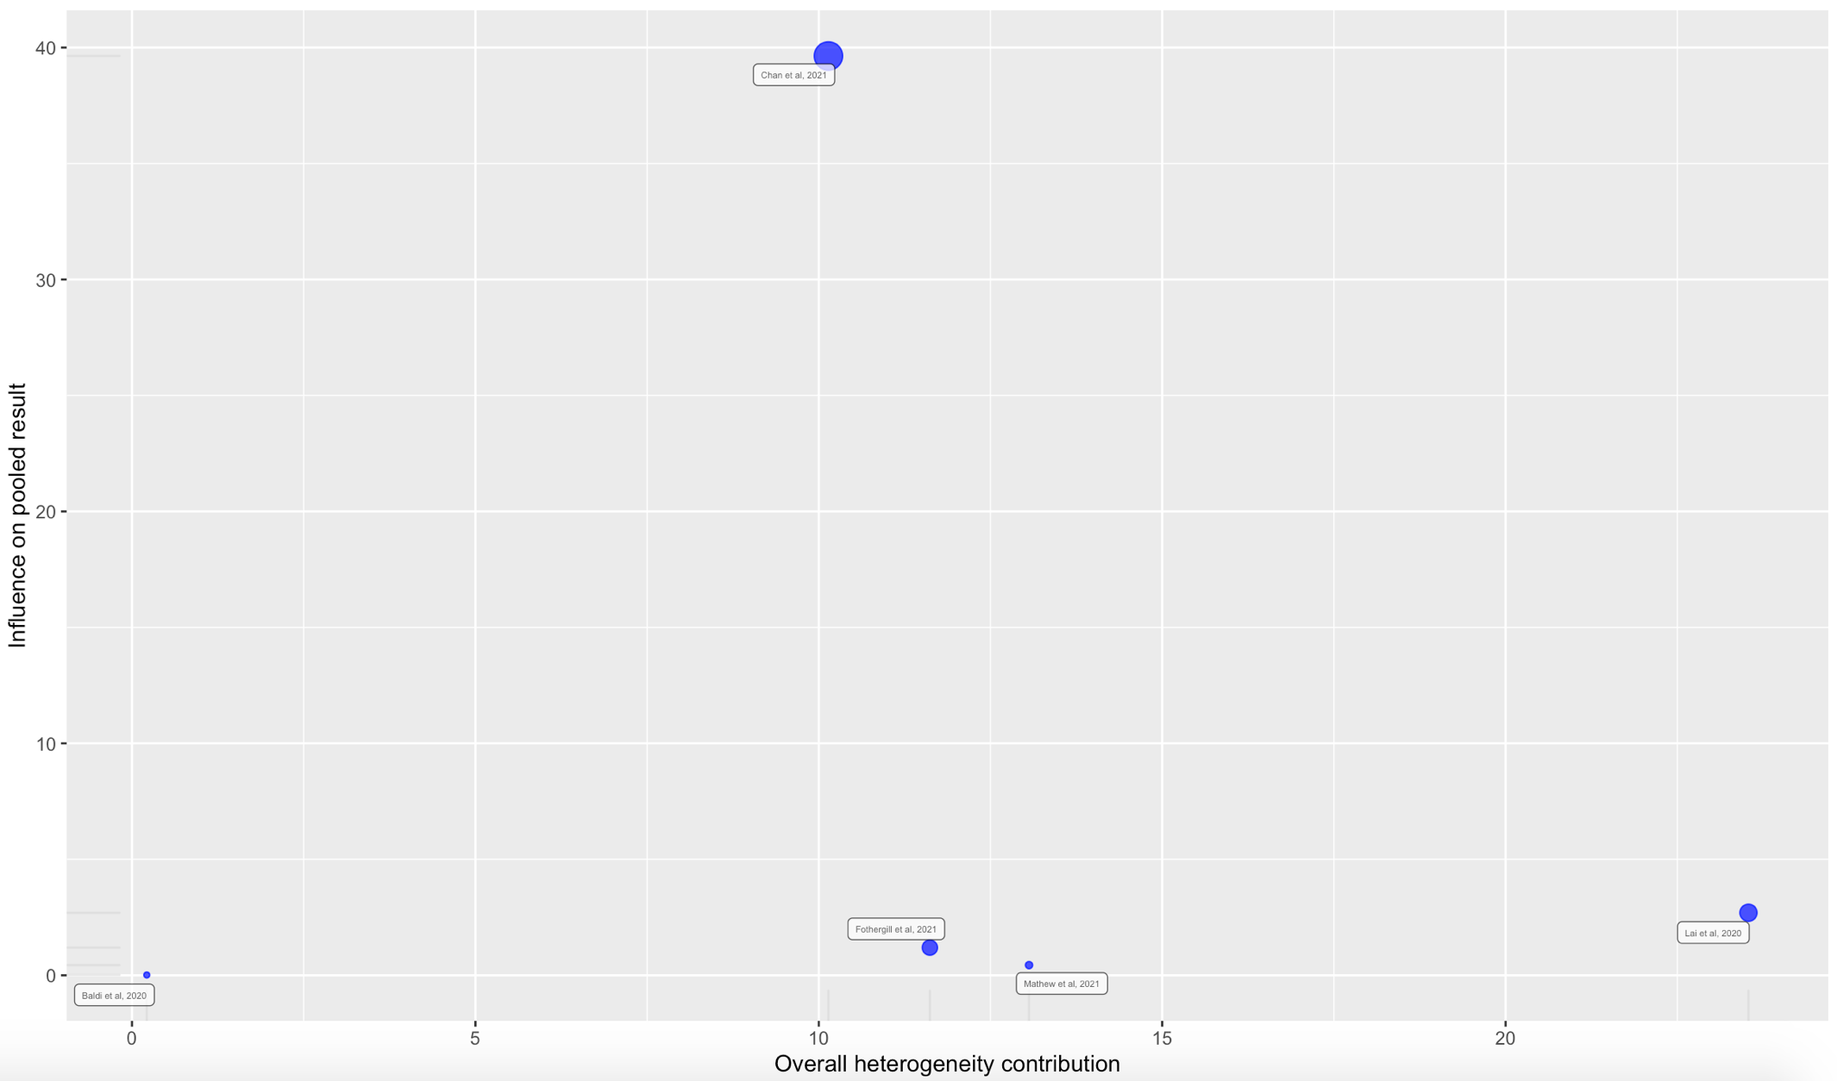
Supplemental Figure 7. Leave-One-Out Analysis for Termination of Resuscitation in the Field
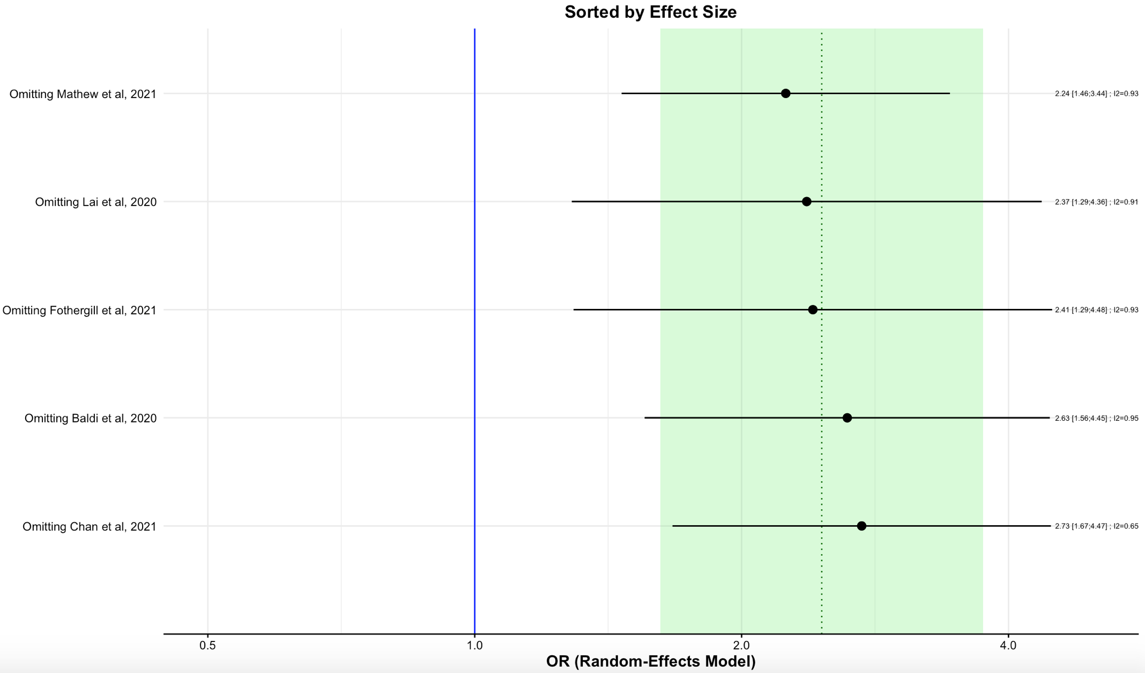
Supplemental Figure 8. Influential Diagnostic Plot for Return of Spontaneous Circulation
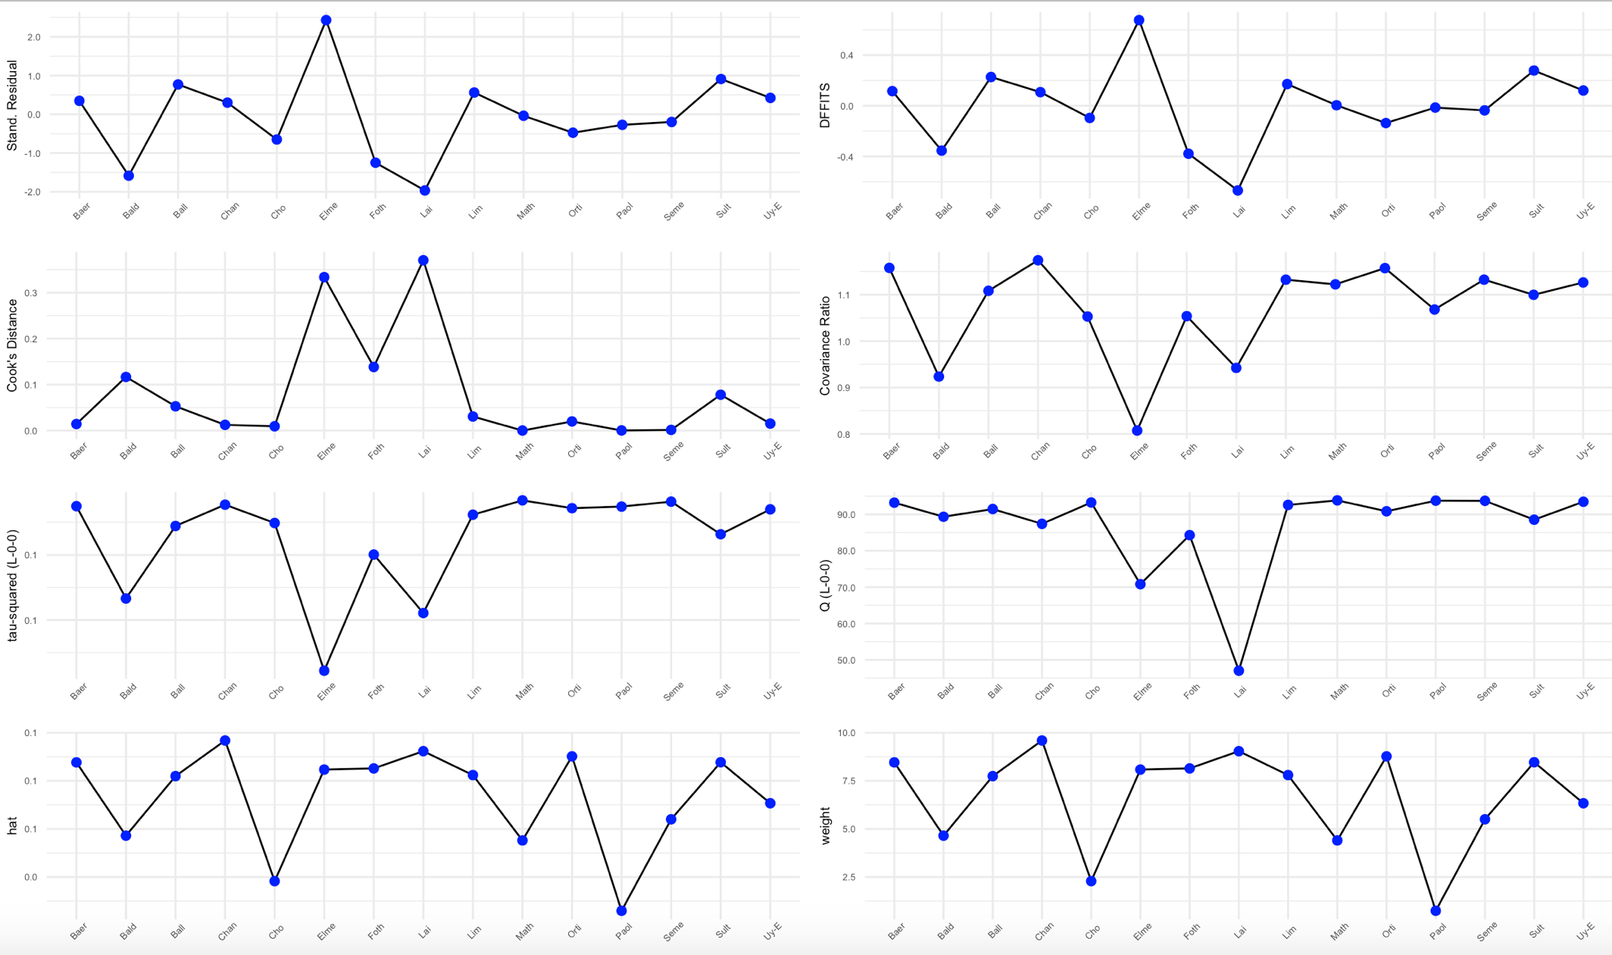
Supplemental Figure 9. Baujat Plot for Return of Spontaneous Circulation
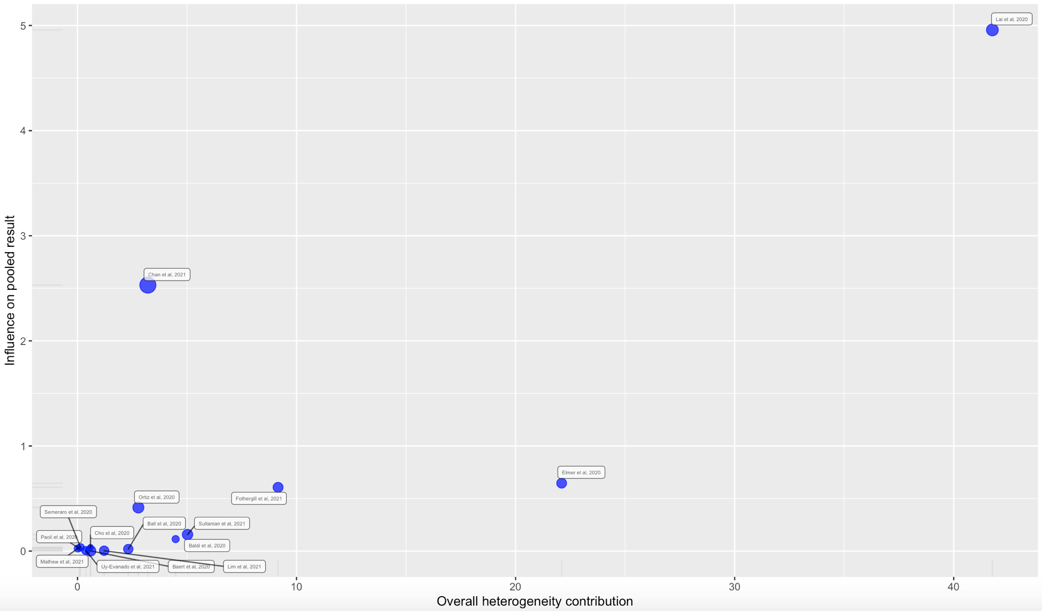
Supplemental Figure 10. Leave-One-Out Analysis for Return of Spontaneous Circulation
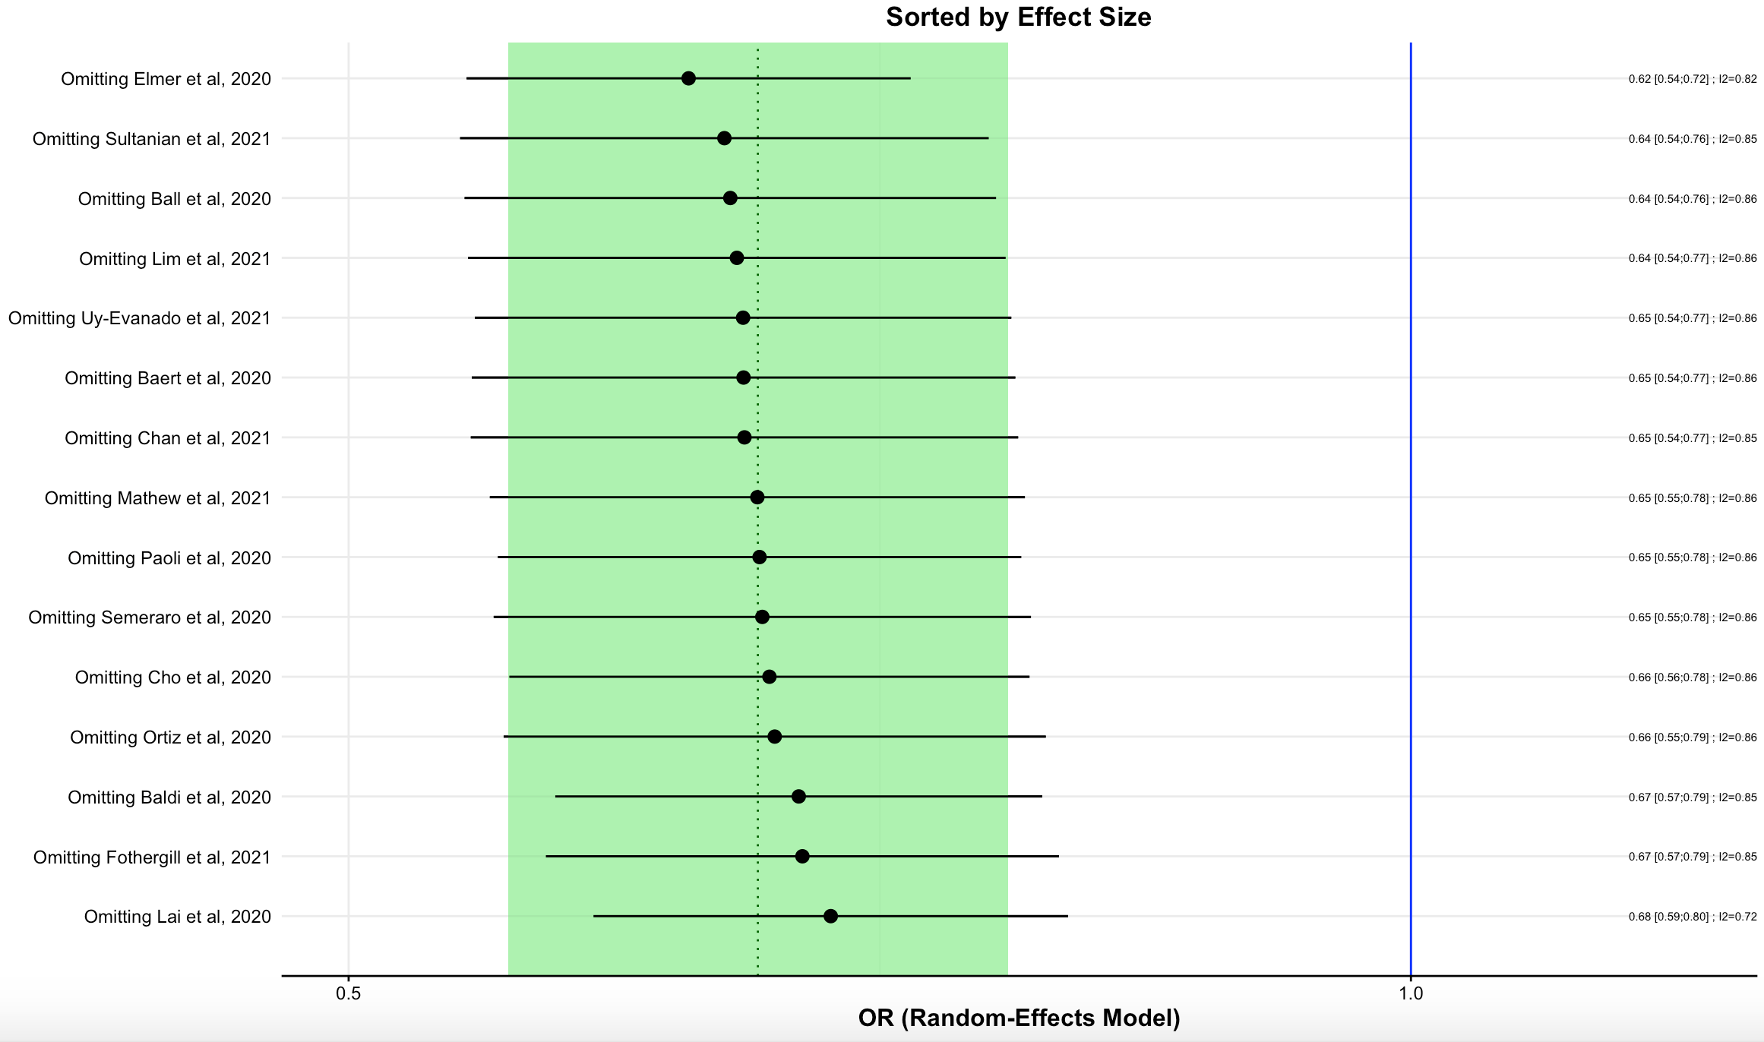
Supplemental Figure 11. Influential Diagnostic Plot for Survival to Hospital Admission
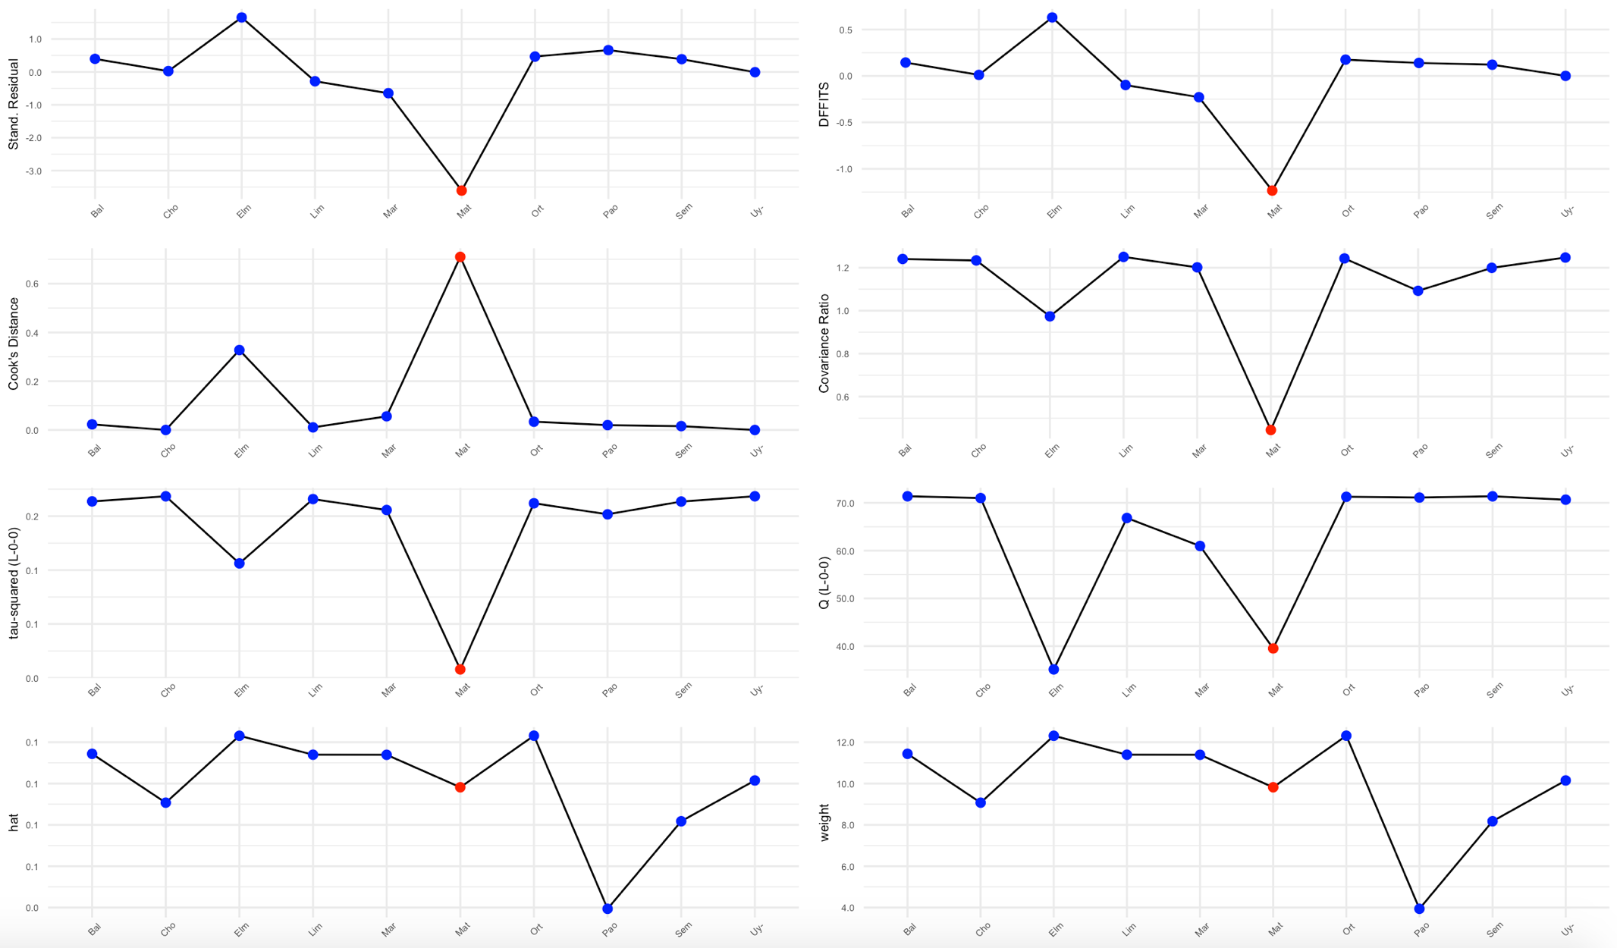
Supplemental Figure 12. Baujat Plot for Survival to Hospital Admission
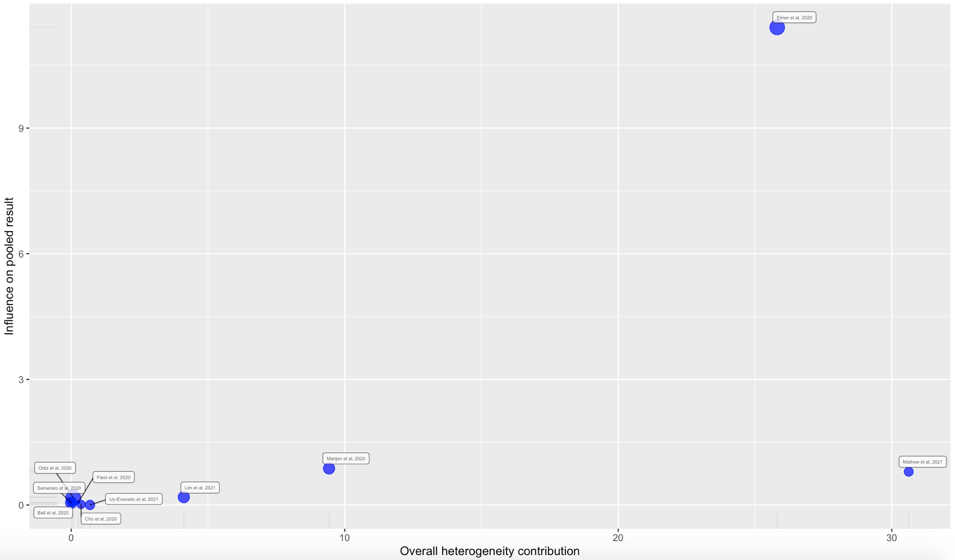
Supplemental Figure 13. Leave-One-Out Analysis for Survival to Hospital Admission
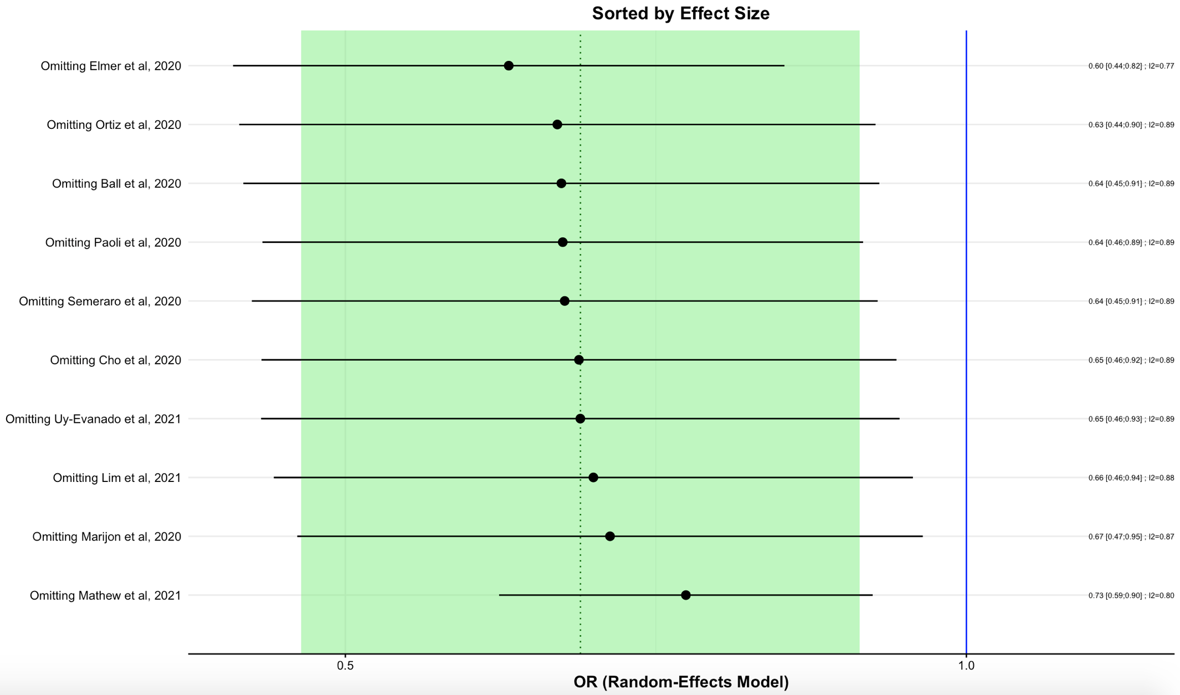
Supplemental Figure 14. Influential Diagnostic Plot for Survival to Hospital Discharge
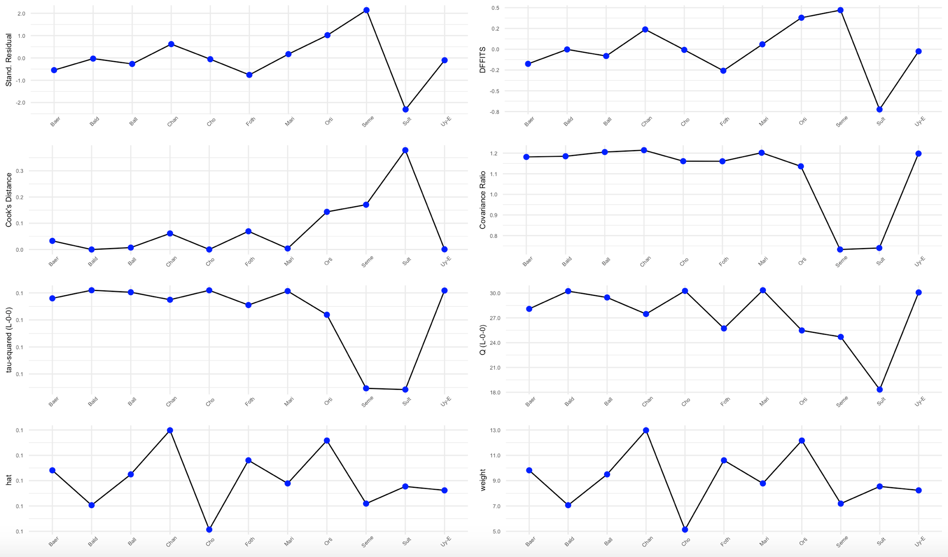
Supplemental Figure 15. Baujat Plot for Survival to Hospital Discharge
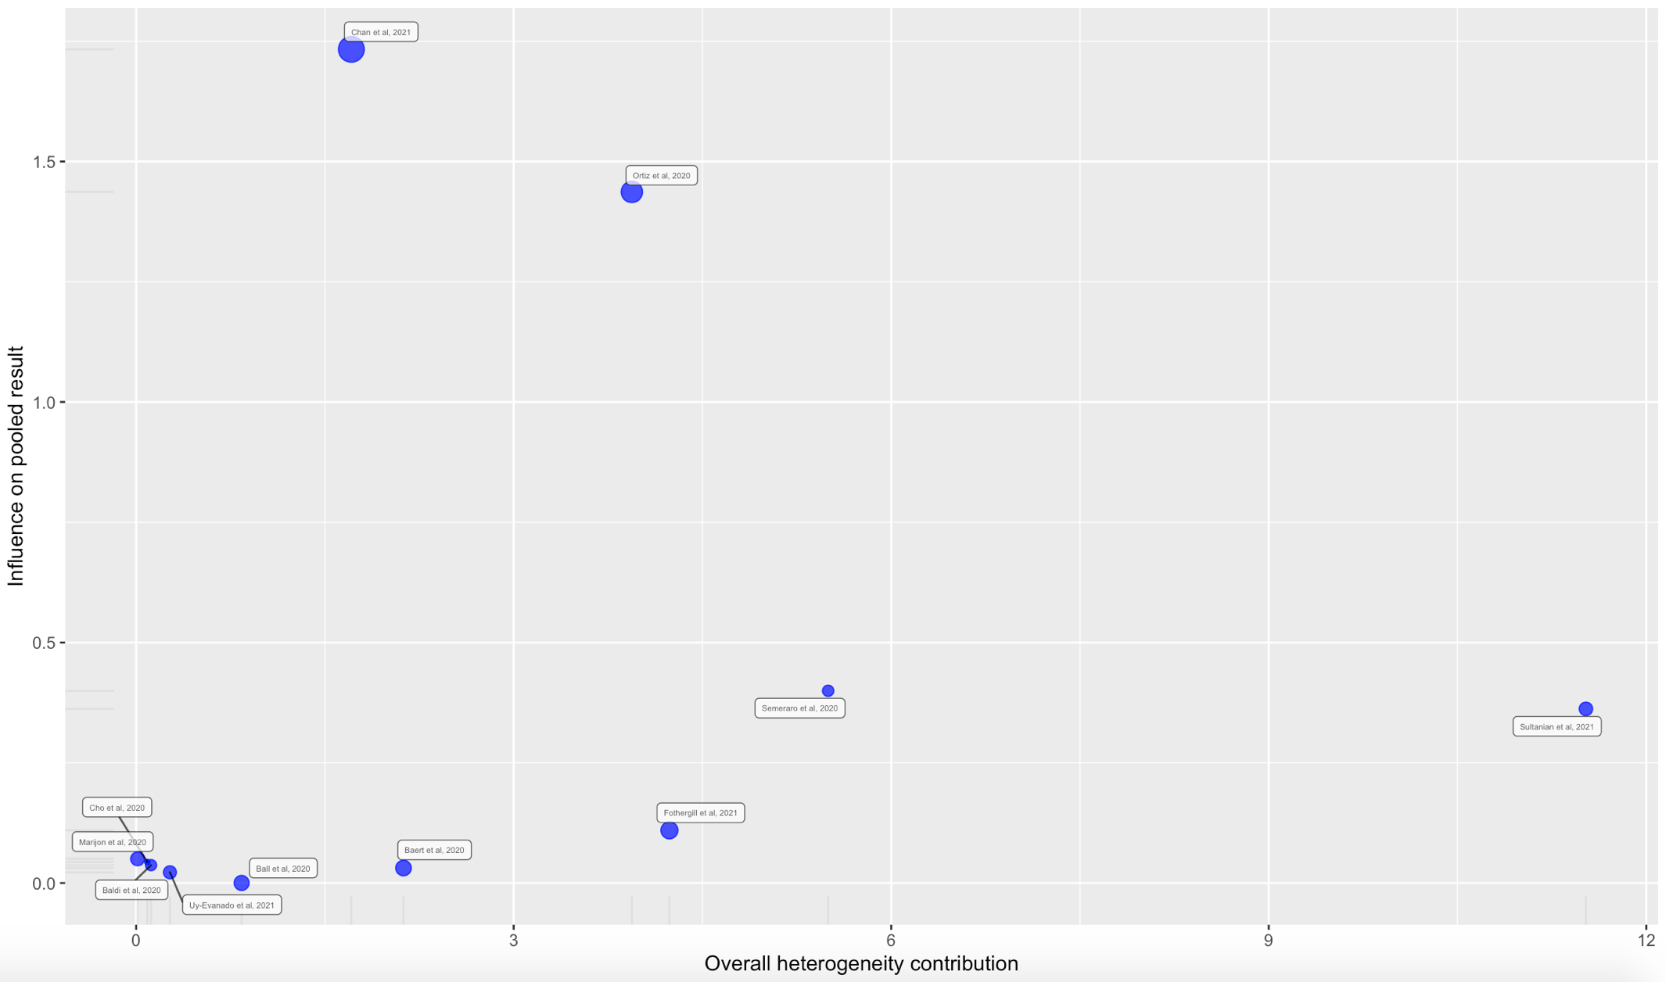
Supplemental Figure 16. Leave-One-Out Analysis for Survival to Hospital Discharge
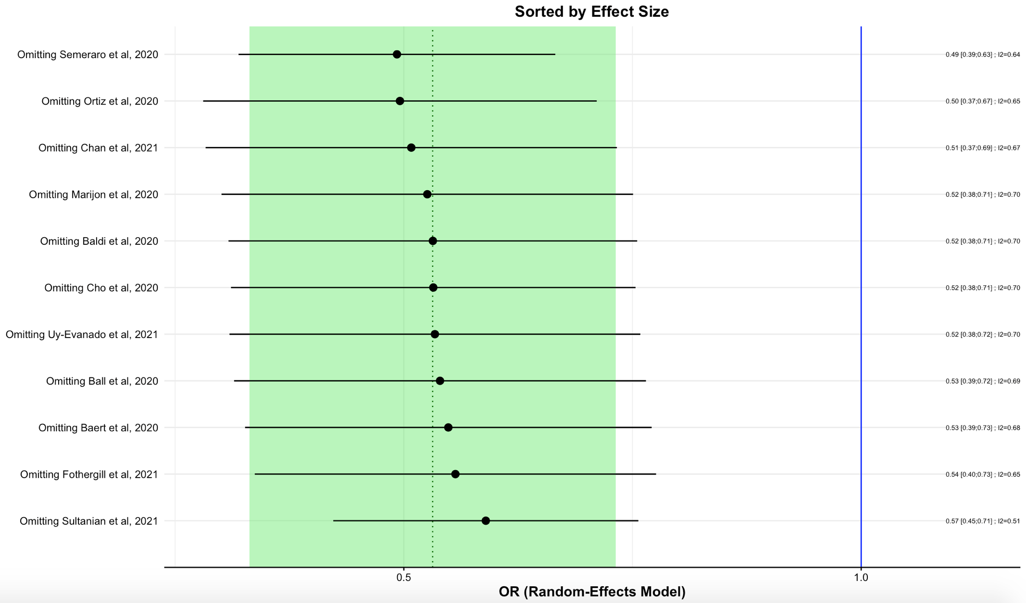
Supplemental Figure 17. Influential Diagnostic Plot for Shockable Rhythm
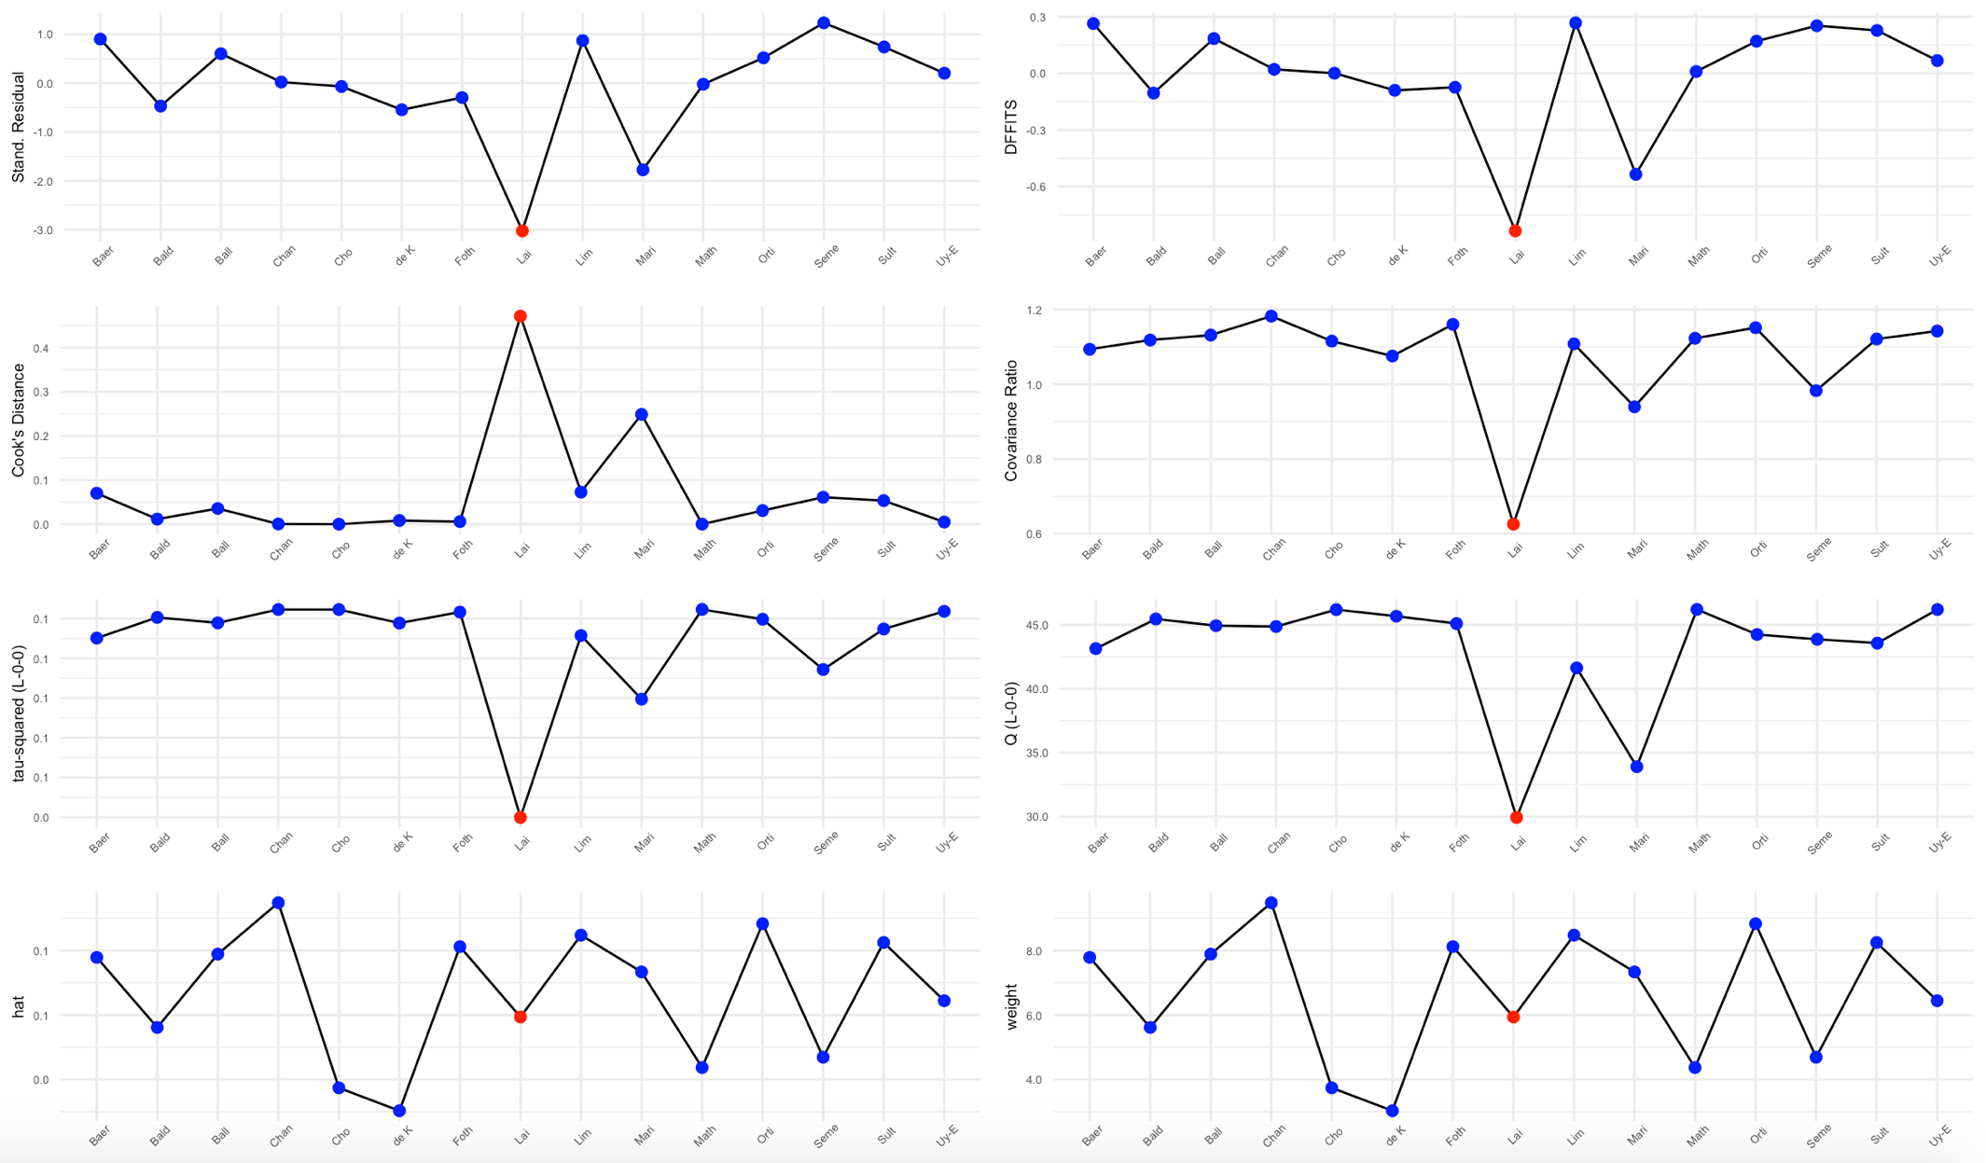
Supplemental Figure 18. Baujat Plot for Shockable Rhythm
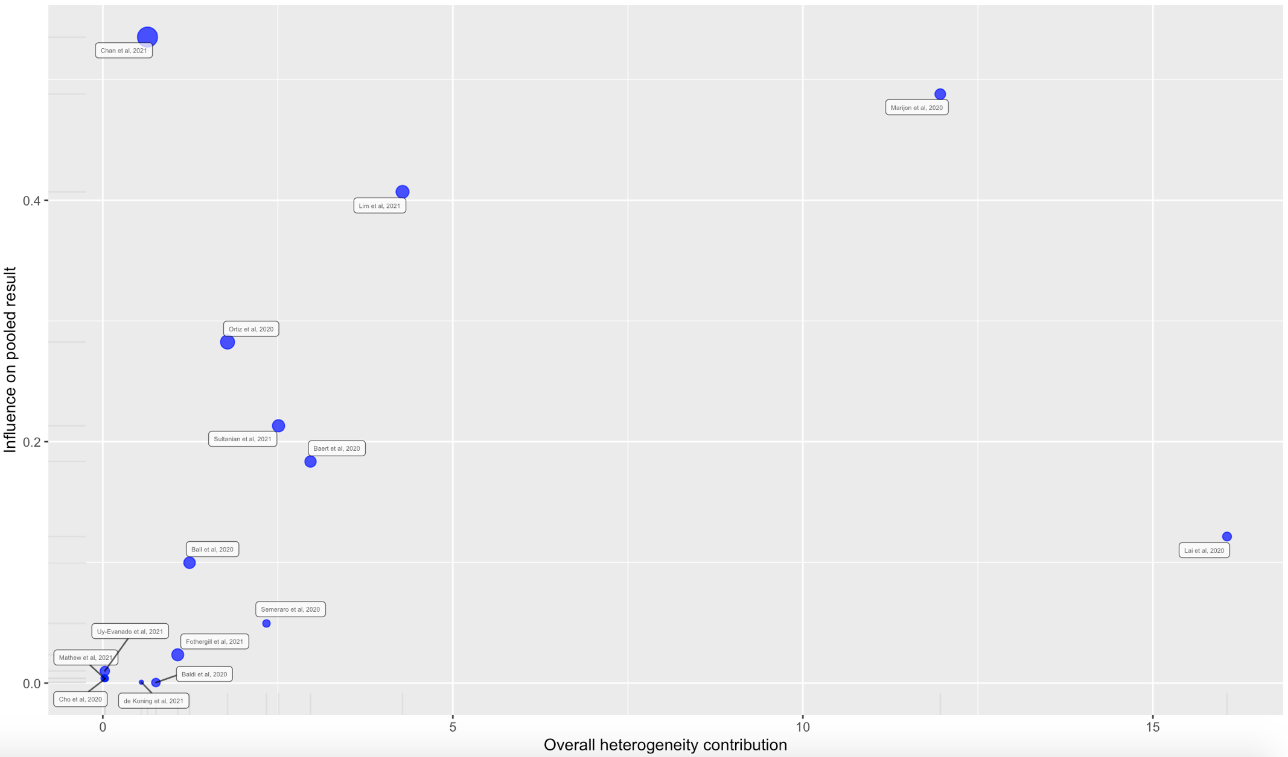
Supplemental Figure 19. Leave-One-Out Analysis for Shockable Rhythm
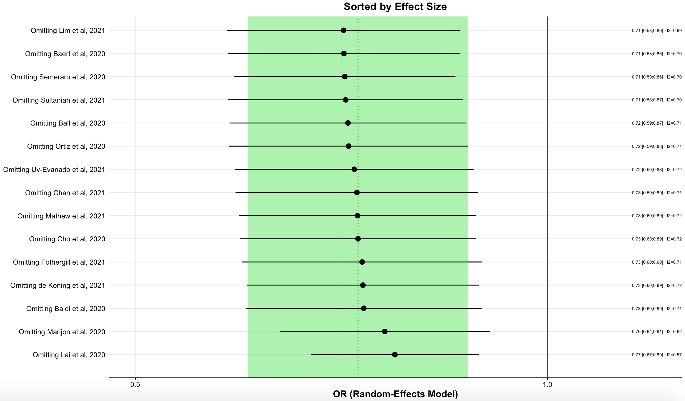
Supplemental Figure 20. Influential Diagnostic Plot for Medical Etiology of Out-of-Hospital Cardiac Arrest
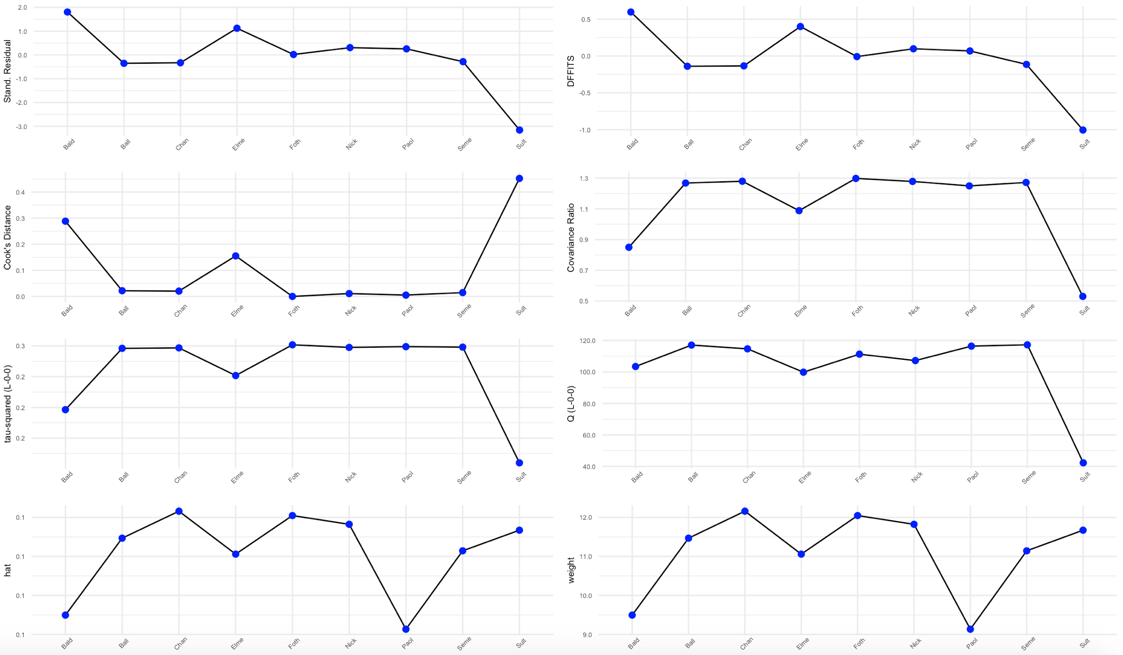
Supplemental Figure 21. Baujat Plot for Medical Etiology of Out-of-Hospital Cardiac Arrest
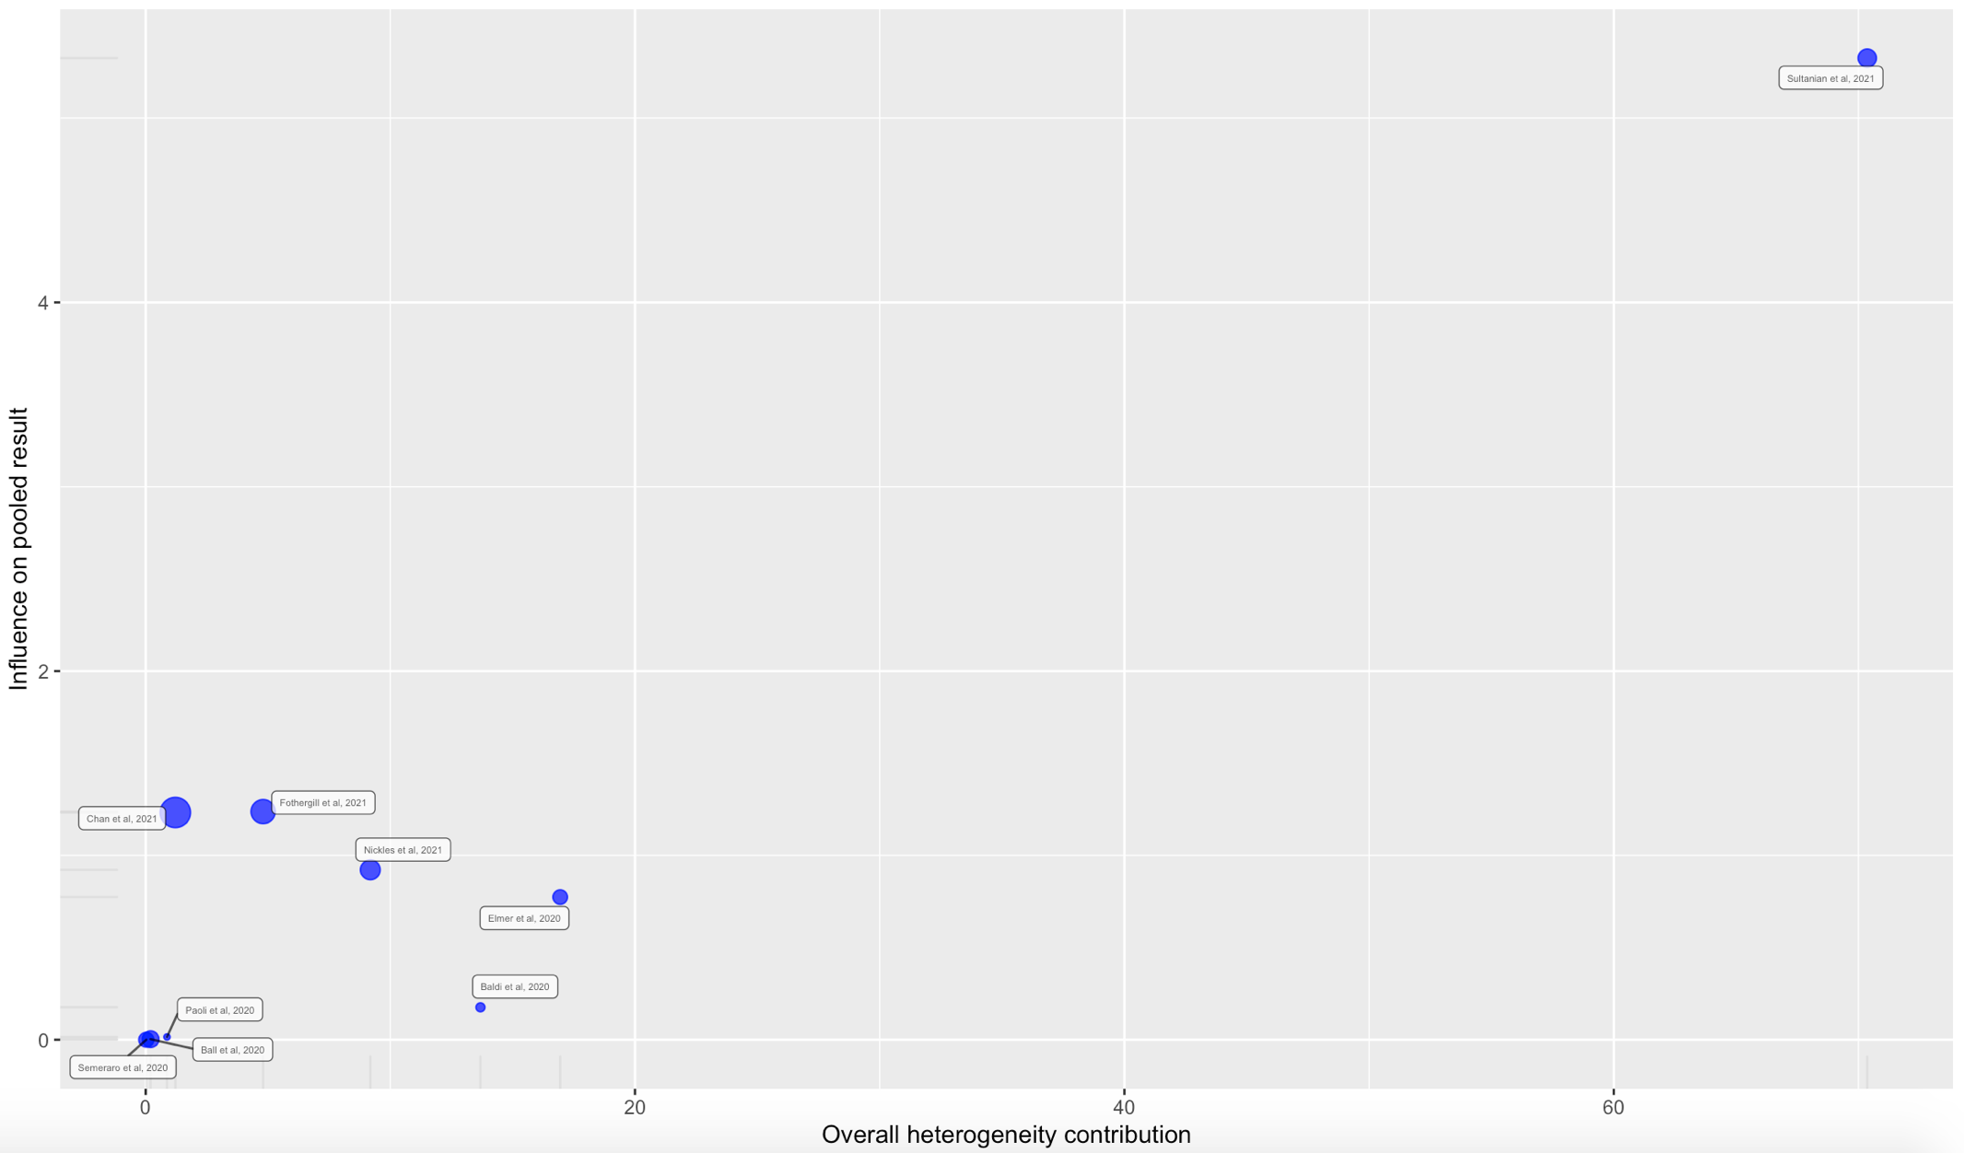
Supplemental Figure 22. Leave-One-Out Analysis for Medical Etiology of Out-of-Hospital Cardiac Arrest
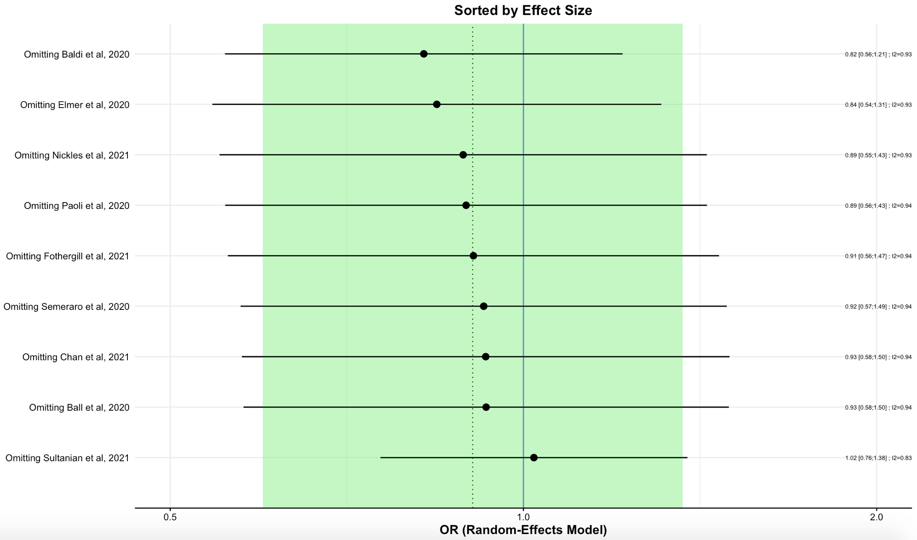
Supplemental Figure 23. Influential Diagnostic Plot for Traumatic Etiology of Out-of-Hospital Cardiac Arrest
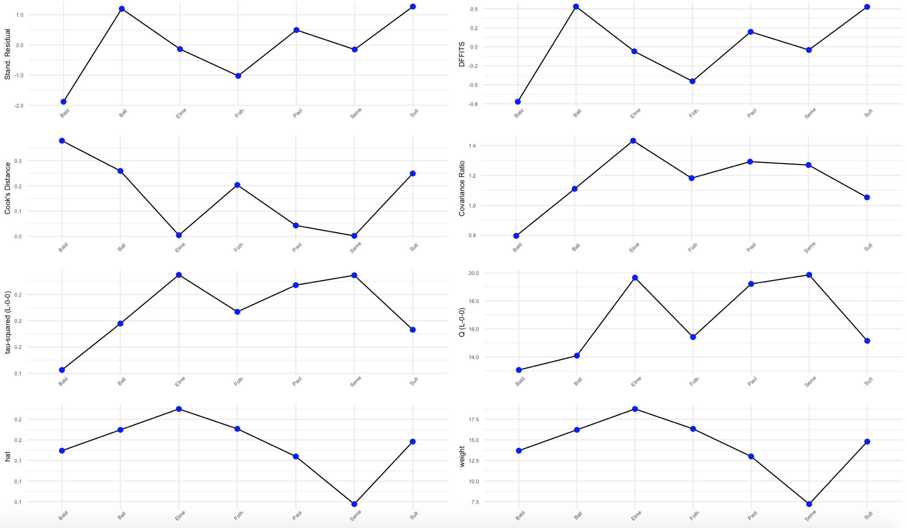
Supplemental Figure 24. Baujat Plot for Traumatic Etiology of Out-of-Hospital Cardiac Arrest
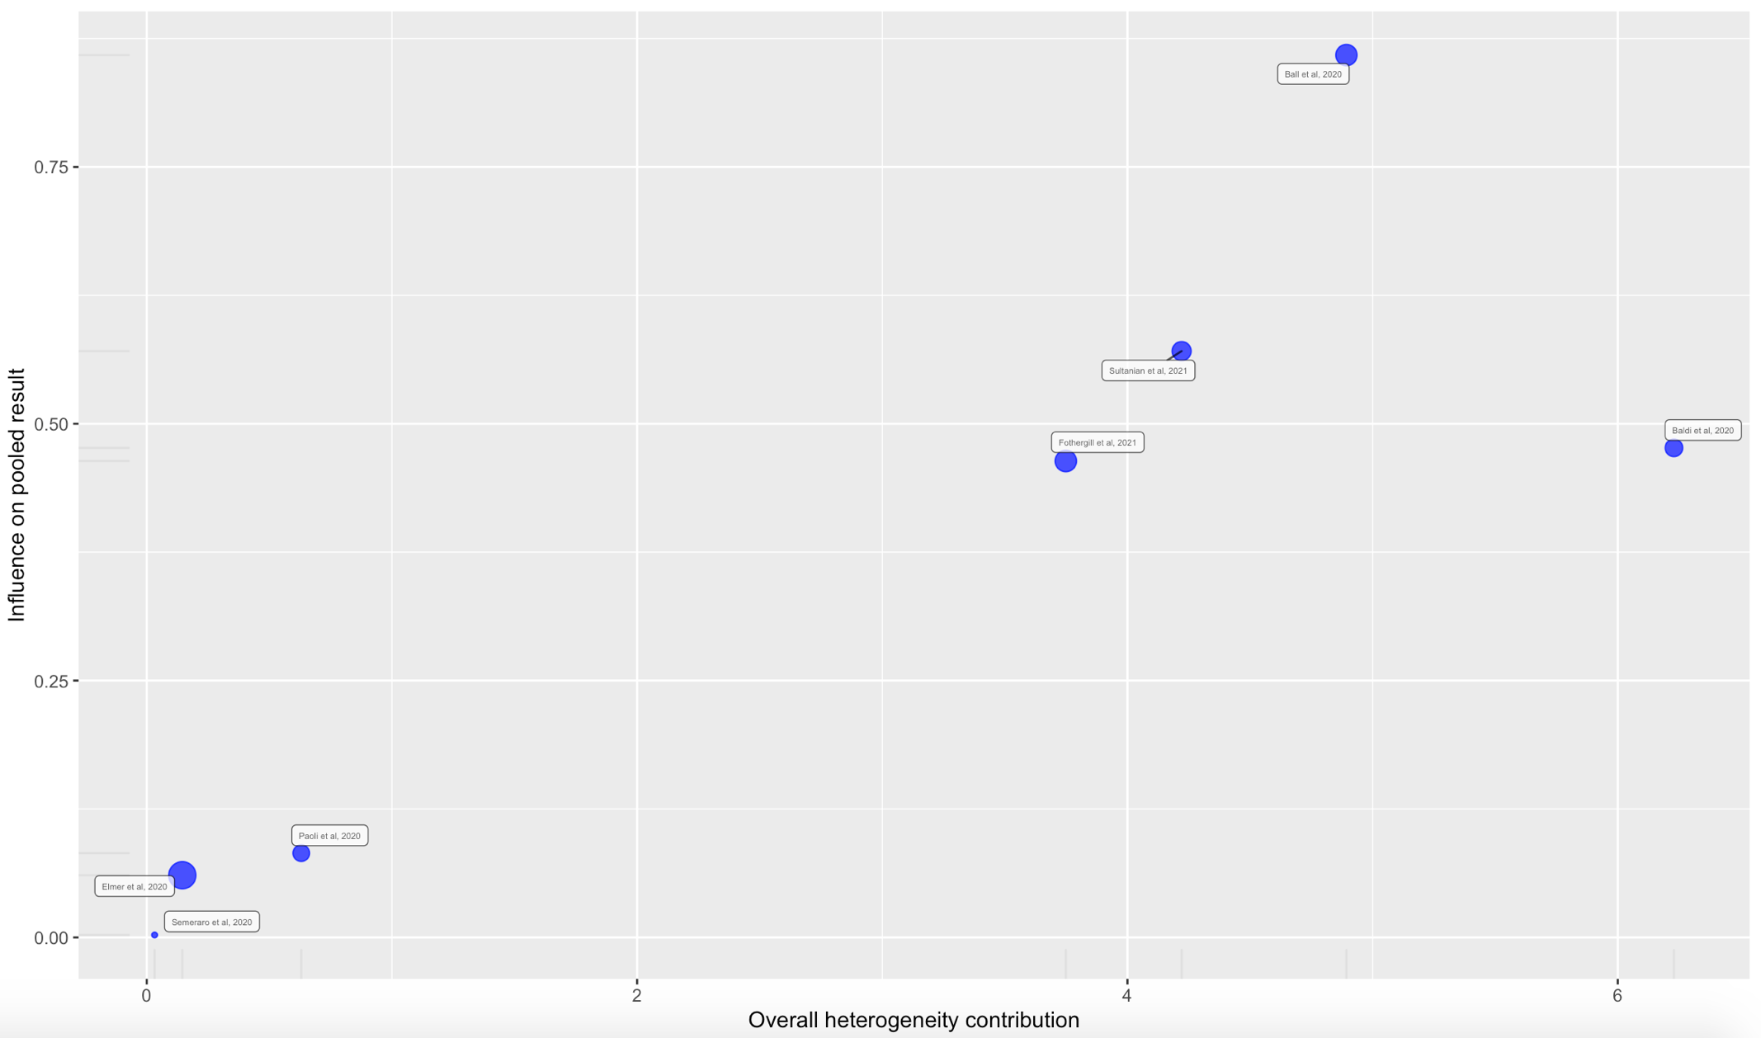
Supplemental Figure 25. Leave-One-Out Analysis for Traumatic Etiology of Out-of-Hospital Cardiac Arrest
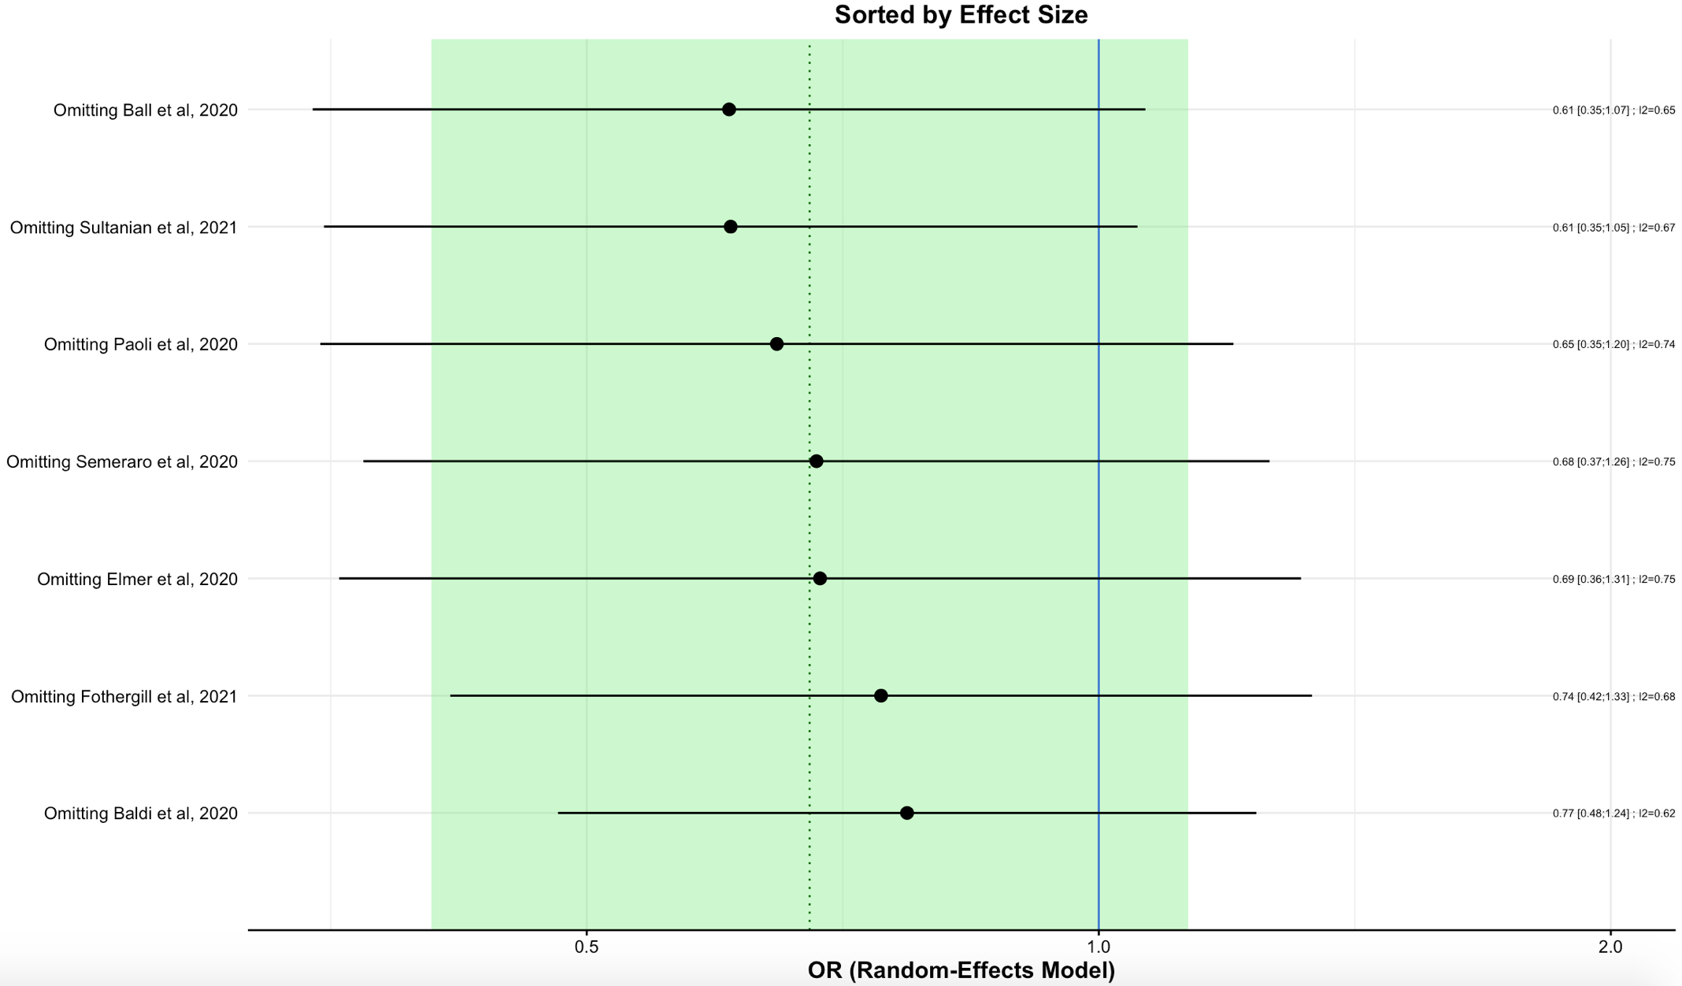
4. Online Supplemental Data

Supplemental Data 1. PRISMA-P 2020 Checklist
Section and Topic | Item # | Checklist item | Location where item is reported
TITLE
Title | 1 | Identify the report as a systematic review. | 1
ABSTRACT
Abstract | 2 | See the PRISMA 2020 for Abstracts checklist. | 2-3
INTRODUCTION
Rationale | 3 | Describe the rationale for the review in the context of existing knowledge. | 4-5
Objectives | 4 | Provide an explicit statement of the objective(s) or question(s) the review addresses. | 5
METHODS
Eligibility criteria | 5 | Specify the inclusion and exclusion criteria for the review and how studies were grouped for the syntheses. | 6
Information sources | 6 | Specify all databases, registers, websites, organisations, reference lists and other sources searched or consulted to identify studies. Specify the date when each source was last searched or consulted. | 6
Search strategy | 7 | Present the full search strategies for all databases, registers and websites, including any filters and limits used. | 6
Selection process | 8 | Specify the methods used to decide whether a study met the inclusion criteria of the review, including how many reviewers screened each record and each report retrieved, whether they worked independently, and if applicable, details of automation tools used in the process. | 7
Data collection process | 9 | Specify the methods used to collect data from reports, including how many reviewers collected data from each report, whether they worked independently, any processes for obtaining or confirming data from study investigators, and if applicable, details of automation tools used in the process. | 7
Data items | 10a | List and define all outcomes for which data were sought. Specify whether all results that were compatible with each outcome domain in each study were sought (e.g. for all measures, time points, analyses), and if not, the methods used to decide which results to collect. | 7
Data items | 10b | List and define all other variables for which data were sought (e.g. participant and intervention characteristics, funding sources). Describe any assumptions made about any missing or unclear information. | 7-8
Study risk of bias assessment | 11 | Specify the methods used to assess risk of bias in the included studies, including details of the tool(s) used, how many reviewers assessed each study and whether they worked independently, and if applicable, details of automation tools used in the process. | 7
Effect measures | 12 | Specify for each outcome the effect measure(s) (e.g. risk ratio, mean difference) used in the synthesis or presentation of results. | 8-9
Synthesis methods | 13a | Describe the processes used to decide which studies were eligible for each synthesis (e.g. tabulating the study intervention characteristics and comparing against the planned groups for each synthesis (item #5)). | 7-9
Synthesis methods | 13b | Describe any methods required to prepare the data for presentation or synthesis, such as handling of missing summary statistics, or data conversions. | 7-8
Synthesis methods | 13c | Describe any methods used to tabulate or visually display results of individual studies and syntheses. | 7-9
Synthesis methods | 13d | Describe any methods used to synthesize results and provide a rationale for the choice(s). If meta-analysis was performed, describe the model(s), method(s) to identify the presence and extent of statistical heterogeneity, and software package(s) used. | 8-9
Synthesis methods | 13e | Describe any methods used to explore possible causes of heterogeneity among study results (e.g. subgroup analysis, meta-regression). | 9
Synthesis methods | 13f | Describe any sensitivity analyses conducted to assess robustness of the synthesized results. | 9
Reporting bias assessment | 14 | Describe any methods used to assess risk of bias due to missing results in a synthesis (arising from reporting biases). | 7
Certainty assessment | 15 | Describe any methods used to assess certainty (or confidence) in the body of evidence for an outcome. | 8-9
RESULTS
Study selection | 16a | Describe the results of the search and selection process, from the number of records identified in the search to the number of studies included in the review, ideally using a flow diagram. | 9, Figure 1
Study selection | 16b | Cite studies that might appear to meet the inclusion criteria, but which were excluded, and explain why they were excluded. | 9, Figure 1
Study characteristics | 17 | Cite each included study and present its characteristics. | 9, 10, Table 1
Risk of bias in studies | 18 | Present assessments of risk of bias for each included study. | 10, Supplemental Table 3
Results of individual studies | 19 | For all outcomes, present, for each study: (a) summary statistics for each group (where appropriate) and (b) an effect estimate and its precision (e.g. confidence/credible interval), ideally using structured tables or plots. | 10-14, Supplemental Tables 1-2
Results of syntheses | 20a | For each synthesis, briefly summarise the characteristics and risk of bias among contributing studies. | 10-14, Table 2
Results of syntheses | 20b | Present results of all statistical syntheses conducted. If meta-analysis was done, present for each the summary estimate and its precision (e.g. confidence/credible interval) and measures of statistical heterogeneity. If comparing groups, describe the direction of the effect. | 10-14, Figures 2-6
Results of syntheses | 20c | Present results of all investigations of possible causes of heterogeneity among study results. | 15
Results of syntheses | 20d | Present results of all sensitivity analyses conducted to assess the robustness of the synthesized results. | 15
Reporting biases | 21 | Present assessments of risk of bias due to missing results (arising from reporting biases) for each synthesis assessed. | 7
Certainty of evidence | 22 | Present assessments of certainty (or confidence) in the body of evidence for each outcome assessed. | 10-14
DISCUSSION
Discussion | 23a | Provide a general interpretation of the results in the context of other evidence. | 16-19
Discussion | 23b | Discuss any limitations of the evidence included in the review. | 19-20
Discussion | 23c | Discuss any limitations of the review processes used. | 19-20
Discussion | 23d | Discuss implications of the results for practice, policy, and future research. | 19
OTHER INFORMATION
Registration and protocol | 24a | Provide registration information for the review, including register name and registration number, or state that the review was not registered. | 5
Registration and protocol | 24b | Indicate where the review protocol can be accessed, or state that a protocol was not prepared. | 5
Registration and protocol | 24c | Describe and explain any amendments to information provided at registration or in the protocol. | Nil
Support | 25 | Describe sources of financial or non-financial support for the review, and the role of the funders or sponsors in the review. | 21
Competing interests | 26 | Declare any competing interests of review authors. | 21
Availability of data, code and other materials | 27 | Report which of the following are publicly available and where they can be found: template data collection forms; data extracted from included studies; data used for all analyses; analytic code; any other materials used in the review. | Supplemental Materials

