Supporting Information
Sub-micro droplet reactor: Green synthesis of Li₃VO₄ anode materials for lithium ion battery
Ha Tran Huu¹, Ngoc Hung Vu^{2,3}, Hyunwoo Ha⁴, Joonhee Moon⁵, Hyun You Kim⁴,
and Won Bin Im^{1,*}
¹Division of Materials Science and Engineering, Hanyang University, 222, Wangsimni-ro, Seongdong-gu, Seoul, 04763, Republic of Korea
²Falcuty of Biotechnology, Chemistry and Environmental Engineering, Phenikaa University, Hanoi 10000, Vietnam
³Phenikaa Research and Technology Institute, A&A Green Phoenix Group, 167 Hoang Ngan, Hanoi 10000, Vietnam
⁴ Department of Materials Science and Engineering, Chungnam National, University, Daejeon, 34134, Korea
⁵Advanced Nano-Surface Research Group, Korea Basic Science Institute, Daejeon 34133, Republic of Korea

* To whom correspondence should be addressed.
Tel : +82-2-2220-0404
E-mail : imwonbin@hanyang.ac.kr

Experimental
Chemical. LiOH⸳H₂O (98%) was purchased from JUNSEI Chemical. Vanadium (V) oxide, V₂O₅ (99.96%) and calcium oxide, CaO (99.9%) was obtained from Sigma-Aldrich.
Preparation pure and Ca-doped samples. Li₃VO₄ and deferent Ca-doping content samples were prepared via humid-assisted solid-state route based on acid-base reaction (ABR) directly from precursors of LiOH, V₂O₅ and CaO. In a typical process, LiOH⸳H₂O, CaO and V₂O₅ with the stoichiometric mole percentage (x% = 0, 1, 3, and 5%) was well mixed and ground in mortar. The obtained mixture was transferred into a 20 mL glass vial which was added another open 3 mL vial containing 1 mL of distilled water. Then, the whole container was maintained in oven at 80ºC. After 24 hours reaction, the water-vial was taken out, and the samples were dried at the same temperature for another 12h before being re-ground and denoted as xLCVO-ABR.
For comparison, pure and 3% Ca-doped Li₃VO₄ was synthesized via SSR following reference.¹ After annealing process, as-prepared samples were re-ground and denoted as 0LCVO-SSR and 3LCVO-SSR, respectively.
Structural and physicochemical characterization. The structural information of as-synthesized samples was obtained from X-ray diffraction (XRD) on Philips X'Pert (Cu Kα radiation) in the 2θ range from 10 to 80º with a step size of 0.026º. The Rietveld refinement was resolved on the general structure analysis system (GSAS) program.² Particles size and morphology of samples were determined by field emission scanning electron microscopy (FESEM, S-4700, Hitachi). The element distribution images were collected from energy-dispersive x-ray spectroscopy (EDS) mapping methods attached on FESEM. The analysis on valence state of elements was investigated by X-ray photoelectron spectroscopy (XPS) measurement carried on VG MultiLab 2000, Thermo Scientific. The specific surface area of particles obtained by the Brunauer–Emmett–Teller (BET) method and the pore size distribution recorded by Barrett-Joyner-Halenda (BJH) were carried out on BELSORP-mini II, BEL Japan, Inc.. The electron paramagnetic resonance (EPR) spectra were acquired on a JEOL JES FA200 EPR spectrometer at room temperature.
Electrochemical characterization. The anode electrodes were prepared via slurry method with mass ratios of 75:20:5 of active materials, conductive agent (Super-P) and binder poly (vinylidiene fluoride) (PVDF) in N-Methyl-2-pyrolidone (NMP) as solvent. The slurry was well mixed in mortal for 30 minutes then coated on copper foil as current collector, then the electrode was dried at 80ºC in vacuum state overnight before cutting into disc with 14 mm diameter by a punch. The estimated total active material loaded on a single electrode disc is around 10 mg. The half-cell using lithium metal foil as counter electrode, polymer membrane as separator, was assembled in Ar-filled glovebox according to the 2032 coin-cell model. The 1:1 mixture of ethylene carbonate and dimethyl carbonate dissolved 1M LiPF₆ was used as electrolyte. The fabricated cell was aged for at least 6h prior to electrochemical measurements.
Charge-discharge profiles were measured on NAGANO BTS-2004H battery charger in the voltage range of 0.2 – 3.0V vs. Li/Li⁺ at current density of 100 mAh⸳g⁻¹. The cycling voltammetry (CV) surveys were conducted on Autolab electrochemical workstation between voltage of 0.2 and 3.0V vs. Li/Li⁺. The electrochemical impedance spectroscopy (EIS) tests were performed using the same Autolab with a voltage of 5 mV amplitude in a frequency range of 100 kHz to 0.01 Hz.
In addition, the coin-type full cells were assembled using a 3LCVO-ABR anode and a LiNi_{0.6}Mn_{0.2}Co_{0.2}O₂ cathode. The anode/cathode capacity ratio was controlled as about 0.9 by adjusting the mass ratio of the anode/cathode. For comparison, a commercial graphite (CG) anode was used instead of the 3LCVO-ABR anode. The obtained full-cells were charged/discharged in working voltage window of 2.5 – 4.5 V. The specific capacities of the assembled full cells were calculated based on the anode mass.
Density functional theory (DFT) calculation method. To construct a Ca-doped Li_{3-x}Ca_{x}VO₄ model, we identified the more energetically favored Ca doping location among two irreducible Li sites (Li1 and Li2) in a Li₃VO₄ unit cell. One Ca dopant was located at the energetically favored doping site, Li2, inside an extended 2 × 2 × 2 Li₃VO₄ supercell (Li₄₈V₁₆O₆₄), which applied for all subsequent DFT calculations. The second Ca dopant was placed on another Li2 site to set the Ca atomic ratio (2/48 = 4.17 at.%) close to the experimental value (3.0 %). The location of the second Ca dopant was identified by calculating the Ca substitution energy of all available Li2 sites in the presence of the first Ca dopant. The final Li₄₆Ca₂V₁₆O₆₄ supercell (Figure S8a,b) was used for electronic analysis.
We performed hybrid-level spin-polarized DFT calculations using a plane-wave basis with the VASP code³ and the HSE06 functional.⁴ The ratio of the exact Hartree-Fock exchange was kept to 25%, a genuine value of HSE06. The initial Li₃VO₄ unit cell structure was optimized using the PBE functional. However, all subsequent calculations including geometry optimization was performed using the HSE06 functional. To appropriately treat the V d-orbitals, the Hubbard U formalism, DFT+U,⁵ with U_{eff} = 3 eV^{6, 7} was applied for V ions. The projector augmented wave method was applied to describe the interaction between the ionic core and the valence electrons.⁸ Valance electron wave functions were expanded in a plane-wave basis up to an energy cutoff of 500 eV. The Brillouin zone was sampled at the Γ-point for geometry optimization and a 2 × 2 × 2 k-points grid sampling was applied for electronic structure analysis. The convergence criteria for the electronic structure and the atomic geometry were set to 10⁻⁴ eV and 0.03 eV/Å, respectively. We used a Gaussian smearing method with a finite temperature width of 0.05 eV to improve convergence of states near the Fermi level.
Calculation of water droplet size
In order to investigate the size-controlling function of steam droplet, an application of Koehler theory^{9, 10} was conducted. In details, in the initial stage, the reaction only begins when water evaporates from liquid form to molecular vapor. Following the Antoine equation¹¹, the vapor pressure of water at 80ºC was estimated while the saturated value was derived from application of Clapeyron – Clausius equation, which were all clearly presented in Supporting Information. Accordingly, the approximate saturation degree, S, of synthesis system was only 0.872 illustrating that the environment inside the vial reactor is sub-saturated condition and not sufficient for the homogeneous or spontaneous nucleation of small water cluster to form further droplet condensation,¹² which could be clarified via Kelvin or curvature effect.¹³ However, growth of vapor droplet could be accelerated by heterogeneous nucleation based on the Raoult or solution effect in which the presence of soluble molecular reduces evaporation rate and hastens the formation as well as survival of droplet. Following the Koehler theory, a combination of two above effects, which could be briefly presented by the equation S1, the droplet growth via condensation and coalescence with surrounding water molecules is determine by the critical saturation degree, S_{c}:
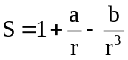 (S1)
where,
S: saturation degree of surrounding environment
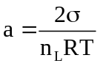
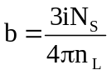
$\text{σ}$: surface tension of water, at 80ºC, 6.26$×$10⁻² (N/m²)
${\text{n}}_{\text{L}}$: molar volume of water
$\text{R}$: ideal gas constant
$\text{i}$: Van’t Hoff factor presenting the number of components split from solute when it is dissolved
${\text{N}}_{\text{s}}$: total number of moles of solute, typically in range of 10⁻¹⁸ to 10⁻¹⁵ moles
and,
${\text{S}}_{\text{c}}\text{=}\sqrt{\frac{\text{4}{\text{a}}^{\text{3}}}{\text{27b}}}\text{+1}$ > S_{system}
Method for estimation of saturation degree, S
Estimate the vapor pressure, e, by application of Antoine Equation:
Vapor Pressure of Water calculator Formula:
P = 10^{A-B/(C+T)} (S2)
Where:
P: Vapor Pressure of Water
T: Water Temperature, in Celsius
A, B, C: Antoine Constants for Water.
When water temperature in the range of 1 – 100ºC:
A = 8.07131, B = 1730.63, C = 233.426;
When the temperature in the range of 99 – 374ºC:
A = 8.14019, B = 1810.94, C = 244.485.
At 80ºC, P = e = 354.5323 mmHg
Estimate the saturation vapor pressure, e_{S}, by using Clapeyron-Clausius Equation:
ln$\left(\frac{{\text{e}}_{\text{sT1}}}{{\text{e}}_{\text{sT2}}}\right)$=$\frac{\text{∆}{\text{H}}_{\text{evaporation}}}{\text{R}}\left(\frac{\text{1}}{\text{T2}}\text{-}\frac{\text{1}}{\text{T1}}\right)$ (S3)
e_{sT}: saturated vapor pressure at T (K)
R: Ideal gas constant = 8.314 J⸳mol⁻¹⸳K⁻¹
$∆H_{evaporation}:$Latent heat of water evaporation = 40650 J⸳mol⁻¹
At T₁ = 273K, e_{s1} = 4.58 mmHg
$→$ At T₂ = 353K, e_{s2} = 406.573 mmHg
$→$ S = e/e_{S} = 0.872.
Lithium ion diffusion coefficient determination method
The lithium ion diffusion coefficient (${\text{D}}_{{\text{Li}}^{\text{+}}}$) was also estimated using the following equation:
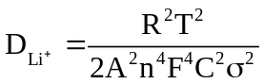 (S4)
in which, R = 8.314 J⸳mol⁻¹⸳K⁻¹ is the ideal gas constant, T = 298.15 K is room temperature in Kelvin scale, A is the effective surface area of the electrode (= specific surface area $×$ mass of active material), n = 1 is number of exchange electrons in the redox process, F = 96485 C⸳mol⁻¹ is Faraday constant, C (mol⸳cm⁻³) is concentration of lithium ions (as concentration of LiPF₆ in electrolyte of 1 mol⸳dm⁻³ = 1000 mol⸳cm⁻³) and σ (Ω⸳s^{-0.5}) is the Warburg coefficient that is deduced as the slope from linear relationship between the real impedance Z’ and the angular frequency ω^{-0.5} using equation (S5) as shown in Figure S13.
Z’ = R_{e} +R_{ct}+ σ$×$ω^{-0.5} (S5)
Pseudocapacitance contribution calculation
Fundamentally, the nano-sized materials could store lithium ions in several following pathways: i) electrical double-layer capacitance (EDLC), referring to the charge separation in a Helmholtz double layer at the electrode/electrolyte interface; ii) pseudocapacitive process, which is the charge transfer process primarily occurring at the electrode/electrolyte interface according to three faradaic mechanisms, underpotential deposition, redox pseudocapacitance, and intercalation pseudocapacitance; and iii) diffusion-controlled redox process, in which the kinetics mostly are limited by the slow rate of the solid phase transition.^{14, 15, 16, 17, 18}
To calculate the pseudocapacitive charge contribution to the total charge storage of the 36LCVO-ABR, the 3LCVO-ABR electrode was tested CV at different scan rates from 0.1 to 5 mV⸳s⁻¹ between 0.2 and 3.0 V vs. Li⁺/Li. Based on the concept of power-law and cumulative principle as below:¹⁹
i = aν^{b} (S6)
where, i represents the obtained reduction peak current (mA) corresponding to a certain scan rate, ν (mV⸳s⁻¹); a and b are constants. The b-value, an indicative for each charge storage process, could be calculated from linear plot of log(i) vs. log(ν) as shown in Figure 5d. In detail, the intercalation – alloying effect was determined by the diffusion-controlled equation S7:
i = nFAC*D^{1/2}ν^{1/2}(αnF/RT)^{1/2}π^{1/2}χ(bt) (S7)
in which, n is number of transferring electrons, F is Faraday constant, A is effective contact area between electrode and electrolyte, C* is the surface concentration of electrode materials, D is chemical diffusion coefficient, α is the transfer coefficient, R is the ideal gas constant, T is the Kelvin temperature and χ(bt) is the normalized current function.¹⁹ According to equation (S7), the b-value of the diffusion-controlled process should be assigned as closed to 0.5. On the other hand, the capacitive effect could be assigned via linear or near-linear relationship between capacitive current and scan rate:¹⁹
i = C_{d}Aν (S8)
where C_{d} corresponds to capacitance. Consequently, b-value of capacitive effect is determined as 1.0 for EDLC and $\sim$1.0 for pseudocapacitive process.²⁰
For further analysis, to study the contribution of each process in total capacity, the cumulative principle was applied based on the concept of separating response current into two components:²¹
i = k₁ν + k₂ν^{1/2} (S9)
or the mathematic-transferring form:
iν^{-1/2} = k₁ν^{1/2} + k₂ (S10)
Where, k₁ is related to capacitive effect and k₂ corresponds to diffusion-controlled constant.
According to the equations (S8, S9), the linear plot of i/ν^{1/2} vs. ν^{1/2} was established at several collected potentials (Figure S15a). The k₁ and k₂ were calculated to be contribution constant of, capacitance and diffusion current, respectively. In detail, based on the slopes calculated via linear plots of equation S10 collecting from selected potential points (e.g, Figure S15a), individual respective k₁ and k₂ were obtained. Then, a pseudocapacitance response current i_{p} = k₁ν was plotted in each certain scan rate as shown in Figure S15b-f. By using mathematic integral method, the contribution of i_{p} in total charge was estimated via:
$\text{\%pseudo-capacitance = }\frac{{\text{S}}_{{\text{i}}_{\text{p}}}}{{\text{S}}_{\text{i}}}\text{ ×}\text{100\%}$ (S11)
in which, ${\text{S}}_{{\text{i}}_{\text{p}}}$ presents for area portion under i_{p} curves corresponding to contribution of pseudocapacitance while ${\text{S}}_{\text{i}}$ exhibits for area potion under original curve related to total charge storage capacity.

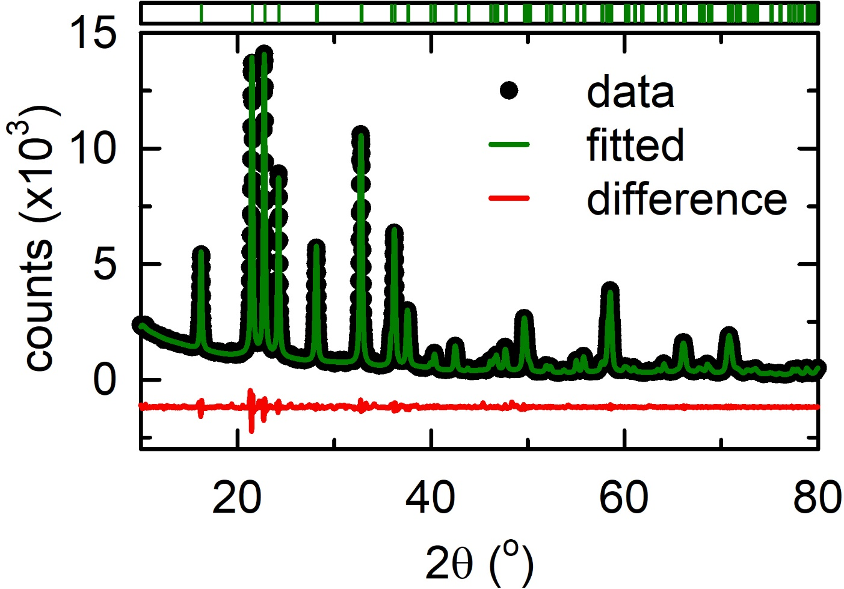
Figure S1. Rietveld refinement based on HR-XRD of 1LCVO-ABR.
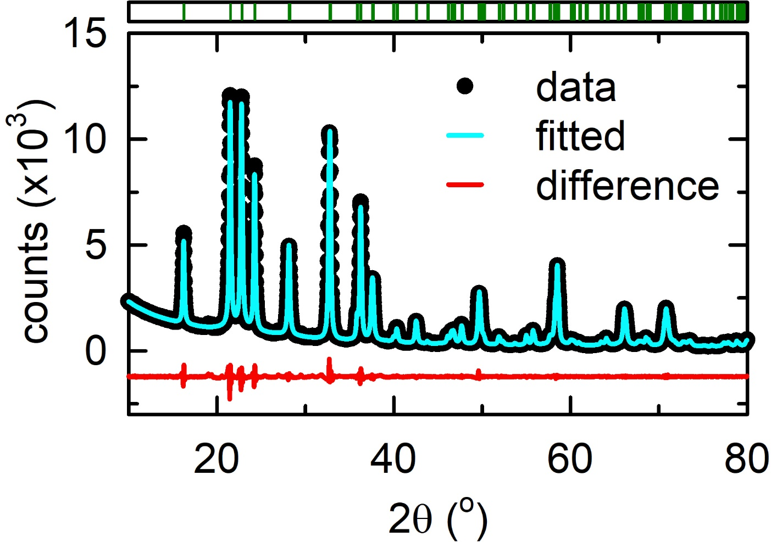
Figure S2. Rietveld refinement based on HR-XRD of 2LCVO-ABR.

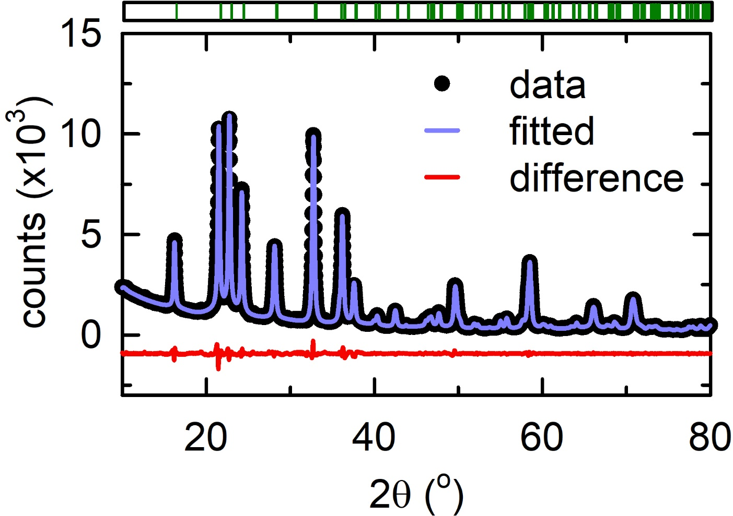
Figure S3. Rietveld refinement based on HR-XRD of 5LCVO-ABR.

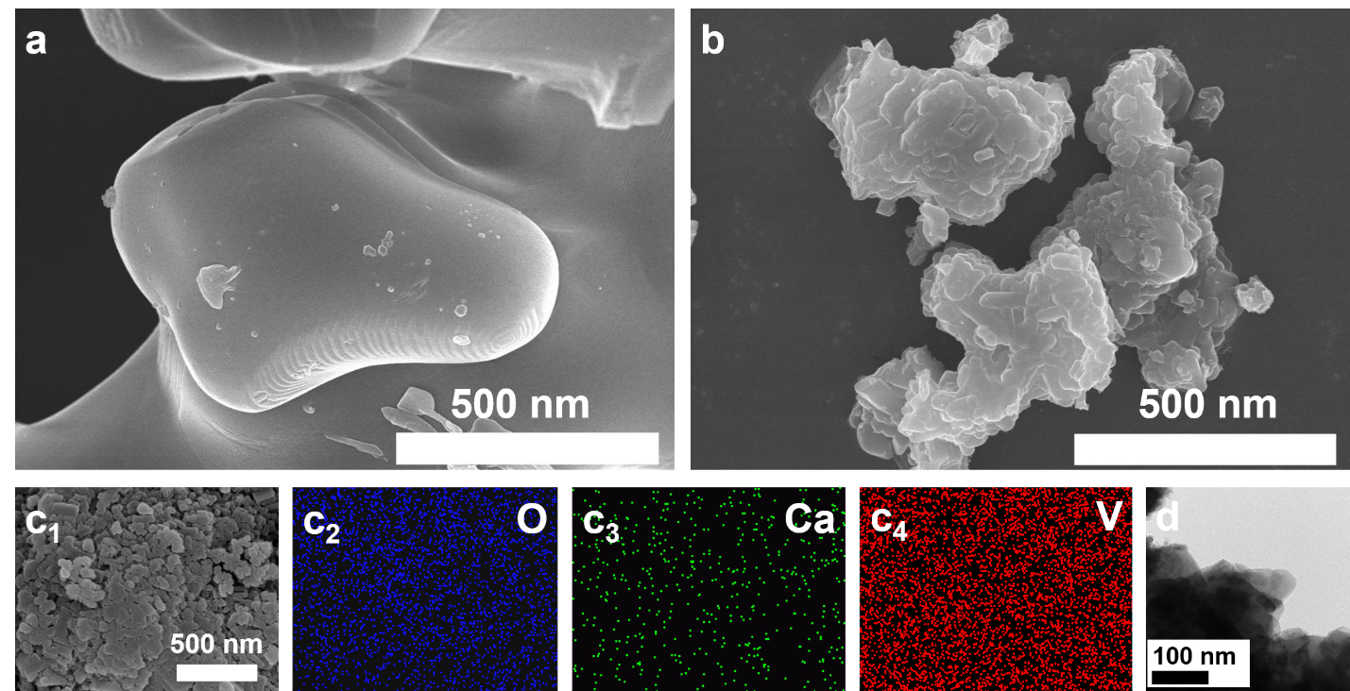
Figure S4. SEM images of (a) 0LCVO-SSR and (b) 3LCVO-SSR; (c1) SEM images of mapping area, EDS mapping of 3LCVO-ABR for (c2) oxygen, (c3) calcium and (c4) vanadium; (d) TEM image of 0LCVO-ABR.

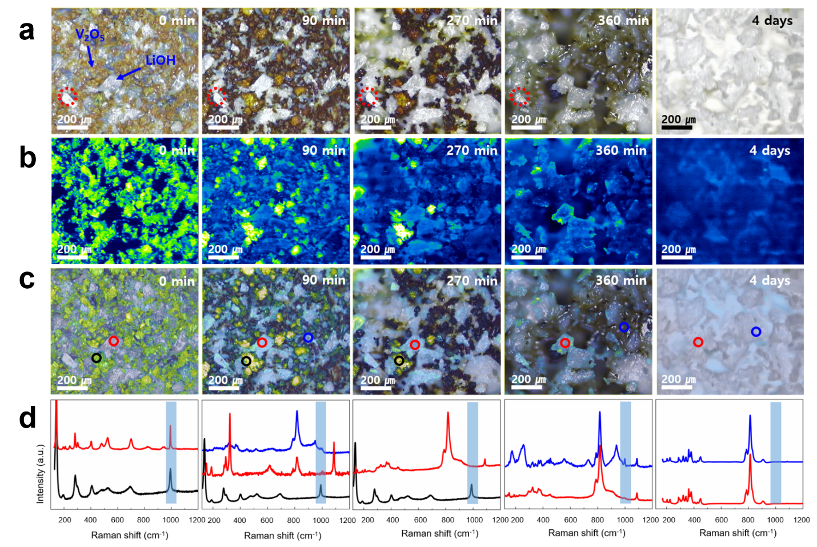
Figure S5. The digital photographs of synthesized sample Li₃VO₄ under (a) naked eyes, (b) laser green light, (c) white light, and (d) the respective in situ Raman spectra at interval times during ABR synthesis process.

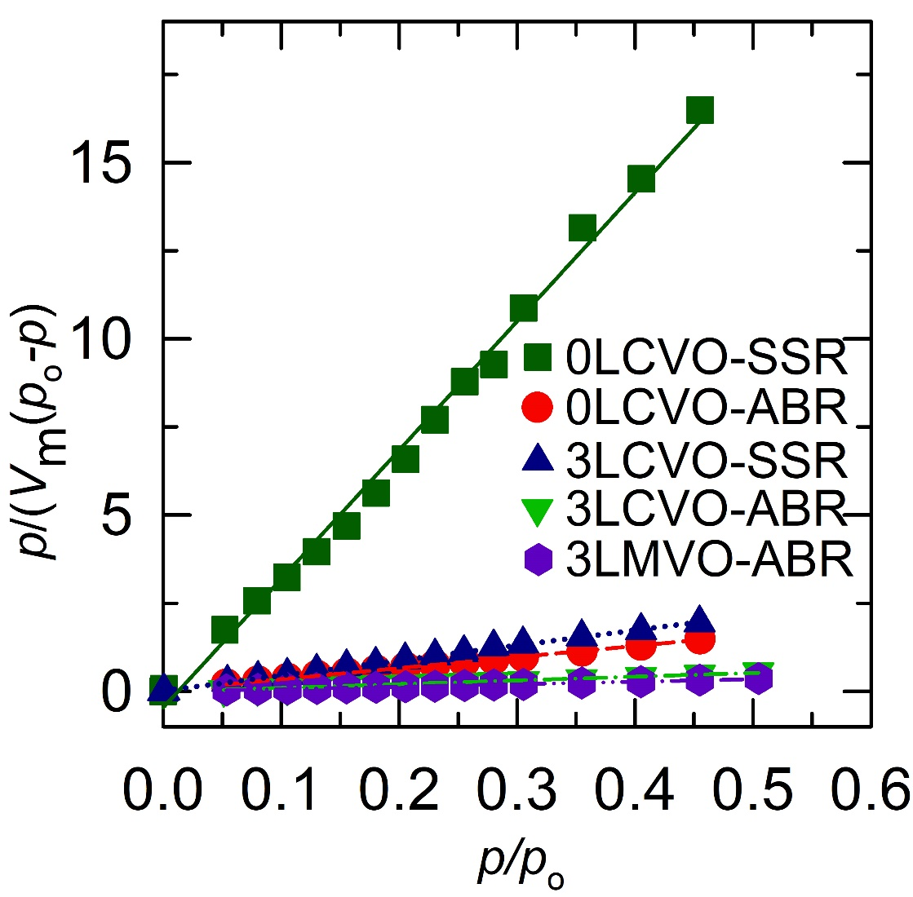
Figure S6. The BET linear plot of as-prepared samples.

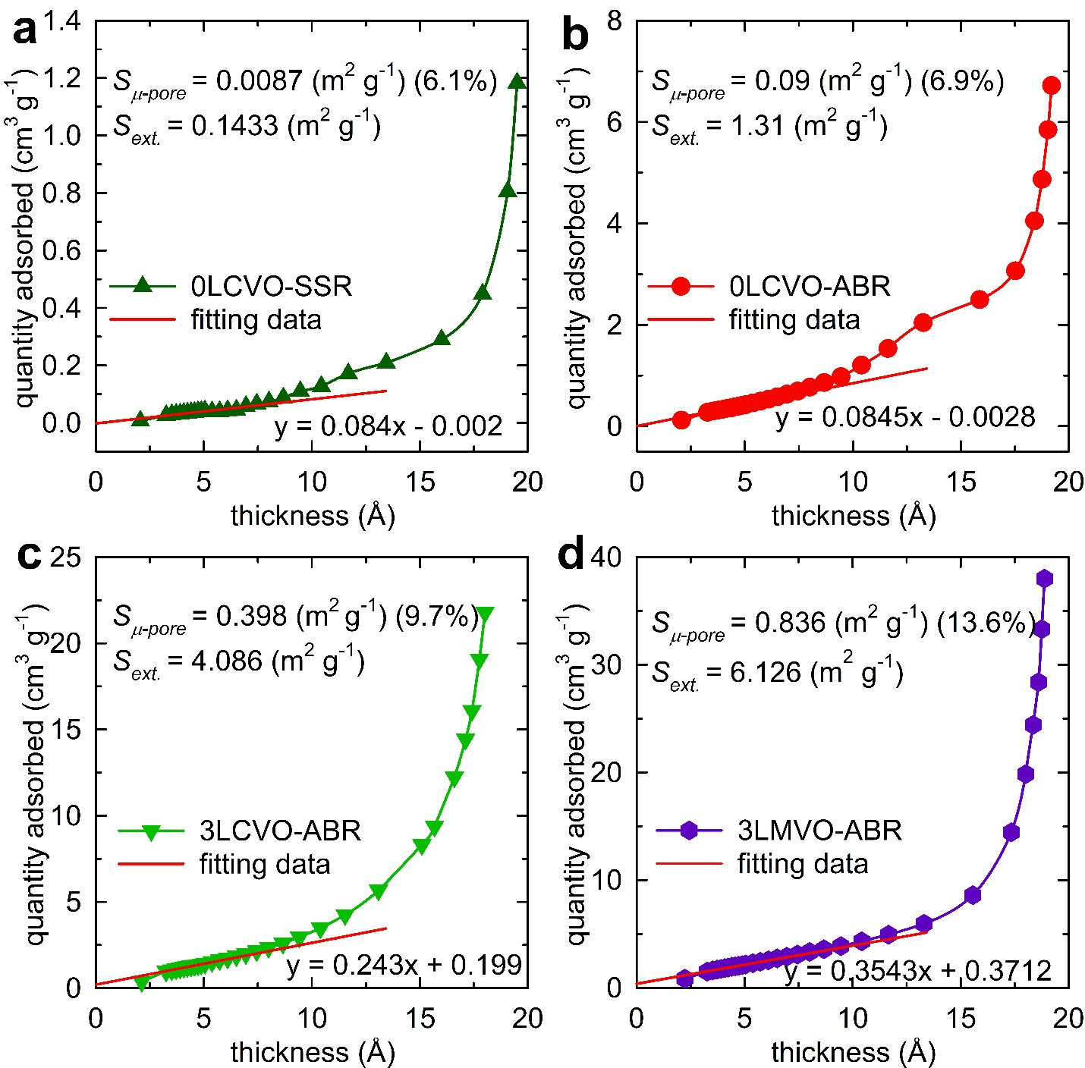
Figure S7. t-plot for determination of external and m-pore surface area of (a) 0LCVO-SSR; (b) 0LCVO-ABR; (c) 3LCVO-ABR and (d) 3LMVO-ABR.

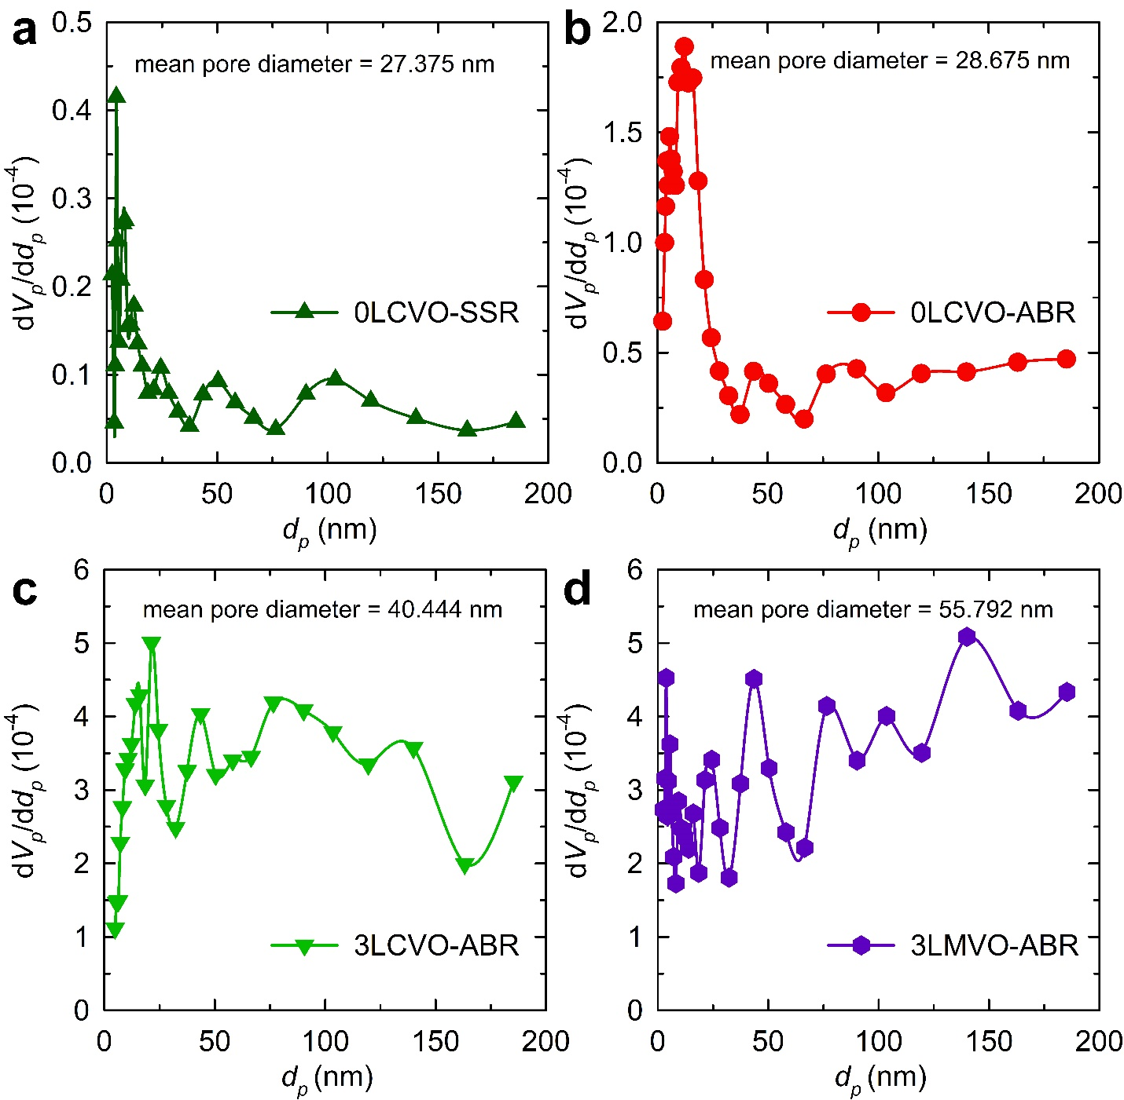
Figure S8. BJH pore size distribution derived from BET data of (a) 0LCVO-SSR; (b) 0LCVO-ABR; (c) 3LCVO-ABR and (d) 3LMVO-ABR.
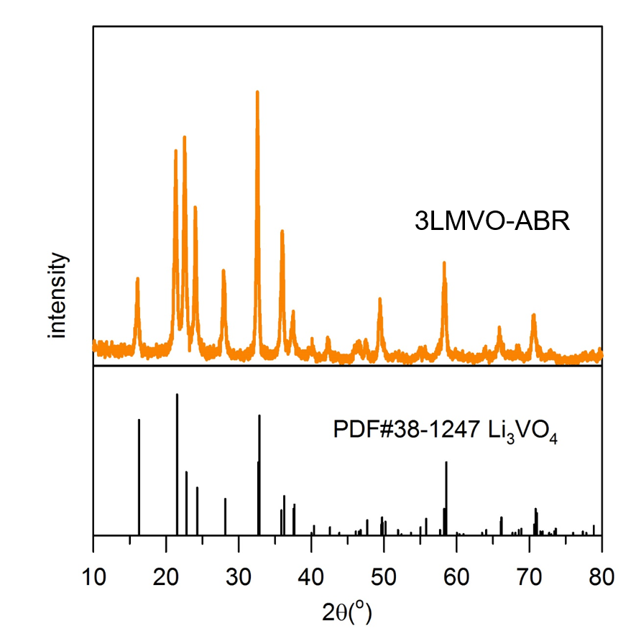
Figure S9. XRD pattern of 3LMVO-ABR.

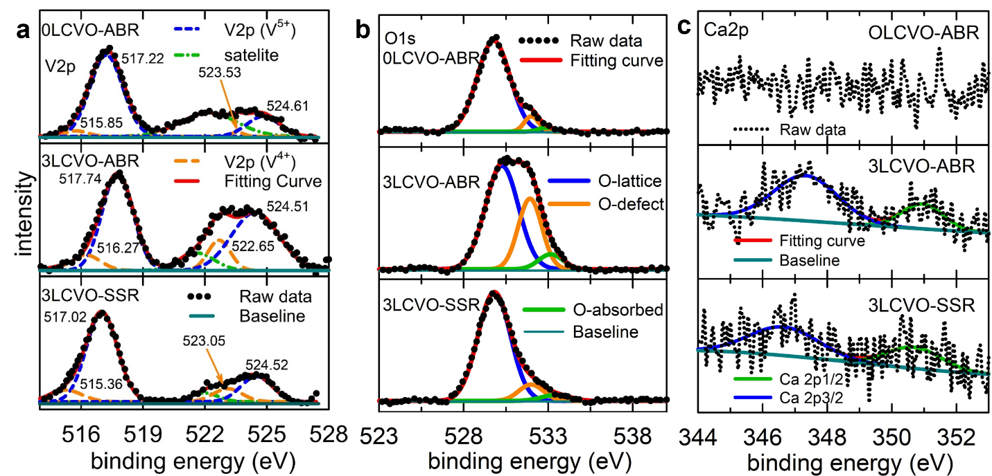
Figure S10. High resolution XPS spectra of (a) V2p, (b) O1s, and (c) Ca2p of 0LCVO-ABR, 3LCVO-ABR and 3LCVO-SSR.

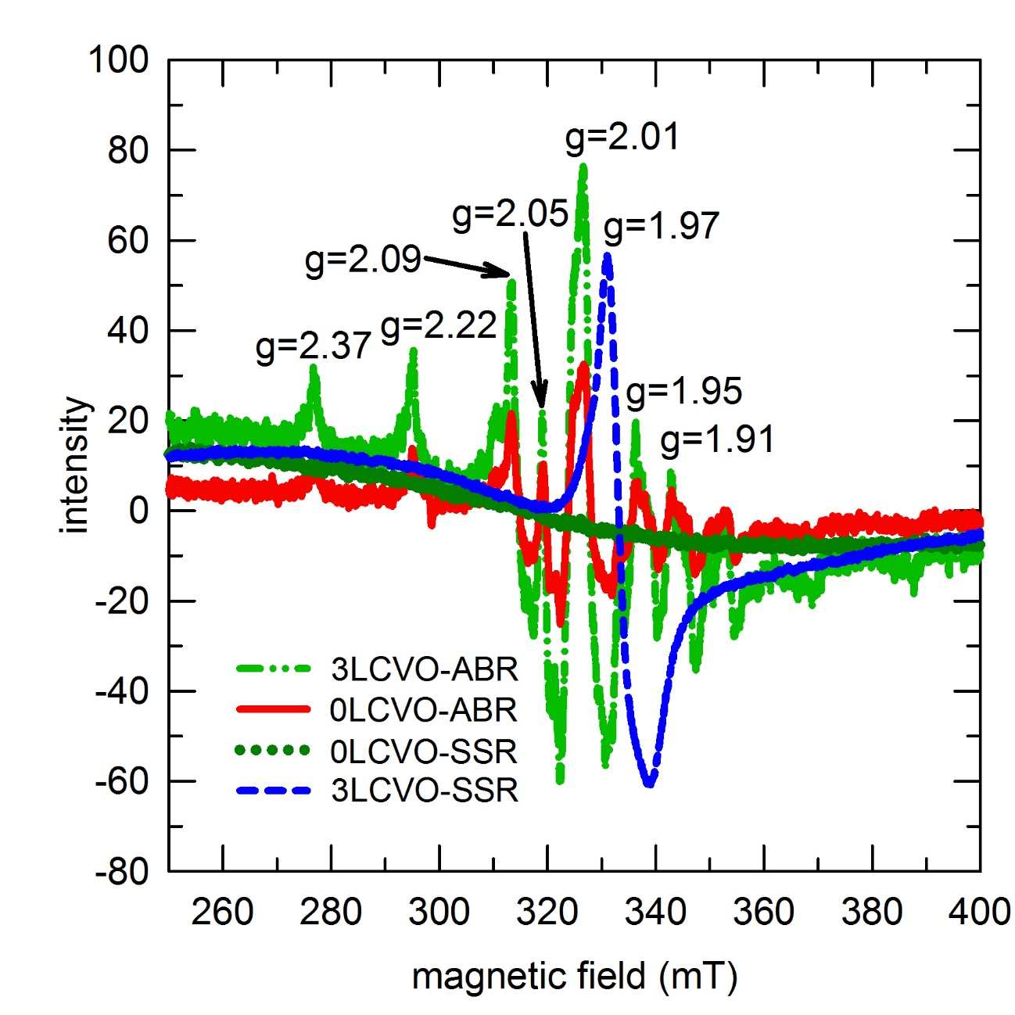
Figure S11. EPR spectra of as-prepared sample.

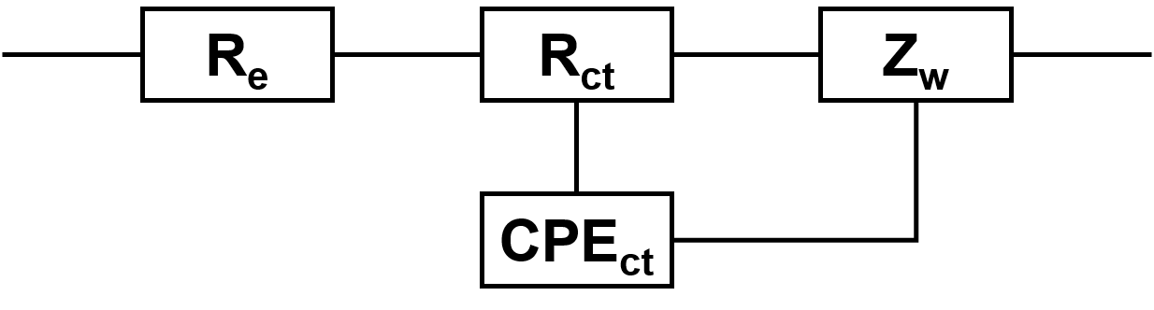
Figure S12. Equivalent circuit model used for fitting EIS spectra.

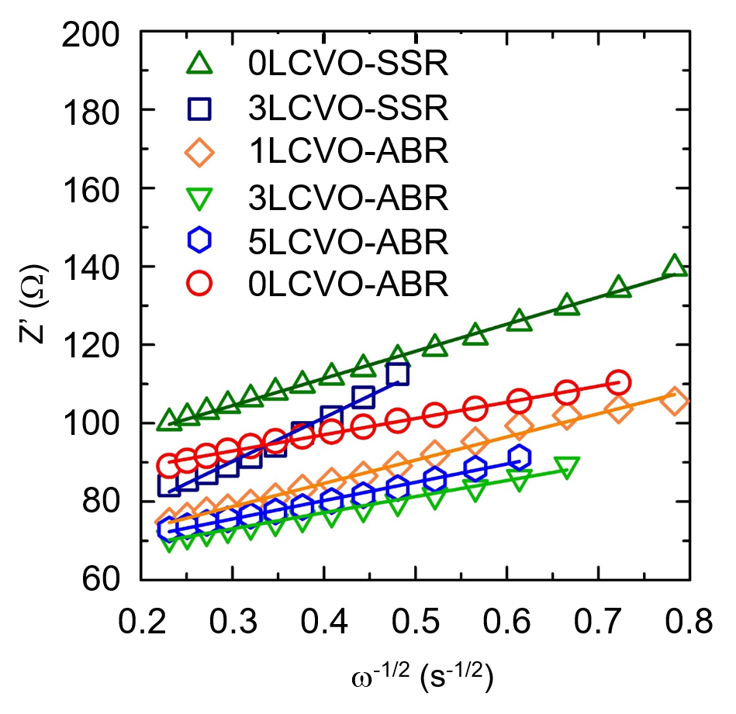
Figure S13. The linear fitting of the real impedance Z’ vs. ω-1/2 relationship of all as-prepared samples.
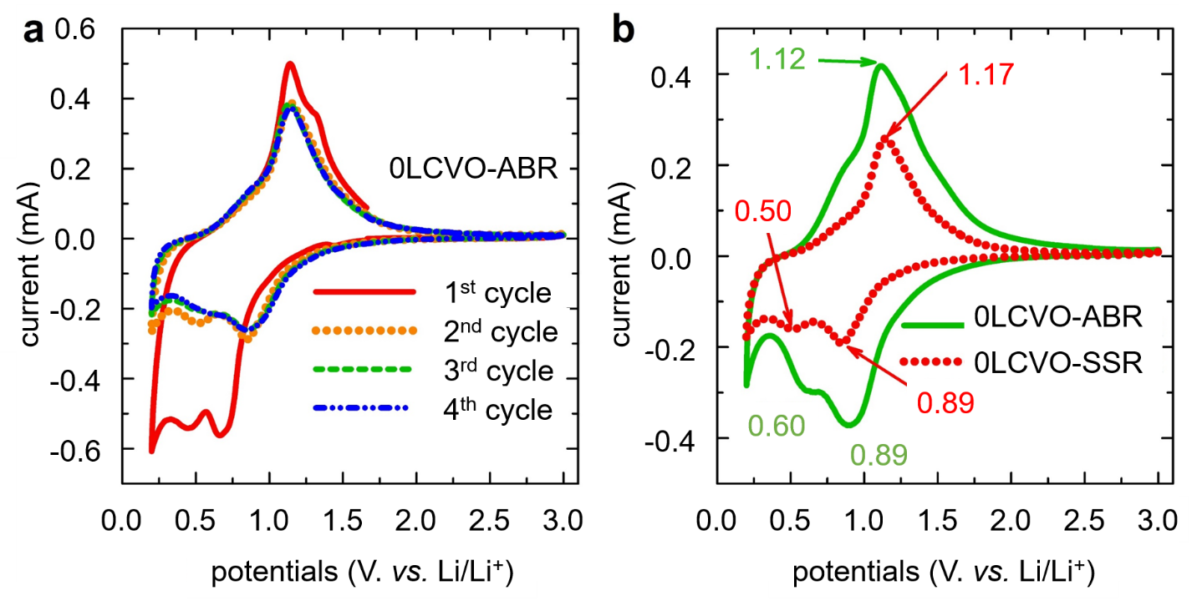
Figure S14. (a) Four first CV cycles of 0LCVO-ABR and (b) comparison of the 2nd CV curves of 0LCVO-ABR and 3LCVO-ABR.

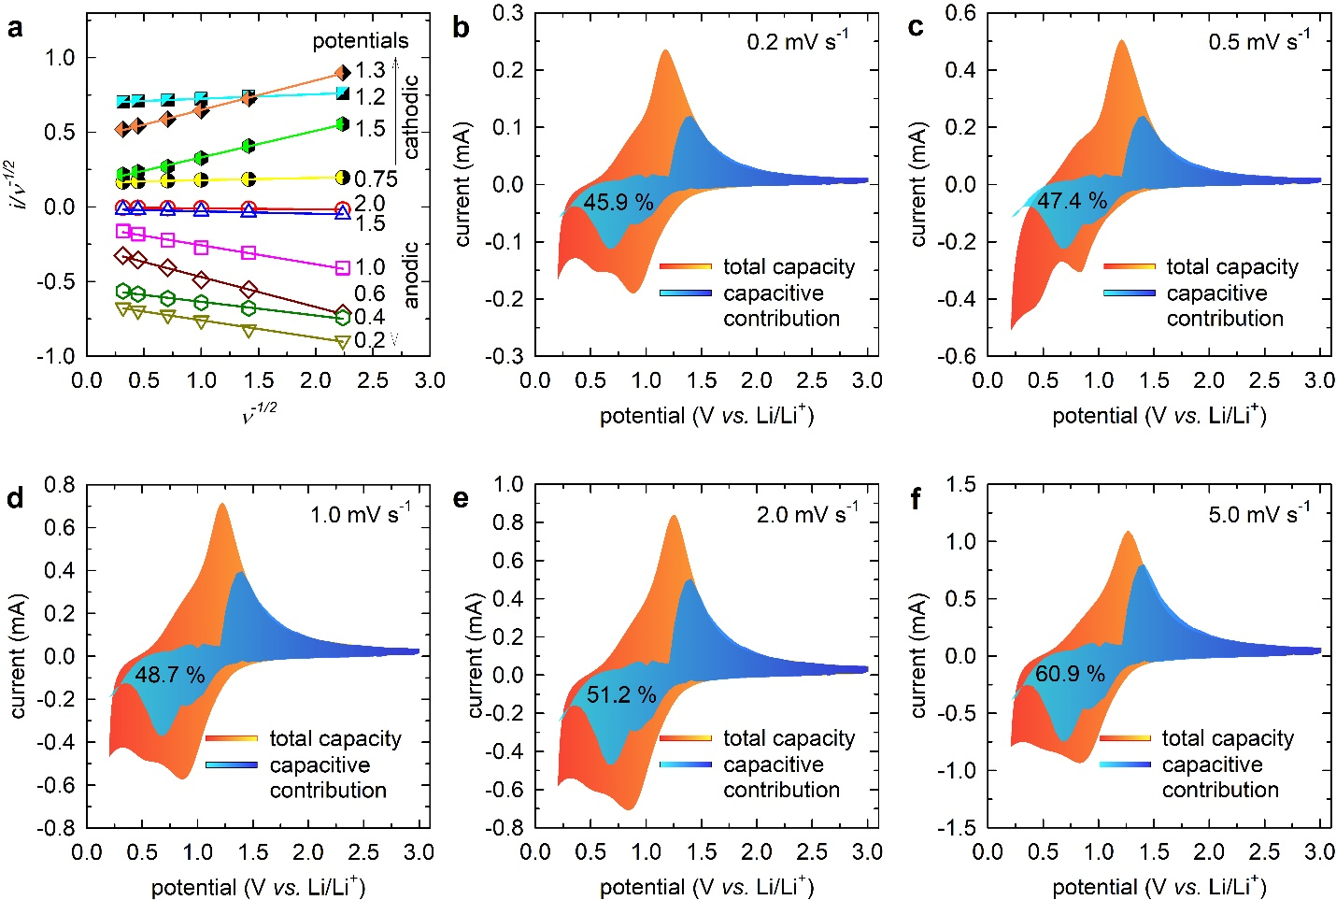
Figure S15. (a) The linear plot of i/ν^{1/2} vs. ν^{1/2} for calculation of k-constants; (b-f) pictorial pseudocapacitance contribution calculation at various potential values.
Table S1. Comparison on lattice parameters and unit cell volume of xLCVO-ABR derived from Rietveld refinement. Note: The numbers in parentheses are the estimated standard deviations of the last significant figure.
samples | 0LCVO-ABR | 1LCVO-ABR | 2LCVO-ABR | 3LCVO-ABR | 5LCVO-ABR
symmetry | orthorhombic
space grpoup | Pmn2₁
a (Å) | 6.3106(3) | 6.3179(1) | 6.3183(4) | 6.3202(5) | 6.3228(3)
b (Å) | 5.4412(2) | 5.4460(5) | 5.4479(4) | 5.4484(4) | 5.4517(1)
c (Å) | 4.9483(2) | 4.9492(2) | 4.9509(3) | 4.9520(2) | 4.9540(3)
V (Å³) | 169.916(2) | 170.250(1) | 170.352(2) | 170.462(3) | 170.515(6)
χ² | 1.724 | 1.707 | 1.295 | 1.639 | 1.211
R_{wp} (%) | 2.50 | 4.04 | 3.58 | 2.58 | 3.40
R_{p} (%) | 1.95 | 3.26 | 2.91 | 2.00 | 3.37
Table S2. Structural parameters of 1LCVO-ABR as obtained from the Rietveld
refinement of X-ray. Note: The numbers in parentheses are the estimated standard deviations of the last significant figure.
atom | Wyckoff position | x | y | z | 100 $×$ U_{iso} (Å²) | g
O1 | 4b | 0.2172(6) | 0.6889(11) | 0.9172(12) | 0.074(3) | 1.0
O2 | 2a | 0.0 | 0.1196(1) | 0.9129(13) | 0.073(2) | 1.0
O3 | 2a | 1/2 | 0.1844(11) | 0.8475(8) | 0.158(6) | 1.0
Li1 | 4b | 0.2507(1) | 0.3457(2) | 0.9662(4) | 0.226(1) | 0.99
Li2 | 2a | 1/2 | 0.8472(2) | 0.9654(3) | 0.318(3) | 0.99
V1 | 2a | 0.0 | 0.8314(5) | -0.0022(0) | 0.165(5) | 1.0
Ca1 | 4b | 0.2507(1) | 0.3457(2) | 0.9662(4) | 0.226(2) | 0.01
Ca2 | 2a | 1/2 | 0.8472(2) | 0.9654(3) | 0.318(4) | 0.01

Table S3. Structural parameters of 2LCVO-ABR as obtained from the Rietveld
refinement of X-ray. Note: The numbers in parentheses are the estimated standard deviations of the last significant figure.
atom | Wyckoff position | x | y | z | 100 $×$ U_{iso} (Å²) | g
O1 | 4b | 0.2217(4) | 0.6847(8) | 0.9012(7) | 0.148(2) | 1.0
O2 | 2a | 0.0 | 0.1249(9) | 0.8961(13) | 0.043(3) | 1.0
O3 | 2a | 1/2 | 0.1761(1) | 0.8439(6) | 0.290(1) | 1.0
Li1 | 4b | 0.2489(8) | 0.3303(2) | 0.9580(2) | 0.346(5) | 0.98
Li2 | 2a | 1/2 | 0.8345(2) | 0.9616(3) | 0.435(4) | 0.98
V1 | 2a | 0.0 | 0.8299(3) | -0.0008(0) | 0.265(2) | 1.0
Ca1 | 4b | 0.2489(8) | 0.3303(2) | 0.9580(2) | 0.346(6) | 0.02
Ca2 | 2a | 1/2 | 0.8345(2) | 0.9616(3) | 0.435(2) | 0.02

Table S4. Structural parameters of 5LCVO-ABR as obtained from the Rietveld
refinement of X-ray. Note: The numbers in parentheses are the estimated standard deviations of the last significant figure.
atom | Wyckoff position | x | y | z | 100 $×$ U_{iso} (Å²) | g
O1 | 4b | 0.2206(5) | 0.6899(1) | 0.9450(1) | 0.102(2) | 1.0
O2 | 2a | 0.0 | 0.1208(1) | 0.9172(13) | 0.109(8) | 1.0
O3 | 2a | 1/2 | 0.1846(2) | 0.8550(0) | 0.290(1) | 1.0
Li1 | 4b | 0.2558(8) | 0.3281(2) | 1.0075(3) | 0.216(4) | 0.95
Li2 | 2a | 1/2 | 0.8419(2) | 0.9537(2) | 0.198(2) | 0.95
V1 | 2a | 0.0 | 0.8299(3) | -0.0008(0) | 0.265(3) | 1.0
Ca1 | 4b | 0.2558(8) | 0.3281(2) | 1.0075(3) | 0.216(2) | 0.05
Ca2 | 2a | 1/2 | 0.8419(2) | 0.9537(2) | 0.198(7) | 0.05

Table S5. DFT-calculated E_{vac} of LVO and LCVO.
sites | E_{vac} (eV) | Ave. E_{vac} (eV)
V_{O1} (LVO) | 4.06 | 3.99
V_{O2} (LVO) | 3.95 | 3.99
V_{O3} (LVO) | 3.97 | 3.99
V_{O1} (LCVO) | 3.33 | 3.50
V_{O2} (LCVO) | 3.65 | 3.50
V_{O3} (LCVO) | 3.51 | 3.50

Table S6. Summary of active materials synthesized from ABR process for lithium ion batteries (LIBs) and sodium ion batteries (SIBs).
materials | application |  | capacity  (mAh⸳g⁻¹) | current density (mA⸳g⁻¹) | cyclability (cycles) | retention (%)
materials | LIBs | SIBs
LiVO₃ | cathode |  | 145.6 | 50 | 50 | 70.85
NaVO₃ orthorhombic |  | cathode | 225.5 | 50 | 50 | 73.77
Li₃VO₄ | anode |  | 268.7 | 100 | 200 | 90.27
BiVO₄ |  | anode | 351.2 | 100 | 100 | 87.62
Na₂MoO₄ | anode |  | 305.2 | 30 | 100 | 75.62
Li₂MoO₄ | anode |  | 423.2 | 100 | 200 | 69.15
Bi₂(MoO₄)₃ |  | anode | 401.2 | 100 | 200 | 91.25
NiMoO₄⸳xH₂O | anode |  | 452.3 | 100 | 50 | 74.65
Fe₂(MoO₄)₃ | anode |  | 1983.6 | 100 | 400 | -
BiOCl | anode |  | 350.5 | 100 | 20 | 45.51
BiOBr | anode |  | 225.2 | 100 | 20 | 42.53
BiOI | anode |  | 195.6 | 100 | 20 | 45.06
FeFe(CN)₆ | cathode |  | 131.5 | 100 | 100 | 80.21
FeFe(CN)₆ |  | cathode | 145.5 | 100 | 100 | 85.62
Na₂Zn₃[Fe(CN)₆]₂ |  | cathode | 58.6 | 62 | 1000 | 95.68
Li₂GeO₃ | anode |  | 401.1 | 100 | 50 | 84.32

References
1. Li H, Liu X, Zhai T, Li D, Zhou H. Li₃VO₄: A Promising Insertion Anode Material for Lithium-Ion Batteries. Advanced Energy Materials 3, 428-432 (2013).
2. Larson A, Von Dreele R. Gsas Los Alamos National Laboratory Report LAUR. (2000).
3. Kresse G, Furthmüller J. Efficiency of ab-initio total energy calculations for metals and semiconductors using a plane-wave basis set. Computational Materials Science 6, 15-50 (1996).
4. Krukau AV, Vydrov OA, Izmaylov AF, Scuseria GE. Influence of the exchange screening parameter on the performance of screened hybrid functionals. The Journal of Chemical Physics 125, 224106 (2006).
5. Dudarev S, Botton G, Savrasov S, Humphreys C, Sutton A. Electron-energy-loss spectra and the structural stability of nickel oxide: An LSDA+ U study. Physical Review B 57, 1505 (1998).
6. Arroyo-de Dompablo ME, Tartaj P, Amarilla JM, Amador U. Computational Investigation of Li Insertion in Li₃VO₄. Chemistry of Materials 28, 5643-5651 (2016).
7. Arroyo-de Dompablo M, Rozier P, Morcrette M, Tarascon J. Electrochemical Data Transferability within Li_{y}VOXO₄ (X= Si, Ge_{0. 5}Si_{0. 5}, Ge, Si_{0. 5}As_{0. 5}, Si_{0. 5}P_{0. 5}, As, P) Polyoxyanionic Compounds. Chemistry of Materials 19, 2411-2422 (2007).
8. Blöchl PE. Projector augmented-wave method. Physical Review B 50, 17953 (1994).
9. Wex H, Stratmann F, Topping D, McFiggans G. The Kelvin versus the Raoult term in the Köhler equation. Journal of The Atmospheric Sciences 65, 4004-4016 (2008).
10. Topping D, McFiggans G. Tight coupling of particle size, number and composition in atmospheric cloud droplet activation. Atmospheric Chemistry and Physics 12, 3253 (2012).
11. Thomson GW. The Antoine Equation for Vapor-pressure Data. Chemical Reviews 38, 1-39 (1946).
12. Grieb M, Brümmer A. Effects of spontaneous condensation in steam-driven screw expanders. IOP Conference Series: Materials Science and Engineering 232, 012078 (2017).
13. McDonald JE. Homogeneous Nucleation of Vapor Condensation. I. Thermodynamic Aspects. Amercan Journal of Physics 30, 870 (1962).
14. Tran Huu H, Nguyen Thi XD, Nguyen Van K, Kim SJ, Vo V. A Facile Synthesis of MoS₂/g-C₃N₄ Composite as an Anode Material with Improved Lithium Storage Capacity. Materials (Basel) 12, 1730 (2019).
15. Yu F, Liu Z, Zhou R, Tan D, Wang H, Wang F. Pseudocapacitance contribution in boron-doped graphite sheets for anion storage enables high-performance sodium-ion capacitors. Materials Horizon 5, 529-535 (2018).
16. Cook JB, Kim H-S, Lin TC, Lai C-H, Dunn B, Tolbert SH. Pseudocapacitive Charge Storage in Thick Composite MoS₂ Nanocrystal-Based Electrodes. Advanced Energy Materials 7, 1601283 (2017).
17. Xiang Y, et al. Pseudocapacitive behavior of the Fe₂O₃ anode and its contribution to high reversible capacity in lithium ion batteries. Nanoscale 10, 18010-18018 (2018).
18. Chen C, et al. Na⁺ intercalation pseudocapacitance in graphene-coupled titanium oxide enabling ultra-fast sodium storage and long-term cycling. Nature Communications 6, 1-8 (2015).
19. Bard AJ, Faulkner LR, Leddy J, Zoski CG. Electrochemical methods: fundamentals and applications. wiley New York (1980).
20. Jiang Y, Liu J. Definitions of Pseudocapacitive Materials: A Brief Review. Energy & Environmental Materials 2, 30-37 (2019).
21. Liu TC, Pell W, Conway B, Roberson S. Behavior of molybdenum nitrides as materials for electrochemical capacitors: comparison with ruthenium oxide. Journal of the Electrochemical Society 145, 1882 (1998).

