Additional File 1.

Additional File 1a. Association of each variable in the model with CKD, as described in the literature
Variable | Association to CKD
Sex | In animal models, male animals have a worse renal prognosis than females. The association in humans is more complex but literature supports the belief that renal diseases progresses slower in women independent of the severity of other progression factors [https://doi.org/10.1016/j.mayocp.2018.12.024]. Genetic factors, male sex, age, and duration of diabetes, are among the nonmodifiable risk factors associated both with onset and progression of kidney disease. [https://doi.org/10.1053/j.ackd.2017.10.011].  - Silbiger SR, Neugarten J. The impact of gender on the progression of chronic renal disease. Am J Kidney Dis. 1995; 25(4):515-533.  - Neugarten J, Acharya A, Silbiger SR. Effect of gender on the progression of nondiabetic renal disease: a meta-analysis. J Am Soc Nephrol. 2000;11(2):319-329.  - Neugarten JS, Silbiger SR, Golestaneh L. Gender and kidney disease. In: Brenner BM, ed. Brenner and Rector’s The Kidney. 8th ed. Amsterdam, Netherlands: Elsevier; 2008:674-680
Age | estimated glomerular filtration rae (eGFR) declines with increasing age [https://doi.org/10.1172/JCI102286]. Prevalence of CKD increases from those aged 18-39 years to those aged 60-70 years, despite between country differences in the absolute quantities, the effect remains [https://doi.org/10.4103/0971-4065.127881]  Genetic factors, male sex, age, and duration of diabetes, are among the nonmodifiable risk factors associated both with onset and progression of kidney disease [https://doi.org/10.1053/j.ackd.2017.10.011].
Diabetes | Diabetes and CKD have a bidirectional relationship. People with diagnosed diabetes have a significantly increased risk of developing CKD [https://doi.org/10.1097/PAP.0000000000000257] while kidney disease can contribute to the development of diabetes [https://doi.org/10.7759/cureus.45615].  Diabetic kidney disease is one of the most frequent and dangerous complications of type 2 diabetes mellitus affecting ⅓ of patients [https://dmsjournal.biomedcentral.com/articles/10.1186/s13098-016-0159-z].
Diabetes Duration | Kim et al. found that the time to worsening CKD was significantly shorter in elderly patinets with more than 10 years of diabetes compared to those with a duration of less than 5 years [https://doi.org/10.4093/dmj.2017.0065]. Genetic factors, male sex, age, and duration of diabetes, are among the nonmodifiable risk factors associated both with onset and progression of kidney disease [https://doi.org/10.1053/j.ackd.2017.10.011].
Hypertension | Hypertension and CKD are closely intertwined as hypertension can lead to deteriorating renal function and progressive CKD can contribute to worsening hypertension [https://doi.org/10.12968/hmed.2021.0440]
SBP | Time-varying systolic blood pressure has been found to be associated with incident CKD with an increase in risk, when SBP is above 120mmHg among individuals with hypertension [https://doi.org/10.2215/CJN.02240311]  Lee et al. found that SBP >= 130mmHg and DBP >= 90mmHg are associated with an increased risk of CKD [https://doi.org/10.23876/j.krcp.21.099]
DBP | Lee et al. found that SBP >= 130mmHg and DBP >= 90mmHg are associated with an increased risk of CKD [https://doi.org/10.23876/j.krcp.21.099]
BMI | Betzler et al.found that both overweight and obesity were associated with increased odds of CKD with a pooled OR (95% CI) of 1.15 (1.03-1.29) and 1.23 (1.06-1.42) respectively [https://doi.org/10.1016/j.maturitas.2021.09.005]

Additional File 1b.

The CKD-EPI** (Chronic Kidney Disease Epidemiology Collaboration) equation [1]

** The CKD-EPI Creatinine-Cystatin C Age, Sex Equation (2021) can be expressed as a single equation:
135 X min (Scr/k,1) α X max (Scr/k,1)-0.544 X min (Scys/0.8,1)-0.323 X max (Scys/0.8,1)-0.778 X 0.9961 age X 0.963 [if female]
Where:
Scr is serum creatinine
Scys is serum cystatin C
k is 0.7 for females and 0.9 for males,
α is -0.219 for females and -0.144 for males
min indicates the minimum of Scr/k or 1
max indicates the maximum of Scr/k or 1

The CKD-EPI research group developed all equations.
**Available at https://www.nejm.org/doi/full/10.1056/NEJMoa2102953#ap1

Additional File 1c. Basal Distribution of Clinical and Demographic Characteristics (after augmentation)

Number of registries | Total |  |  | Database 1 |  |  | Database 2 |  |  | Database 3
Number of registries | N = 351,130 |  |  | n = 70,788 |  |  | n = 157,050 |  |  | n = 123,292
Quantitative Variables | mean | std | min, max | mean | std | min, max | mean | std | min, max | mean | std | min, max
Age | 57.93 | 19.74 | 18, 100 | 68.22 | 11.05 | 21, 99 | 70.26 | 13.13 | 18, 100 | 36.31 | 9.93 | 18, 100
SBP | 119.85 | 16.17 | 40, 180 | 130.88 | 16.26 | 40, 180 | 122.59 | 16.04 | 40, 180 | 110.04 | 9.44 | 60, 180
DBP | 75.09 | 10.37 | 40.120 | 77.28 | 9.22 | 40, 120 | 77.99 | 11.16 | 40, 120 | 70.15 | 7.79 | 50, 100
BMI | 26.56 | 4.50 | 12.50 | 27.40 | 5.00 | 12.42, 49.95 | 25.90 | 4.78 | 12, 50 | 26.94 | 3.62 | 13.92, 49.67
Diabetes Duration (T2DD) | 2.76 | 5.50 | 0, 56.87 | 9.71 | 7.43 | 0, 56.87 | 1.76 | 3.72 | 0, 9.6 | 0.03 | 0.55 | 0, 31
Qualitative Variables | Absolute Frequency (n) |  | Relative Frequency (%) | Absolute Frequency (n) |  | Relative Frequency (%) | Absolute Frequency (n) |  | Relative Frequency (%) | Absolute Frequency (n) |  | Relative Frequency (%)
Sex (F) | 164375 |  | 46.81% | 60,436 |  | 85.38% | 91,099 |  | 58.01% | 12,84 |  | 10.41%
Hypertension (Yes) | 146726 |  | 41.79% | 57,423 |  | 81.12% | 88,189 |  | 56.15% | 1,114 |  | 0.90%
Diabetes (Yes) | 94520 |  | 26.92% | 65,221 |  | 92.14% | 28,757 |  | 18.31% | 542 |  | 0.44%
CKD (Yes) | 175565 |  | 50.00% | 60,134 |  | 84.95% | 112,95 |  | 71.92% | 2,481 |  | 2.01%

Additional File 1d. Shapiro-Wilk Normality Test for quantitative independent variables

Shapiro-Wilk Normality Test (Quantitative)
Variable | W | p-value | Conclusion
Age | 0.9508 | 0.0000 | NO normal
Diabetes Duration | 0.4287 | 0.0000 | NO normal
SBP | 0.9147 | 0.0000 | NO normal
DBP | 0.8519 | 0.0000 | NO normal
BMI | 0.9812 | 0.0000 | NO normal

Additional File 1e. Spearman Correlation Heatmap
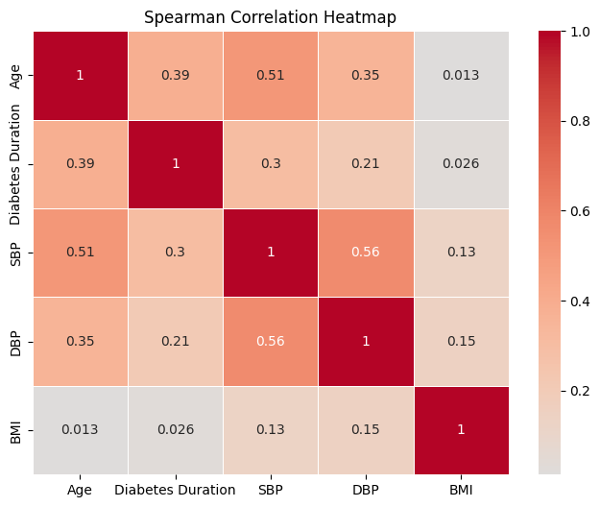

Additional File 1f. Chi-squared test for statistical association between qualitative independent variables.

Chi2
Variable 1 | Variable 2 | p-value
Sex | Hypertension | <0.01
Sex | Diabetes | <0.01
Hypertension | Diabetes | <0.01

Additional File 1g. Mann-Whitney’s U test for statistical association between categorical and quantitative variables

Mann-Whitney's U test
Variable 1 | Variable 2 | p-value
Sex | Age | <0.01
Sex | Diabetes Duration | <0.01
Sex | SBP | <0.01
Sex | DBP | <0.01
Sex | BMI | <0.01
Hypertension | Age | <0.01
Hypertension | Diabetes Duration | <0.01
Hypertension | SBP | <0.01
Hypertension | DBP | <0.01
Hypertension | BMI | <0.01
Diabetes | Age | <0.01
Diabetes | Diabetes Duration | <0.01
Diabetes | SBP | <0.01
Diabetes | DBP | <0.01
Diabetes | BMI | <0.01

Additional File 1h. Bivariate Analyses for statistical association between independent variables and the outcome variable.

Bivariate Analyses
Dependent | Independent | p-value | Test
CKD | Age | <0.01 | Mann Whitney's U
CKD | Diabetes Duration | <0.01 | Mann Whitney's U
CKD | SBP | <0.01 | Mann Whitney's U
CKD | DBP | <0.01 | Mann Whitney's U
CKD | BMI | <0.01 | Mann Whitney's U
CKD | Sex | <0.01 | Chi2
CKD | Hypertension | <0.01 | Chi2
CKD | Diabetes | <0.01 | Chi2

Additional File 1i. Durbin-Watson and Breusch-Pagan tests.

Independence of errors: Durbin-Watson test
DW: 1.8582, p-value < 2.2E-16
The Durbin-Watson statistic 1.86 indicates little to no autocorrelation, validated with a p-value < 0.01. Therefore, the assumption is confirmed.

Homoscedasticity: Breusch-Pagan Test [2]
BP: 80239, df: 8, p-value < 2.2E-16
The BP statistic suggests heteroscedasticity, and the p-value < 2.2E-16 confirms the significance. Therefore, there is strong evidence for heteroscedasticity in the model, and the assumption is rejected.

Additional File 1j. Chosen Binomial Regression model, including the “eight readily available” variables on the AI Algorithm

 | Estimate | Std. Error | z value | Pr(>|z|) | e^beta
(Intercept) | -11.735 | 0.111 | -105.541 | <0.01 | 8.01E-06
Diabetes (Yes) | 0.7079 | 0.03016 | 23.47 | <0.01 | 2.0297
Hypertension (Yes) | 0.625 | 0.01945 | 32.1343 | <0.01 | 1.8680
Diabetes Duration | 0.01422 | 0.0024 | 5.914 | <0.01 | 1.0143
SBP | 0.00893 | 0.000542 | 16.475 | <0.01 | 1.0090
DBP | 0.006674 | 0.0008293 | 8.047049 | <0.01 | 1.0067
BMI | 0.015525583 | 0.0018539421 | 8.374362 | <0.01 | 1.0156
Age | 0.114752192 | 0.0007796715 | 147.180184 | <0.01 | 1.2160
Sex (M) | 0.940805264 | 0.0186063622 | 50.563633 | <0.01 | 2.5620

Additional File 1k. Goodness of fit metrics for the final model

Model Variation
Measure | Value
AIC | 91281
R2 (McFadden's) | 0.433
R2 (Nagelkerke) | 0.531

Additional File 1l. Goodness of fit metrics for different regression models, introducing and excluding different features at a time:

Model features tested | R2 McFadden | R2 Nagelkerke | AIC
8 features | 0.4333846 | 0.5312212 | 91281
7 features (no Diabetes) | 0.4300369 | 0.5277782 | 91818.25
7 features (no hypertension) | 0.4269334 | 0.5245781 | 92318.12
6 features (no Diabetes, no Hypertension) | 0.4216971 | 0.519161 | 93159.51
7 features (no BMI) | 0.432951 | 0.5307758 | 91348.88
7 features (no age) | 0.2320305 | 0.3069755 | 123710.6
7 features (no diabetes duration) | 0.4331661 | 0.5309968 | 91314.24
6 features (no diabetes, no diabetes duration) | 0.4206196 | 0.5180434 | 93333.06
6 features (no SBP, no DBP) | 0.4310663 | 0.5288378 | 91650

Additional file 1m. Confusion matrix and performance metrics for the final model, used in the diabetic patient strata

Arkangel app | CKD EPI <60mL/min/1.73m² (true case) | CKD EPI >=60mL/min/1.73m² (false case) | Total | Metric | Value | IC 0.95% - Lower | IC 0.95% - Upper
Classification | CKD EPI <60mL/min/1.73m² (true case) | CKD EPI >=60mL/min/1.73m² (false case) | Total | Sensitivity | 0.930 | 0.926 | 0.935
 | CKD EPI <60mL/min/1.73m² (true case) | CKD EPI >=60mL/min/1.73m² (false case) | Total | Specificity | 0.707 | 0.692 | 0.721
 | CKD EPI <60mL/min/1.73m² (true case) | CKD EPI >=60mL/min/1.73m² (false case) | Total | Precision | 0.918 | 0.913 | 0.923
AI Algorithm true case | 12283 | 1095 | 13378 | Accuracy | 0.881 | 0.876 | 0.886
AI Algorithm false case | 919 | 2643 | 3562 | F1 score | 0.924 | 0.920 | 0.929
Total | 13202 | 3738 | 16940 | AUC | 0.810 | 0.809 | 0.828

Additional file 1n. Confusion matrix and performance metrics for the final model, used in the non- diabetic patient strata

Arkangel app | CKD EPI <60mL/min/1.73m² (true case) | CKD EPI >=60mL/min/1.73m² (false case) | Total | Metric | Value | IC 0.95% - Lower | IC 0.95% - Upper
Classification | CKD EPI <60mL/min/1.73m² (true case) | CKD EPI >=60mL/min/1.73m² (false case) | Total | Sensitivity | 0.902 | 0.897 | 0.906
Training dataset | CKD EPI <60mL/min/1.73m² (true case) | CKD EPI >=60mL/min/1.73m² (false case) | Total | Specificity | 0.927 | 0.924 | 0.930
 | CKD EPI <60mL/min/1.73m² (true case) | CKD EPI >=60mL/min/1.73m² (false case) | Total | Precision | 0.890 | 0.885 | 0.894
AI Algorithm true case | 16514 | 2047 | 18561 | Accuracy | 0.917 | 0.914 | 0.919
AI Algorithm false case | 1799 | 25903 | 27702 | F1 score | 0.896 | 0.892 | 0.900
Total | 18313 | 27950 | 46263 | AUC | 0.910 | 0.912 | 0.917
Additional file 1o. Comparison between performances in the T2D/ non-T2D stratified sample, using the final model

Model | Sensitivity | Specificity | Precision | Accuracy | F1 score | AUC
Diabetics (T2D) | 0.930 | 0.707 | 0.918 | 0.881 | 0.924 | 0.810
Non-Diabetics (non-T2D) | 0.902 | 0.927 | 0.890 | 0.917 | 0.896 | 0.910
Absolute Difference | 0.029 | -0.220 | 0.028 | -0.036 | 0.029 | -0.100
Z test p-value | 0.066 | 0.061 | 0.059 | 0.07 | 0.061 | 0.700

Additional file 1p. Confusion matrix and performance metrics for the final model, used for male patients

Az Testing confusion matrix - male | CKD EPI <60mL/min/1.73m² (true) | CKD EPI >=60mL/min/1.73m² (false) | Total | Metric | Value | IC 0.95% - Lower | IC 0.95% - Upper
 |  |  |  | Sensitivity | 0.898 | 0.893 | 0.904
 |  |  |  | Specificity | 0.945 | 0.942 | 0.948
 |  |  |  | Precision | 0.894 | 0.893 | 0.904
CKD model | 10266 | 1212 | 11478 | Accuracy | 0.929 | 0.926 | 0.932
Non-CKD model | 1162 | 20903 | 22065 | F1 score | 0.896 | 0.891 | 0.901
Total | 11428 | 22115 | 33543 | AUC | 0.922 | 0.919 | 0.925

Additional file 1q. Confusion matrix and performance metrics for the final model, used for female patients

Az Testing Confusion matrix – female | CKD EPI <60mL/min/1.73m² (true) | CKD EPI >=60mL/min/1.73m² (false) | Total | Metric | Value | IC 0.95% - Lower | IC 0.95% - Upper
 |  |  |  | Sensitivity | 0.923 | 0.919 | 0.926
 |  |  |  | Specificity | 0.798 | 0.790 | 0.806
 |  |  |  | Precision | 0.906 | 0.902 | 0.910
CKD model | 18531 | 1930 | 20461 | Accuracy | 0.882 | 0.879 | 0.886
Non-CKD model | 1556 | 7643 | 9199 | F1 score | 0.914 | 0.910 | 0.918
Total | 20087 | 9573 | 29660 | AUC | 0.861 | 0.856 | 0.865

Additional file 1r. Confusion matrix and performance metrics for the final model, used in stratified age

Az Testing confusion matrix [< 40] | CKD EPI <60mL/min/1.73m² (true) | CKD EPI >=60mL/min/1.73m² (false) | Total | Metric | Value | IC 0.95% - Lower | IC 0.95% - Upper
 |  |  |  | Sensitivity | 0.611 | 0.538 | 0.681
 |  |  |  | Specificity | 0.997 | 0.996 | 0.998
 |  |  |  | Precision | 0.718 | 0.641 | 0.784
CKD model | 107 | 42 | 149 | Accuracy | 0.993 | 0.991 | 0.994
Non-CKD model | 68 | 15129 | 15197 | F1 score | 0.660 | 0.601 | 0.720
Total | 175 | 15171 | 15346 | AUC | 0.804 | 0.768 | 0.841

Az Testing confusion matrix [40,60] | CKD EPI <60mL/min/1.73m² (true) | CKD EPI >=60mL/min/1.73m² (false) | Total | Metric | Value | IC 0.95% - Lower | IC 0.95% - Upper
 |  |  |  | Sensitivity | 0.840 | 0.829 | 0.851
 |  |  |  | Specificity | 0.933 | 0.928 | 0.937
 |  |  |  | Precision | 0.831 | 0.819 | 0.842
CKD model | 3539 | 720 | 4259 | Accuracy | 0.907 | 0.902 | 0.911
Non-CKD model | 674 | 9985 | 10659 | F1 score | 0.835 | 0.826 | 0.845
Total | 4213 | 10705 | 14918 | AUC | 0.886 | 0.880 | 0.892

Az Testing confusion matrix [> 60] | CKD EPI <60mL/min/1.73m² (true) | CKD EPI >=60mL/min/1.73m² (false) | Total | Metric | Value | IC 0.95% - Lower | IC 0.95% - Upper
 |  |  |  | Sensitivity | 0.927 | 0.924 | 0.93
 |  |  |  | Specificity | 0.591 | 0.578 | 0.603
 |  |  |  | Precision | 0.914 | 0.91 | 0.917
CKD model | 25151 | 2380 | 27531 | Accuracy | 0.868 | 0.8641 | 0.8714
Non-CKD model | 1976 | 3432 | 5408 | F1 score | 0.920 | 0.917 | 0.924
Total | 27127 | 5812 | 32939 | AUC | 0.759 | 0.7523 | 0.7653

Additional file 1s. Multicollinearity evidence table

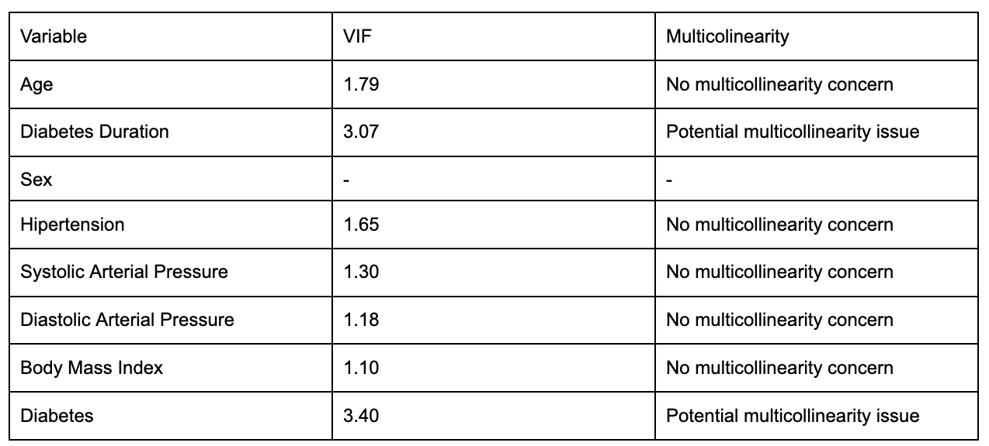

BIBLIOGRAPHY

1. Clinical Version: eGFR using CKD-EPI (2021 update) | QxMD [Internet]. Calculate by QxMD. [cited 2024 Apr 23]. Available from: https://qxmd.com/calculate/calculator_251/egfr-using-ckd-epi-2021-update
2. Breusch TS, Pagan AR. A Simple Test for Heteroscedasticity and Random Coefficient Variation. Econometrica. 1979;47(5):1287–94.
3. Ravizza S, Huschto T, Adamov A, Böhm L, Büsser A, Flöther FF, et al. Predicting the early risk of chronic kidney disease in patients with diabetes using real-world data. Nat Med. 2019 Jan;25(1):57–9.
4. Chan L, Nadkarni GN, Fleming F, McCullough JR, Connolly P, Mosoyan G, et al. Derivation and validation of a machine learning risk score using biomarker and electronic patient data to predict progression of diabetic kidney disease. Diabetologia. 2021 Jul;64(7):1504–15.
5. Qin J, Chen L, Liu Y, Liu C, Feng C, Chen B. A Machine Learning Methodology for Diagnosing Chronic Kidney Disease. IEEE Access. 2020;8:20991–1002.
6. Islam MdA, Majumder MdZH, Hussein MdA. Chronic kidney disease prediction based on machine learning algorithms. J Pathol Inform. 2023 Jan 12;14:100189.
7. Jeong B, Cho H, Kim J, Kwon SK, Hong S, Lee C, et al. Comparison between Statistical Models and Machine Learning Methods on Classification for Highly Imbalanced Multiclass Kidney Data. Diagnostics. 2020 Jun 18;10(6):415.
8. Kumar A, Sinha N, Bhardwaj A. A novel fitness function in genetic programming for medical data classification. J Biomed Inform. 2020 Dec 1;112:103623.
9. Weber C, Röschke L, Modersohn L, Lohr C, Kolditz T, Hahn U, et al. Optimized Identification of Advanced Chronic Kidney Disease and Absence of Kidney Disease by Combining Different Electronic Health Data Resources and by Applying Machine Learning Strategies. J Clin Med. 2020 Sep;9(9):2955.

