Supplementary Information

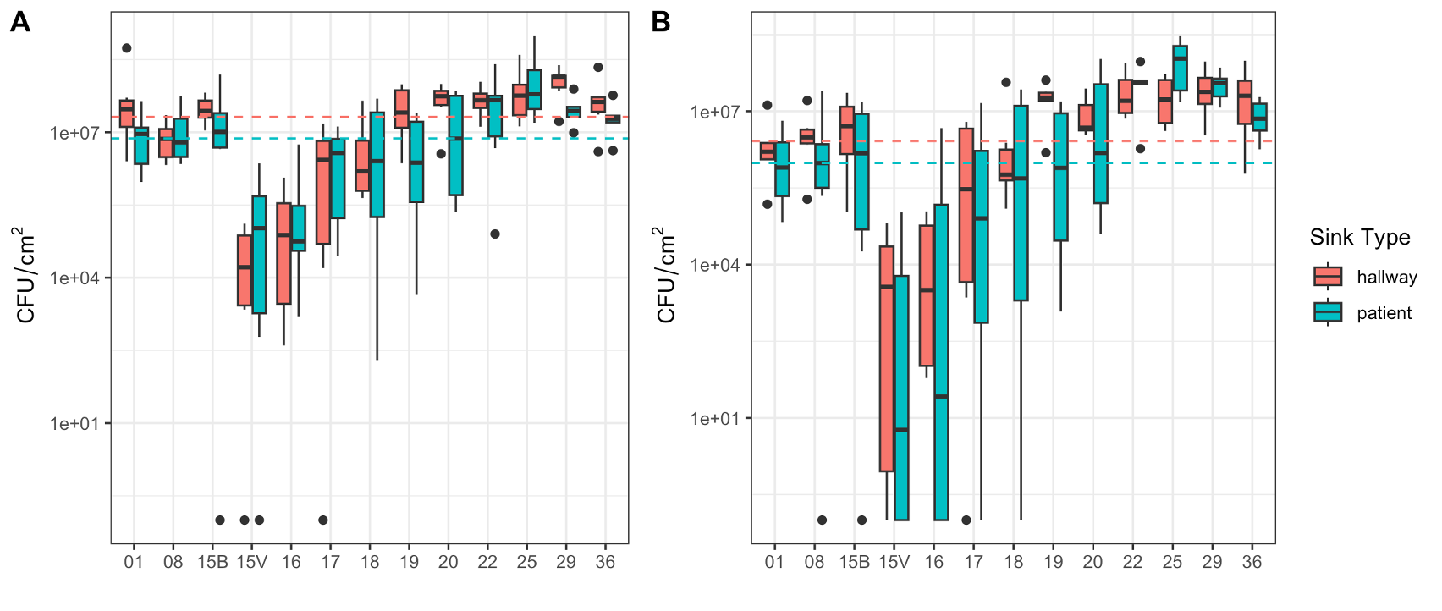
Supplementary Figure 1. (A) Cultured total bacteria and (B) carbapenem-resistant bacteria from sink drain biofilms separated by sink location (hallway or patient), where drains were disinfected on Day 15. Dashed horizontal lines represent the median CFU/cm² of the first three timepoints for each sink location (Hallway is red; patient is blue).

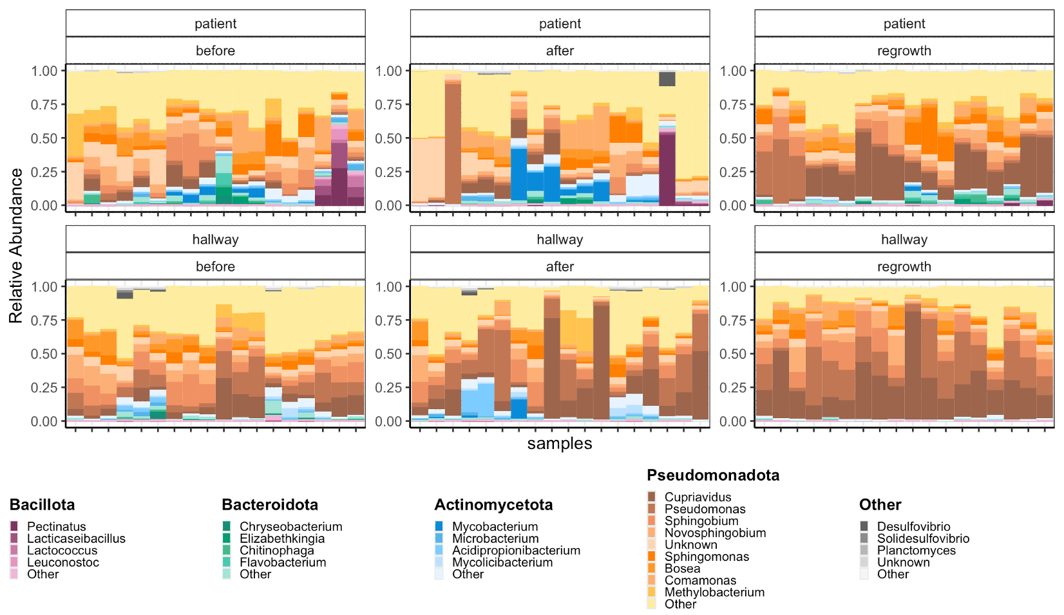
Supplementary Figure 2. Stacked barplot overview of all samples separated by sink location (top: patient room sink samples, bottom: hallway sink samples). Plots are faceted by experimental phase. Cupriavidus and Pseudomonas are the dominant genera in the regrowth phase in both sink location; however, the patient sinks contain Bacteroidota that persists throughout the growth phases.

Table 1. Alpha diversity measures including [IQR] and p-values across the three growth phases. P-values were computed using the Kruskal-Wallis test and adjusted for multiple testing using Benjamin Hochberg correction.
Alpha Diversity Measures | Before | After | Regrowth | p-value
Observed | 1577.0 [1512.8, 1602.3] | 1570.5 [1451.0, 1614.0] | 1536.0 [1430.0, 1579.8] | 0.051
Inverse Simpson | 11.4 [9.6, 15.2] | 8.9 [5.0, 11.8] | 6.0 [4.3, 8.3] | 0.00003*
Shannon | 3.3 [3.1, 3.6] | 3.1 [2.5, 3.5] | 2.5 [2.3, 3.0] | 0.00005*
Chao1 | 1605.2 [1567.1,1622.1] | 1607.6 [1553.4,1623.3] | 1579.5 [1476.0,1604.8] | 0.03*

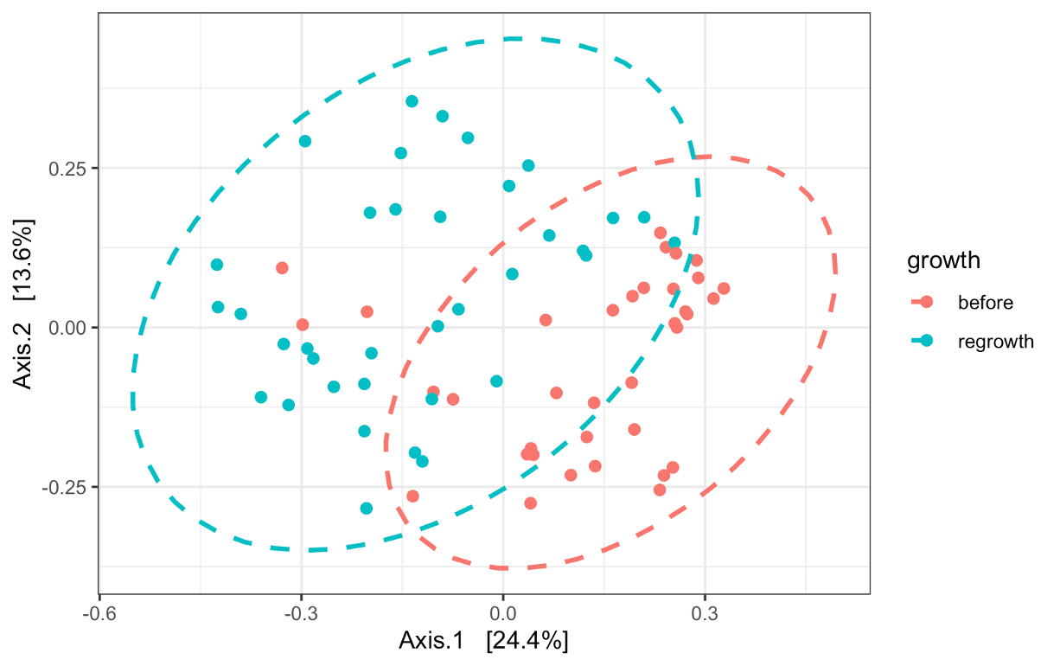
Supplementary Figure 3. PCoA of beta diversity analysis of the biofilm samples before disinfection and during the regrowth phase (Bray-Curtis, p = 0.001, PERMANOVA) adjusted for room type (hallway versus patient).

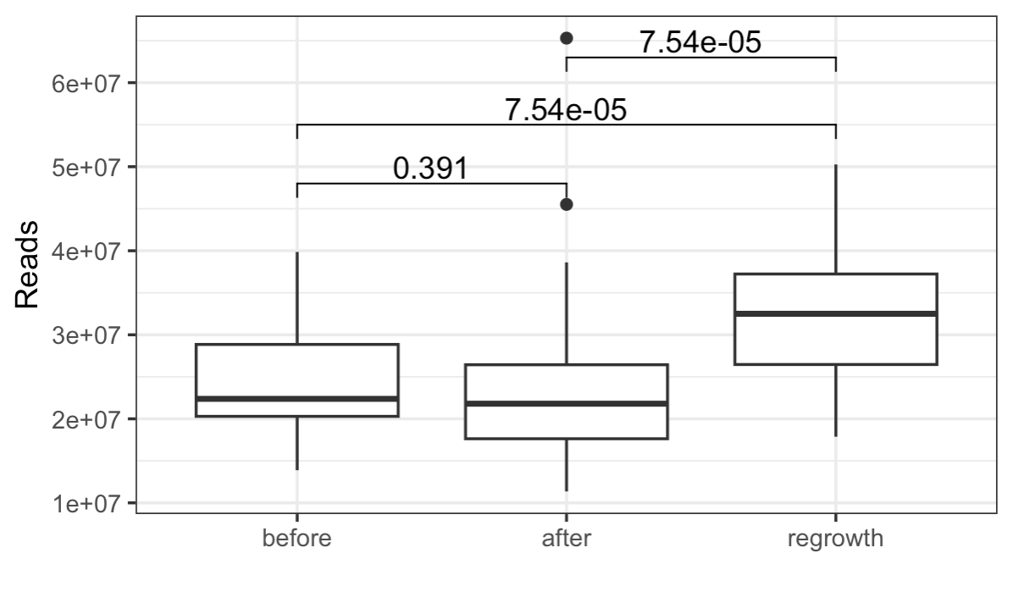
Supplementary Figure 4. Boxplots demonstrating the number of sequencing reads left after filtering and removing contaminants. The regrowth phase has significantly higher reads than both before and after. Bracket values indicate p values from Wilcoxon Rank Sum test.

Table 2. The top 15 differentially abundant taxa with a mean abundance > 0.001 between either ‘After’ or Regrowth’ phases compared to Before’ as determined by MaAslin3. All 15 of the most significant differences were between before and regrowth.

Growth Phase Compared to Before | q-value | mean abundance | genus
regrowth | 4.07753E-12 | 15.87295327 | Cupriavidus
regrowth | 5.39678E-09 | 0.08268031 | Ralstonia
regrowth | 8.12776E-08 | 0.173434549 | Burkholderia
regrowth | 4.33167E-07 | 0.008558102 | Alcaligenes
regrowth | 6.11117E-07 | 10.63282072 | Pseudomonas
regrowth | 6.16674E-06 | 2.433628983 | Stenotrophomonas
regrowth | 3.86399E-05 | 0.038306086 | Janthinobacterium
regrowth | 4.369E-05 | 0.01995481 | Stutzerimonas
regrowth | 6.9124E-05 | 0.02214547 | Dysgonomonas
regrowth | 6.9124E-05 | 0.00242812 | Polaribacter
regrowth | 9.00398E-05 | 0.016414974 | Caballeronia
regrowth | 0.000120819 | 0.101060069 | Paraburkholderia
regrowth | 0.000191687 | 0.150135651 | Achromobacter
regrowth | 0.000517931 | 7.918881652 | Sphingobium
regrowth | 0.000589824 | 0.004382996 | Herminiimonas
regrowth | 0.000762598 | 0.002440325 | Chitiniphilus

Supplementary Table 3. All 73 genera of pathogens (as defined by CZID). The median relative abundances are reported for each experimental growth phase.
Genus | before | after | regrowth
Abiotrophia | 8.89E-08 | 7.19E-08 | 4.05E-08
Achromobacter | 1.13E-03 | 1.07E-03 | 1.07E-03
Acinetobacter | 2.50E-04 | 2.32E-04 | 5.40E-04
Actinomadura | 4.95E-05 | 7.18E-05 | 2.79E-05
Actinomyces | 6.66E-05 | 9.99E-05 | 2.53E-05
Actinotignum | 1.51E-06 | 2.03E-06 | 4.04E-07
Aerococcus | 2.00E-07 | 1.04E-07 | 2.62E-07
Aeromonas | 2.30E-04 | 2.45E-04 | 1.96E-04
Aggregatibacter | 3.80E-07 | 2.77E-07 | 8.73E-08
Agrobacterium | 1.10E-03 | 1.48E-03 | 6.65E-04
Arcanobacterium | 5.93E-07 | 1.03E-06 | 1.81E-07
Arcobacter | 6.63E-07 | 1.69E-07 | 2.15E-07
Bacillus | 4.37E-05 | 5.43E-05 | 2.55E-05
Bartonella | 4.71E-06 | 2.70E-06 | 1.65E-06
Bordetella | 6.05E-04 | 4.78E-04 | 4.85E-04
Borrelia | 3.61E-07 | 3.62E-07 | 3.73E-07
Brevibacillus | 1.87E-05 | 1.75E-05 | 7.45E-06
Brucella | 3.42E-04 | 2.98E-04 | 2.34E-04
Burkholderia | 1.74E-03 | 1.59E-03 | 1.59E-03
Campylobacter | 1.91E-06 | 9.02E-07 | 4.57E-07
Cardiobacterium | 8.22E-06 | 8.97E-06 | 3.41E-06
Citrobacter | 3.09E-04 | 7.24E-04 | 1.55E-04
Clostridium | 1.05E-05 | 1.49E-05 | 4.40E-06
Corynebacterium | 1.32E-04 | 2.61E-04 | 7.04E-05
Coxiella | 8.63E-07 | 2.68E-07 | 1.01E-06
Cronobacter | 4.30E-05 | 4.57E-05 | 2.18E-05
Edwardsiella | 2.52E-05 | 2.30E-05 | 1.00E-05
Eikenella | 3.22E-06 | 2.59E-06 | 1.22E-06
Elizabethkingia | 4.87E-04 | 2.17E-04 | 1.76E-04
Enterobacter | 6.67E-04 | 2.00E-03 | 4.57E-04
Enterococcus | 3.50E-06 | 4.44E-06 | 1.11E-06
Escherichia | 1.84E-04 | 1.36E-04 | 5.82E-05
Haemophilus | 1.17E-06 | 7.03E-07 | 6.07E-07
Helicobacter | 1.11E-06 | 8.61E-07 | 6.08E-07
Kingella | 4.24E-06 | 4.04E-06 | 1.85E-06
Klebsiella | 5.20E-04 | 7.41E-04 | 2.48E-04
Legionella | 9.17E-05 | 4.86E-05 | 2.07E-05
Leptospira | 3.66E-06 | 3.52E-06 | 2.39E-06
Listeria | 1.35E-06 | 1.53E-06 | 5.91E-07
Methylorubrum | 2.80E-03 | 9.95E-04 | 1.26E-03
Moraxella | 5.60E-06 | 7.63E-06 | 3.64E-06
Morganella | 1.44E-05 | 7.98E-06 | 6.32E-06
Mycobacterium | 1.40E-03 | 4.30E-03 | 4.77E-04
Mycobacteroides | 3.52E-05 | 6.01E-05 | 1.41E-05
Mycolicibacter | 1.03E-04 | 1.30E-04 | 2.75E-05
Mycolicibacterium | 1.11E-03 | 2.09E-03 | 3.04E-04
Neisseria | 5.46E-05 | 4.85E-05 | 2.41E-05
Nocardia | 2.91E-04 | 3.55E-04 | 1.29E-04
Pasteurella | 1.08E-07 | 2.37E-07 | 6.74E-08
Peptoniphilus | 9.81E-08 | 3.40E-07 | 1.59E-06
Photobacterium | 1.20E-05 | 7.75E-06 | 5.65E-06
Plesiomonas | 2.72E-06 | 2.27E-06 | 1.49E-06
Porphyromonas | 4.15E-06 | 3.26E-06 | 2.18E-06
Prevotella | 1.97E-05 | 2.58E-05 | 1.28E-05
Proteus | 2.28E-06 | 1.50E-06 | 4.05E-07
Providencia | 2.84E-06 | 2.75E-06 | 1.58E-06
Pseudomonas | 2.33E-02 | 1.87E-02 | 5.43E-02
Ralstonia | 7.15E-04 | 6.76E-04 | 9.23E-04
Rhodococcus | 2.02E-04 | 2.93E-04 | 9.54E-05
Rothia | 2.42E-05 | 2.32E-05 | 5.37E-06
Salmonella | 3.91E-05 | 3.94E-05 | 2.44E-05
Serratia | 2.31E-04 | 2.31E-04 | 1.62E-04
Shewanella | 4.77E-05 | 3.52E-05 | 3.30E-05
Shigella | 1.04E-06 | 6.59E-07 | 1.79E-07
Staphylococcus | 3.39E-06 | 3.63E-06 | 1.31E-06
Stenotrophomonas | 1.17E-02 | 8.32E-03 | 1.85E-02
Streptococcus | 6.78E-06 | 6.17E-06 | 1.86E-06
Tannerella | 2.91E-06 | 1.55E-06 | 8.58E-07
Treponema | 5.26E-07 | 2.47E-07 | 9.42E-08
Trueperella | 4.40E-06 | 8.42E-06 | 1.84E-06
Ureaplasma | 2.16E-07 | 4.22E-07 | 2.08E-07
Vibrio | 3.95E-05 | 3.29E-05 | 2.16E-05
Yersinia | 2.99E-05 | 2.51E-05 | 1.48E-05

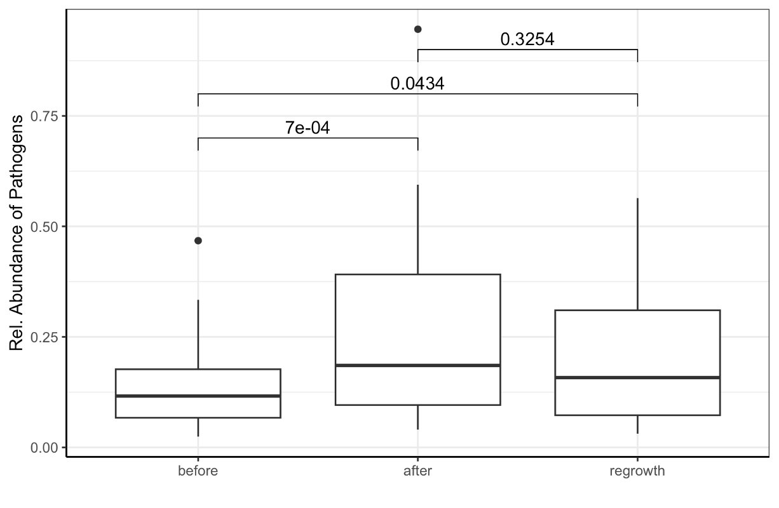
Supplementary Figure 5. Relative abundance of pathogen-containing genera across the growth phases. Bracket values indicate p values from Wilcoxon Rank Sum test.

Supplementary Table 4. Bray-Curtis beta diversity measures between hallway and patient sinks. All are significant and explain 13%-14% of the variance.
Growth | R² | F | p-value
before | 0.144 | 5.71 | 0.001
after | 0.133 | 5.21 | 0.001
regrowth | 0.142 | 5.64 | 0.001

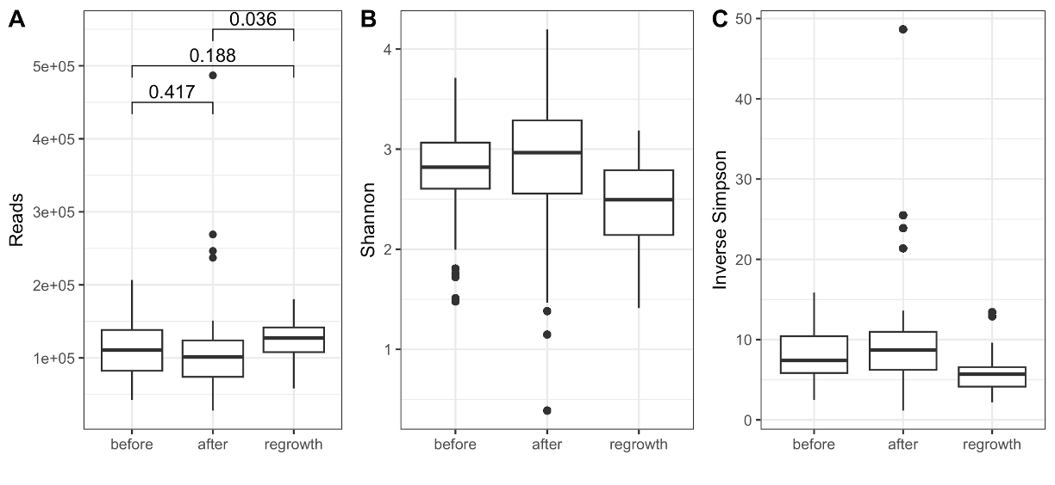
Supplementary Figure 6. Boxplots of (A) number of reads associated with ARGs, as well as (B) Shannon and (C) Inverse Simpson diversity indices measuring ARG diversity across growth phases. There were no significant changes in alpha diversity of ARGs across the study duration.

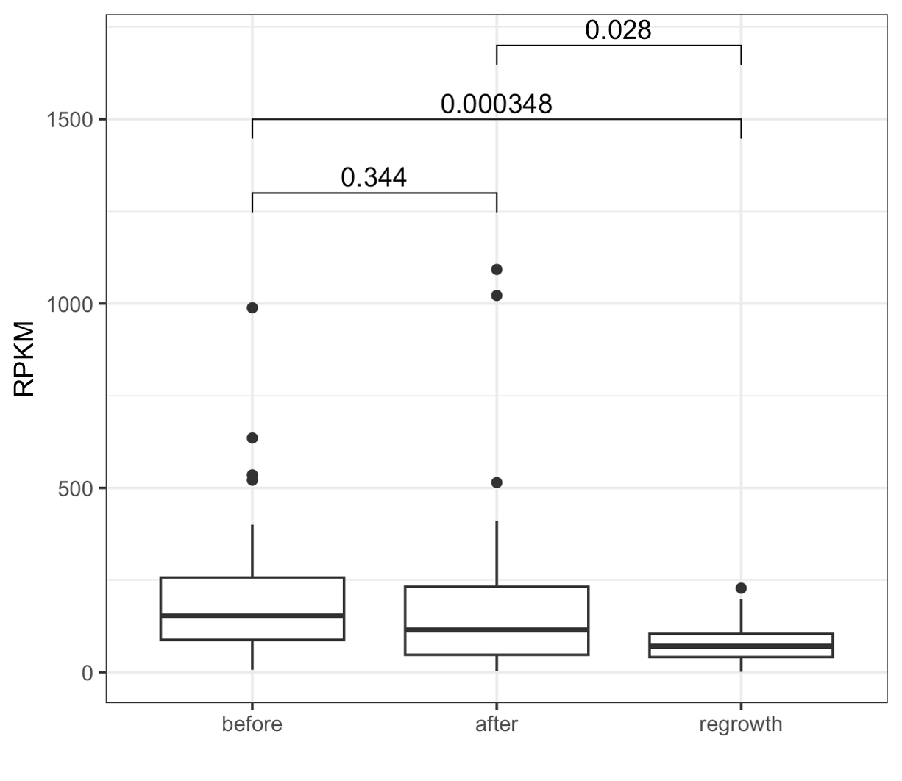
Supplementary Figure 7. Boxplots of abundance of ARGs associated with carbapenem resistance over the experimental phases. Bracket values indicate p values from Wilcoxon Rank Sum test.

Supplementary Table 5. Overview of CARD-assigned drug classes and resistance mechanisms from the annotated ARGs in the long-read sequencing data
Resistance Mechanisms | antibiotic target alteration, antibiotic efflux, antibiotic inactivation, reduced permeability to antibiotic, antibiotic target protection, antibiotic target replacement
Drug Classes | Aminoglycoside antibiotic, Aminocoumarin antibiotic, Carbapenem, Cephalosporin, Diaminopyrimidine antibiotic, Disinfecting agents and antiseptics, Elfamycin antibiotic, Fluoroquinolone antibiotic, Glycylcycline, Glycopeptide antibiotic, Lincosamide antibiotic, Macrolide antibiotic, Monobactam, Nitroimidazole antibiotic, Nitrofuran antibiotic, Nucleoside antibiotic, Peptide antibiotic, Penicillin beta-lactam, Phenicol antibiotic, Phosphonic acid antibiotic, Pleuromutilin antibiotic, Rifamycin antibiotic, Streptogramin antibiotic, Streptogramin A antibiotic, Streptogramin B antibiotic, Sulfonamide antibiotic, Tetracycline antibiotic

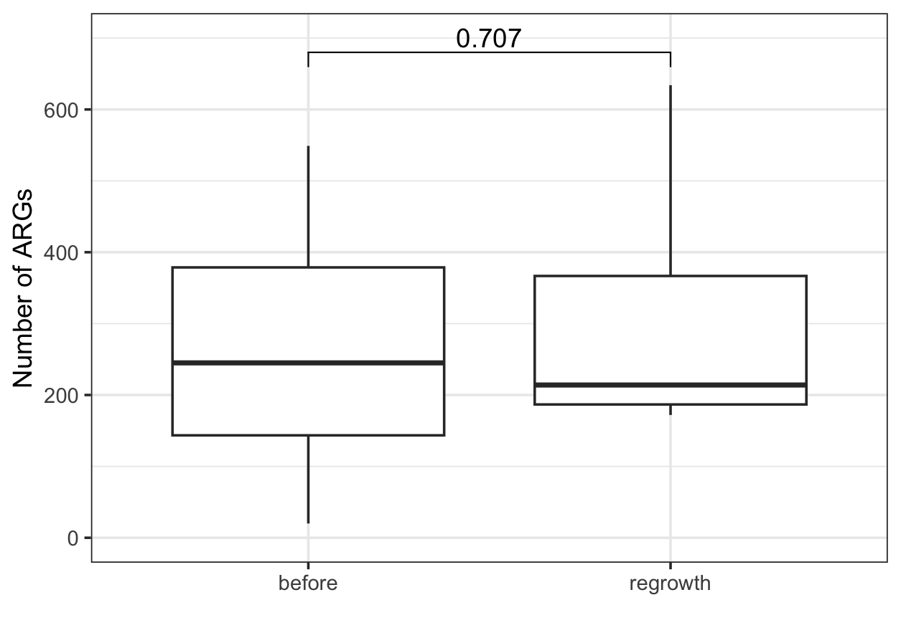
Supplementary Figure 8. Boxplot of the number of ARGs before and after treatment. There were no significant differences as determined by Wilcoxon Rank Sum test, shown above the bracket.

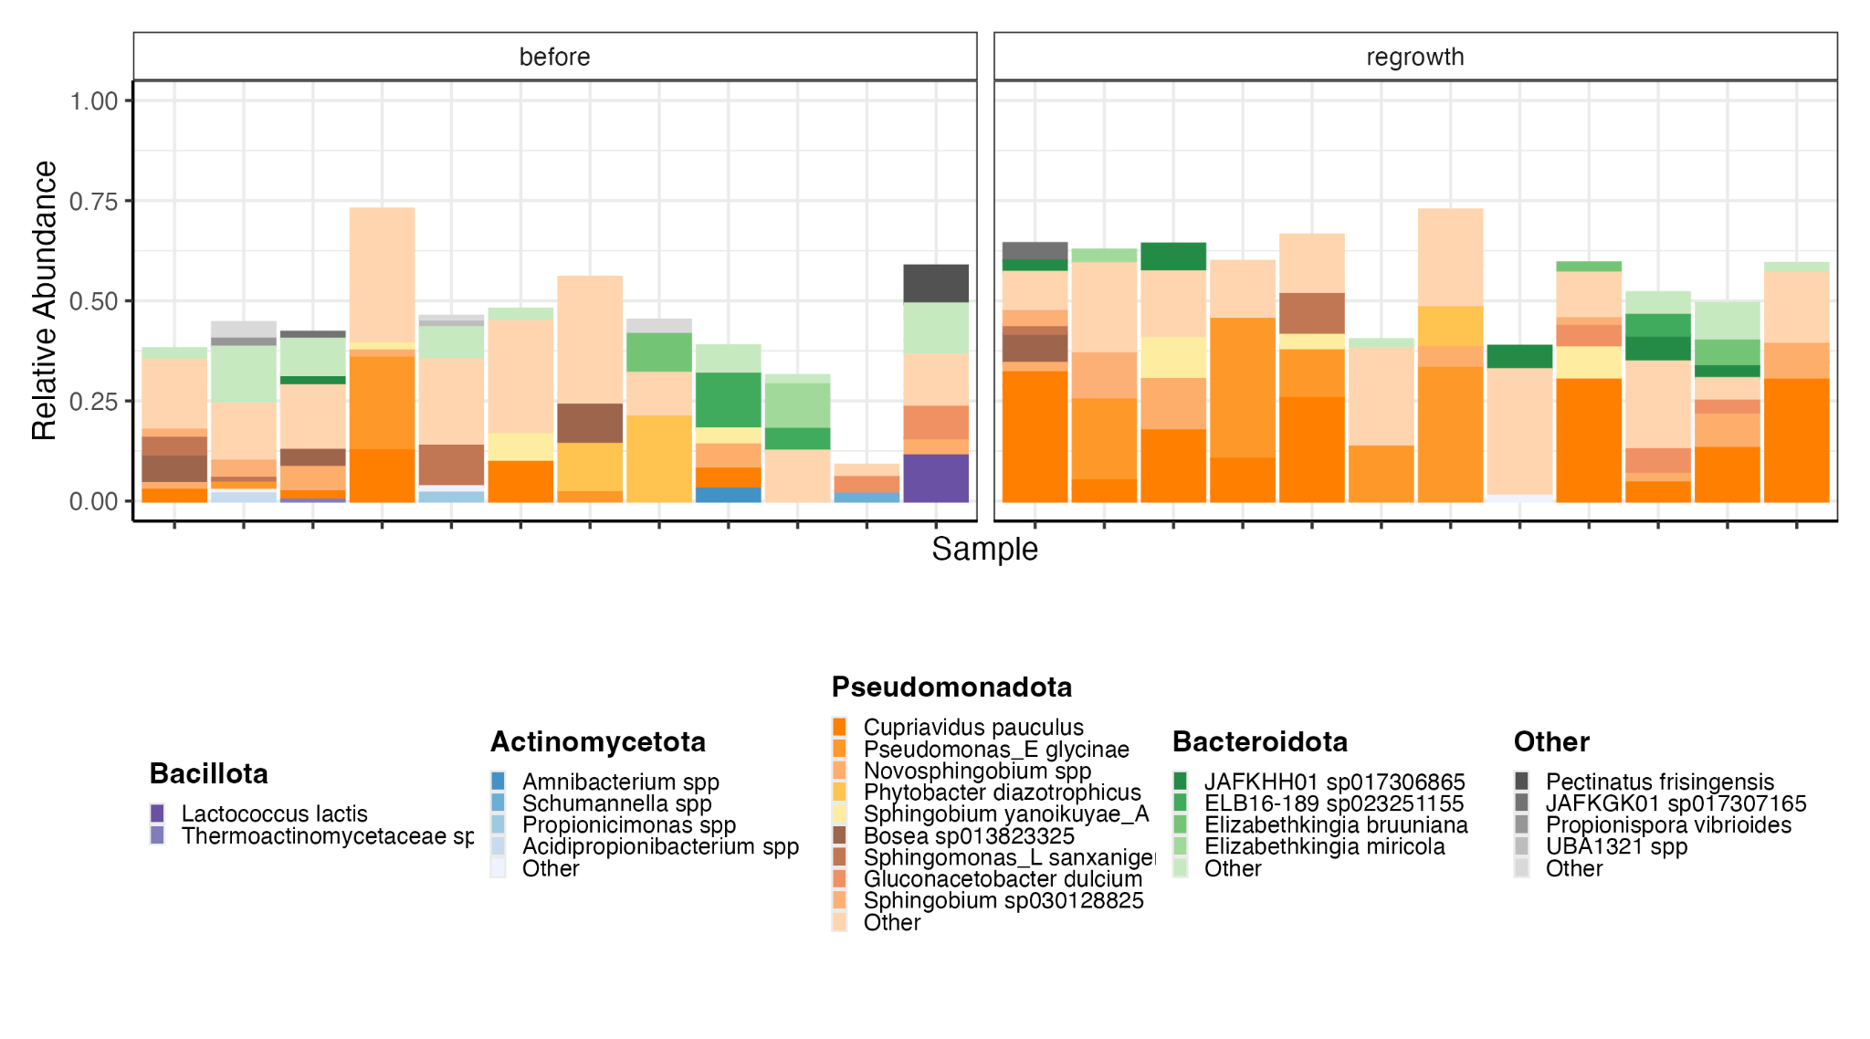
Supplementary Figure 9. Stacked barplot of only the MAGs with ARGs in each sample separated by experimental phase at the species level.

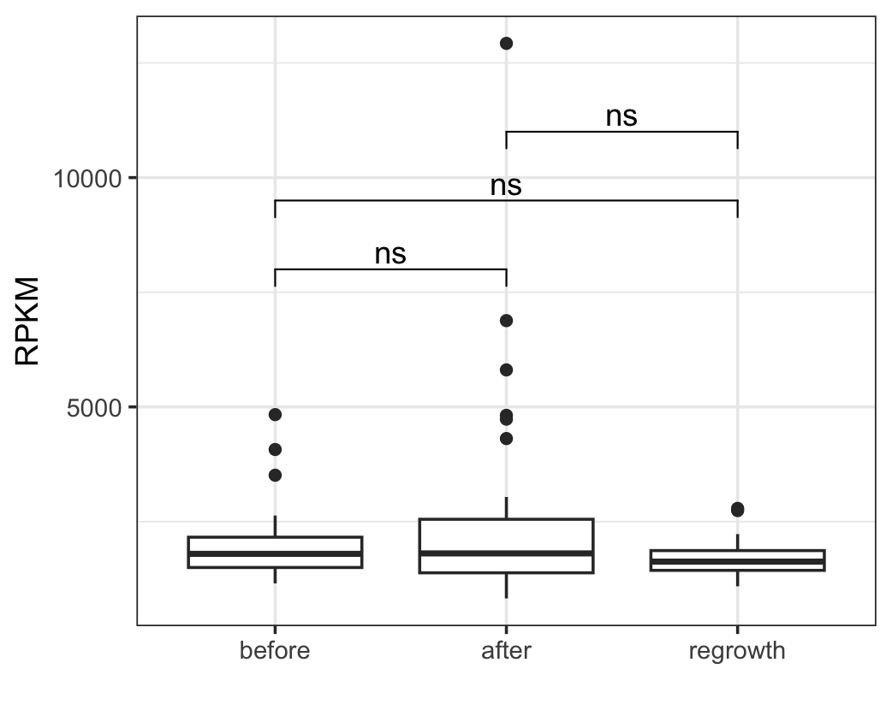
Supplementary Figure 10. Boxplot showing reads per kilobase million (RPKM) of efflux pumps across the study period from the shotgun metagenomic sequencing data. No significant differences (ns) were observed between the experimental phases.

Supplementary Table 6. Description of resistance categories and ARGs associated with them. Carbapenemases included enzymes directly hydrolyzing carbapenem antibiotics, while efflux pumps comprised genes that confer multidrug resistance through exporting antibiotics out of the cell. Porins include outer membrane proteins that can influence drug uptake. Quarternary ammonium compounds (QAC) genes are associated with resistance to disinfectants, and fosfomycin genes confer resistance to fosfomycin, while aminoglycoside-modifying enzymes modify aminoglycosides to reduce their activity. The “other” category captured ARGs not falling into the previous classes, including β-lactamases with specificity outside carbapenems and ARGs with vancomycin resistance.

Resistance type | ARGs
Carbapenemases | OXA-2, OXA-674, SGM-7, SGM-6
Efflux pumps | adeF, acrB, acrD, acrA, emrB, emrR, mdtB, mdtC, smeA, smeD, smeE, smeF, smeR, oqxA, oqxB, marA, baeR, CRP, Pseudomonas aeruginosa soxR, Acinetobacter baumannii AmvA, Acinetobacter baumannii AbaQ, Escherichia coliAcrAB-TolC with MarR mutations conferring resistance to ciprofloxacin and tetracycline, mdeA, leuO
ESBLs/AmpC | BlaB-38, BlaB-34, BlaB-25, BlaB-9, CME-2, CME-3, GOB-23, GOB-29, GOB-13
Porin mutations | OmpA, Klebsiella pneumoniae KpnE, Klebsiella pneumoniae KpnF, Klebsiella pneumoniae KpnG
Aminoglycoside-modifying enzymes | AAC(6′)-IIa, aadS, ANT(2″)-Ia, AAC(6′)-Iv, aadA27, AAC(6′)-Iak, APH(9)-Ic, AAC(6′)-Ib′, AAC(3)-IIIc, aadA
Fosfomycin resistance | Escherichia coli EF-Tu mutants conferring resistance to Pulvomycin, Escherichia coli GlpT with mutation conferring resistance to fosfomycin, Escherichia coli UhpT with mutation conferring resistance to fosfomycin, fosA5, FosA8, FosXCC, FosI
QAC resistance | qacG, qacL, qacJ
Other | vanH gene in vanD cluster, vanT gene in vanG cluster, vanW gene in vanG cluster, vanY gene in vanB cluster, ArnT, eptB, LptD, msbA, nimA, nimJ, PLA-1, PmrF, rsmA, vanG, vanW gene in vanI cluster, EreD, lsaE, tet(X), vanY gene in vanG cluster, vanH gene in vanB cluster, vanY gene in vanM cluster, vanH gene in vanO cluster, ESP-1, ErmF, Mycobacterium tuberculosis rpoC mutations confer resistance to rifampicin, tet(36), vanY gene in vanF cluster, tet(Q), LnuH, sul1, sul2, floR

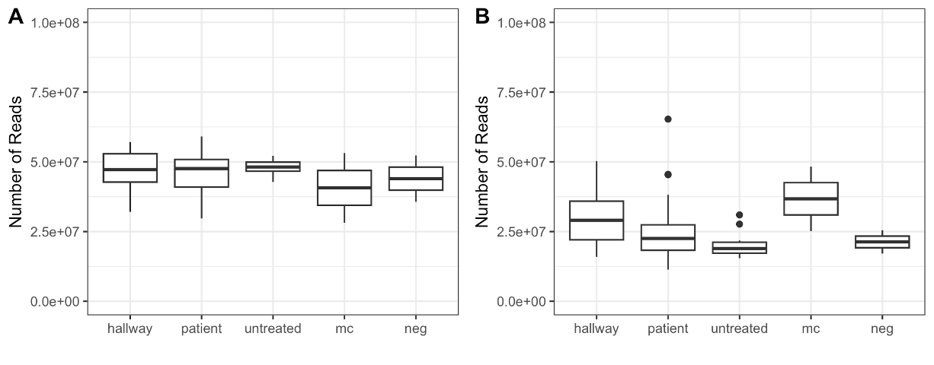
Supplementary Figure 11. Boxplots demonstrating the number of sequencing reads generated (A) before and (B) after filtering which were assigned to only bacteria and removal of contaminants (see methods). Samples were divided into the categories of treated hallway sinks (“hallway”), treated patient room sinks (“patient”), untreated sinks (“untreated”), mock community positive sequencing controls (“mc”), and negative controls (“neg”).

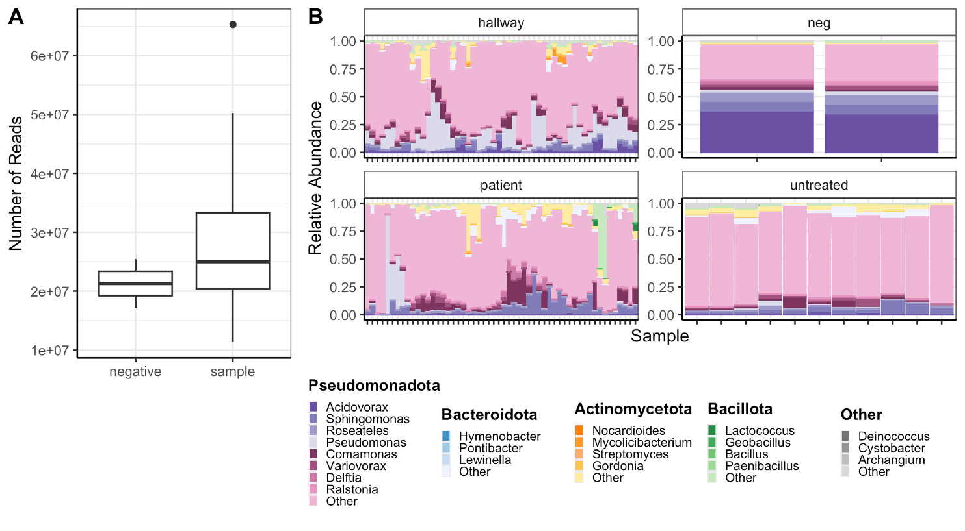
Supplementary Figure 12. (A) Boxplots of the number of reads between the negative controls (n= 2) and biofilm samples (n=119). The difference in reads was not significant (p=0.4) as determined by a permutation test, likely due to unequal group size. (B) Stacked barplots comparing the negative controls to the biological samples. The color scheme was developed based on taxa present in the negative controls, emphasizing contrasts with the biofilm communities.

