Supplementary Table S1 Prognosis-related proteins in HCC.
Protein name | KM | HR | 95%CI | P value*
ACETYLATUBULINLYS40 | 0.000 | 1.574 | (1.108-2.237) | 0.011
S6_pS235S236 | 0.004 | 0.644 | (0.435-0.953) | 0.028
CRAF_pS338 | 0.010 | 0.127 | (0.023-0.696) | 0.017
PAI1 | 0.022 | 1.385 | (1.128-1.700) | 0.002
AKT | 0.024 | 0.619 | (0.393-0.974) | 0.038
S6 | 0.029 | 1.700 | (1.021-2.829) | 0.041
NOTCH1 | 0.034 | 0.207 | (0.067-0.646) | 0.007
BRAF | 0.034 | 1.872 | (1.139-3.079) | 0.013
P27_pT198 | 0.047 | 0.239 | (0.058-0.977) | 0.046
NF2 | 0.048 | 2.212 | (1.032-4.742) | 0.041

Supplementary Table S2 Proteins involved in IPPS model.
Protein name | Coef | HR | 95%CI | P value*
AKT | -0.887 | 0.411 | (0.246-0.688) | 0.000
BRAF | 0.734 | 2.085 | (1.213-3.582) | 0.007
P27_pT198 | -1.837 | 0.159 | (0.032-0.785) | 0.024
Coef: coefficient; HR: Hazard Radio; 95%CI: 95% confidence interval in HR.* P value in Cox regression.

Supplementary Table S3 Protein correlation analysis results.
model proteins | gap-associated protein | cor | P-value | gap-associated protein | cor | P-value
AKT | PTEN | 0.579 | 7.08E-18
AKT | PRDX1 | -0.530 | 1.06E-14
AKT | SMAC | -0.539 | 2.84E-15
BRAF | BRD4 | 0.689 | 3.33E-27 | MSH6 | 0.552 | 4.30E-16
BRAF | BAK | -0.665 | 7.92E-25 | SF2 | -0.552 | 4.59E-16
BRAF | JNK_pT183Y185 | -0.655 | 6.57E-24 | EGFR_pY1068 | -0.548 | 8.81E-16
BRAF | KU80 | 0.651 | 1.55E-23 | RBM15 | 0.544 | 1.40E-15
BRAF | BRCA2 | -0.650 | 1.66E-23 | CMET_pY1235 | -0.538 | 3.19E-15
BRAF | CRAF | 0.631 | 7.86E-22 | SNAIL | -0.536 | 4.19E-15
BRAF | X1433BETA | -0.630 | 1.04E-21 | INPP4B | -0.536 | 4.36E-15
BRAF | ACVRL1 | -0.616 | 1.28E-20 | EIF4G | 0.535 | 5.14E-15
BRAF | FOXO3A_pS318S321 | -0.608 | 6.06E-20 | P70S6K_pT389 | -0.533 | 7.03E-15
BRAF | RB | -0.607 | 6.29E-20 | MAPK_pT202Y204 | -0.533 | 7.14E-15
BRAF | CDK1 | -0.603 | 1.43E-19 | P53 | -0.531 | 8.48E-15
BRAF | RAD51 | -0.602 | 1.72E-19 | CMYC | -0.530 | 1.03E-14
BRAF | ARID1A | 0.601 | 1.82E-19 | DUSP4 | -0.529 | 1.16E-14
BRAF | COG3 | 0.587 | 1.90E-18 | JAB1 | -0.529 | 1.20E-14
BRAF | TSC1 | 0.586 | 2.51E-18 | ARAF_pS299 | -0.524 | 2.45E-14
BRAF | ERALPHA | -0.578 | 9.23E-18 | DIRAS3 | -0.518 | 5.02E-14
BRAF | P90RSK_pT359S363 | -0.577 | 9.88E-18 | X53BP1 | 0.518 | 5.21E-14
BRAF | CD31 | -0.576 | 1.21E-17 | FOXO3A | -0.513 | 9.20E-14
BRAF | S6 | 0.573 | 1.88E-17 | BCL2 | -0.508 | 1.90E-13
BRAF | HEREGULIN | -0.573 | 1.96E-17 | PKCALPHA | 0.505 | 2.68E-13
BRAF | PARPCLEAVED | -0.573 | 2.02E-17 | MTOR | 0.503 | 3.26E-13
BRAF | NRAS | -0.559 | 1.53E-16 | SRC_pY416 | -0.502 | 3.73E-13
BRAF | BRAF_pS445 | 0.558 | 2.02E-16
P27_pT198 | COLLAGENVI | 0.586 | 2.35E-18 | MRE11 | 0.534 | 5.78E-15
P27_pT198 | MEK1_pS217S221 | 0.579 | 7.12E-18 | CMYC | 0.533 | 7.19E-15
P27_pT198 | STATHMIN | 0.564 | 8.14E-17 | MSH6 | -0.509 | 1.59E-13

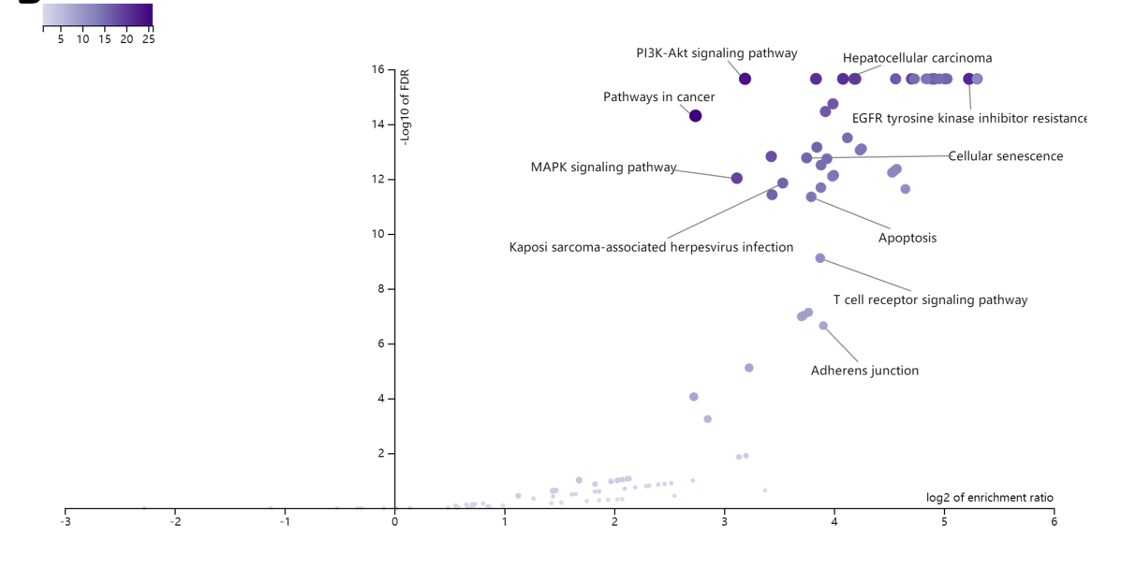
Figure S1 KEGG pathway enrichment analysis showed that signaling pathways such as Hepatocellular carcinoma, PI3k-Akt signaling pathway, and MAPK signaling pathway are associated with prognostic risk model protein-mediated biological regulation.

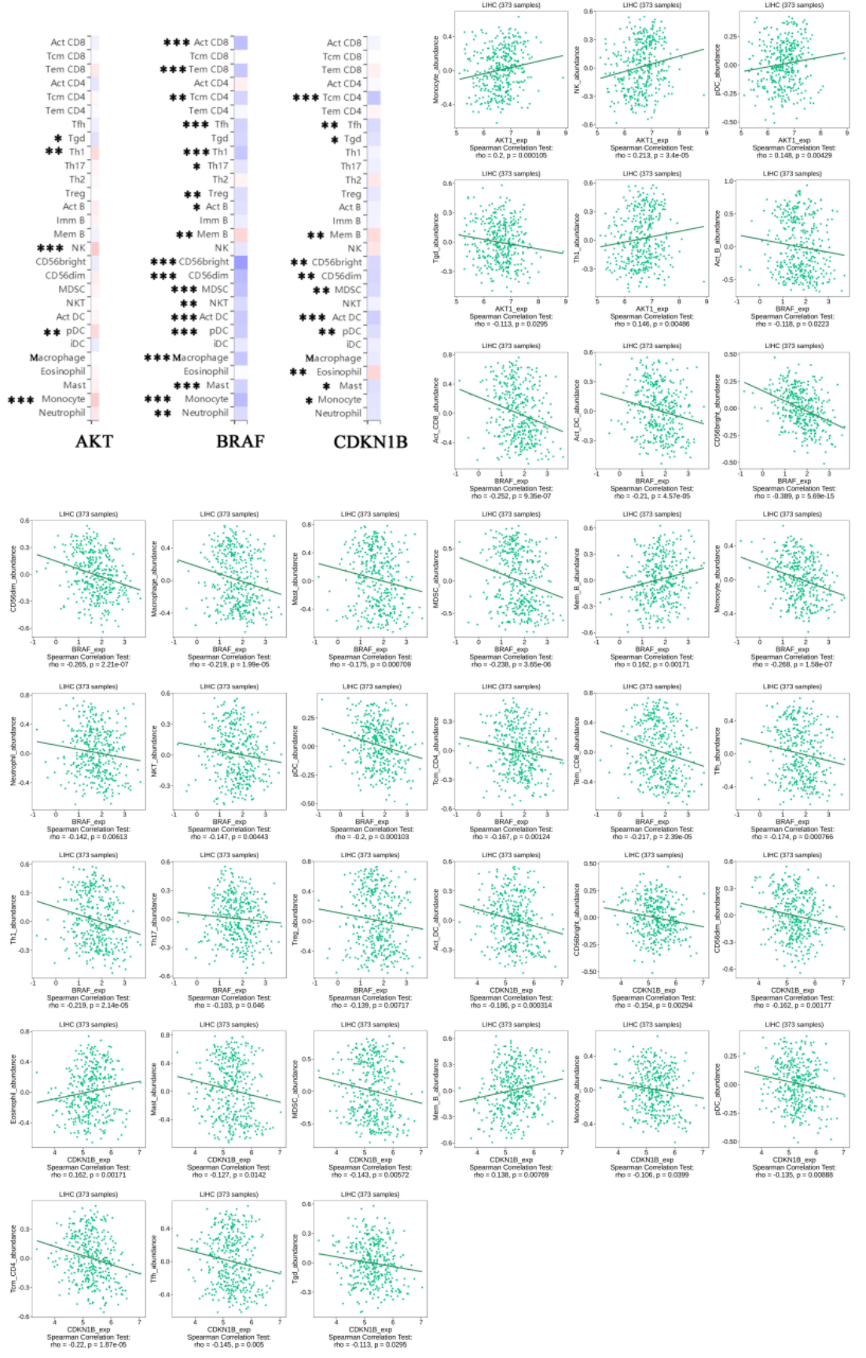

Figure S2 Correlation analysis of prognostic risk model protein expression levels and immune cell subsets in HCC.

Figure S3 Correlation analysis of prognostic risk model protein expression levels and Immunoinhibitor in HCC.

Figure S4 Correlation analysis of prognostic risk model protein expression levels and immune activator in HCC.

Figure S5 Correlation analysis of prognostic risk model protein expression levels and MHC in HCC.

