Table 1. Optimization of the reaction conditions
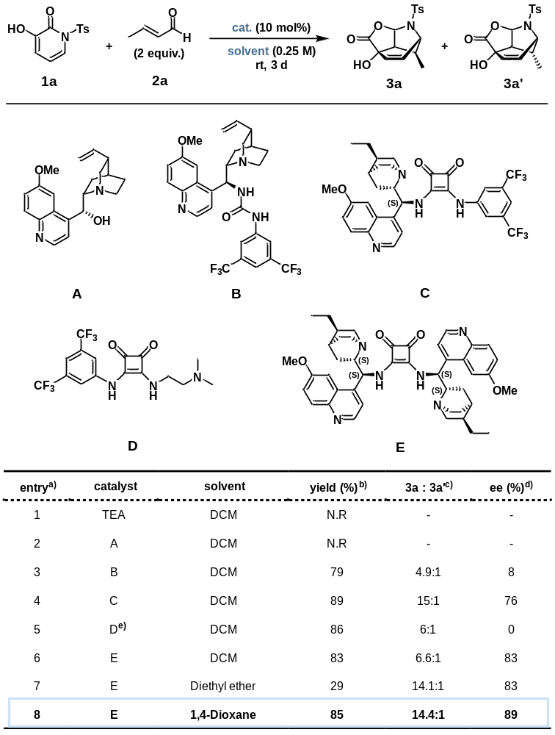
^{a)} Reaction conditions: Reactions were performed with 1a (0.075 mmol), 2a (0.151 mmol), and the catalyst (10 mol%) in the indicated solvent (0.30 mL, 0.25 M) at r.t for 72 h. ^{b)} The yields of 3a were determined by ¹H NMR spectroscopic analysis with 1,2-dibromoethane as an internal standard. ^{c)} The diastereomeric ratio (dr) was determined by spectroscopic analysis. ^{d)} Enantiomeric excess (ee) was determined by HPLC analysis. ^{e)} The reaction was performed at 55 °C for 24 h.
Table 2. Optimization of 3-hydroxy-2-pyridone substrates^{a)}
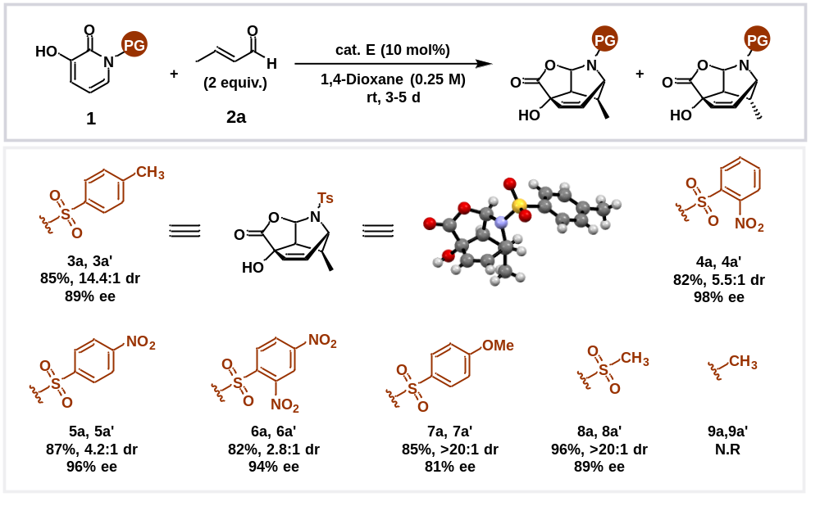^{a)} Reaction conditions: Reactions were performed with 1 (0.084 mmol), 2a (0.169 mmol), and catalyst E (10 mol%) in 1,4-dioxane (0.34 mL, 0.25 M) at r.t. for 3–5 days. The yields of the products were determined by ¹H NMR spectroscopic analysis with 1,2-dibromoethane as an internal standard. The diastereomeric ratio (dr) was determined by spectroscopic analysis. Enantiomeric excess (ee) was determined by HPLC analysis.
Table 3. Substrate scope^{a)}
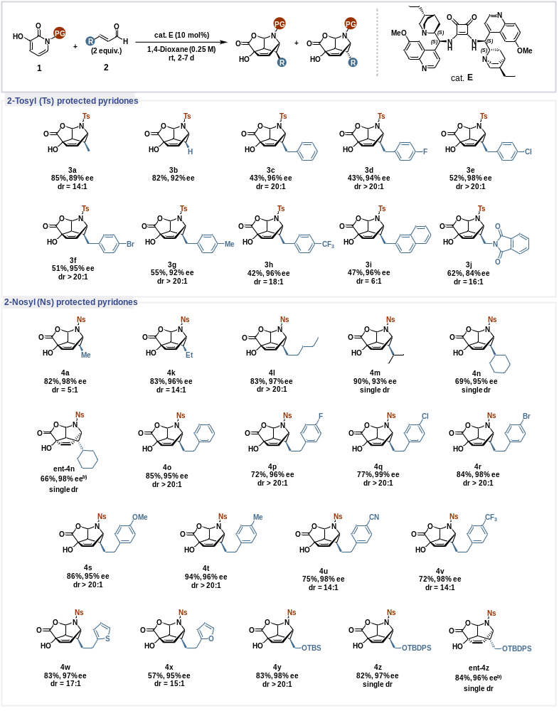^{a)} Reaction conditions: Reactions were performed with 1 (0.084 mmol), 2a (0.169 mmol), and catalyst E (10 mol%) in 1,4- dioxane (0.34 mL, 0.25 M) at r.t. for 5–7 days. The yields of the products were determined by ¹H NMR spectroscopic analysis with 1,2-dibromoethane as an internal standard. The diastereomeric ratio (dr) was determined by spectroscopic analysis. Enantiomeric excess (ee) was determined by HPLC analysis. ^{b)} Reactions were performed with a pseudoenantiomer of catalyst E (10 mol%) under the same conditions (see Table S5).
Table 4. Optimization of the deoxygenation of allylic alcohols.
