Scheme 1. Total Synthesis of (+) peduncularine
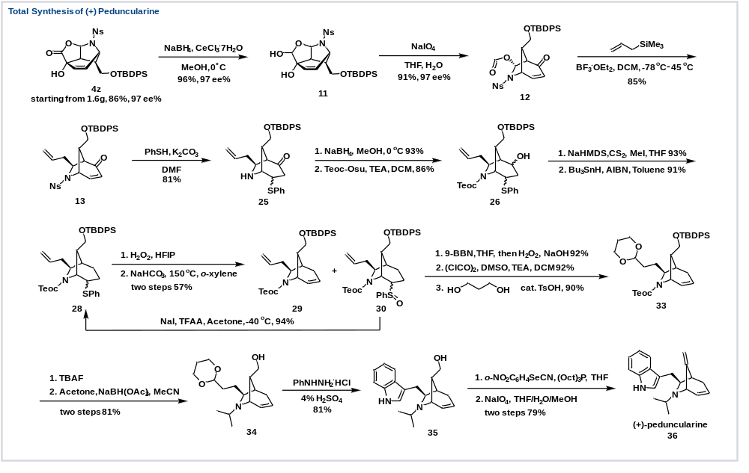 Scheme 2. Synthesis of Δ^{2,3}(+)-peduncularine
