Supplementary Table S1-Locations delimited for the collection of primary data in the Carajás Mineral Province and the criteria applied for the classification of the degree of anthropogenic impact used as a factor used in the analysis of the data collected in May and November 2022.
Basin/ Degree of impact | Location/Code | Specifications
Itacaiúnas/Control | REBIO-Tapirapé Biological Reserve/IRT | A fully-protected conservation unit created by federal decree 97.719 of May 5th, 1989. No direct human interference permitted, except actions aimed at the preservation of the direct environment. This reserve is publicly owned and controlled. Public visitation is allowed for educational purposes, following specific regulations. Scientific research depends on prior authorization and is also regulated.
Itacaiúnas/Control | Águas Claras River/I-RAC | The collection site is within the Campos Ferruginosos National Park, which was created by federal decree on June 5th, 2017. The collection point is located upstream from the mine.
Itacaiúnas /Impacted | Blue River/I-RAZ | A river with reddish water and a large number of illegal mining sites.
 | Gray River/I-RCZ | River bordering active iron, copper, and lead mines
Parauapebas/Control | Rio das Neves/P-RN | Areas isolated from urban centers, mines, and mine tailings (headwaters in the Serra Norte in the case of the Rio das Neves and in the Serra da Bocaina in the case of Porto do Limão).
Parauapebas/Control | Porto do Limão/P-PL
Parauapebas/Impacted | Igarapé Gelado Environmental Protection Area/P-AIG | Although it is a sustainable-use conservation unit, the bodies of water of this area are used to irrigate farmland and deposit mine tailings.
Parauapebas/Impacted | Sossego Mine/P-MS | River that runs through one of the active copper mines in the Carajás Mineral Province.

Supplementary Table S2 – Total abundance of fish species captured per basin (Itacaiúnas and Parauapebas) and location (impacted and control) in Carajás
TAXONOMIC GROUP  (CLASS/ORDER/Family/Species) | ITACAIÚNAS |  |  |  | Subtotal IRB | PARAUAPEBAS |  |  |  | Subtotal PRB | Subtotal control | Subtotal impacted | Subtotal Dry | Subtotal Rainy | TOTAL
TAXONOMIC GROUP  (CLASS/ORDER/Family/Species) | Control |  | Impacted |  | Subtotal IRB | Control |  | Impacted
 | Dry | Rainy | Dry | Rainy | Subtotal IRB | Dry | Rainy | Dry | Rainy
ACTINOPTERYGII
CHARACIFORMES
Anostomidae
Anostomus ternetzi Fernández-Yépez, 1949 | 0 | 0 | 0 | 0 | 0 | 0 | 1 | 0 | 0 | 1 | 1 | 0 | 0 | 1 | 1
Leporinus friderici Bloch, 1974 | 27 | 11 | 3 | 7 | 48 | 3 | 8 | 1 | 0 | 12 | 49 | 11 | 34 | 26 | 60
Leporellus vittatus Valenciennes, 1850 | 1 | 0 | 0 | 0 | 1 | 0 | 0 | 0 | 0 | 0 | 1 | 0 | 1 | 0 | 1
Schizodon vittatus Valenciennes, 1850 | 6 | 2 | 0 | 0 | 8 | 0 | 0 | 0 | 0 | 0 | 8 | 0 | 6 | 0 | 8
Bryconidae
Salminus hilarri Valenciennes, 1850 | 3 | 2 | 0 | 0 | 5 | 3 | 1 | 0 | 0 | 4 | 9 | 0 | 6 | 3 | 9
Characidae
Cynopotamus juruenae Menezes, 1987 | 0 | 0 | 0 | 0 | 0 | 1 | 0 | 0 | 0 | 1 | 0 | 0 | 1 | 0 | 1
Moenkhausia cf. sanctaefilomenae Steindachner, 1907 | 0 | 0 | 0 | 1 | 1 | 0 | 0 | 0 | 0 | 0 | 1 | 0 | 0 | 1 | 1
Ctenoluciidae
Boulengerella cuvieri Spix & Agassiz, 1829 | 0 | 0 | 0 | 0 | 0 | 2 | 4 | 2 | 2 | 10 | 6 | 4 | 4 | 6 | 10
Cynodontidae
Hydrolycus tatauaia Toledo-Piza, Menezes & Santos, 1999 | 33 | 0 | 0 | 0 | 33 | 0 | 0 | 0 | 0 | 0 | 33 | 0 | 33 | 0 | 33
Raphiodon vulpinus Spix & Agassiz, 1829 | 0 | 5 | 0 | 0 | 5 | 0 | 0 | 0 | 0 | 0 | 5 | 0 | 0 | 5 | 5
Erythrinidae
Hoplerythrinus unIRWeniatus Spix & Agassiz, 1829 | 0 | 0 | 0 | 0 | 0 | 0 | 0 | 1 | 0 | 1 | 0 | 1 | 1 | 0 | 1
Hoplias curupira Oyakawa & Mattox, 2009 | 4 | 1 | 0 | 0 | 5 | 1 | 0 | 1 | 3 | 5 | 6 | 4 | 6 | 4 | 10
Hoplias malabaricus Bloch, 1974 | 2 | 0 | 0 | 7 | 9 | 3 | 1 | 6 | 0 | 10 | 6 | 13 | 11 | 8 | 19
Prochilodontidae
Prochilodus nigricans Spix & Agassiz, 1829 | 5 | 0 | 0 | 0 | 5 | 18 | 13 | 28 | 3 | 62 | 36 | 31 | 51 | 16 | 67
Serrasalmidae
Myleus sp. Müller & Troschel, 1844 | 3 | 0 | 0 | 0 | 3 | 9 | 0 | 3 | 0 | 12 | 12 | 3 | 15 | 0 | 15
Myloplus rubripinnis Müller & Troschel, 1844 | 2 | 0 | 1 | 0 | 3 | 7 | 1 | 7 | 0 | 15 | 0 | 0 | 17 | 1 | 18
Pygocentrus nattereri Kner,1858 | 5 | 0 | 0 | 0 | 5 | 2 | 21 | 0 | 0 | 23 | 28 | 0 | 7 | 21 | 28
Serrasalmus brandti Lütken, 1875 | 0 | 0 | 0 | 0 | 0 | 0 | 0 | 1 | 0 | 1 | 0 | 1 | 1 | 0 | 1
Serrasalmus hollandi Eigenmann, 1915 | 7 | 0 | 0 | 0 | 7 | 0 | 1 | 0 | 1 | 2 | 8 | 1 | 7 | 2 | 9
Serrasalmus manueli Fernández-Yépez & Ramírez, 1967 | 5 | 0 | 0 | 1 | 6 | 0 | 0 | 0 | 0 | 0 | 5 | 1 | 5 | 1 | 6
Serrasalmus rhombeus Linnaeus, 1766 | 3 | 4 | 0 | 1 | 8 | 0 | 0 | 1 | 0 | 1 | 7 | 2 | 4 | 5 | 9
Serrasalmus spilopleura Kner,1858 | 5 | 1 | 1 | 17 | 24 |  | 3 | 3 | 1 | 7 | 9 | 22 | 9 | 22 | 31
Triportheidae
Triportheus albus Cope, 1872 | 0 | 0 | 0 | 1 | 1 | 0 | 0 | 0 | 0 | 0 | 0 | 1 | 0 | 1 | 1
Triportheus trifurcatus Castelnau, 1855 | 0 | 0 | 0 | 0 | 0 | 0 | 1 | 0 | 0 | 1 | 1 | 0 | 0 | 1 | 1
CICHLIFORMES
Cichlidae
Aequidens tetramerus Heckel, 1840 | 0 | 0 | 0 | 0 | 0 | 0 | 0 | 1 | 0 | 1 | 5 | 1 | 1 | 5 | 1
Cichla ocellaris Bloch & Schneider, 1801 | 0 | 0 | 0 | 0 | 0 | 1 | 0 | 0 | 0 | 1 | 1 | 0 | 1 | 0 | 1
Crenicichla lepidota Heckel, 1840 | 2 | 0 | 1 | 0 | 3 | 0 | 2 | 3 | 0 | 5 | 4 | 4 | 6 | 2 | 8
Crenicichla ocutirostris Günther, 1862 | 0 | 0 | 0 | 0 | 0 | 1 | 0 | 0 | 0 | 1 | 1 | 0 | 1 | 0 | 1
Crenicichla sp. Heckel, 1840 | 0 | 3 | 0 | 0 | 3 | 0 | 0 | 0 | 1 | 3 | 3 | 1 | 0 | 4 | 6
Geophagus neambi Lucena & Assis, 2010 | 1 | 7 | 1 | 0 | 9 | 2 | 0 | 0 | 10 | 12 | 10 | 11 | 4 | 17 | 21
Heros severus Heckel, 1840 | 0 | 0 | 0 | 0 | 0 | 0 | 1 | 0 | 0 | 1 | 1 | 0 | 0 | 1 | 1
Retroculus lapidifer Castelnau, 1855 | 0 | 2 | 0 | 0 | 2 | 2 | 0 | 0 | 16 | 18 | 4 | 16 | 2 | 18 | 20
Satanoperca jurupari Heckel, 1840 | 0 | 0 | 0 | 0 | 0 | 0 | 1 | 90 | 10 | 100 | 1 | 100 | 90 | 11 | 101
Satanoperca sp. Günther, 1862 | 0 | 0 | 0 | 0 | 0 | 0 | 0 | 0 | 23 | 23 | 0 | 23 | 0 | 23 | 23
CLUPEIFORMES
Pristigasteridae
Pellona castelnaeana Valenciennes, 1847 | 5 | 0 | 0 | 0 | 5 | 0 | 0 | 0 | 0 | 0 | 5 | 0 | 5 | 0 | 5
Pellona flavipinnis Valenciennes, 1837 | 0 | 1 | 0 | 0 | 1 | 0 | 0 | 0 | 0 | 0 | 1 | 0 | 0 | 1 | 1
GYMNOTIFORMES
Gymnotidae
Electrophorus electricus Linnaeus, 1766 | 0 | 0 | 0 | 0 | 0 | 0 | 0 | 0 | 1 | 1 | 0 | 1 | 0 | 1 | 1
Sternopygidae
Eigenmannia sp. Jordan & Evermann, 1896 | 1 | 28 | 3 | 26 | 58 | 0 | 0 | 0 | 11 | 11 | 29 | 40 | 4 | 65 | 69
Sternopygus macrurus Bloch & Schneider, 1801 | 0 | 0 | 0 | 2 | 2 | 0 | 0 | 0 | 0 | 0 | 0 | 2 | 0 | 2 | 2
OSTEOGLOSSIFORMES
Osteoglossidae
Osteoglossum bicirrhosum Cuvier, 1829 | 1 | 0 | 0 | 0 | 1 | 0 | 0 | 0 | 0 | 0 | 1 | 0 | 1 | 0 | 1
PERCIFORMES
Pomacentridae
Tometes sp. Valenciennes, 1850 | 0 | 0 | 0 | 0 | 0 | 1 | 0 | 0 | 0 | 1 | 1 | 0 | 1 | 0 | 1
Scianidae
Plagioscion squamosissimus Heckel, 1840 | 29 | 3 | 0 | 0 | 32 | 0 | 1 | 0 | 0 | 1 | 33 | 0 | 29 | 4 | 33
SILURIFORMES
Auchenipteridae
Ageneiosus apiaka Ribeiro, RappPy-Daniel & Walsh, 2017 | 1 | 0 | 0 | 0 | 1 | 0 | 1 | 0 | 0 | 1 | 2 | 0 | 1 | 1 | 2
Ageneiosus inemis Linnaeus, 1766 | 64 | 0 | 0 | 1 | 65 | 3 | 1 | 0 | 0 | 4 | 68 | 1 | 67 | 2 | 69
Auchenipterus nuchalis Spix & Agassiz, 1829 | 0 | 0 | 0 | 0 | 0 | 1 | 0 | 0 | 0 | 1 | 1 | 0 | 0 | 0 | 1
Trachelyopterus galeatus Linnaeus, 1766 | 0 | 0 | 0 | 1 | 1 | 0 | 0 | 0 | 0 | 0 | 0 | 1 | 1 | 0 | 1
Heptapteridae
Leptorhamdia sp. Eigenmann, 1918 | 0 | 0 | 0 | 1 | 1 | 0 | 0 | 0 | 0 | 0 | 0 | 1 | 0 | 1 | 1
Loricariidae
Baryancistrus sp. RappPy-Daniel, 1989 | 2 | 0 | 0 | 0 | 2 | 1 | 0 | 0 | 0 | 1 | 3 | 0 | 3 | 0 | 3
Farlowella smithi Fowler, 1913 | 0 | 2 | 0 | 1 | 3 | 0 | 0 | 0 | 0 | 0 | 2 | 1 | 0 | 3 | 3
Hypostomus cochliodon Kner,1854 | 0 | 0 | 0 | 1 | 1 | 0 | 0 | 0 | 0 | 0 | 0 | 1 | 0 | 1 | 1
Hypostomus paucipunctatus Hollanda Carvalho & Weber, 2005 | 0 | 1 | 0 | 0 | 1 | 0 | 0 | 0 | 0 | 0 | 1 | 0 | 0 | 1 | 1
Hypostomus plecostomus Linnaeus, 1758 | 1 | 0 | 4 | 0 | 5 | 10 | 0 | 1 | 1 | 12 | 11 | 6 | 16 | 1 | 17
Hypostomus punctatus Valenciennes, 1840 | 0 | 0 | 0 | 1 | 1 | 0 | 0 | 0 | 8 | 8 | 0 | 9 | 0 | 9 | 9
Squaliforma emarginata Valenciennes, 1840 | 0 | 0 | 1 | 0 | 1 | 1 | 0 | 0 | 0 | 1 | 1 | 1 | 2 | 0 | 2
Pimelodidae
Hemisorubim platyrhynchos Valenciennes, 1840 | 3 | 0 | 0 | 0 | 3 | 2 | 0 | 0 | 1 | 3 | 5 | 1 | 5 | 1 | 6
Pimelodus sp. Lacépède, 1803 | 0 | 0 | 0 | 0 | 0 | 0 | 1 | 0 | 0 | 1 | 1 | 0 | 0 | 1 | 1
Sorubim trigonocephalus Miranda Ribeiro, 1920 | 0 | 2 | 0 | 0 | 2 | 0 | 1 | 0 | 0 | 1 | 3 | 0 | 0 | 3 | 3
TETRAODONTIFORMES
Tetraodontidae
Colomesus tocantinensis Amaral, Brito, Silva & Carvalho, 2013 | 0 | 0 | 0 | 0 | 0 | 0 | 1 | 0 | 0 | 1 | 1 | 0 | 0 | 1 | 1
CHONDRICHTHYES
MYLIOBATIFORMES
Potamotrygonidae
Potamotrygon orbignyi Castelnau, 1855 | 0 | 0 | 0 | 0 | 0 | 0 | 0 | 0 | 1 | 1 | 0 | 1 | 1 | 0 | 1
TOTAL |  |  |  |  |  |  |  |  |  |  |  |  |  |  | 766

Supplementary Table S3. Final GAMLSS model of the total abundance of the fish assemblage as a function of the season, area, basin, and the interactions of these factors in the Carajás Mineral Province, northern Brazil. Legend: AIC = Akaike Information Criterion; R² = Coefficient of Determination. Values in bold script indicate significance differences (p < 0.05).

Univariate model: Abundance ~ 1, sigma.formula= ~ Season; Family: Binomial Negative type I; AIC= 317.361; R²= 25.64%.
Mu coefficient | Estimate | Standard Error | t | p
Intercept | 2.6203 | 0.2144 | 12.22 | 3.38e-16
Sigma coefficient | Estimate | Standard Error | t | p
Intercept | 0.2073 | 0.2605 | 0.796 | 0.4301
Rainy season | 1.7508 | 0.4538 | 3.858 | 0.0003

Supplementary Table S4. Results of the PERMANOVA applied to the fish beta diversity, which evaluates the effects of season, area, basin, and their interactions (season:basin; area:basin) in the Carajás Mineral Province in May and November 2022. R² = Coefficient of Determination; F = Fisher’s test; p = probability. Significant results (p < 0.05) are shown in bold script.

Univariate model:Beta diversity ~ Season + Area + Basin + Season:Basin + Area:Basin; Permutations = 9.999; P adjusted method = Bonferroni.
Variable | Degrees of Freedom | R² (%) | F | p
Season | 1 | 2.75 | 0.8905 | 0.5700
Area | 1 | 3.69 | 1.1939 | 0.2680
Basin | 1 | 6.69 | 2.1639 | 0.0112
Season:Basin | 1 | 1.46 | 0.4731 | 0.9535
Area:Basin | 1 | 4.89 | 1.5815 | 0.0744
Residuals | 26 | 80.48

Supplementary Table S5 – Species Contributions to Beta Diversity (SCBD) of the fish assemblage of the Carajás Mineral Province in May and November 2022. Values in bold script indicate a significant difference in the SCBD, and * indicates the highest value in the comparison.
Species | Season |  | Area |  | Basin
Species | Rainy | Dry | Control | Impacted | IRB | PRB
Aequidens tetramerus | 0.0176 | 0.0009 | 0.0184 | 0.0009 | 0.0245 | 0.0006
Ageneiosus apiaka | 0.0051 | 0.0005 | 0.0056 | 0.0000 | 0.0004 | 0.0059
Ageneiosus inermis | 0.0128 | 0.0408 | 0.0280 | 0.0172 | 0.0458 | 0.0054
Anostomus ternetzi | 0.0140 | 0.0000 | 0.0147 | 0.0000 | 0.0000 | 0.0162
Auchenipterus nuchalis | 0.0000 | 0.0013 | 0.0015 | 0.0000 | 0.0000 | 0.0009
Baryancistrus sp. | 0.0000 | 0.0024 | 0.0015 | 0.0000 | 0.0009 | 0.0009
Boulengerella cuvieri | 0.0112 | 0.0059 | 0.0133 | 0.0058 | 0.0000 | 0.0172
Cichla ocellaris | 0.0000 | 0.0013 | 0.0008 | 0.0000 | 0.0000 | 0.0009
Colomesus tocantinensis | 0.0024 | 0.0000 | 0.0025 | 0.0000 | 0.0000 | 0.0028
Crenicichla lepidota | 0.0281 | 0.0210 | 0.0317 | 0.0164 | 0.0163 | 0.0338
Crenicichla ocutirostris | 0.0000 | 0.0919 | 0.0591* | 0.0001 | 0.0000 | 0.0650
Crenicichla sp. | 0.0106 | 0.0000 | 0.0104 | 0.0014 | 0.0138 | 0.0010
Cynopotamus juruenae | 0.0000 | 0.0013 | 0.0008 | 0.0000 | 0.0000 | 0.0009
Eigenmannia sp. | 0.1320* | 0.0473 | 0.0559 | 0.1652* | 0.1700* | 0.0446
lectrophorus electricus | 0.0035 | 0.0000 | 0.0000 | 0.0053 | 0.0000 | 0.0040
Farlowella smithi | 0.0054 | 0.0000 | 0.0039 | 0.0028 | 0.0075 | 0.0000
Geophagus neambi | 0.0454 | 0.0127 | 0.0316 | 0.0398 | 0.0462 | 0.0259
Hemisorubim platyrhynchos | 0.0009 | 0.0056 | 0.0036 | 0.0014 | 0.0027 | 0.0028
Heros severus | 0.0051 | 0.0000 | 0.0053 | 0.0000 | 0.0000 | 0.0059
Hoplerythrinus unIRBeniatus | 0.0000 | 0.0017 | 0.0000 | 0.0016 | 0.0000 | 0.0012
Hoplias curupira | 0.0133 | 0.0535 | 0.0101 | 0.0565 | 0.0127 | 0.0431
Hoplias malabaricus | 0.0390 | 0.0721 | 0.0458 | 0.0601 | 0.0520 | 0.0530
Hydrolycus tatauaia | 0.0000 | 0.0326 | 0.0211 | 0.0000 | 0.0279 | 0.0000
Hypostomus cochliodon | 0.0070 | 0.0000 | 0.0000 | 0.0107 | 0.0098 | 0.0000
Hypostomus paucipunctatus | 0.0033 | 0.0000 | 0.0034 | 0.0000 | 0.0046 | 0.0000
Hypostomus plecostomus | 0.0035 | 0.0527 | 0.0089 | 0.0427 | 0.0350 | 0.0138
Hypostomus punctatus | 0.0090 | 0.0000 | 0.0000 | 0.0137 | 0.0026 | 0.0086
Leporinus friderici | 0.0809 | 0.1597* | 0.1207 | 0.0980 | 0.1365* | 0.0832
Leporinus vittatus | 0.0000 | 0.0005 | 0.0003 | 0.0000 | 0.0004 | 0.0000
Leptorhamdia sp. | 0.0070 | 0.0000 | 0.0000 | 0.0107 | 0.0098 | 0.0000
Moenkhausia cf. sanctaefilomenae | 0.0070 | 0.0000 | 0.0000 | 0.0107 | 0.0098 | 0.0000
Myleus sp. | 0.0000 | 0.0177 | 0.0087 | 0.0048 | 0.0014 | 0.0117
Myloplus rubripinnis | 0.0046 | 0.0293 | 0.0110 | 0.0198 | 0.0094 | 0.0189
Osteoglossum bicirrhosum | 0.0000 | 0.0005 | 0.0003 | 0.0000 | 0.0004 | 0.0000
Pellona castelnaeana | 0.0000 | 0.0043 | 0.0028 | 0.0000 | 0.0037 | 0.0000
Pellona flavipinnis | 0.0046 | 0.0000 | 0.0049 | 0.0000 | 0.0075 | 0.0000
Pimelodus sp. | 0.0563 | 0.0000 | 0.0591 | 0.0000 | 0.0000 | 0.0650*
Plagioscion squamosissimus | 0.0160 | 0.0209 | 0.0282 | 0.0000 | 0.0352 | 0.0028
Potamotrygon orbignyi | 0.0000 | 0.0017 | 0.0000 | 0.0016 | 0.0000 | 0.0012
Prochilodus nigricans | 0.0450 | 0.1504* | 0.1068 | 0.0483 | 0.0065 | 0.0000
Pygocentrus nattereri | 0.1198 | 0.0053 | 0.1265* | 0.0000 | 0.0024 | 0.1360*
Raphiodon vulpinus | 0.0234 | 0.0000 | 0.0246 | 0.0000 | 0.0327 | 0.0000
Retroculus lapidifer | 0.0367 | 0.0027 | 0.0084 | 0.0483 | 0.0092 | 0.0376
Salminus hilarii | 0.0263 | 0.0159 | 0.0356 | 0.0000 | 0.0405 | 0.0079
Satanoperca jurupari | 0.0228 | 0.0870* | 0.0053 | 0.1034* | 0.0000 | 0.0818*
Satanoperca sp. | 0.0215 | 0.0000 | 0.0000 | 0.0329 | 0.0000 | 0.0249
Schizodon vittatus | 0.0066 | 0.0034 | 0.0088 | 0.0000 | 0.0117 | 0.0000
Serrasalmus brandtii | 0.0000 | 0.0017 | 0.0000 | 0.0016 | 0.0000 | 0.0012
Serrasalmus hollandi | 0.0032 | 0.0040 | 0.0049 | 0.0014 | 0.0034 | 0.0037
Serrasalmus manueli | 0.0031 | 0.0093 | 0.0060 | 0.0047 | 0.0117 | 0.0000
Serrasalmus rhombeus | 0.0194 | 0.0047 | 0.0154 | 0.0119 | 0.0283 | 0.0012
Serrasalmus spilopleura | 0.0678 | 0.0210 | 0.0205 | 0.0944 | 0.0939* | 0.0155
Sorubim trigonocephalus | 0.0139 | 0.0000 | 0.0146 | 0.0000 | 0.0130 | 0.0059
Squaliforma emarginata | 0.0000 | 0.0112 | 0.0008 | 0.0095 | 0.0087 | 0.0009
Sternopygus macrurus | 0.0134 | 0.0000 | 0.0000 | 0.0204 | 0.0187 | 0.0000
Tometes sp. | 0.0000 | 0.0013 | 0.0008 | 0.0000 | 0.0000 | 0.0009
Trachelyopterus galeatus | 0.0112 | 0.0000 | 0.0000 | 0.0172 | 0.0157 | 0.0000
Triportheus albus | 0.0112 | 0.0000 | 0.0000 | 0.0172 | 0.0157 | 0.0000
Triportheus trifurcatus | 0.0051 | 0.0000 | 0.0053 | 0.0000 | 0.0000 | 0.0059

Supplementary S6. Biological Collection License from SISBIO (Biodiversity Authorization and Information System)
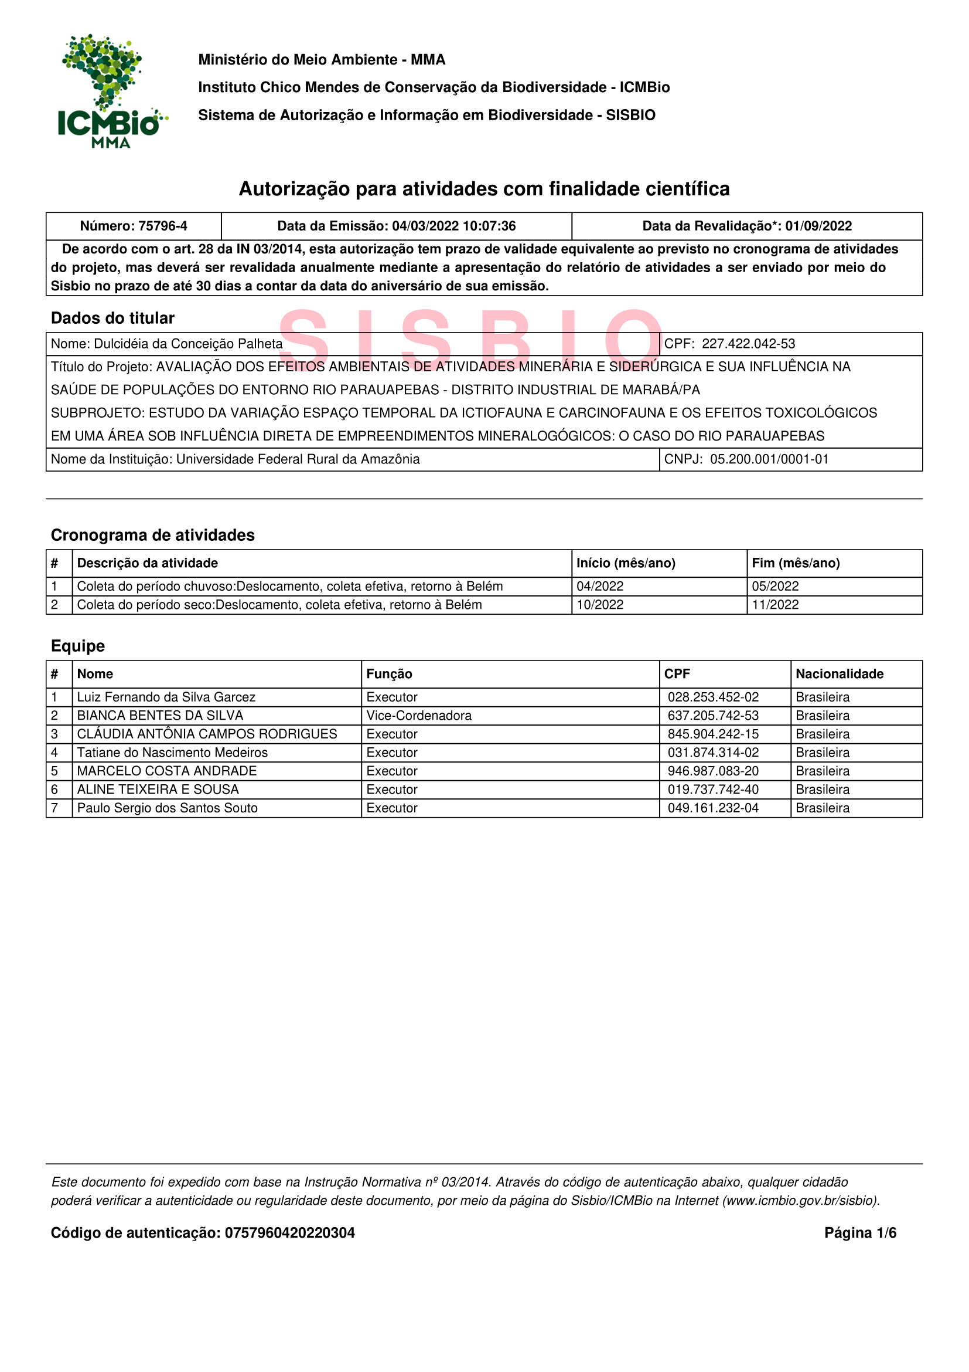

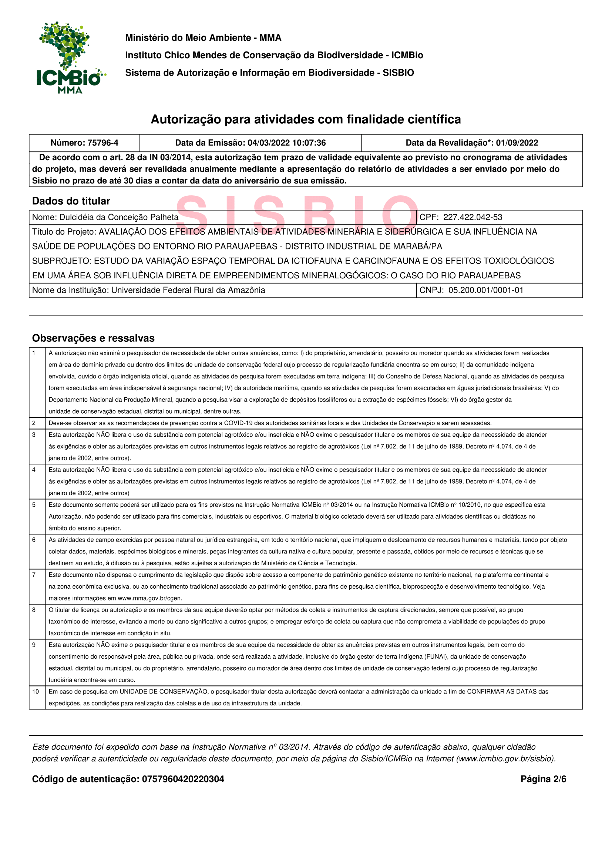
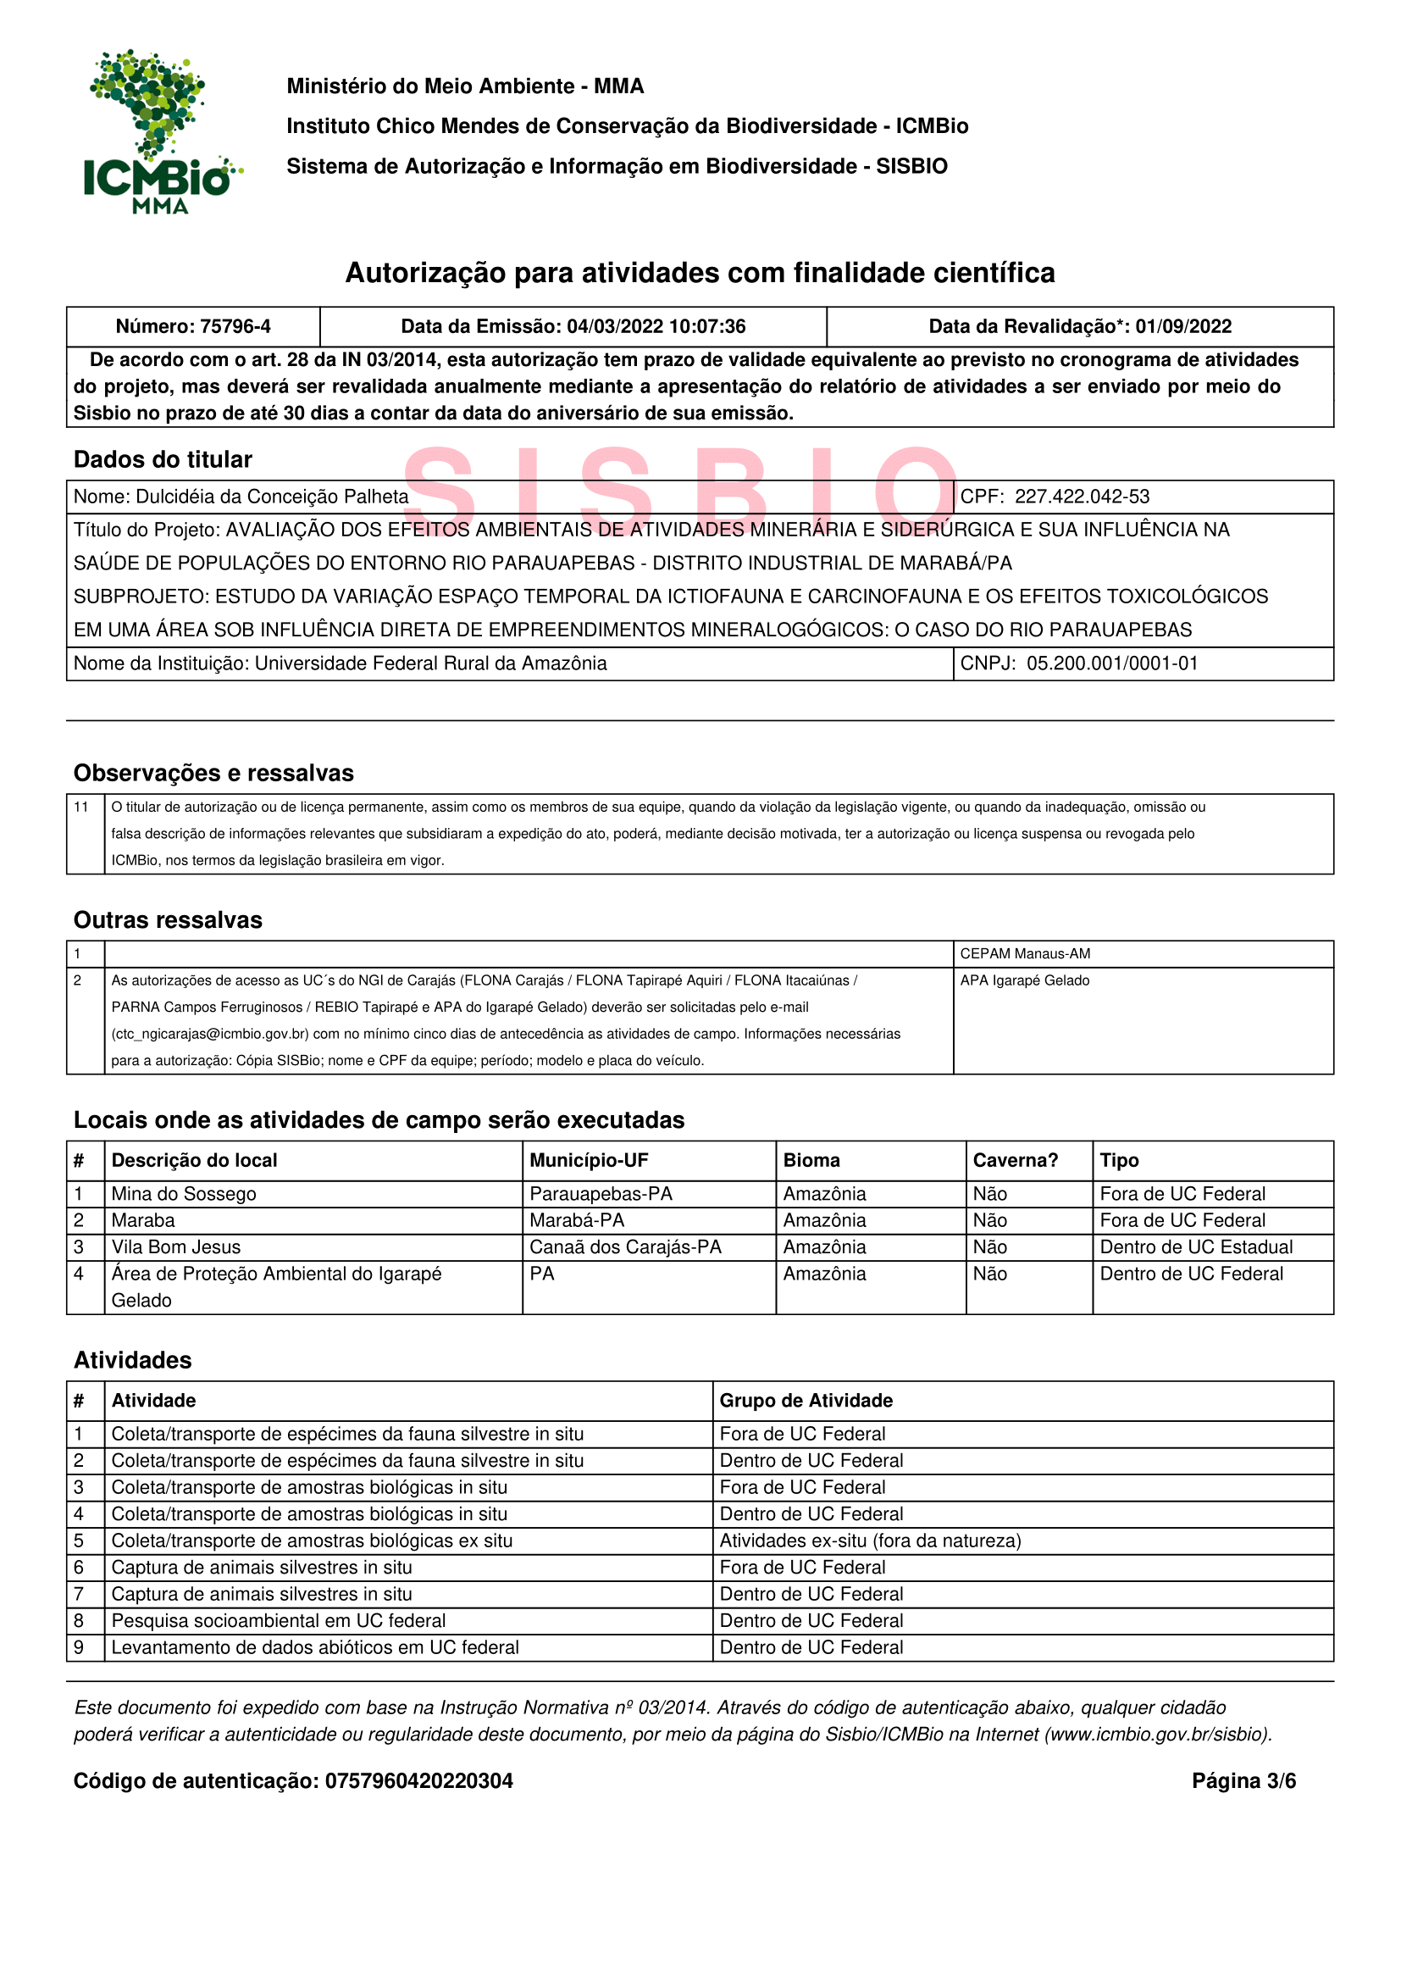
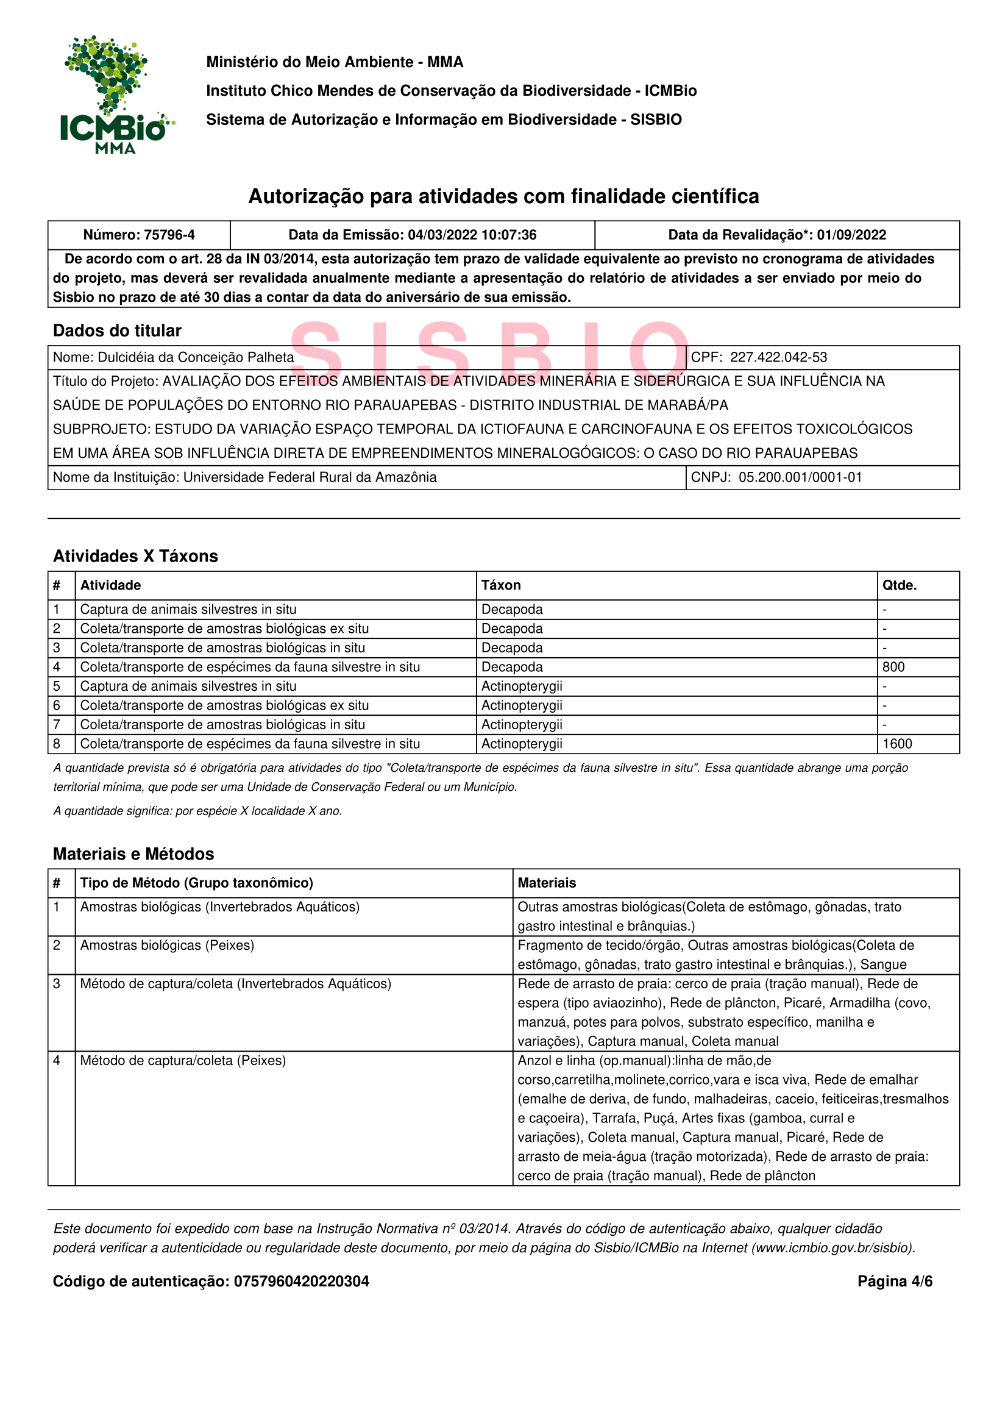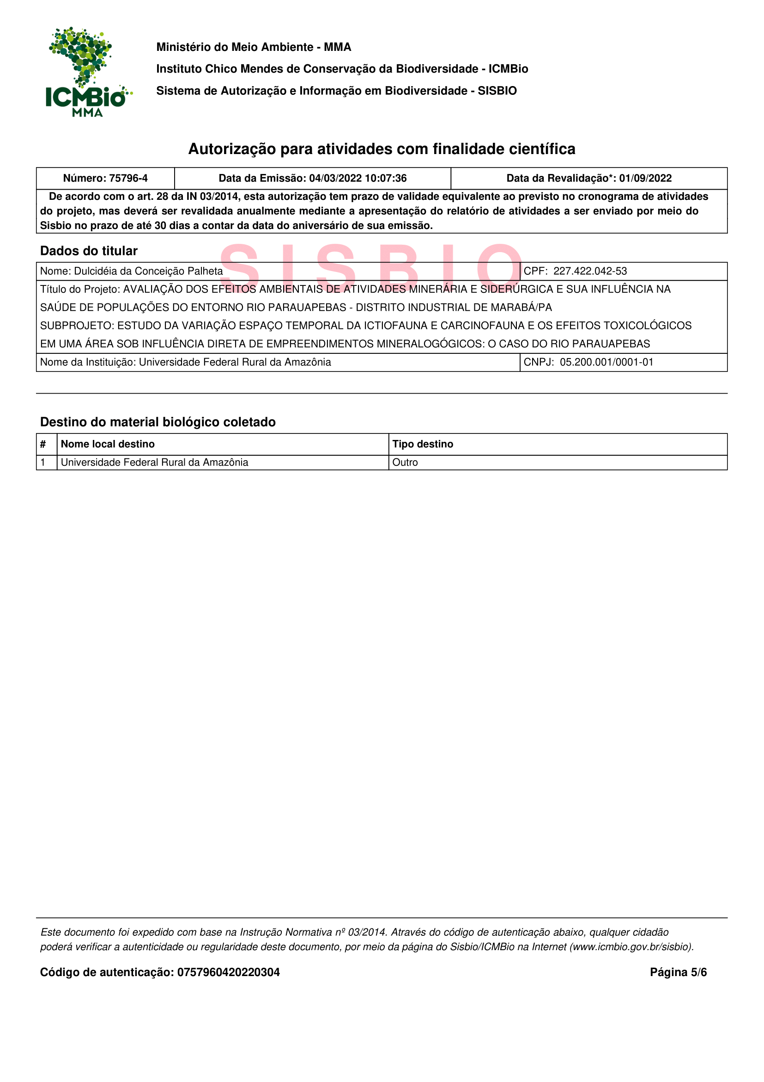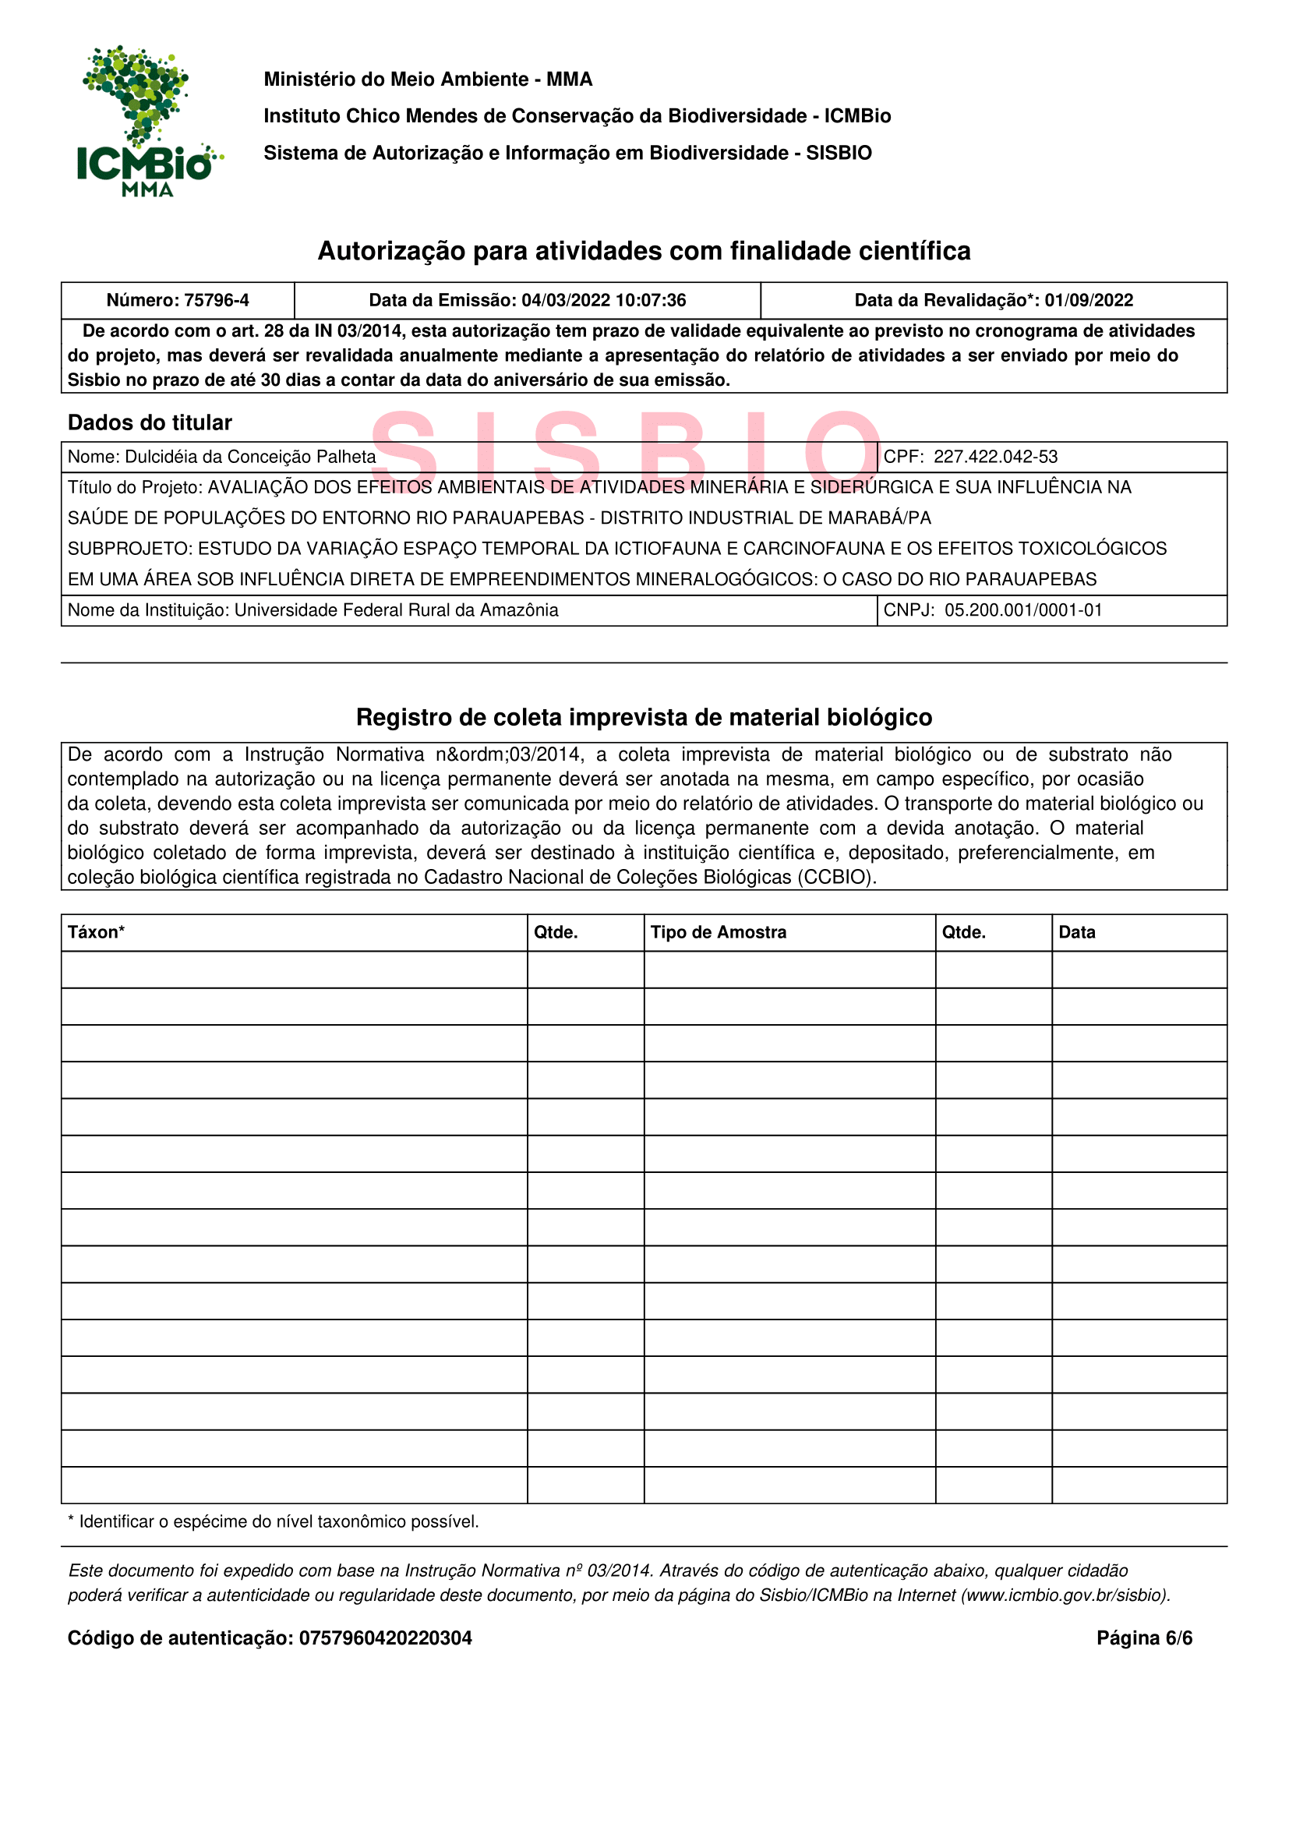

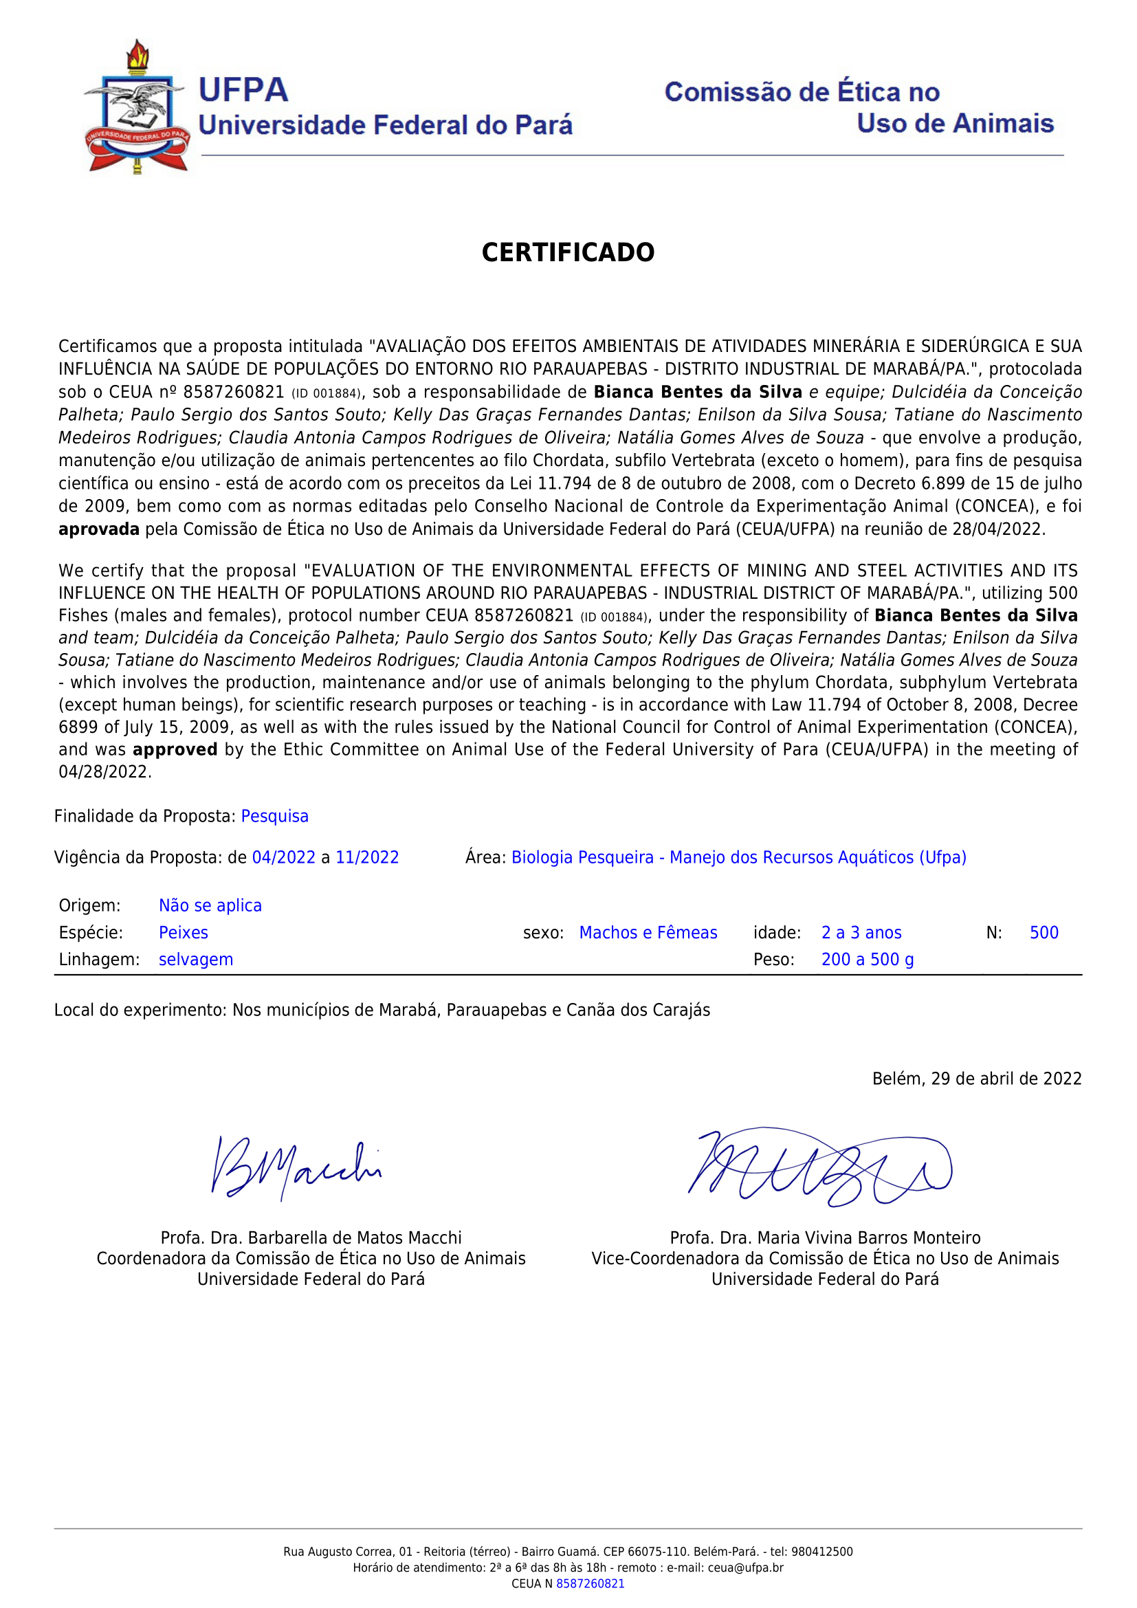
Supplementary S7. Certificate from the Ethics Committee for Animal Use (CEUA)

