Supplementary

Supplementary A. Spatial distribution of independent variables associated with climatic factors across different temporal scales. (A) Warm season, (B) Cold season, (C) Annual period.
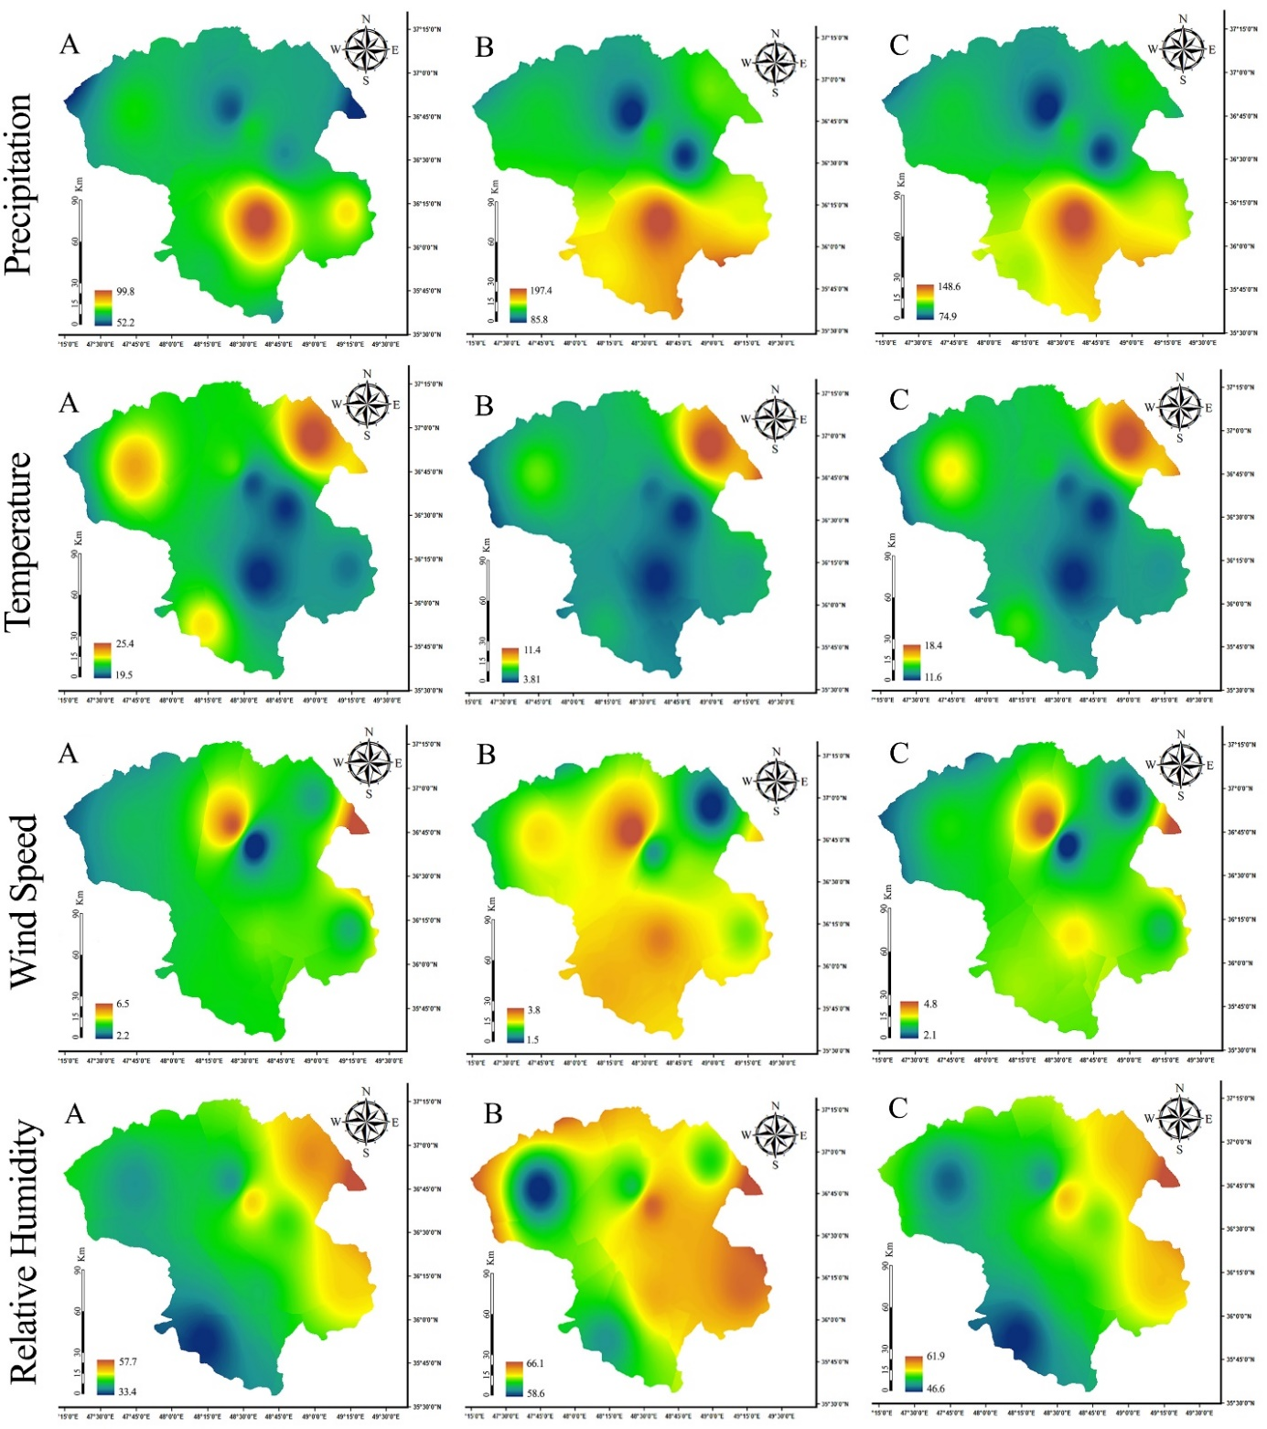

Supplementary B. Spatial distribution of landform variables and anthropogenic activity indicators in the study area. (A) Aspect, (B) TWI, (C) DTB, and (D) DTR.

