Extended Data Fig.1
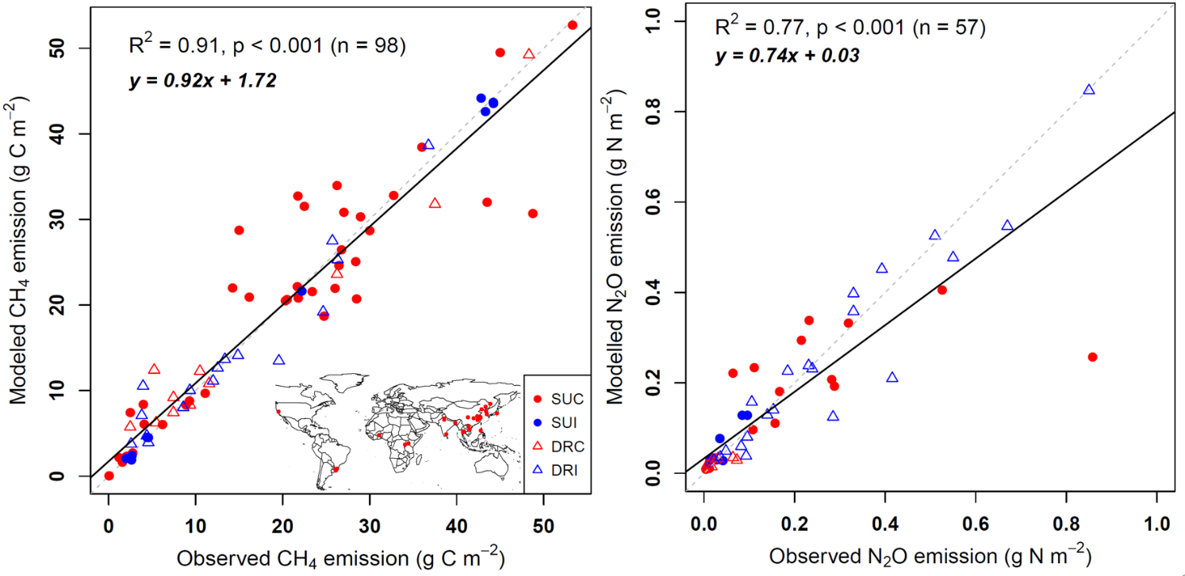
Evaluation of model performance by comparing the modeled and observed cumulative CH₄ (a) and N₂O (b) fluxes from rice-based cropping systems across the globe. The red dashed line is the 1:1 line and the closed red dots on the map represent the locations of the included sites. SU: single rice or systems with upland crops, DR: double rice systems, C: continuous flooding, I: intermittent flooding.

Extended Data Fig.2
The importance of decreased rice-based ecosystem area in determining projected GHG emissions globally. (a) modeled effects of changing physical rice area; (b) decomposition of projected trend of long-term GHG emissions into contributions from shifts in physical area of different rice-based ecosystems and weighted mean fluxes during the whole projection period and (c) late of this century.

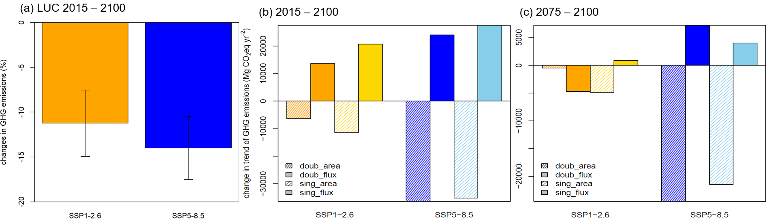

Extended Data Fig.3
Comparison of energy yields across different rice‐centered cropping patterns. The panel of the right is the dumbbell plot to show specific comparison of different rice-based cropping systems. DR: double-rice system, RW: rice-wheat(winter) system, MR: maize-rice system, and Roth: rice-other upland crops (e.g., rapeseed, potato, and sunflower etc.) systems.

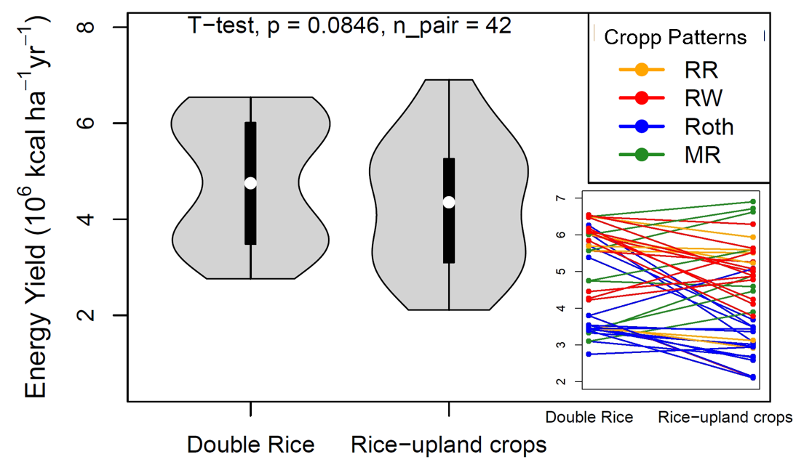

Extended Data Fig. 4
Projected changes in overall GHG emissions from global rice-based ecosystems for major rice-producing countries after implementing DTRU pathway as an alternative to replace STDR under both SSP-RCP scenarios.
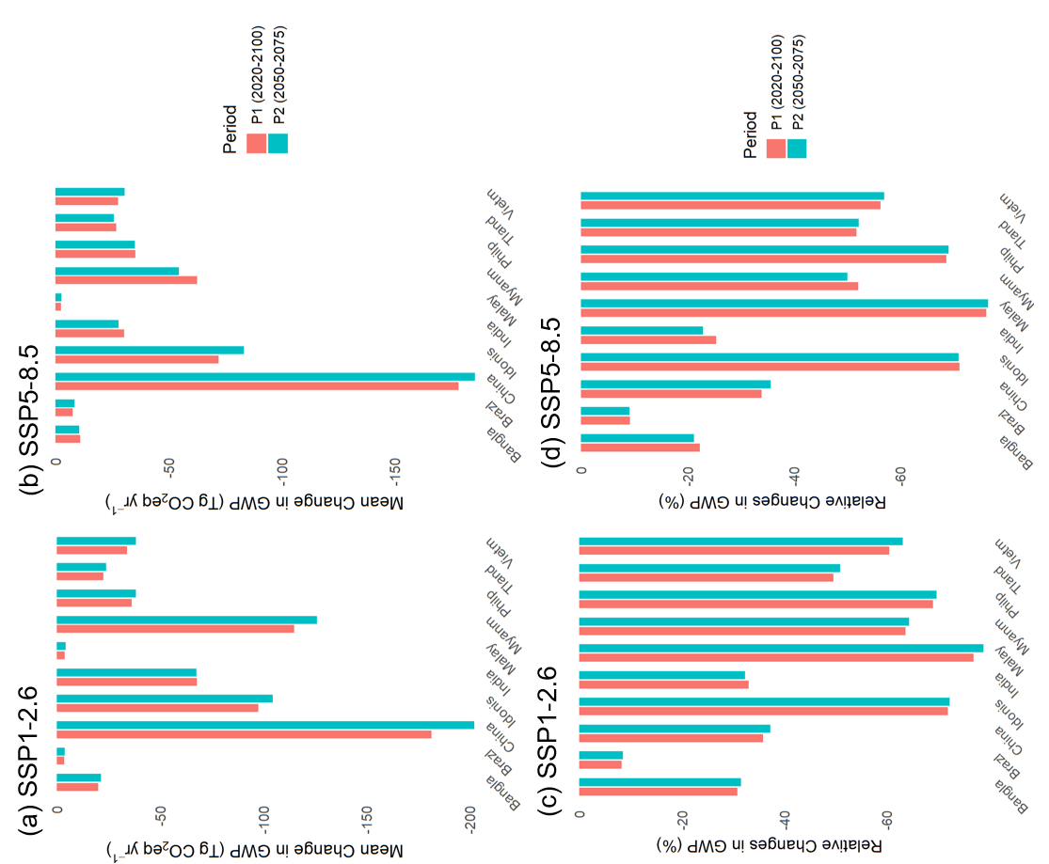
Absolute (a,b) and relative (c,d) changes in GWP. The results are exhibited for two periods of projections with P2 representing the neutrality period.

Extended Data Fig.5
Spatial variation patterns of the effects of implementing DTRU to replace STDR pathway on projected CH₄ (a) and N₂O (b) emissions from rice-based ecosystems globally. The figures exhibit the mean responses for SSP1-2.6 and SSP5-8.5.
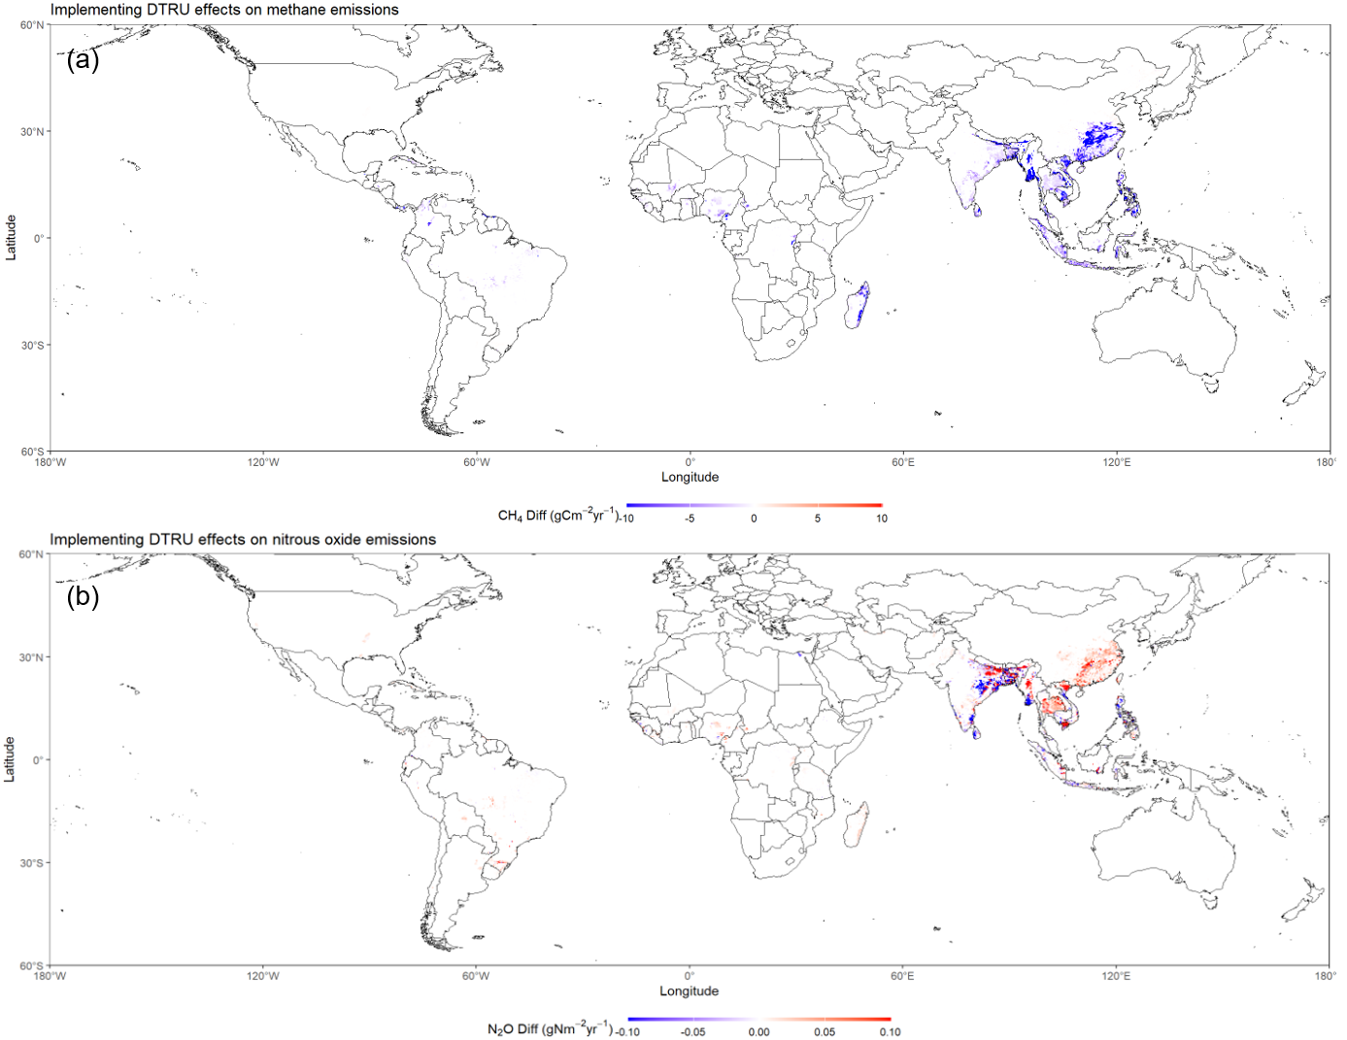

Extended Data Fig.6 Changes of expenditure for rice prior carbon pricing being recycled (a), and carbon revenue (b) generated by shifting different rice-based cropping patterns pathways.
The ranges reflect the uncertainty from varying constant of demand and supply elasticities (see Method section). The black dots denote the optimal projection. Carbon revenue indicates carbon tax

