Supplementary Text1
The effect of land use changes associated losses in rice physical area on GHG emissions

The land-use change (LUC) trends reflect the needs of decreasing agricultural carbon footprint while maintaining food supply in the projected future. Because it is less likely for rice-cultivation to remain current extent globally, the reduction in physical rice cultivation area (from LUH2.0) set the basis of our subsequent projections (Gao et al., 2025; Hurtt et al., 2020). By fixing the land-use change input data at the level of 2015, our simulations showed that LUC are projected to decrease total GHG emissions by 11.23% and 14.0% under SSP1-2.6 and SSP5-8.5 scenarios, respectively with the conventional cropping pattern pathway.
It is important to highlight that, for this study, such projected effect is approximately equivalent with the consequence of losses in physical area of rice-based ecosystems based on the LUH2.0 inputs. The conversions between rice-based ecosystems and upland cropping systems is an important LUC type, which have shown significant impacts on GHG dynamics (i.e., CH₄ and N₂O) (Eusufzai et al., 2010; Wu et al., 2017; Yuan et al., 2016). Varying water regimes, floodings and drainages, are the key features of this LUC practices. However, their impacts could not be shown independently. Because the TRIPLEX-GHG modelv2.0 provides consecutive simulations of soil biogeochemical cycles and the responses to different types of flooding and drainage practices over years (Song et al., 2022; Song et al., 2023; Zhu et al., 2014).
For CH₄ dynamics, rice loss to upland crops transfers native soils from a significant CH₄ source to a small net CH₄ sink whose magnitude is neglectable(Tang et al., 2023). Therefore, the LUC effect on CH₄ dynamics stems from the suppressed methanogens but activated methanotrophs activities after drainage, which are well represented in our model frameworks (Jiang et al., 2022; Kong et al., 2019; Ma et al., 2013). The effectiveness of our modeled LUC could also be observed indirectly from the “dry-to-wet” approaches. The increased CH₄ emissions after initial flooding practices are less intensive for the long-term upland soils (approach3 and 4) compared with that of paddy-existing soils because the latter tend to have accumulated SOC content (Fig. 4) (Eusufzai et al., 2010).
Regarding N₂O emissions, converting rice-paddies to upland cropping systems lead to 1.2— ~3 times larger N₂O emissions, a part of which could be attributed to the favored denitrification with rich organic matter. However, it is still controversial whether integrate this part of emission into rice-based GHG budget. Plus, the relative minor contribution of N₂O to total GHG relative to rice CH₄ underscore the priority of focusing on variation in CH₄ dynamics when accounting LUC effects (Carlson et al., 2017).
Overall, the TRIPLEX‑GHG modeling framework effectively captures both seasonal hydrology‑driven emissions and the broader land‑use change legacy.

Supplementary Text2
Effect of changing N management and irrigation on projected GHG emissions
Corresponding with the land use changes (projected decreasing rice-based ecosystem area), N and irrigation managements also vary greatly under both SSPs (Supplementary Fig. S11). These changes are based on the judgements of IAMs’ responses to social-economical decisions under different scenarios. For example, SSP5-8.5 emphasize fossil fuel-based development, but under this scenario, extensive investment could be made to improve agriculture efficiency, such as enhanced N fertilizer (as suggested by decreasing weighted mean N application rate) (O'Neill et al., 2016).
It is noteworthy that the N management and irrigation practices are consistent for both STDR and DTRU pathways for each scenario because of the same cropping intensities (i.e., double cropping wherever applicable).
With STDR pathway our simulation experiments revealed that efforts in changing N and irrigation managements are projected to decrease GHG emissions from global rice-based ecosystems in the 21st century. Under SSP5-8.5, the overall decreased use of N chemical fertilizer and manure on rice-based ecosystems (Supplementary Fig. S11) would present a consistent mitigation effect on both CH₄ (-5.3±1.1%) and N₂O (-2.9±0.3%) emissions globally (Supplementary Fig. S7 ac). Regarding SSP1-2.6, shifts in N management are projected to pose less impact on GHG emissions. As for irrigation, generally increased projected relative irrigated rice-based area under SSP5-8.5 would significantly mitigate CH₄ emissions by ~5% whereas enhance N₂O emissions by ~1.3% (Supplementary Fig. S7 bd). In contrast, less variations in irrigation changes under SSP1-2.6 result in less robust effects on rice GHG emissions.
Our projections are generally in line with the reported mitigation potential focusing on N management and irrigation (or flooding) alterations. Manure is projected to play a vital role as both N and C source and the latter account for a key substrate for producing CH₄ in our study (Hu et al., 2024). While the mechanism of mineral N controls on CH₄ emissions from paddy soils are still uncertain (Adviento-Borbe and Linquist, 2016).
The influence of changing water regime on GHG emissions from rice-based ecosystems have been widely addressed(Kritee et al., 2018). Expanded irrigation equipment allow the spreading application of intermittent flooding, which would significantly reduce CH₄ but enhance N₂O emissions and such mitigation potential has been well established (Bo et al., 2022). In consistent, our modeled results showed stronger overall mitigation effect of irrigation changes under SSP5-8.5 due to the larger increase in irrigated area.
Collectively, we acknowledge the efforts of management driven mitigation as the background of applying DTRU pathway, the mitigation approach of structural changes.

Supplementary Text3
Potential of promoting ratoon rice cultivation

The ratoon rice systems refers to a rice cultivation system where a second crop (ratoon season rice) is formed from the regrowth of tillers after harvest. This approach offers significant advantages in maintaining yields and saving human labors. Thus, ratoon rice is emerging to be recommended in several places, in particular growing rapidly in southern China (Peng et al., 2023).
However, our projections exclude the possibility of widely cultivated ratoon rice to replace double-rice or rice-upland systems in the future, with following reasons.
First, the grain yield of ratoon rice is highly inconsistent and the mean harvests are only about 50% of main rice crop (range 5 – 100%) (Liu et al., 2024). Such significant instability mostly results from rolling damage of machine harvester.
Second, the quality (the milling and eating) of main rice crop (of ratoon rice) is worse than middle-rice and late-rice, let alone the ratoon season’s (Alizadeh and Habibi, 2016). This implies challenges in direct human food supply.
Third, the ratoon rice cultivation is less likely to significantly reduce GHG emissions than rice-upland systems due to prolonged flooding conditions (Yu et al., 2024). Although ratoon rice does decrease CH₄ emissions compared with double-rice, the long-term effect of the cultivation could bring more challenges in emitting GHGs (primarily CH₄). Plus, compared with ratoon rice cropping, promoting rice-upland crop systems also bring other benefits including crop diversities (Heikonen et al., 2025).
Collectively, this study assumed no large-scale usage of ratoon rice during projection. More long-term field experiments to investigate the difference between ratoon rice and traditional double-rice or rice-upland crops systems should be conducted in future studies.

Supplementary Text4
Model descriptions of TRIPLEX-GHGv2.0 and performance evaluation

TRIPLEX-GHG modelv2.0 has been widely applied for estimating the dynamics of CO₂, CH₄, and N₂O emissions from terrestrial ecosystems across different spatiotemporal scales. Here, we provide a detailed descriptions of processes directly regulate CH₄ and N₂O fluxes from rice-based ecosystems.
Specifically, two CH₄ production pathways, acetoclastic and hydrogenotrophic methanogenesis are modeled explicitly to represent the characteristics of CH₄ sources under aerobic and anaerobic conditions, respectively.
CH₄ production through acetoclastic methanogenesis pathway (${Rprod}_{{acCH}_{4}}$) is governed by the consumption of acetate as following equation:
$${Rprod}_{{acCH}_{4}}= {COEfrac}_{ace}·V_{max,conace}·\frac{[ace]}{K_{conace}+[ace]}·f_{T}·f_{pH}·$$
Here, $V_{max,conace}$ and $K_{conace}$ indicate the maximum acetate consumption rate and half saturation coefficient for acetate. $COEfrac$ is the constant for CH₄ production ratio. $[ace]$ represent the concentration of acetate which is primarily produced by the fermentation from DOC under varying conditions. TRIPLEX-GHGv2.0 describe this process with Michaelis–Menten kinetics based on IBIS-microbe model (Song et al., 2020).
Under flooding conditions, anoxic soil significantly favors hydrogenotrophic methanogenesis, which reduces CO₂ to CH₄
$${Rprod}_{{hyCH}_{4}}= {COEfrac}_{co2}·{Ran}_{{CO}_{2}}·\frac{1}{1+η[O_{2}]}·f_{T}·f_{pH}·f_{wfps}$$
Where ${COEfrac}_{co2}$ is a fixed fraction of ${Ran}_{{CO}_{2}}$, the anaerobic respiration rate, that convert into CH₄ and $η$ is a parameter reflecting the sensitivity of methanogen to O₂ inhibition (Raivonen et al., 2017). ${Ran}_{{CO}_{2}}$ is predominantly controlled by temperature, represented as ${anRQ}_{10}$, from original model framework.
Conversely, regarding CH₄ oxidation, TRIPLEX-GHG v2.0 employed double-substrate Michaelis–Menten kinetics equation, with two sets of parameters demonstrating the different dominant methanotrophic species in aerobic (high affinity groups, e.g., upland soil clusters, USCs) and anaerobic (low affinity groups, type I and II) soils (Song et al., 2024).
$${Roxid}_{{CH}_{4}}= V_{max,OxCH_{4}}·\frac{[{CH}_{4}]}{K_{{ CH}_{4}}+[{CH}_{4}]}·\frac{[O_{2}]}{K_{{ O}_{2}}+[O_{2}]}·f_{T}·f_{pH}·f_{wfps}·f_{soilN}$$
Where $V_{max,OxCH_{4}}$ is the optimal CH₄ oxidation rate while $K_{{ OxCH}_{4}}$ and $K_{{OxO}_{2}}$ denote the half saturation coefficients for CH₄ and O₂, respectively.
After the sensitivity analysis of model parameters, model calibration was conducted focusing on the most sensitivity parameter, ${anRQ}_{10}$ of anaerobic respiration. The fitted parameters presented an exponential relationship with multiyear annual mean air temperatures (5.264909 + -0.8522294 * log(Temp), R² = 0.70, p<0.001), which was subsequently employed for obtaining the global parameters while others kept as default (Supplementary Table S5). This founding is consistent with previous studies, which well established the predominant role of temperature in regulating CH₄ emissions (Chang et al., 2021; Qian et al., 2022; Zhu et al., 2014).
Regarding N₂O production from rice-based ecosystem soils, nitrification and denitrification are the predominantly responsible processes.
$$Rnit= V_{max,nit}·B_{nit}·\frac{[{NH}_{4}]}{K_{{ nit, NH}_{4}}+[{NH}_{4}]}f_{T}·f_{pH}·f_{wfps}$$
$V_{max,nit}$ represents the maximum nitrification rate or nitrification potential while $K_{{ nit, NH}_{4}}$ is the half saturation coefficient; $B_{nit}$ is the biomass concentration of nitrifiers; N₂O production rates from nitrification is based on a certain fraction (Zhang et al., 2017).
In TRIPLEX-GHG modelv2.0, denitrification is modeled stepwise to represent the chain reaction process, which are linked by the competition for DOC by the specific denitrifiers during each step. Double substrate based Michaelis–Menten equation is applied for estimating rates of reaction (${Rden}_{{NO}_{x}}$) as well as the growth and mortality of different denitrifier groups. Subsquently, the consumption rates of ${NO}_{x}$ substrates ($F_{ANNOx}$) is computed with Eq in this model.
$${Rden}_{{NO}_{x}}= {MUR}_{NOx}·\frac{[DOC]}{K_{DOC}+[DOC]}·\frac{[{NO}_{x}]}{K_{{NO}_{x}}+[{NO}_{x}]}$$
$$F_{ANNOx}= {COE}_{dNOx}· B_{denit}·\left(\frac{{Rden}_{{NO}_{x}}}{{EFF}_{NOX}}+\frac{{MAI}_{NOX}·\left[{NO}_{X}\right]}{\left[N\right]}\right)·f_{NOX, T}·f_{pH}$$
Where ${MUR}_{NOx}$ is the maximum growth rate of NOx denitrifiers; $K_{DOC}$ and $K_{{NO}_{x}}$ indicate the half-saturation values of C and N oxides, respectively; ${COE}_{dNOx}$ is the coefficient of ${NO}_{X}$ consumption; $B_{denit}$ is the biomass of the denitrifiers (kg C m⁻³); ${EFF}_{NOX}$ is the efficiency of the NO_{X} denitrifiers (kg C kg N ⁻¹); ${MAI}_{NOX}$ is the maintenance coefficient of NO_{X} (h⁻¹); $\left[N\right]$ indicates the total mineral N concentration.
Specifically, anaerobic ammonium oxidation (ANAMMOX) and nitrifier denitrification, which are vital for N cycles in rice-paddy and wetlands, are also included as consistent with our previous study Song et al. (2023). It is noteworthy that although occasionally detected, consumption of N₂O is not well understood and has not been incorporated in this study (Jørgensen and Elberling, 2012).
Anaerobic balloon is employed in TRIPLEX-GHG v2.0 as a conceptual term to allow separated microbial reactions under different soil oxygen status simultaneously. The size of anaerobic balloon reflects the changes in soil oxygen status and regulates the distributions of substrates for biogeochemical processes (Gilhespy et al., 2014).
Three major gas transportation pathways are incorporated in current TRIPLEX-GHG v2.0 including diffusion, plant-mediate transportation, and ebullition for rice-based ecosystems while only diffusion process dominates gaseous transportations under non-flooding seasons or circumstances.
Molecular diffusive flux within the soil profile and between soil and atmosphere, based on Fick’s first law, depends on the concentration gradient and the diffusion coefficient of the compound. TRIPLEX-GHGv2.0 has a detailed representation of such process by accounting effective diffusivities in water or air the drastic variations of diffusivities at the interface (Song et al., 2020).
In addition, plant-mediated transportation plays a major role in exchanges of both gases between soil and atmosphere for rice-paddies, especially under the inundation environments due to the well develop aerenchyma. In consistent with previous studies, we employed the formulation from Stephen et al. (1998) that uses specific gas concentration gradient and the density of cross-sectional area of root ending which varies with leaf area index (LAI), specific leaf area (SLA), and soil depth (Raivonen et al., 2017; Song et al., 2023).
Particularly for gas emissions from wetlands and rice-paddies, ebullition is a main pathway while the modeling of this process remain coarsely represented and challenging (Peltola et al., 2018). Our model utilizes the approach of hydrostatic equilibrium which determine the bubble formation when the combined partial pressures of different gaseous compounds (e.g., CH₄, CO₂, O₂, N₂O, N₂) reach a certain threshold (Song et al., 2020).

Supplementary Text5
Indices for evaluating model performances

The index of agreement (D), the root mean square error (RMSE), and the coefficient of determination (R²) were used to evaluate our model’s performance in daily time step, and the D-value and RMSE were calculated as follows:
$D=1- \frac{\sum_{i=1}^{n}{{(S_{i}-O_{i})}^{2}}}{\sum_{i=1}^{n}{{(\left|S_{i}-¯O\right|+\left|O_{i}-\overline{O}\right|)}^{2}}}$,
$RMSE= \sqrt{\frac{\sum_{i=1}^{n}{{(S_{i}-O_{i})}^{2}}}{n}}$.

Here, $S_{i}$ is the ith simulated result corresponding to the number of observations; $O_{i}$ is the ith observed value; and $\overline{O}$ is the mean of the observed values during the experimental period. D varies between 0 and 1, and is excessively sensitive to extreme values (Willmott, 1981). The model performance was considered to be perfect and unmeaningful when the D value was set to 1 and 0, respectively. The RMSE is the key value representing the difference between the simulated and observed values, and is significantly affected by the data units (e.g., mg C m⁻² day⁻¹ compared with kg C ha⁻¹ day⁻¹).
All the observed flux data was obtained from published literatures with GetData software (Digitize graphs and plots - GetData Graph Digitizer - graph digitizing software (getdata-graph-digitizer.com))

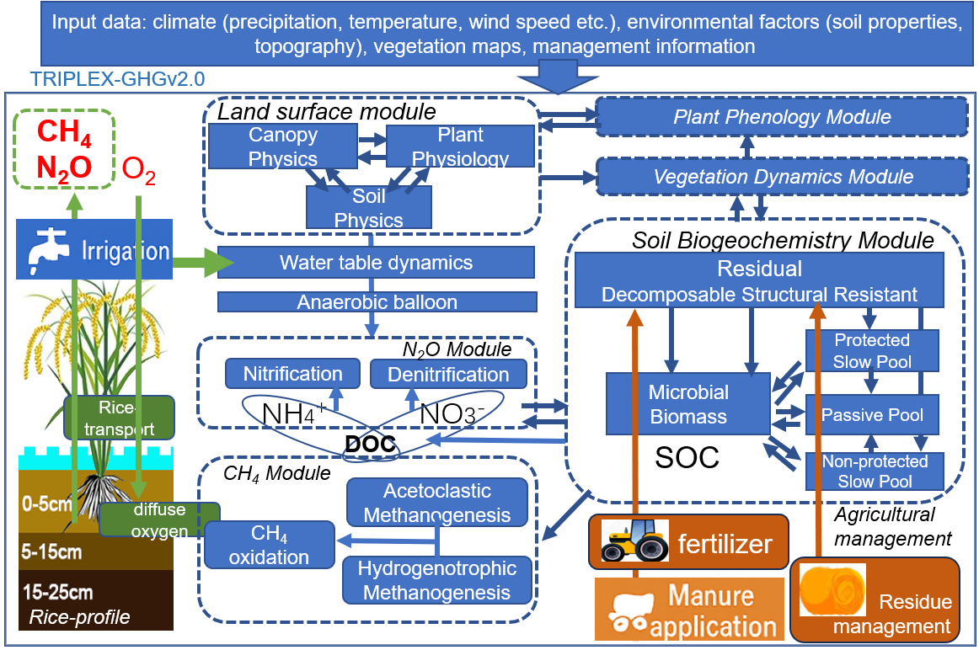
Supplementary Fig. S1 Conceptual structure of current TRIPLEX-GHG modelv2.0, specifically focusing on the dynamics of simulating methane (CH₄) and nitrous oxide (N₂O) emissions from rice-based ecosystems. This figure is revised from Song et al. 2023.

Supplementary Fig. S2 Evaluations of the model performances by comparing the modeled and observed daily CH₄ fluxes from rice-based ecosystems under different management and environmental conditions. For model performances for simulating dynamics of daily N₂O fluxes, please refer to Song et al. (2023).
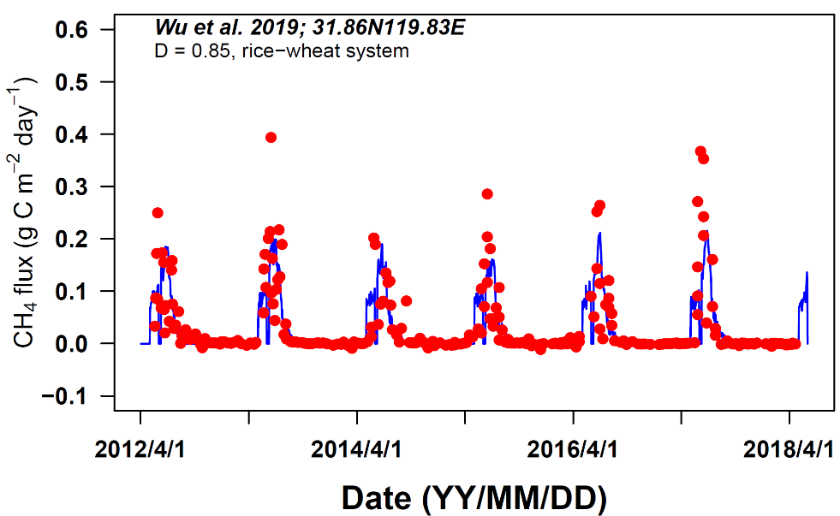
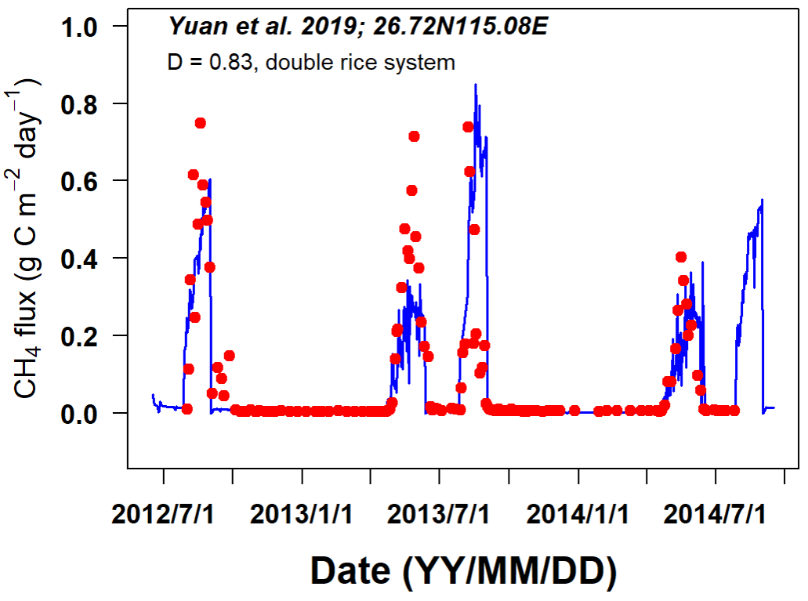
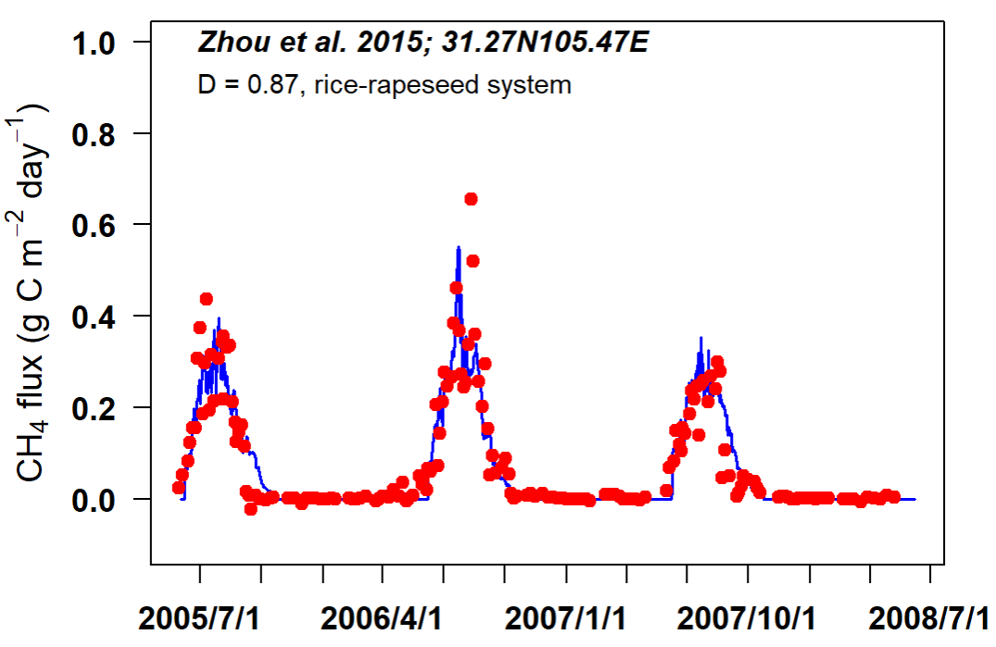
Supplementary Fig. S3 TRIPLEX-GHGv2.0 estimates of CH₄ emission from global rice-based ecosystems, covering both growing and non-growing seasons, and comparison against previous studies over historical period.

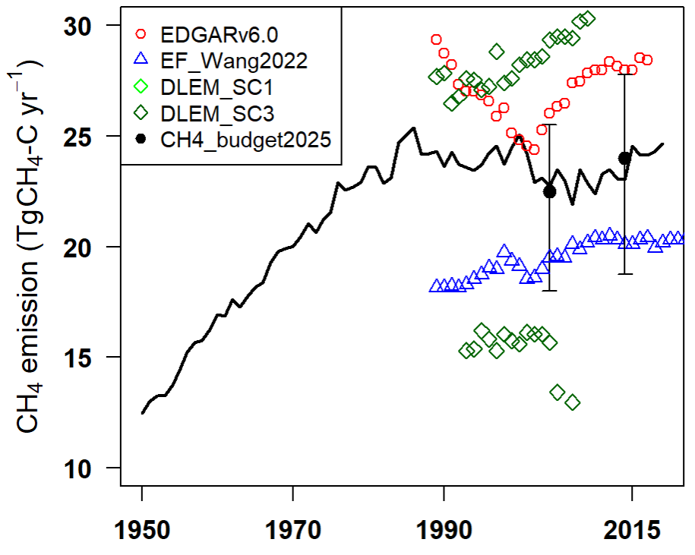

Supplementary Fig. S4 Changes in global rice harvest area during 1990 – 2100 with different cropping pattern pathways under both SSP-RCP scenarios. “conven” (conventional) indicates keep current mixed cropping patterns for projection period while “maxrice” and “dou2sin” denotes the DRE and RUS pathway to fully develop rice-centered cropping intensity. Dashed grey line represents mean harvest area during reference period.

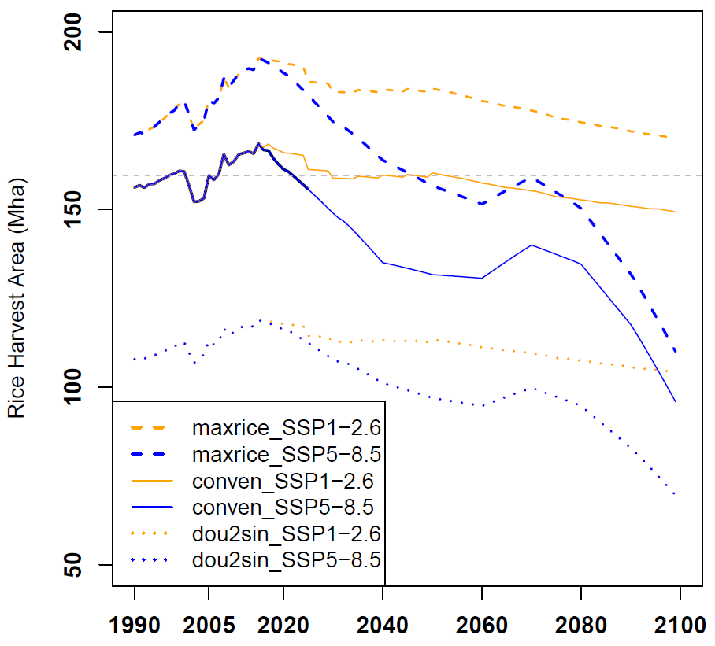

Supplementary Fig. S5 The spatial distribution of weighted mean annual CH₄ (a) and N₂O (b) emissions during reference period (1995 – 2015) from global rice-based ecosystems.
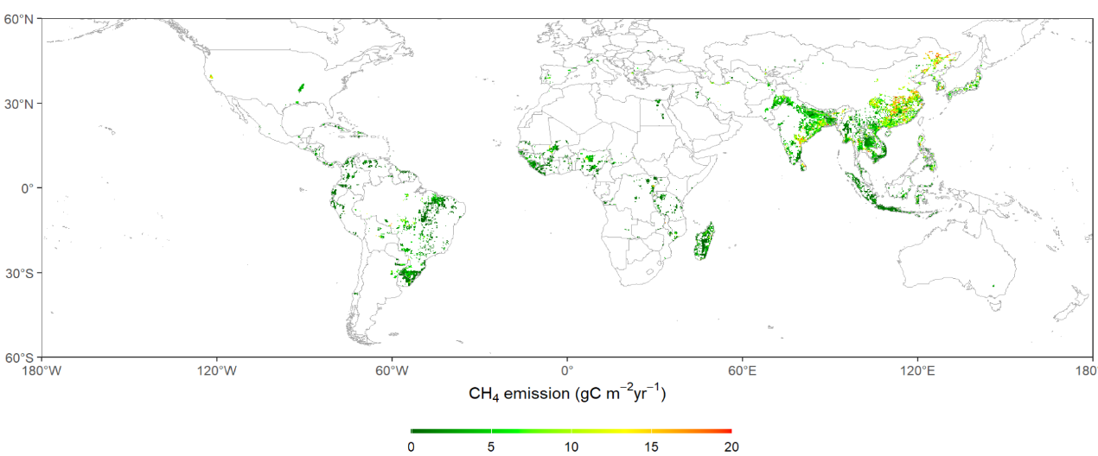
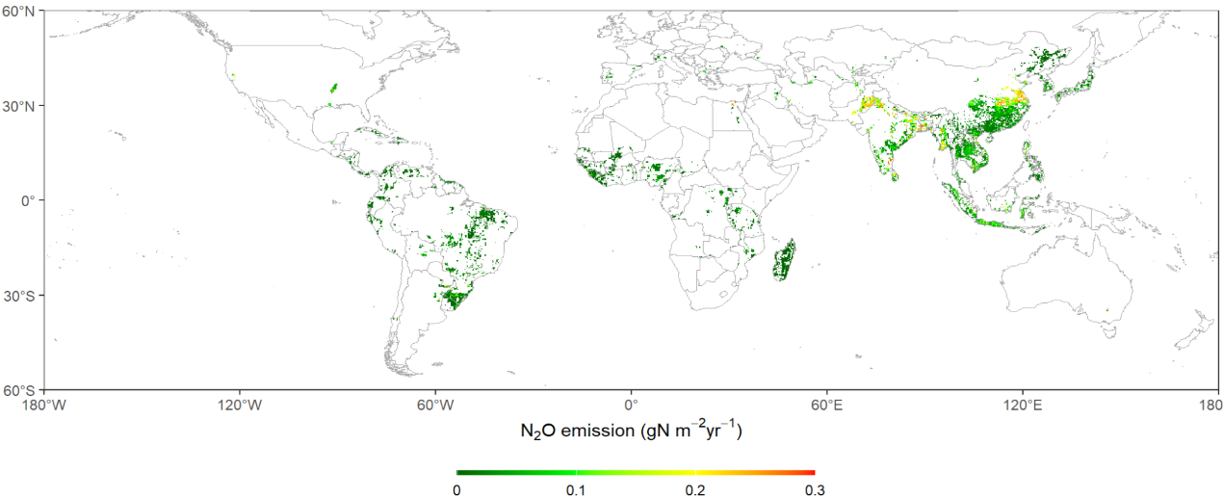
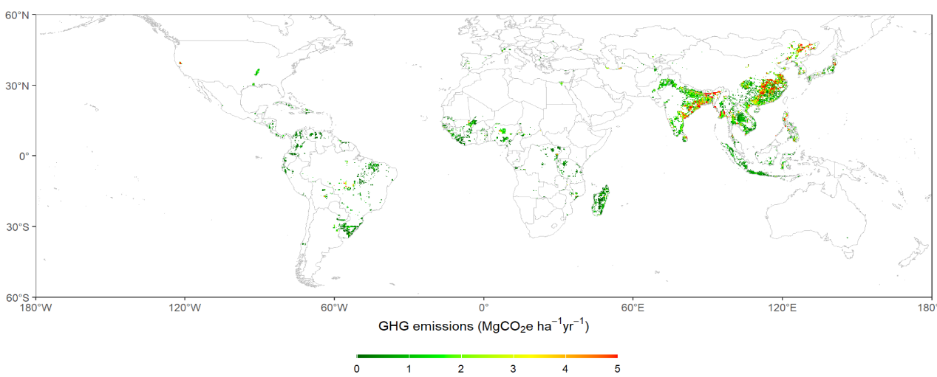

Supplementary Fig. S6 The spatial distribution of changes in weighted mean annual GHG emissions during neutrality period (2050 – 2075) compared with reference period (1995 – 2015) from global rice-based ecosystems under SSP5-8.5 (a) and SSP1-2.6 (b) scenarios.
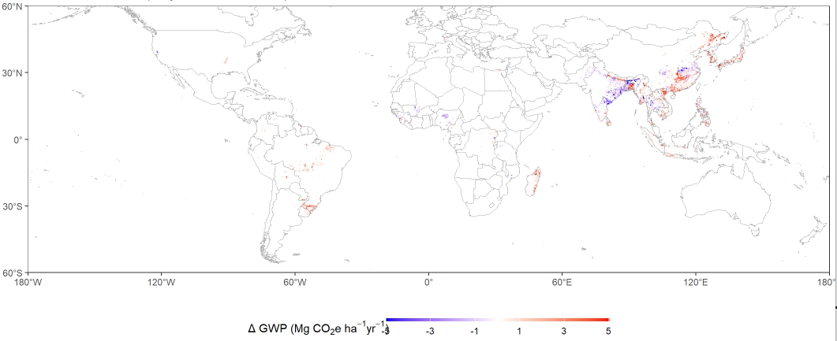
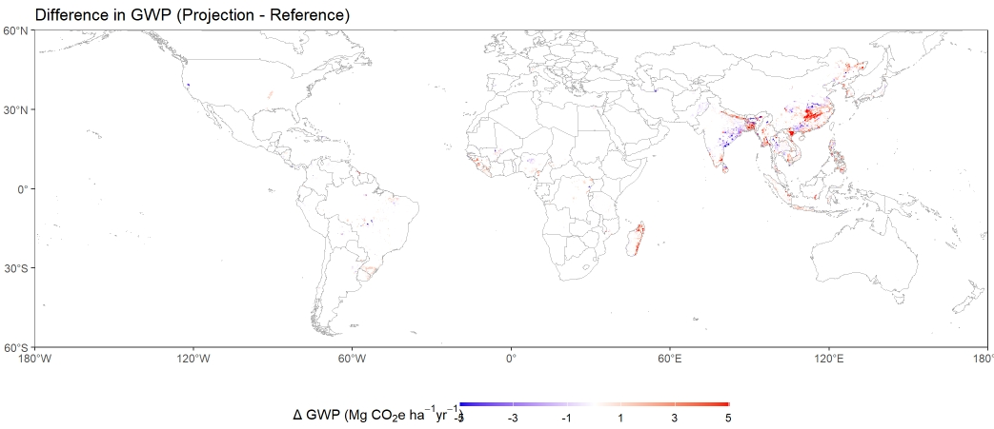

Supplementary Fig. S7 Impacts of implementing single to double-rice (STDR) pathway. (a) relative changes in overall GHG emissions relative to conventional pathway (CONV); (b-c) Absolute changes in projected overall GHG emissions from global rice-based ecosystems (in GWP) for different rice-producing countries after introducing STDR pathway which would fully recover of double rice growth in the future.
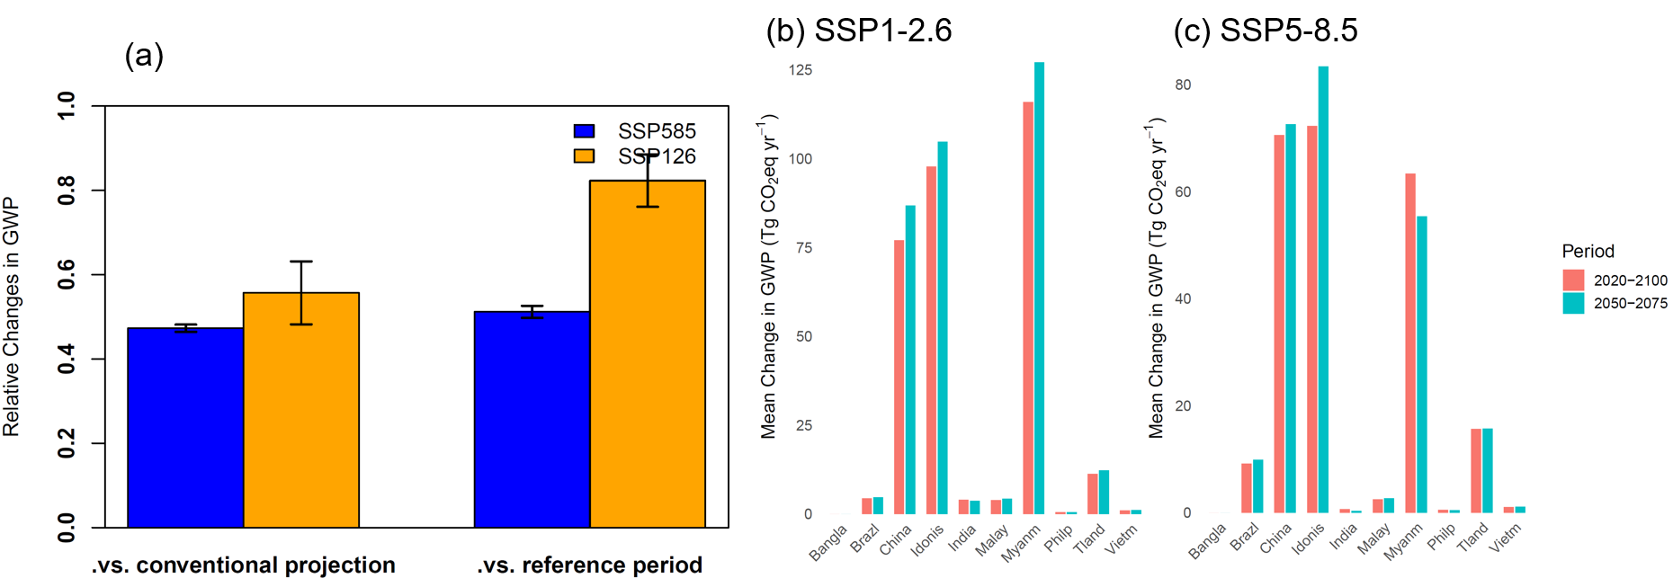

Supplementary Fig. S8 Modeled effect of N management and irrigation changes on CH₄ and N₂O emissions during the projection period with DRE pathway. The results were obtained from the additional simulation experiments. N management and irrigation changes, as input data, were aggregated on the basis of LUH2.0 dataset. The dataset was produced by IAMs, considering climate and social-economic changes in the possible future scenarios.

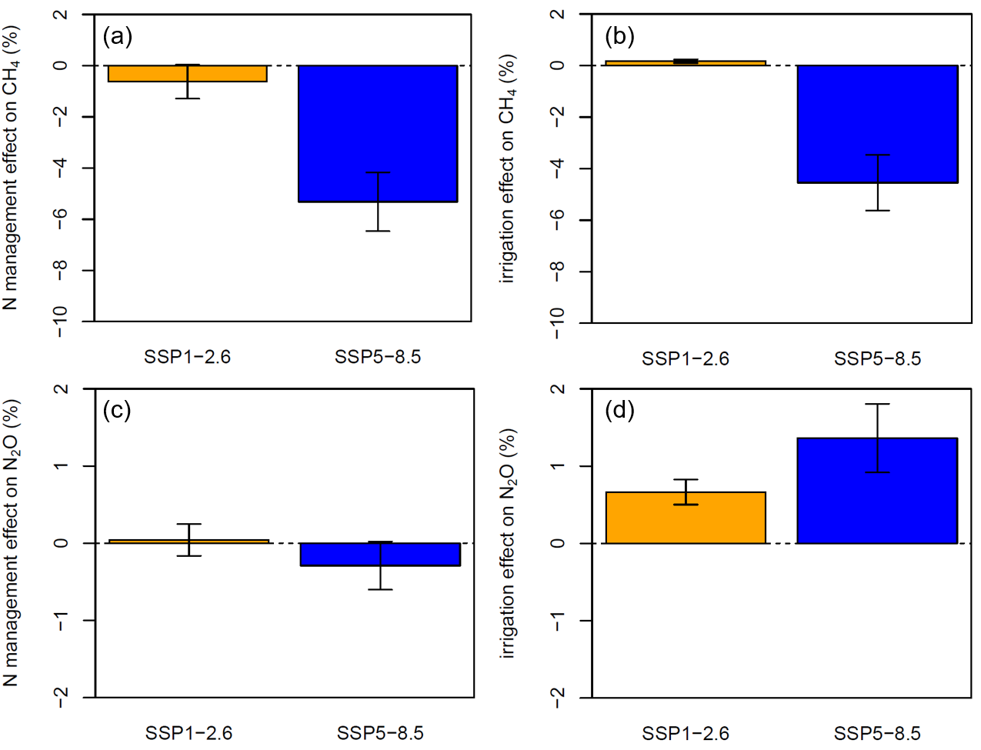
Supplementary Fig. S9 Spatial variations of climate change induced changes in GHG emissions with STDR pathway under SSP1-2.6 (a); spatial variations of the difference in GHG emissions after shifting STDR to DTRU pathway under SSP1-2.6 (b).
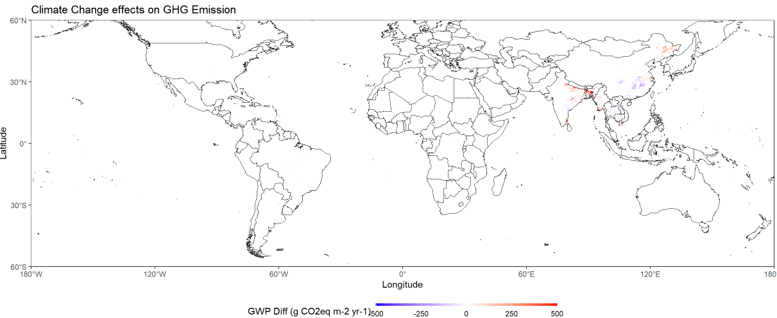
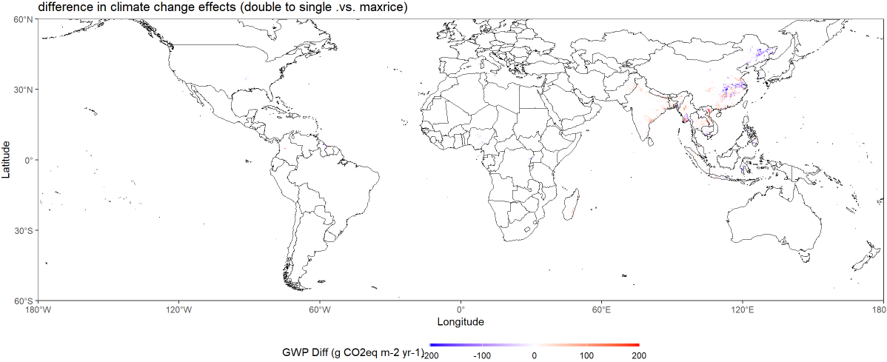
Supplementary Fig. S10 Spatial variation patterns of increases in CH4 emissions after implementing TERU apch3 under SSP1-2.6 (a) and SSP5-8.5 (b).

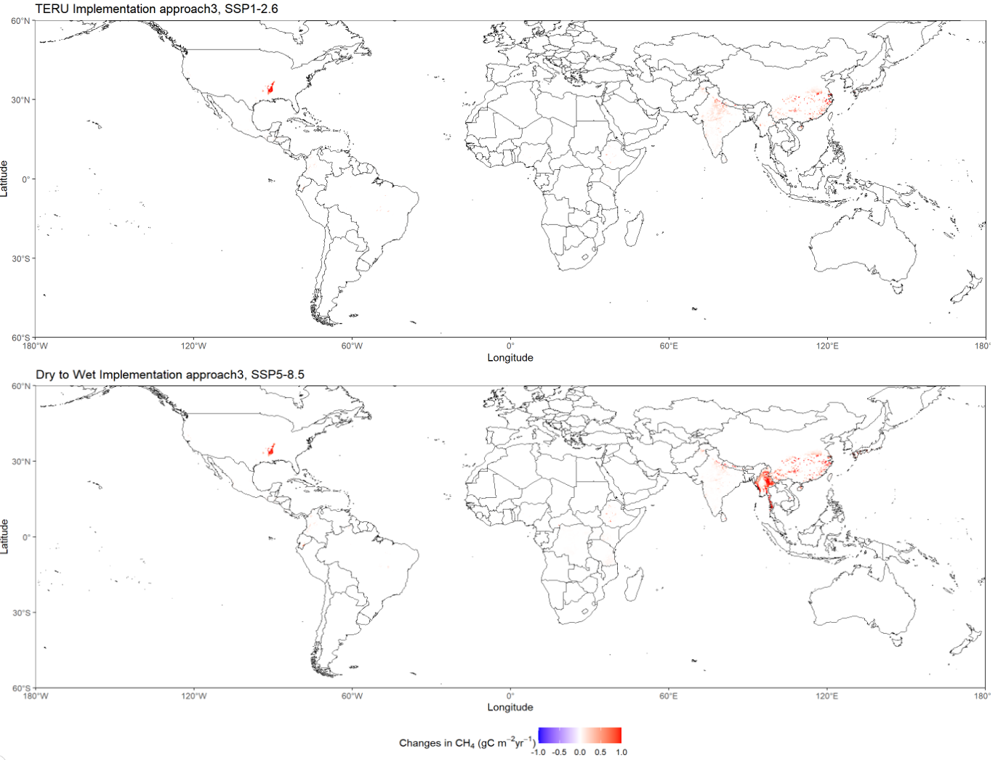

Supplementary Fig. S11 percent changes in daily mean air temperature and annual precipitation for global rice-based ecosystems under two SSP-RCP scenarios.

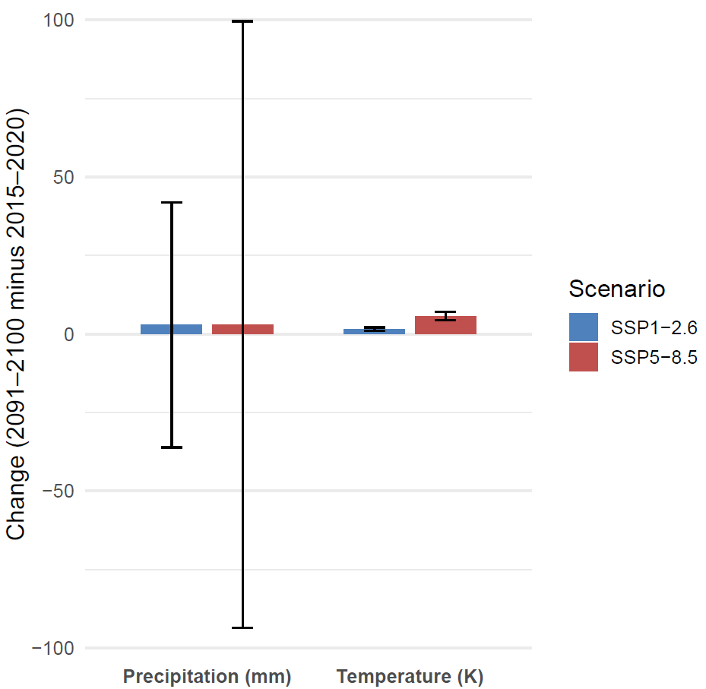
Supplementary Fig. S12 Historical physical and harvest area of rice paddy on a global scale based on different public datasets (a). spatial pattern of the difference in rice physical area between GloRicev1.0 and LUHv2.0 that we applied in the present study.
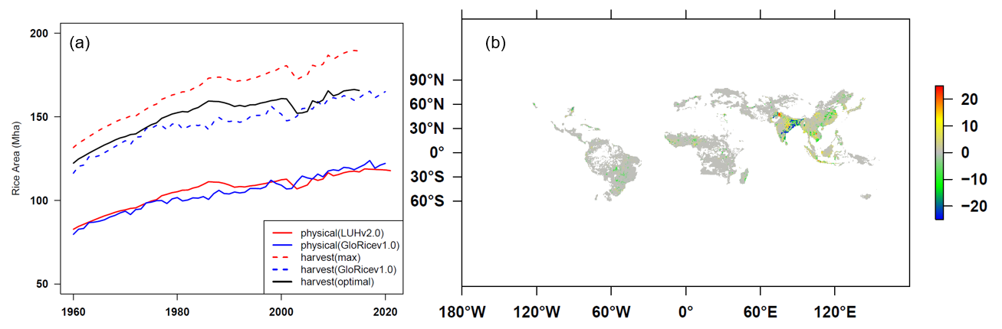

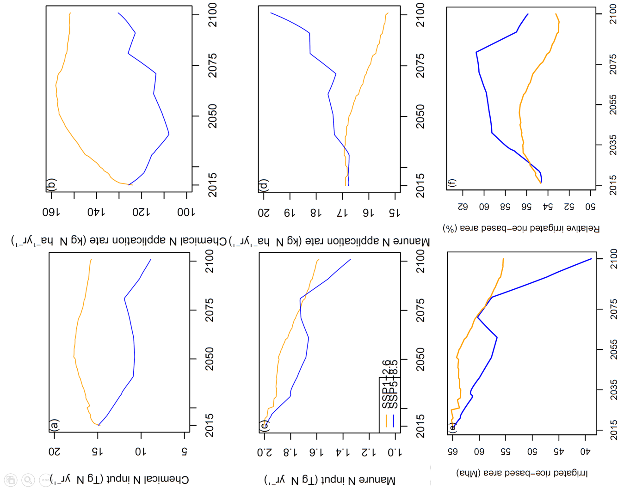
Supplementary Fig. S13 Management N inputs and the weighted mean application rates in global rice-based ecosystems during the projection period under SSP1-2.6 and SSP5-8.5 scenarios.

Table S1. Model simulation experiment designs for attributing projections of GHG emissions from global rice-based ecosystems to different driving factors.

Scenario | Climate | CO2 conc. | N deposition | Cropping patterns | Land use change | N Managements | Irrigation
S0 | 2015 | 2015 | 2015 | CONV. | 2015—2100 LUHv2.0 | 2015 | 2015—2100
S1 multifactor | 2015—2100 | 2015—2100 | 2015—2100 | CONV/ STDR/ DTRU | 2015—2100 LUHv2.0 | 2015—2100 | 2015—2100
S2 No Climate CO2 | 2015 | 2015 | 2015—2100 | STDR/ DTRU | 2015—2100 LUHv2.0 | 2015—2100 | 2015—2100
S3 No rice area change | 2015—2100 | 2015—2100 | 2015—2100 | CONV/ STDR/ DTRU | 2015 | 2015—2100 | 2015—2100
S4 No N manage | 2015—2100 | 2015—2100 | 2015—2100 | STDR | 2015—2100 LUHv2.0 | 2015 | 2015—2100
S5 No irrigation | 2015—2100 | 2015—2100 | 2015—2100 | STDR | 2015—2100 LUHv2.0 | 2015—2100 | 2015

Table S2. Different approaches (apch1-4) to govern the targeted expansion of rice-upland crop systems (TERU) to neighborhood, non-rice distributed area and the yield area gain relative to DTRU pathway under both SSPs.
Approach | Cropping sys. | Rice existing pixels | 2year no rice pixels | Irrigation | Topography | Perc.area gain  (SSP1-2.6/5-8.5)
RUS | Rice-upland crop/ Single rice | N.A. | N.A. | N.A. | N.A. | N.A.
TDW apch1 | Rice-upland crop/ Single rice | 25% | N.A. | yes | no | 2.4/6.4
TDW apch2 | Rice-upland crop/ Single rice | 25%/15%/5% | N.A. | no | <200m/<600m | 3.0/5.9
TDW apch3 | Rice-upland crop/ Single rice | N.A. | 20% | yes | no | 3.1/6.2
TDW apch4 | Rice-upland crop/ Single rice | N.A. | 6% | no | <200m/<600m | 3.0/6.8

Table S3. Comparison of energy yields of different rice-based ecosystems, in particular
site | type | year | system | crop pattern | kcal ha-1 yr-1 | paper
1 | DR | 2019 | DR | CRR | 6260.90331 | Effects of Typical Cropping Patterns of Paddy-UplandMultiple Cropping Rotation on Rice Yield and Greenhouse Gas Emissions
1 | RU | 2019 | Rpa | CRI | 3492.13678
2 | DR | 2019 | DR | RRR | 6058.34485
2 | RU | 2019 | Rpa | RRI | 3091.49071
3 | DR | 2020 | DR | CRR | 5707.97823
3 | RU | 2020 | Rpa | CRI | 3690.94541
4 | DR | 2020 | DR | RRR | 5383.10174
4 | RU | 2020 | Rpa | RRI | 3489.15773
To be continued

Table S5. Optimized parameters for the methane (CH4) module of paddy soils in the TRIPLEX-GHGv2.0 model.

Parameter | Unit | Value (range) | References | Note
$${COEfrac}_{ace}$$ | - | 0.4 | Song et al. 2020
$$V_{max,conace}$$ | mol m⁻³ h⁻¹ | 0.5 (0.1—0.9) | Song et al. 2020
$$K_{conace}$$ | mol m⁻³ | 0.05 | Song et al. 2020
$${COEfrac}_{co2}$$ | - | 0.5 (0.25—0.7) | Zhu et al. 2014; Raivonen et al. 2017
$$η$$ | m³ mol⁻¹ | 400 | Raivonen et al. 2017
$${anRQ}_{10}$$ | - | 2.5 (2.15—3.5) | Zhu et al. 2014; Raivonen et al. 2017
$$V_{max,OxCH_{4}}$$ | mol m⁻³ h⁻¹ | 0.36/2 | Song et al. 2020; Zhuang et al. 2013; Song et al. 2024 | Anaerobic/Aerobic
$$K_{{ CH}_{4}}$$ | mol m⁻³ | 0.05/0.0075 | Song et al. 2020; Zhuang et al. 2013; Song et al. 2024 | Anaerobic/Aerobic
$$K_{{ O}_{2}}$$ | mol m⁻³ | 0.03/0.02 | Song et al. 2020; Zhuang et al. 2013; Song et al. 2024 | Anaerobic/Aerobic

References

Adviento-Borbe, M.A.A. and Linquist, B., 2016. Assessing fertilizer N placement on CH4 and N2O emissions in irrigated rice systems. Geoderma, 266: 40-45.
Alizadeh, M.R. and Habibi, F., 2016. A Comparative Study on the Quality of the Main and Ratoon Rice Crops. Journal of Food Quality, 39(6): 669-674.
Bo, Y., Jägermeyr, J., Yin, Z., Jiang, Y., Xu, J., Liang, H. and Zhou, F., 2022. Global benefits of non-continuous flooding to reduce greenhouse gases and irrigation water use without rice yield penalty. Global Change Biology, 28(11): 3636-3650.
Carlson, K.M., Gerber, J.S., Mueller, N.D., Herrero, M., MacDonald, G.K., Brauman, K.A., Havlik, P., O’Connell, C.S., Johnson, J.A., Saatchi, S. and West, P.C., 2017. Greenhouse gas emissions intensity of global croplands. Nature Climate Change, 7(1): 63-68.
Chang, K.-Y., Riley, W.J., Knox, S.H., Jackson, R.B., McNicol, G., Poulter, B., Aurela, M., Baldocchi, D., Bansal, S. and Bohrer, G., 2021. Substantial hysteresis in emergent temperature sensitivity of global wetland CH4 emissions. Nature Communications, 12(1): 2266.
Eusufzai, M.K., Tokida, T., Okada, M., Sugiyama, S.-i., Liu, G.C., Nakajima, M. and Sameshima, R., 2010. Methane emission from rice fields as affected by land use change. Agriculture, Ecosystems & Environment, 139(4): 742-748.
Gao, P., Gao, Y., Ou, Y., McJeon, H., Iyer, G., Ye, S., Yang, X. and Song, C., 2025. Heterogeneous pressure on croplands from land-based strategies to meet the 1.5 °C target. Nature Climate Change.
Gilhespy, S.L., Anthony, S., Cardenas, L., Chadwick, D., del Prado, A., Li, C., Misselbrook, T., Rees, R.M., Salas, W., Sanz-Cobena, A., Smith, P., Tilston, E.L., Topp, C.F.E., Vetter, S. and Yeluripati, J.B., 2014. First 20 years of DNDC (DeNitrification DeComposition): Model evolution. Ecological Modelling, 292: 51-62.
Heikonen, S., Heino, M., Jalava, M., Siebert, S., Viviroli, D. and Kummu, M., 2025. Climate change threatens crop diversity at low latitudes. Nature Food, 6(4): 331-342.
Hu, Q., Li, J., Xie, H., Huang, Y., Canadell, J.G., Yuan, W., Wang, J., Zhang, W., Yu, L., Li, S., Lu, X., Li, T. and Qin, Z., 2024. Global methane emissions from rice paddies: CH4MOD model development and application. iScience, 27(11).
Hurtt, G.C., Chini, L., Sahajpal, R., Frolking, S., Bodirsky, B.L., Calvin, K., Doelman, J.C., Fisk, J., Fujimori, S., Klein Goldewijk, K., Hasegawa, T., Havlik, P., Heinimann, A., Humpenöder, F., Jungclaus, J., Kaplan, J.O., Kennedy, J., Krisztin, T., Lawrence, D., Lawrence, P., Ma, L., Mertz, O., Pongratz, J., Popp, A., Poulter, B., Riahi, K., Shevliakova, E., Stehfest, E., Thornton, P., Tubiello, F.N., van Vuuren, D.P. and Zhang, X., 2020. Harmonization of global land use change and management for the period 850–2100 (LUH2) for CMIP6. Geosci. Model Dev., 13(11): 5425-5464.
Jiang, M., Xu, P., Wu, L., Zhao, J., Wu, H., Lin, S., Yang, T., Tu, J. and Hu, R., 2022. Methane emission, methanogenic and methanotrophic communities during rice-growing seasons differ in diversified rice rotation systems. Science of The Total Environment, 842: 156781.
Jørgensen, C.J. and Elberling, B., 2012. Effects of flooding-induced N2O production, consumption and emission dynamics on the annual N2O emission budget in wetland soil. Soil Biology and Biochemistry, 53: 9-17.
Kong, D., Li, S., Jin, Y., Wu, S., Chen, J., Hu, T., Wang, H., Liu, S. and Zou, J., 2019. Linking methane emissions to methanogenic and methanotrophic communities under different fertilization strategies in rice paddies. Geoderma, 347: 233-243.
Kritee, K., Nair, D., Zavala-Araiza, D., Proville, J., Rudek, J., Adhya, T.K., Loecke, T., Esteves, T., Balireddygari, S., Dava, O., Ram, K., S. R, A., Madasamy, M., Dokka, R.V., Anandaraj, D., Athiyaman, D., Reddy, M., Ahuja, R. and Hamburg, S.P., 2018. High nitrous oxide fluxes from rice indicate the need to manage water for both long- and short-term climate impacts. Proceedings of the National Academy of Sciences, 115(39): 9720-9725.
Liu, B., Yuan, S. and Peng, S., 2024. A Synthesis Analysis of the Relationship between Main and Ratoon Crop Grain Yields in Ratoon Rice, Agronomy.
Ma, K., Conrad, R. and Lu, Y., 2013. Dry/Wet Cycles Change the Activity and Population Dynamics of Methanotrophs in Rice Field Soil. Applied and Environmental Microbiology, 79(16): 4932-4939.
O'Neill, B.C., Tebaldi, C., van Vuuren, D.P., Eyring, V., Friedlingstein, P., Hurtt, G., Knutti, R., Kriegler, E., Lamarque, J.F., Lowe, J., Meehl, G.A., Moss, R., Riahi, K. and Sanderson, B.M., 2016. The Scenario Model Intercomparison Project (ScenarioMIP) for CMIP6. Geosci. Model Dev., 9(9): 3461-3482.
Peltola, O., Raivonen, M., Li, X. and Vesala, T., 2018. Technical note: Comparison of methane ebullition modelling approaches used in terrestrial wetland models. Biogeosciences, 15(3): 937-951.
Peng, S., Zheng, C. and Yu, X., 2023. Progress and challenges of rice ratooning technology in China. Crop and Environment, 2(1): 5-11.
Qian, H., Zhang, N., Chen, J., Chen, C., Hungate, B.A., Ruan, J., Huang, S., Cheng, K., Song, Z., Hou, P., Zhang, B., Zhang, J., Wang, Z., Zhang, X., Li, G., Liu, Z., Wang, S., Zhou, G., Zhang, W., Ding, Y., van Groenigen, K.J. and Jiang, Y., 2022. Unexpected Parabolic Temperature Dependency of CH4 Emissions from Rice Paddies. Environmental Science & Technology, 56(8): 4871-4881.
Raivonen, M., Smolander, S., Backman, L., Susiluoto, J., Aalto, T., Markkanen, T., Mäkelä, J., Rinne, J., Peltola, O., Aurela, M., Lohila, A., Tomasic, M., Li, X., Larmola, T., Juutinen, S., Tuittila, E.S., Heimann, M., Sevanto, S., Kleinen, T., Brovkin, V. and Vesala, T., 2017. HIMMELI v1.0: HelsinkI Model of MEthane buiLd-up and emIssion for peatlands. Geosci. Model Dev., 10(12): 4665-4691.
Song, C., Luan, J., Xu, X., Ma, M., Aurela, M., Lohila, A., Mammarella, I., Alekseychik, P., Tuittila, E.-S., Gong, W., Chen, X., Meng, X. and Yuan, W., 2020. A Microbial Functional Group-Based CH4 Model Integrated Into a Terrestrial Ecosystem Model: Model Structure, Site-Level Evaluation, and Sensitivity Analysis. Journal of Advances in Modeling Earth Systems, 12(4): e2019MS001867.
Song, H., Peng, C., Zhang, K. and Zhu, Q., 2022. Integrating major agricultural practices into the TRIPLEX-GHG model v2.0 for simulating global cropland nitrous oxide emissions: Development, sensitivity analysis and site evaluation. Science of The Total Environment, 843: 156945.
Song, H., Peng, C., Zhu, Q., Chen, Z., Blanchet, J.-P., Liu, Q., Li, T., Li, P. and Liu, Z., 2024. Quantification and uncertainty of global upland soil methane sinks: Processes, controls, model limitations, and improvements. Earth-Science Reviews, 252: 104758.
Song, H., Zhu, Q., Blanchet, J.-P., Chen, Z., Zhang, K., Li, T., Zhou, F. and Peng, C., 2023. Central Role of Nitrogen Fertilizer Relative to Water Management in Determining Direct Nitrous Oxide Emissions From Global Rice-Based Ecosystems. Global Biogeochemical Cycles, 37(11): e2023GB007744.
Tang, H., Huang, Y., Yuan, J., Hassan, M.U., Liu, N. and Yang, B., 2023. Effects of Typical Cropping Patterns of Paddy-Upland Multiple Cropping Rotation on Rice Yield and Greenhouse Gas Emissions. Agronomy, 13(9): 2384.
Willmott, C.J., 1981. On the Validation of Model. Physical Geography, 2(2): 219-232.
Wu, X., Liu, H., Zheng, X., Lu, F., Wang, S., Li, Z., Liu, G. and Fu, B., 2017. Responses of CH4 and N2O fluxes to land-use conversion and fertilization in a typical red soil region of southern China. Scientific Reports, 7(1): 10571.
Yu, H., Zhu, R., Zhang, X., Meng, X., Kong, C., Zhang, G., Liu, X., Li, Y., Yu, Y. and Yao, H., 2024. Responses of yield, CH4 and N2O emissions to ratoon rice cropping and different management practices. Field Crops Research, 319: 109622.
Yuan, Y., Dai, X., Wang, H., Xu, M., Fu, X. and Yang, F., 2016. Effects of Land-Use Conversion from Double Rice Cropping to Vegetables on Methane and Nitrous Oxide Fluxes in Southern China. PLOS ONE, 11(5): e0155926.
Zhang, K., Peng, C., Wang, M., Zhou, X., Li, M., Wang, K., Ding, J. and Zhu, Q., 2017. Process-based TRIPLEX-GHG model for simulating N2O emissions from global forests and grasslands: Model development and evaluation. Journal of Advances in Modeling Earth Systems, 9(5): 2079-2102.
Zhu, Q., Liu, J., Peng, C., Chen, H., Fang, X., Jiang, H., Yang, G., Zhu, D., Wang, W. and Zhou, X., 2014. Modelling methane emissions from natural wetlands by development and application of the TRIPLEX-GHG model. Geosci. Model Dev., 7(3): 981-999.

